CXT-Fish: Group-Disjoint Evaluation and Foreground-Sufficiency Training for Context-Robust Underwater Fish Recognition
Xiao Qin
College of Computer Science and Engineering, Shandong University of Science and Technology, Qingdao 266590, China
Corresponding author: Xiao Qin, xiao.qin@sdust.edu.cn

Abstract
Video-derived underwater fish benchmarks contain correlated observations: adjacent frames from one recording are not independent evidence for a new recording. We audited this problem in Fish4Knowledge and constructed F4K-16T, a fixed 27,133-image, 16-species protocol with 8,680 recorded groups. The study combines recorded-group-disjoint evaluation with foreground and donor-context interventions that test whether predictions remain stable when non-recipient evidence conflicts with the fish label. We then instantiated a simple label-level foreground-sufficiency objective. During training, one shared classifier predicts the species from both ordinary RGB and a mask-derived view in which fine surrounding detail is suppressed; at the recognition stage, after fish crops are available, inference still uses one ordinary RGB image and one forward pass. After fixing the method and evaluation definitions, we performed a three-fold, three-seed group-disjoint re-evaluation on the same Fish4Knowledge-derived corpus used during development. Cross-class donor-context-composite macro-F1 increased from 0.5189 to 0.5913, an equal-weight paired difference of 7.24 percentage points. Conditional on the completed development process, frozen fold allocation, trained checkpoints, seeds, and donor manifest, the paired group-cluster bootstrap 95% interval was 6.13 to 8.20 points. Mean clean macro-F1 changed from 0.9577 to 0.9556. Bounded post-hoc controls remained positive across five alternative donor assignments, exceeded an ordinary-RGB two-view control by 6.83 points, and persisted after donor-subject suppression. The evidence supports a targeted improvement under the tested synthetic, mask-defined intervention family, not clean-accuracy improvement, natural-context invariance, external-domain generalization, or end-to-end monitoring-system validation.
Keywords: underwater fish recognition; group-disjoint evaluation; contextual shortcuts; foreground sufficiency; robustness evaluation; Fish4Knowledge
Article type: Research Paper

1 Introduction
Underwater cameras now support biodiversity surveys, fisheries assessment, aquaculture management, habitat monitoring, and long-duration ecological observation. Converting these image streams into dependable species records remains challenging because appearance varies with illumination, turbidity, motion, viewpoint, camouflage, occlusion, and habitat structure (Salman et al. 2016; Villon et al. 2018; Saleh et al. 2022). Deep visual models have nevertheless reached very high recognition accuracy on established underwater benchmarks, including Fish4Knowledge (Olsvik et al. 2019; Knausgard et al. 2022; Zhao and Dong 2025). Such performance demonstrates strong discrimination within a benchmark, but its scientific meaning depends on what constitutes an independent evaluation unit.
Fish4Knowledge is derived from underwater video and provides repeated observations associated with tracking/group identifiers (Boom et al. 2016). When frames from the same recorded group are shared between fitting and evaluation, pose, local illumination, camera state, crop geometry, and scene appearance can recur across the split. A high score can then combine two easier and harder tasks: recognizing another frame from a represented recording sequence and recognizing a fish from an unseen recorded group. Neither target is intrinsically invalid. The problem arises when performance for the former is interpreted as evidence for the latter. More generally, when the correlation unit is larger than the nominal sampling unit, split design becomes part of the statistical estimand (Roberts et al. 2017).
A second difficulty is that high clean accuracy does not identify which visual evidence supports a prediction. A classifier may rely mainly on fish morphology, exploit contextual regularities that remain stable within correlated recordings, or combine both. Shortcut learning studies show that benchmark-predictive backgrounds, textures, and acquisition signatures can coexist with excellent in-distribution accuracy but fail under intervention (Torralba and Efros 2011; Geirhos et al. 2019, 2020; Xiao et al. 2021). In underwater imagery, however, context is not synonymous with an irrelevant background: seabed, water colour, camera response, crop geometry, subject-removal artifacts, and genuine species-habitat associations may all carry predictive information. We therefore use the deliberately broad term contextual shortcut for predictive non-subject or intervention-sensitive cues without asserting that every such cue is non-causal or ecologically meaningless.
These observations expose a coupled gap in current underwater recognition research. Evaluation protocols are difficult to interpret when correlated observations cross the split, while context-aware training methods are difficult to interpret without a stress test that directly perturbs contextual evidence. High recognition accuracy alone cannot distinguish a subject-driven classifier from one whose apparent reliability partly reflects stable recording context. Conversely, identifying a context-sensitive failure mode is operationally incomplete unless it can be mitigated without creating an impractical deployment pipeline. We therefore treat evaluation design and mitigation as a single scientific problem: first identify the generalization unit and failure mode, then test whether a minimal training intervention reduces that specific vulnerability without assuming that all context should be removed.
To this end, we construct F4K-16T, a 16-species protocol derived from Fish4Knowledge under a fixed minimum-recorded-group rule. The protocol uses group-disjoint partitions, group-balanced metrics, nearest-neighbour audits, foreground views, and deterministic donor-context composites. We then introduce CXT-Fish, which adds a foreground-sufficiency term during training. A shared classifier predicts the same label from the ordinary RGB image and from a mask-derived view in which fine surrounding detail is suppressed. Masks are privileged training information only: inference uses one ordinary RGB image, one model forward, and no mask, donor image, group identifier, or auxiliary branch.
This study makes three contributions. First, it provides an integrated reliability audit for Fish4Knowledge-derived recognition, linking recorded-group-disjoint evaluation, nearest-neighbour correlation analysis, group-aware summaries, and controlled context interventions. Second, it instantiates a simple label-level foreground-sufficiency objective in which segmentation-derived information is privileged during training but absent from the recognition-stage inference graph. This is an application-specific intervention, not a new learning paradigm. Third, it separates the main same-corpus frozen group-disjoint re-evaluation from bounded post-hoc controls of donor assignment, duplicated RGB supervision, donor-subject evidence, architecture sensitivity, and representation-level stress. This evidence hierarchy supports a targeted robustness claim: cross-class donor-context-composite macro-F1 increased by 7.24 points, whereas clean macro-F1 changed by -0.21 points.
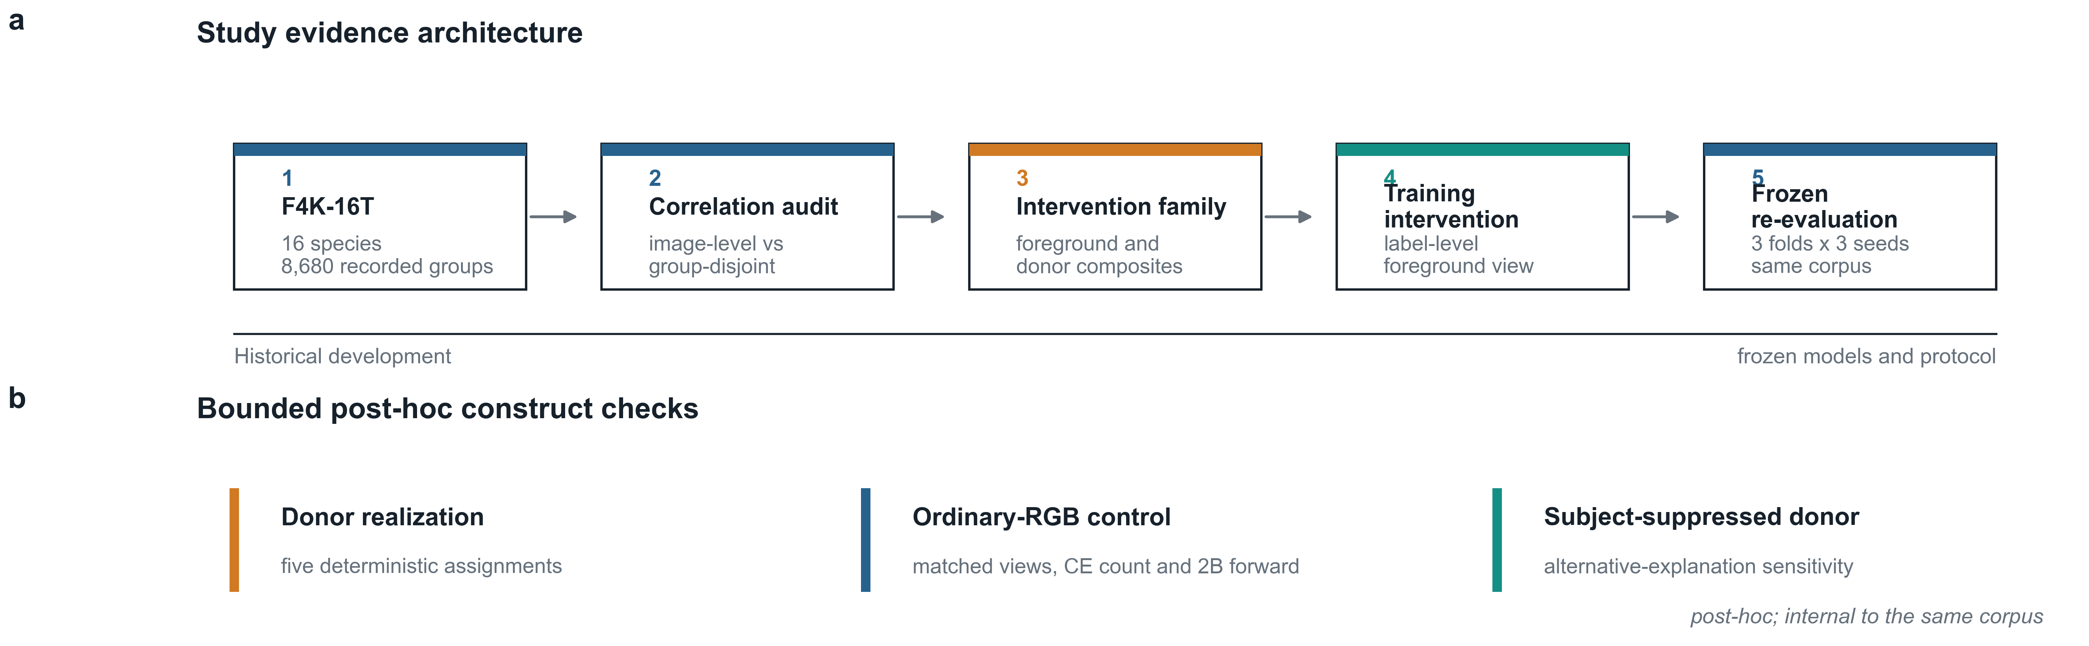
Fig. 1 Study design and evidence hierarchy. The solid path is the main evidence chain from correlation audit to the same-corpus frozen group-disjoint re-evaluation. Dashed branches denote post-hoc validity controls and boundary analyses conducted after the main method definitions were fixed; they are not independent validation or a second blind evaluation. CXT-Fish changes training, not the ordinary RGB inference pathway.

2 Related work

2.1 Underwater fish recognition
Automatic fish recognition has progressed from engineered colour, texture, and shape descriptors to convolutional networks, attention mechanisms, and multi-stage detection-classification systems. Fish4Knowledge established a large-scale video-derived monitoring benchmark and end-to-end research pipeline (Boom et al. 2016). Later studies showed that deep hierarchical features, squeeze-and-excitation modules, transfer learning, and feature fusion can achieve strong performance in unconstrained underwater imagery (Salman et al. 2016; Olsvik et al. 2019; Knausgard et al. 2022). Zhao and Dong (2025) reported 99.27% accuracy on Fish4Knowledge under an 80/10/10 image partition, illustrating the high within-benchmark discrimination attainable under frame-level evaluation. Our question is orthogonal: whether the same level of confidence is warranted when correlated recorded groups are kept disjoint and contextual evidence is deliberately perturbed.
Survey literature emphasizes that deployment performance remains sensitive to habitat, camera, water conditions, annotation practice, and species composition (Saleh et al. 2022). These factors motivate both class-balanced metrics and explicit statement of the evaluation unit. CXT-Fish therefore does not compete through a larger backbone or a new detection architecture. Instead, it asks whether a simple training intervention can improve a precisely defined reliability failure revealed by a stricter protocol.

2.2 Shortcut learning and contextual evidence
Shortcut learning refers to decision rules that exploit predictive but brittle correlations rather than the evidence intended by the task designer (Geirhos et al. 2020). ImageNet studies have shown that backgrounds can support classification by themselves and can redirect predictions when foreground and background cues conflict (Xiao et al. 2021). Texture bias and non-robust features provide related explanations for why conventional accuracy can coexist with fragility under distribution shift (Geirhos et al. 2019; Ilyas et al. 2019; Recht et al. 2019). These ideas are especially relevant to underwater video, where temporally local frames may share colour cast, water-column appearance, camera viewpoint, and habitat structure.
Training-time privileged information is a broader learning setting in which auxiliary information is available during learning but absent at prediction (Vapnik and Vashist 2009; Lopez-Paz et al. 2016). Foreground masking, subject–context recomposition, and background perturbation are established ways to probe or reduce contextual reliance (Torralba and Efros 2011; Geirhos et al. 2020; Xiao et al. 2021). Earlier live-fish recognition work already used trajectory-aware separation to keep images from one trajectory sequence out of both training and testing, together with trajectory-level voting (Huang et al. 2015). In underwater fish recognition, CLIB is a close domain-specific contrastive approach that uses subject/background views to reduce background influence (Yan et al. 2024). We therefore do not claim the first use of segmentation-derived training information, foreground/context manipulation, or contrastive learning. The narrower distinction here is a label-level sufficiency objective coupled to a recorded-group-aware reliability protocol and a layered construct-validity package. The objective does not force original and foreground representations to coincide, and the paper does not infer that label-level supervision is generally superior to contrastive learning.

2.3 Correlated observations and group-aware evaluation
Cross-validation is most interpretable when the split unit matches the unit across which generalization is claimed. Repeated measurements from the same patient, site, animal, video, or acquisition episode violate the independence assumptions implicit in random observation-level partitioning. In spatial and hierarchical data, inappropriate random splits can substantially underestimate generalization error because near-duplicate or strongly correlated observations appear on both sides of the split (Roberts et al. 2017). The same concern applies to video-derived computer-vision benchmarks: frame-level and group-level evaluation estimate different quantities.
Group-aware evaluation should also be separated conceptually from class imbalance. A common species may contribute many correlated observations, while a rare species may contribute few independent groups. Reweighting or margin adjustment can address frequency imbalance (Cui et al. 2019; Cao et al. 2019; Menon et al. 2021), but it does not prevent the same recorded group from crossing a split. Conversely, group-disjoint evaluation can reveal a lower class-balanced score even when image-level accuracy remains very high. CXT-Fish therefore reports macro-F1 and group-balanced accuracy alongside conventional accuracy and treats the recorded group as the correlation proxy. The group identifier is not interpreted as a verified biological identity. Figure 1 summarizes the resulting evidence hierarchy.

3 Materials and methods

3.1 Dataset, recorded groups, and the F4K-16T protocol
We audited 27,370 Fish4Knowledge image records spanning 23 labelled species and 8,725 tracking/group identifiers. We use recorded group to denote the available trajectory/group identifier: it is a proxy for a correlated sequence of observations, not a verified biological identity of an individual fish. The F4K-16T modelling subset retains the 16 species satisfying the Gate-0 pre-specified requirement of at least 15 recorded groups per species. This rule yields 27,133 images from 8,680 recorded groups; seven species comprising 237 images are excluded. The threshold was fixed before method development and is treated as a protocol-design choice rather than a theoretical requirement for three-fold evaluation. The full 23-species inclusion audit is retained in the public repository. Table 1 summarizes the dataset and evidence partitions.
Table 1 Dataset and evidence partitions
Data component | Images | Recorded groups | Species | Role
Audited Fish4Knowledge records | 27,370 | 8,725 | 23 | Parsing, class and correlation audit
F4K-16T | 27,133 | 8,680 | 16 | Frozen modelling subset
Historical development train | 18,681 | 6,076 | 16 | Method development only
Historical development validation | 4,124 | 1,302 | 16 | Development evaluation only
Historical internal test | 4,328 | 1,302 | 16 | Not used for method selection; later redistributed by frozen outer folds
Outer fold 1 test | 8,772 | 2,894 | 16 | Main frozen evaluation fold
Outer fold 2 test | 9,377 | 2,893 | 16 | Main frozen evaluation fold
Outer fold 3 test | 8,984 | 2,893 | 16 | Main frozen evaluation fold

The historical development split and the later outer folds partition the same corpus. Consequently, a group can have influenced method development historically and later appear in an outer-test fold, even though every final fold is internally group-disjoint between fitting, checkpoint selection, and evaluation. This distinction is central to the evidence interpretation below.

3.2 Evidence stages and same-corpus group-disjoint re-evaluation
The study is organized into four evidence stages. First, Gate-0 characterizes correlation and compares image-level with group-disjoint evaluation. Second, a historical group-disjoint development split is used for intervention development. Third, after the method, group-uniform sampler, seeds, checkpoint rule, context generators, and evaluation metrics are frozen, F0 and F1 are retrained across three group-disjoint folds and three pre-specified seeds (17, 2026, and 3407), producing the main frozen ResNet18 evaluation. Fourth, after those results have been observed without reopening method development, post-hoc controls examine donor-assignment sensitivity, generic two-view supervision, and donor-intervention construct validity. These later analyses narrow alternative explanations but do not constitute a second independent evaluation stage.
The three outer folds are loaded from the frozen group manifest using its fixed split seed. For each fold, the designated test groups are held out first. The remaining groups are partitioned into outer-train and fold-local inner-development groups by stable hash ordering separately within each species, using the fixed 0.15 inner-development fraction with at least one development group and at least one fitting group per species. Outer-train, inner-development, and outer-test groups are mutually disjoint, and both fitting and inner-development manifests contain all 16 frozen species. The same fold-local manifests are shared by F0 and CXT-Fish; model seeds do not change the split. Held-out evaluation groups are therefore disjoint from all groups used to fit the model and select its checkpoint in that fold. Test-fold images are never used for optimization or checkpoint selection. We call the main experiment a same-corpus frozen group-disjoint re-evaluation: it estimates robustness across held-out recorded groups after the method definitions were fixed, but it is not method-development-independent holdout validation, a fully blind nested evaluation, or independent external validation. Historical development and the final folds are partitions of the same Fish4Knowledge-derived corpus, so this evidence boundary is stated explicitly.
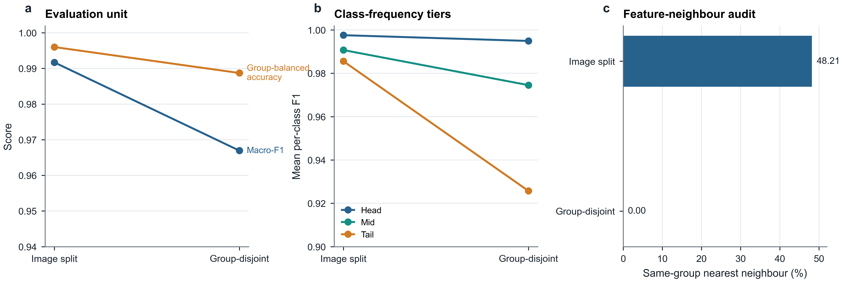
Fig. 2 Group-aware evaluation changes the performance estimate. (a) Mean macro-F1 and group-balanced accuracy under image-level and group-disjoint splitting. (b) Head, mid, and tail per-class F1. (c) Deep-feature same-group nearest-neighbour fractions across the two protocols; the complementary pHash audit is reported in the text.

3.3 Context-diagnostic sanity checks
Before training CXT-Fish, we used only the frozen historical train/validation partitions to characterize what information remained available under subject and context manipulations. All diagnostic CNN conditions used separately trained ImageNet-initialized ResNet18 models at fixed seed 407; the geometry-only condition used multinomial logistic regression rather than RGB pixels. These experiments are development diagnostics, not main frozen outer-fold evaluation results.
The diagnostic views were defined before fitting their separate classifiers. Foreground-only retains RGB pixels inside the official subject mask and replaces the outside region with the fixed foreground-view construction used for CXT-Fish, namely Gaussian-blurred RGB with a three-pixel feather. Background-only suppresses the annotated subject region according to the frozen matched-view construction while retaining the non-primary region; it is evaluated with a separately trained diagnostic classifier. Constant-fill replaces the annotated subject region with neutral RGB (128,128,128); inpainted background applies OpenCV Telea inpainting with radius 3 after one 3 x 3 elliptical dilation of the mask; shuffled-mask background fills the non-primary region using a deterministically assigned mask from a different recorded group; mask-only copies the official binary fish mask into three channels; and geometry-only uses six normalized mask-box features: width, height, area, centre x, centre y, and aspect ratio. These separate models quantify information available in each constructed view rather than the response of the ordinary-RGB F0 model to an out-of-distribution input.
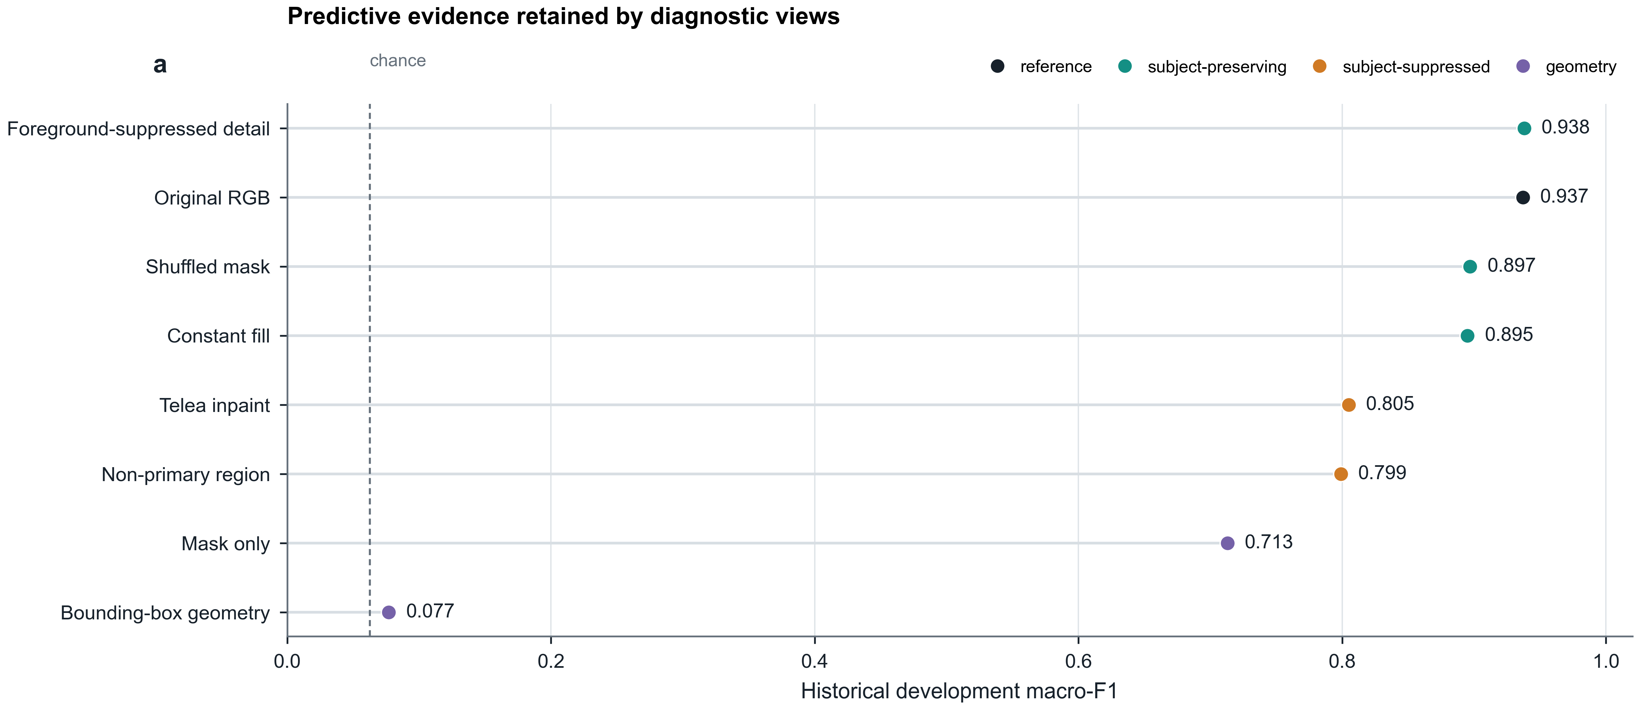
Fig. 3 Context-diagnostic sanity checks on the historical development validation partition. Several views retain substantial predictive non-subject/contextual signal. We reserve the stronger shortcut-susceptibility interpretation for the conflicting-context interventions rather than treating every contextual cue as ecologically spurious.

3.4 Donor-context composite interventions
The final evaluation includes four views: ordinary RGB, foreground-sufficient, same-class donor-context composite, and cross-class donor-context composite. The donor composites are controlled stress tests designed to preserve the recipient subject while replacing or conflicting the surrounding visual evidence. They are not presented as photorealistic counterfactual scenes and are not assumed to contain a fish-free background.
Let x_r denote a recipient image, x_d a donor image, m_r the feathered recipient mask, and R(.) the deterministic resizing/alignment operation that maps the donor to the recipient canvas. In the frozen implementation, both images are converted to RGB, the donor is directly resized to the recipient width and height with PIL bilinear interpolation without aspect-ratio padding, and the recipient mask is resized with nearest-neighbour interpolation before Gaussian feathering. The uint8 composite is rounded and clipped on the recipient canvas before ordinary resizing, tensor conversion, and ImageNet normalization. The donor-context composite is constructed as x_dc = m_r * x_r + (1 - m_r) * R(x_d). For each recipient and intervention type, exactly one donor is selected from the same held-out outer fold. Same-class donors share the recipient species but have a different recorded group; cross-class donors have both a different species and a different recorded group.
Cross-class donor selection is performed over eligible donor images rather than by first balancing donor species. Donor-species frequencies are therefore unequal and are reported as an audited characteristic of the intervention rather than hidden nuisance variation. Table 2 defines the four evaluation views, and Fig. 4 summarizes the donor-composite construction. Under the frozen seed-3407 manifests, all 16 donor species occur in every fold, while the cross-class donor-frequency range is approximately 0.16%-28.05% depending on fold. Maximum donor-image reuse is 8-9 times and maximum donor-group reuse is 77-120 times across folds.
Table 2 Evaluation views and intervention semantics
View | Construction | Question | Interpretation limit
Original RGB | Ordinary recipient crop | Clean within-corpus recognition | Does not imply external-domain generalization
Foreground-sufficient | Recipient foreground retained; fine surrounding detail Gaussian-blurred | Does label predictiveness persist after fine-context suppression? | Synthetic training/evaluation view
Same-class composite | Recipient subject with donor context from another group of same class | Sensitivity to within-class contextual change | Donor can contain subject fragments
Cross-class composite | Recipient subject with donor context from another species and group | Susceptibility to conflicting donor context | Stress test, not causal background replacement

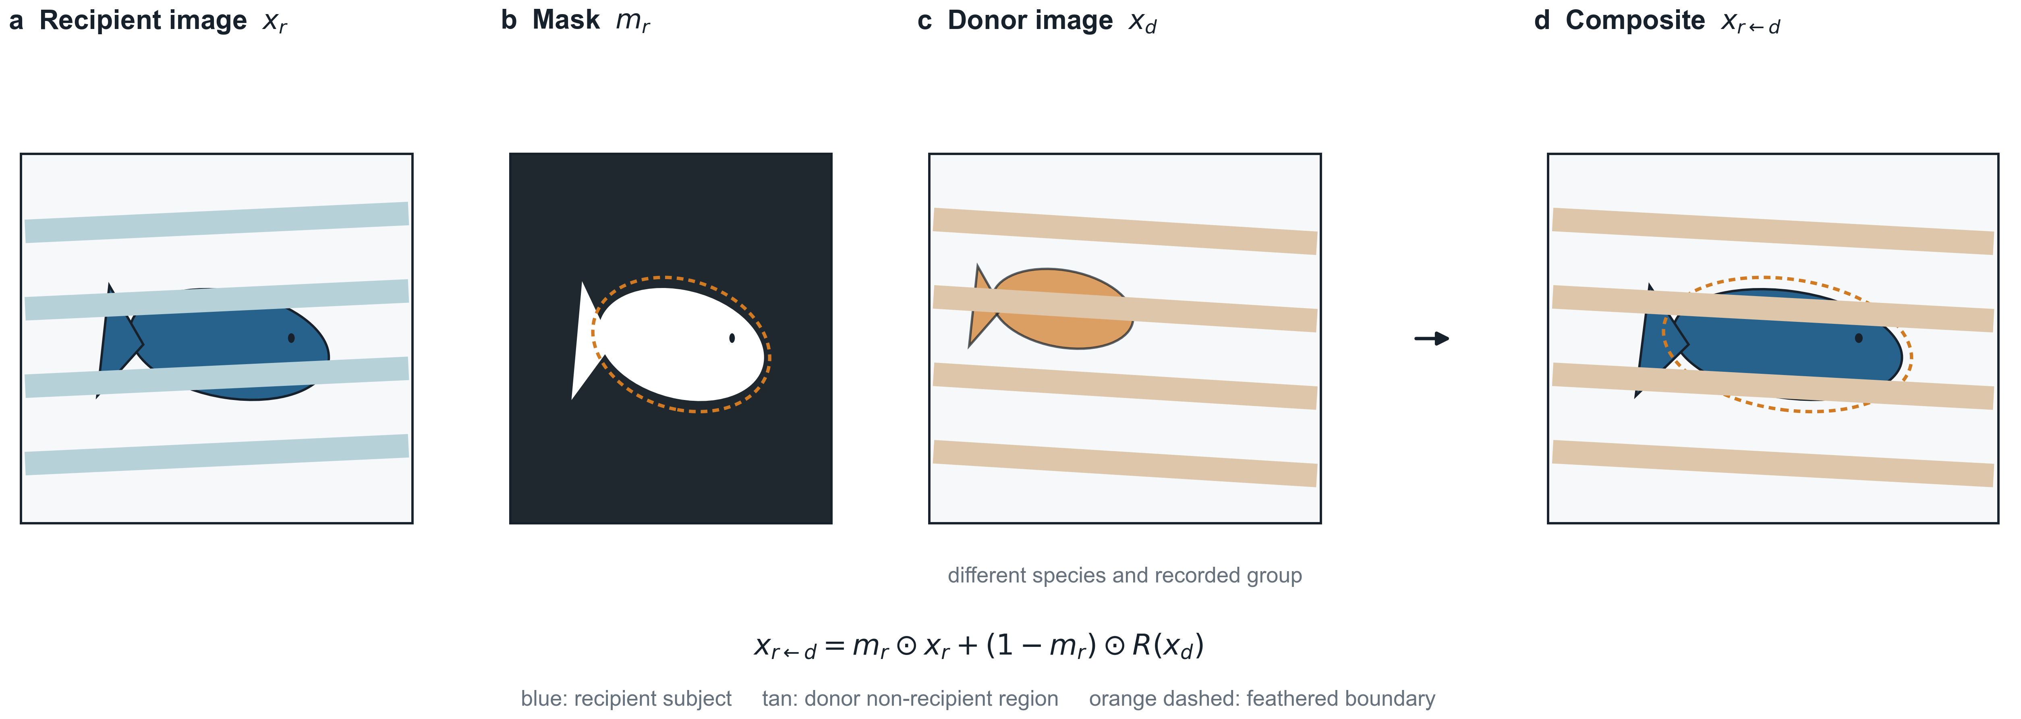
Fig. 4 Schematic construction of a donor-context composite. The recipient foreground is combined with visual evidence from an eligible donor in the same held-out fold. The diagram illustrates the frozen operation; raw Fish4Knowledge images are not redistributed in the manuscript. The resulting composite is a controlled conflicting-context stress test, not a claim of photorealistic background substitution

3.5 Foreground-sufficiency training
CXT-Fish is intentionally architecture-light. F0 is an ImageNet-initialized ResNet18 trained with cross-entropy under a recorded-group-uniform sampler, so each recorded group receives equal expected sampling weight before an image is drawn from that group. F1, the final CXT-Fish method, uses the same backbone, initialization, sampler, optimization schedule, checkpoint rule, and ordinary RGB input, but adds a second label-supervised training view derived from the official foreground mask.
For an RGB training sample x, the auxiliary foreground view x_fg is constructed from the same paired geometric augmentation as the ordinary view, then retains the official subject-mask pixels while replacing the outside region with the fixed Gaussian-blurred RGB context and three-pixel feather used throughout the frozen protocol. The shared classifier receives both views in one concatenated 2B forward. The objective is L = CE(f(x), y) + lambda_fg CE(f(x_fg), y), with lambda_fg = 1.0. Ordinary augmentation comprises RandomResizedCrop with scale 0.08–1.0 and aspect ratio 3/4–4/3, followed by a shared 0.5 horizontal flip and shared ColorJitter (brightness, contrast, saturation 0.1; hue 0.05), bilinear resize, tensor conversion, and ImageNet normalization. Foreground sufficiency is used operationally for this label-supervised context-suppressed view; it does not denote a formal proof that the foreground alone contains all predictive information.
Foreground sufficiency does not require original and foreground representations to coincide. Instead, it means that the context-suppressed view remains separately label-predictive under the auxiliary cross-entropy term. The term therefore describes the training intervention and its operational evaluation, not a formal subject-only identifiability claim.
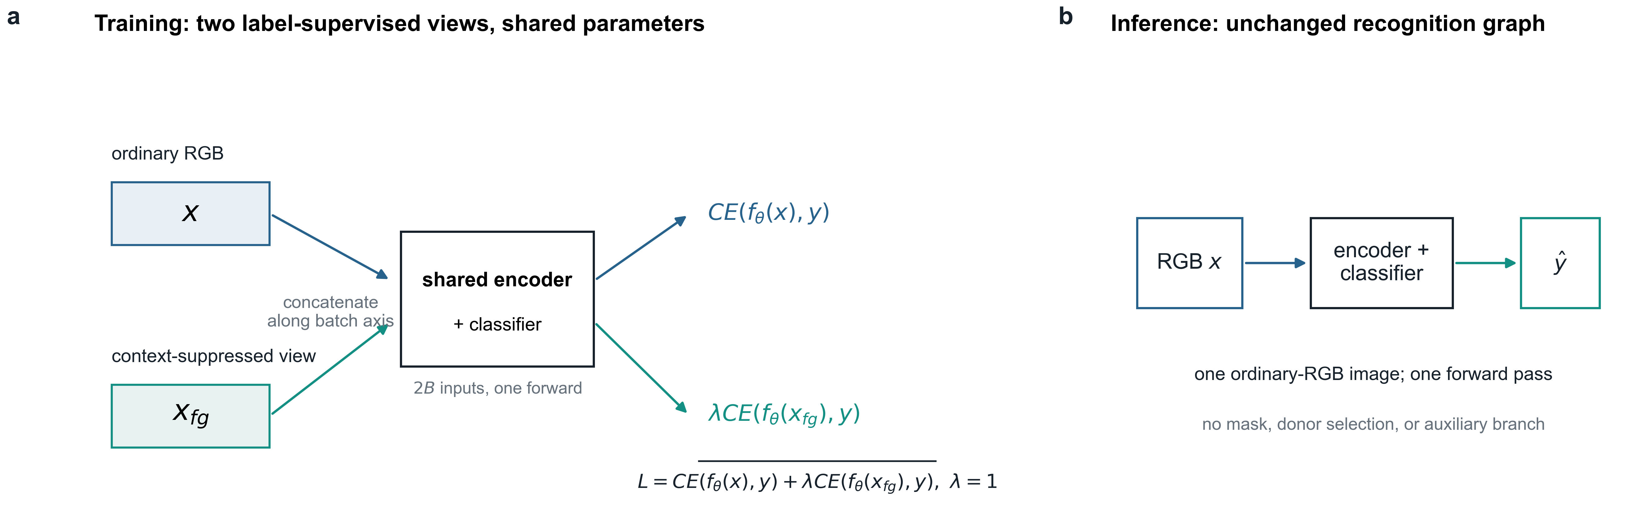
Fig. 5 CXT-Fish foreground-sufficiency training. Ordinary and foreground-sufficient views share one classifier and contribute two cross-entropy terms during training. At inference the auxiliary branch disappears: the model receives one ordinary RGB image and performs one forward pass without a mask, donor, or group identifier

3.6 Outcomes and diagnostic metrics
The principal recognition summaries are macro-F1, tail-class F1, and group-balanced accuracy. Macro-F1 gives equal weight to species but remains image-weighted within each species; it is not an equal-weight recorded-group estimand. For the outer evaluation, head, mid, and tail tiers are constructed deterministically from each fold's outer-training species frequencies rather than imported from a single development split. The resulting fold-local mappings are reported in Supplementary Table S2. Group-balanced accuracy first averages correctness within each recorded group and then averages over groups, reducing domination by long recordings. Image-level accuracy and weighted F1 are retained as secondary descriptive measures. A post-hoc species-group-balanced robustness sensitivity is reported separately.
Context robustness is summarized on the fixed views in Table 2. We also report conditional donor attraction (DAR-flip), defined as the fraction of originally correct recipient predictions that change to the cross-class donor label under the donor-context composite, and prediction agreement between the original and cross-class-composite predictions. DAR-flip is a directional diagnostic rather than a standalone quality metric because its conditioning set depends on original-view correctness. Neither DAR-flip nor agreement proves that contextual dependence has been eliminated.

3.7 Statistical analysis
The frozen outer protocol recorded clean macro-F1, tail F1, and group-balanced accuracy as primary recognition metrics and donor-context quantities as secondary robustness measures. For the final manuscript synthesis, we report a conditional bootstrap interval for one focal robustness contrast: the paired difference in cross-class donor-context-composite macro-F1. We report this single interval rather than presenting a correlated family of robustness measures as independent inferential endpoints. This reporting focus does not upgrade the same-corpus design to independent validation.
For fold f and seed s, the paired cell effect is the CXT-Fish macro-F1 minus the F0 macro-F1 on the same frozen cross-class donor-context composite. The reported point estimate is the equal-weight mean of the nine fold-seed differences. This makes each trained evaluation cell contribute equally rather than weighting folds by image count.
Uncertainty is estimated with 5,000 paired group-cluster bootstrap replicates. The cluster unit is the recipient recorded group; donor identities and donor reuse are held fixed through the complete frozen recipient-donor manifest rather than resampled as a second clustering dimension. Within every replicate, recipient recorded groups are resampled with replacement separately within fold and ground-truth species. The same sampled groups are used for paired methods and across the three pre-specified seeds before macro-F1 is recomputed for each fold-seed cell; the nine paired cell differences are then averaged with equal weight. The resulting conditional paired group-cluster bootstrap interval quantifies held-out-group resampling uncertainty conditional on the completed development process, the fixed outer-fold allocation and fold × species stratum sizes, the frozen trained checkpoints and three seeds, and the complete seed-3407 recipient-donor manifest. It does not estimate alternative fold assignments, method-selection uncertainty, optimization-seed population uncertainty, alternative donor-generation mechanisms, higher-level acquisition-unit variability, or external-dataset variability. The recorded-group counts for each fold × species stratum are reported in Supplementary Table S2 to make the finite-cluster structure explicit.

3.8 Post-hoc validity controls

3.8.1 Donor-realization sensitivity
After observing the main frozen result, we assessed whether the robustness effect depended on the single seed-3407 donor assignment. Before any additional inference, five alternative deterministic donor seeds (4101-4105) were fixed under the same candidate pool, eligibility, ordering, hash-selection, and composite-construction rules. No donor realization was selected or discarded based on its result. Frozen F0/F1 checkpoints were evaluated under all five assignments, producing 90 additional method-realization evaluations across the existing nine fold-seed cells. These results are descriptive post-hoc sensitivity checks and do not replace the seed-3407 manuscript result.

3.8.2 F0-2RGB supervision- and compute-matched control
A second post-hoc control tested whether the F1 advantage could be explained by generic duplicated supervised exposure rather than foreground-specific supervision. F0-2RGB uses the same ResNet18, ImageNet initialization, group-uniform sampler, 64-recipient batches, concatenated 2B model forward, two cross-entropy terms, AdamW configuration, cosine schedule, 40-epoch budget, inner-development clean-accuracy checkpointing rule, and three fixed seeds as CXT-Fish. The second view is instead an independently augmented ordinary-RGB image; no mask, foreground blur, or background editing is used. All nine control-training cells were completed before outer evaluation was opened.
The focused comparison is CXT-Fish versus F0-2RGB on cross-class donor-context-composite macro-F1. Clean, foreground, same-composite, DAR-flip, and prediction agreement are descriptive. For the corrected exploratory analysis, recorded groups are resampled with replacement within fold and ground-truth species. The same fold-level group draw is shared by CXT-Fish and F0-2RGB and across all three optimization seeds, matching the resampling structure of the main ResNet18 analysis. The observed point estimate is computed directly from the nine paired fold-seed effects rather than from the mean of the bootstrap distribution. The resulting 5,000-replicate percentile interval is labelled exploratory and post-hoc.

3.8.3 Donor-subject-suppressed construct-validity sensitivity
A third post-hoc analysis examined whether the original donor-context result depended primarily on visible donor-subject evidence outside the recipient foreground. We first quantified residual donor foreground using the official donor and recipient masks under the frozen composite geometry. We then constructed a donor-subject-suppressed sensitivity view while preserving the original seed-3407 recipient-donor pairing, recipient mask, frozen F0/F1 checkpoints, and composite geometry. Before compositing, the donor subject was suppressed using the already frozen Telea procedure used in the context diagnostics: one 3 x 3 elliptical mask dilation followed by OpenCV Telea inpainting with radius 3. No model was retrained and no donor was reassigned.
The analysis comprised the same 18 frozen F0/F1 model cells. Its CXT-Fish-F0 cross-composite contrast was summarized using the same species-stratified, paired group-cluster resampling structure as the main analysis. This interval is explicitly post-hoc and exploratory. The intervention tests whether the observed effect is confined to visible donor-subject evidence; it does not constitute a natural-background or external-domain evaluation.

3.9 Architecture-sensitivity and mechanism-boundary analyses
To test whether the qualitative robustness direction depends entirely on ResNet18, we transfer the baseline/intervention distinction to MobileNetV3-Large over the same three group-disjoint folds using one pre-specified seed (3407). Because only one optimization seed is evaluated, the MobileNet analysis is not treated as a second main evaluation; its uncertainty reflects group resampling conditional on that seed and does not quantify across-seed variability.
A separately frozen two-stage mask-guided subject-non-primary contrastive Route C control is retained as a mechanism stress test in the public repository and Supplementary Note S6. Route C is not a faithful CLIB reproduction and is not used as a competitive baseline. Its purpose is only to test whether a stronger representation-level constraint automatically improves the target clean-robustness profile under one fixed protocol.

3.10 Implementation details
Table 3 Frozen implementation settings
Component | Setting
Main backbone | ResNet18, ImageNet initialization
Architecture sensitivity | MobileNetV3-Large, ImageNet initialization
Input resolution | 224 x 224
Recipient batch size | 64 before two-view concatenation
Optimizer | AdamW
Learning rate / weight decay | 3 x 10^-4 / 1 x 10^-4
Schedule | Cosine annealing, maximum 40 epochs
Checkpoint selection | Fold-local inner-development clean accuracy; patience 7
Pre-specified ResNet seeds | 17, 2026, 3407
Foreground transform | Gaussian blur kernel 21, sigma 5.0; feather radius 3
Auxiliary loss weight | lambda = 1.0
Official Fish4Knowledge TEST | Not accessed

The public repository contains the fixed configuration files, evaluation scripts, group-aware metrics, donor-manifest builders, bootstrap implementations, validity-control audits, construct-validity analyses, and compact result artifacts used for the manuscript. The current frozen evidence snapshot reports 88 passing tests. The construct-validity package was inference- and reanalysis-only: it created no new model checkpoint and did not access the official Fish4Knowledge TEST partition.

4 Results

4.1 Group-disjoint evaluation changes the estimated generalization performance
At Gate-0, the image-level split produced mean macro-F1 0.9917 +/- 0.0039 across three ResNet18 seeds, whereas the group-disjoint split produced 0.9669 +/- 0.0084, a decrease of 2.48 percentage points. Group-balanced accuracy decreased more modestly from 0.9960 to 0.9887. The discrepancy was concentrated away from the most frequent classes: head-class F1 changed from 0.9976 to 0.9949, mid-class F1 from 0.9907 to 0.9745, and tail-class F1 from 0.9856 to 0.9257.
Nearest-neighbour audits document a structural difference between the protocols. Under the image-level split, 25.5% of pHash nearest neighbours and 48.2% of deep-feature nearest neighbours across partitions came from the same recorded group; both fractions were zero after group-disjoint splitting (Fig. 2). The image-level and group-disjoint protocols therefore yield materially different estimates of benchmark difficulty. Same-group crossing is directly documented by the nearest-neighbour audit, but the 2.48-point macro-F1 difference is not interpreted as a causal decomposition attributable exclusively to that factor because the complete partition composition also changes.

4.2 Context diagnostics reveal multiple predictive non-subject signals
The fixed development diagnostics showed that substantial label information remained available after several subject-removal or mask manipulations. The matched-view background-only model reached macro-F1 0.7995. A mask-only classifier reached 0.7127, while the six-feature geometry-only model reached only 0.0768, indicating that detailed silhouette and other mask structure are more informative than coarse scale-position geometry alone. Constant-fill and shuffled-mask background diagnostics reached 0.8955 and 0.8968, respectively, whereas Telea-inpainted background reached 0.8053.
The near-equality of constant-fill and shuffled-mask conditions argues against the recipient fish-hole shape being the sole source of the background diagnostic signal. The lower but still substantial inpainted-background result is consistent with both residual environmental/camera context and artifacts induced by subject removal. These experiments demonstrate substantial predictive non-subject/contextual signal availability, but not a causal claim that the natural background alone determines species identity. We reserve the stronger shortcut-susceptibility interpretation for failures exposed by the conflicting-context interventions (Fig. 3).

4.3 Development ablations identify foreground sufficiency as the final intervention
Table 4 Historical development ablations (development validation only). Values are means ± sample SD across the three fixed development seeds; they are descriptive and do not define the main frozen estimand.
Variant | Training objective | Clean macro-F1 | Tail F1 | Group-bal. acc. | Cross composite | DAR-flip
F0 | Group-uniform RGB CE | 0.9619 +/- 0.0111 | 0.9427 +/- 0.0198 | 0.9866 +/- 0.0019 | 0.5402 +/- 0.0027 | 0.1995 +/- 0.0047
F1 | F0 + foreground CE | 0.9733 +/- 0.0055 | 0.9622 +/- 0.0229 | 0.9887 +/- 0.0042 | 0.5844 +/- 0.0426 | 0.1790 +/- 0.0332
F2 | F0 + feature consistency | 0.9598 +/- 0.0053 | 0.9168 +/- 0.0197 | 0.9864 +/- 0.0011 | 0.4991 +/- 0.0231 | 0.2089 +/- 0.0219
F3 | F0 + foreground CE + consistency | 0.9649 +/- 0.0097 | 0.9541 +/- 0.0104 | 0.9892 +/- 0.0011 | 0.5941 +/- 0.0298 | 0.1772 +/- 0.0330

F2 did not improve the target clean-robustness profile. F3 achieved the highest mean development cross-composite score, but it added a representation-consistency assumption and produced a less favourable clean-robustness balance. F1 was selected because it most directly instantiated the label-level study hypothesis with no additional representation constraint; it was not selected by maximizing cross-composite macro-F1. F2 and F3 were retained as diagnostic ablations, and the F1 definition was frozen before the three-fold outer re-evaluation. The outer analysis therefore compares only the frozen F0 and F1 definitions (Table 4).

4.4 Main frozen ResNet18 evaluation isolates a robustness gain rather than a clean-accuracy gain
Table 5 Main same-corpus frozen ResNet18 group-disjoint re-evaluation across three folds × three seeds. Values are equal-weight means ± sample SD across the nine fold–seed cells. Paired differences are computed from unrounded cell-level values. The cross-class composite interval is the conditional paired group-cluster bootstrap interval reported for the focal robustness contrast.
Outcome | F0 | CXT-Fish | Paired difference | Favourable cells | Status
Original macro-F1 | 0.9577 +/- 0.0086 | 0.9556 +/- 0.0193 | -0.21 pp | 6/9 | Descriptive
Tail F1 | 0.9233 +/- 0.0209 | 0.9260 +/- 0.0249 | +0.26 pp | 5/9 | Descriptive
Group-balanced accuracy | 0.9887 +/- 0.0016 | 0.9895 +/- 0.0025 | +0.09 pp | 7/9 | Descriptive
Foreground macro-F1 | 0.8331 +/- 0.0228 | 0.9550 +/- 0.0107 | +12.19 pp | 9/9 | Descriptive
Same-class composite macro-F1 | 0.9229 +/- 0.0151 | 0.9291 +/- 0.0300 | +0.62 pp | - | Descriptive
Cross-class composite macro-F1 | 0.5189 +/- 0.0251 | 0.5913 +/- 0.0437 | +7.24 pp | 8/9 | Conditional bootstrap interval: +6.13 to +8.20 pp
DAR-flip (lower favourable) | 0.2146 +/- 0.0164 | 0.1792 +/- 0.0166 | -3.54 pp | 9/9 | Descriptive

Across the nine fold-seed cells, mean original-view macro-F1 changed from 0.9577 for F0 to 0.9556 for CXT-Fish, an equal-weight mean difference of -0.21 percentage points. Six of nine cells favoured CXT-Fish on clean macro-F1, but the variability was large enough that these data do not support a general clean-accuracy improvement claim. Tail F1 changed by +0.26 points and group-balanced accuracy by +0.09 points; both are descriptive and similarly insufficient for a universal improvement claim.
The clearest separation appeared under conflicting donor context. Cross-class donor-context-composite macro-F1 increased from 0.5189 to 0.5913, an equal-weight paired improvement of 7.24 percentage points. The 5,000-replicate paired group-cluster bootstrap yielded a conditional 95% interval of +6.13 to +8.20 points under the frozen fold allocation, checkpoints, seeds, and donor manifest. Eight of nine fold-seed cells improved. DAR-flip decreased from 0.2146 to 0.1792 and was lower for CXT-Fish in all nine cells. Thus, the main frozen result is higher performance under the tested synthetic conflicting-context intervention, not better ordinary-view recognition (Table 5; Fig. 6).
Because the main macro-F1 is class-balanced but image-weighted within species, we additionally computed a post-hoc group-weighted robustness sensitivity from the frozen per-image predictions. For cross-class composites, recorded-group-balanced accuracy changed from 0.6979 ± 0.0278 for F0 to 0.7426 ± 0.0161 for CXT-Fish, an equal-weight nine-cell difference of +4.47 percentage points (8/9 favourable cells). A stricter species–group-balanced accuracy changed from 0.5271 ± 0.0156 to 0.5944 ± 0.0269, a +6.73-point difference (9/9 favourable cells). These favourable-cell counts are descriptive and are not interpreted as nine independent statistical trials; these are sensitivity estimands, not replacements for the main frozen macro-F1 result; the full cell table and definitions are in Supplementary Table S1.
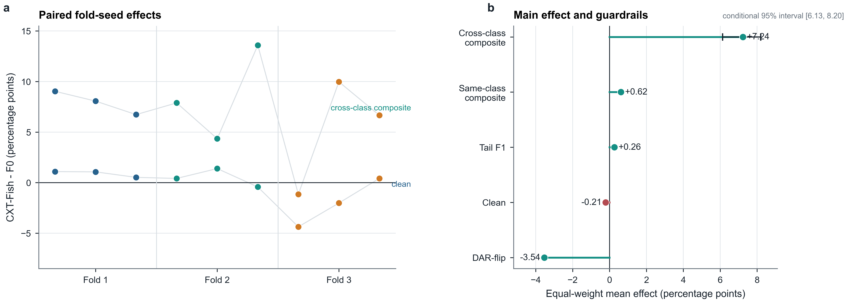
Fig. 6 Main same-corpus frozen ResNet18 re-evaluation. (a) Mean macro-F1 across ordinary, foreground-sufficient, same-class-composite, and cross-class-composite views. (b) Equal-weight paired effects across nine fold–seed cells. The cross-class donor-context-composite difference is accompanied by the manuscript's conditional 5,000-replicate paired group-cluster bootstrap interval; lower DAR-flip is favourable.

4.5 The robustness effect is not confined to one donor assignment
Table 6 Post-hoc donor-realization sensitivity using frozen checkpoints. Differences are computed from unrounded cell-level values; favourable-cell counts are descriptive and are not treated as independent statistical trials.
Donor realization | F0 cross F1 | CXT-Fish cross F1 | CXT-Fish - F0 | Favourable cells
Primary 3407 | 0.5189 | 0.5913 | +7.24 pp | 8/9
4101 | 0.5148 | 0.5948 | +8.00 pp | 8/9
4102 | 0.5146 | 0.6030 | +8.84 pp | 8/9
4103 | 0.5112 | 0.5956 | +8.45 pp | 9/9
4104 | 0.5168 | 0.5966 | +7.98 pp | 8/9
4105 | 0.5160 | 0.5934 | +7.74 pp | 8/9

The frozen seed-3407 donor assignment yielded the manuscript effect of +7.24 points. Using the same frozen checkpoints and donor-construction mechanism, all five alternative deterministic donor realizations produced positive equal-weight effects: +8.00, +8.84, +8.45, +7.98, and +7.74 points for seeds 4101–4105. The mean effect across the five alternatives was +8.20 points (SD 0.44), with four realizations favourable in eight of nine cells and one in all nine cells. These are post-hoc donor-realization sensitivity results, not a second primary endpoint.
These post-hoc results make an unusually favourable seed-3407 donor pairing an unlikely sole explanation for the observed robustness difference. They do not test arbitrary contextual shifts, because all six realizations share the same candidate-pool definition, donor eligibility, hash-selection mechanism, and composite family. The analysis addresses assignment variance within one intervention family, not uncertainty over intervention families (Table 6; Fig. 7a).

4.6 Generic two-view supervision does not explain the full robustness gain
Table 7 Post-hoc F0-2RGB supervision- and compute-matched control
Method | Clean | Foreground | Same composite | Cross composite | DAR-flip | Agreement
F0 | 0.9577 | 0.8331 | 0.9229 | 0.5189 | 0.2146 | -
F0-2RGB | 0.9551 | 0.8282 | 0.9188 | 0.5230 | 0.2037 | 0.7254
CXT-Fish | 0.9556 | 0.9550 | 0.9291 | 0.5913 | 0.1792 | 0.7617

F0-2RGB nearly matched the clean performance of CXT-Fish (0.9551 versus 0.9556) while retaining duplicated supervised exposure, a concatenated 2B model forward, two cross-entropy terms, and comparable BatchNorm exposure. However, its cross-class donor-context-composite macro-F1 was 0.5230, compared with 0.5913 for CXT-Fish. The corrected observed equal-weight paired difference was +6.83 percentage points. A 5,000-replicate species-stratified paired group-cluster bootstrap, sharing each fold-level group draw across both methods and all three seeds, gave an exploratory conditional percentile interval of +5.71 to +7.87 points. The observed point estimate is computed from the nine paired fold-seed effects; this control is post-hoc and does not modify the main result.
F0-2RGB also achieved lower foreground macro-F1 (0.8282 versus 0.9550), higher DAR-flip (0.2037 versus 0.1792), and lower original-to-composite prediction agreement (0.7254 versus 0.7617). Thus, generic duplicated supervised exposure alone does not explain the full donor-context robustness advantage. Because the ordinary-RGB control views use independently sampled augmentations whereas CXT-Fish derives the foreground view from the same geometric augmentation before suppressing context, this comparison narrows but does not uniquely identify the causal mechanism (Table 7; Fig. 7b).
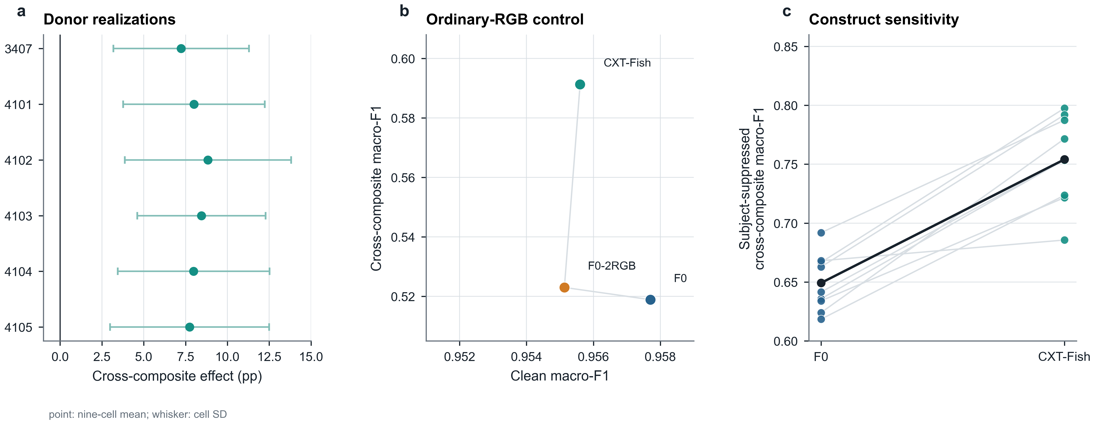
Fig. 7 Post-hoc validity controls. (a) The CXT-Fish minus F0 cross-class effect remains positive for the frozen seed-3407 donor assignment and five alternative deterministic donor realizations. (b) F0-2RGB nearly matches clean performance but not the donor-context robustness of CXT-Fish. (c) The CXT-Fish–F0 effect remains positive after donor-subject suppression under frozen pairings. These controls are post-hoc and exploratory; they do not constitute independent validation.

4.7 The robustness difference persists after suppressing donor-subject evidence
The frozen donor composites contained measurable but generally limited donor-foreground residue outside the recipient foreground. Across 27,133 frozen recipient-donor pairs, the residual donor-foreground fraction of the full composite had a mean of 3.01%, a median of 2.82%, and a 95th percentile of 5.81%. Only 0.096% of pairs exceeded 10% residual donor foreground.
We therefore repeated the frozen-pair evaluation after suppressing the donor subject while retaining the same recipient, donor assignment, recipient mask, checkpoint, and compositing geometry. The equal-weight CXT-Fish–F0 difference was +10.48 percentage points, with an exploratory 5,000-replicate conditional percentile interval of +9.38 to +11.61 points. All nine fold–seed cells remained positive, although the magnitude varied substantially across cells. A post-hoc donor-species-equal-weight correctness sensitivity also remained positive; detailed donor-species and residual-bin heterogeneity are reported in Supplementary Tables S7–S8. This analysis narrows the visible-donor-subject explanation but does not establish natural-background or external-domain robustness.
This result indicates that the original robustness advantage is not confined to composites containing visible donor-subject evidence. It should not be interpreted as evidence of natural-background invariance because the donor-subject-suppressed images remain synthetic and may contain inpainting and compositing artifacts.

4.8 Fold and seed heterogeneity reveal where the claim is strongest
The average robustness improvement concealed meaningful variation in clean recognition. At the fold level, clean macro-F1 changes were +0.89, +0.46, and -1.99 percentage points for folds 1-3, respectively, while the corresponding cross-composite changes were +7.94, +8.61, and +5.16 points. DAR-flip decreased in every fold by approximately 3.27-3.87 points. Fold 3 therefore demonstrates that the donor-context robustness gain can coexist with a material clean cost. The present analysis does not isolate which classes, recording characteristics, or other fold-composition factors caused that larger cost.

4.9 Architecture sensitivity shows a larger clean-robustness trade-off
Table 8 Architecture-sensitivity summary
Backbone | Method | Seed structure | Clean | Foreground | Same composite | Cross composite | DAR-flip
ResNet18 | F0 | 3 folds x 3 seeds | 0.9577 | 0.8331 | 0.9229 | 0.5189 | 0.2146
ResNet18 | CXT-Fish | 3 folds x 3 seeds | 0.9556 | 0.9550 | 0.9291 | 0.5913 | 0.1792
MobileNetV3-Large | MV0 | 3 folds x 1 seed | 0.9580 | 0.8175 | 0.9269 | 0.5173 | 0.2173
MobileNetV3-Large | MV1 | 3 folds x 1 seed | 0.9286 | 0.9198 | 0.8861 | 0.5656 | 0.1700
Table 8 Architecture-sensitivity summary. Values are means across the three outer folds for the one pre-specified MobileNet seed; differences are computed from unrounded cell-level values. MobileNet is architecture-sensitivity evidence only, with cross-class composite effects positive in 2/3 folds.
At the pre-specified MobileNet seed, foreground-sufficiency training improved mean foreground macro-F1 by 10.22 points and cross-class donor-context-composite macro-F1 by 4.82 points, while DAR-flip decreased by 4.73 points. Foreground improved in all three folds and DAR-flip decreased in all three; cross-class composite improved in two of three folds and decreased in one. However, ordinary-view macro-F1 decreased by 2.94 points and same-class-composite macro-F1 by 4.09 points. MobileNetV3-Large is therefore architecture-sensitivity evidence with heterogeneous cross-class effects, not cross-backbone validation or backbone-agnostic evidence (Table 8; Fig. 8).
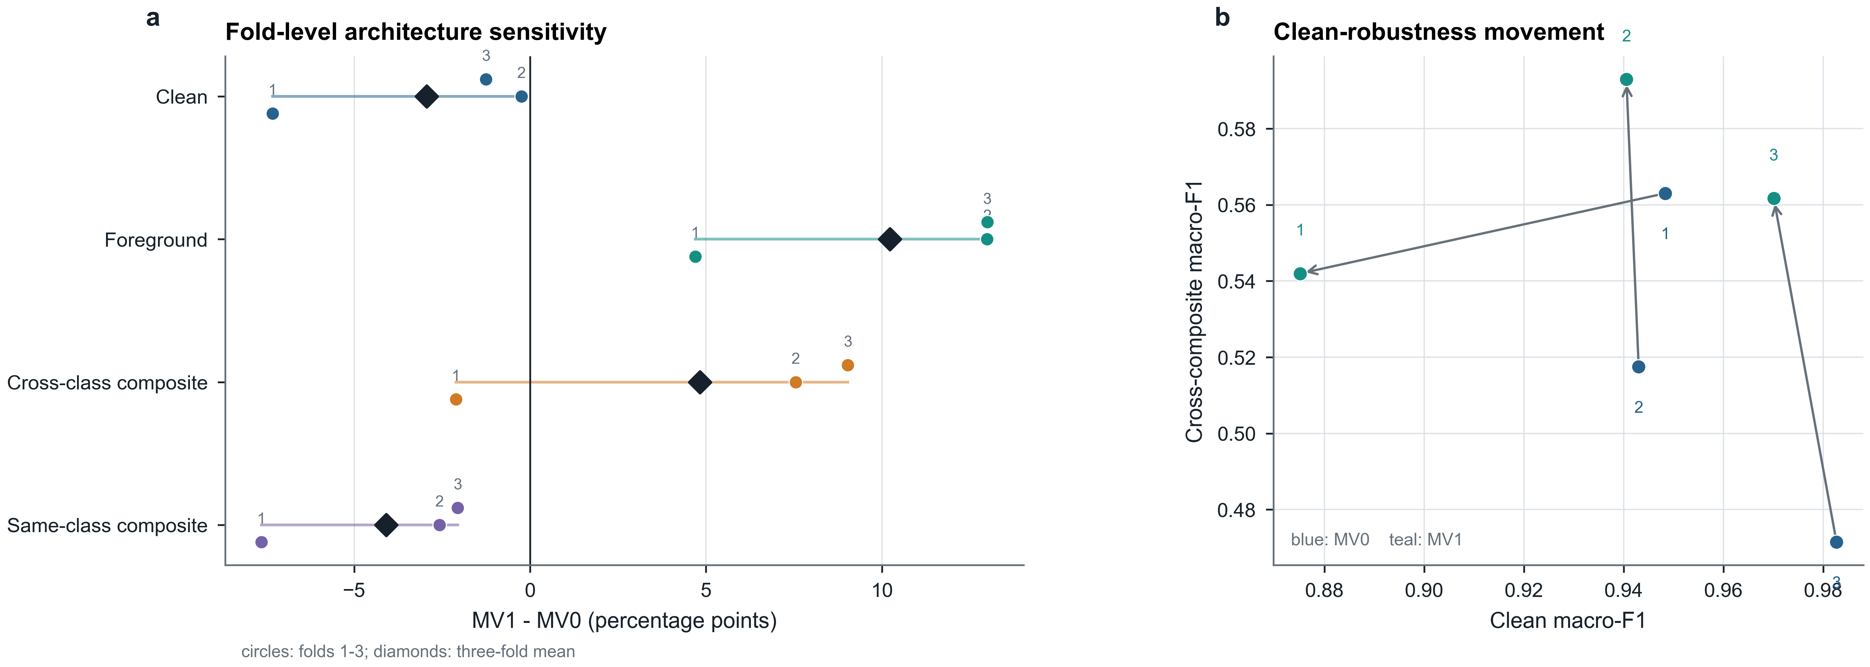
Fig. 8 Architecture-sensitivity boundary. (a) MobileNetV3-Large fold-level effects show foreground gains in 3/3 folds, cross-class-composite gains in 2/3 folds, and heterogeneous clean cost. (b) Clean versus cross-class-composite macro-F1 for ResNet18 and MobileNetV3-Large. The MobileNet result is a one-seed sensitivity analysis, not a second main evaluation.

5 Discussion

5.1 A narrow but strengthened robustness claim
The main result is deliberately narrow. In the same-corpus frozen ResNet18 group-disjoint re-evaluation, foreground-sufficiency training improved performance under the tested synthetic conflicting donor-context intervention without improving mean clean recognition. The 7.24-point cross-class-composite gain, lower DAR-flip in all nine paired cells, and positive group-weighted sensitivities jointly support a targeted robustness interpretation. They do not establish natural-context invariance, external-domain generalization, or a universal accuracy benefit.
The post-hoc controls narrow three alternative explanations. The effect remained positive across five additional deterministic donor assignments, making one favourable seed-3407 pairing an unlikely sole explanation. CXT-Fish also exceeded the supervision- and compute-matched ordinary-RGB two-view control by 6.83 points, although the control does not match every augmentation-correlation detail. Finally, the effect persisted after visible donor-subject evidence was suppressed while pairings and checkpoints remained fixed. These analyses strengthen construct validity within the frozen intervention family; they do not create an independent evaluation.

5.2 Foreground-specific supervision versus generic two-view training
CXT-Fish imposes a relatively weak requirement: when fine surrounding detail is suppressed, the annotated subject should remain sufficient for the species label. The method does not force original and foreground representations to be identical, and it does not prohibit the ordinary-view classifier from using ecological or visual context that is genuinely useful. This matters because context in underwater imagery is heterogeneous: some cues may be incidental acquisition signatures, while others may carry real species-habitat information.
The F0-2RGB result provides the most direct mechanism-oriented control in the current evidence package. Simply doubling supervised RGB exposure with matched compute does not reproduce the cross-composite improvement, even though clean performance is almost identical to CXT-Fish. The historical F2/F3 ablations and the supplementary Route C experiment similarly show that stronger representation-level constraints did not automatically yield a better clean–robustness profile under the tested protocols. These observations should not be generalized into a claim that representation invariance or contrastive learning is inferior. They show only that the final label-sufficiency instantiation addresses the target failure more favourably in this study.

5.3 The evaluation unit is part of the model claim
The Gate-0 result has a broader methodological implication. An image-level split and a group-disjoint split are not merely two implementation choices for the same quantity; they approximate different generalization targets. The former can be appropriate when the application concerns additional frames from already represented recordings. The latter is more relevant when a model is expected to recognize fish from unseen recorded groups. Neither is automatically wrong; the error arises when one target is described as the other.
This distinction is especially important for video-derived marine data because a long sequence can contribute many visually similar observations. Image-level accuracy can remain near saturation while class-balanced and rare-class estimates change materially under group isolation. Reporting the split unit, group counts, and group-balanced metrics therefore becomes part of the scientific model claim rather than a minor implementation detail.

5.4 What donor-context composites do - and do not - measure
The donor intervention remains a synthetic stress test rather than a natural domain shift. However, the construct audit narrows one important ambiguity. Residual donor foreground occupied on average 3.01% of the composite area, with a median of 2.82% and a 95th percentile of 5.81%; only a small fraction of pairs contained more than 10% residual donor foreground. More importantly, suppressing the donor subject while preserving the frozen recipient-donor pairings did not remove the CXT-Fish advantage: the post-hoc difference remained +10.48 points. The original result therefore cannot be attributed solely to the presence of a competing visible donor fish.
This does not convert the intervention into a causal background experiment. Telea inpainting, resizing, mask feathering, donor habitat structure, acquisition cues, and unnatural scene combinations remain part of the perturbation. The appropriate construct is robustness to conflicting non-recipient contextual evidence under a controlled synthetic intervention family. The new analysis reduces donor-subject contamination as an alternative explanation but does not establish robustness to arbitrary environmental, camera, site, or geographic shifts. The donor-realization analysis similarly addresses assignment variance within a fixed intervention family, not intervention-family uncertainty itself.

5.5 Operational implications
The practical attraction of CXT-Fish is that the intervention is confined to training. The deployed classifier has the ordinary RGB inference graph of its baseline backbone: one image, one classifier, and one forward pass. Segmentation masks are not needed at inference, and no donor selection or second view is generated online. The structural claim is therefore that CXT-Fish does not introduce a segmentation dependency into the recognition-stage inference graph. It does not claim that the full marine-monitoring pipeline is unchanged: these experiments begin after fish crops are available and do not evaluate detector errors, tracking failures, multi-fish overlap, crop errors, or downstream ecological aggregation from raw video.
CXT-Fish nevertheless assumes foreground masks during training. These masks are privileged annotation rather than a free deployment resource and may increase data-preparation cost where only species labels or bounding boxes are available. The present study does not test automatically generated masks or quantify sensitivity to mask quality. We also do not claim a measured latency, energy, or memory advantage because no hardware-specific deployment benchmark was frozen; training is more expensive because each recipient contributes two supervised views in one concatenated forward.

5.6 Limitations
External validity. The principal evidence is limited to the 16-class F4K-16T subset of Fish4Knowledge. Group-disjoint evaluation prevents direct crossing of recorded groups inside each evaluation cell, but it does not establish independence across cameras, sites, dates, water conditions, species inventories, or data sources. Higher-level acquisition units such as camera, session, deployment, or date could not be verified from the frozen recognition metadata and may remain shared across recorded groups. Independent multi-site or cross-dataset replication is required before broader generalization claims can be made.
Intervention validity. Donor-subject contamination was quantitatively audited and further examined with a fixed donor-subject-suppressed sensitivity analysis, reducing but not eliminating construct ambiguity. The donor species distribution is unequal by construction, although a donor-species-equal-weight descriptive sensitivity remains positive. The remaining central limitation is that both the original and subject-suppressed interventions are synthetic and do not reproduce naturally occurring camera, site, habitat, geographic, or cross-dataset shifts.
Evaluation design. Historical development and the main group-disjoint folds partition the same corpus. Although each final fold prevents direct recorded-group overlap between fitting, checkpoint selection, and evaluation, the analysis does not undo method selection performed earlier on the corpus and is not equivalent to a fully blind nested evaluation or external validation. The conditional bootstrap interval quantifies held-out-group resampling uncertainty conditional on the frozen trained models, the completed development process, and the frozen seed-3407 donor realization. The least represented fold × species strata contain relatively few recorded groups, so percentile cluster intervals should be interpreted as approximate finite-sample uncertainty summaries.
Boundary evidence. Donor-realization, F0-2RGB, donor-subject-suppressed, and group-weighted analyses are post-hoc validity controls, not new independent endpoints. MobileNetV3-Large is evaluated with one pre-specified seed and has heterogeneous cross-class effects, so it does not estimate across-seed or backbone-independent uncertainty. Route C is a fixed mechanism stress control rather than a faithful CLIB reproduction or exhaustive contrastive comparison. Only the cross-class donor-context-composite macro-F1 difference in the main ResNet18 re-evaluation receives the manuscript's conditional bootstrap interval; all newer control intervals are explicitly exploratory.

6 Conclusion
For video-derived underwater recognition, the evaluation unit is part of the scientific claim. In Fish4Knowledge, keeping recorded groups disjoint lowered class-balanced performance estimates and revealed substantial predictive information outside the annotated subject. CXT-Fish addresses one resulting failure mode with a simple label-level foreground-sufficiency intervention that leaves recognition-stage inference unchanged. In the same-corpus frozen ResNet18 re-evaluation, cross-class donor-context-composite macro-F1 increased by 7.24 points while clean macro-F1 changed by -0.21 points. The effect remained positive across donor assignments, beyond an ordinary-RGB two-view control, and after donor-subject suppression under frozen pairings. These findings support targeted robustness to the tested synthetic, mask-defined intervention family. They do not establish a general accuracy gain, context invariance, external-domain transfer, or end-to-end deployment reliability.

7 Reproducibility and data/code availability
Code, configurations for deterministic split reconstruction, manifest hashes, audit reports, figures, and compact result artifacts are publicly available at https://github.com/Xiaoqin-pro/ctp-fish. The public repository does not redistribute trained checkpoints or full per-image prediction outputs; complete training and per-image replay additionally require an authorized local copy of the Fish4Knowledge-derived data under the original access terms. This manuscript is grounded in the frozen validity-control and construct-validity snapshot at commit 11624e0f804b8f69dbd878b04a9f430bab03c055. The original main outer result and donor manifest remain unchanged; later packages add only post-hoc validity controls, inference-only construct checks, statistical reanalysis, and reproducible figure sources. The evidence package reports 88 passing tests and no access to the official Fish4Knowledge TEST partition. The principal inference is conditional on the completed development process, frozen models/seeds, and frozen donor realization. A path-independent export of the frozen donor pairings is provided in reports/portable_frozen_donor_manifest.csv with a local resolver note; raw images, masks, and ignored split manifests remain subject to the original data-access terms.
Table 9 Key reproducibility assets
Asset | Purpose | Identifier / path
Final evidence snapshot | Validity controls + construct-validity package | commit 11624e0f804b
Frozen main outer result | Original main F0/F1 evidence | commit 0332cd9bf580
Validity-control protocol | Donor sensitivity and F0-2RGB specification | commit 11ecb6436e78
Construct-validity protocol | Statistics repair and donor-subject sensitivity | commit 7471c0cb6430
Main ResNet bootstrap | Conditional main bootstrap interval | experiments/cxt_fish_resnet_outer_bootstrap_5000.json
Corrected RGB2 bootstrap | Exploratory paired interval v2 | experiments/cxt_fish_rgb2_vs_f1_bootstrap_5000_v2.json
Donor residual audit | Quantifies visible donor-subject residue | reports/cxt_fish_donor_foreground_residual_audit.md
Fish-suppressed bootstrap | Post-hoc construct-validity sensitivity | experiments/cxt_fish_fish_suppressed_donor_bootstrap_5000.json
Construct-validity report | Final limits and integrity summary | reports/cxt_fish_construct_validity_final_report.md
Claims and limits | Permitted and prohibited manuscript claims | reports/cxt_fish_claims_and_limits.md

Statements and Declarations
Funding. The author received no specific funding for this work.
Competing Interests. The author has no relevant financial or non-financial interests to disclose.
Author Contributions. Xiao Qin conceived the study, designed the methodology and evaluation protocol, implemented the software, conducted the experiments, analyzed the results, prepared the figures and tables, and wrote and revised the manuscript.
Data Availability. The study uses Fish4Knowledge-derived image records subject to the original data-access terms. The paper does not redistribute raw images. Class-selection records, group-aware protocol descriptions, evaluation summaries, frozen donor audits, and code required to reproduce the reported analyses from an authorized local copy of the data are available in the public repository specified above.
Ethics Approval. Not applicable. The study analyzes an existing underwater fish image dataset and does not involve human participants or newly collected vertebrate-animal experiments.
Use of generative artificial intelligence. A large-language-model assistant was used for language drafting, structural editing, and figure-layout assistance during manuscript preparation. It was not used to generate experimental observations, select models based on undisclosed results, or alter frozen numerical results. The author reviewed the final manuscript and remains fully accountable for its content.

References
Boom BJ, Huang PX, He J, Fisher RB (eds) (2016) Fish4Knowledge: Collecting and Analyzing Massive Coral Reef Fish Video Data. Springer, Cham. https://doi.org/10.1007/978-3-319-30208-9
Cao K, Wei C, Gaidon A, Arechiga N, Ma T (2019) Learning imbalanced datasets with label-distribution-aware margin loss. In: Advances in Neural Information Processing Systems 32, pp 1567-1578
Cui Y, Jia M, Lin T-Y, Song Y, Belongie S (2019) Class-balanced loss based on effective number of samples. In: Proceedings of the IEEE/CVF Conference on Computer Vision and Pattern Recognition, pp 9268-9277. https://doi.org/10.1109/CVPR.2019.00949
Efron B, Tibshirani RJ (1993) An Introduction to the Bootstrap. Chapman and Hall/CRC, New York. https://doi.org/10.1201/9780429246593
Geirhos R, Jacobsen J-H, Michaelis C, Zemel R, Brendel W, Bethge M, Wichmann FA (2020) Shortcut learning in deep neural networks. Nature Machine Intelligence 2:665-673. https://doi.org/10.1038/s42256-020-00257-z
Geirhos R, Rubisch P, Michaelis C, Bethge M, Wichmann FA, Brendel W (2019) ImageNet-trained CNNs are biased towards texture; increasing shape bias improves accuracy and robustness. In: International Conference on Learning Representations. https://openreview.net/forum?id=Bygh9j09KX
He K, Zhang X, Ren S, Sun J (2016) Deep residual learning for image recognition. In: Proceedings of the IEEE Conference on Computer Vision and Pattern Recognition, pp 770-778. https://doi.org/10.1109/CVPR.2016.90
Howard A, Sandler M, Chu G, Chen L-C, Chen B, Tan M, Wang W, Zhu Y, Pang R, Vasudevan V, Le QV, Adam H (2019) Searching for MobileNetV3. In: Proceedings of the IEEE/CVF International Conference on Computer Vision, pp 1314-1324. https://doi.org/10.1109/ICCV.2019.00140
Huang PX, Boom BJ, Fisher RB (2015) Hierarchical classification with reject option for live fish recognition. Machine Vision and Applications 26(1):89–102. https://doi.org/10.1007/s00138-014-0641-2
Ilyas A, Santurkar S, Tsipras D, Engstrom L, Tran B, Madry A (2019) Adversarial examples are not bugs, they are features. In: Advances in Neural Information Processing Systems 32, pp 125-136
Khosla P, Teterwak P, Wang C, Sarna A, Tian Y, Isola P, Maschinot A, Liu C, Krishnan D (2020) Supervised contrastive learning. In: Advances in Neural Information Processing Systems 33, pp 18661-18673
Knausgard KM, Wiklund A, Sordalen TK, Halvorsen KT, Kleiven AR, Jiao L, Goodwin M (2022) Temperate fish detection and classification: a deep learning based approach. Applied Intelligence 52:6988-7001. https://doi.org/10.1007/s10489-020-02154-9
Lopez-Paz D, Bottou L, Schölkopf B, Vapnik V (2016) Unifying distillation and privileged information. In: International Conference on Learning Representations.
Menon AK, Jayasumana S, Rawat AS, Jain H, Veit A, Kumar S (2021) Long-tail learning via logit adjustment. In: International Conference on Learning Representations. https://openreview.net/forum?id=37nvvqkCo5
Olsvik E, Trinh CMD, Knausgard KM, Wiklund A, Sordalen TK, Kleiven AR, Jiao L, Goodwin M (2019) Biometric fish classification of temperate species using convolutional neural network with squeeze-and-excitation. In: Advances and Trends in Artificial Intelligence. Lecture Notes in Computer Science, vol 11606, pp 89-101. https://doi.org/10.1007/978-3-030-22999-3_9
Recht B, Roelofs R, Schmidt L, Shankar V (2019) Do ImageNet classifiers generalize to ImageNet? In: Proceedings of the 36th International Conference on Machine Learning, PMLR 97:5389-5400
Roberts DR, Bahn V, Ciuti S, Boyce MS, Elith J, Guillera-Arroita G, Hauenstein S, Lahoz-Monfort JJ, Schroder B, Thuiller W, Warton DI, Wintle BA, Hartig F, Dormann CF (2017) Cross-validation strategies for data with temporal, spatial, hierarchical, or phylogenetic structure. Ecography 40:913-929. https://doi.org/10.1111/ecog.02881
Saleh A, Sheaves M, Rahimi Azghadi M (2022) Computer vision and deep learning for fish classification in underwater habitats: a survey. Fish and Fisheries 23:977-999. https://doi.org/10.1111/faf.12666
Salman A, Jalal A, Shafait F, Mian A, Shortis M, Seager J, Harvey E (2016) Fish species classification in unconstrained underwater environments based on deep learning. Limnology and Oceanography: Methods 14:570-585. https://doi.org/10.1002/lom3.10113
Torralba A, Efros AA (2011) Unbiased look at dataset bias. In: Proceedings of the IEEE Conference on Computer Vision and Pattern Recognition, pp 1521-1528. https://doi.org/10.1109/CVPR.2011.5995347
Vapnik VN, Vashist A (2009) A new learning paradigm: learning using privileged information. Neural Networks 22:544–557. https://doi.org/10.1016/j.neunet.2009.06.042
Villon S, Mouillot D, Chaumont M, Darling ES, Subsol G, Claverie T, Villeger S (2018) A deep learning method for accurate and fast identification of coral reef fishes in underwater images. Ecological Informatics 48:238-244. https://doi.org/10.1016/j.ecoinf.2018.09.007
Xiao K, Engstrom L, Ilyas A, Madry A (2021) Noise or signal: the role of image backgrounds in object recognition. In: International Conference on Learning Representations. https://openreview.net/forum?id=gl3D-xY7wLq
Yan Q, Du X, Li C, Tian X (2024) CLIB: contrastive learning of ignoring background for underwater fish image classification. Frontiers in Neurorobotics 18:1423848. https://doi.org/10.3389/fnbot.2024.1423848
Zhao J, Dong X (2025) Underwater fish species recognition based on feature fusion visual attention graph convolutional networks. Intelligent Marine Technology and Systems 3:14. https://doi.org/10.1007/s44295-025-00064-5

