

Richard Huang

Technical:

North Arrow





North Arrow

Richard Huang

# Table of Content

Table of Content 3

# Summary

# This document details all the technical aspects of the Soccer Manager program. It will list all externally sourced code and the critical methods that the program is dependent on

# My own action event and key Binding

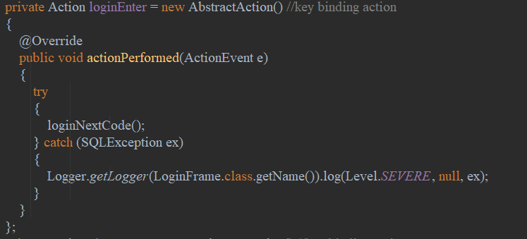

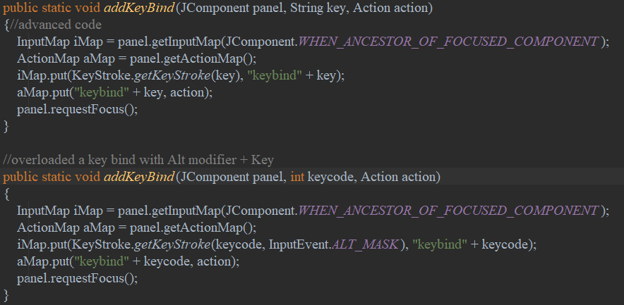

First, I create an action variable using abstract action () class, then putting it through my own method, assigning a key to a panel.

In the jpanel if the key is pressed in that panel the code inside an action variable will be executed.

Sources: <https://stackoverflow.com/questions/22741215/how-to-use-key-bindings-instead-of-key-listeners>

# JFreeChart

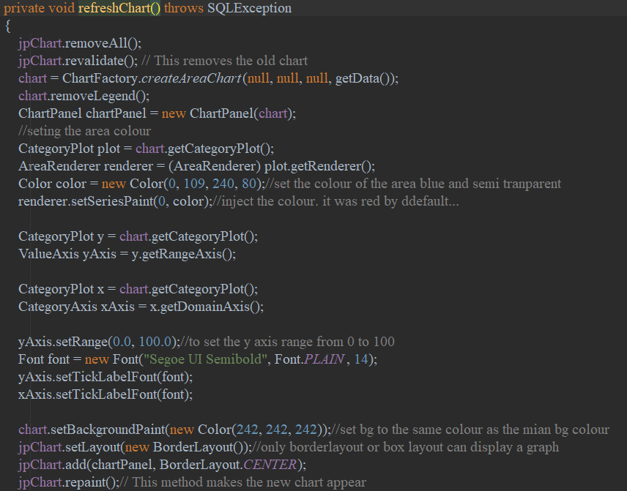

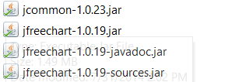

These jar files are used

This method when called, will display a chart in the component jpChart.

The method is called refresh as the graph will need to be constantly be updated depending on user’s selection of button.

Therefore, the method start with removing the existing graph in panel jpChart and implement a new one.

A getData method is used which, determines the state of the user’s choice and gather accordingly

Category plot x and y are used to set the font to Segoe UI and fix the y axis to range from 0 to 100

Source: <http://www.jfree.org/jfreechart/>

<https://github.com/k33ptoo/Java-Programming-Netbeans-Metro-UI-Design-Material-UI-Design-Jtable-JFreeCharts-Moder-UI>

# Row Filter, or dynamic search bar

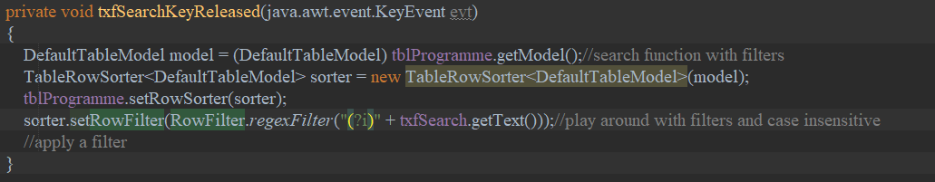

This code applies a filter to the Jtable component, whenever a key is pressed in the search bar that matches the text in the txfSearch component((?i)means ignore case).

Source: <https://www.youtube.com/watch?v=Uq4v-bIDAIk>

# Custom Cursor:

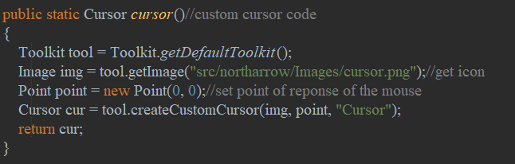

When this code is called in a class, it will set the UI’s cursor into an image I prepared myself. Then set the point of response of the mouse to the left top point. (point 0,0)

<https://www.youtube.com/watch?v=5HCOM6E8ydc>

# Material Design

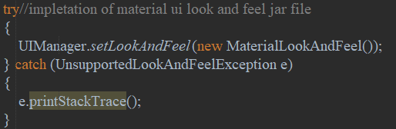

Set a material design look and feel to most swing component.

This reskins the standard swing components

These methods are imported

Using jar file:



Source: <https://github.com/atarw/material-ui-swing/releases>

# Drag Bar and gradient button

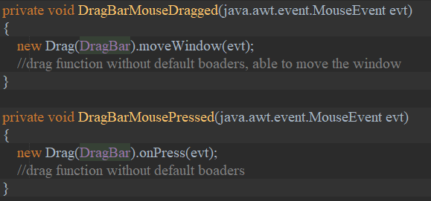

This allows the moving of a undecorate frame.

These methods are imported

Using the Jar file:



This Jar file also provides me with two extra custom swing component, a gradiant coloured button, which was used in the login frame, and Panel.

Source: <https://github.com/k33ptoo/KControls>

# Critical Algorithm

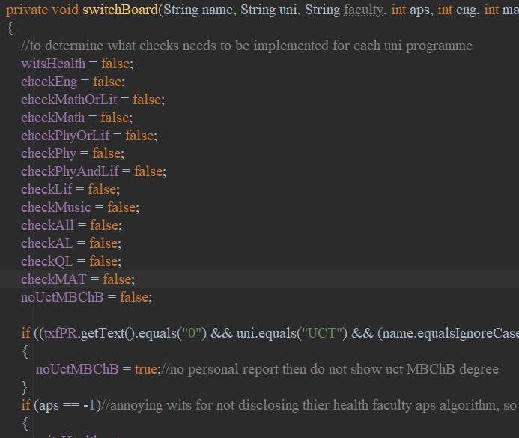

For the personalization of programme to work, a switch board is needed as different programmes have different criteria that needs to be tested so that it will filter the non applicable out. Therefore, this method is called for each programme, customizing for that programme what checks is needed and what is not.

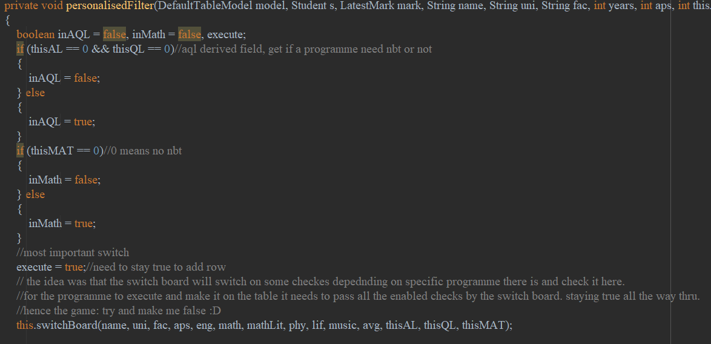

For a programme to be displayed for the user, the user’s data needs to be checked with all the checks that is switched on by the switchboard. It needs to pass all the check(e.g. user’s APS needs to be greater than the required APS)

Boolean variable EXECUTE is set true at the start and if it didn’t pass one of the test that is switched on. Execute will be false. And the programme will not be displayed.

If it meets all the requirement then the programme will be displayed.

Hence the ability to personalise a user’s programme.