**Practical4**

**Name: Xiaosheng Liang**

**Date: October 21, 2016**

1) In **owner.cvs**, I have changed some songs to be my own and make sure the song list corresponds to what I have done.

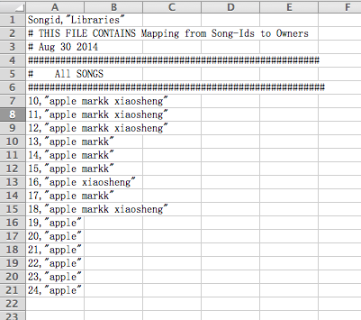

2) For **build_all** method in **album.rb,** I have defined the method like this.

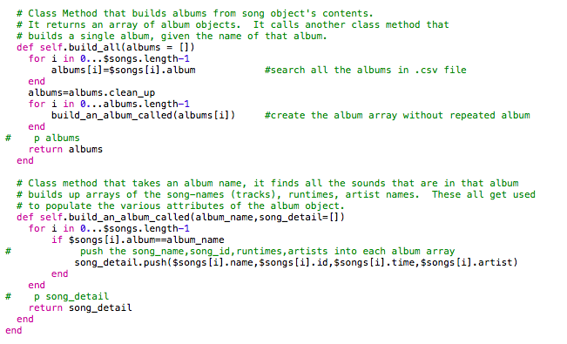

I got all the information from $songs[] and pick the name of albums into a new array, and deleted the repeated, that’s **albums**. And calling the mehod **build_an_album_called** to build a single album and add details (include song_name, id, runtimes, artist).

3) By using the method **clean_up()**, the names of actor could be get from **$hash_owners** and remove repeated ones.

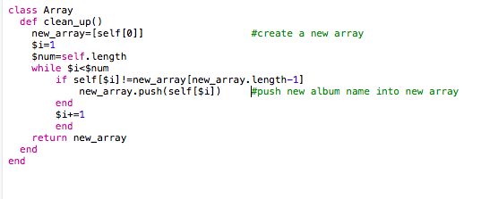

4) In **reader.rb ,** when we read the song_id from 2 .cvs files, we should check whether it is a number, if it’s a number, then check whether it’s in the range of 10 to 24. Finally, adding the song_id in **$songs** and **$hash_owners**.

