Explorations in Ruby: Practicals
Practical 1
Name: Xiaosheng Liang
Date: 28th September
It is assumed that you have been through all the examples mentioned in the lecture, you need to have typed all of the stuff mentioned there (at least once) and be familiar with what was done.

- In irb and each of the primitives class and instance_of? test the following to see what types of object they are and explain why you get the answers you do:
  - “hello there big boy”
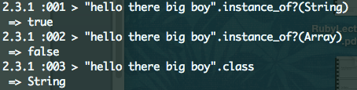
“hello there big boy” is a String not a Array.
  - 56
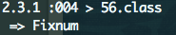
56 is a Fixnum.
  - 34.00
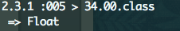
34.00 is a Float.
  - 0.222222354454365
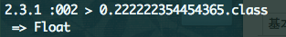
0.222222354454365 is a Float.
  - [“a”, “b”, “c”]
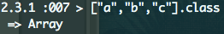
  - +
It is an operation.
  - PI
PI is a constant.
  - Math::PI
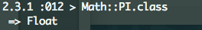
Math:PI is a Float.
  - add
add is a variable.
  - hellow
hello is a variable.
  - hello = 8 and then check hello with class
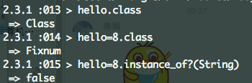
hello=8 is a Fixnum. hello is a Class.
  - “goodbye”
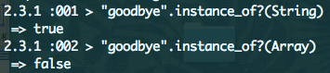
“goodbye” is a String not a Array.
  - (56 + 45.32)
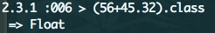
(56+45.32) is a Float.
  - (56 + 45)
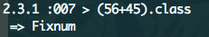
(56+45) is a Fixnum.
  - 5.to_s
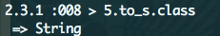
5.to_s is transforming 5 to string.
  - “5”.to_i
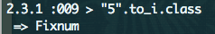
“5”.to_i means transforming “5” to int.
  - five.to_s
five is a variable and five.to_s doesn’t belong to any class.

- In irb what happens when you evaluate the following. Try to predict it before trying them:
  - “hello there big boy”.include?(“boy”)
“hello there big boy” includes “boy”.
  - “hello there big boy”.include(“ big”)
“hello there big boy” includes “ big” (space and letters).
  - “hello there big boy”.include?(“ ere”)
There is no space before letter “ere” in “hello there big boy”.
  - What happens when you evaluate: [“a”, “b”, “c”] + [“d”]
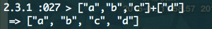
[“a”, “b”, “c”] + [“d”] is adding [“d”] in [“a”, “b”, “c”].
  - What happens when you evaluate: [“a”, “b”, “c”] + “d” 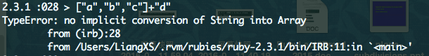
[“a”, “b”, “c”] and “d” are different types.
  - Is there an easy way to capitalise words, so “hello” becomes “Hello” ?
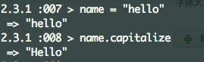
  - In the same vein, make “hello” “HELLO”.
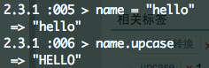
  - Write a command to print out your name.
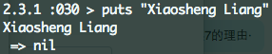
  - Write a method to print out your name.
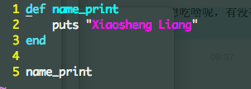
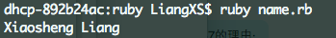
  - Write a method to print out any name.
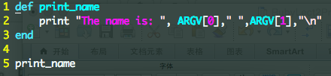
  - Set up the varibles, maxi, dick and twinko so that they are all assigned numbers but two of them are assigned to the same numbers. Then show with a series of equality tests which ones actually have the same value.
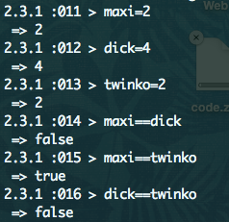
  - If you change the variables with the same number to be a Float and Fixnum does it change the results of the equality tests ?
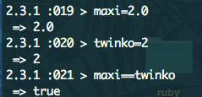
maxi and twinko are not same type but same value.
  - Do a version of these test using strings rather than numbers.
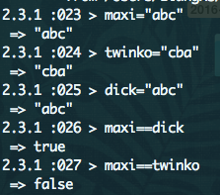
- What’s a predicate ?
Predict is a method which end with a question mark ‘?’ return either ’true’ or ‘false’. For example:
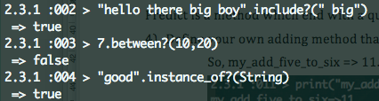
- Define your own adding method that always adds 5 and 6 together.
So, my_add_five_to_six => 11.
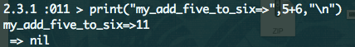
- Put this defined method in a file and call it using the ruby command outside of irb
