IBM cloud command line output:

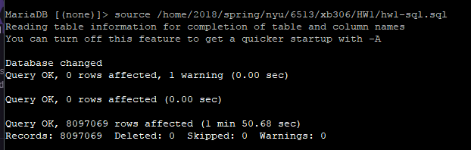

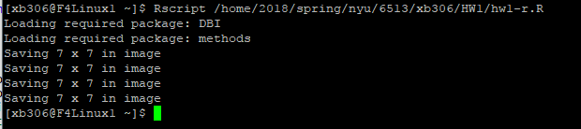

Plots (saved in current directory & /home/2018/spring/nyu/6513/xb306/HW1/plots/):

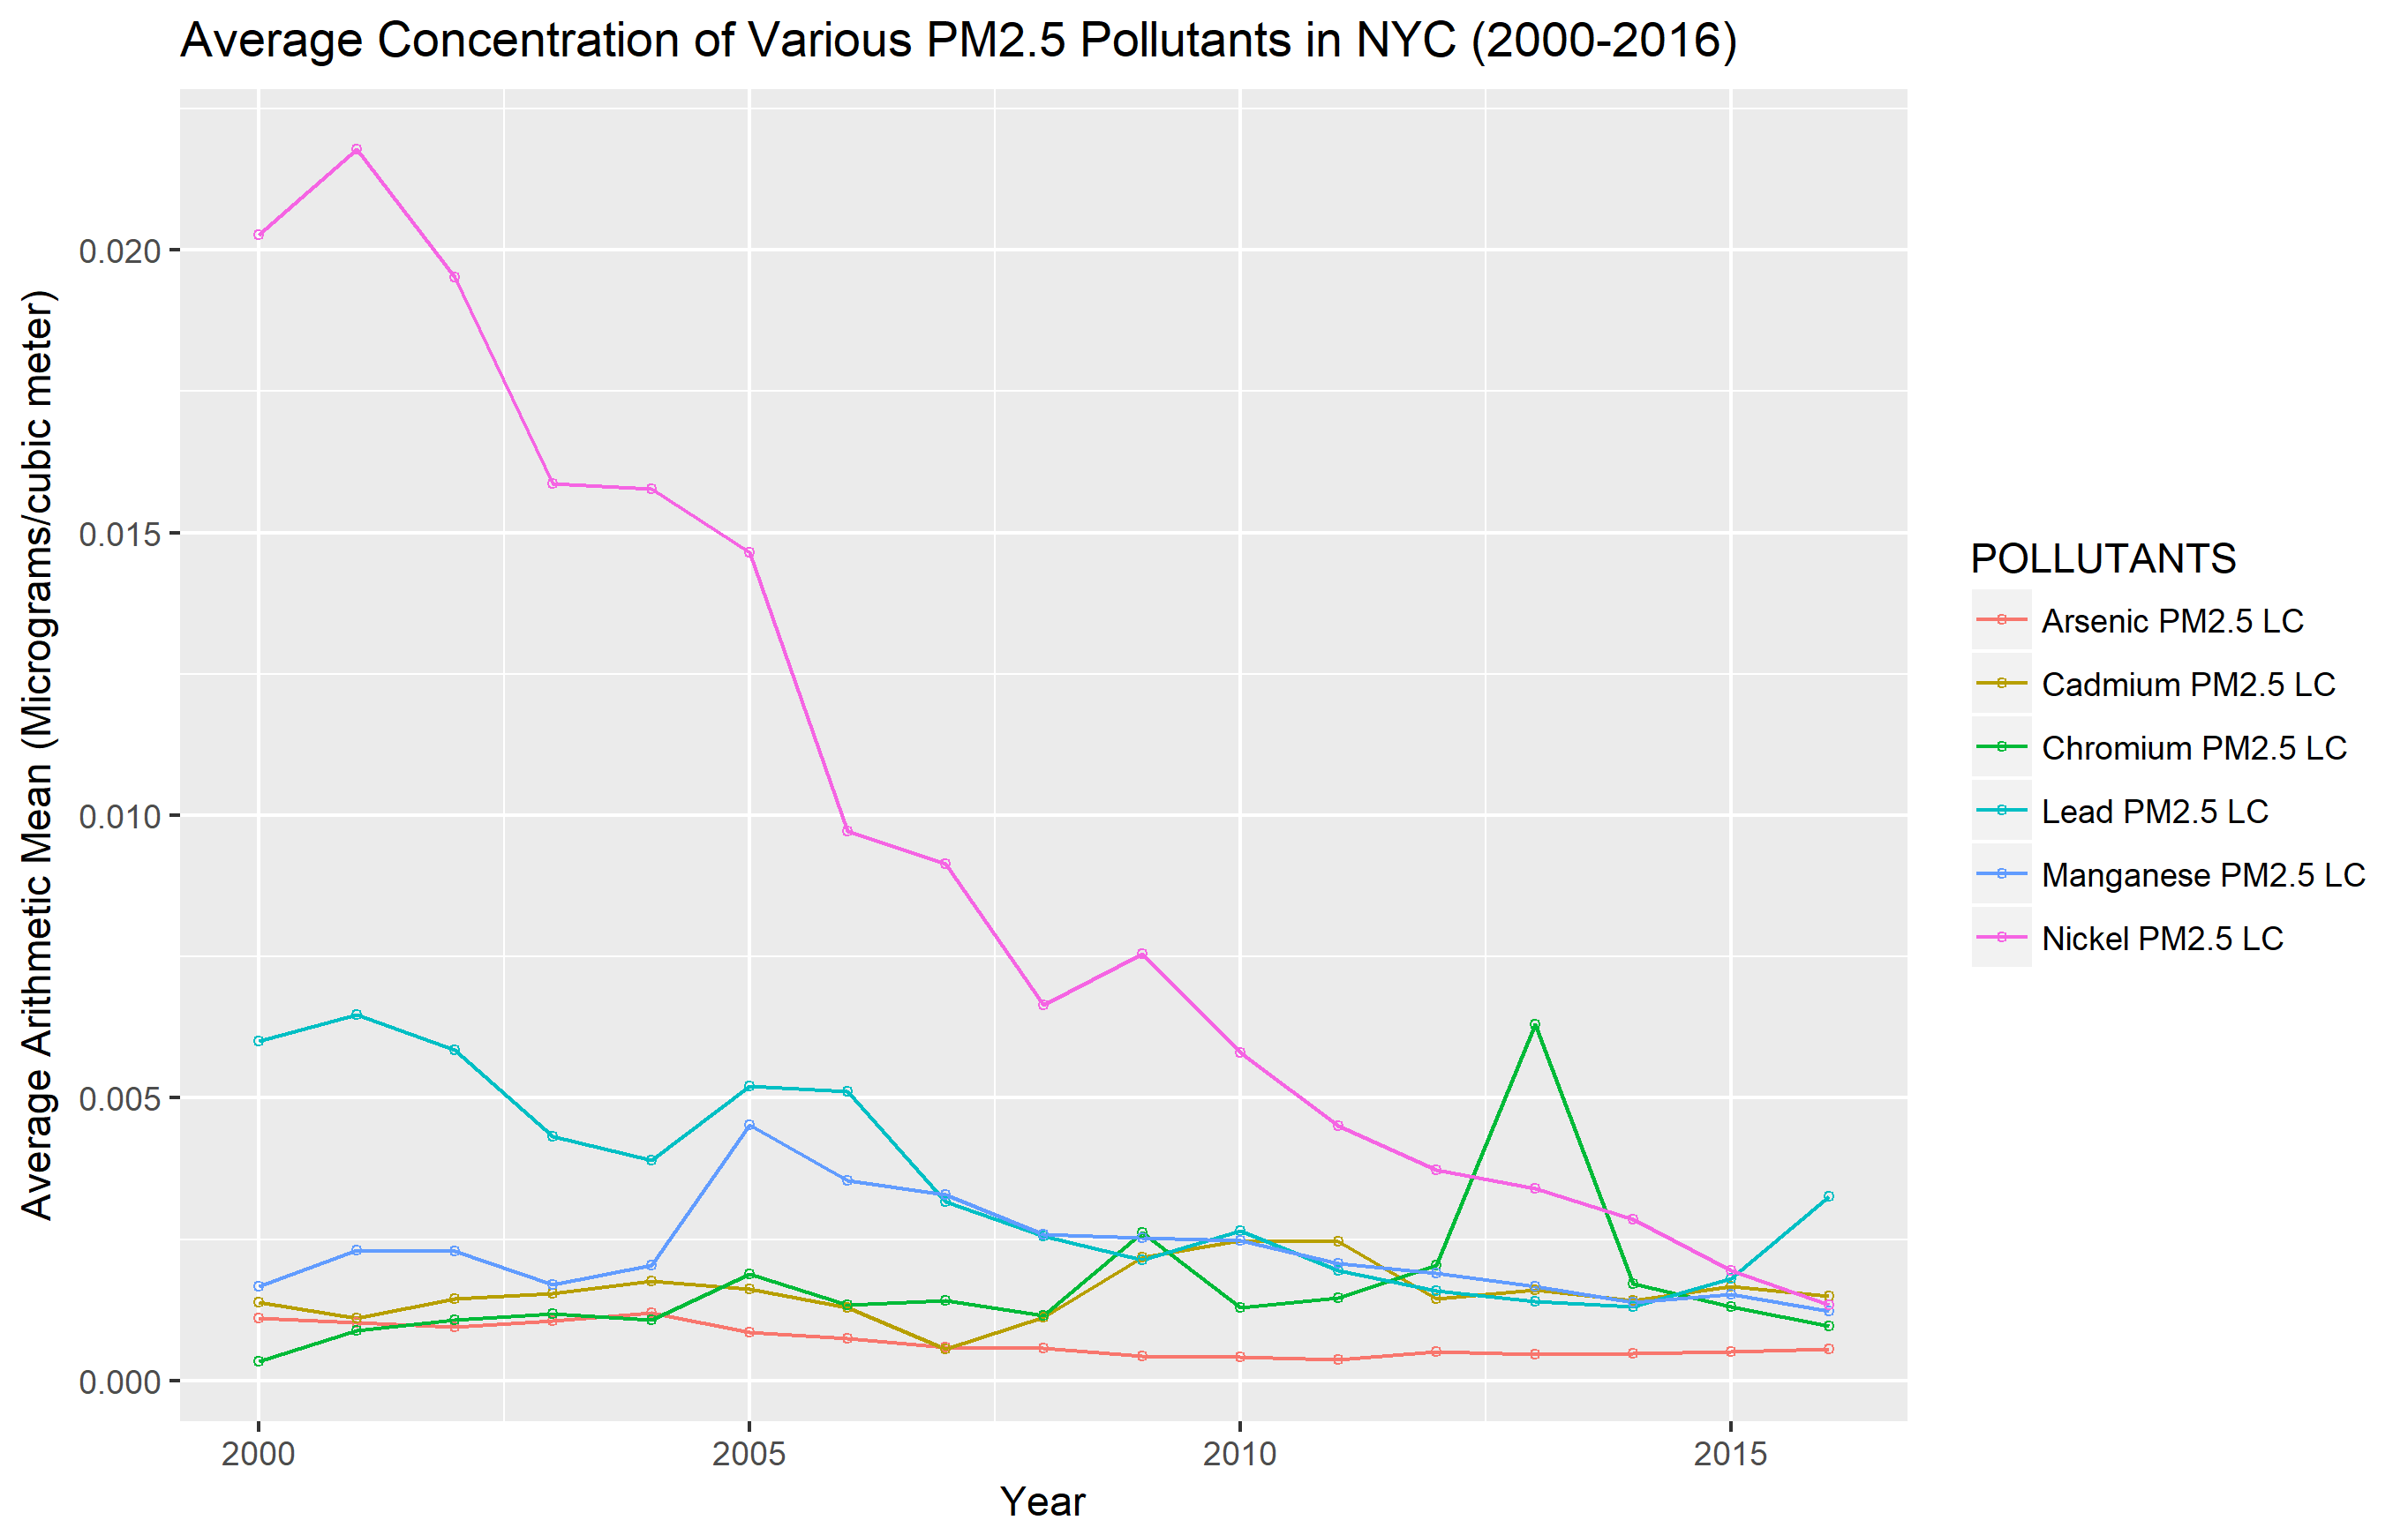

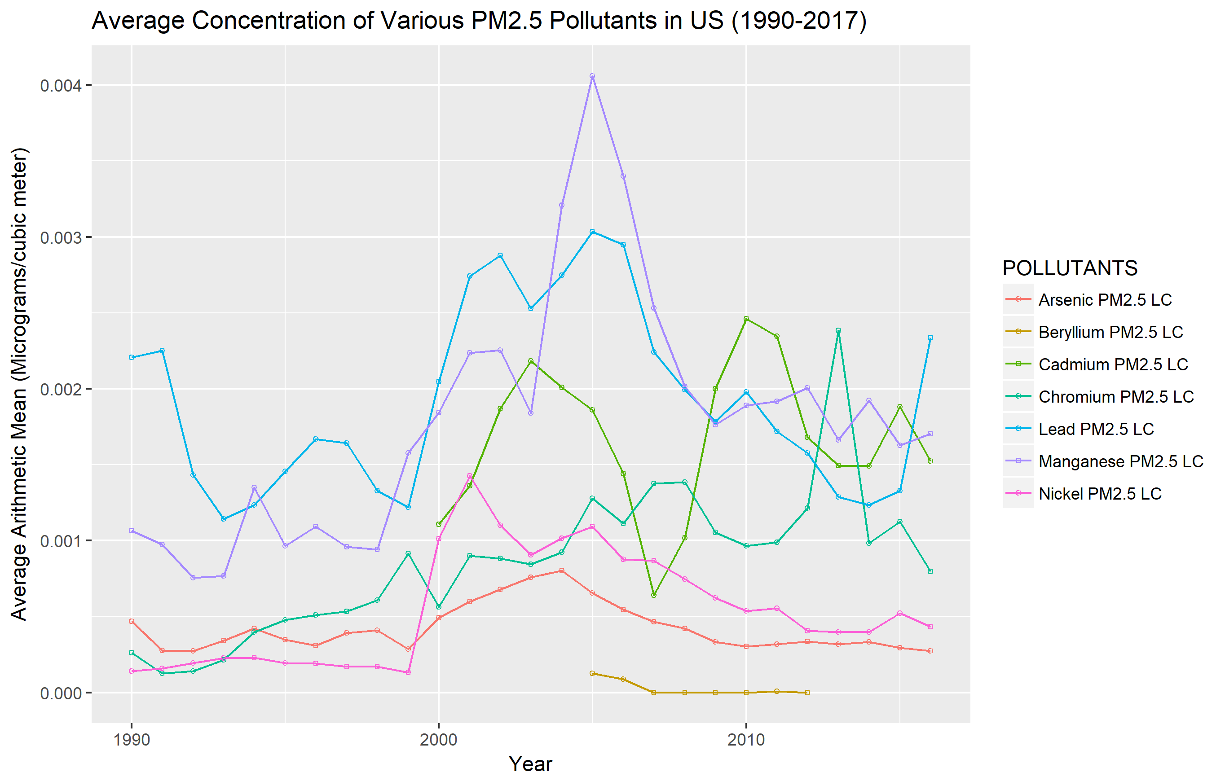

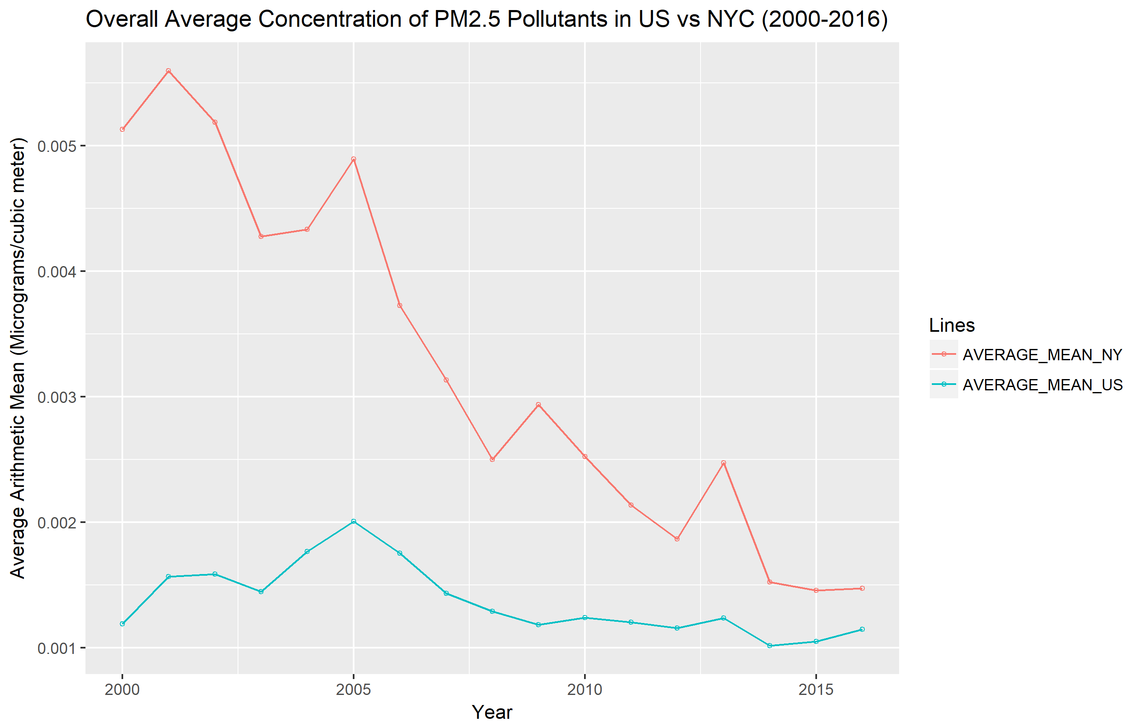

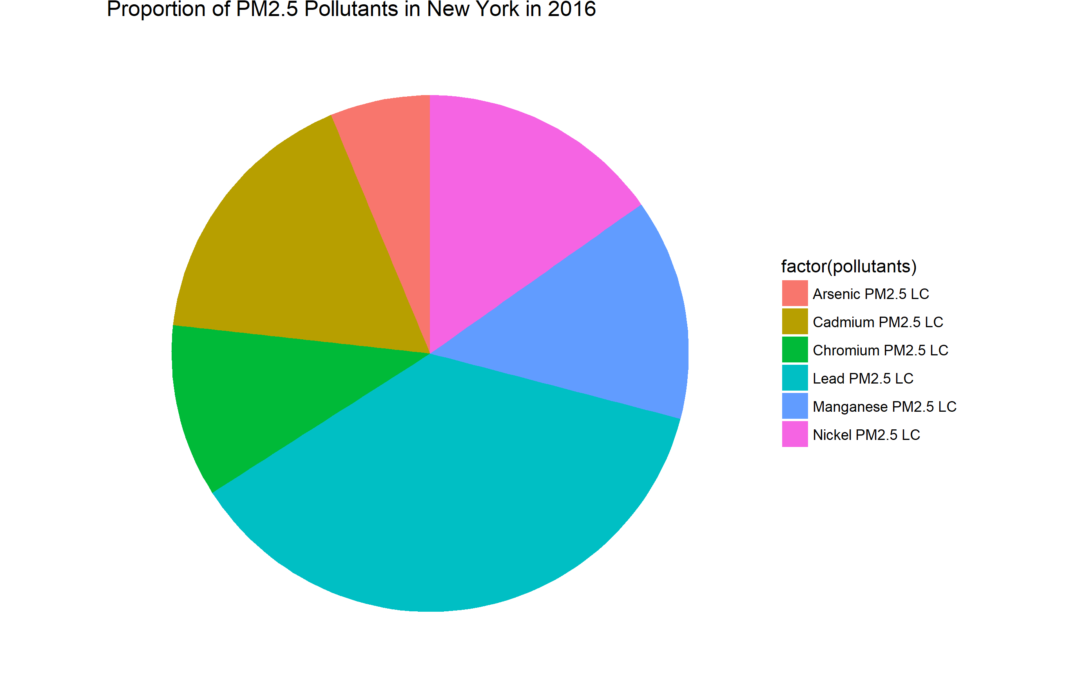

Reference

<http://www.sthda.com/english/wiki/ggplot2-pie-chart-quick-start-guide-r-software-and-data-visualization>

<http://programminghistorian.github.io/ph-submissions/lessons/getting-started-with-mysql-using-r>

<https://www.kaggle.com/epa/hazardous-air-pollutants/version/1>

<https://stackoverflow.com/questions/18503177/r-apply-function-on-specific-dataframe-columns>

<https://stackoverflow.com/questions/33594642/beautiful-pie-charts-with-r/>

Acknowledgement

This project was supported by IBM Cloud Facility. I am grateful to IBM Cloud who provided free server resources and platform for all of us CS-GY 6513 students.

I am also indebted to Prof. Raman Kannan and Om Narayan, who have been offering me assistance and support. Thank you!