Documentation

# Code Outline:

**class Deque {**

**private:**

**string *queue, remove;**

**int num_elements, size_of_queue, head, tail, previousHead, previousTail,minSize;**

**public:**

**Deque();**//Default constructor

**void grow(int, T*);** //Doubles the size of the queue when needed, this method is wrapped around a try/catch structure to catch unexpected error(i.e out of memory and etc). More specifically I threw an OUT_OF_RANGE exception.

**void shrink(int, T*);** //Halves the size of the queue when needed this method is wrapped around a try/catch structure to catch unexpected error(i.e out of memory and etc). More specifically I threw an OUT_OF_RANGE exception.—Altho it might never happen when calling shrink method…

**~Deque();** //Destructor, deletes T *queue when program terminates

**void push_front(T);**//adds elements to the front of the queue, calls grow when queue is full, and copied content from the old array to the new array in the following manner: copied the element from previousTail(of the old array) as the 1st element of the new array, and tail++ until it wraps around and copied every element from the old array to the new array.(essentially when tail and head meet)

**void push_back(T)**;//adds elements to the back of the queue, calls shrink when queue is less than ¼ full, and copied content from the old array to the new array in the following manner: copied the element from previousTail(of the old array) as the 1st element of the new array, and tail++ until it wraps around and copied every element from the old array to the new array.(essentially when tail and head meet)

**string pop_front();//**removes the element at the front of the queue—1)Fixed bug found in this method from previous submission of part a, made sure it didn’t shrink when the head happens to be @ index 0 and ¼ full when the queue is @ min. size 8,(like it would shrink if there’s only 2 element left in size 8 queue) this caused problem when it called the shrink method, and when it called pop_front again, it returned an empty string.---so fixed. 2) Checks and handles the error if the queue happens to be empty.

**string pop_back();//**removes the element at the back of the queue. Checks and handles the error if the queue happens to be empty.

**int size();//**returns the size_of_queue , or the size of my array

**bool empty();//**returns true if the queue is empty

**string toStr();** //the toStr() method the professor wants

**void print_queue()**;//prints the queue in another way—this method is commented out

# General Description

For this part of the project, I implemented a double ended queue that grows when the array is full, and shrinks when it’s ¼ full using Templates. I initialized the “head” on the left and of the array, and “tail” on the right end of the array. (They change obviously as user push/pop accordingly) Handles the 2 errors the professor specified, handle errors when popping front and back of an empty array, as well as trying to catch out_of_memory errors.

# Test Cases:

|  |  |  |  |  |  |  |  |  |
| --- | --- | --- | --- | --- | --- | --- | --- | --- |
| Test Case | | Test Description | | Expected Result | Actual Result | Pass/Fail | | |
| 1 | push element into an empty queue | | Element gets pushed | | Element gets pushed | | Passed |
| 2 | pop an element form an empty queue | | Nothing happens/throw exception | | Code cout a line saying there’s nothing to pop | | Passed |
| 3 | push element to a full queue(using push_front) | | Element gets pushed and queue size doubles | | Element gets pushed and queue size doubles | | Passed |
| 4 | Element gets popped and queue size shrinks by half(both front and back tested) | | Element gets popped and queue size shrinks by half | | Element gets popped and queue size shrinks by half | | Passed |
| 5 | Pushing in front the front 6 elements, and pushing front back 3 elements | | Elements gets push and doubled bc it reached capacity | | Same as expected | | Passed |
| 6 | Poping from back from the populated array in test case 5 | | Items get pop out in the order they should be | | Same as expected | | Passed |
| 7 | Pushing 9 elements from front and pop 6 of them from back | | Array should populate and double after it gotten to 9, and shrinks after poping so many elements | | Same as expected | | Passed |
| 8 | Populated 17 elements randomly, and poped out from the front continuously until there is only 8 elements in the array | | Should expect growing and shrinking of array respectively. | | Same as expected | | Passed |
| 9 | Continue to pop things randomly from front and back from the remaining of above array until its empty, and pop front and back couple times more | | To throw some sort of exceptions or error | | I wrote my code to catch this in if/else statements, so cout statements was throwed, and suggested the user to put in more stuff before they can pop anymore. | | passed |
| 10 | Randomly push and pop | | Print out accordingly | | Same as expected | | Passed |

# Sample output screenshots:

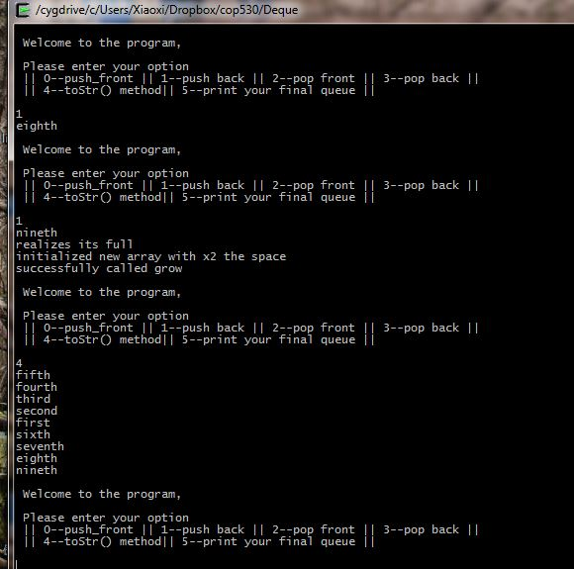 Sample output 1 Sample output 2

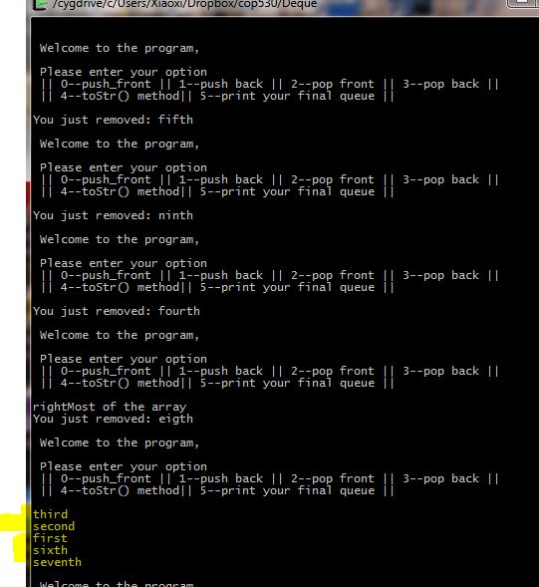

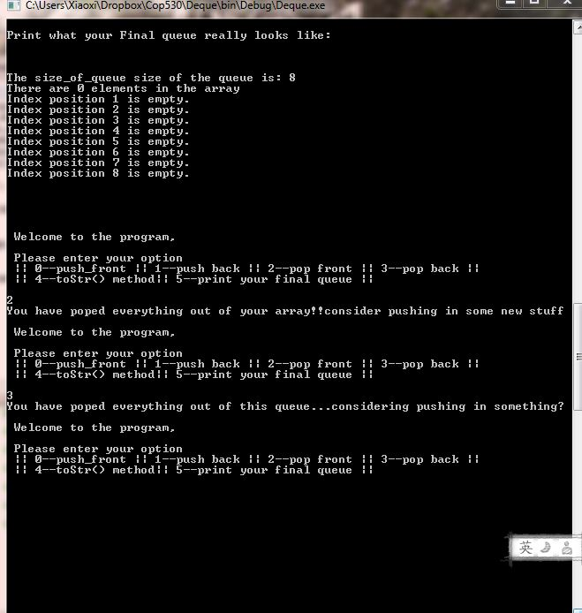

Sample output 3