Student ID:103043833

Name:Xiaoxiao Cao

# Setup Screenshot

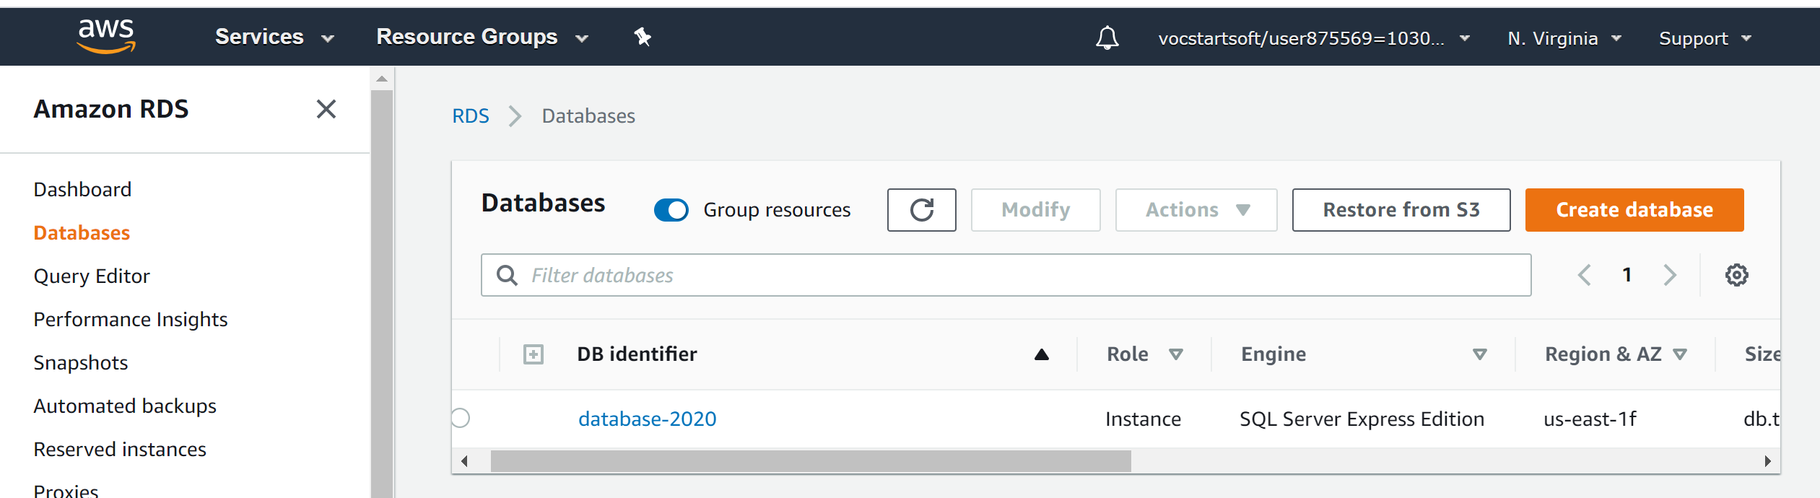

# Task 2 Screenshot

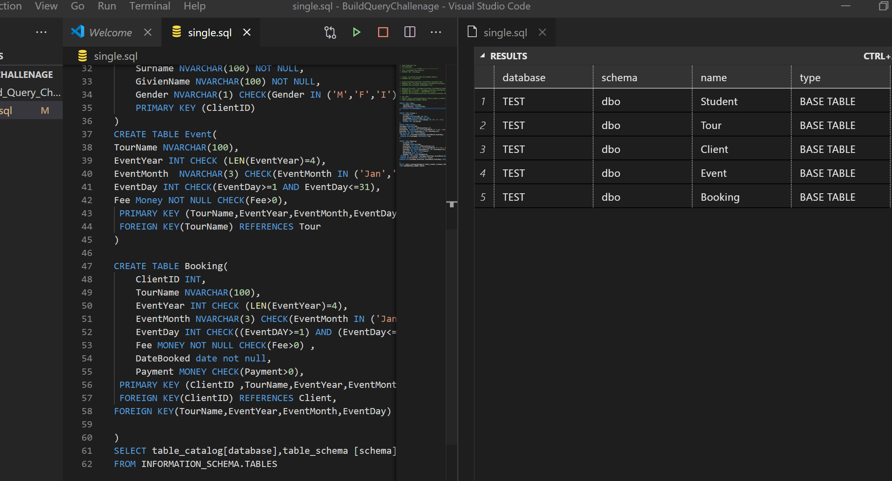

# Task 3 Screenshot

