1. Download address: For Windows

<https://www.libsdl.org/download-2.0.php>

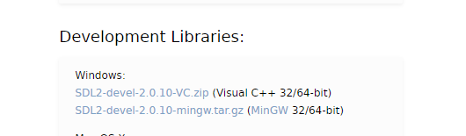

1. Compile

将SDL库里lib和include文件夹下的文件放到MinGW对应的lib和include中

CmakeLists:

cmake_minimum_required(VERSION 3.4.1)

project(SDL_test)

SET(CMAKE_C_COMPILER mingw32-gcc)

SET(CMAKE_CXX_COMPILER mingw32-g++)

#include_directories(C:/Users/mwang9/Downloads/Tool/SDL2-2.0.10/i686-w64-mingw32/include/SDL2)

#link_directories(C:/Users/mwang9/Downloads/Tool/SDL2-2.0.10/i686-w64-mingw32/lib)

add_executable(SDL_test sdl_test.cpp)

target_link_libraries(SDL_test mingw32 SDL2main SDL2) #mingw32,SDL2main和SDL2有顺序

1. Problems encountered

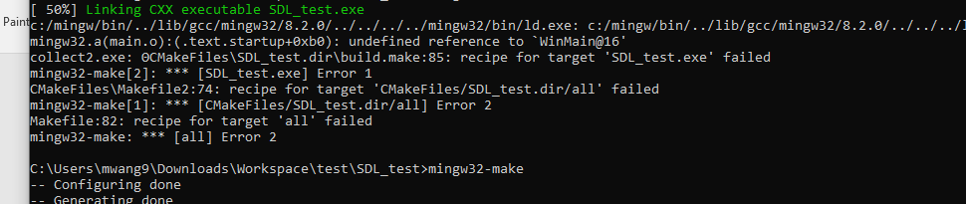

Reason:没有链接mingw32库

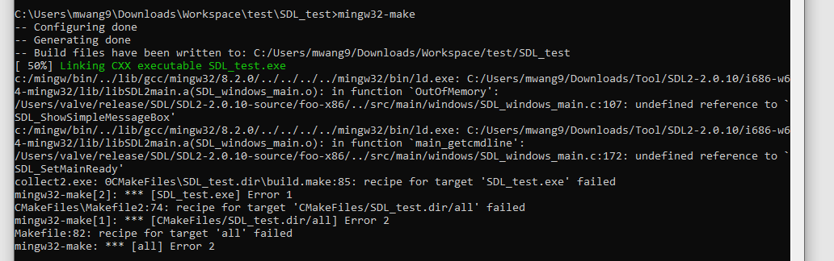

Reason: SDL2与SDL2main库的顺序放错