1.Download source code from teamforge

--create a new folder

--enter the folder

--Run the command line

git init //init the folder to git repository

git clone [addr] //addr see the picture,download source code from the remote repository

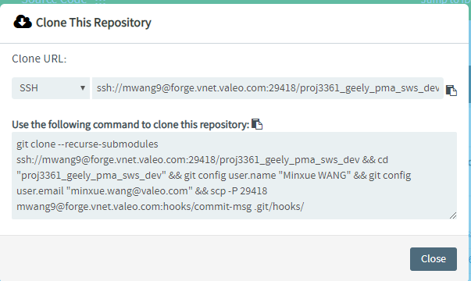

2. Upload code to teamforge

Git add .

Git commit –m “add test.txt file”

Git remote add origin

ssh://mwang9@forge-training.vnet.valeo.com:29418/proj2375_fs11_demo_b

git push –u origin master

