Task-Specific Perceptions and General Attitudes: A Principal Component Analysis of Public Evaluations of AI
Group Name: A.I.titudes
Group Members:
- Ll Xinqing, 222033015, xinqingli@link.cuhk.edu.cn
– Regression (Methods and Results), Discussion
- LIU Xiaoyan, 119030049, xiaoyanliu@link.cuhk.edu.cn
– Introduction, Related paper, PCA (method and results)

Course:
CSS5230: Introduction to Machine Learning for Social Science
Teacher:
Sahba Zojaji
University:
The Chinese University of Hong Kong, Shenzhen
Date:
May, 2nd, 2025



Abstract:
As artificial intelligence (AI) technologies become increasingly embedded in everyday life, public acceptance hinges on technical performance and emotional responses such as comfort and perceived capability. This study investigates how task-specific evaluations of AI shape broader general attitudes. Using survey data from 99 UK-based participants who assessed 42 distinct AI tasks, we measured both comfort level and perceived capability for each task, alongside general attitudes using the General Attitudes toward AI Scale (GAAIS). Principal Component Analysis (PCA) revealed a robust two-dimensional structure in public perception: one component related to Big Data/Automation and another to Human Judgment. These dimensions were then used as predictors in linear and Random Forest regression models. Results consistently showed that comfort with Big Data/Automation tasks is the strongest predictor of positive AI attitudes, while human judgment factors played a minimal role. Although Random Forest models performed well on training data (R² > 0.85), test performance was modest (R² ≈ 0.15–0.19), suggesting individual variability and model overfitting. The findings offer both theoretical and practical insights by linking granular, task-specific attitudes to broader sentiment. We also propose a quadrant-based ethical visualization framework to identify AI tasks requiring caution, particularly those rated as high in capability but low in comfort. This approach contributes to the responsible design and governance of AI technologies.
Keywords: Artificial Intelligence (AI), Public Attitudes, Principal Component Analysis (PCA), Comfort and Capability, Predictive Modeling, Ethical Design

1. Introduction
The rapid advancement of artificial intelligence (AI) has fueled extensive discussions not only on its technical capabilities but also on its broader social and emotional impacts [1]. While AI systems are often heralded for their potential to improve efficiency, foster innovation, and generate economic growth, concerns regarding ethical risks, algorithmic bias, and the delegation of human judgment to non-human agents have simultaneously gained prominence. As AI technologies increasingly permeate fields such as healthcare, education, finance, and creative industries, understanding public perceptions of AI has become a critical issue for both technology developers and policymakers [2].
Traditional models such as the Technology Acceptance Model (TAM) [3] provide a foundation for understanding how individuals evaluate new technologies. However, AI deployment often occurs in ways that extend beyond voluntary personal adoption, with institutional actors implementing AI systems in contexts that deeply affect individuals’ lives. In such cases, emotional responses such as trust, comfort, and perceived competence toward AI systems play a central role in shaping public acceptance [4].
Public perceptions of AI are multidimensional and task-specific. People may feel relatively comfortable with AI performing technical tasks such as data analysis or recommendation systems, while expressing discomfort toward AI engagement in sensitive domains like mental health counseling or criminal sentencing, even when AI demonstrates technical competence [5]. To better understand these complex perceptions, it is necessary to examine evaluations across a diverse range of AI applications systematically.
This study investigates how individuals evaluate AI performance across 42 different tasks, focusing on two key dimensions: comfort level, which reflects emotional acceptance, and perceived capability, which reflects technical competence judgments. Rather than analyzing task evaluations individually, we employ Principal Component Analysis (PCA) to reduce the dimensionality of comfort and capability evaluations, identifying underlying components that summarize general patterns of public response. Subsequently, we examine whether these principal components can predict individuals’ overall attitudes toward AI, as measured by the General Attitudes toward AI Scale (GAAIS) [6].
By integrating dimensionality reduction and predictive modeling, this study offers a computational social science approach to understanding how specific task-based perceptions relate to broader attitudes toward AI. Our findings contribute to a nuanced, data-driven understanding of public sentiment, providing valuable insights for developers, policymakers, and scholars aiming to align AI innovation with societal expectations and emotional acceptance.

1.1 Research Questions
To address these aims, this study is guided by the following research questions:
- What underlying dimensions can be identified in public evaluations of AI task comfort and perceived capability?
— Through Principal Component Analysis, we seek to uncover the latent structure of public responses to AI tasks.
- To what extent do these dimensions predict individuals’ general attitudes toward AI?
— By employing predictive modeling, we aim to assess how task-specific perceptions inform broader, generalized attitudes toward AI technologies.
2. Related Work
2.1 Prior Applications of Machine Learning in Understanding Public Perceptions of AI

In recent years, machine learning (ML) methods have increasingly been employed in social science research to analyze public perceptions of emerging technologies, including artificial intelligence. A growing body of work has used supervised and unsupervised ML techniques to capture complex attitudinal and behavioral data patterns that are not easily identified through traditional survey analysis.

One line of research has applied dimensionality reduction techniques, such as Principal Component Analysis (PCA) and factor analysis, to uncover latent structures in how people evaluate AI technologies. For example, Sindermann et al. [5] utilized factor analysis to identify distinct dimensions of AI acceptance across various application domains, highlighting the differentiation between functional and emotional responses. Similarly, studies like Hasan et al. [7] have employed PCA to reduce the complexity of large-scale survey datasets, allowing researchers to detect coherent patterns in public evaluations of AI systems.

In addition to dimensionality reduction, machine learning models such as Random Forests, Support Vector Machines, and neural networks have been increasingly adopted to predict individuals’ attitudes or behavioral intentions based on a set of psychological, demographic, or task-specific predictors. For instance, Sharpe and Ciriello [1] used ensemble learning methods to predict public trust in AI across different societal sectors, demonstrating that ML models can achieve higher predictive accuracy compared to traditional regression approaches.

Moreover, several studies have emphasized task-specific evaluations when exploring public attitudes toward AI. Research has shown that public perceptions vary significantly depending on the context in which AI is applied, with tasks involving ethical complexity (e.g., healthcare decision-making, criminal justice) often eliciting lower levels of comfort and trust compared to technical tasks (e.g., recommendation systems, financial forecasting) [8][5]. However, most prior work has descriptively examined these evaluations, without systematically linking task-specific perceptions to broader, generalized attitudes toward AI.

Overall, prior research highlights the promise of machine learning techniques for modeling complex public attitudes, especially in contexts where human responses are multidimensional, heterogeneous, and sensitive to specific technology applications.

2.2 Gaps Addressed by This Study

Despite the valuable contributions of existing work, several gaps remain that this study aims to address.

First , although dimensionality reduction techniques like PCA have been used in previous research, they have often served primarily descriptive purposes — identifying patterns without integrating them into predictive models. This study advances the field by extracting underlying dimensions from task-based evaluations through PCA and using these dimensions as predictors in modeling general attitudes toward AI. By doing so, we demonstrate the utility of PCA not merely as a data summarization tool but as an integral component of predictive analytics.

Second, while some studies have incorporated broad psychological constructs such as trust, fear, or technological optimism, few have focused specifically on emotional responses such as comfortableness across a wide range of AI tasks. Comfort is an important affective dimension that may mediate acceptance but is often overlooked relative to cognitive evaluations of competence or trustworthiness. By explicitly modeling comfort and perceived capability together, this project provides a richer and more emotionally sensitive account of public perceptions.

Finally, most prior research has tended to treat public attitudes toward AI either in isolation (task-specific) or at an abstract level (general trust/fear), without systematically connecting the two. Our study fills this methodological gap by empirically linking concrete task evaluations with abstract attitudinal outcomes, offering a more integrated understanding of how public sentiment toward AI forms and evolves.

Through these contributions, this project advances both the methodological toolkit and substantive knowledge base for research at the intersection of AI, public perception, and computational social science.

3. Methodology
3.1 Dataset
This study utilizes the dataset chbr_100014_AI_R_Data_mmc1, which includes survey responses from 99 participants assessing 42 AI tasks. Each AI task is evaluated based on two key dimensions: Comfort Level (How comfortable participants feel about AI performing a specific task) and Perceived AI Capability (How competent AI is perceived to be at performing the task). The dataset also includes responses to the General Attitude toward AI Scale (GAAIS) [9], which measures both positive and negative attitudes toward AI, as well as the Technology Readiness Index (TRI), capturing optimism, innovation, discomfort, and insecurity regarding technology.

Data were collected from 100 non-student participants in the UK (50 male, 50 female, all aged >18). One male participant’s data were excluded for failing all 11 attention checks (see Section 2.3.5), indicating potential lack of engagement with the survey. The sample focused on workers, as they are likely affected by AI in both personal and employment contexts [10][11][12], providing a dual-purpose research sample. One participant indicated employment in Prolific’s screening but reported unemployment at survey time; the rest were employed or self-employed.The final sample had a mean age of 36.15 years (SD = 10.25, range 20–64).
Participants first completed a measure of General Attitudes towards Artificial Intelligence, which consisted of 32 items. Each item was rated on a 5-point Likert scale (“strongly disagree” to “strongly agree”). The first 16 items assessed positive attitudes toward AI (e.g., AI enhancing human capabilities, improving efficiency), while the remaining 16 items assessed negative attitudes (e.g., concerns about job displacement, ethical issues).
Subsequently, participants evaluated a series of Specific Applications of AI, where they were presented with descriptions of tasks that AI systems could potentially perform. Participants were asked to rate:
Their comfortableness with AI performing each task, on a 5-point scale (“very uncomfortable” to “very comfortable”). Then, the perceived capability of AI compared to humans for each task was measured on a 5-point scale (“AI much less capable than humans” to “AI much more capable than humans”).
Built-in survey logic ensured that participants responded to every item (with the option to select “prefer not to answer”), minimizing missing data. Attention checks were incorporated to maintain data quality.
The dataset provides rich measures of individual differences in attitudes towards AI, comfort with AI across different domains, and beliefs about AI’s relative capabilities compared to humans.

3.2 Perform Principal Component Analysis (PCA)
We applied Principal Component Analysis (PCA) to the items assessing participants’ comfortableness with AI applications and their perceived capability of AI across different tasks. The objective was to reduce the dimensionality of the data and extract key latent components that could serve as predictors in subsequent analyses.
Separate PCAs were conducted for the comfortableness and perceived capability datasets, each initially including all 42 task items. Variables were standardized before analysis. For both comfortableness and capability ratings, we followed a data-driven approach to variable selection. Items that demonstrated weak relationships with the overall factor structure — operationalized as communalities below 0.3 or principal component loadings below 0.4 — were iteratively removed. PCA was re-run after each removal to reassess the factor structure and identify further weakly contributing items.
After this process， for comfortableness, 23 items were retained for the final PCA， and for perceived capability, 21 items were retained for the final PCA.

3.3 Random Forest Regression Analysis
Random Forest Regression models were employed to investigate how participants’ sense of comfort and perceived capability regarding AI applications predict their attitudes in specific scenarios. The algorithm was selected for its ability to model non-linear relationships and capture interactions between predictors without parametric assumptions.
The analysis predicted responses for:
- Positive scenario items (PR1-PR16)
- Negative scenario items (NR1-NR16)
Predictors were principal component scores from PCA:
Comfortableness components (ScomFactor1-2) | Capability components (ScapFactor1-2)
ScomFactor1: big data/automation comfort | ScapFactor1: big data/automation capability
ScomFactor2: human judgment comfort | ScapFactor2: human judgment capability

3.4 Model Implementation
Models were implemented using scikit-learn with:
- 5-fold cross-validation
- Grid search optimization for hyperparameters: n_estimators [100, 200], max_depth [None, 10], min_samples_split [2, 5], max_features [‘sqrt’, ‘log2’]

3.5 Evaluation Metrics
Performance assessed through:
- R-squared (R²): variance explained
- Mean Squared Error (MSE): prediction accuracy
- Mean Absolute Error (MAE): error magnitude
- Cross-validated MSE: generalizability

Variable importance was evaluated using mean decrease in impurity, revealing how different AI perception dimensions influenced attitudes across contexts.

- Result
  - PCA
The PCA cleanly segregates perceptions into two dimensions—Big Data/Automation and Human Judgment—across both comfort and capability. Automation-driven components dominate variance, while human judgment plays a distinct yet complementary role.

Table 1: PCA Results - Variance Explained by Components
Component | Comfort_Variance_Explained | Capability_Variance_Explained
Factor 1 | 0.3093 | 0.3147
Factor 2 | 0.1016 | 0.1151

As shown in Table 1 “PCA Results - Variance Explained by Components”, the first two principal components of Comfortableness and Capability variables explain approximately 30.9% and 31.5% of the variance, respectively, with the second components explaining 10.2% and 11.5%. This indicates that most of the information can be captured by the first two components, providing effective dimensionality reduction for subsequent regression analyses.

Figure1.2.3.4.plot of comfortableness and capability
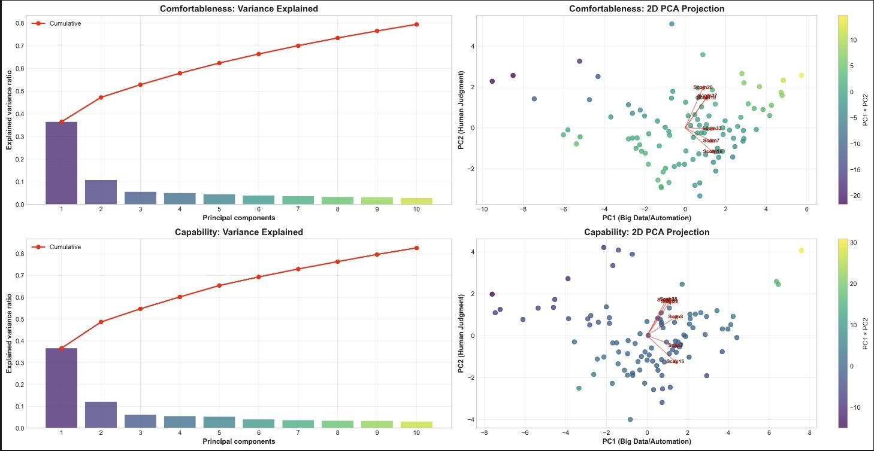
PCA on Comfortableness
PC1 (Big Data/Automation): Dominated by variables Scom16, Scom33, Scom7 (positive) and Scom14, Scom13 (negative).PC2 (Human Judgment): Key variables included Scom20, Scom37 (positive) and Scom21, Scom31 (negative).
PCA on Capability
PC1 (Big Data/Automation): Strongly associated with Scap8, Scap7, Scap16 (positive) and Scap30, Scap25 (negative).PC2 (Human Judgment): Highlighted by Scap38, Scap15 (positive) and Scap26, Scap27 (negative).
Figure2. Factor Correlations
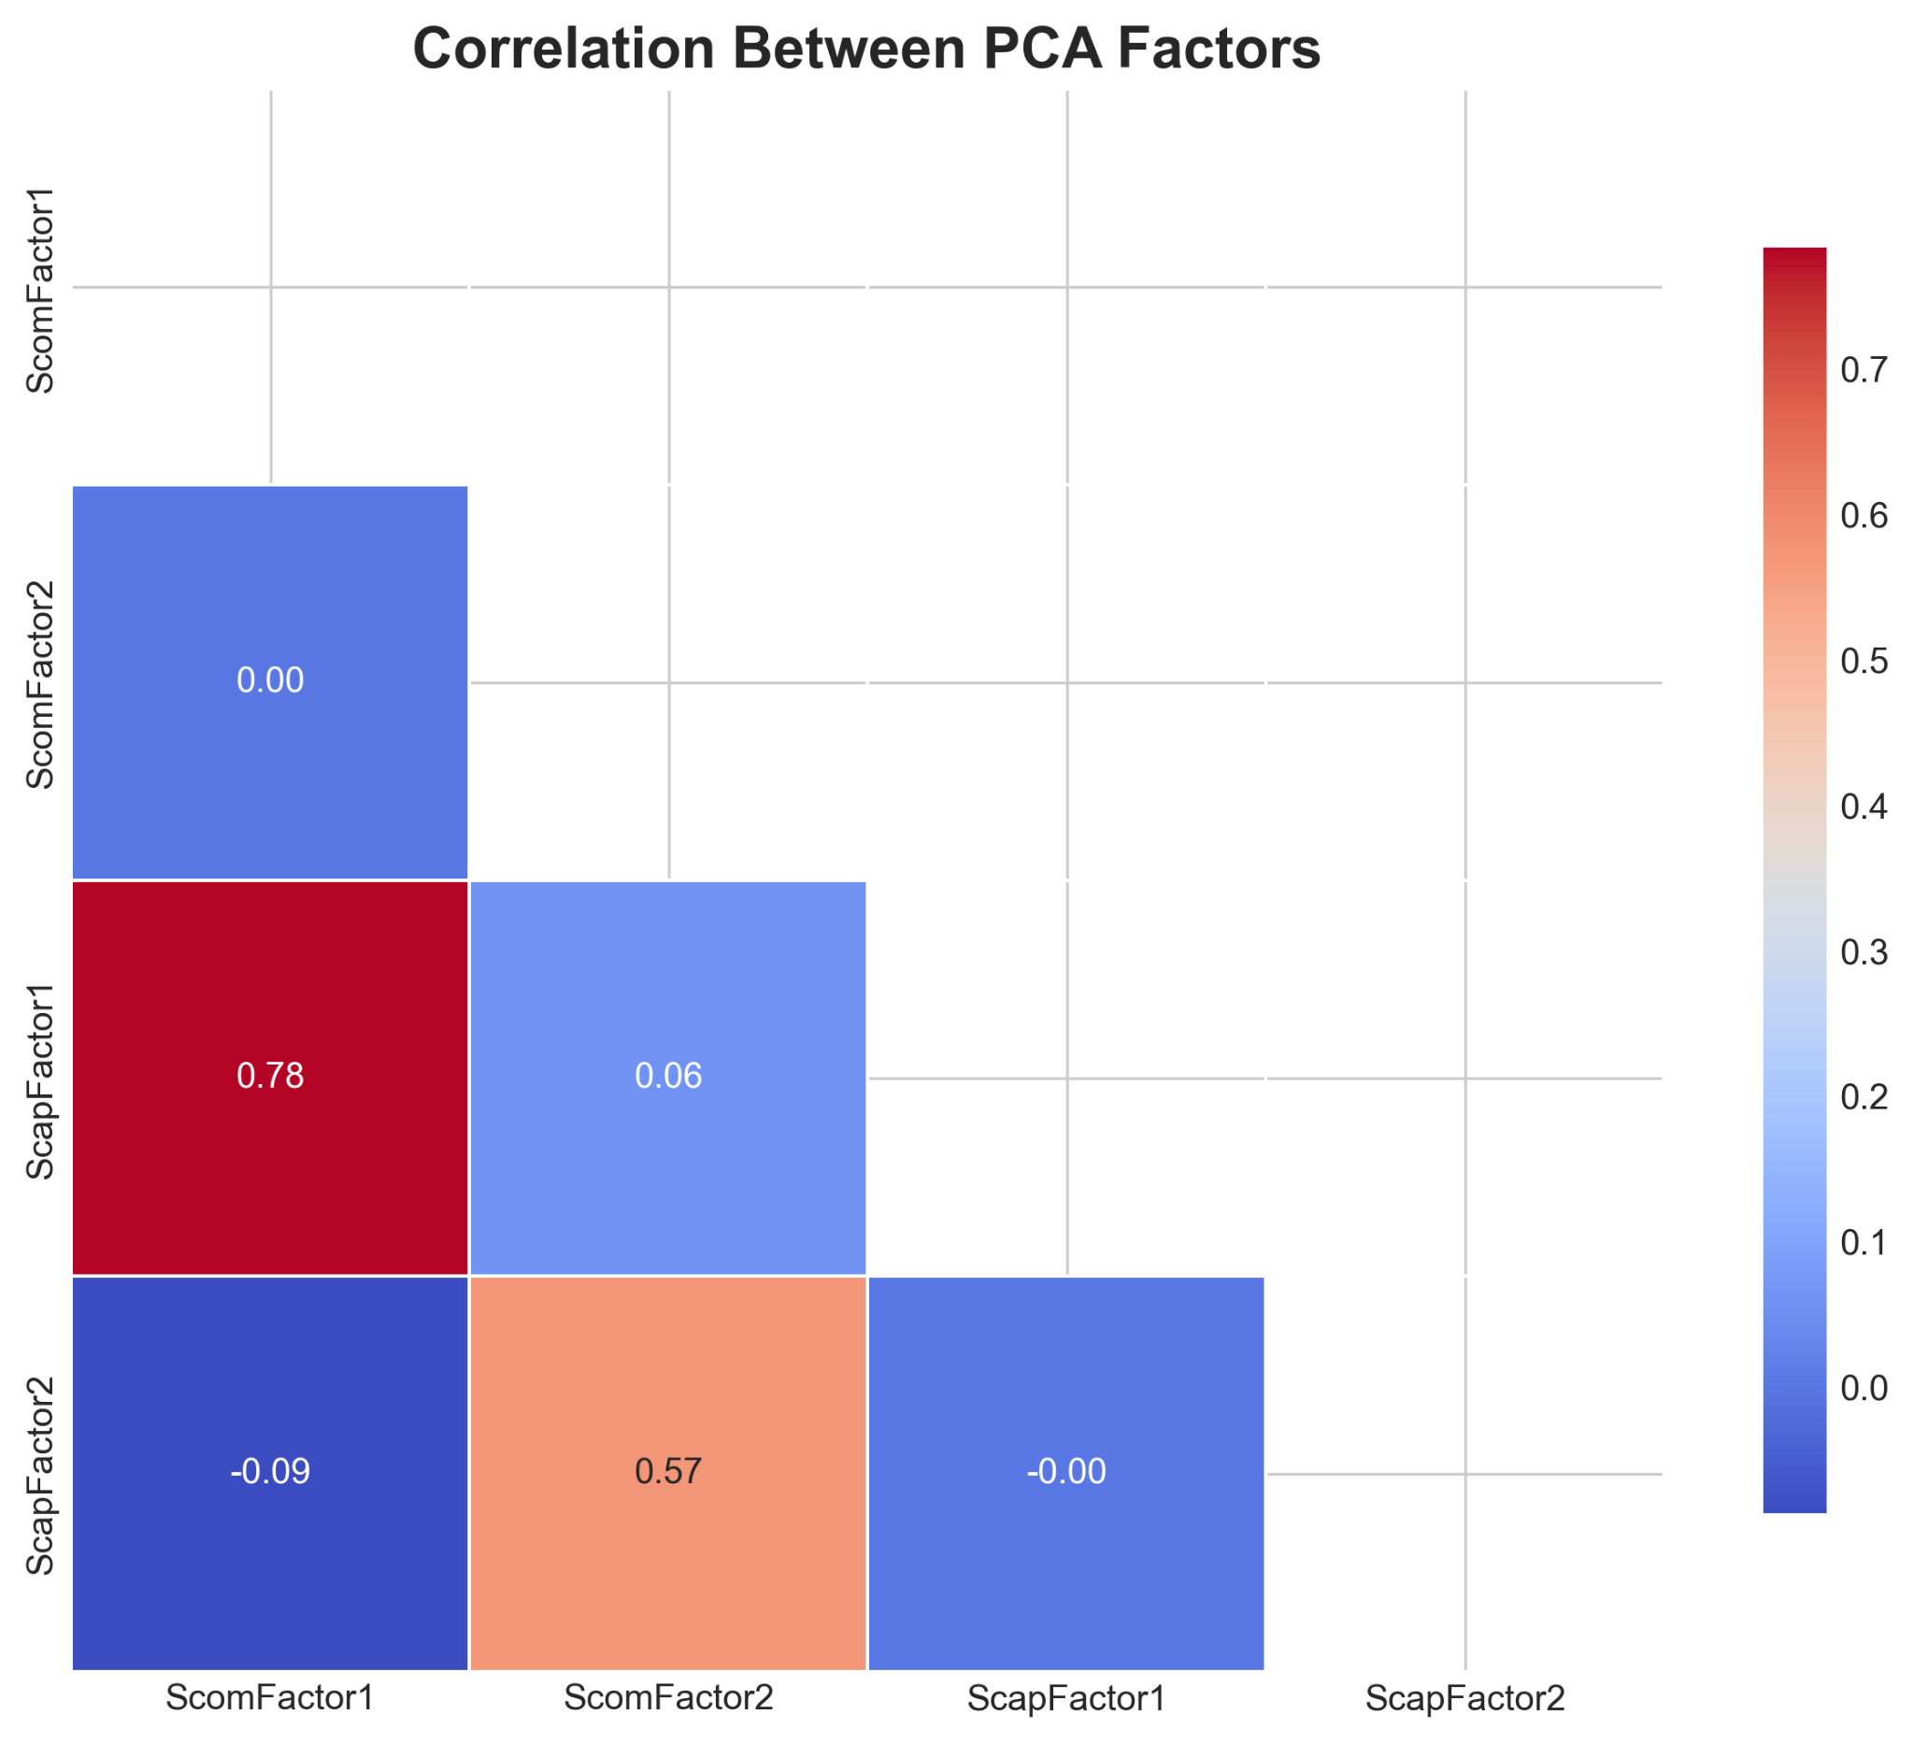
- ScomFactor1 (Comfortableness) and ScapFactor1 (Capability) showed a strong positive correlation (r = 0.78).
- ScomFactor2 (Comfortableness) and ScapFactor2 (Capability) were moderately correlated (r = 0.57).

4.2 Regression
4.2.1 Linear Regression Analysis
Table 2. Regression Results for Principal Components and Attitude Scores
Attitude | Factor | r | p_corr | F | p_F
Positive General Attitudes | Comfortableness (Big Data/Automation) | 0.71 | <.001 | 100.89 | <.001
Positive General Attitudes | Comfortableness (Human Judgement) | 0.09 | 0.396 | 0.73 | 0.396
Positive General Attitudes | Capability (Big Data/Automation) | 0.57 | <.001 | 46.69 | <.001
Positive General Attitudes | Capability (Human Judgement) | -0.09 | 0.363 | 0.83 | 0.363
Negative General Attitudes | Comfortableness (Big Data/Automation) | 0.55 | <.001 | 41.81 | <.001
Negative General Attitudes | Comfortableness (Human Judgement) | -0.05 | 0.621 | 0.25 | 0.621
Negative General Attitudes | Capability (Big Data/Automation) | 0.31 | 0.002 | 10.38 | 0.002
Negative General Attitudes | Capability (Human Judgement) | -0.12 | 0.238 | 1.41 | 0.238

As shown in Table 2, regression analysis for Positive General Attitudes reveals that COMfactor1 (Big Data/Automation dimension of comfort) demonstrates a significant positive influence (r = 0.71, p < .001, F = 100.89), while the human judgment dimension of comfort (COMfactor2) shows no significant effect (r = 0.09, p = 0.396). Regarding the capability dimension, Big Data/Automation-related capability (CAPfactor1) also exhibits a significant positive correlation (r = 0.57, p < .001, F = 46.69), whereas the human judgment dimension of capability (CAPfactor2) shows no significant impact (r = -0.09, p = 0.363).

For Negative General Attitudes, COMfactor1 similarly demonstrates a significant influence (r = 0.55, p < .001, F = 41.81), while COMfactor2 shows no significant effect (r = -0.05, p = 0.621). Regarding capability dimensions, CAPfactor1 displays a relatively weak but significant correlation (r = 0.31, p = 0.002, F = 10.38), while CAPfactor2 remains non-significant (r = -0.12, p = 0.238).

4.2.2 Random Forest Regression Analysis
Table 3. Random Forest Regression Results for Attitude Prediction
Attitude Type | Feature | Importance | Training R² | Test R²
Positive | COMfactor1 | 0.6214 | 0.9168 | 0.1924
Positive | COMfactor2 | 0.0981
Positive | CAPfactor1 | 0.1739
Positive | CAPfactor2 | 0.1065
Negative | COMfactor1 | 0.4153 | 0.8774 | 0.1421
Negative | COMfactor2 | 0.1751
Negative | CAPfactor1 | 0.2562
Negative | CAPfactor2 | 0.1534

We conducted random forest regression analysis to validate the findings from linear regression further and explore potential non-linear relationships (as shown in Table 3). For positive attitude prediction, results indicate that COMfactor1 has the highest importance (0.6214), followed by CAPfactor1 (0.1739), CAPfactor2 (0.1065), and COMfactor2 (0.0981). The model demonstrates excellent overall performance, with a training set R² of 0.9168 and a test set R² of 0.1924.

For negative attitude prediction, the feature importance distribution follows a similar pattern but with lower magnitudes: COMfactor1 (0.4153) remains the most important predictor, followed by CAPfactor1 (0.2562), COMfactor2 (0.1751), and CAPfactor2 (0.1534). The model also performs well, with a training set R² of 0.8774 and a test set R² of 0.1421.

5. Discussion
The present analyses reveal a clear and consistent structure underlying attitudes toward AI tasks. Principal component analysis (PCA) demonstrates that perceptions of both comfortableness and capability can be effectively reduced to two major dimensions: Big Data/Automation and Human Judgment. The first principal component, representing automation-driven aspects, explains the largest proportion of variance in both domains, while the second component, reflecting human judgment, accounts for a smaller but meaningful share. This two-dimensional structure is further supported by factor loadings and scree plots, which show that data-driven and human-centric tasks are distinctly separated in participants’ responses.

Regression analyses, including both linear regression and random forest models, further validate the importance of these dimensions. Across both analytical approaches, the Big Data/Automation dimension of comfort (COMfactor1) consistently emerges as the most crucial predictor of attitudes toward AI, especially for positive attitudes. In contrast, factors related to human judgment (COMfactor2 and CAPfactor2) show relatively weak and often non-significant effects. The strong positive correlation between the automation-related comfort and capability factors (r = 0.78) and the moderate correlation for human judgment factors (r = 0.57) suggest that individuals who are comfortable with automation-driven tasks also tend to feel more capable in those domains.

Notably, while the random forest models exhibit extremely high explanatory power on the training set (R² > 0.85), their performance on the test set is relatively weak (R² ≈ 0.15-0.19), indicating potential overfitting and highlighting the complexity and individual variability in AI attitude prediction. This pattern underscores the need for cautious interpretation and consideration of additional influencing factors.

Overall, these findings demonstrate that the two-dimensional structure identified by PCA not only simplifies the complexity of attitudes toward AI tasks but also provides a robust foundation for predictive modeling. The dominance of the automation dimension in both comfort and capability highlights the central role of data-driven processes in shaping public attitudes toward AI, while the relatively minor role of human judgment factors suggests that these aspects, though present, are less influential in the current context.

Limitations and Future Directions:
Several limitations should be noted when interpreting these findings. First, the relatively small sample size (approximately 100 participants) may affect the stability and generalizability of the results. Second, the sample includes participants from various professional backgrounds without controlling for industry-specific factors, which could introduce confounding effects. Third, the study primarily focused on comfort and capability dimensions, potentially overlooking other essential factors such as personal experiences and educational background.

The findings have significant implications for both AI development and policy-making. For AI product designers, the results provide valuable insights for prioritizing development efforts. Tasks falling in the “high capability-high comfort” quadrant represent areas where AI applications are most likely readily accepted by users. Conversely, tasks in the "high capability-low comfort" quadrant require special attention to ethical considerations and user education. These insights can also inform policymakers in developing more effective AI governance frameworks that align with public attitudes and concerns.

Future research should address these limitations and expand the findings in several directions. First, increasing the sample size would enhance the statistical power and reliability of the results. Second, controlling for industry, educational background, and other demographic variables would allow for more precise analysis of attitude formation. Third, developing a quadrant-based visualization framework could help identify and categorize different types of AI tasks:
1. High Capability, High Comfort (Widely Accepted AI Tasks)
2. High Capability, Low Comfort (Ethical Concern Tasks)
3. Low Capability, High Comfort (Underestimated AI Potential)
4. Low Capability, Low Comfort (Rejection-Prone AI Tasks)

This framework would be particularly valuable for identifying tasks in the "High Capability, Low Comfort" quadrant requiring special ethical considerations. Future studies should also explore other factors influencing AI attitudes, such as personal experiences, cultural background, and exposure to AI technologies. Such investigations would provide a more comprehensive understanding of the complex dynamics shaping public attitudes toward AI.

Reference
[1] Sharpe, P. and Ciriello, R.F., 2024. Exploring attachment and trust in AI companion use.
[2] Zhang, M., Eack, S. M., & Chen, Z. Z. (2025). Preference Learning Unlocks LLMs’ Psycho-Counseling Skills (No. arXiv:2502.19731). arXiv. https://doi.org/10.48550/arXiv.2502.19731
[3] Davis, F.D., 1989. Technology acceptance model: TAM. Al-Suqri, MN, Al-Aufi, AS: Information Seeking Behavior and Technology Adoption, 205(219), p.5.
[4] Stein, J.-P., Messingschlager, T., Gnambs, T., Hutmacher, F., & Appel, M. (2024). Attitudes towards AI: Measurement and associations with personality. Scientific Reports, 14(1), 2909. https://doi.org/10.1038/s41598-024-53335-2
[5] Sindermann, C., Sha, P., Zhou, M., Wernicke, J., Schmitt, H. S., Li, M., Sariyska, R., Stavrou,.M., Becker, B., & Montag, C. (2021). Assessing the Attitude Towards Artificial Intelligence: Introduction of a Short Measure in German, Chinese, and English Language. KI - Künstliche Intelligenz, 35(1), 109–118. https://doi.org/10.1007/s13218-020-00689-0
[6] Schepman, A., & Rodway, P. (2020). Initial validation of the general attitudes towards Artificial Intelligence Scale. Computers in human behavior reports, 1, 100014.
[7] Hasan, B. M. S., & Abdulazeez, A. M. (2021). A review of principal component analysis algorithm for dimensionality reduction. Journal of Soft Computing and Data Mining, 2(1), 20-30.
[8] Horowitz, M. C., & Kahn, L. (2021). What influences attitudes about artificial intelligence adoption: Evidence from U.S. local officials. PLOS ONE, 16(10), e0257732. https://doi.org/10.1371/journal.pone.0257732
[9] Grassini, S. (2023). Development and validation of the AI attitude scale (AIAS-4): A brief measure of general attitude toward artificial intelligence. Frontiers in Psychology, 14, 1191628. https://doi.org/10.3389/fpsyg.2023.1191628
[10] Frontier Economics. (2018). The impact of artificial intelligence on work: An evidence review prepared for the royal society and the British academy. London: Frontier Economics. htt ps://royalsociety.org/-/media/policy/projects/ai-and-work/frontier-review-theimpact-of-AI-on-work.pdf.
[11] Makridakis, S. (2017). The forthcoming Artificial Intelligence (AI) revolution: Its impact on society and firms. Futures, 90, 46-60.
[12] Olhede, S. C., & Wolfe, P. J. (2018). The growing ubiquity of algorithms in society: implications, impacts and innovations. Philosophical Transactions of the Royal Society A: Mathematical, Physical and Engineering Sciences, 376(2128), 20170364.
[13] Song, B. and Wang, N., 2024. Emotion Building and Technology Adoption during the User’s Time with AI Companions.Sindermann, C., Sha, P., Zhou, M., Wernicke, J., Schmitt, H. S., Li, M., Sariyska, R., Stavrou, M., Becker, B., & Montag, C. (2021). Assessing the Attitude Towards Artificial Intelligence: Introduction of a Short Measure in German, Chinese, and English Language. KI - Künstliche Intelligenz, 35(1), 109–118. https://doi.org/10.1007/s13218-020-00689-0

