PCA Analysis Report

LOADING DATASET
Successfully loaded dataset with 99 rows and 218 columns

PCA ANALYSIS: COMFORTABLENESS
Analyzing 23 variables with 99 valid samples

Comfortableness - Scree Plot
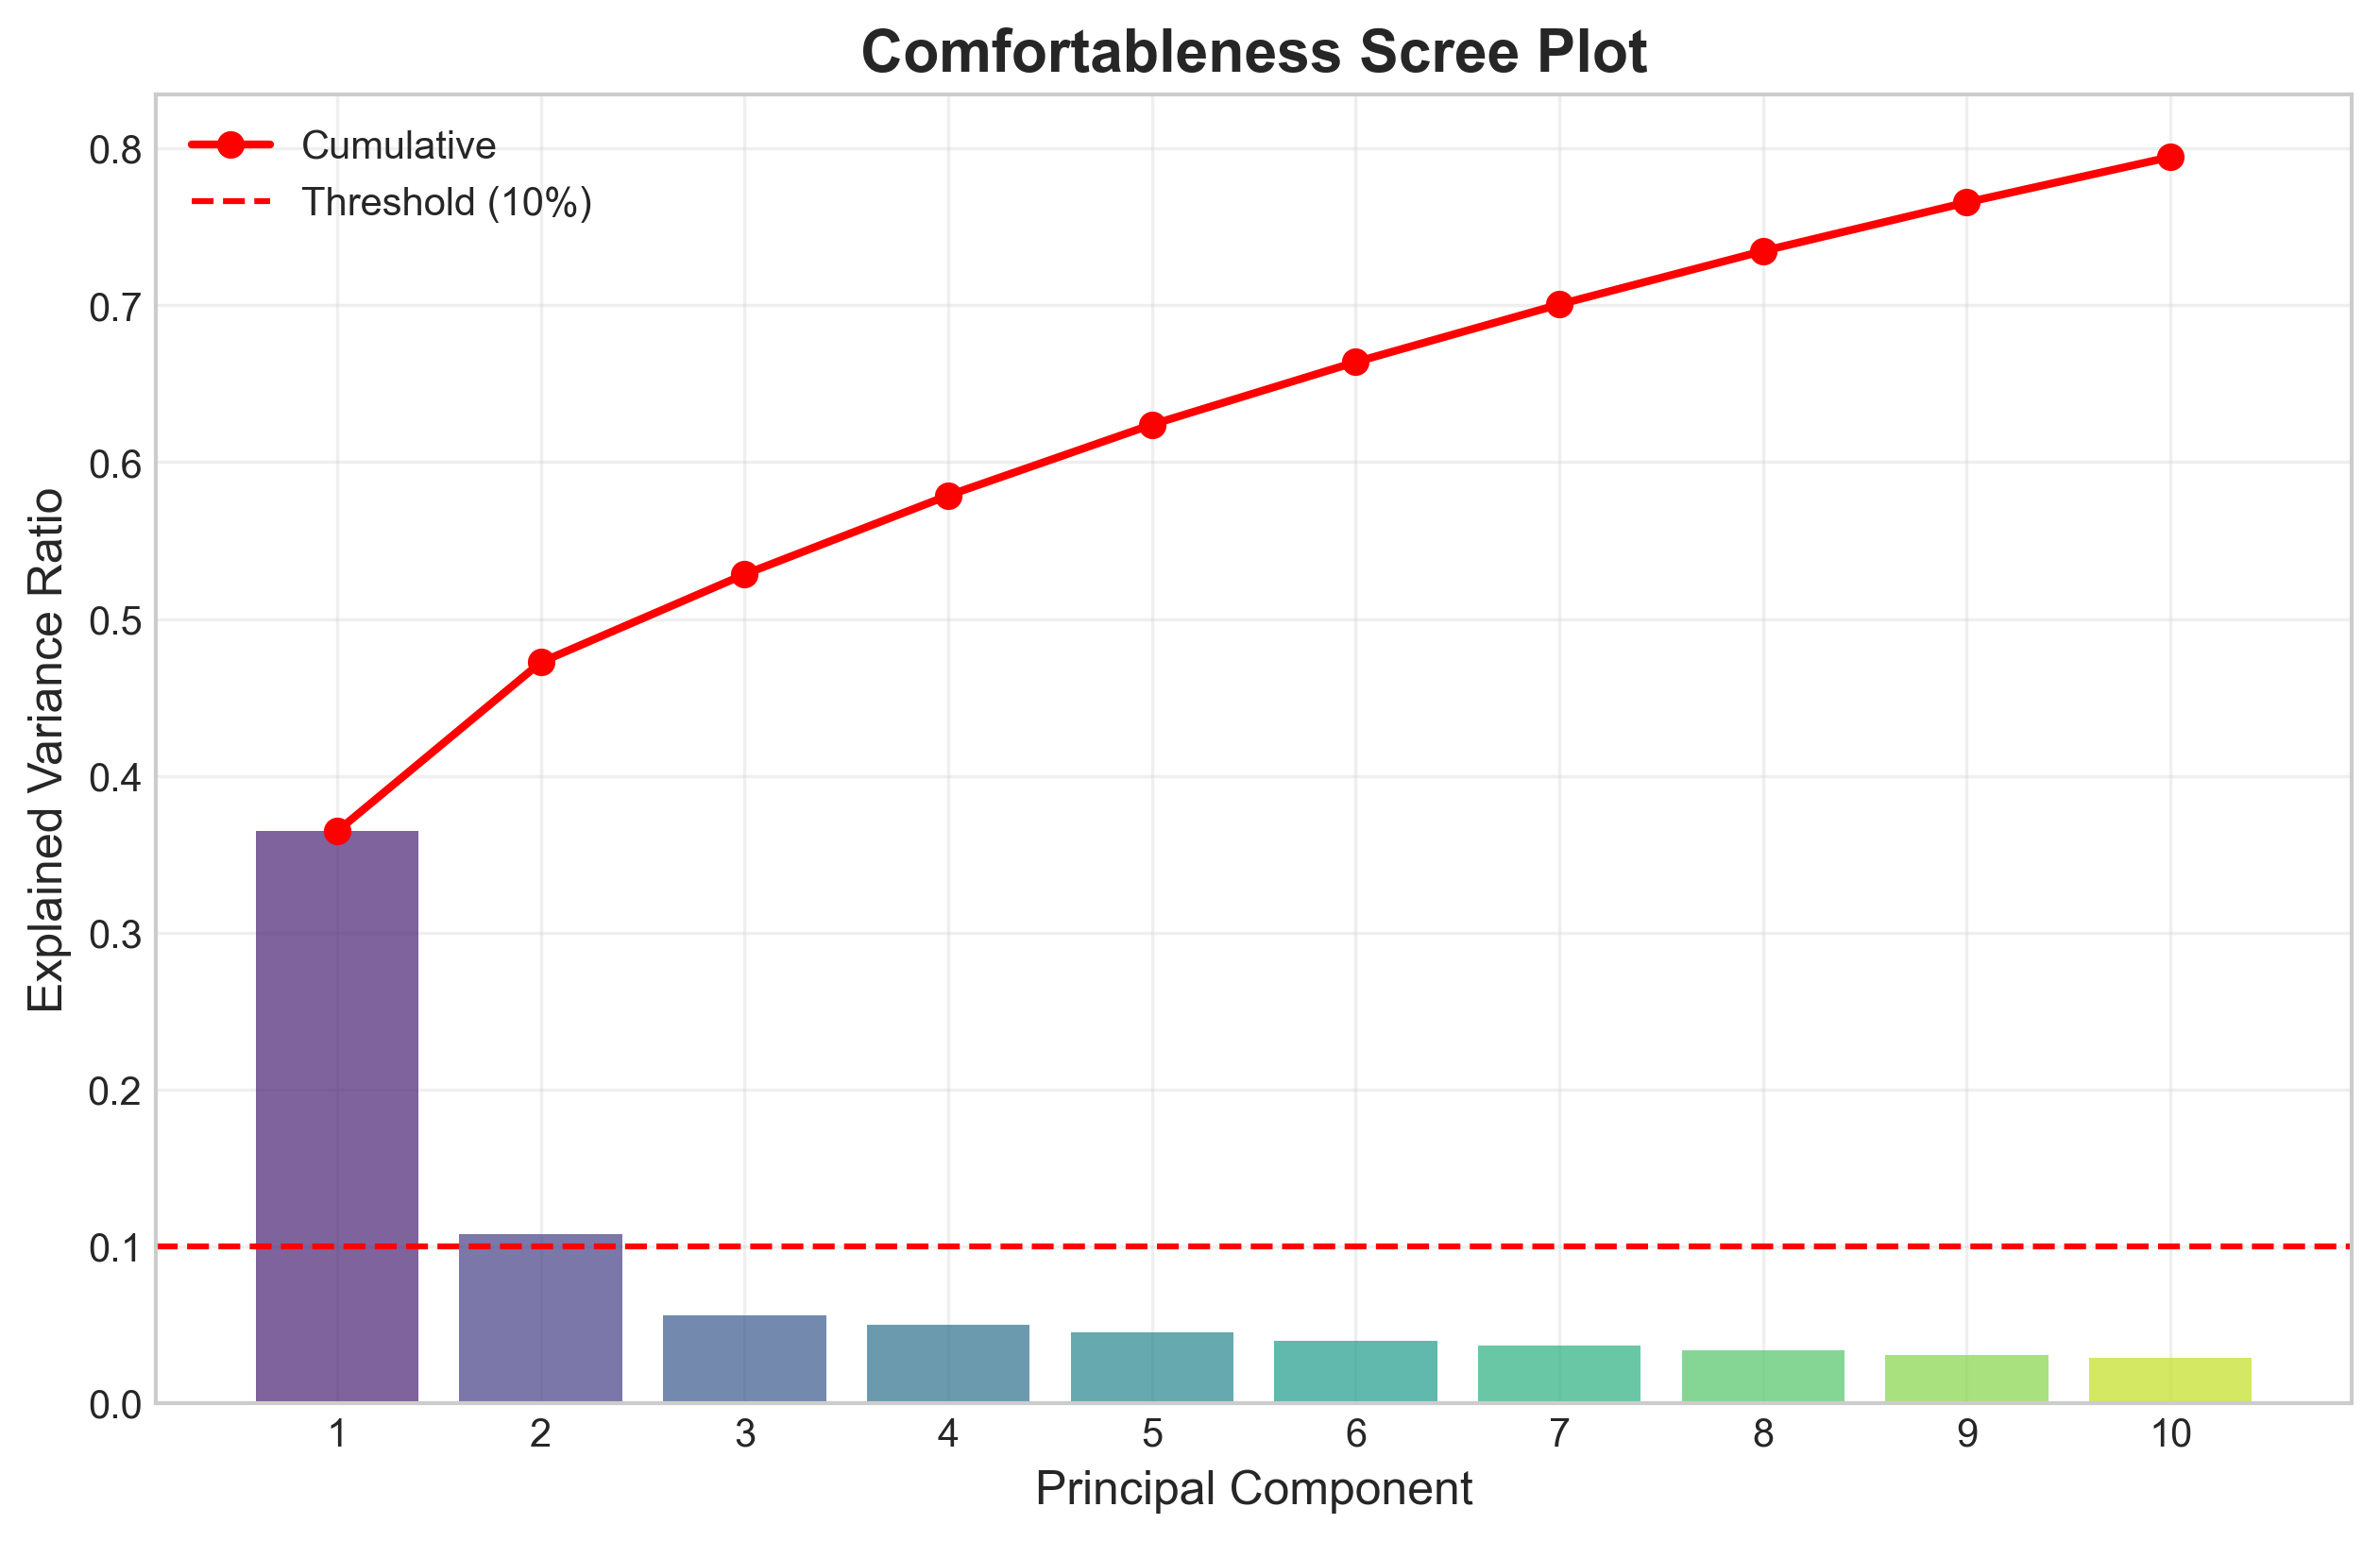

Comfortableness - Explained Variance by Component
Component | Explained Variance | Cumulative Explained Variance
PC1 | 0.3648 | 0.3648
PC2 | 0.1077 | 0.4725
PC3 | 0.0560 | 0.5285
PC4 | 0.0503 | 0.5788
PC5 | 0.0452 | 0.6240
PC6 | 0.0398 | 0.6638
PC7 | 0.0367 | 0.7006
PC8 | 0.0340 | 0.7346
PC9 | 0.0310 | 0.7656
PC10 | 0.0289 | 0.7946

Comfortableness - Component Loadings
Variable | Component 1 (Big Data/Automation) | Component 2 (Human Judgment)
Scom3 | 0.2165 | -0.1650
Scom6 | 0.2062 | 0.2493
Scom7 | 0.2484 | -0.1244
Scom8 | 0.2221 | 0.1314
Scom11 | 0.1923 | -0.1810
Scom12 | 0.2109 | -0.1972
Scom13 | 0.1622 | 0.2430
Scom14 | 0.1453 | -0.1254
Scom15 | 0.2007 | 0.2804
Scom16 | 0.2615 | -0.2264
Scom17 | 0.1808 | 0.1817
Scom20 | 0.1699 | 0.3775
Scom21 | 0.1710 | -0.2969
Scom22 | 0.1838 | 0.1872
Scom27 | 0.2031 | -0.1241
Scom28 | 0.2162 | 0.2274
Scom29 | 0.2093 | -0.1327
Scom31 | 0.2065 | -0.2547
Scom32 | 0.2480 | -0.0929
Scom33 | 0.2553 | -0.0098
Scom36 | 0.1717 | 0.1514
Scom37 | 0.2131 | 0.2995
Scom40 | 0.2479 | -0.1786

Comfortableness - Component Loadings Plot
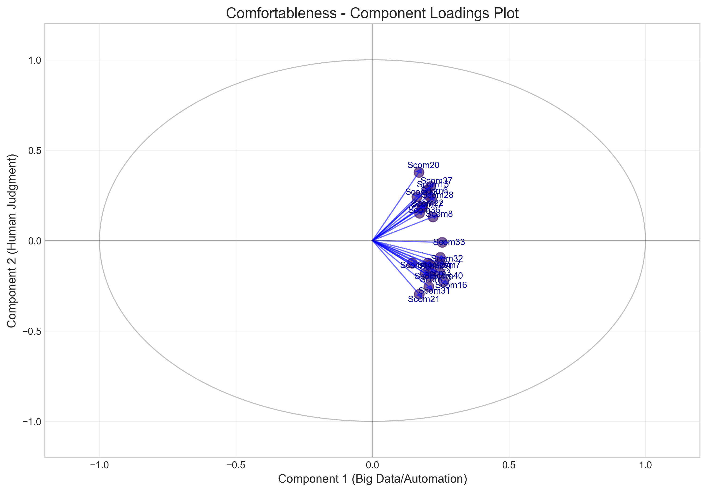

Comfortableness - PCA Scatter Plot
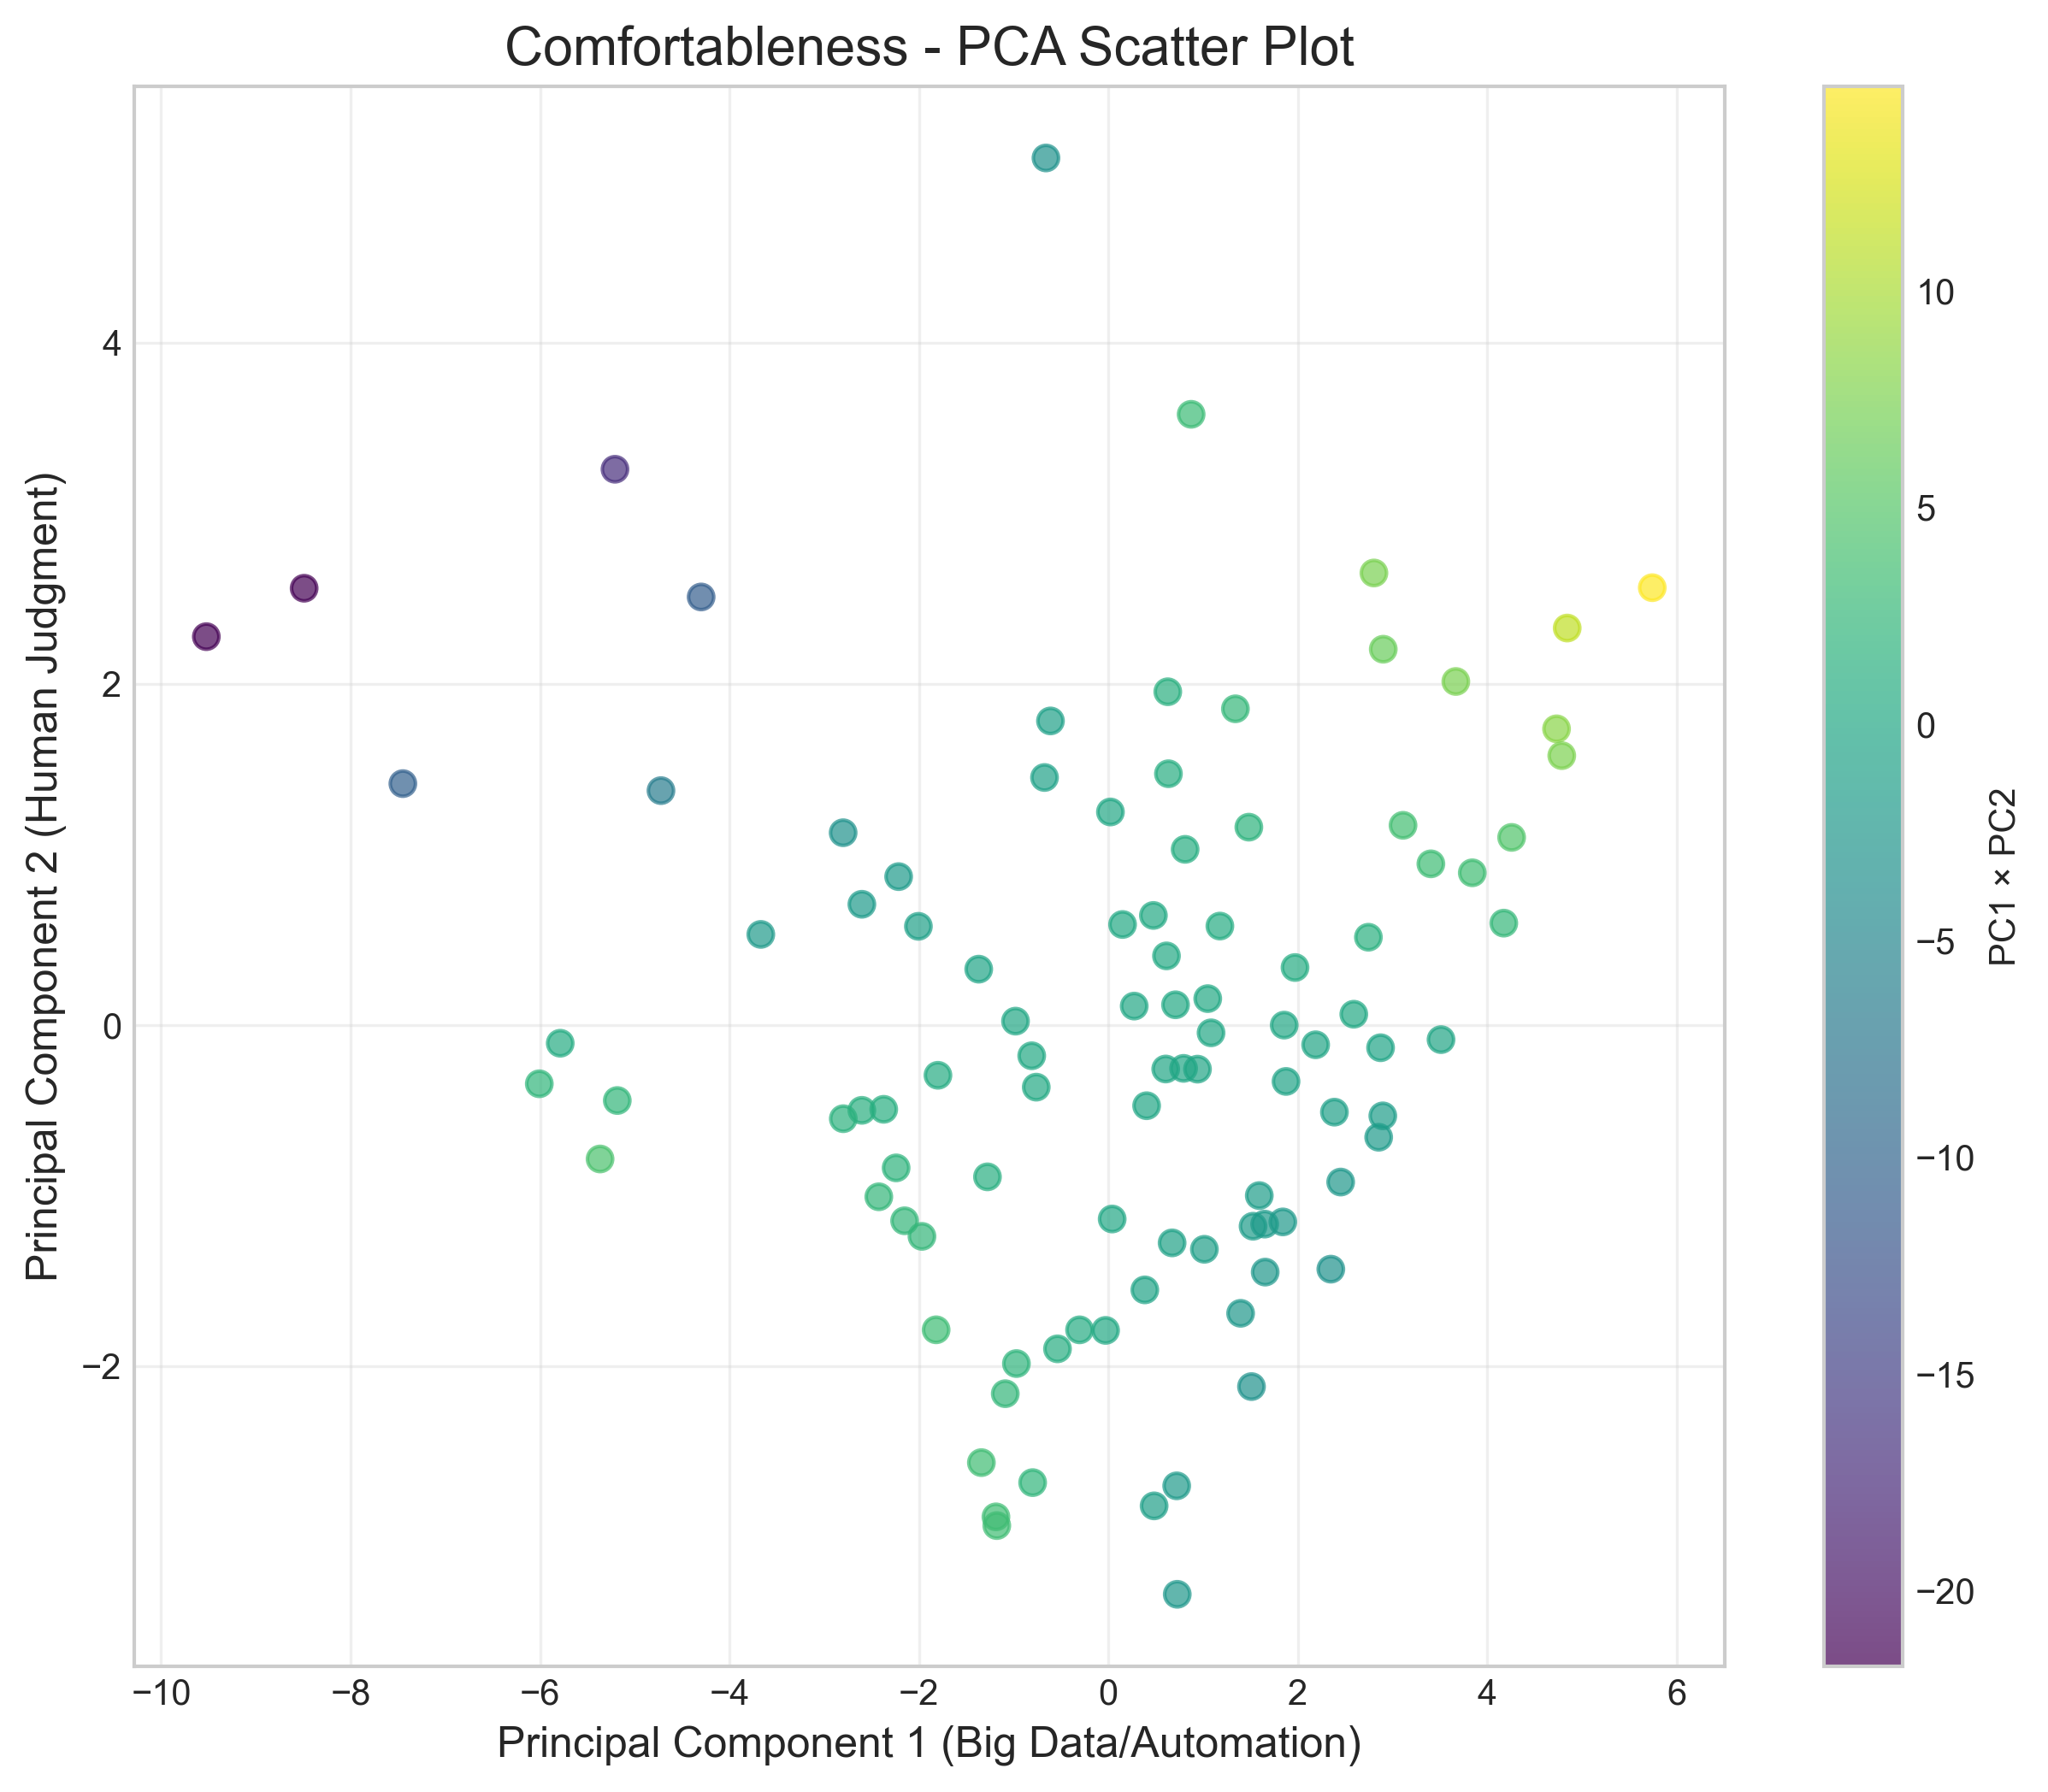

PCA ANALYSIS: CAPABILITY
Analyzing 21 variables with 99 valid samples

Capability - Scree Plot
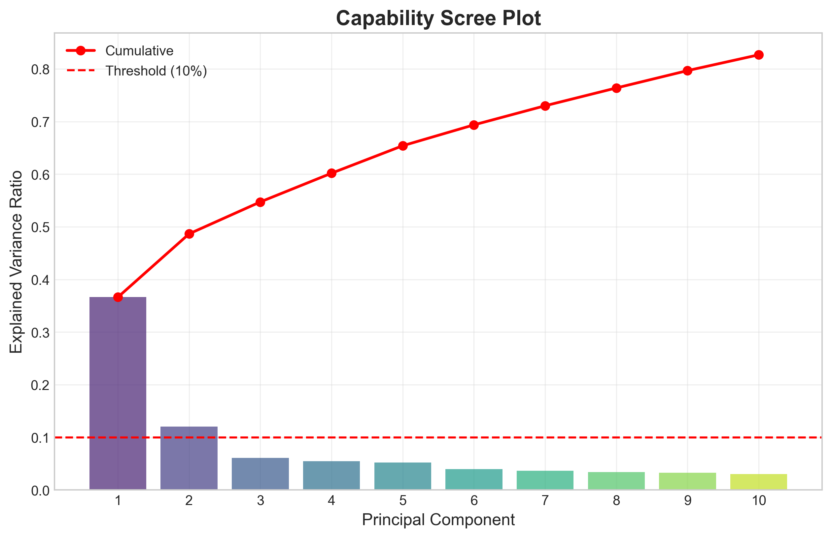

Capability - Explained Variance by Component
Component | Explained Variance | Cumulative Explained Variance
PC1 | 0.3662 | 0.3662
PC2 | 0.1203 | 0.4866
PC3 | 0.0606 | 0.5472
PC4 | 0.0546 | 0.6017
PC5 | 0.0522 | 0.6540
PC6 | 0.0396 | 0.6936
PC7 | 0.0363 | 0.7299
PC8 | 0.0338 | 0.7637
PC9 | 0.0330 | 0.7967
PC10 | 0.0300 | 0.8267

Capability - Component Loadings
Variable | Component 1 (Big Data/Automation) | Component 2 (Human Judgment)
Scap1 | 0.1965 | 0.1746
Scap4 | 0.2083 | 0.1487
Scap6 | 0.2589 | 0.1300
Scap7 | 0.2693 | -0.0925
Scap8 | 0.2705 | 0.1715
Scap10 | 0.2189 | -0.1410
Scap11 | 0.2255 | -0.1739
Scap15 | 0.1788 | 0.3256
Scap16 | 0.2685 | -0.2400
Scap19 | 0.1977 | -0.0632
Scap20 | 0.2142 | 0.3099
Scap25 | 0.1673 | 0.0465
Scap26 | 0.2064 | -0.3292
Scap27 | 0.2491 | -0.3131
Scap30 | 0.1414 | 0.2025
Scap31 | 0.1938 | -0.2239
Scap32 | 0.2398 | -0.0189
Scap36 | 0.1860 | 0.0896
Scap37 | 0.1920 | 0.2543
Scap38 | 0.2028 | 0.3335
Scap40 | 0.2392 | -0.3078

Capability - Component Loadings Plot
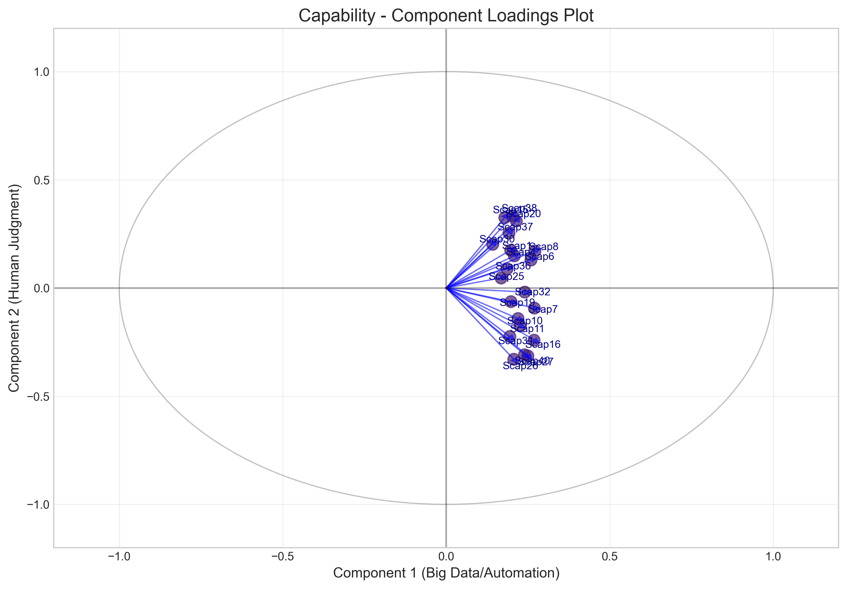

Capability - PCA Scatter Plot
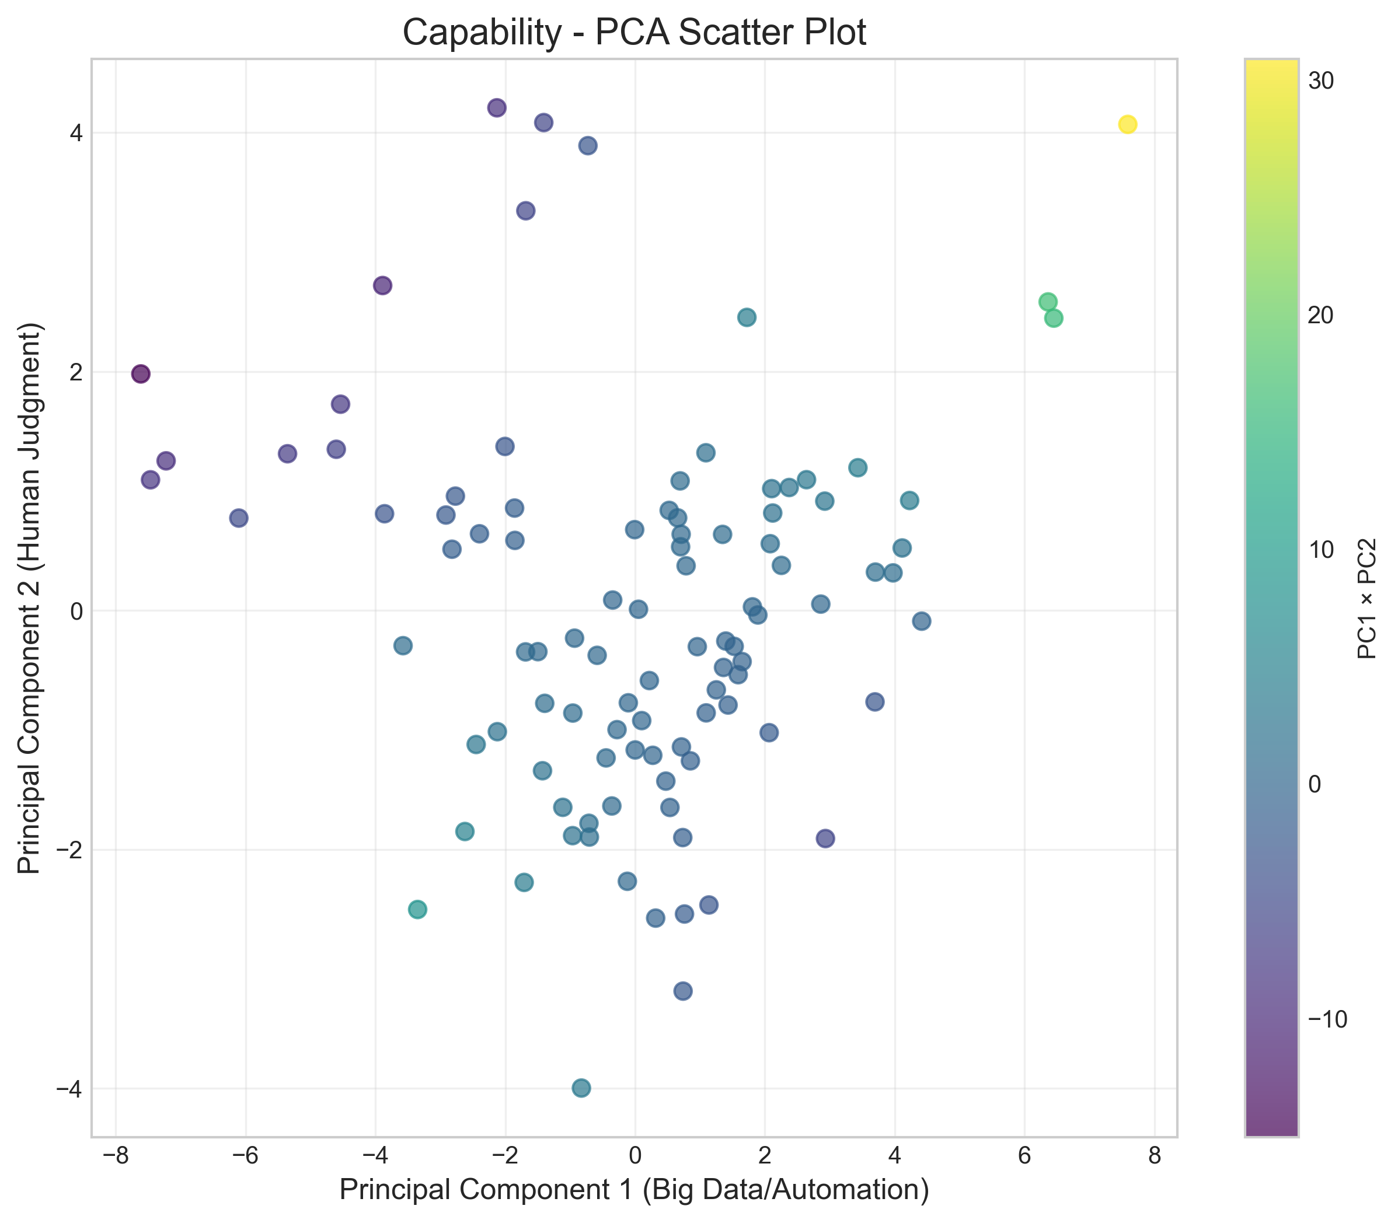

FACTOR SCORES AND STATISTICS
Factor components saved to 'outputs/pca_factors.csv' with 99 samples

Preview of Factor Scores (First 10 rows)
ScomFactor1 | ScomFactor2 | ScapFactor1 | ScapFactor2
-5.7871 | -0.1059 | -6.1044 | 0.7726
1.1771 | 0.5810 | -0.0057 | 0.6759
3.1107 | 1.1717 | 2.2545 | 0.3769
0.8737 | 3.5813 | 7.5921 | 4.0669
-2.4238 | -1.0061 | -2.6209 | -1.8500
1.5273 | -1.1787 | -0.2778 | -0.9975
4.7313 | 1.7374 | 6.3640 | 2.5815
0.2726 | 0.1119 | 1.0956 | -0.8573
-4.2995 | 2.5104 | -1.4064 | 4.0820
1.0134 | -1.3138 | 0.7617 | -2.5403

Descriptive Statistics for Factor Scores
count | mean | std | min | 25% | 50% | 75% | max
99.0000 | 99.0000 | 99.0000 | 99.0000
0.0000 | -0.0000 | -0.0000 | -0.0000
2.9113 | 1.5817 | 2.7874 | 1.5977
-9.5234 | -3.3365 | -7.6140 | -3.9967
-1.3550 | -1.1415 | -1.5898 | -1.0724
0.6052 | -0.1149 | 0.2728 | -0.0382
1.8489 | 1.0659 | 1.5579 | 0.8855
5.7418 | 5.0842 | 7.5921 | 4.2057

COMFORTABLENESS COMPONENTS INTERPRETATION

Component 1 - Big Data/Automation
Loadings Type | Variables
Highest positive loadings | Scom16, Scom33, Scom7, Scom32, Scom40
Highest negative loadings | Scom14, Scom13, Scom20, Scom21, Scom36

Component 2 - Human Judgment
Loadings Type | Variables
Highest positive loadings | Scom20, Scom37, Scom15, Scom6, Scom13
Highest negative loadings | Scom21, Scom31, Scom16, Scom12, Scom11

CAPABILITY COMPONENTS INTERPRETATION

Component 1 - Big Data/Automation
Loadings Type | Variables
Highest positive loadings | Scap8, Scap7, Scap16, Scap6, Scap27
Highest negative loadings | Scap30, Scap25, Scap15, Scap36, Scap37

Component 2 - Human Judgment
Loadings Type | Variables
Highest positive loadings | Scap38, Scap15, Scap20, Scap37, Scap30
Highest negative loadings | Scap26, Scap27, Scap40, Scap16, Scap31

FACTOR CORRELATIONS

Factor Correlations Heatmap
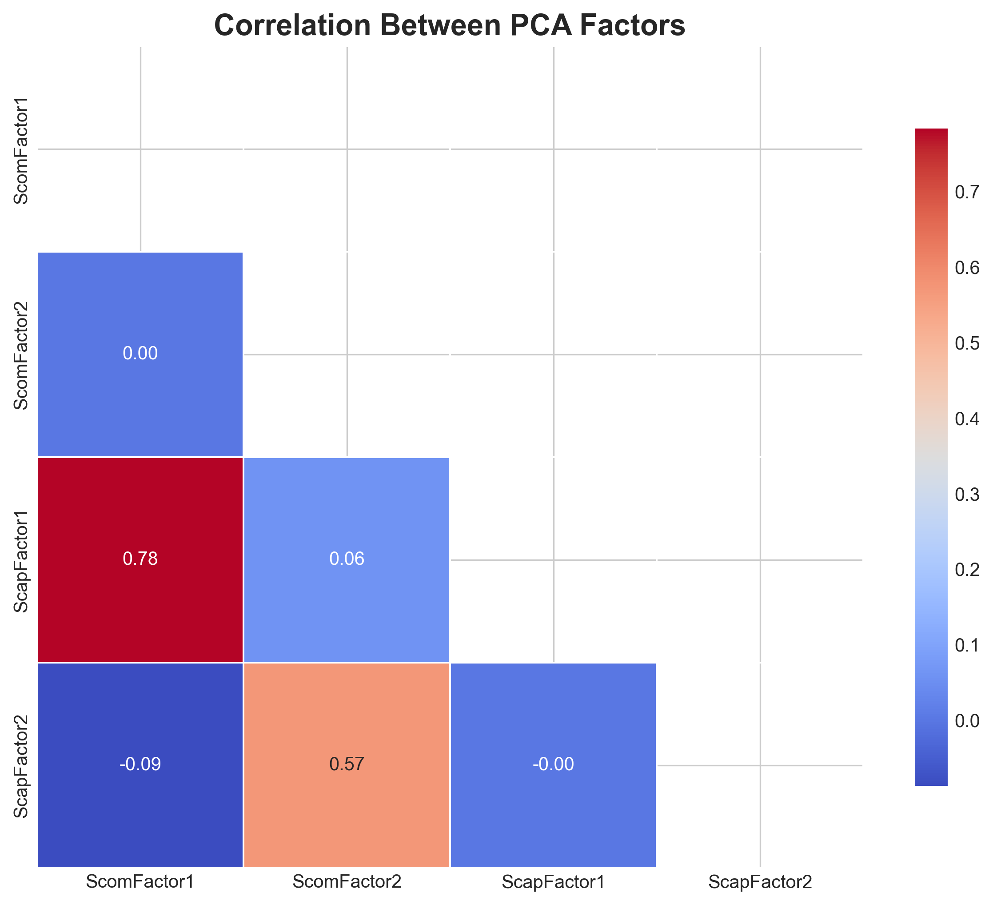

Factor Correlation Matrix
Factor | ScomFactor1 | ScomFactor2 | ScapFactor1 | ScapFactor2
ScomFactor1 | 1.0000 | 0.0000 | 0.7837 | -0.0869
ScomFactor2 | 0.0000 | 1.0000 | 0.0620 | 0.5714
ScapFactor1 | 0.7837 | 0.0620 | 1.0000 | -0.0000
ScapFactor2 | -0.0869 | 0.5714 | -0.0000 | 1.0000

