1. **Create a histogram comparing the distribution of global sales for sports games and shooter games**

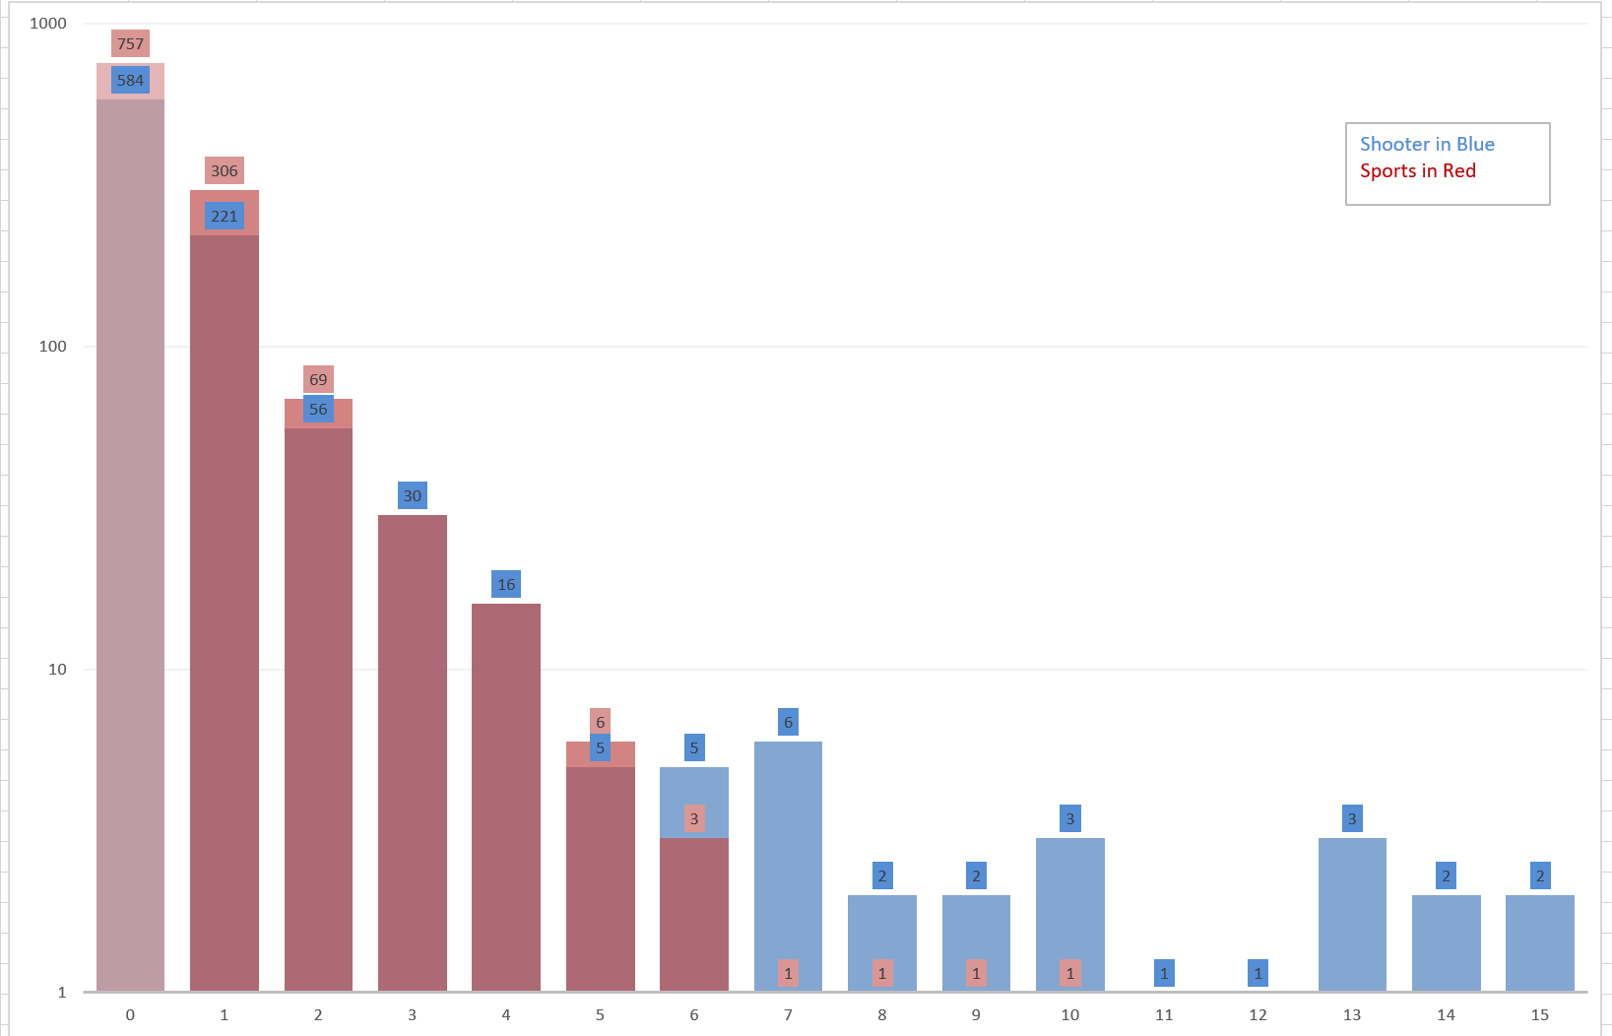

**2) Create a dashboard for the average critic score for Sports games and Shooter games.**

