Data Dictionary

                'average_car’: ’average car count in one household’,

                'pctWhite: 'Whites not Hispanic or Latino',

                'pctBlack': 'Black not Hispanic or Latino',

                'pctIndian': 'Indian and Alaska Native not Hispanic or Latino',

                'pctAsian': 'Asian not Hispanic or Latino',

                'pctHispanic': 'Hispanic',

‘pctVacant’: ’percent of vacant houses’,

                ‘pctPoverty’: ’poverty rate’,

‘MedRent’: median rent

‘MedHHInc’: ‘average median house income’,

‘pctBachelor’: ‘proportion of population with at least bachelor's degree’,

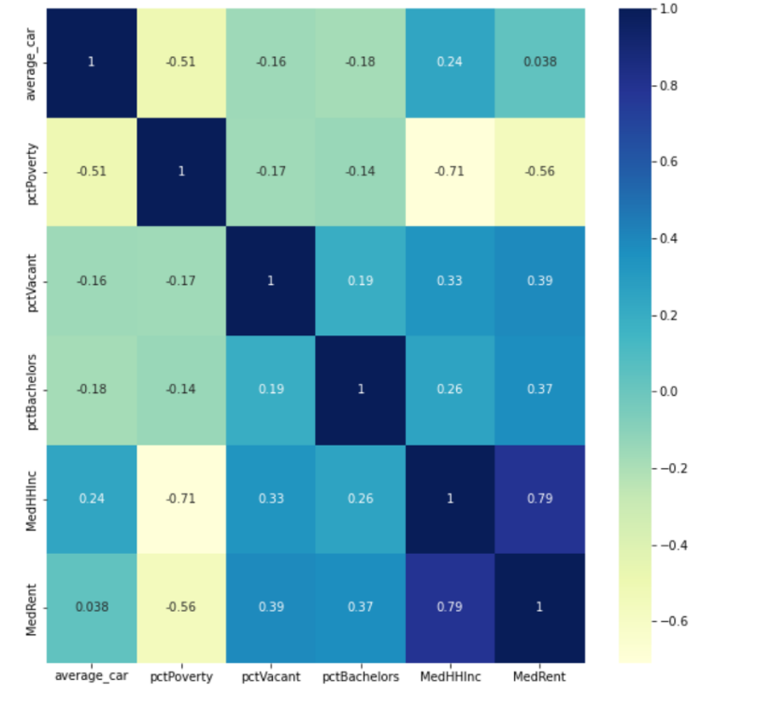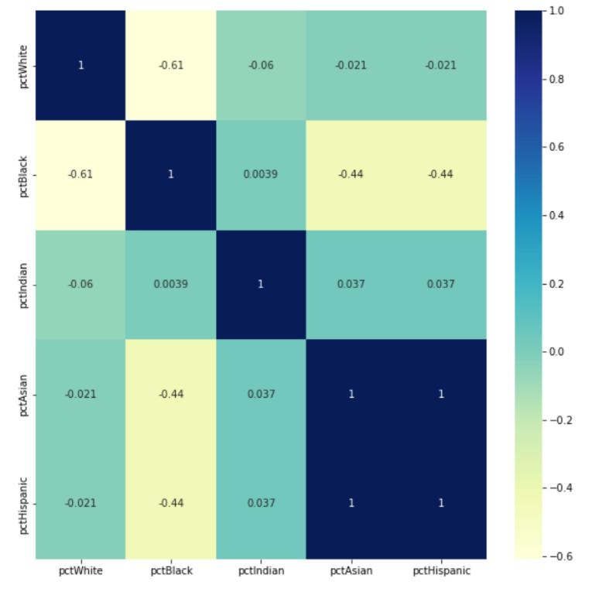Correlation matrix: according to the correlation matrix, ‘MedRent’ & ‘MedHHInc’, and 'pctAsian' & 'pctHispanic' are highly correlated. Thus, the regression models don’t use 'pctHispanic' and ‘MedRent’ as predictors.

1. Inflow visit: visits counts flowing into a specific tract from all other places
   1. dependent variables = visit counts in March 2019

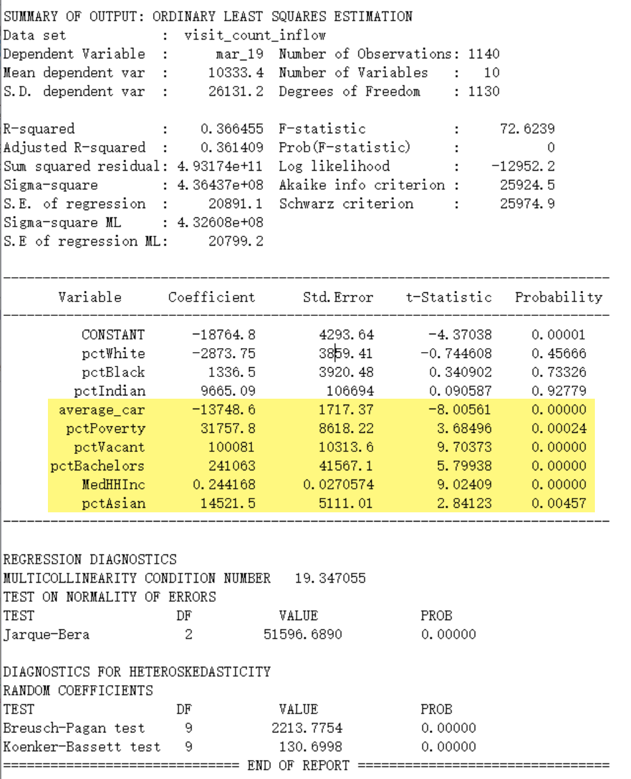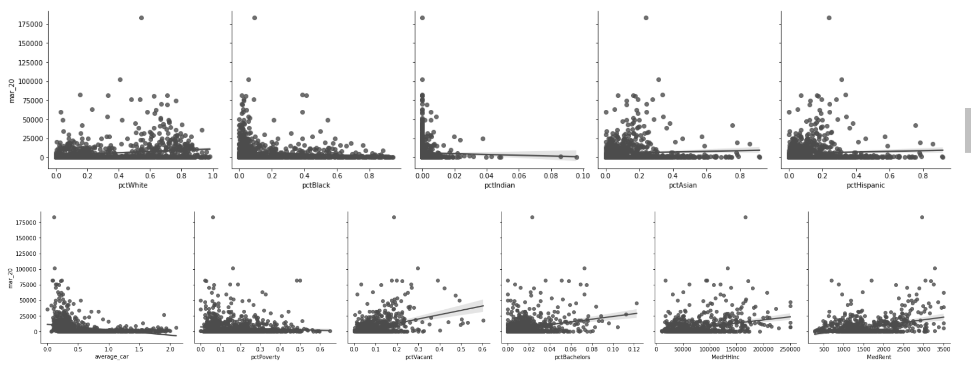

1.2 dependent variables = visit counts in March 2020

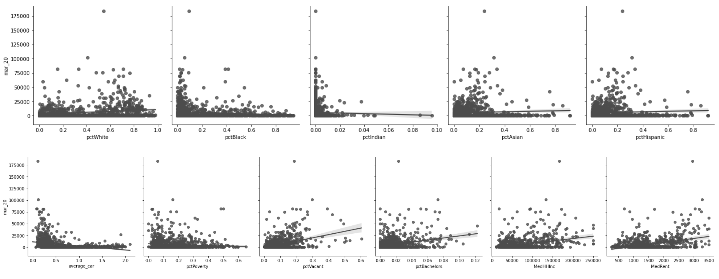

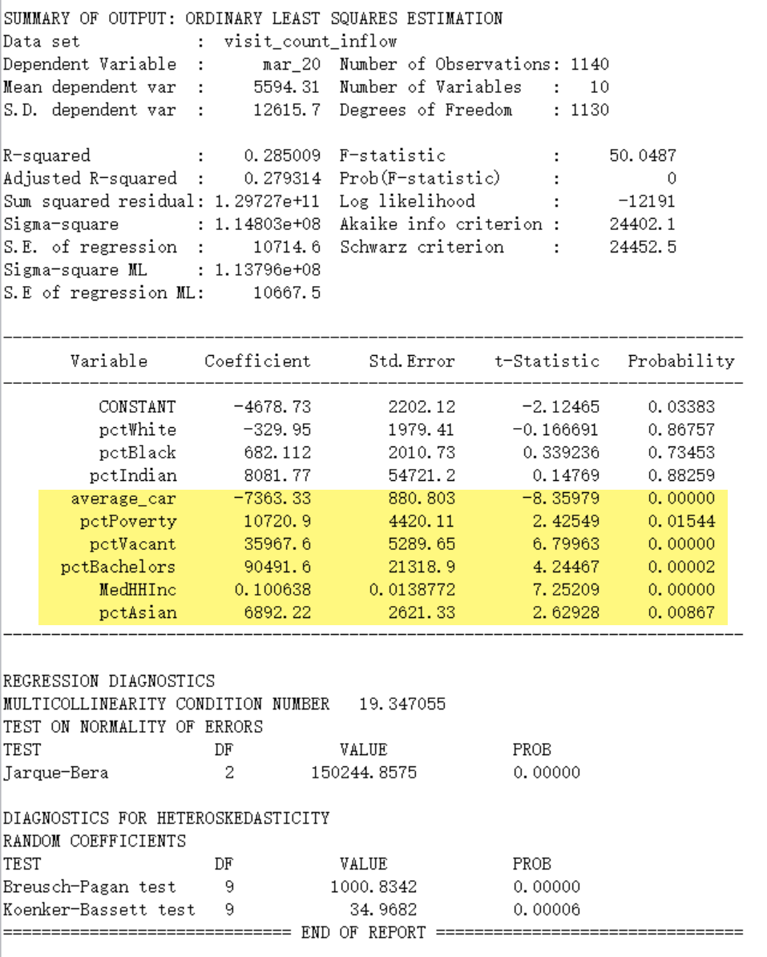1.3 dependent variables = visit count change between March 2019 to March 2020

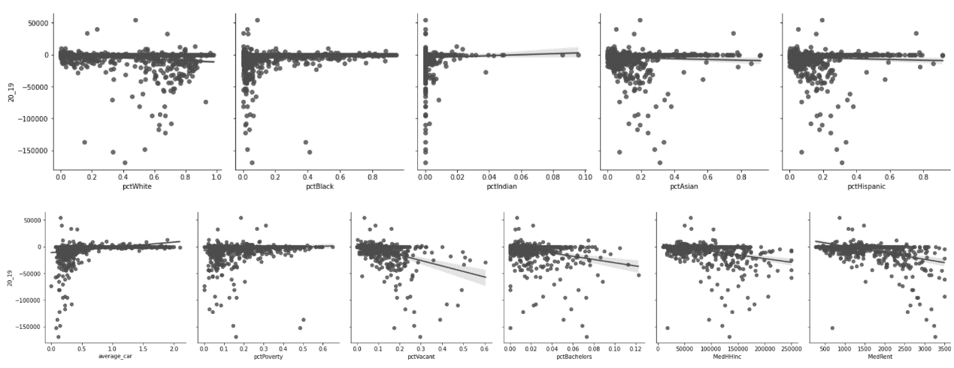=

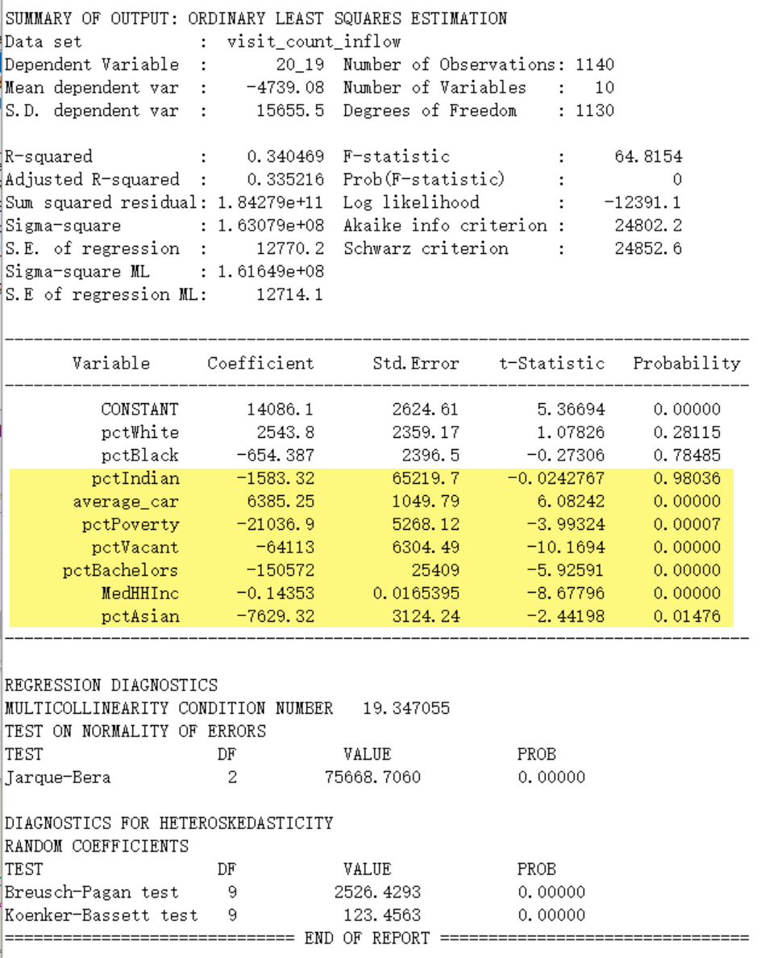

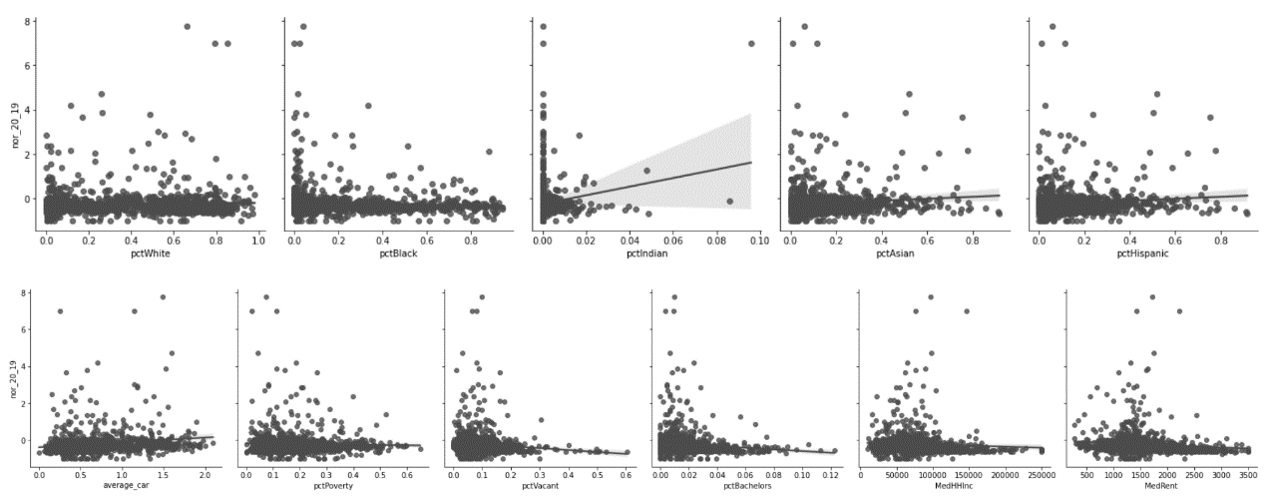1.4 dependent variable= the percent change of visit counts flowing into a specific tract from all other places from 2019 to 2021  
 =-

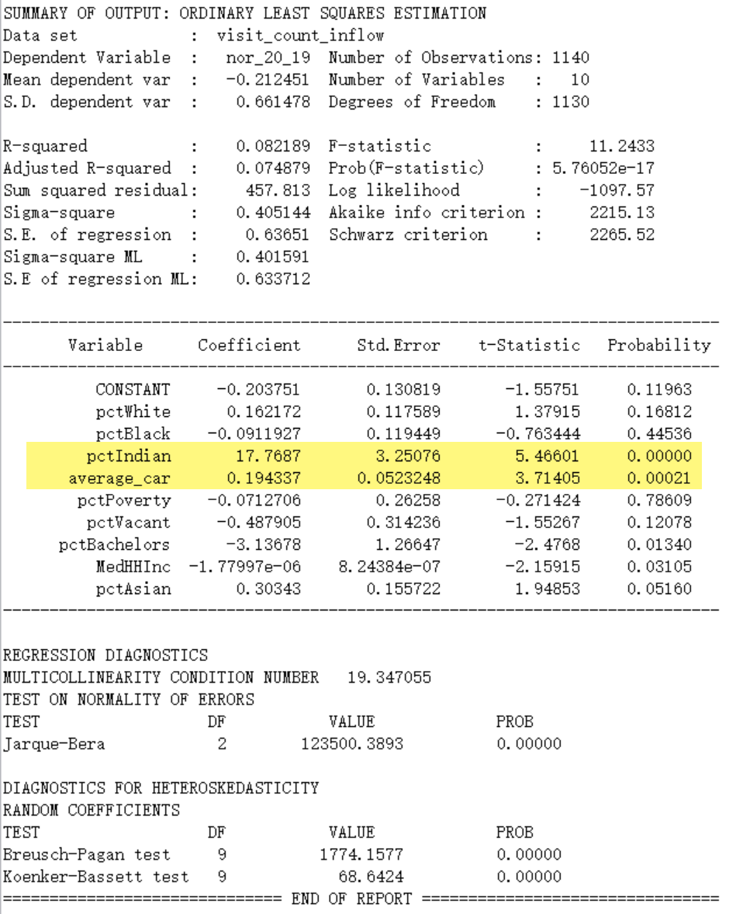

1. outflow visit: visits counts flowing from a specific tract to all other places
   1. dependent variables = visit counts in March 2019

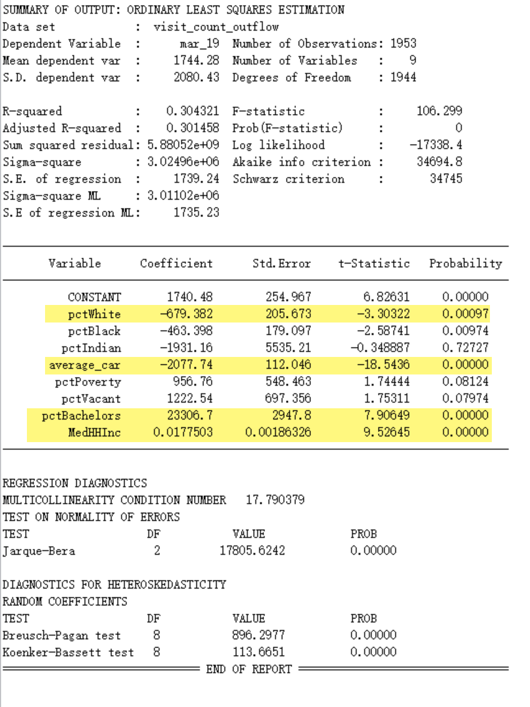 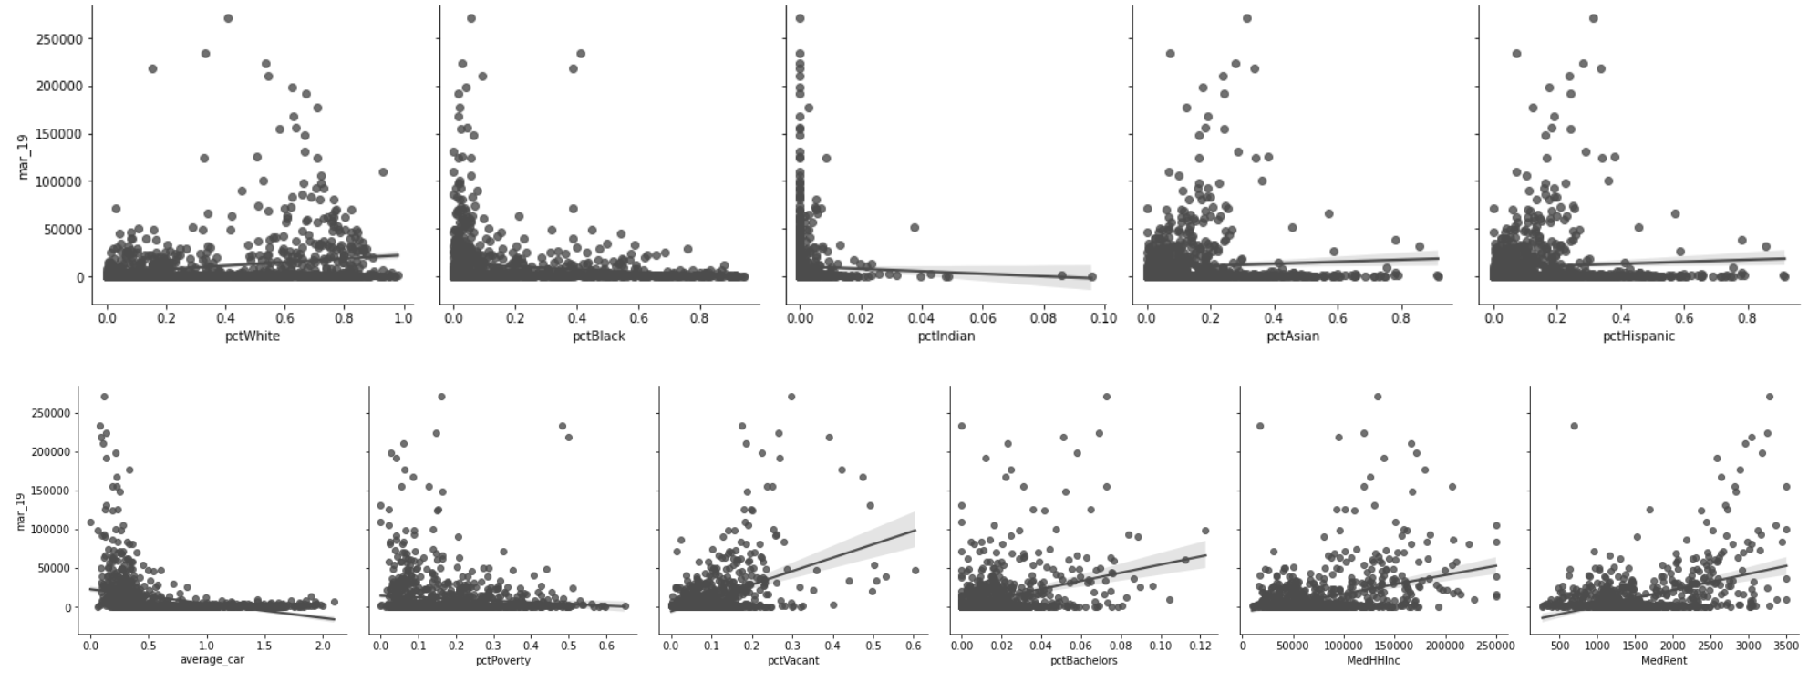

2.2 dependent variables = visit counts in March 2020

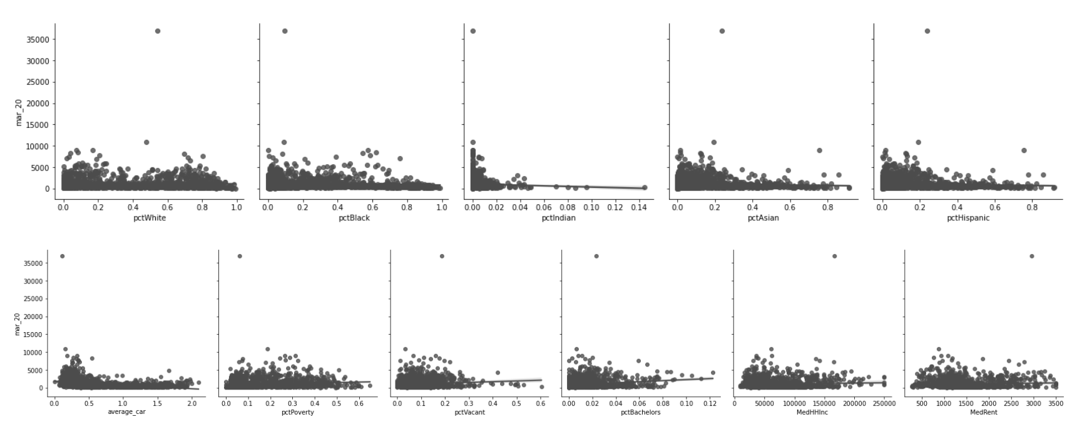

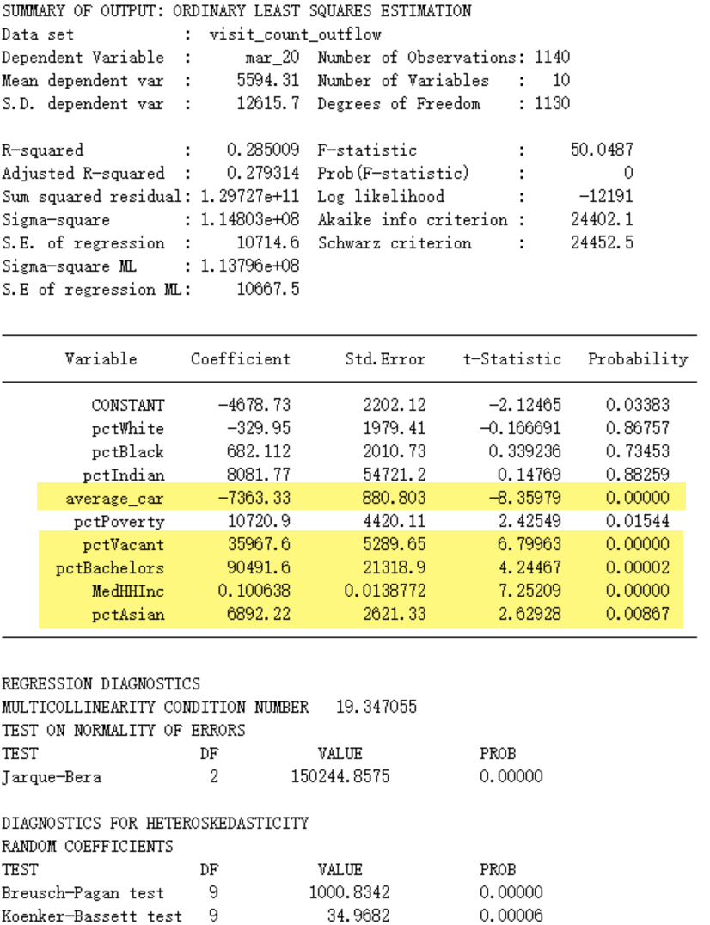1.3 dependent variables = visit

count change between March 2019 to March 2020

=

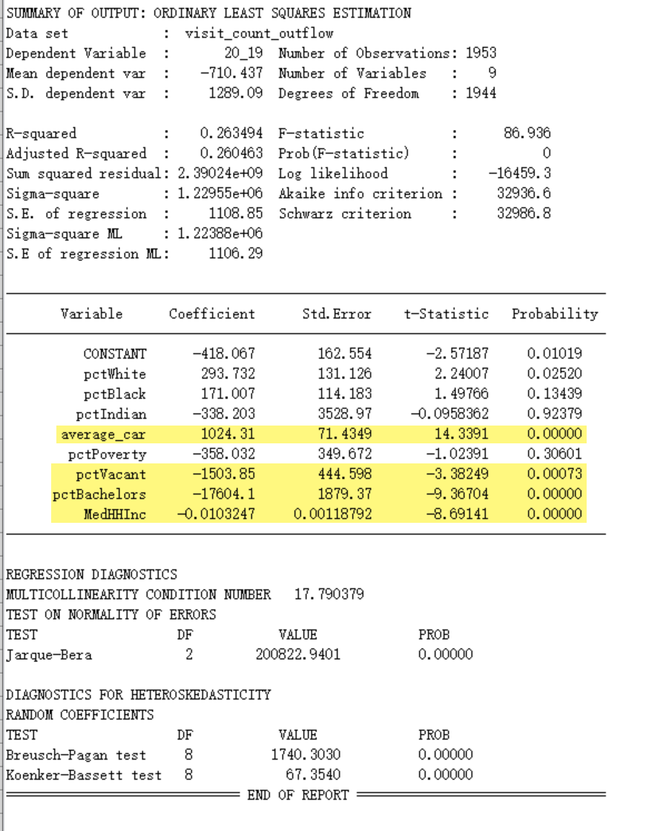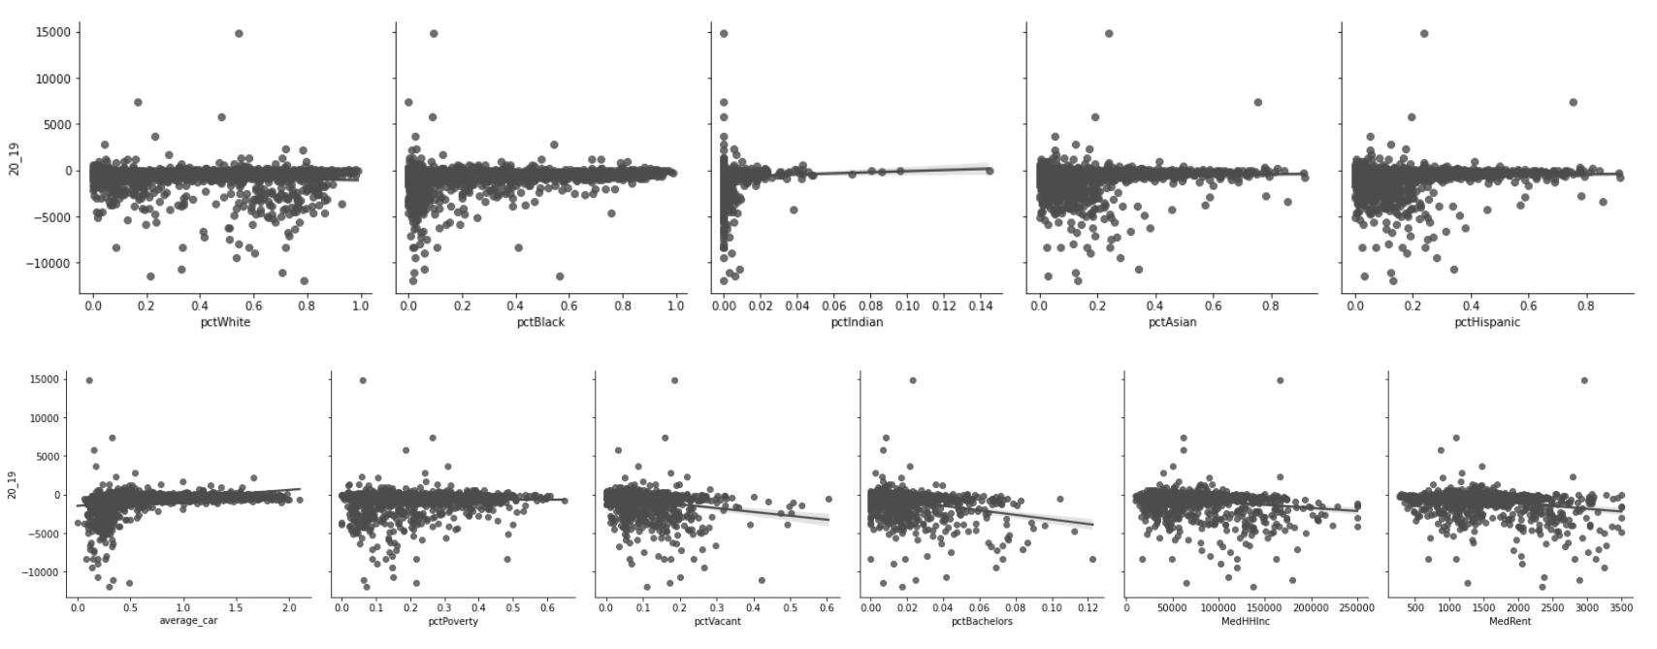

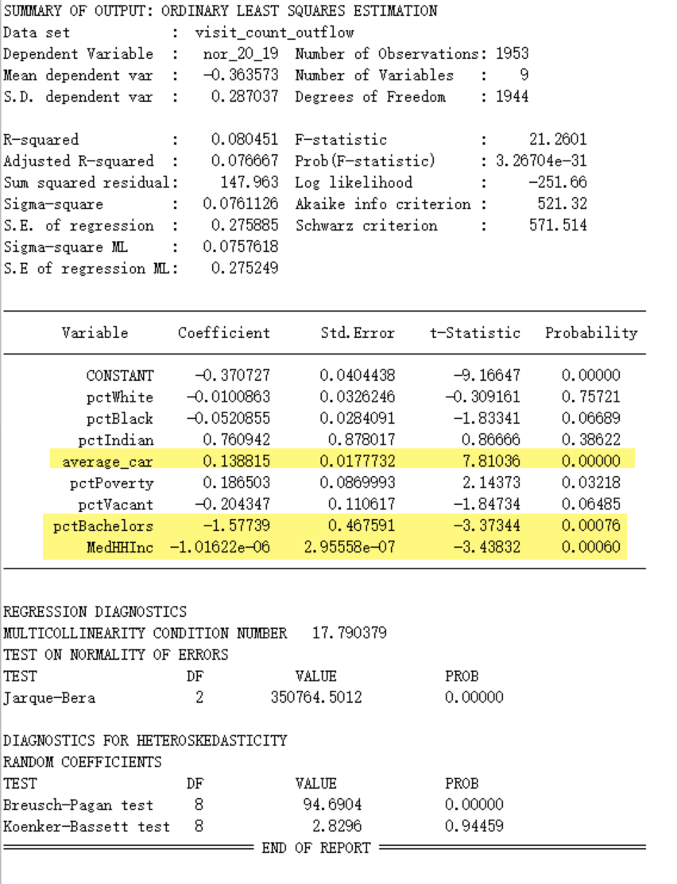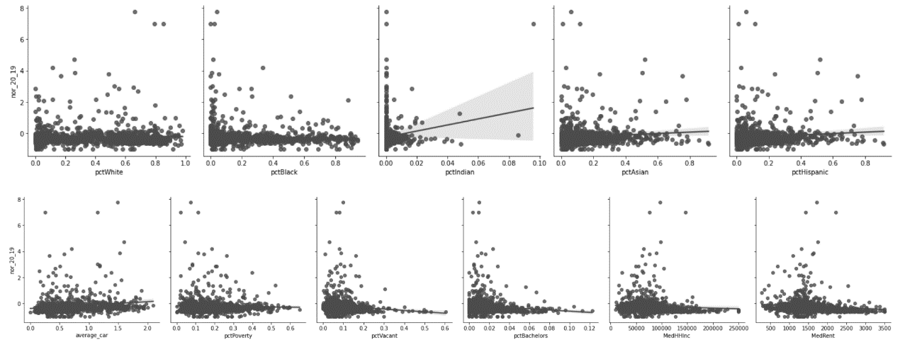1.4 dependent variable= the percent change of visit counts flowing into a specific tract from all other places from 2019 to 2021  
 =-