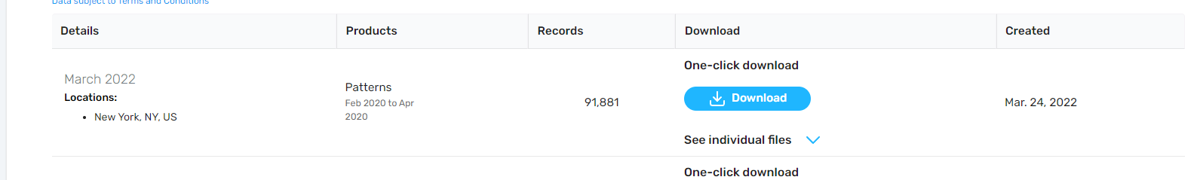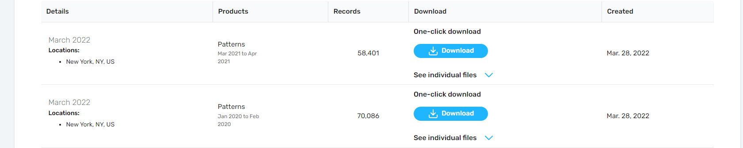

<https://docs.safegraph.com/docs/core-places>

