# Web and Database Computing

# Section 1: Research & Features

## What will the platform look like?

Through our research, we decided that a student’s club platform should be a web application which allows for users to be able to research, see events from, create and join different clubs at their university with ease. It should provide some context of the university’s clubs, how they are run and how to perform the actions listed about. Users should have an account where they can see what clubs they are in and events specific to those clubs. It should have a clean UI, be accessible and easy to use, minimising cognitive and kinematic load. Below we discuss some aspects from researched pages we liked and disliked, as well as which parts we will and wont implement.

We looked at all the south Australian university’s platforms for their clubs.

The Adelaide university “YouX” platform utilises a clean user interface, with a modern design and classic black and white colour scheme which is attractive to users. Instantly, you can see a wide range of options on the menu bar, a search bar and log in tab. We liked the way that upcoming events are displayed on the home page, however, did not like the lack of context the page gives to the actual functionality of the website. You must scroll down past some irrelevant content to find any information about the platform, clubs and quick links. This increases cognitive load and kinematic load, as you must move your mouse a lot, and look in unconventional areas to get to them. Even to get to the club index page, you must first find the page called clubs, and then press a link on this page which takes you to the index. This is far too difficult for such a key feature of the page and in our own webpage, we will focus on making the task of getting to the club index page far easier, and ensure that context for the page and its features are provided on the home page..

When looking at The UniSA, “USASA empowering you” platform, the UI can appear slightly clustered, however not awful, and the quick links appear without scrolling, so you can easily press the link to take you to a page which displays all clubs, so you can search for and get information about clubs. This ability to easily get to seeing what clubs are about with low kinematic and cognitive load makes using the website much more pleasurable and accessible, hence we want to implement this into our platform. We do not, however, want to home screen to appear as clustered and visually unappealing, so we will ensure that it doesn’t have too much content on it.

Overall, our home page should display information about the platform and some context of university clubs, as well as displaying quick links clearly without having to scroll for them.

In both these websites, as well as some others we researched such as Harvard universities and ANU, each club has their own path, where they have an “About us” section, some photos and videos, as well as options to sign up to their social media pages. The Adelaide uni platform does not let you join a club, instead it just gives you links to go to their social medias/ website where you can rsvp to events. The UniSA platform allows you to, when logged in, join the club on the platform. For our platform, we do want social media links, but also the capacity to enrol into clubs and RSVP to events on platform as it makes the experience of using our platform richer.

Another feature we want to implement is displaying events that are upcoming, like what ANU does. Other platforms outsource this requirement to the club’s social media pages, but our platform will have events on our page, and allow users to see all their upcoming events for their respective clubs.

These sites also have contact us pages, as well as additional information, such as how to make a club and instructions on how to enrol into clubs. This increases usability as it provides users with real information on how to go about using the platform and something we will implement also.

Overall, the platform will feature a home page, providing context to the platform and student clubs, with quick links for regularly accessed pages clear and easy to access, including one to see the club list. Users will be able to see all the student clubs and be able to press a link to the club they are interested in. This link should lead to a page describing the club, how to sign up for the club, club events and links to the club’s social medias/website. Users will be able to view all the clubs they are enrolled in, events for that club and their user information in their own “user” page.

## What information will users be required to supply?

To register for an account, users will need to contact information to authenticate their account and authorize access to their user data. This account will allow end users to sign up to the various clubs available on the website.

Specifically, users will need to provide their email, a username that will represent the primary key, and a password.

How will they log in and sign up?

The log in process will be standard and, without getting too technical, will flow as follows:

* The user will be able to press on the log-in icon in the top right corner, taking them to the log-in page.
* On the log-in page, returning users will be able to enter their username and password to sign in. This will send an HTTP-request to the server.
* If valid, the server will assign a unique authentication token back to the front end in an HTTP-Response. If not, server responds with an error code and prompt the user to sign in again.
* This token is stored in the browser’s local storage.
* Now the user can access protected parts of the site, as every time they try to access it, the token is sent with the HTTP-request.

The sign-up process will be conducted in a similar manner:

* User will fill in registration form.
* Sends the registration form from front-end to the server via HTTP-POST request.
* System ensures all fields are valid and present, or else it will respond with an error code.
* Server creates a new account for the user, which is stored in the user database.
* Unique authentication token is generated and sends it back to the user with an HTTP response where it is stored in local storage.
* User is logged in and can access protected areas of site with authentication token, and in future can log in as account is stored in a database on the server.

## How will they interact with the system?

Interaction with the system will be simple, accessible, and effective. It will combine elements from all the systems we have looked at, but especially from the UniSA clubs platform as this platform allows users to register for clubs on the platform, instead of just linking to the clubs social media pages.

### Users

Once logged in, users will be taken to their profile page where they are able to see all the clubs they are registered for, account info and any upcoming events.

From there, they can navigate through menus, or press the quick link to find the clubs index. There, they can freely search through all of the student clubs by scrolling or searching on the search bar. They can also filter search, so that they can narrow clubs down to categories. They can then press on a club and see information, look at events, go to social media website and enrol in said club.

### Club managers

Club managers will be able to log into their platform and are taken to a page with important statistics of their page. This will include members, upcoming events, and social media.

They will be able to manage their own user information, see members of club, remove members of club, post updates and events to members or public, create events both public and private, and see RSVPs for events. They will also still be able to use the system as a user can otherwise, without the ability to join other clubs.

### System admins

When logged in, system admins will be able to manage their own user info, manage users and club managers, and sign-up other admins through a link on their own personal page.

## What Features will our site include?

Some features of the website are available to public users who aren’t logged in or do not have an account.

This includes being able to search through the club’s index, which lists all available student clubs. This index has a search bar, where you can search for key words and club names, as well as a filter feature to show only clubs of a certain category.

### User:

Users will have a variety of features which will allow them to use the platform in an effortless and accessible manner.

- Users will be able to log in/ sign up, having their own account with their personal information.

- Link their accounts to social media account.

- When logged in, users can edit, change their information.

- They can join one or more student clubs, which they can find through the search.

- They will have a “feed” section on their user page, which will display updates from the clubs they are joined to. They will also have a section which will show all upcoming events for these clubs also.

- They can select these events and RSVP, sending their relevant information to club managers.

- They will also be able to sign up for email notifications for their clubs to be able to see special events and other updates.

### Club managers

Club managers features differ to average users.

- They can also sign up/log in and manage their own information.

- They can view all the members of their clubs on their own club management page.

- They can post updates, set to be public for all users, or private for just club members.

- They can create events, set to be public for all users, or private for just club members, and update these events with information.

- They can receive RSVP requests from users for their events.

### System admins

System admins have different features again.

- They can also sign up/log in and manage their own information.

- They can manage users and club managers.

- They can manage overall clubs.

- Sign up other system admins.

In the next section, we discuss how these features will be implemented into our design.

# Section Two – Site Design, How Features Will Be Implemented Into System and Review.

### Website design – Planning

Before creating our mock-ups, first we must look at the information found from our research and write some brief descriptions of how we want our web app to look. Our goals are to maximise usability and accessibility by minimising cognitive and kinematic load while maintaining an aesthetically pleasing and smooth UI, utilising good UI practices.

Consistent elements

Every page will have a navigation, which will appear at the top as the number of pages on this platform is relatively small. Account info will appear in the top right corner, as is convention amongst most web-platforms and other minor details at the bottom of page such as links to contact the helpdesk for the platform and other related features. The platforms title will appear above the menu navigation, similar to how it appears on YouX.

Home page

The first thing users will see when they enter our site is the home page. It is important that we establish content about what our platform’s mission is: To allow for users to see different student clubs, what events and updates they offer and sign up to them. We also must show them how to do this and where. The site must also have a search, as some users would just like to search to find content they are after. Shortcuts to frequently used pages and login must also be prominent.

Clubs page

Most users will then likely go straight to the club’s page, as this is the main drawing point of the platform. This page will have a brief description of what is on this page and how you can use it. It will essentially say: here you can find all the student clubs and can press on them to see more information about them and register for them. Below this text the actual index will start, first displaying all the clubs, and then you can use the search or narrow the fields down with the filter. We may need to utilise agile principles and put this onto a separate page however depending on practicality.

Individual club’s pages

For users

The individual club pages will all follow the same template. Title, photo and text about the club, updates and events, and also display an option to sign up for the club as well as links to the social medias/club websites and email notification sign up on the right-hand side. This will reduce kinematic load and cognitive load, as many users may already know what club they want to join this club, and having this option on the side of the screen will make it easiest to do so.

For club managers

Club managers will have the same view of this page but with some key differences. Each of the club’s elements can be edited. Or at least, they can update the events and updates from this page if they choose.

Members account page

This page will be the users “home base” so to speak, providing them with all the relevant information to them including: Their user information, the clubs that they are a part of, upcoming events and updates from clubs they are a part of.

These elements are all for the basic users, club managers will have slightly differing appearances of the clubs they manage, and their account page.

Club manager account page

This page will be set out very similarly to the members account page, however with some key differences. Instead of displaying the clubs they are a part of, it will show the members of their club, instead of showing all their upcoming events, it will show their clubs events and same goes for the updates. They can then press on create/ manage events and updates to be taken to a page where they can do exactly that.

Create/ manage events and updates page

This page will display all of the current events, and below it updates, for the club managers club. Here they will be able to press on the events and edit information about them through a forum. They can also add events and updates here too and check the RSVPs for the events.

System admin account page

The system admins account page will again follow a similar format to the users and club manager account page. The difference being that its options are manage personal info, manage users, sign up other admins and manage clubs.

### Sketching Mock Ups:

Upon completion of planning, we got to work making some basic sketches in paper, following the guidelines we set out and then begun creating virtual mock-ups, where we could be far more precise with how we want our page to look. The sketches were basically just us trying to figure out approximately how we would want to lay out the content of our webpages.

The sketches then allowed up to develop the mock-ups for our side, fully annotated with brief discussions on design decisions. The first four mock ups will show the main flow of the webpage, from a logged in user landing on the home page of the platform, to RSVPing for an even or registering for a club. The next multiple will show the account pages for Users, Managers and Admins, as well as how they interact with these pages.

### Consistent elements, main content div and briefly about inner content divs

All the main site pages will have their content stored inside a main content div, this div will take up about 80% of the width of the webpage. We will discuss the dimensions of the specific elements for each page. Inner content divs will have varying amounts of paddings going up to about 30px to ensure that elements are appropriately spaced. All headings at the top of the screen will be H1 and subheadings in H2. On the next page, we begin showing mock ups and how we plan to implement features.

## Mock Ups and How Features Will Be Implemented

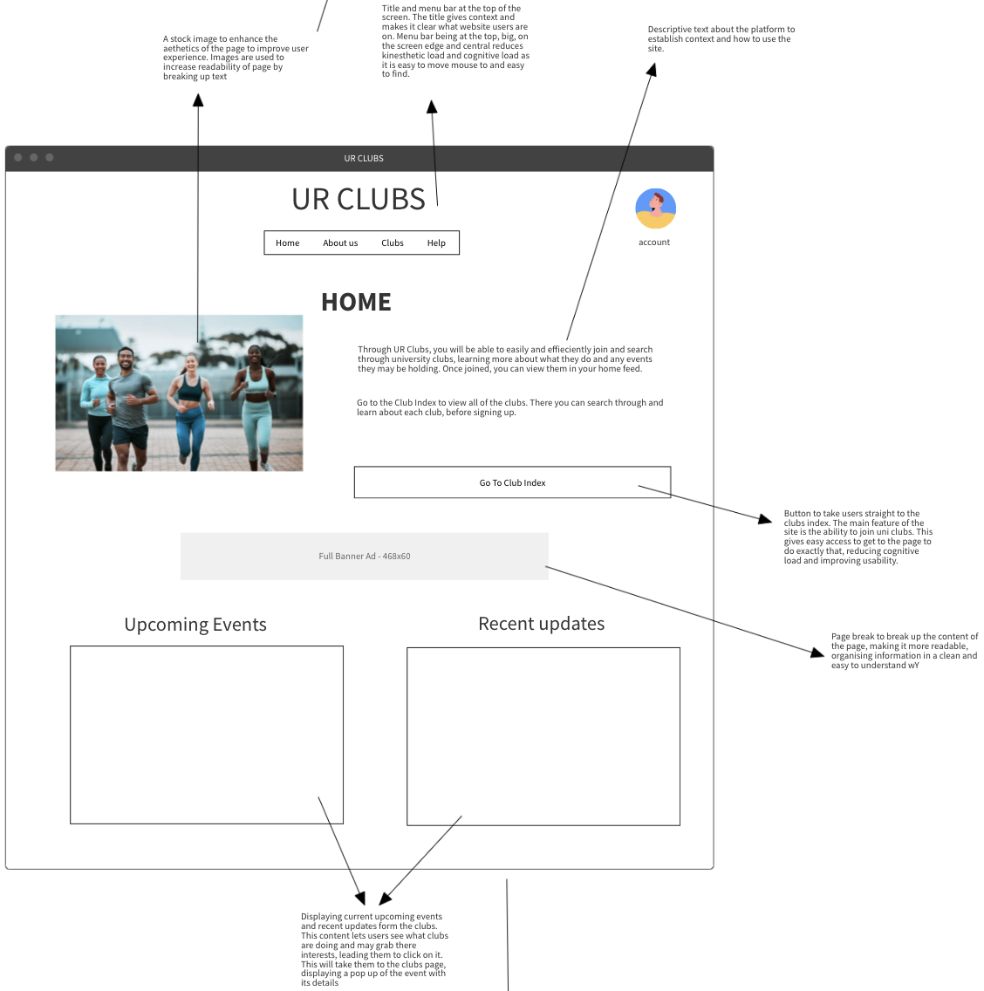

Context and features:

The first thing users will see when they enter our site is the home page.

The page is establishing content for what our platform is about through some brief descriptive text. It tells the user how to use the platform and where to go to be able to view the Uni clubs and sign up to them.

At the bottom of the page, we also display the most recent upcoming, public events and updates from the Uni clubs on the platform. This is because it may catch users’ interest and lead to them signing up to one of these clubs.

Dimensions:

The image and text divs which appear side by side at the top will take up about 50% of the main content div each. The image will be around 400 by 600px, the paragraphs will be around 40% width and the button will be around 100px by 600px. The upcoming events and recent events divs will also take up 50% width each. The space where events and updates appear will be around 600 by 400 px each.

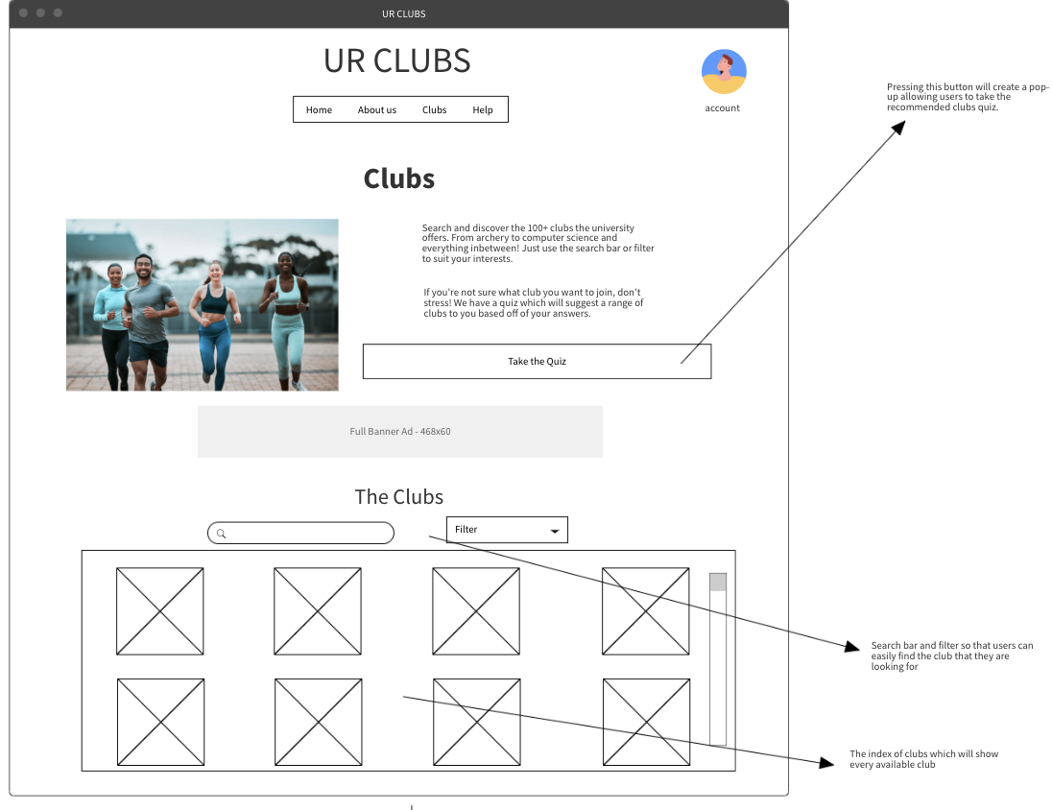

Features and context:

The club page is where the main functionality for the base users of the program resides.

It is where users will be able to search through the club index to find a club that they would like to join using the search feature. When they press on a club, they will be taken to the club’s individual webpage which contains more information about the club and will allow them to join.

It also contains functionality of a short club picker quiz. This is an additional feature we will implement which will allow for users to input certain characteristics and some clubs will be recommended to them.

Dimensions:

The dimensions of the image, text and button at the top will share the same dimensions as the home page. The gap between the clubs index and content above will be about 100px long. The clubs title will be about h2 font size and then the div containing all the clubs will take up about 80% of the main content div and each individual club will be about 200px big.

Features and context:

The individual clubs page is where users will be able to see information relevant to specific clubs. It is also where they will be able to find events which they can RSVP to. These events will then show up in their own person events tab in their account page. In the social media links, they will have the option to sign up to get sent email notifications also.

Users will be able to register for the club from this page by pressing the register for club button. This will send the users information, as an HTTP-request where they can be approved and be added to the database of users for the club.

Dimensions:

The image and updates/events will take up 50% width each, and the social media bar on the side will be outside of the main content div. The images again will have the same dimensions as previous, and the events and updates spaces will be the same size also.

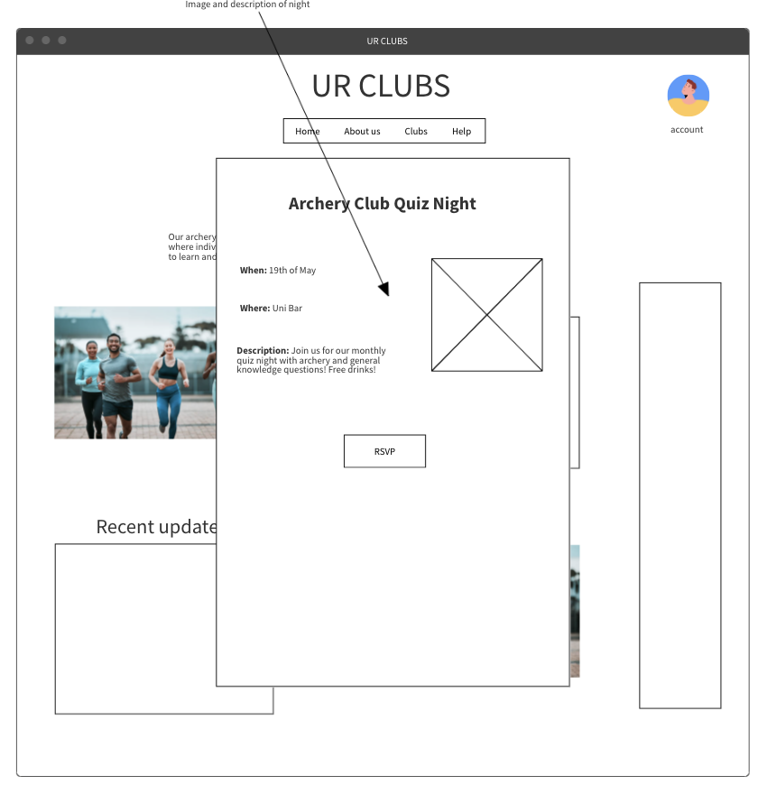

Context and features:

When a user presses on an event. A pop-up of the event is shown where the user can then view information about the event and RSVP. When the user RSVP’s, there username is sent as an HTTP-Request to the server and added to the database for the event.

Dimensions:

The popup will be about 50% of the screen. The image and text will take up 50% of the pop up each and the RSVP button will be around 20 by 20px.

Context and features:

On this page, the functionality will be for users to manage their account information, see the clubs they are enrolled it, events from their enrolled clubs and updates from enrolled clubs.

They can manage account info by pressing on edit info, there they will be able to freely change information. When they do this, and submit, an HTTP-request is sent to the server to update their information in the database.

The clubs will be displayed through the use of a function which gets the clubs they are enrolled in and displays them. Events and updates will work similarly except it will request to get events from their clubs and events they are RSVP’d to.

Dimensions:

Each of the divs containing the tabs will take up about 50% of the main content div each, the tabs themselves taking up about 40% of each div. The individual clubs to press on will be the the same size as they were on the clubs’ page.

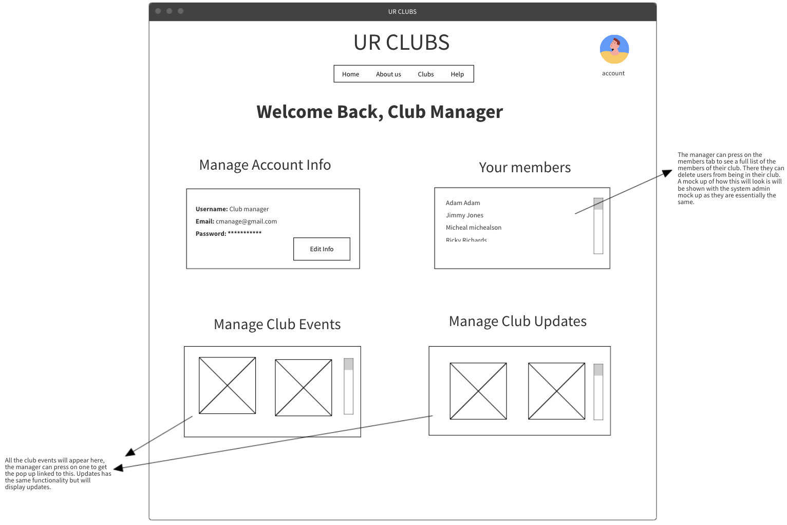

Context and features:

On this page, account managers will be able to manage their account information, see their club’s members and they can add/ manage events and updates.

This page will function extremely similarly to the users page. Manage account info will be the same, managing club events and updates will use a function which requests to get all events and updates. The your members page will use a function which requests to get the first and last name of all users who are in the database of their clubs and only users who have the relevant authentication token will be able to do this.

Dimensions:

Dimensions are the exact same as users page.

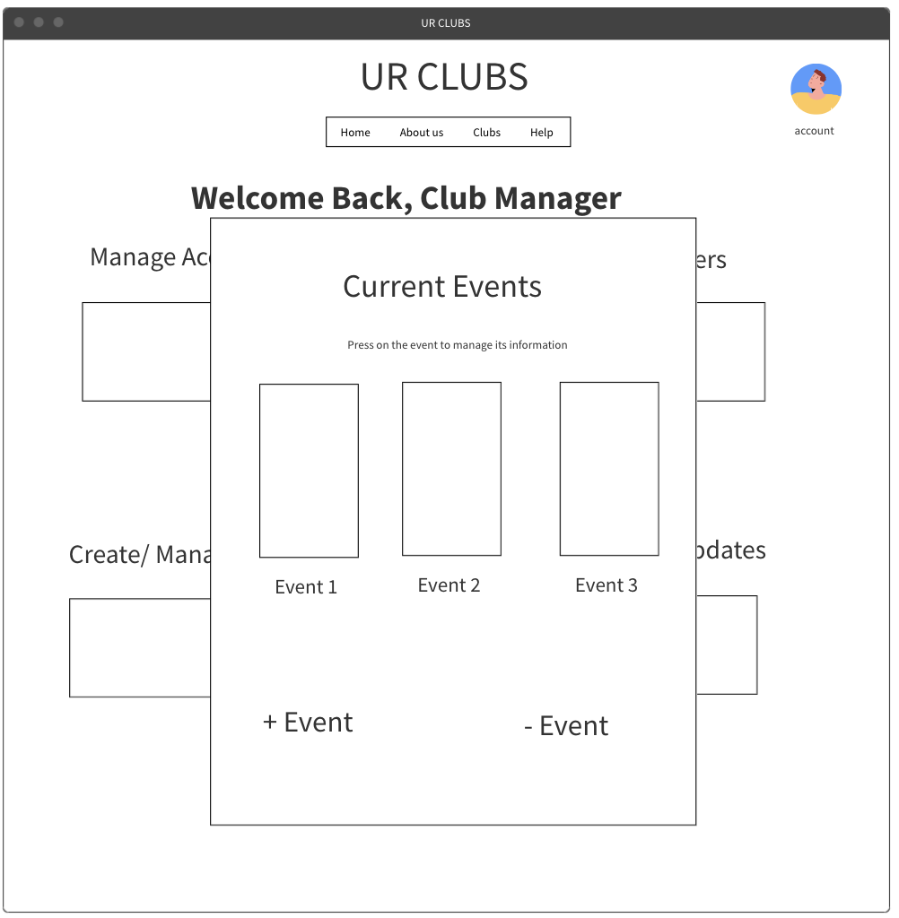

Features and context:

When the club manager presses on the manage club events page, they get this popup which allows them to press on an event to edit its information as well as add and subtract events. When choosing to add an event, they will be able to set it to be public or private. Private events are only available to be RSVP’d to by club members and public by anyone. This will be done by sending a request to add the event to that club’s event database with the relevant information. Anyone can see all events, both public and private from the individuals club page. The same process is done for updates. When they press on an event, they can see who RSVP’d has.

Dimensions:

The popup will take up 50% width of the screen. The events will be about 25% each with padding in-between to keep them reasonably spaced. The plus and minus events buttons at the bottom will be around 25% width each.

On this page, system admins will be able to manage their account information, manage users, sign up other admins and manage clubs.

Managing account info and managing system users will function the same as it does for club managers. Only difference being that manage system users sends a request to get all users of the system.

Dimensions:

Again, same as for the previous user pages.

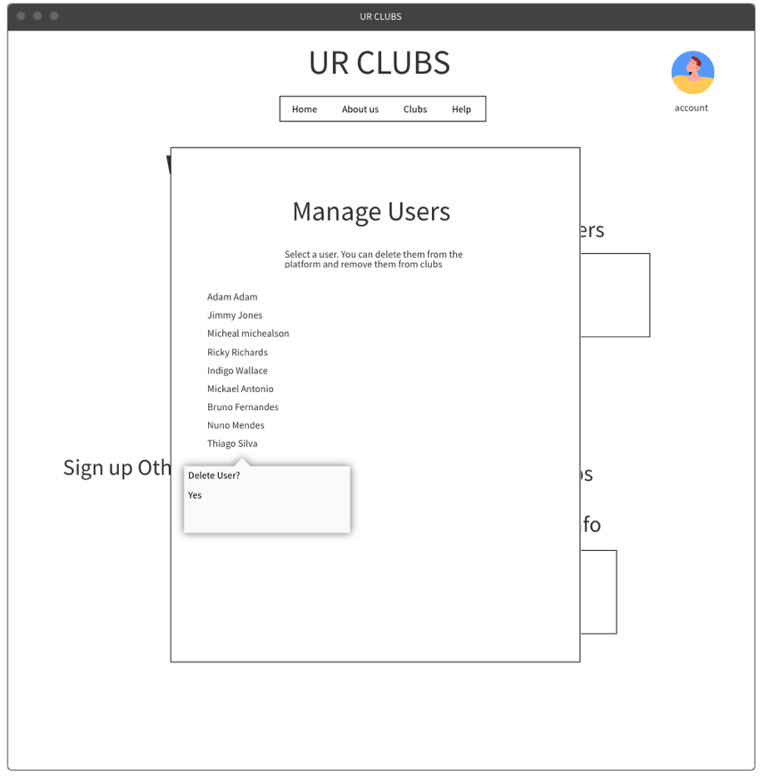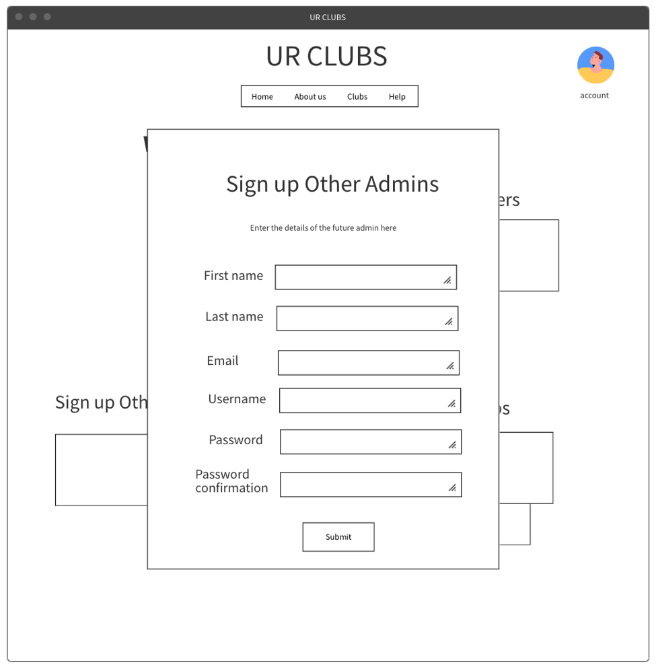

Context and Features:

The manager users page where you can delete users from platform/ clubs. When the admin presses on, and deletes a user, a request is sent to the server to delete that user from the users database.

A similar popup will appear for manage clubs, where they will get a list of clubs and be able to select a club and remove that club or a user from that club.

Dimensions:

Popup will take 50% width. Container for all the names will be 100% width and will need to scroll down to see all names in final product.

Context and features:

The Pop up to sign up other admins. Here, the admins can enter the details of the future admin into a form. When submit is pressed, a request for the information to be stored in the system admins database is sent to the server.

Dimensions:

Pup up takes 50% width of page. Each input will be around 30% of popup leaving room for the label which will be around 10% width. Button will be around 30 by 20px

Context and features:

Here is the log in page. Gives returning users the option to sign in using their username and password. Name and password gets sent to server via HTTP-request, if credentials are valid an authentication token is sent back which is stored in users local storage so that they can use site. If not, an error will occur and user is prompted to try again.

Creating an account will send the form to the server in an http-request and if successful, the users information is added to the users database and they get an authentication token to use for the session.

Dimensions:

This container will be about 50% of the width of the screen. The inputs will be around 20% each. This is important to allow for the create account form, as the inputs will appear side by side.

### Review

Once we completed the mock-ups of our webpage, we went on to get a review from people outside of our group as well as going back over the mock ups ourselves to see how we can improve our design.

We walked through the mock-ups with several fellow students from other groups who provided us with some feedback on the mock-ups that we had made. We were concerned mainly with how to improve the usability of the site and how we can further minimise cognitive and kinematic load. We asked them to provide a short paragraph about what they liked/ didn’t like. This is what we received from a student called Alex from another group:

“We liked how you have a clear home page which provides a good base for understanding what the site is about and I appreciate the quick link to go straight to the club’s page. This made it easy for me to do what I wanted to do on the site. The club index page seems intuitive, as it displays all the clubs, and you can easily search through them. I would like to be able to hide the information about the club so that I can just use the club search feature to reduce the kinematic load. I would also say that club managers should have a better way of managing events, as doing it through a popup would feel clunky and the popup also has poor design due to how compressed everything is. We also didn’t like that system admins only have the ability to remove users, they should also be able to manage clubs in some way and also the option to remove a user from the system should not appear as a simple popup. It should appear lower and be more difficult to do considering it is a pretty high impact task.”

We broke down their points into some dot points to make it easy for us to implement these changes.

1. System Users should be able to do more than just remove a user from the system.
2. The option to remove a user from the system should appear quite low on the popup to stop a system admin from accidentally removing a user.
3. As a club manager, I should have a better interface for managing events, as the proposed one seems like it wouldn’t function well when implemented.
4. Have an option to hide the contextual information on the club index page to reduce kinematic load of the users instead of having to scroll down to see all the available clubs.

We also talked to the member of the group “we_will_have_a_cool_webpage’, Tanvi Srivastava, who gave the following feedback. We talked to her in person, and recorded what she said here:

“Your design seems really good! It seems easy to use and is very to the point which is great as it will reduce cognitive load for the users. I think that the club events, updates and yur events tabs shouldn’t be so small, as you probably wouldn’t be able to see many events and it would be quite congested.”

We took away the following point from this discussion:

1. The club events, updates, and your events tabs across all the different types of user pages should be resized as it would currently be too squished.

We then went back and re-reviewed the design ourselves. We came to the following conclusions about how we can improve our web app further:

1. Signing up a system admin by having another one input their details isn’t a very intuitive method and makes it unnecessarily in-accessible to sign up system admins. We should have it so that anyone can attempt to sign in but another system admin has to accept it.
2. There is no current way to make a club, this is a key feature we must implement.

We then made a few changes to the mock-ups to remedy these changes.

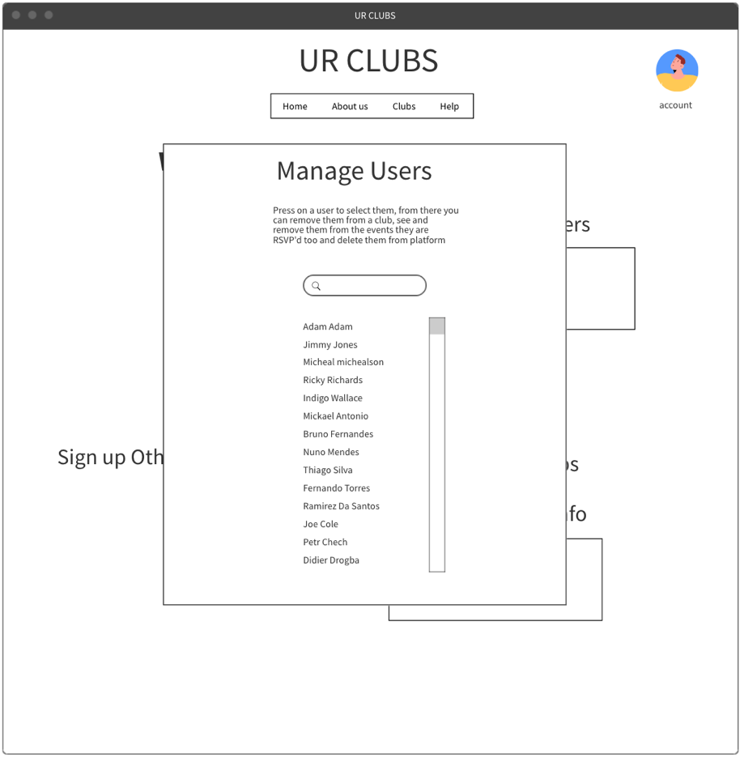

These mock-ups are to reflect the first two criticisms made from the individual who reviewed our mock-ups. We integrated a two-step system, where you first select a user from the list, or you can use the search to find them, and then select them. Once selected you can then see the user’s username as well as the clubs they are enrolled in and the events that they have RSVP’d to.

From there, you can press one of the bottom buttons which will allow you to select one or many clubs or events to remove them from. You can also press the bottom right button to remove the user, this will come up with a warning before you can do it and prompt you to re-enter your password for security reasons.

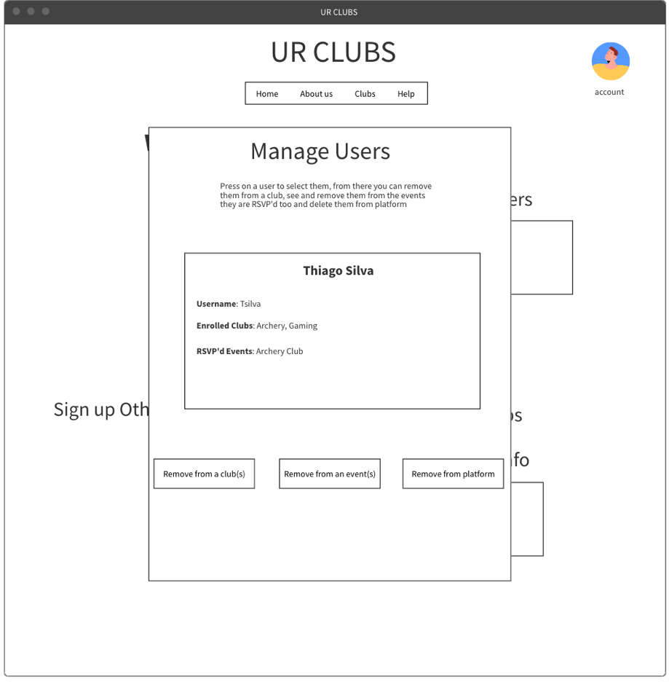

To address the third problem, we decided to make it so that the club managers cannot make changes to events and updates from their account page, but rather that they do it directly from their individual club page. This will decrease cognitive load, as having all the events in that tiny box area makes things extremely clustered, whereas doing it on the actual club’s page is far more intuitive.

When the club manager presses edit, they will be greeted with a popup for allowing them to edit, delete and add updates, events, and social media links.

The final piece of feedback we received was to create add an option to hide the contextual information at the top of the club index page, so that the page only shows the actual club’s index. This can be easily fixed by adding a button which will hide everything in the div tag containing this information, just leaving the index.

When we reviewed what we had created ourselves, we realised that on the users account page, we needed to have more dedicated space for each of their tabs. This is the solution we came up with. Each tab has its own horizontal space where each of their respected objects reside. This set up allows for things to be clearer, reducing cognitive load as previously there wasn’t enough space, making things congested and hard to find. Each Row will take up about 80% of the main content div.

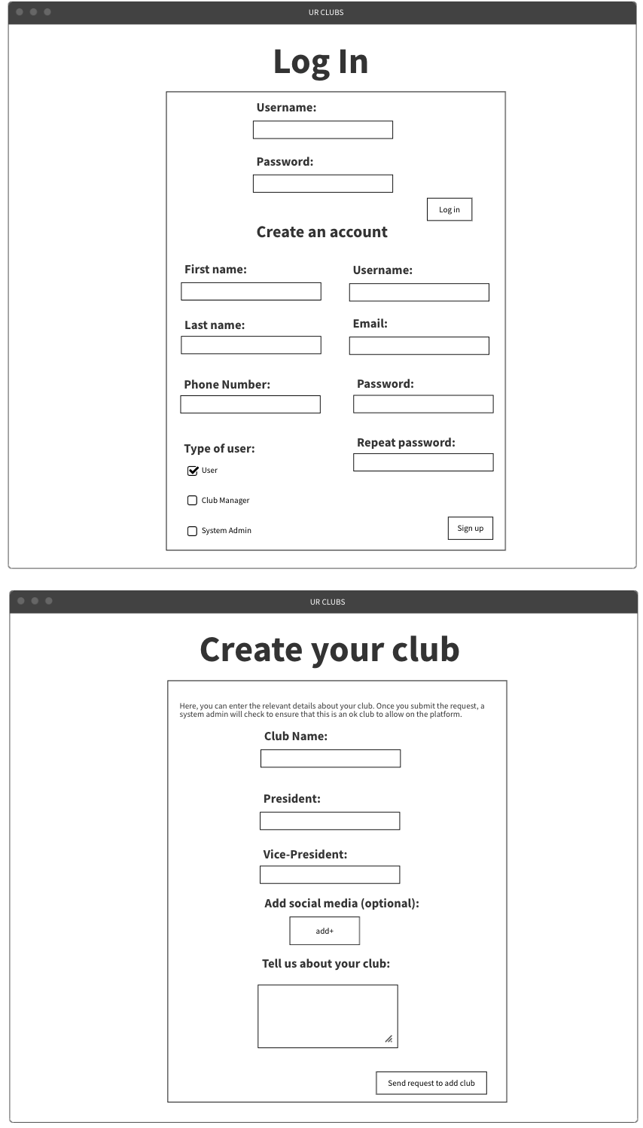

Here is the updated login and create your club pages.

The log in page now includes a check box to sign in as an admin. When this box is checked, and someone signs up using it, it adds it to a que of requests for this and only another system admin can accept it through the mange users tab.

The create your club page lets a club manager input the relevant details of their club. They can then send a request to a system admin to allow for the club be added. System admins will be able to accept it through the manage clubs tab where they will be able to select an option to see requested clubs. When a new club manager is signed up, they are taken straight to this page.

## Website Responsiveness and Structure

As we plan to use Bootstrap 5 to structure and guide our web development, many of our dimensions will be structured around their container, row, and column classes. This will allow us to more easily implement a page filled with components that are fluid with the dimensions of the website.

Creating a div with the class ‘container’ will create a responsive fixed width container with its max-width changing on different screen sizes measured by pixels. This will also allow elements within that div to respond to screen size change.

In a similar fashion, rows and columns can be implemented with nested divisions that can organize elements into the 12 columns available in a Bootstrap 5 row. For example, adding the class ‘row’ to an overhead div that contains two divisions with the class ‘col-sm-12 col-md-6 col-lg-6’ will organise the divisions so they fill those number of columns dependent on whether the screen size is currently sm, md, or lg.

Elements within those rows also scale, by implementing:

<meta name=”viewport” content=”width=device-width, initial-scale=1.0”>

All of these put together help create a responsive webpage that responds to screen size changes by organizing divs and scaling elements within. In most cases, this should ensure the website looks presentable and organized in many devices, however there are some parts of the website that need some dynamic changes so text don’t become cluttered.

**Navigation Drop Down – Mobile use** example

One specific section is the navigation bar. When exploring using a website on a larger device, having a full navigation bar will be of no issue. But, on smaller hand-held devices, all the links on the navigation bar may become too cluttered and unusable.

By using some Bootstrap 5 classes, we plan to implement a dynamically changing navigation bar, so that when the screen is under a certain number of pixels, the navigation bar option is hidden and replaced by a menu button that reveals a drop down navigation area.

Comparison:

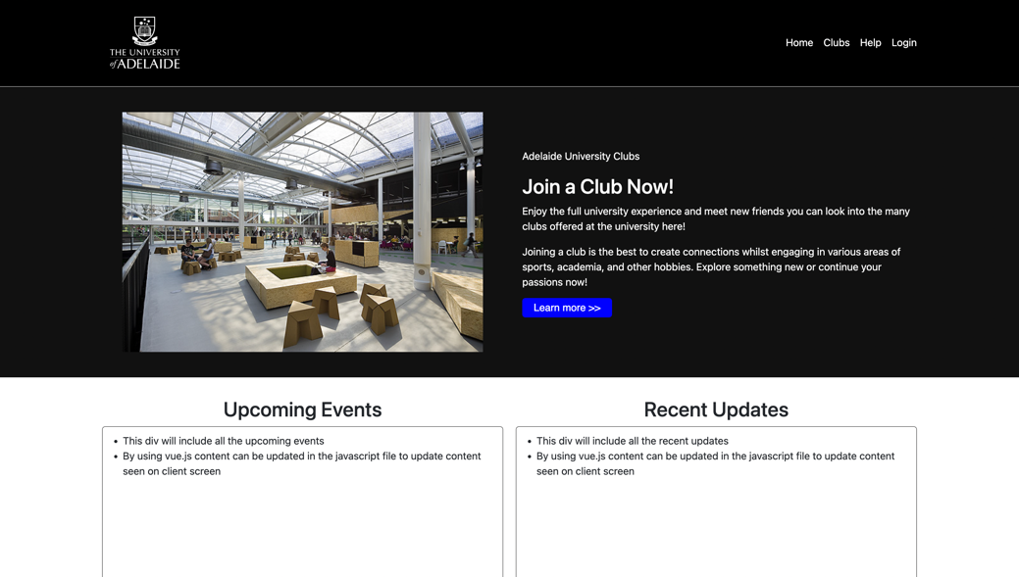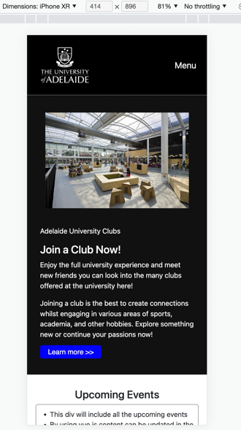

### Closing

In the end, these are the designs we will replicate when building our website using HTML, CSS and JavaScript to maximise usability and accessibility by minimising kinematic and cognitive load. It is likely that our designs will continue to develop as we learn more about web design, and as creating a web-app is an agile iterative process.