**Core-shell structure of Pt-doped Co cluster coated by single carbon layer for HER**

*Results and Discussions*

For the cobalt metal, it exists two different geometries, in P6_3/mmc and Fm3m space group [1], Fig. 1. According to our simulation results, the later one possesses the more stable configuration by 0.16 eV per atom. This conclusion is also in line with previous observation.[2]

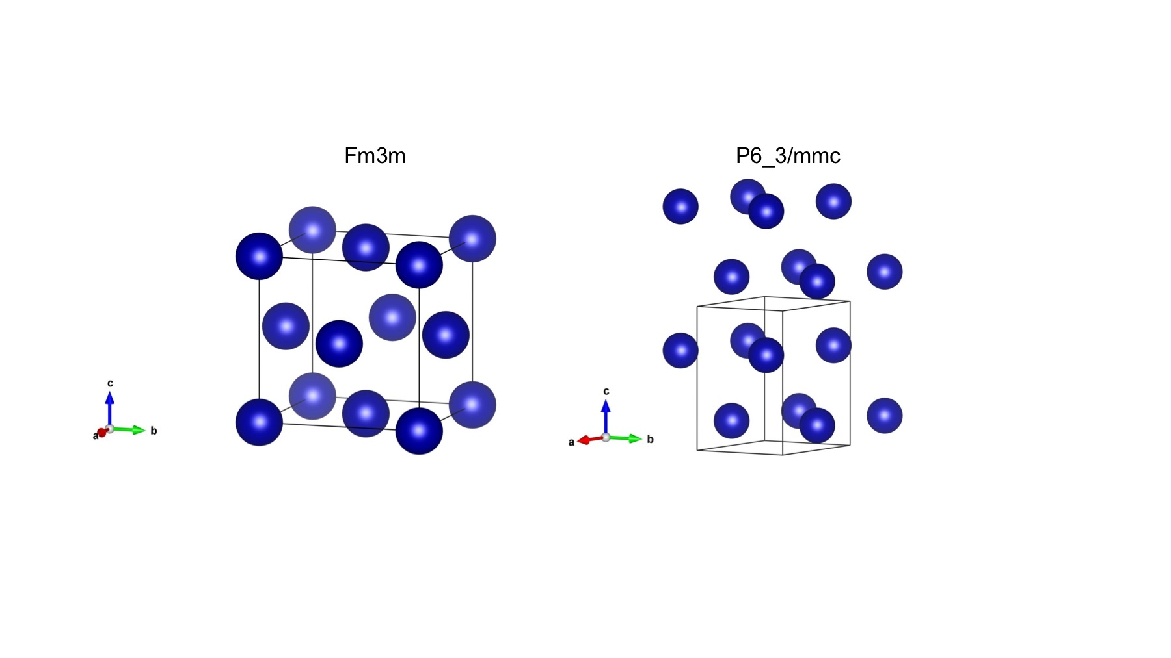

Figure 1 Two existing structures for cobalt metal, Fm3m and P6_3mmc, respectively.

The cobalt cluster Co55, consisted of 55 atoms was adopted from the previous study and placed in a 25*25*25 box, as shown in Fig. 2.[3] The corner, edge and body sites were select for Pt replacement. Those possessed the lowest energy will be adopted for further study.

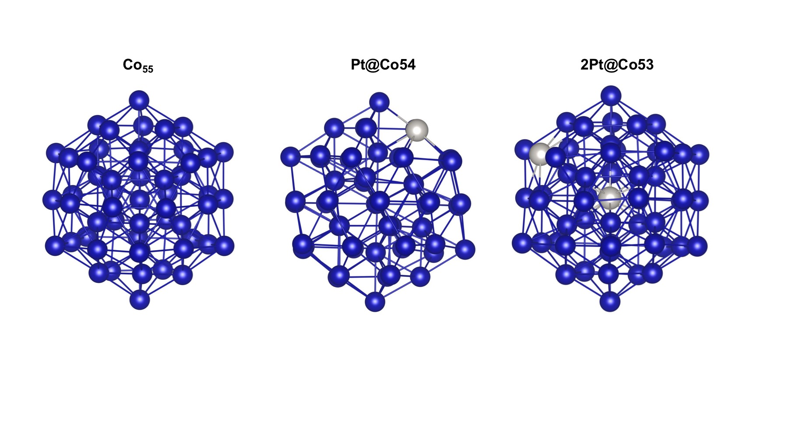

Figure 2 The C55, Pt@Co54, and 2Pt@Co53 clusters, respectively.

For single and double Pt atoms doping, the most stable configurations were shown in Fig. 2, denoted as Pt@Co54 and 2Pt@Co53, respectively. For single Pt doping, Pt@C54, the edge site is the most favourite site, by lower the second lowest, the corner site, by 0.15 eV. The least favourite site is the body site. As the doping ratio increases, the most stable 2Pt@Co configuration is the one where two Pt atoms doping at both edge and body site. Hence, for more than one Pt atoms doped Pt@Co alloy cluster, only one Pt atom tends to dope on the outer surface of the cluster. Others choose the body sites to dope. Obviously, only the outer doped Pt could provide active site for HER. It could be concluded that the HER performance would not be linear enhanced as the Pt doping ratio increases. This is also in line with the experimental observations in our study.

The core-shell structure, Pt@Co@C, was built using C240 as the shell and the alloy cluster as the core in the mass-centred position. The charge differences of the relaxed core-shell structures were shown in Fig. 4. The possible reaction sites (*) were denoted in Fig. 3.

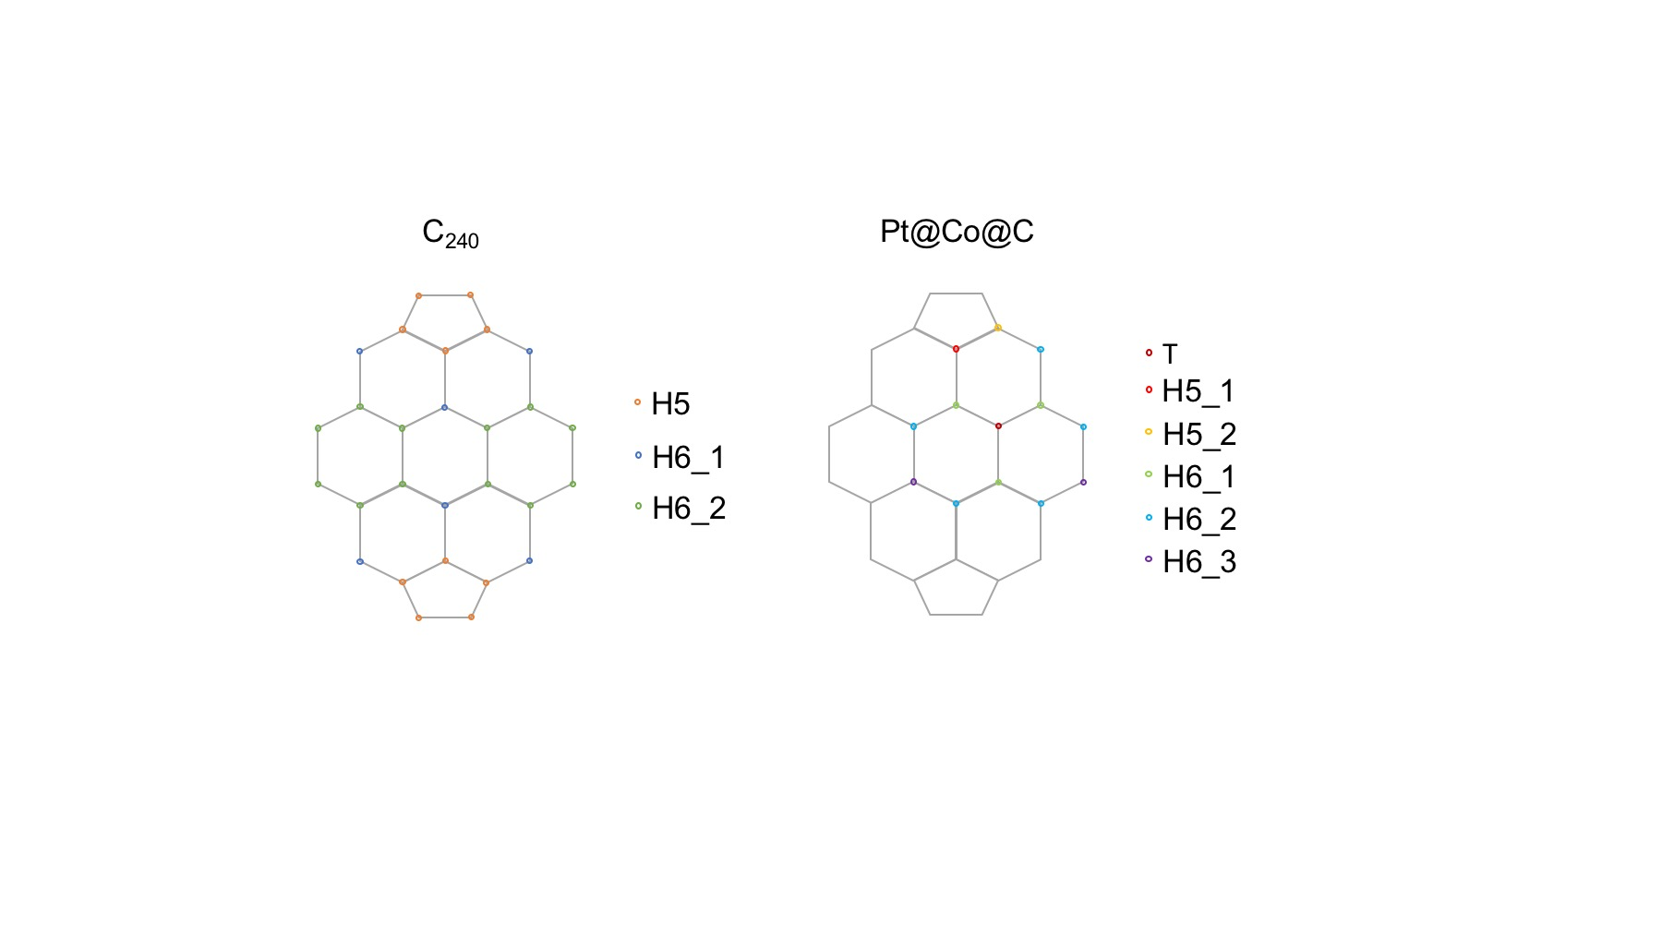

Figure 3 The possible reaction sites for C240 and Pt@Co@C, respectively. The equivalent sites are denoted in the same colour.

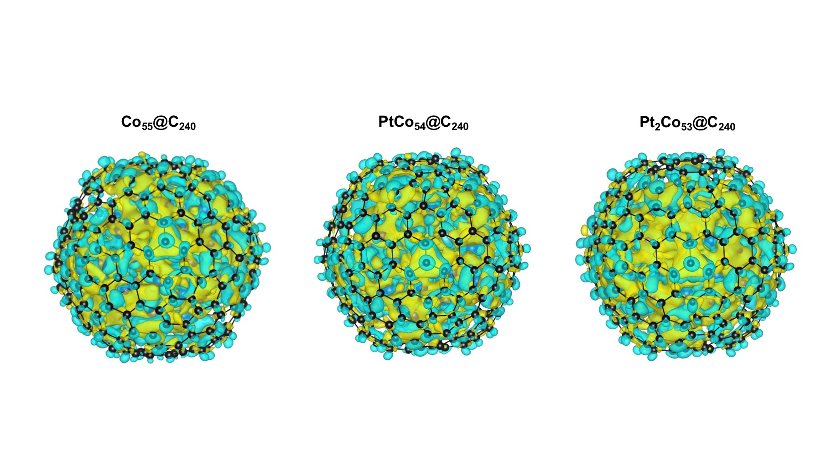

Figure 4 The charge difference of core-shell structures for Co55@C240, PtCo54@C240 and Pt2Co53@C240, respectively. The isosurface is set to 0.001 e/Bohr3.

FOR THE JOURNAL PAPER

Density Functional Theory (DFT) calculations were adopted to screen out good catalysts of Pt doped Co clusters and further modification of carbon coating. Predominately, |∆G(H*)| is a good descriptor for the HER and it should be closed to zero to compromise for H* adsorption and desorption within the reactions. [4] Our models have included the metal clusters, *i.e.* Co cluster, and Pt doped Co clusters in different ratio. And the C240 fullerene ball to mimic the outer carbon coating for the metal clusters, as previous studies.[5],[6] Unlike the metal clusters used in previous studies, which are simple cubic C55 clusters, the Co55 clusters in our study was adopted the global minima with the Gupta potential, as shown in Fig. XX.3 The energy difference of those two clusters was 1.05 eV/atom, which is too enormous to be ignored. Further Pt doping positions were also considered. According to our results, single Pt atom tends to dope on the edge position, whereas adding another Pt atom in Co clusters, the dual Pt atom prefer doping on edge and body position. Obviously, only the outer doped Pt could provide active site for HER. It could be concluded that the HER performance would not be linear enhanced as the Pt doping ratio increases. This is also in line with the experimental observations in our study. Furthermore, to avoid the DFT description failure on the open shell d-electrons of the transition metal, DFT+U, originally proposed by Anisimov *et al.*,[7] is adopted to treat the strongly correlated electron intra-atomic Coulomb (U) and exchange (J) interactions properly within a HF-like theory, while the rest of the system with pure DFT.

*Calculation details*

All the calculations were carried out based on Density Functional Theory, implanted in Vienna *ab-initio* Package (VASP).[8],[9] The Perdew-Burke-Ernzerhof (PBE) functional [10],[11] for the exchange-correlation term was used with the projector augmented wave method. [12],[13] A plane wave cutoff of 500 eV with forces converged to 0.01 eV/Å. On-site Hubbard *U* corrections, 3.3, were employed for the Co metal d electrons.[14],[15] Spin polarisation was counted in all the calculations. Gamma only was selected for the K-point sampling, due to the size of our models.

The free energies of the intermediates were obtained by

$$∆G\left(H^{*}\right)=∆E\left(H^{*}\right)+∆ZPE-T∆S$$

where *∆E(H*)* is the adsorption energy calculated by

$$∆E\left(H^{*}\right)=E_{H@core-shell}-E_{core-shell}-\frac{1}{2}E_{H_{2}}$$

*∆ZPE* is the zero-point energy change, and *∆S* is the entropy change of adsorption H. All the analysis within DFT scope were using normal-mode analysis, proposed by Nørskov.[16]

where, *ZPE(H2)* is 0.27 eV.12 Since the vibration frequency of H is less than 1 meV, *∆S=S(H*)-0.5*S(H2) ≈ -0.5S(H2)*. For H2 at 300K and 1 atm, *TS(H2)* = 0.41 eV. Then the *T∆S≈* -0.2 eV.

1. A. Taylor and R. W. Floyd, *Acta Cryst.*, **3**, 285, 1950;
2. C. S. Yoo, H. Cynn, P. Söderlind and V. Iota, *Phys. Rev. Lett.*, **84**, 4132, 2000;
3. L. Zhan, J. Z. Y. Chen, W.-K. Liu, and S. K. Lai, *J. Chem. Phys.*, **122**, 244707, 2005;
4. J. Greeley, T. F. Jaramillo, J. Bonde, I. Chorkendorff, and J. K. Nørskov, *Nat. Mater.*, **5**, 909, 2006;
5. H. Zhang, Z. Ma, J. Duan, H. Liu, G. Liu, T. Wang, K. Chang, M. Li, L. Shi, X. Meng, K. Wu, and J. Ye, *ACS Nano*, **10**, 684, 2016;
6. J. Su, Y. Yang, G. Xia, J. Chen, P. Jiang and Q. Chen, *Nat. Commun.*, **8**, 14969, 2017;
7. V. I. Anisimov, J. Zaanen, and O. K. Andersen, *Phys. Rev. B*, **44**, 943, 1991;
8. G. Kresse and J. Furthmüller, *Comput. Mat. Sci.*, **6**, 15, 1996;
9. G. Kresse and J. Furthmüller, *Phys. Rev. B*, **54**, 11169, 1996;
10. J. P. Perdew, K. Burke, and M. Ernzerhof, *Phys. Rev. Lett.*, **77**, 3865, 1996;
11. J. P. Perdew, K. Burke, and M. Ernzerhof, *Phys. Rev. Lett.*, **78**, 1396, 1997;
12. P. E. Blochl, *Phys. Rev. B*, **50**, 17953, 1994;
13. G. Kresse, and D. Joubert, *Phys. Rev. B*, **59**, 1758, 1999;
14. S. L. Dudarev, S. Y. Savrasov, C. J. Humphreys, and A. P. Suttom, *Phys. Rev. B*, **57**, 1505, 1998;
15. L. Wang, T. Maxisch, and G. Ceder, *Phys. Rev. B*, **73**, 195107, 2006;
16. J. K. Nørskov, T. Bligaard, A. Logadottir, J. R. Kitchin, J. G. Chen, S. Pandelov, and U. Stimming, *J. Electrochem. Soc.*, **152**, J23, 2005;