* 建立新弹窗：

<https://www.bilibili.com/video/BV1Qf4y1F7Zv/?p=3&vd_source=5523ba64b70cfde7abf1c94281d7f89f>

11:27

* 弹窗警告：

<https://www.bilibili.com/video/BV1Qf4y1F7Zv?p=3&vd_source=5523ba64b70cfde7abf1c94281d7f89f>

19:30

* 场景切换：

<https://www.bilibili.com/video/BV1Qf4y1F7Zv/?p=4&spm_id_from=pageDriver&vd_source=5523ba64b70cfde7abf1c94281d7f89f>

3:00

* 更换鼠标指针图标：

<https://www.bilibili.com/video/BV1Qf4y1F7Zv/?p=4&spm_id_from=pageDriver&vd_source=5523ba64b70cfde7abf1c94281d7f89f>

4:00

* 属性绑定和属性监听：

<https://www.bilibili.com/video/BV1Qf4y1F7Zv?p=6&vd_source=5523ba64b70cfde7abf1c94281d7f89f>

* 事件：

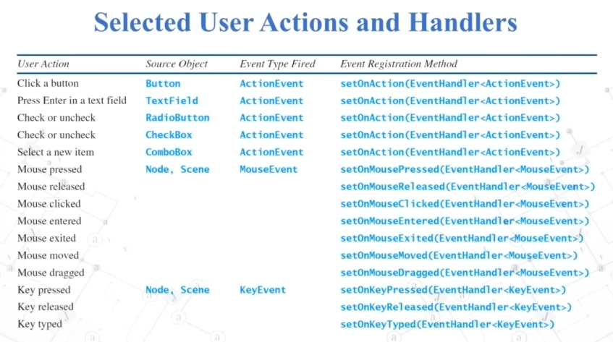

* 鼠标拖拽事件（例子：拖拽文件进入文本框并显示绝对路径）：

<https://www.bilibili.com/video/BV1Qf4y1F7Zv?p=7&spm_id_from=pageDriver&vd_source=5523ba64b70cfde7abf1c94281d7f89f>

16:23