**Pre-Lab for Lab 2**

Xiaoyu Zhou, 1004081147

**Part I**

**Part II**

1. If the truth table in Table 2 was given in full, how many rows would it have?

There would be 26 rows in the truth table, which is 64 rows.

1. Draw a schematic.

1. Create a new Quartus Prime project for your circuit and write the Verilog code.

module mux(LEDR, SW);

input [9:0] SW;

output [9:0] LEDR;

mux1 u1(

.u(SW[0]),

.w(SW[2]),

.s1(SW[9]),

.out1(Connection1)

);

mux2 u2(

.v(SW[1]),

.x(SW[3]),

.s1(SW[9]),

.out2(Connection2)

);

mux3 u3(

.in1(Connection1),

.in2(Connection2),

.s0(SW[8]),

.m(LEDR[0])

);

endmodule

module mux1(u, w, s1, out1);

input u; //selected when s is 0

input w; //selected when s is 1

input s1; //select signal

output out1; //output

assign out1 = s1 & w | ~s1 & u;

endmodule

module mux2(v, x, s1, out2);

input v; //selected when s is 0

input x; //selected when s is 1

input s1; //select signal

output out2; //output

assign out2 = s1 & x | ~s1 & v;

endmodule

module mux3(in1, in2, s0, m);

input in1; //selected when s is 0

input in2; //selected when s is 1

input s0; //select signal

output m; //output

assign m = s0 & in1 | ~s0 & in2;

endmodule

1. Simulate your circuit with ModelSim for different values of s, u, v, w and x.

**Part III**

1. Write the expressions for seven Boolean functions, one for each segment of the 7-segment decoder.

|  |  |  |  |  |  |  |  |  |  |  |  |
| --- | --- | --- | --- | --- | --- | --- | --- | --- | --- | --- | --- |
|  | HEX0 | HEX1 | HEX2 | HEX3 | HEX4 | HEX5 | HEX6 | c3 | c2 | c1 | c0 |
| 0 | 0 | 0 | 0 | 0 | 0 | 0 | 1 | 0 | 0 | 0 | 0 |
| 1 | 1 | 0 | 0 | 1 | 1 | 1 | 1 | 0 | 0 | 0 | 1 |
| 2 | 0 | 0 | 1 | 0 | 0 | 1 | 0 | 0 | 0 | 1 | 0 |
| 3 | 0 | 0 | 0 | 0 | 1 | 1 | 0 | 0 | 0 | 1 | 1 |
| 4 | 1 | 0 | 0 | 1 | 1 | 0 | 0 | 0 | 1 | 0 | 0 |
| 5 | 0 | 1 | 0 | 0 | 1 | 0 | 0 | 0 | 1 | 0 | 1 |
| 6 | 0 | 1 | 0 | 0 | 0 | 0 | 0 | 0 | 1 | 1 | 0 |
| 7 | 0 | 0 | 0 | 1 | 1 | 1 | 1 | 0 | 1 | 1 | 1 |
| 8 | 0 | 0 | 0 | 0 | 0 | 0 | 0 | 1 | 0 | 0 | 0 |
| 9 | 0 | 0 | 0 | 1 | 1 | 0 | 0 | 1 | 0 | 0 | 1 |
| A10 | 0 | 0 | 0 | 1 | 0 | 0 | 0 | 1 | 0 | 1 | 0 |
| B11 | 1 | 1 | 0 | 0 | 0 | 0 | 0 | 1 | 0 | 1 | 1 |
| C12 | 0 | 1 | 1 | 0 | 0 | 0 | 1 | 1 | 1 | 0 | 0 |
| D13 | 1 | 0 | 0 | 0 | 0 | 1 | 0 | 1 | 1 | 0 | 1 |
| E14 | 0 | 1 | 1 | 0 | 0 | 0 | 0 | 1 | 1 | 1 | 0 |
| F15 | 0 | 1 | 1 | 1 | 0 | 0 | 0 | 1 | 1 | 1 | 1 |

|  |  |  |  |  |
| --- | --- | --- | --- | --- |
| HEX0 | 00 | 01 | 11 | 10 |
| 00 | 0 | 1 | 0 | 0 |
| 01 | 1 | 0 | 0 | 0 |
| 11 | 0 | 1 | 0 | 0 |
| 10 | 0 | 0 | 1 | 0 |

|  |  |  |  |  |
| --- | --- | --- | --- | --- |
| HEX1 | 00 | 01 | 11 | 10 |
| 00 | 0 | 0 | 0 | 0 |
| 01 | 0 | 1 | 0 | 1 |
| 11 | 1 | 0 | 1 | 1 |
| 10 | 0 | 0 | 1 | 0 |

|  |  |  |  |  |
| --- | --- | --- | --- | --- |
| HEX2 | 00 | 01 | 11 | 10 |
| 00 | 0 | 0 | 0 | 1 |
| 01 | 0 | 0 | 0 | 0 |
| 11 | 1 | 0 | 1 | 1 |
| 10 | 0 | 0 | 0 | 0 |

|  |  |  |  |  |
| --- | --- | --- | --- | --- |
| HEX3 | 00 | 01 | 11 | 10 |
| 00 | 0 | 1 | 0 | 0 |
| 01 | 1 | 0 | 1 | 0 |
| 11 | 0 | 0 | 1 | 0 |
| 10 | 0 | 1 | 0 | 1 |

|  |  |  |  |  |
| --- | --- | --- | --- | --- |
| HEX4 | 00 | 01 | 11 | 10 |
| 00 | 0 | 1 | 1 | 0 |
| 01 | 1 | 1 | 1 | 0 |
| 11 | 0 | 0 | 0 | 0 |
| 10 | 0 | 1 | 0 | 0 |

|  |  |  |  |  |
| --- | --- | --- | --- | --- |
| HEX5 | 00 | 01 | 11 | 10 |
| 00 | 0 | 1 | 1 | 1 |
| 01 | 0 | 0 | 1 | 0 |
| 11 | 0 | 1 | 0 | 0 |
| 10 | 0 | 0 | 0 |  |

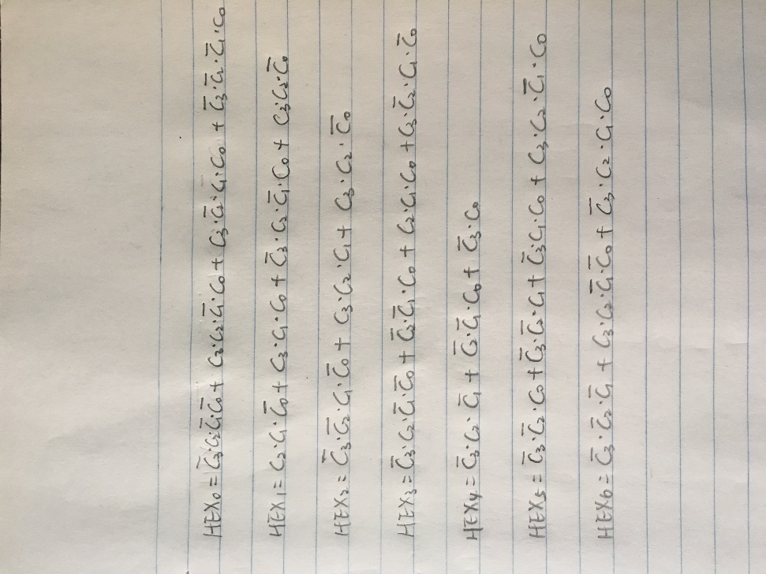

|  |  |  |  |  |
| --- | --- | --- | --- | --- |
| HEX`6 | 00 | 01 | 11 | 10 |
| 00 | 1 | 1 | 0 | 0 |
| 01 | 0 | 0 | 1 | 0 |
| 11 | 1 | 0 | 0 | 0 |
| 10 | 0 | 0 | 0 | 0 |

So, we can have:

1. Write a Verilog module.

module mux(HEX0, SW);

input [9:0] SW;

output [6:0] HEX0;

hex0 u1(

.c3(SW[0]),

.c2(SW[1]),

.c1(SW[2]),

.c0(SW[3]),

.out1(HEX0[0])

);

hex1 u2(

.c3(SW[0]),

.c2(SW[1]),

.c1(SW[2]),

.c0(SW[3]),

.out2(HEX0[1])

);

hex2 u3(

.c3(SW[0]),

.c2(SW[1]),

.c1(SW[2]),

.c0(SW[3]),

.out3(HEX0[2])

);

hex3 u4(

.c3(SW[0]),

.c2(SW[1]),

.c1(SW[2]),

.c0(SW[3]),

.out4(HEX0[3])

);

hex4 u5(

.c3(SW[0]),

.c2(SW[1]),

.c1(SW[2]),

.c0(SW[3]),

.out5(HEX0[4])

);

hex5 u6(

.c3(SW[0]),

.c2(SW[1]),

.c1(SW[2]),

.c0(SW[3]),

.out6(HEX0[5])

);

hex6 u7(

.c3(SW[0]),

.c2(SW[1]),

.c1(SW[2]),

.c0(SW[3]),

.out7(HEX0[6])

);

endmodule

module hex0(c3, c2, c1, c0, out1);

input c3; //selected when s is 0

input c2; //selected when s is 1

input c1; //select signal

input c0;

output out1; //output

assign out1 = ~c3 & c2 & ~c1 & ~c0 | c3 & c2 & ~c1 & c0 | c3 & ~c2 & c1 & c0 | ~c3 & ~c2 & ~c1 & c0;

endmodule

module hex1(c3, c2, c1, c0, out2);

input c3; //selected when s is 0

input c2; //selected when s is 1

input c1; //select signal

input c0;

output out2; //output

assign out2 = c2 & c1 & ~c0 | c3 & c1 & c0 | ~c3 & c2 & ~c1 & c0 | c3 & c2 & ~c0;

endmodule

module hex2(c3, c2, c1, c0, out3);

input c3; //selected when s is 0

input c2; //selected when s is 1

input c1; //select signal

input c0;

output out3; //output

assign out3 = ~c3 & ~c2 & c1 & ~c0 | c3 & c2 & c1 | c3 & c2 & ~c0;

endmodule

module hex3(c3, c2, c1, c0, out4);

input c3; //selected when s is 0

input c2; //selected when s is 1

input c1; //select signal

input c0;

output out4; //output

assign out4 = ~c3 & c2 & ~c1 & ~c0 | ~c2 & ~c1 & c0 | c2 & c1 & c0 | c3 & ~c2 & c1 & ~c0;

endmodule

module hex4(c3, c2, c1, c0, out5);

input c3; //selected when s is 0

input c2; //selected when s is 1

input c1; //select signal

input c0;

output out5; //output

assign out5 = ~c3 & c2 & ~c1 | ~c2 & ~c1 & c0 | ~c3 & c0;

endmodule

module hex5(c3, c2, c1, c0, out6);

input c3; //selected when s is 0

input c2; //selected when s is 1

input c1; //select signal

input c0;

output out6; //output

assign out6 = ~c3 & ~c2 & c0 | ~c3 & ~c2 & c1 | ~c3 & c1 & c0 | c3 & c2 & ~c1 & c0;

endmodule

module hex6(c3, c2, c1, c0, out7);

input c3; //selected when s is 0

input c2; //selected when s is 1

input c1; //select signal

input c0;

output out7; //output

assign out7 = ~c3 & ~c2 & ~c1 | c3 & c2 & ~c1 & ~c0 | ~c3 & c2 & c1 & c0;

endmodule

1. Simulation.

