[**hdfs mount为linux本地文件系统**](http://zhengzhuangjie.iteye.com/blog/1459248)

1、软件下载

[hdfs-webdav.war](http://zhengzhuangjie.iteye.com/admin/blogs/detail?name=hdfs-webdav.war&can=2&q=)

<http://code.google.com/p/hdfs-webdav/downloads/list>

把war包放到tomcat下面，启动tomcat会自动解压该war包，在/usr/tomcat6/webapps/hdfs-webdav/linux_mount_lib/目录下有fuse-2.7.4.tar.gz和neon-0.28.3.tar.gz，所以下面的包也可以不用下载

neon

<http://www.webdav.org/neon/neon-0.29.6.tar.gz>

fuse

<http://sourceforge.net/projects/fuse/files/fuse-2.X/2.8.7/>

2、软件安装

yum install gcc

yum install libxml*

tar -zxvf neon-0.28.3.tar.gz

cd /usr/tomcat6/webapps/hdfs-webdav/linux_mount_lib/neon-0.28.3

./configure

make

make install

cd ..

tar zxvf davfs2-1.3.3.tar.gz

cd davfs2-1.3.3

./configure

make

make install

cd ..

tar zxvf fuse-2.7.4.tar.gz

cd fuse-2.7.4  
./configure  
make  
make install

vim /usr/tomcat6/webapps/hdfs-webdav/WEB-INF/classes/hadoop-site.xml

 <property>  
   <name>fs.default.name</name>  
   <value>hdfs://10.0.30.235:9000/</value>  
   <description>namenode</description>  
 </property>

scp 10.0.30.151:/download/hadoop-0.20.203.0/hadoop-core-0.20.203.0.jar /usr/tomcat6/webapps/hdfs-webdav/WEB-INF/lib/

并删除掉lib目录下旧的hadoop jar包

scp 10.0.30.151:/download/hadoop-0.20.203.0/lib/commons-configuration-1.6.jar /usr/tomcat6/webapps/hdfs-webdav/WEB-INF/lib

启动hadoop集群

启动tomcat

访问<http://192.168.1.31/hdfs-webdav>

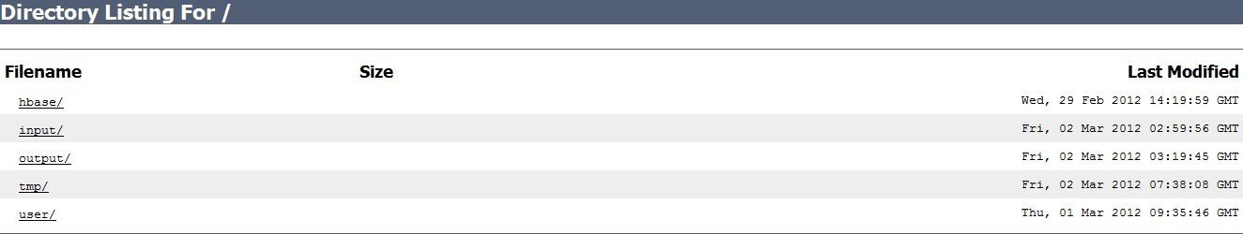

在tomcat服务器上创建一下信息

mkdir /download/hdfs  
groupadd davfs2  
useradd -g davfs2 davfs2  
mount -t davfs <http://10.0.30.151/hdfs-webdav> /download/hdfs  
cd /download/hdfs

ls

C:\Users\DongGod\AppData\Local\youdao\ynote\images\ECCE7399360743CFB708B7104EC9AFF1\b4192b8d-395f-3c81-96c2-e951bf75e584.jpeg

至此，扩展hadoop hdfs,实现WebDav协议,并将hdfs mount为linux本地文件系统成功！