1. Corn

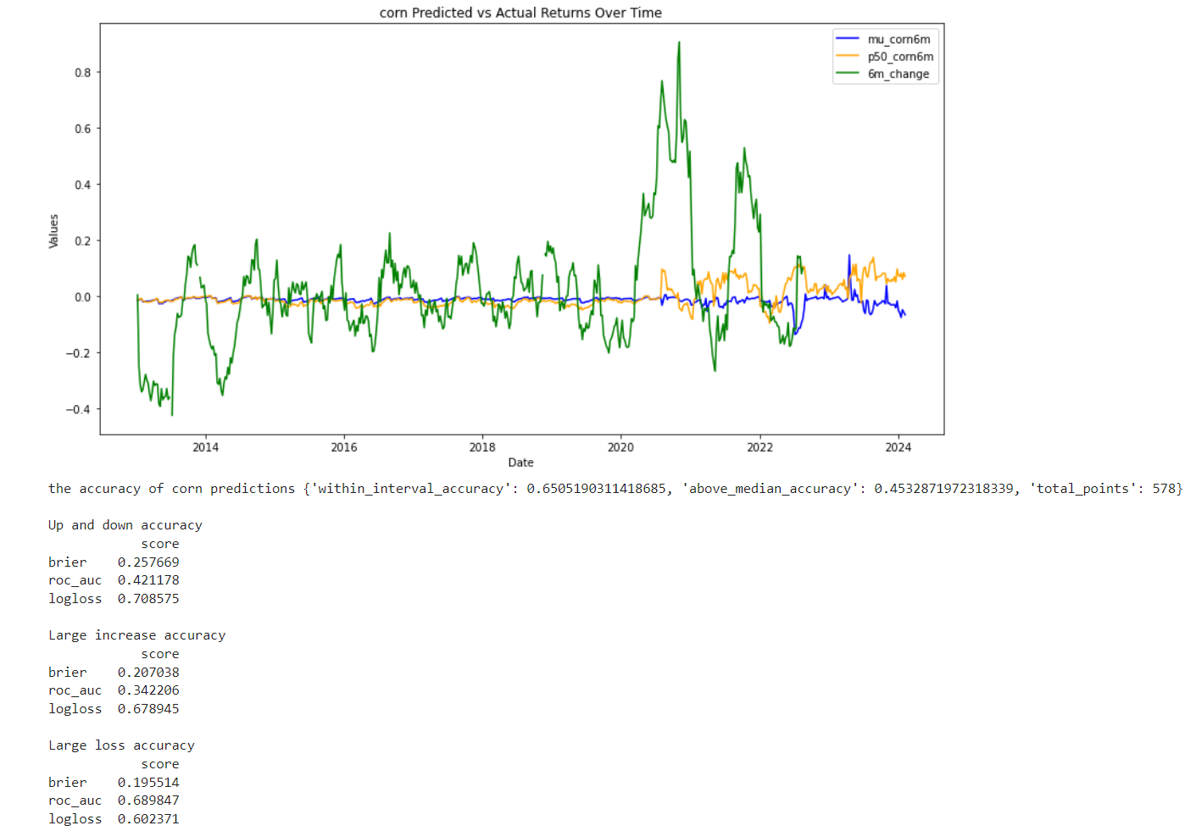

1. Bac

The general accuracy is very low. The predict is not very useful.

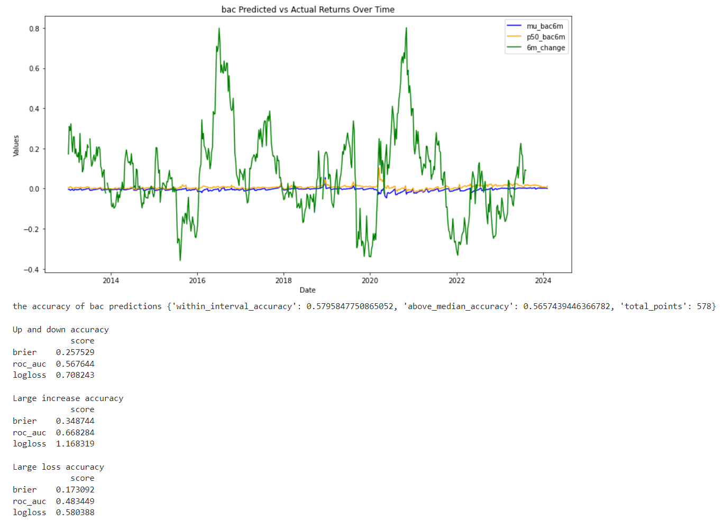

1. Citi

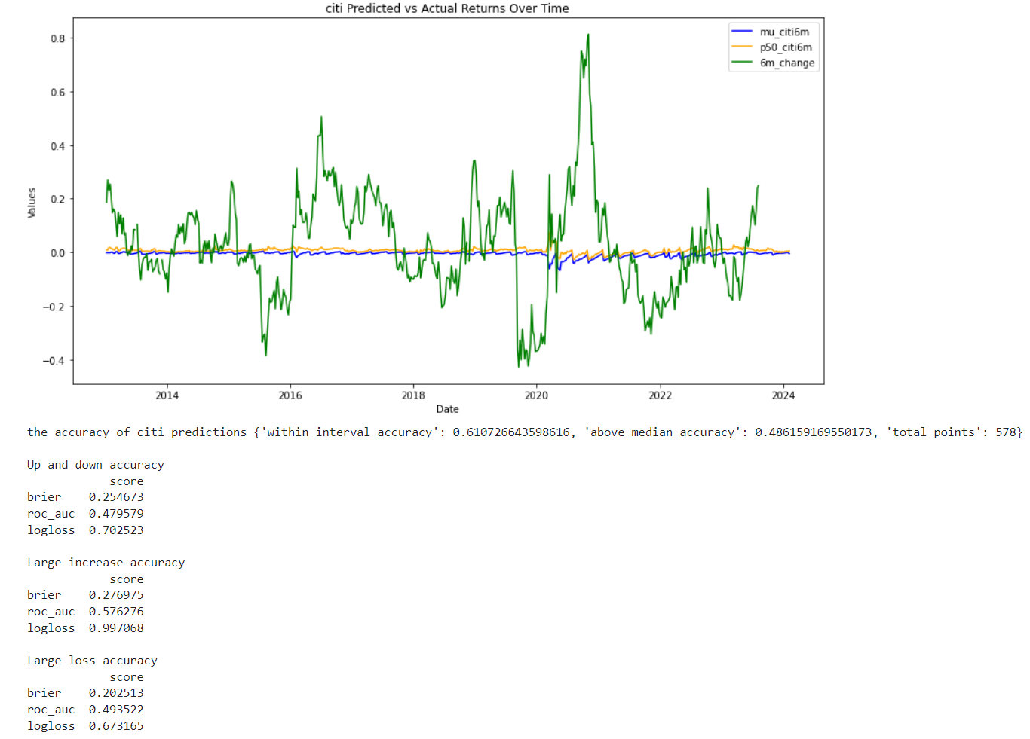

4. gold

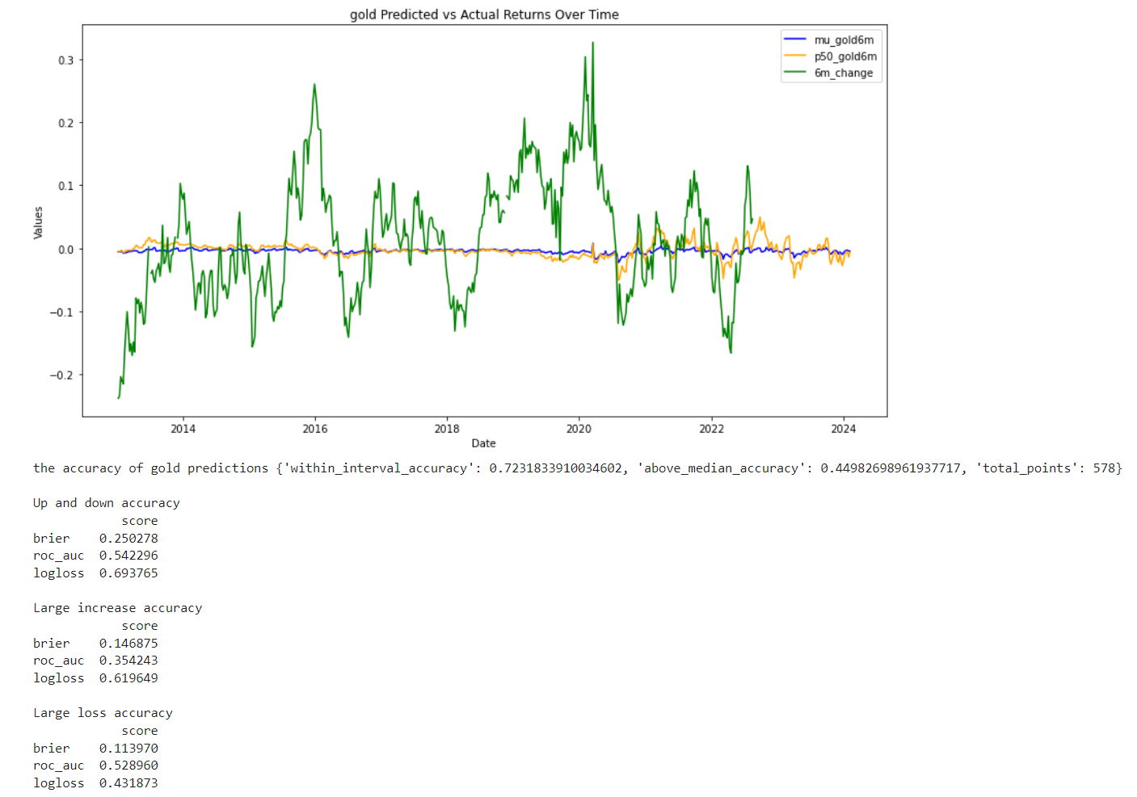

1. iyr

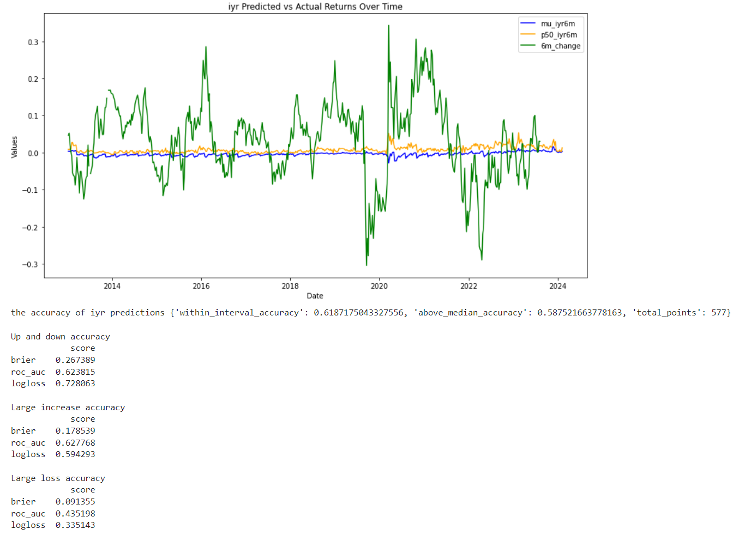

6.

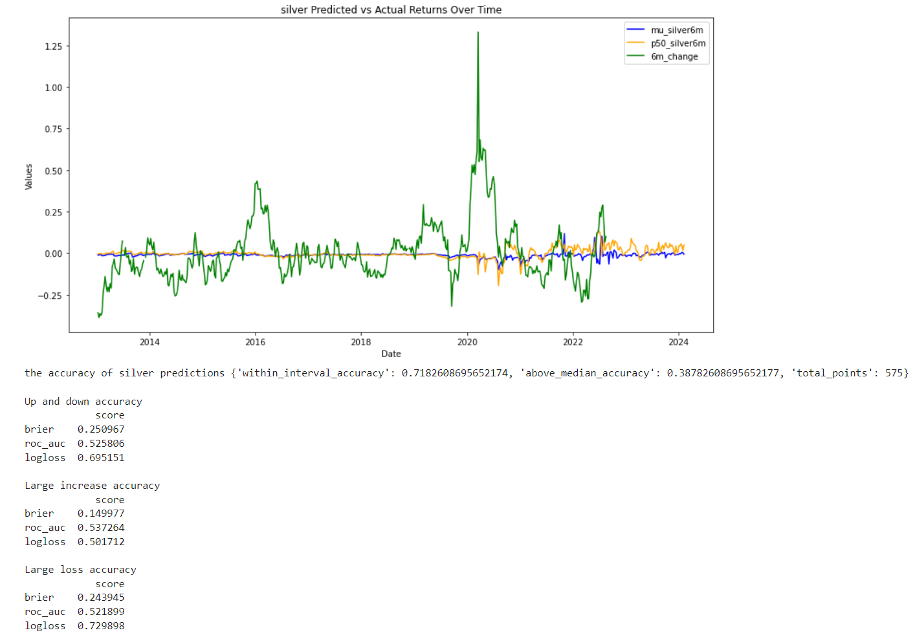

7.

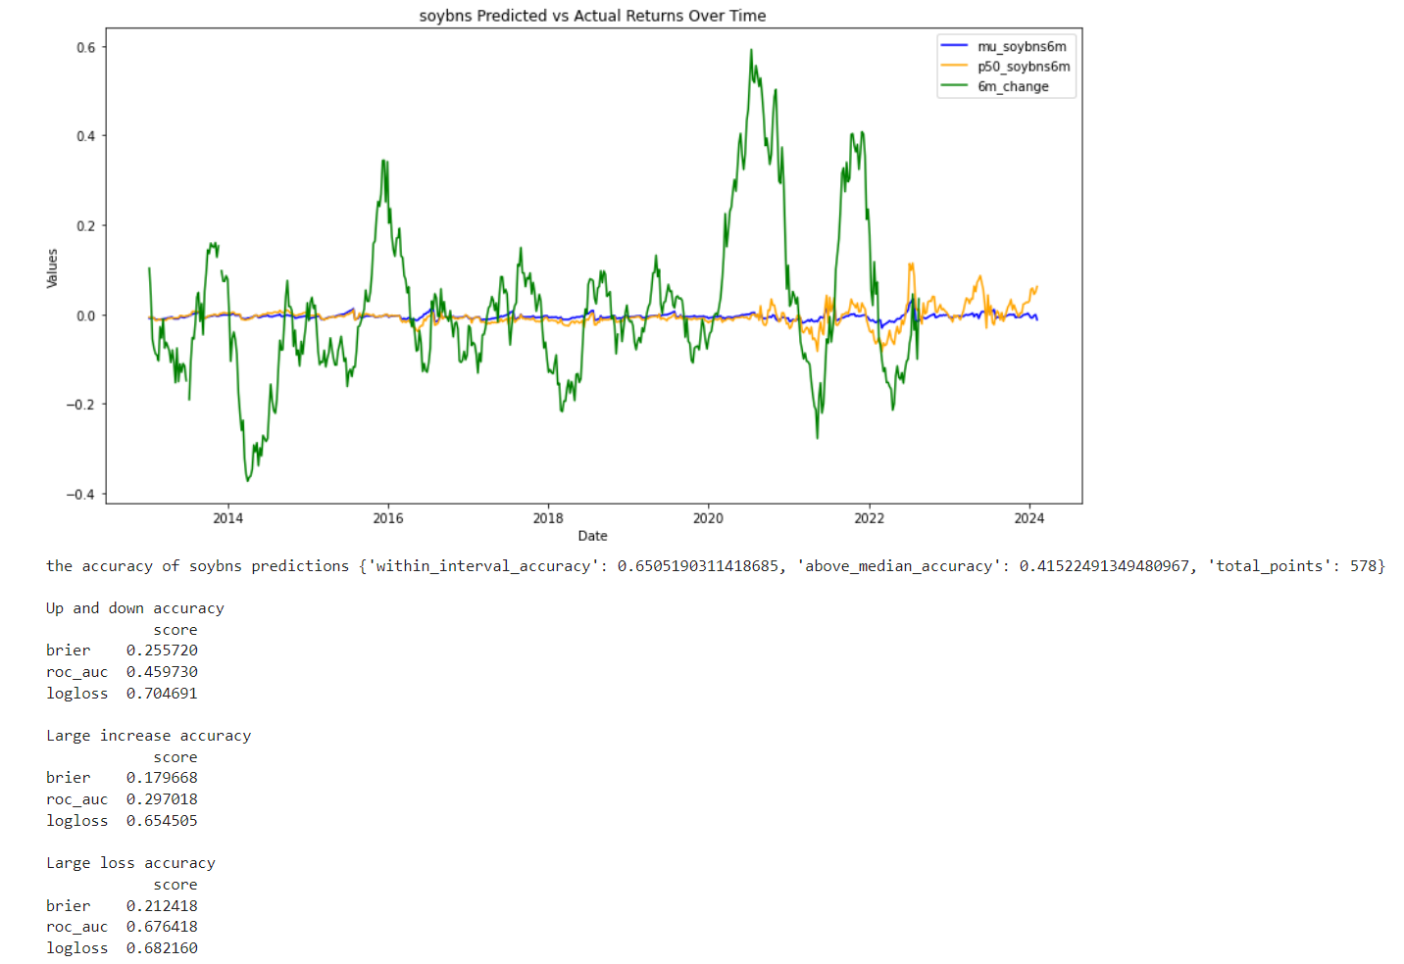

8. This performs better in large loss part.

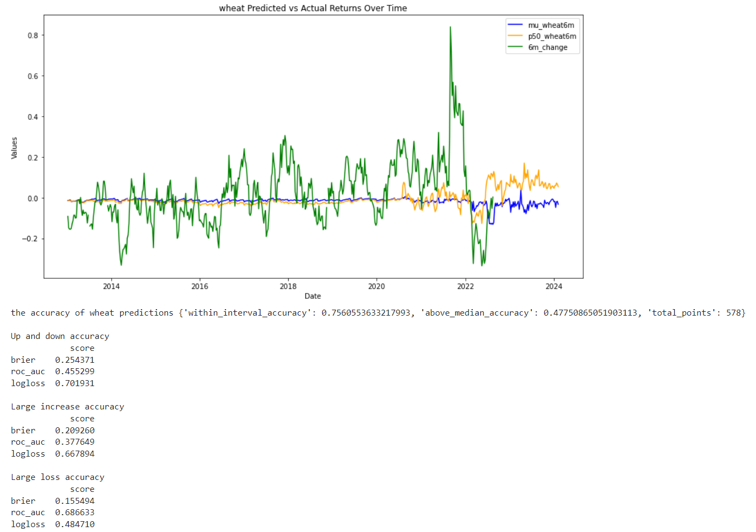

9. CPI The true value is in period of 1 month. Better in large loss part.

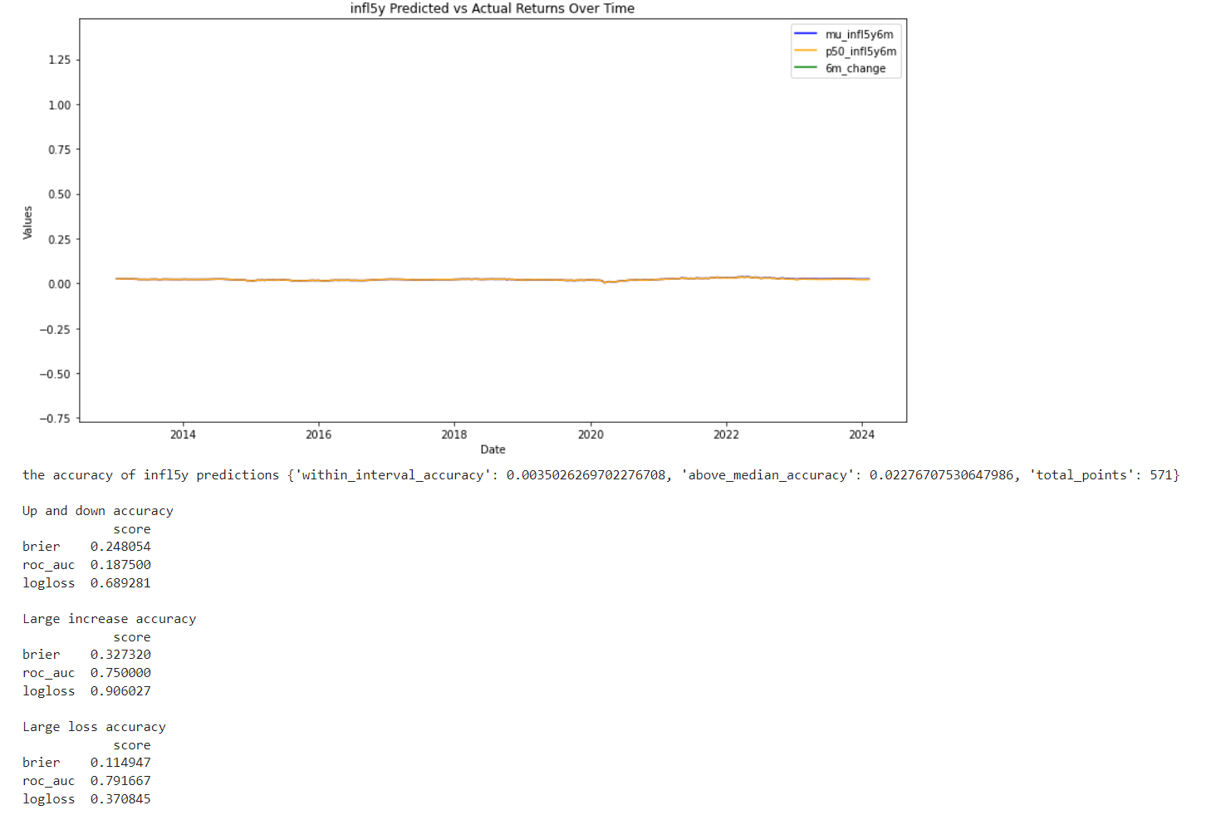

|  |  |  |  |
| --- | --- | --- | --- |
|  | brier | roc_auc | logloss |
| Corn(large loss) | 0.1955 | 0.6898 | 0.6024 |
| Gold(large loss) | 0.1140 | 0.5290 | 0.4319 |
| Silver(large increase) | 0.1500 | 0.5373 | 0.5017 |
| Wheat(large loss) | 0.1555 | 0.6866 | 0.4847 |
|  |  |  |  |
|  |  |  |  |
|  |  |  |  |

The statistics shows some significance in the large loss and large increase part. Corn and wheat has a big auc in the large loss part. The underlying assets of these two products are food future, which shows the risk neutral probability can help predict large loss in the future in some food products. The silver and gold has a low brier score and logloss score. This shows that when we are making correct predict, we have a very high probability to realize it in the future. According to this, people can reduce the risk of making wrong decisions.