*Geophysical Research Letters*

Supporting Information for

**Deducing** **Aerodynamic Roughness Length from Abundant Anemometer Tower Data to Inform Wind Resource Modeling**

Jiamin Wang1, Kun Yang1,2, Ling Yuan3, Jiarui Liu1, Zhong Peng4,5, Zuhuan Ren1, Xu Zhou2

1Ministry of Education Key Laboratory for Earth System Modeling, Department of Earth System Science, Institute for Global Change Studies, Tsinghua University, Beijing 100084, China.

2National Tibetan Plateau Data Center, State Key Laboratory of Tibetan Plateau Earth System, Environment and Resources, Institute of Tibetan Plateau Research, Chinese Academy of Sciences, Beijing 100101, China.

3China State Shipbuilding Corporation Haizhuang Windpower Co., Ltd., Chongqing 401123, China.

4School of Surveying and Land Information Engineering, Henan Polytechnic University, Jiaozuo 454000, China

5State Key Laboratory of Resources and Environment Information System, Institute of Geographic Sciences and Natural Resources Research, Chinese Academy of Sciences, Beijing 100101, China

Corresponding author: Kun Yang ([yangk@tsinghua.edu.cn](mailto:yangk@tsinghua.edu.cn))

**Contents of this file**

* 1. Data
  2. Derivation of aerodynamic roughness length

Figures S1 to S6

References

1.1 Data

A more detailed supplementary explanation of data used in this study is listed according to their purposes as follows.

First, two remote sensing datasets were used to analyze the distribution of $z_{0}$ over different surface conditions. They are the 500-m MODIS Global Land Cover Type product (MCD12Q1 (IGBP), Friedl et al., 2010) and the 8-day 500-m Leaf Area Index (LAI, Yuan et al., 2011; Lin et al., 2023) in 2019. The 8-day LAI was averaged to yearly LAI. The land cover type and LAI value at each anemometer tower were determined by the mode and the average of remote sensing data at the nearest nine grids, respectively.

Second, three gridded datasets of $z_{0}$ were evaluated. They were from ERA5 (Hersbach et al., 2020 & 2023a), NCEP Climate Forecast System Version 2 (CFSv2, Saha et al., 2012 & 2014) and Peng et al. (2022). The aerodynamic roughness length from ERA5 ($z_{0_ERA5}$) was derived based on vegetation types and snow cover with the temporal and spatial resolution of month and $0.25°×0.25°$. CFSv2 offered monthly mean $z_{0}$ ($z_{0_CFSv2}$) at 00:00, 06:00, 12:00, and 18:00 UTC with the spatial resolution of $0.205°×\sim 0.204°$. We found that $z_{0_CFSv2}$ has similar characteristics to $z_{0_ERA5}$ (Figure S1), which suggests that $z_{0_CFSv2}$ is most likely also determined by land cover types, although no indication was found in the official documentations. Peng et al. (2022) provided 1-km monthly $z_{0}$ ($z_{0_Peng}$), which was produced based on truth data of $z_{0}$ and MODIS remote sensing data with the aid of machine learning techniques. These “true” $z_{0}$ values were derived from observations provided by FLUXNET network (https://FLUXNET.org/data/download-data/), AmeriFlux network (https://AmeriFlux.lbl.gov/data/download-data/), and other sites. Note that $z_{0_Peng}$ only provided $z_{0}$ over vegetated areas. In the evaluation, we ignored their temporal variations by averaging $z_{0}$ to yearly $z_{0}$. The $z_{0}$ values at anemometer towers from the three products were determined by $z_{0}$ in the nearest grid.

**1.2** **Derivation of** **aerodynamic roughness length**

We derived $z_{0}$ values from neutral wind profiles, because anemometer towers cannot provide observations of the temperature profile or sensible heat flux, which are required for the atmospheric stability correction. The core theory is the neutral logarithmic wind profile equation (LWPE):

$u=\frac{u_{*}}{k}ln\left(\frac{z-d}{z_{0}}\right)$ (S1)

where $u$ is the wind speed ($m/s$) at $z$, the measuring height above ground ($m$), $u_{*}$ is the friction velocity ($m/s$), $k$ is the von Karman constant and equals to 0.4, and $d$ is the zero-plane displacement height ($m$).

To test the reliability of the derived $z_{0}$ values, we used them and the wind speeds at any height from anemometer towers to extrapolate the wind profiles, and compared the extrapolations with measurements of anemometer towers. The extrapolation accuracy was measured in terms of the correlation coefficient ($R$), the mean bias percentage ($MBP$) and the relative root mean-squared error ($RRMSE$). In the “all samples” case, the stability correction function must be taken into account in LWPE (Equations S2-5). We calculated stability correction functions based on the hourly surface sensible heat flux and surface pressure from ERA5 (Hersbach et al., 2023b).

$u=\frac{u_{*}}{k}\left[ln\left(\frac{z-d}{z_{0}}\right)-Ψ_{m}\left(\frac{z-d}{L}\right)+Ψ_{m}\left(\frac{z_{0}}{L}\right)\right]$ (S2)

where *L* is the Monin–Obukhov length ($m$), $Ψ_{m}\left(\frac{z-d}{L}\right)$ and $Ψ_{m}\left(\frac{z_{0}}{L}\right)$ represent the stability correction function. Specifically, following Dyer & Hicks (1970):

$L=-\frac{ρTc_{p}{u_{*}}^{3}}{kgH}$ (S3)

$ζ= \frac{z-d}{L}$ (S4)

$Ψ_{m}\left(ζ\right)=\left\{\begin{aligned}2ln\left(\frac{1+x}{2}\right)+ln\left(\frac{1+x^{2}}{2}\right)-2\tan^{-1}x+\frac{π}{2}, with x= {\left[1-16ζ\right]}^{1/4}, for ζ<0 \\ -5ζ, for ζ≥0\end{aligned}\right.$ (S5)

among them, $ρ$ is density ($kg/m^{3}$), $T$ is temperature ($K$), $p$ is surface pressure ($Pa$), $c_{p}$ is heat capacity $(1004J/{{kg}/K)}$, $g$ is the gravitational constant ($9.8m/{s^{2}}$), $H$ is the sensible heat flux ($W/{m^{2}}$), and $ζ$ ranges from $-2$ to $2$ (Sozzi, 1998).

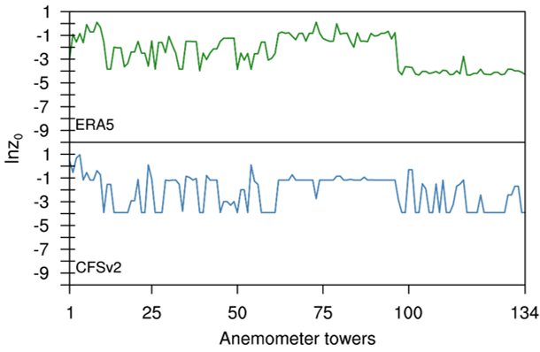

**Figure S1**. The comparison of $lnz_{0}$ from ERA5 and CFSv2 at each anemometer tower. The horizontal axis represents the serial number of anemometer towers sorted by land cover types. The above green and the below blue solid lines represent $lnz_{0}$ from ERA5 and CFSv2.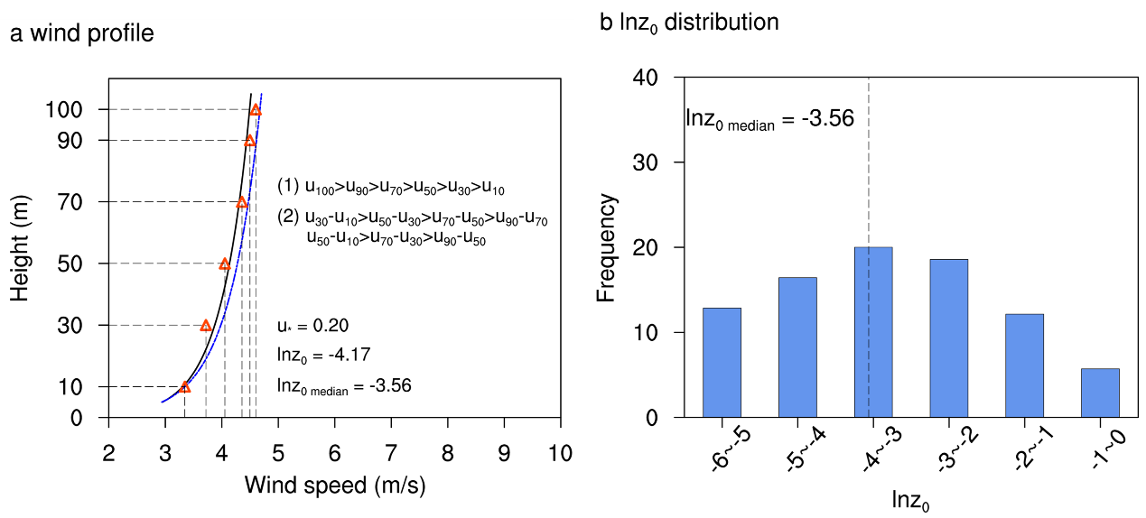

**Figure S2.** A schematic illustration of the $z_{0}$ derivation, taking a randomly selected anemometer tower as an example. (a) Wind profiles at a timestamp. The red triangles correspond to measured wind speed at each height of the anemometer tower. The black and blue solid lines represent the fitted wind profiles with $lnz_{0}$ = -4.17 or $u_{*}=0.20m/s$ at the corresponding timestamp and $lnz_{0}$ as the median (-3.56) of valid samples. (b) The histogram distribution of all $lnz_{0}$ of valid samples.

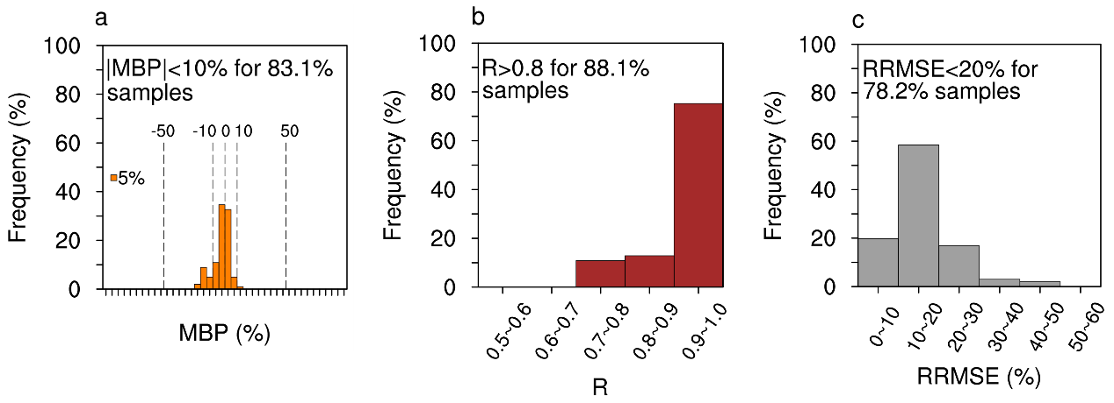

**Figure S3**. (a) Frequency distribution of mean bias percentage ($MBP$) for all samples when wind speeds are extrapolated from 10 m. The width of each bar means the MBP is divided at 5% intervals. (b and c) are the same as (a) but for the correlation coefficient ($R$) and relative root mean-squared error ($RRMSE$).

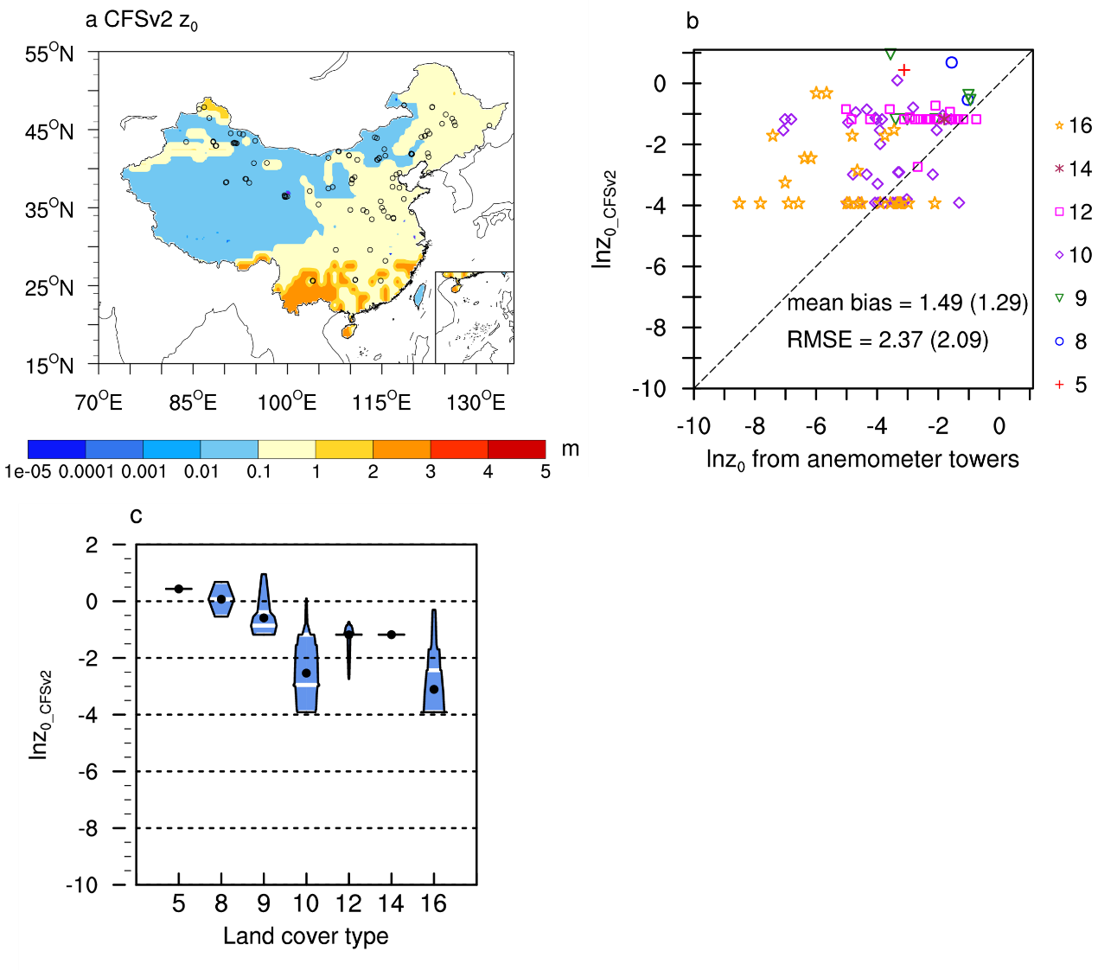

**Figure S4**. The performance of gridded $z_{0}$ products from CFSv2 ($z_{0_CFSv2}$), (a) Spatial pattern of $z_{0_CFSv2}$. The circles represent locations of anemometer towers. (b) The comparison of ${lnz}_{0_CFSv2}$ against derived $lnz_{0}$ from anemometer towers. The symbols with different colors and shapes represent land cover types. The legends on the right refer to specific land cover types, including mixed forests (legend “5”), woody savannas (legend “8”), savannas (legend “9”), grasslands (legend “10”), croplands (legend “12”), cropland/natural vegetation mosaics (legend “14”) and barren or sparsely vegetated type (legend “16”). The mean bias and root mean squared error (RMSE) outside and inside parentheses were calculated based on all anemometer towers and towers over vegetated areas, respectively. (c) Violin plot of ${lnz}_{0}$ under different land cover types. The numbers in the horizontal coordinate correspond to land cover types as the same as in (b). For each violin shape, the width means the relative frequency with which each ${lnz}_{0}$ value occurs; black dot represents the average value, and the three white lines from top to bottom mean the upper quartile, the median and the lower quartile. Some white lines overlap.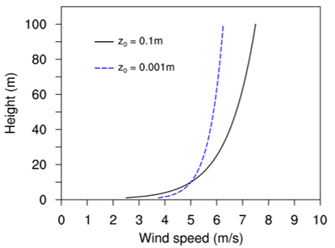

**Figure S5**. A schematic illustrating the effect of $z_{0}$ on wind profile under neutral condition.

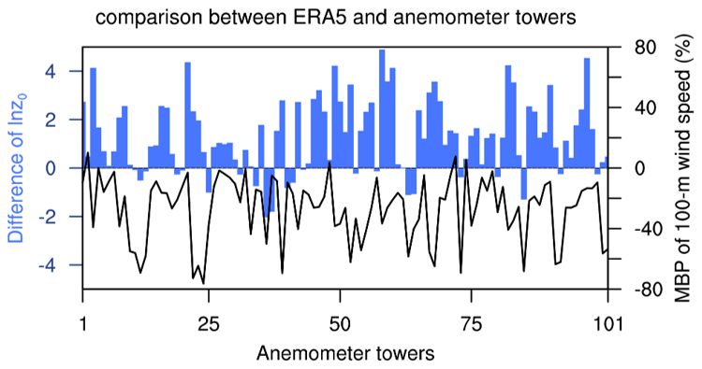

**Figure S6**. Based on valid near-neutral samples of wind profiles, the difference of $lnz_{0}$ ($ERA5-anemometer towers$) and mean bias percentage (MBP) of 100-m wind speed between ERA5 and anemometer towers. For anemometer towers without measurements at 100 m, the 100-m wind speed was extrapolated from the 10-m wind speed using $z_{0}$.

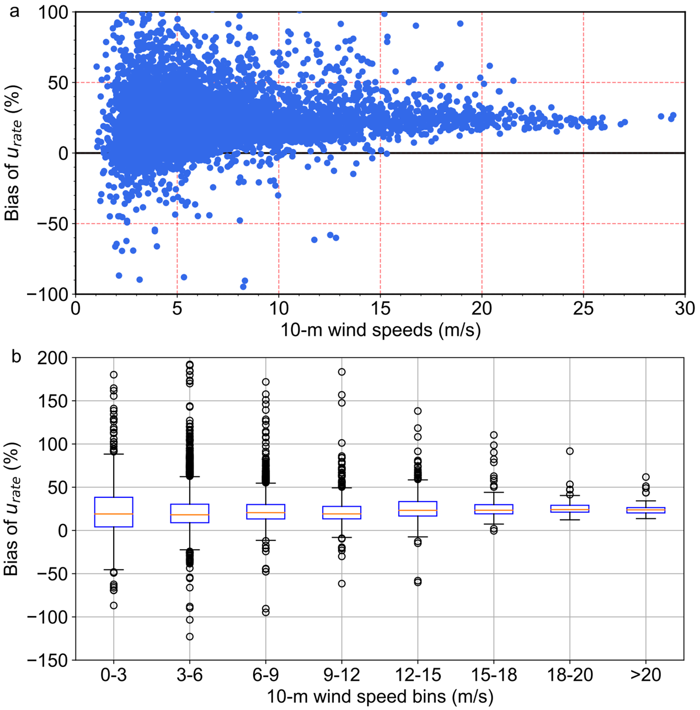

**Figure S7.** (a) Biases in ${rate}_{u}$ of ERA5 at 32 anemometer towers ($ERA5-anemometer towers$) as a function of 10-m wind speeds for valid near-neutral samples of wind profiles. The anemometer towers are those where the difference in ${lnz}_{0}$ between ERA5 and the anemometer towers ($ERA5-anemometer towers$) is greater than 2. (b) Box plot of bias in ${rate}_{u}$ of ERA5 across different wind speed bins. Each box shows the median (orange line), interquartile range (white box), whiskers representing the 1.5 interquartile range (IQR, spanning from the 25th to the 75th percentile) and open circles representing outliers.

**References**

Dyer, A. J., & Hicks, B. B. (1970). Flux-Gradient Relationships in the Constant Flux Layer. *Quarterly Journal of the Royal Meteorological Society*, 96, 715-721. <https://doi.org/10.1002/qj.49709641012>

Hersbach, H., Bell, B., Berrisford, P., Biavati, G., Horányi, A., Muñoz Sabater, J., et al. (2023a). ERA5 monthly averaged data on single levels from 1940 to present [Dataset]. Copernicus Climate Change Service (C3S) Climate Data Store (CDS). <https://doi.org/10.24381/cds.f17050d7>

Hersbach, H., Bell, B., Berrisford, P., Biavati, G., Horányi, A., Muñoz Sabater, J., et al. (2023b). ERA5 hourly data on single levels from 1940 to present [Dataset]. Copernicus Climate Change Service (C3S) Climate Data Store (CDS). <https://doi.org/10.24381/cds.adbb2d47>

Hersbach, H., Bell, B., Berrisford, P., Hirahara, S., Horányi, A., Muñoz Sabater, J., et al. (2020). The ERA5 global reanalysis. Quarterly Journal of the Royal Meteorological Society, 146(730), 1999–2049. <https://doi.org/10.1002/qj.3803>

Peng, Z., Tang, R., Jiang, Y., Liu, M., & Li, Z. L. (2022). Global estimates of 500 m daily aerodynamic roughness length from MODIS data. ISPRS *Journal of Photogrammetry and Remote Sensing*, 183, 336–351. <https://doi.org/10.1016/j.isprsjprs.2021.11.015>

Saha, S., Moorthi, S., & Wu, X. (2014). The NCEP Climate Forecast System Version 2. Journal of Climate, 27, 2185–2208. <https://doi.org/10.1175/JCLI-D-12-00823.1>

Saha, S., Moorthi, S., Pan, H., Wu, X., Wang, J., Nadiga, S., et al. (2012). NCEP Climate Forecast System Version 2 (CFSv2) Monthly Products [Dataset]. Research Data Archive at the National Center for Atmospheric Research, Computational and Information Systems Laboratory. <https://doi.org/10.5065/D69021ZF>

Sozzi, R., Favaron, M., & Georgiadis, T. (1998). Method for Estimation of Surface Roughness and Similarity Function of Wind Speed Vertical Profile. [*Journal of Applied Meteorology and Climatology*](https://journals.ametsoc.org/view/journals/apme/apme-overview.xml), 37, 461-469. [https://doi.org/10.1175/1520-0450(1998)037<0461:MFEOSR>2.0.CO;2](https://doi.org/10.1175/1520-0450(1998)037%3c0461:MFEOSR%3e2.0.CO;2)