The Unexpected Superiority of Near-Surface Wind Speed in Day-ahead Wind Farm Power Forecasting
Xin Xia^{a,1}, Peidu Li^{a,b} , Yong Luo^{a,*}
ª Ministry of Education Key Laboratory for Earth System Modeling, Department of Earth System Science, Tsinghua University, Beijing 100084, China
^{b} Plateau Atmosphere and Environment Key Laboratory of Sichuan Province, School of Atmospheric Sciences, Chengdu University of Information Technology, Chengdu 610225, China

Abstract
As wind power integration continues to expand, forecasting accuracy is critical for grid stability, yet scientific selection of meteorological input variables remains a key bottleneck. This study conducts systematic analysis of wind speeds at different heights using complete gradient observational data from a Gobi wind farm in northwestern China. Diagnostic and predictive assessments using EOF, SHAP, and EEMD methods reveal that near-surface 10 m wind speed outperforms conventionally prioritized hub-height wind speed in both explaining power variations and forecasting performance. Wind direction-based validation using site geometric configuration provides compelling evidence that wake effects significantly suppress upper-level wind measurement importance while preserving near-surface predictive value. Even under free-stream conditions, 10 m wind speed maintains superior performance, indicating additional mechanisms beyond wake interference. Multi-source prediction strategies integrating WRF simulations driven by GFS and ECMWF data achieve optimal performance with RMSE of 31.80 MW and 11.86% correlation improvement compared to baseline methods. Frequency-domain decomposition reveals 10 m wind speed exhibits highest correlation with power at daily and longer time scales, indicating unique advantages in capturing large-scale meteorological drivers. This research establishes a complete framework spanning diagnostic analysis, predictive assessment, wake validation, strategy development, and mechanism interpretation, challenging conventional assumptions about hub-height wind speed criticality. Results demonstrate high-accuracy forecasting using easily accessible near-surface standard observations, providing new methodologies for variable selection and strategy optimization while offering scientific foundations for measurement system design and forecasting optimization.

Highlight
- Wind direction analysis validates wake effects suppress hub-height predictive value. (84)
- 10-m wind speed outperforms hub-height measurements for farm-level power prediction. (84)
- Multi-method framework integrates EOF, EEMD, and SHAP for interpretable analysis. (81)
- Dual-perspective evaluation considers both variable contribution and predictability. (84)
- Multi-source fusion achieves 7.13% RMSE reduction and 11.86% correlation gain. (78)
Keywords: Wind farm power forecasting; Wake effect validation; Multi-height wind speed; Interpretable machine learning; Near-surface wind measurements

Introduction
To address the challenges of climate change, wind energy—one of the most widely deployed renewable resources—has experienced rapid growth and large-scale implementation worldwide. As installed wind power capacity continues to expand and its share in power systems increases, accurate wind power forecasting has become a critical requirement for ensuring grid stability, optimizing dispatch, and improving economic efficiency. This need applies not only to the secure operation of large-scale power systems but also to the refined management of generation assets, including equipment maintenance, performance assessment, and market trading decisions.

Across various temporal scales, wind power forecasting has evolved into a multi-tiered framework, ranging from minutes to years. Among these, day-ahead forecasting has drawn particular attention due to its central role in electricity market operations and grid scheduling. Unlike short-term or long-term forecasts, day-ahead prediction is highly sensitive to meteorological conditions and relies heavily on high-quality numerical weather prediction (NWP) data to establish accurate mappings between meteorological variables—especially wind speed—and power output over a 24–240 hour horizon. In recent years, artificial intelligence approaches, including machine learning, deep learning, and hybrid models, have shown clear advantages for improving day-ahead forecasts. However, their effectiveness still depends on rigorous data processing and the careful construction of input variables. Regardless of the modeling technique, the central challenge remains the same: to establish a physically consistent and robust mapping between meteorological inputs and power output. This “wind-to-power” mechanism is the core of any forecasting system, directly determining the scientific basis for input selection and the effectiveness of prediction strategies.

Within this mechanism, the scientific selection of input variables is particularly critical, as it directly affects both forecast accuracy and model robustness. Most existing studies consider hub-height wind speed to be the most important predictor, a view rooted in the single-turbine power curve theory: under idealized, homogeneous inflow, hub-height wind speed directly drives blade rotation and, through aerodynamic processes, converts wind energy into electrical power. However, this physical relationship is derived from single-turbine, controlled conditions, whereas the operational environment of an actual wind farm is far more complex. Total farm power output represents the aggregate performance of multiple turbines operating under non-uniform inflow and wake interactions. The wakes generated by upstream turbines can significantly alter the inflow conditions of downstream turbines, producing a highly non-uniform, temporally varying three-dimensional turbulent structure. Transitioning from single-turbine to farm-level forecasting thus involves not only a scaling-up in size but also a fundamental change in governing physics. Whether the assumed advantage of hub-height wind speed persists under such conditions, and how wind speeds at different heights vary in their representativeness for farm-level power, remain open questions requiring systematic empirical investigation.

Moreover, hub-height wind speed measurements often rely on dedicated meteorological masts or nacelle-mounted sensors, whereas near-surface 10 m wind speed is a standard observation at meteorological stations and a default output of most weather models, with long historical records and lower acquisition costs. Demonstrating that 10 m wind speed can serve as a representative predictor for total farm power would reduce dependence on dedicated measurement infrastructure, broaden data availability, and significantly enhance the scalability and practicality of wind power forecasting.

Despite substantial research in this area, methodological and interpretive limitations remain. Traditional statistical approaches offer good interpretability but are limited in predictive skill, while deep learning methods can markedly improve accuracy but often lack physical consistency, making it difficult to reveal the underlying mechanisms of variable influence. More critically, much of the existing work on “interpretability” stops at post hoc variable importance ranking—essentially visualizing the outputs of black-box models—rather than explicit reasoning grounded in physical processes. This shallow form of interpretability is insufficient to address questions about the representativeness of wind speeds at different heights under specific conditions and offers limited guidance for variable selection and strategy design across sites and regimes. There is therefore a clear need for a systematic methodology that integrates physical consistency with interpretable analysis, forming a closed loop from understanding variable mechanisms to optimizing prediction strategies.

In this study, we propose a framework that combines physical consistency with explicit interpretability to analyze the drivers of total farm power from multi-height wind speed observations. In contrast to conventional post hoc interpretability methods, we integrate empirical orthogonal function (EOF) analysis, SHAP (SHapley Additive exPlanations), and ensemble empirical mode decomposition (EEMD) to examine the physical mechanisms of key variables from multiple perspectives, including spatiotemporal decomposition and quantitative attribution. We then assess the predictive performance of these variables under different temporal scales and meteorological conditions, and finally design and validate a set of application-oriented forecasting strategies. Throughout the analysis, wind shear classification is incorporated as a diagnostic tool to explore the mechanisms and strategy performance under varying boundary-layer structures.

The contributions of this study are twofold. Theoretically, it establishes a systematic paradigm that integrates physical consistency and explicit interpretability, providing a transferable methodology for understanding the relationships between multi-height wind speeds and total farm power. From an engineering perspective, it offers a physically grounded basis for selecting key input variables and optimizing forecasting strategies across different sites and wind regimes, thereby enhancing the accuracy, adaptability, and robustness of operational forecasting systems. Importantly, if 10 m wind speed proves advantageous for farm-level power prediction, it would enable the use of easily accessible standard meteorological observations for efficient power conversion, reducing dependence on specialized measurement data and facilitating large-scale deployment of wind power forecasting. The remainder of this paper is organized as follows: Section 2 presents the data and methods, Section 3 reports the stratified analysis results, Section 4 discusses the physical mechanisms and engineering implications, and Section 5 concludes the study.

Data and method

2.1 study site and observation data
The observational dataset was collected from a wind farm located in the arid and semi-arid Gobi region of northwestern China, specifically the Changma wind farm in Yumen, Gansu Province. The wind farm consists of 134 wind turbines, each with a rated capacity of 1.5 MW and a hub height of 61.5 m. The site is characterized by relatively flat terrain with minimal topographical variations, providing favorable conditions for investigating boundary-layer wind profiles with reduced terrain-induced turbulence effects. 典型戈壁下垫面，下垫面平整，风况较为稳定，是一种条件较好且较为有风资源稳定特性的风电场
A 70 m meteorological tower is situated at 96.81° E, 40.21° N, equipped with four measurement levels at 10 m, 30 m, 50 m, and 70 m above ground, each providing wind speed and wind direction observations. In addition, air temperature is recorded at the 10 m level. All meteorological variables are sampled at 15-minute intervals, and corresponding total wind farm power output is recorded at the same temporal resolution. The dataset spans from 1 May 2021 to 31 October 2022, yielding over 52318 synchronized meteorological–power observations. Data quality control procedures, including the removal of outliers and missing values, were applied to ensure high reliability for subsequent statistical and predictive analyses.

2.2 Numerical Weather Prediction (NWP) Data
High-resolution numerical weather prediction (NWP) data were produced using the Weather Research and Forecasting (WRF) model, driven by archived global analyses from the Global Forecast System (GFS) of NCEP and the High-Resolution Forecast (HRES) of ECMWF. These two global models are widely used in operational and research contexts, and their inclusion provides a representative basis for the forecasting framework. Both datasets were dynamically downscaled with WRF to generate regional-scale forecasts for the study site.
The WRF simulations used nested domains to increase spatial resolution toward the wind farm. In the GFS-driven configuration (GFS-WRF), three domains were applied at horizontal resolutions of 27 km, 9 km, and 3 km. In the ECMWF-driven configuration (EC-WRF), two domains were used at 9 km and 3 km. Both setups employed 51 vertical levels and identical physics parameterizations: the Morrison microphysics scheme, RRTMG longwave and shortwave radiation schemes, YSU planetary boundary layer scheme, Noah land surface model, and Kain–Fritsch cumulus parameterization (omitted for the innermost domain).
Simulations were run in a rolling forecast mode. Each run was initialized once per day and integrated for 100 hours. The first 28 hours were discarded as spin-up, and the remaining outputs were used to produce forecasts with lead times of 24 h, 48 h, and 72 h. Forecast segments from consecutive runs were combined to form continuous time series covering the full study period. WRF outputs, archived at 15-minute intervals, were bilinearly interpolated to the location of the meteorological tower. Forecast variables at multiple heights, together with other meteorological parameters, served as inputs for the variable attribution analysis described in Section 2.3.

2.3 Analytical Framework for Variable Identification
This study employed multiple analytical methods to examine the relationships between multi-level wind speeds and total power output from the perspectives of spatiotemporal variability, variable contribution, predictability, and wind shear conditions, and to evaluate the performance of different prediction strategies.

2.3.1 Spatiotemporal Decomposition Methods
Empirical orthogonal function (EOF) analysis was used to extract the dominant spatiotemporal modes from multi-level wind speed and power time series, followed by physical interpretation of the resulting patterns. To separate variability at different time scales, ensemble empirical mode decomposition (EEMD) was applied to decompose the time series into intrinsic mode functions (IMFs), distinguishing short-term fluctuations, seasonal variations, and long-term trends.
In this study, EEMD was not only applied as a statistical decomposition tool, but more importantly as a data-driven approach to explore underlying mechanisms of wind–power coupling across different temporal scales.

2.3.2 Interpretability Analysis
SHAP (SHapley Additive exPlanations) was applied to the outputs of the forecasting framework to quantify the contribution of different meteorological variables to the power forecasting results. All SHAP computations were performed using an independently trained LightGBM regression model, which took the forecasted wind speeds from each prediction strategy as inputs and the observed power output as the target variable. The LightGBM model was tuned using a grid search over key hyperparameters to achieve optimal performance for the SHAP analysis. This setup ensured both efficient computation and clear interpretability of the SHAP values. The method calculates marginal contributions at both sample-specific and global scales, allowing physical interpretation of variable importance.
SHAP的公式

2.3.3 Correlation Analysis
Spearman rank correlation and Pearson correlation coefficients were calculated to assess statistical relationships between meteorological variables and power output. Spearman correlation captures nonlinear monotonic relationships, while Pearson correlation measures linear associations.

2.3.4 Wind Shear Index Calculation and Classification
Wind shear exponents (α) were calculated from vertical wind speed profiles, and boundary-layer conditions were classified into types such as stable and convective. Classification followed established schemes in previous studies and enabled analysis of variable representativeness and prediction strategy performance under different shear conditions.

2.3.5 Prediction Performance Metrics
Root mean square error (RMSE), bias, and correlation coefficient (R) were used to evaluate prediction performance. RMSE reflects overall error magnitude, bias indicates systematic deviation, and correlation measures consistency between predictions and observations. These metrics were applied consistently across wind speed predictions, power predictions, and multi-strategy comparisons to ensure comparability.

2.4 Prediction Modeling Framework
The wind power forecasting component of this study employed machine learning-based regression models to establish relationships between meteorological variables and farm-level power output. LightGBM was selected as the primary modeling framework due to its computational efficiency, robust handling of mixed data types, and superior regression performance in time series forecasting applications.
LightGBM 公式
The modeling process followed a systematic framework incorporating data preprocessing, model training, hyperparameter optimization, and performance validation. To prevent data leakage, the time series dataset was partitioned chronologically into training (70%), validation (10%), and testing (20%) sets. This temporal split preserved the sequential nature of the data while ensuring that future information did not influence model training.
The training set was used for model parameter learning, while the validation set guided hyperparameter optimization through grid search over key parameters including learning rate, number of estimators, maximum depth, and regularization parameters. All prediction performance analyses and strategy comparisons were conducted exclusively on the independent testing set to ensure unbiased evaluation of forecasting capabilities.
Model inputs consisted of numerical weather prediction outputs at multiple heights and temporal lead times, with specific variable configurations determined based on the analytical results described in Sections 2.3.1-2.3.4. The modeling framework was designed to accommodate different prediction strategies and input variable combinations, enabling systematic evaluation of alternative forecasting approaches.
The detailed specification of prediction strategies, including direct prediction, two-step modeling, and multi-source fusion approaches, is presented in Section 3.3 based on the variable contribution analysis and predictability assessment results.

Results

3.1 Analysis of Observational Data

3.1.1 Spatiotemporal Characteristics from EOF Analysis
To examine the vertical distribution characteristics of wind speed at the study site, we applied an EOF decomposition to multi-height wind speed measurements. Wind speed data from four measurement levels on the meteorological mast (10 m, 30 m, 50 m, and 70 m) were standardized, and the covariance matrix was decomposed to obtain eigenvalues and corresponding modes.
The EOF analysis (Fig. 1) reveals that the first four principal modes account for 94.10%, 4.50%, 1.00%, and 0.40% of the total variance, respectively. The first mode exhibits exceptional dominance, accounting for 94.10% of the total variance and substantially exceeding all other modes, which indicates a highly coherent pattern in wind speed variability. The loading coefficients for this mode are consistently positive across all heights, with values of 0.478 (10 m), 0.507 (30 m), 0.509 (50 m), and 0.505 (70 m), demonstrating remarkable uniformity with a range of only 0.031. This indicates strong synchronization of wind speed variations across all heights, reflecting pronounced positive correlations throughout the vertical profile. The second mode (4.50%) captures wind shear-related variations, though its limited contribution confirms the low wind shear characteristic of this site. While the loading coefficients show general uniformity, subtle differences among heights suggest that each level may contribute differently to power prediction accuracy. This observation warranted further statistical analysis of the height-specific relationships between wind speed and power output.
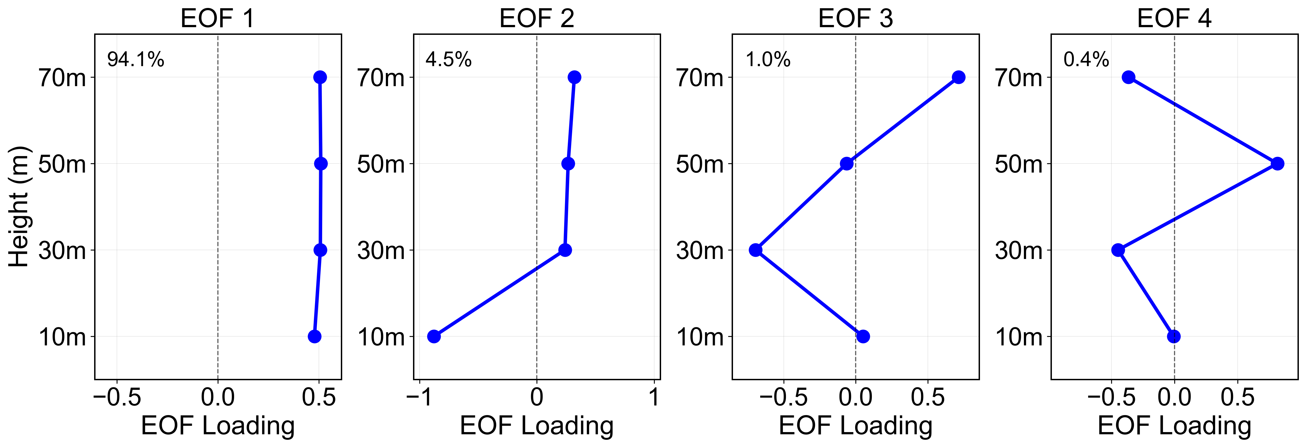
Figure 3.X. EOF loadings of wind speed at 10–70 m for the first four modes. The variance contribution of each mode is indicated, showing the dominant vertical structures and variability patterns across heights.

3.1.2 Statistical Correlation Analysis
Following the uniform wind profile revealed by the EOF analysis, we assessed the statistical relationship between wind speed at each height and the farm power output to identify the most critical meteorological driver for forecasting. Given the potential for nonlinear relationships, we employed Spearman rank correlation analysis. The results (Fig. 2) demonstrate that 10 m wind speed exhibits the highest correlation with power output (rs = 0.83, p < 0.001), substantially exceeding correlations at other heights including 70 m (rs = 0.79), 50 m (rs = 0.79), and 30 m (rs = 0.78). Other meteorological variables display considerably weaker correlations with power, with 10 m temperature showing rs = 0.02 and 10 m humidity showing rs = −0.01 (not significant). The strong correlations among wind speeds at different heights align with the EOF findings.
These results challenge conventional assumptions where hub-height wind speed typically serves as the most effective predictor of power output rather than near-surface wind speed. To verify this finding and elucidate the mechanisms underlying the contributions of different meteorological variables, we conducted an interpretable machine learning analysis.

Figure 2. Spearman correlation matrix between meteorological variables and wind farm power output. The color scale represents correlation coefficients ranging from -0.5 to 1.0, with blue indicating positive correlations and orange indicating negative correlations. Asterisks denote statistical significance levels (* p < 0.05, ** p < 0.01, *** p < 0.001).

3.1.3 Interpretable Machine Learning Analysis
Using the meteorological observations, we trained two models (LightGBM and Random Forest) to predict power output and employed the SHAP method to quantify the importance of each input variable. Both models achieved strong predictive performance (R² > 0.81), with LightGBM demonstrating slightly superior performance. Consequently, the following SHAP analysis is based on the LightGBM model, providing a robust basis for interpretation.
The SHAP analysis consistently identified 10 m wind speed as the most influential meteorological factor, with an importance score of 19.91, more than double that of any other variable (Figure 3a). This remarkable dominance of near-surface wind speed over hub-height measurements is particularly noteworthy, given that the 70 m wind speed (closer to typical hub height) ranks only second with an importance score of 8.66, followed by 50 m wind speed (5.04). This finding corroborates the statistical correlation analysis presented in Section 3.1.2, which similarly demonstrated the superior predictive value of 10 m wind speed measurements. The prominence of 10 m wind speed indicates that near-surface meteorological conditions capture the essential atmospheric dynamics affecting wind power generation more effectively than measurements at higher altitudes. Temperature at 10 m ranked as the fourth most important variable (importance score 2.62), reflecting its influence on air density and power output efficiency. The remaining meteorological variables, including wind direction components at various heights, showed progressively lower importance scores, confirming the hierarchical structure of meteorological influences observed in the correlation analysis.
The SHAP beeswarm plot (Figure 3b) provides insights into how individual feature values affect model predictions. For wind speed variables (10 m, 50 m, and 70 m), high wind speed values (depicted in red) predominantly generate positive SHAP values, indicating they increase predicted power output, while low wind speed values (shown in blue) produce negative SHAP values, decreasing the predicted output. This relationship demonstrates the expected positive correlation between wind speed and power generation, with 10 m wind speed showing the widest range of SHAP value impacts. The 10 m temperature exhibits an inverse relationship pattern where high temperature values tend to generate negative SHAP values while low temperature values produce positive impacts. This counterintuitive finding reflects the physics of wind power generation whereby higher temperatures reduce air density and decrease power output even at constant wind speeds, while cooler temperatures increase air density and enhance power generation efficiency. The wind direction components show more scattered SHAP value distributions without clear directional trends, suggesting their effects are context-dependent and related to specific turbine orientations and wake effects within the wind farm layout.
Figure 3c presents a SHAP waterfall plot for a representative individual sample to illustrate the model decision-making process. Starting from the baseline prediction of 47.18 kW (the average power output across all samples), the model adjusts this value through sequential contributions from each feature to reach a final prediction of 33.55 kW for this specific case. Several features contribute to reducing the predicted power output below the baseline. The 10 m wind speed contributes -5.26 kW, indicating below-average wind conditions. Temperature adds -2.32 kW, suggesting that temperature effects further reduce the expected output. Various wind direction components provide smaller negative contributions. Conversely, 50 m and 70 m wind speeds provide modest positive contributions (+2.29 and +1.86 kW respectively), partially offsetting the negative impacts but insufficient to reach the baseline level. This case study demonstrates the model ability to integrate multiple meteorological factors simultaneously, weighing their individual contributions to arrive at a physics-informed prediction.
The results indicate that near-surface meteorological observations can explain approximately 81% of the variability in power output. The remaining 19% is likely attributable to factors not represented in mast-based meteorological measurements, including weather-regime-related upper-level wind changes, curtailment or grid maintenance activities, turbine outages or maintenance downtime, aging-related performance degradation, and other non-meteorological influences affecting farm-wide generation. This finding underscores that although near-surface observations play a dominant role in wind power forecasting, improving forecast accuracy will require incorporating additional factors that influence total power output.
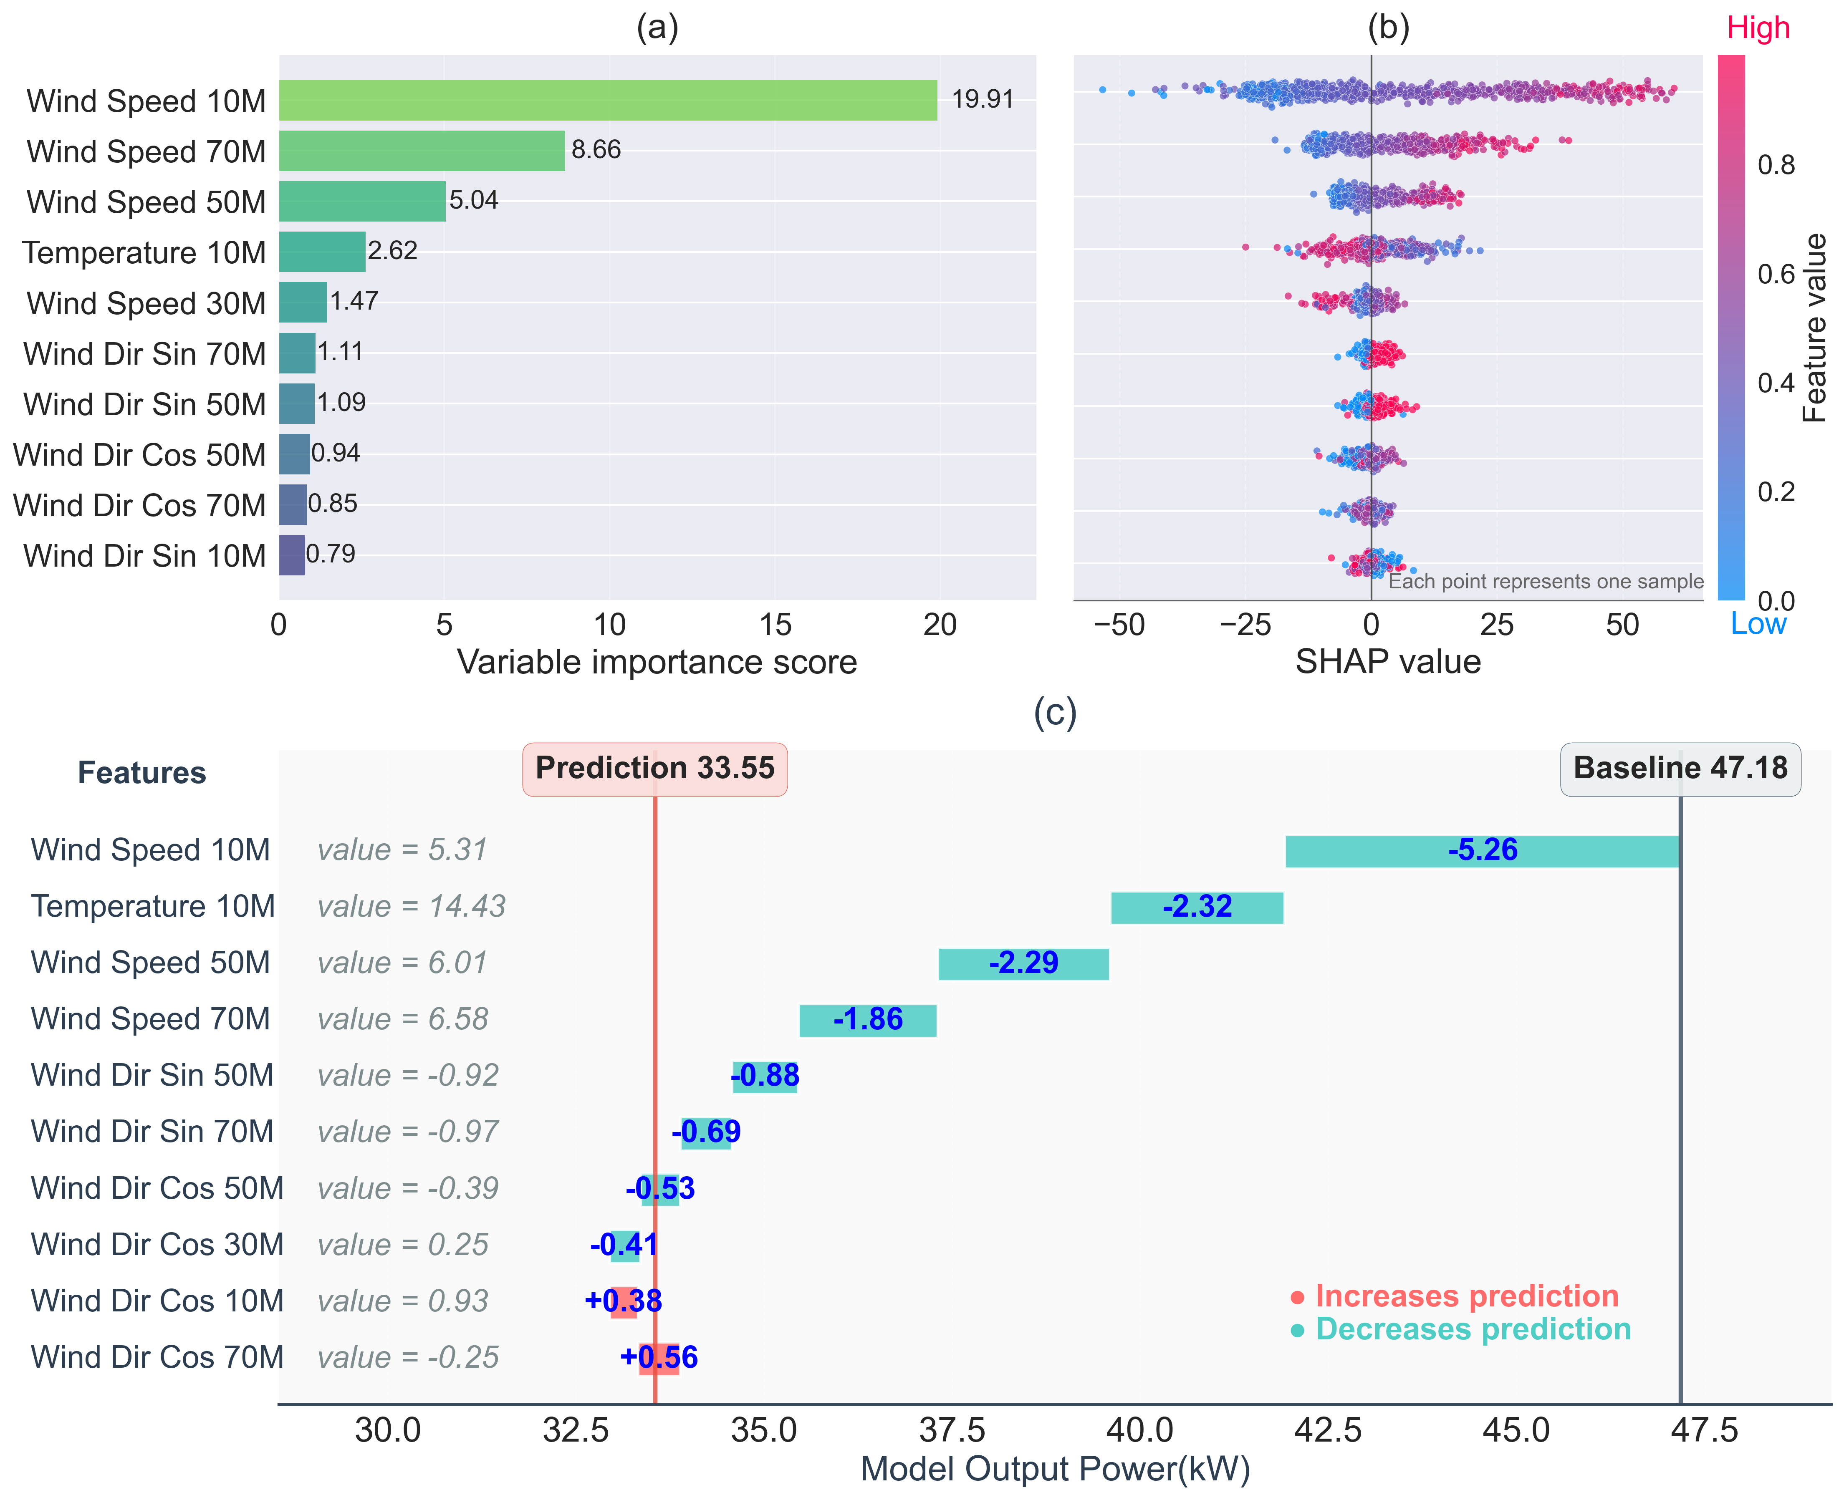
Figure 3. SHAP-based interpretability analysis of the wind power prediction model. SHAP values quantify the contribution of each feature to individual predictions, where larger absolute values indicate stronger influence on model output. (a) Variable importance ranking based on mean absolute SHAP values, showing the top 10 most influential features. The importance score represents the average predictive influence of each feature across all test samples. (b) Feature impact distribution (bee swarm plot) illustrating how individual feature values affect model predictions. Each point represents one sample, with colors indicating normalized feature values (blue for low values, red for high values). Positive SHAP values increase the predicted power output, while negative values decrease it. (c) SHAP waterfall plot for an individual sample, demonstrating the step-by-step prediction process. The plot shows how each feature contributes to moving the prediction from the baseline value (47.18 kW) to the final predicted output (33.55 kW). Blue bars indicate features that decrease the prediction, while green bars indicate features that increase it.

3.2 Evaluation of Day-ahead Predictability of Key Meteorological Variables
Based on the statistical analysis and SHAP-based interpretability results in Section 3.1, the 10 m and 70 m wind speeds were identified as the most influential variables for explaining farm-level power output. However, variable contribution to power prediction is not equivalent to its own forecast ability. To design effective forecasting strategies, it is essential to consider both importance and predictability. Therefore, this section evaluates the day-ahead predictive performance of wind speeds at these two key heights using WRF daily cycle forecast simulations driven by global numerical weather prediction models from our unified operational wind power forecasting system designed specifically for this regional wind farm.
The analysis is organized into four perspectives, including overall performance characteristics, seasonal variations, diurnal cycle patterns, and wind shear conditions. The evaluation employs three diagnostic metrics: Root Mean Square Error (RMSE, ranging from 0 to infinity with lower values indicating better performance), Pearson correlation coefficient (ranging from -1 to 1 with values closer to 1 indicating stronger linear relationships), and bias (mean difference between forecasts and observations, with values near zero indicating minimal systematic error). These metrics collectively provide a comprehensive assessment of forecast accuracy, temporal consistency, and systematic tendencies in the numerical weather prediction system.

3.2.1 Overall Performance
The results show a consistent pattern across both EC-WRF and GFS-WRF. Forecast ability decreases with increasing height (Figure X). The 10 m wind speed achieves the best overall performance, with the lowest RMSE, the highest correlation coefficient, and almost negligible bias. In particular, EC-WRF yields a bias of only −0.009 m/s, indicating high accuracy. In contrast, the 70 m wind speed performs worst across all three metrics, with a progressively stronger positive bias at higher levels, revealing a systematic overestimation in upper-level forecasts.
Comparing data sources, forecasts driven by ECMWF generally outperform those driven by GFS, which is consistent with the finer resolution and more advanced parameterization schemes of the ECMWF system. However, this superiority is not uniform across all conditions, and relative performance shifts under specific situations, as explored in subsequent subsections.
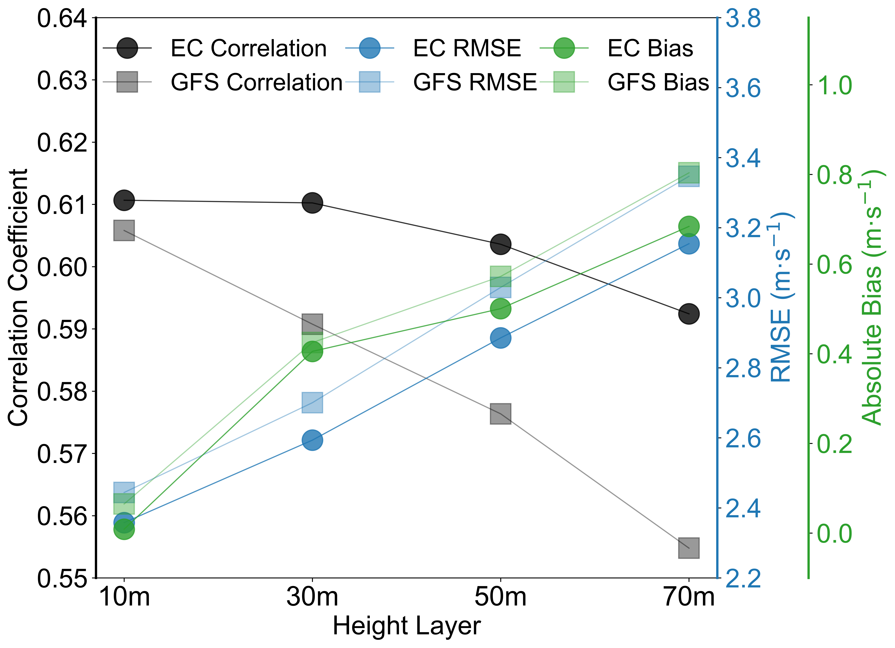
Figure 3.X. Multi-dimensional performance comparison of wind speed forecasts across different height layers. Three key metrics are displayed using separate y-axes: correlation coefficient (left, black), RMSE (right, blue), and absolute bias (right, green). Circular symbols represent ECMWF forecasts, while square symbols represent GFS forecasts.

3.2.2 Seasonal Characteristics
Moving from overall patterns to temporal variations, monthly-scale analysis reveals distinct seasonal forecast behaviors. At the monthly scale (Figure X), forecast trends from both data sources remain broadly consistent with observations, but systematic errors show clear seasonal dependence and increase with height. During January–March 2022, forecasts at all levels closely match observations, whereas from August to October 2022, forecasts at all levels significantly overestimate wind speeds, with larger errors at higher altitudes.
This seasonal bias pattern suggests that a uniform WRF configuration is insufficient to capture seasonal boundary-layer processes, particularly under the stable stratification commonly observed in late summer and early autumn. The result points to the need for season-specific optimization of physical parameterizations to improve forecast performance in the future.

Figure X. Seasonal characteristics of EC and GFS wind speed forecast bias at 10m and 70m heights. Box plots showing the temporal evolution of day-ahead forecast bias from May 2021 to October 2022. Each box represents the distribution of daily bias values within each month, where the central line indicates the median, box edges show the 25th and 75th percentiles, and whiskers extend to the 5th and 95th percentiles. Dark gray and light gray lines represent EC and GFS models at 10m height, while dark red and light red lines represent EC and GFS models at 70m height, respectively.

3.2.3 Diurnal Bias Characteristics
Examining forecast performance at finer temporal scales, analysis of diurnal cycles reveals distinct daily patterns of forecast error (Figure X). At 10 m, the bias peaks positively at 08:00 and negatively at 20:00, with minima around 00:00 and 12:00. This diurnal pattern reflects systematic deficiencies in representing the daily evolution of near-surface winds associated with boundary-layer development and decay.
At higher levels (30 to 70 m), the pattern differs markedly. A small negative bias occurs during 12:00 to 18:00, while pronounced positive biases dominate from 19:00 until the following midday. These contrasting patterns indicate differences in forecast performance across the vertical profile during different times of day.
Notably, relative performance between the two data sources also varies by time of day. From afternoon through early morning, GFS-WRF exhibits smaller biases, whereas EC-WRF performs better during the rest of the day. This temporal complementarity provides a physical basis for later multi-source fusion strategies.

Figure X. Diurnal bias patterns of EC and GFS wind speed forecasts across multiple height levels. Bar plots showing the statistical distribution of day-ahead forecast bias for wind speeds at 10m, 30m, 50m, and 70m heights throughout 24-hour periods. Each horizontal bar represents the percentile distribution of hourly bias values, where light colors indicate the 50% data range (interquartile range), medium colors show the 80% data range (10th-90th percentiles), and dark colors represent the 95% data range (5th-95th percentiles). Green bars represent EC model performance, while gray bars represent GFS model performance. Filled circles denote median bias values.

3.2.4 Forecast Skill under Wind Shear Conditions
To further understand forecast performance under operationally relevant conditions, we stratified the analysis by boundary-layer stability characteristics. Wind farm operations are particularly sensitive to vertical wind profile structure, as different stability regimes affect both individual turbine performance and wake interactions. We calculated wind shear exponents (α) using the power law relationship, and classified samples into six regimes based on shear strength and diurnal timing. These regimes include weak shear day (16,392 records), weak shear night (12,167), moderate day (8,026), moderate night (11,990), strong shear day (1,294), and strong shear night (1,496).
For 10 m wind speed, the best forecast ability occurs under moderate night conditions, followed by moderate day and weak shear cases, while strong shear regimes yield the poorest performance. The 70 m wind speed shows a different pattern: forecasts perform better during daytime but display the largest errors at night, particularly under weak shear conditions. These results align closely with the diurnal bias analysis, confirming that WRF exhibits systematic overestimation of upper-level winds under stable nighttime conditions. This finding reveals consistent forecast error patterns across different analytical approaches.

Figure X. Forecast performance under different wind shear and stability conditions. Scatter plots showing correlation coefficient vs RMSE for day-ahead wind speed forecasts at 10m daytime, 10m nighttime, 70m daytime, and 70m nighttime conditions. Points are colored by model (blue for EC, pink for GFS) and shaped by wind shear intensity (circles for weak, squares for moderate, triangles for strong shear). Points positioned closer to the bottom-right indicate superior forecast skill.

3.2.5 Summary
In summary, the 10 m wind speed consistently outperforms the 70 m wind speed in predictive ability, with near-zero bias compared to the pronounced positive bias at hub height and above. Forecast errors increase with height, a pattern that holds across seasons, diurnal cycles, and shear regimes. Between the two data sources, EC-WRF generally provides superior performance, though GFS-WRF shows relative advantages in certain periods and conditions, underscoring the potential benefits of combining complementary sources.
The diurnal and shear-based analyses further highlight systematic forecast error patterns that are linked to atmospheric stability conditions and their diurnal evolution. This not only confirms the greater predictive value of 10 m wind speed identified in Section 3.1 but also reveals its dual advantage of high contribution and high predictability. Together, these findings establish a firm foundation for the forecasting strategies developed in Section 3.3, which integrate both variable importance and predictability considerations. Additionally, the observed error patterns suggest that future research on boundary-layer representation in numerical models may provide pathways for further forecast improvements.

3.3 Construction of Prediction Strategies

3.3.1 Prediction Strategy Design
Based on the variable contribution analysis presented in Section 3.1 and the predictability assessment in Section 3.2, particularly the finding that 10 m wind speed provides a strong contribution to power forecasting, a total of eleven forecasting strategies were developed. These strategies were designed to systematically investigate the influence of input variable selection, data fusion, and modeling pathway on forecasting performance, and were organized into four categories. All machine learning components in these strategies used LightGBM due to its computational efficiency and strong regression performance, with hyperparameters tuned via grid search and cross-validation as described in Section 2.3.2 and 2.4.
The first category, referred to as direct prediction strategies, employed an end-to-end modeling pathway in which wind speed from NWP output at a single height was directly used to predict total power output. Four configurations were included, combining two NWP data sources—ECMWF-HRES and GFS—with two wind speed heights, 10 m and 70 m. For instance, in one configuration, ECMWF-HRES 10 m wind speed was used directly as the sole predictor variable for power forecasting, while in another configuration, GFS 70 m wind speed was applied in the same manner. The second category, termed two-step strategies, adopted a multi-stage machine learning approach. In these strategies, the first LightGBM model was trained to correct the NWP-derived wind speed to reduce systematic forecast errors, and the second model was trained to map the corrected wind speed to total power output. Four configurations were implemented, following the same combinations of data source and wind speed height as in the direct prediction strategies. The third category, defined as cross-source corrected fusion strategies, combined information from multiple NWP sources at the same height using the multi-stage approach. For a given height, wind speeds from GFS and ECMWF were corrected separately and then used together as combined predictors in the power-forecasting model. Two configurations were included, one at 10 m and one at 70 m, thereby isolating the effect of cross-source information at each height. The fourth category, representing the full fusion strategy, integrated all available wind speed information through the multi-stage framework. This strategy applied wind speed correction separately to the four series—ECMWF-HRES 10 m, ECMWF-HRES 70 m, GFS 10 m, and GFS 70 m—and subsequently combined them into a unified predictor set for power forecasting. Only one configuration belonged to this category.
This classification ensures that the forecasting strategies share a consistent methodological framework, enabling controlled comparisons across differences in input height, data source, and modeling pathway. The full specification of each strategy, including the experimental identifier, description, and associated performance metrics, is provided in Table 3.1.
Table 3.1. Comparative performance of wind power forecasting strategies using different modeling pathways and data configurations.
Rank | Strategy ID | Category | Pathway | Data source | Height | RMSE  (MW) | Correlation
1 | Fusion-M2 | 4 | Two-step | EC and GFS | 10m and 70m | 31.80 | 0.661
2 | X-M2-10m | 3 | Two-step | EC and GFS | 10m | 32.03 | 0.660
3 | X-M2-70m | 3 | Two-step | EC and GFS | 70m | 32.33 | 0.647
4 | E-M1-10m | 1 | Direct | EC | 10m | 33.15 | 0.632
5 | E-M2-10m | 2 | Two-step | EC | 10m | 33.16 | 0.630
6 | G-M2-10m | 2 | Two-step | GFS | 10m | 32.90 | 0.626
7 | G-M2-70m | 2 | Two-step | GFS | 70m | 32.80 | 0.622
8 | E-M1-70m | 1 | Direct | EC | 70m | 33.47 | 0.622
9 | G-M1-10m | 1 | Direct | GFS | 10m | 33.76 | 0.610
10 | E-M2-70m | 2 | Two-step | EC | 70m | 33.71 | 0.609
11 | G-M1-70m | 1 | Direct | GFS | 70m | 34.24 | 0.590

3.3.2 Forecasting Performance Comparison across Strategies
The day-ahead power forecasting results under different strategies reveal several consistent patterns, as summarized in Table 3.1.
For single data source experiments covering both direct and two-step strategies, the findings are consistent with the observational analyses in Sections 3.1 and 3.2. Forecasts based on 10 m wind speeds consistently outperform those based on 70 m across all configurations. In the direct forecasting strategies, E-M1-10m (Rank 4, RMSE 33.15 MW) and G-M1-10m (Rank 9, RMSE 33.76 MW) both yields substantially lower errors than their 70 m counterparts E-M1-70m (Rank 8, RMSE 33.47 MW) and G-M1-70m (Rank 11, RMSE 34.24 MW). The two-step forecasting strategies follow the same trend, with 10 m configurations consistently ranking higher. This advantage reflects both the stronger statistical relationship between 10 m wind speed and power output and the higher inherent accuracy of the 10 m wind speed forecasts.
Comparing the two strategy pathways shows that the two-step approach consistently produces smaller errors and more stable results across scenarios. For single-source strategies, the RMSE for direct forecasting ranges from 33.15 MW to 34.24 MW, compared with 32.80 MW to 33.71 MW for the two-step approach. This improvement is evident across all data source and height combinations, demonstrating the effectiveness of the wind speed correction step in reducing systematic forecast errors.
In the comparison of data sources, ECMWF-driven forecasts generally surpass those based on GFS for both strategy pathways. This pattern holds consistently except for E-M2-70m (Rank 10, RMSE 33.71 MW), which underperforms relative to G-M2-70m (Rank 7, RMSE 32.80 MW). This agrees with the earlier source performance analysis and confirms ECMWF superior baseline accuracy for most configurations.
When comparing single source and multi-source fusion strategies, clear benefits emerge from source complementarity. X-M2-10m (Rank 2, RMSE 32.03 MW) achieves superior performance compared to X-M2-70m (Rank 3, RMSE 32.33 MW) and all single-source strategies, ranking second overall. Notably, X-M2-10m approaches the performance of the optimal fusion configuration while using only 10 m wind speed data, highlighting both the importance of height selection and the value of cross-source information fusion.
The integrated strategy combining multiple data sources, multiple heights, and a two-step modeling framework delivers the best performance. Fusion-M2 (Rank 1) reduces RMSE to 31.80 MW and achieves a correlation coefficient of 0.661, representing the optimal configuration among all tested strategies. Compared with the widely used baseline G-M1-70m (Rank 11), Fusion-M2 achieves a 7.13% reduction in RMSE and a 12.03% improvement in correlation coefficient, demonstrating substantial enhancement in predictive skill.
Overall, these results validate the earlier variable analysis and confirm that combining multi-source fusion with a two-step modeling framework provides a robust and effective approach for improving day-ahead wind power forecasting, offering a clear technical pathway for system optimization.

3.3.3 Performance Evaluation under Wind Shear Conditions
To comprehensively assess the robustness and adaptability of the forecasting strategies, we further evaluated their performance under different wind shear conditions. This analysis provides a practically relevant assessment of strategy effectiveness across diverse boundary-layer stability regimes that commonly occur in wind farm operations.
The results reveal a consistent performance ranking across all six shear categories (Figure X). Fusion-M2 consistently outperforms all other strategies, demonstrating the strongest stability and adaptability across all conditions. In general, all strategies perform better during daytime than nighttime, with differences primarily reflected in the magnitude of errors rather than the overall pattern. More specifically, under daytime conditions, high shear yields the best performance, followed by low shear and then moderate shear. At night, high shear remains superior to moderate shear, while low shear conditions lead to the poorest performance. The superior performance under high shear conditions may be partially influenced by the smaller sample size (1,294 daytime and 1,496 nighttime records) compared to the other two categories, which could contribute to the observed lower RMSE values.
Further comparisons highlight the influence of data source and wind speed height on strategy effectiveness. Consistent with the findings in Section 3.2, GFS-driven strategies tend to perform better under high shear conditions, whereas ECMWF-driven strategies show more stable advantages under other regimes, underscoring the value of combining multiple data sources. The second-best strategy is X-M2-10m in five out of six categories, with the only exception being X-M2-70m under moderate daytime conditions. These results emphasize the importance of 10 m wind speed. Strategies based on 10 m consistently outperform those based on 70 m, while the latter often exhibit larger errors. This pattern is highly consistent with the observational analysis in Section 3.1 and the forecast skill evaluation in Section 3.2.
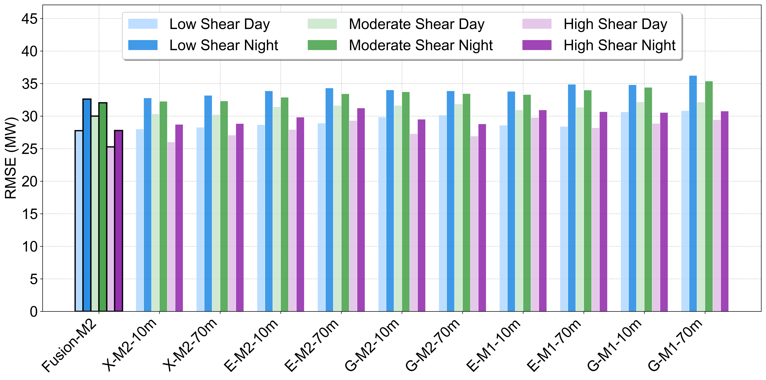
Figure 3.X. Wind power forecasting performance under varying wind shear and diurnal conditions. Test set RMSE values between predicted and actual total wind farm power output are shown for eleven strategies across six environmental scenarios. Fusion-M2, highlighted with black borders, significantly outperforms all other strategies.
Overall, these findings indicate that the proposed forecasting strategies maintain their relative advantages not only under average conditions but also across the diverse boundary-layer stability regimes encountered in wind farm operations. In particular, the multi-source fusion strategy demonstrates greater resilience under challenging conditions, highlighting its engineering value for building stable and reliable day-ahead forecasting systems in practice.

Discussion and conclusion

4.1 Possible Mechanisms Underlying the Importance of Near-Surface 10 m Wind Speed for the Entire Wind Farm
To investigate why 10 m wind speed shows superior performance in power forecasting, Ensemble Empirical Mode Decomposition (EEMD) was applied to decompose wind speed series at four levels (10 m, 30 m, 50 m, and 70 m) together with the farm-level power series into intrinsic mode functions (IMFs) representing different temporal scales. This frequency-domain analysis highlights vertical differences in wind speed signals and their linkages with forecasting performance.
During the observation period, the mean wind speeds at 10 m, 30 m, 50 m, and 70 m were 5.59 m/s, 6.40 m/s, 6.60 m/s, and 6.75 m/s, respectively. From an energy perspective, higher levels clearly carry more kinetic energy. However, contrary to conventional expectation, the 10 m wind speed showed notable importance for power forecasting. This indicates that its predictive value does not simply arise from wind energy density, but rather reflects deeper physical mechanisms.

4.1.1 Time-Scale Identification and Vertical Structure
The EEMD decomposition generated twelve IMFs for each series, which can be grouped into three frequency ranges. High-frequency components (IMF1–3) span sub-hourly to half-day scales (1–12 h) and are dominated by small-scale and local disturbances. Mid-frequency components (IMF4–6) cover diurnal to multi-day scales (1–5 d) and reflect the influence of synoptic systems. Low-frequency components (IMF7–12) represent weekly to seasonal scales and long-term trends (half-month to several years), capturing climate variability.

4.1.2 Frequency-Domain Correlation Across Heights
Correlation analysis among wind speed IMFs at different heights revealed distinct vertical structures (Figure 10, top). Strong consistency was found among 30 m, 50 m, and 70 m winds, with correlations above 0.8 across all bands and reaching approximately 0.9 for IMF2–12. This indicates that these levels are largely governed by the same flow processes.
In contrast, the 10 m wind exhibited a different pattern. At high-frequency scales (IMF1–3), correlations with upper levels dropped sharply, with IMF1 as low as 0.1–0.3. This suggests that near-surface fluctuations are fundamentally different from those aloft. Considering that the mast was located within the wind farm, this decoupling highlights a key physical mechanism. At hub height (70 m), the flow is directly influenced by turbine wakes and associated turbulence, while at 10 m the wake effect is much weaker, leaving a relatively clean wind signal.
At mid-frequency scales (IMF4–6), correlations rose to 0.8–0.9, reflecting the uniform impact of synoptic processes across heights. At low-frequency scales, correlations fell again in IMF7–8, rebounded in IMF9–11, and diverged once more for the trend component (IMF12). This indicates that over longer time scales, the 10 m wind speed provides a more stable representation of the environmental drivers of power, while upper levels may be affected by cumulative wake effects and more complex boundary-layer dynamics.

4.1.3 Frequency Matching Between Wind Speed and Power
The correlation between wind speed IMFs and power IMFs further illustrates the advantage of 10 m wind speed (Table X). In the high-frequency band (IMF1–3), all heights showed relatively low correlations with power (r < 0.5), reflecting the strong influence of non-meteorological factors such as turbine operations, maintenance, and curtailment. These short-term fluctuations in power are therefore not well explained by meteorology alone.
As the time scale increased, correlations improved. For IMF4 the coefficient reached 0.679, and for IMF5 it peaked at 0.807. At this multi-day weather scale (IMF5, approximately 1.7-day cycle), the correlation of 10 m wind speed with power (r = 0.807) was nearly the same as that of 70 m (r = 0.784). This indicates that at synoptic scales, winds at different heights all capture power variations reasonably well. From IMF5 onward, corresponding to time scales longer than two days, the 10 m wind consistently maintained correlations above 0.8 with power (IMF5–9), underscoring its advantage at the key scales relevant for forecasting.
A noteworthy feature appeared at longer scales. In IMF11–12, representing seasonal and trend variations, the correlation between 10 m wind speed and power reached 0.921 and 0.936, respectively, while correlations for upper levels dropped markedly. This strong long-term consistency suggests that 10 m wind speed provides a more reliable indicator of the climatic and environmental variations that drive farm-level power output.

4.1.4 Frequency-Domain Interpretation of Physical Mechanisms
The EEMD analysis reveals that 10 m wind speed exhibits stronger correlations with power at time scales longer than two days, while correlations at high-frequency scales remain relatively weak for all heights. Although upper-level winds carry more energy, they show weaker long-term consistency with power variations.
The high-frequency decoupling of 10 m wind speed from upper levels, together with its strong alignment with power at synoptic and longer scales, provides a robust physical interpretation. In flat terrain wind farms, near-surface measurements are less disturbed by turbine wakes and therefore preserve a cleaner record of the large-scale meteorological signal that drives power output. This scale-separation mechanism provides a new perspective on why 10 m wind speed is particularly valuable for forecasting.
The time scales longer than two days correspond directly to the horizon of day-ahead power forecasting. Therefore, the advantage of 10 m wind speed is not merely statistical but has direct practical relevance, translating into improved day-ahead forecasting skill. From an engineering perspective, this finding implies that easily accessible near-surface observations are sufficient to capture the critical information needed for power prediction, providing a practical and cost-effective basis for the design and optimization of forecasting systems.
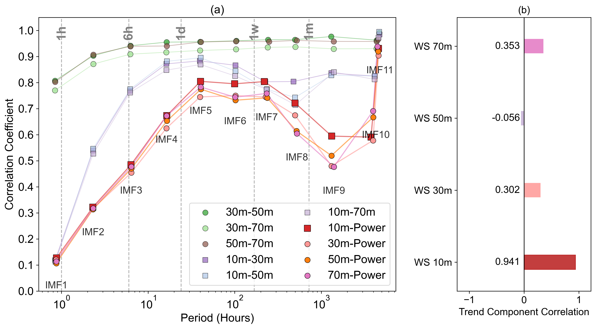
Figure X. Frequency-domain correlation analysis of multi-height wind speeds and power output. (a) Correlation coefficients between wind speed intrinsic mode functions (IMFs) at different heights and between wind speeds and power output across various temporal scales. Time scale annotations indicate characteristic periods: 1hr (hourly variations), 6hr (sub-daily processes), 1d (diurnal cycle), 1w (synoptic to weekly scale), 1m (monthly variations). Green symbols represent correlations among 30-70 m wind speeds, blue and purple symbols show correlations between 10 m and upper-level winds, and red and pink symbols indicate correlations between wind speeds at each measurement height and power output. (b) Trend component (IMF12) correlations between wind speeds at different heights and power output.

4.1.5 Implications for Forecasting Strategy Design
The EEMD analysis provides strong evidence that 10 m wind speed maintains superior correlation with power output at time scales longer than two days, while showing reduced coupling with upper-level winds at high frequencies. This pattern suggests that near-surface measurements preserve large-scale meteorological signals while upper levels are contaminated by wake effects. The frequency-domain decomposition reveals that high-frequency components (sub-daily scales) are dominated by non-meteorological factors such as turbine operations, maintenance activities, and grid management decisions, which introduce substantial noise into the wind-power relationship.
These findings have important implications for forecasting strategy optimization. The dominance of non-meteorological influences at high frequencies suggests that forecasting models could achieve better performance by focusing on mid-to-low frequency components rather than attempting to fit high-frequency noise. This provides a physical justification for why time series decomposition methods such as EMD and EEMD have shown effectiveness in wind power forecasting applications. By filtering out high-frequency disturbances and emphasizing the meteorologically-driven signals at daily and longer time scales, such approaches can improve the signal-to-noise ratio in the modeling process.
The results demonstrate that EEMD, when applied as a data-driven mechanism exploration method, can effectively separate the influences of wake effects and large-scale meteorological signals, thereby providing physical insights beyond statistical correlations. However, this interpretation remains inferential, based on statistical decomposition rather than direct observation of wake influences. To rigorously test the wake effect hypothesis, a controlled experimental design is needed that can separate wake-affected from wake-free conditions using the same measurement infrastructure. The geometric configuration of the study site, combined with its distinct wind climate, provides an ideal natural experiment for such validation.

4.2 Wind Direction-Based Validation of Wake Effect Hypothesis
To validate the proposed wake effect mechanism underlying the superior performance of 10 m wind speed, we conducted a field investigation at the study site in September 2025. The consistent findings across statistical correlation analysis (Section 3.1.2), SHAP interpretability analysis (Section 3.1.3), and optimal forecasting strategy performance (Section 3.3) establish the reliability of SHAP-based variable importance assessment for further mechanistic investigation. Therefore, we employed the same SHAP analytical framework to examine variable importance under controlled wind direction conditions that naturally separate wake-influenced from free-stream flow regimes.
The site inspection revealed that the wind farm consists of 134 turbines arranged primarily in a regular 4×33 grid pattern with two additional turbines interspersed within the array, oriented north-south, with the meteorological tower positioned approximately 586 m to the west of the wind farm boundary. This configuration, combined with the predominant east-west wind regime at the site, provides an ideal natural experiment for testing wake effects under controlled geometric conditions.

4.2.1 Site Configuration and Wind Climate
The wind farm layout exhibits a highly regular pattern with turbines arranged primarily in a 4×33 grid with two additional turbines interspersed within the array (Figure X). The inter-turbine spacing is 1200 m (approximately 14.6 rotor diameters) in the east-west direction and 300 m (approximately 3.7 rotor diameters) in the north-south direction. The meteorological tower is positioned 586 m (approximately 7.1 rotor diameters) to the west of the nearest turbine row, ensuring that for easterly winds, the measurement point experiences substantial wake influence from the entire wind farm, while for westerly winds, the tower receives completely undisturbed free-stream flow.
Wind rose analysis at 70 m height for the study period confirms a distinct bimodal distribution with dominant easterly (E-ENE) and westerly (W-WSW) flow regimes, accounting for approximately 68% of all observations (Figure X). This natural wind climate segregation allows for a controlled comparison of wake-affected versus free-stream conditions using the same measurement infrastructure and analytical framework.
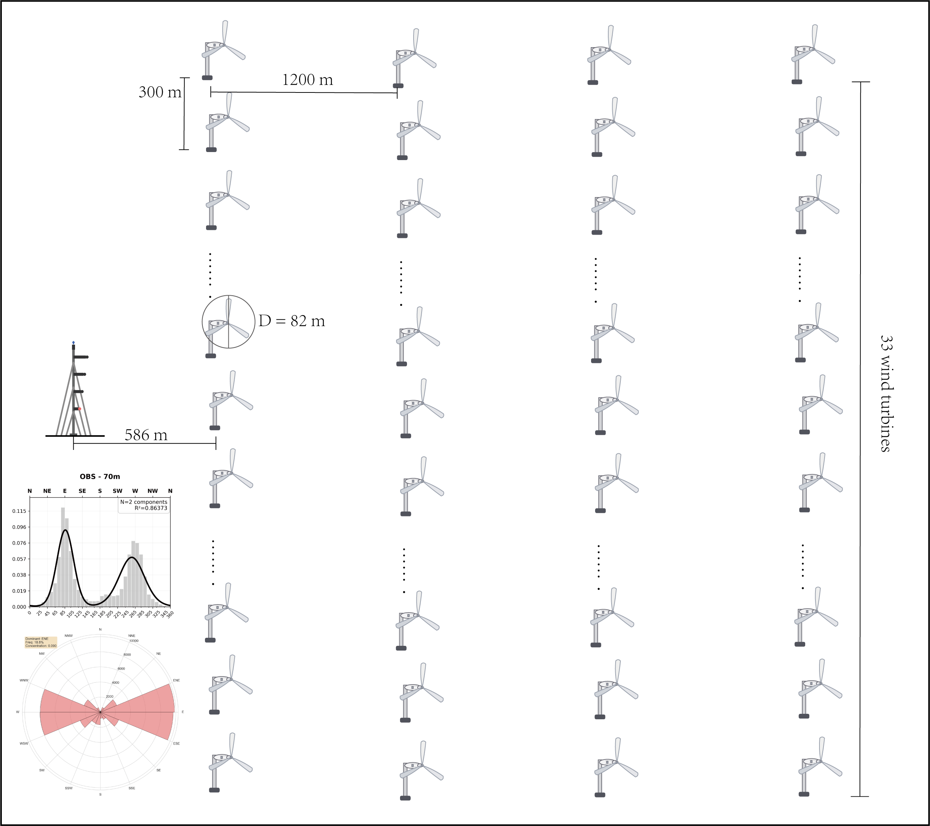
Figure X. Site configuration characteristics for wake effect validation. Schematic layout of the wind farm showing the spatial arrangement of 134 wind turbines in a primarily 4×33 grid pattern with two additional turbines interspersed within the array. The meteorological tower is positioned 586 m west of the wind farm boundary. Key geometric parameters include 1200 m east-west inter-turbine spacing (approximately 14.6 rotor diameters) and 300 m north-south spacing (approximately 3.7 rotor diameters), with turbine rotor diameter D = 82 m. The inset wind rose diagram shows wind direction distribution at 70 m height for the study period (May 2021 - October 2022), revealing a bimodal pattern with dominant easterly (E-ENE) and westerly (W-WSW) flow regimes.

4.2.2 Wind Direction Stratified SHAP Analysis
To ensure the most stringent comparison between wake-affected and free-stream conditions, we applied strict wind direction criteria requiring consistent wind directions across all four measurement heights (10 m, 30 m, 50 m, and 70 m). Only samples where all heights simultaneously recorded easterly winds (representing maximum wake influence) or westerly winds (representing free-stream conditions) were included in the analysis. This rigorous filtering ensures that the comparison reflects the most extreme contrasts between wake-affected and undisturbed flow regimes.
As shown in Figure X (a), under easterly wake-affected conditions, the SHAP analysis reveals an extreme dominance of 10 m wind speed with an importance score substantially exceeding all other meteorological variables. The wind speeds at upper levels (30 m, 50 m, and 70 m), despite being closer to hub height, show dramatically reduced importance scores, comparable to wind direction components and temperature. This pronounced suppression of upper-level wind speed importance under wake conditions strongly supports the hypothesis that wake effects significantly degrade the representativeness of hub-height measurements for total farm power prediction.
In contrast, as shown in Figure X (b), under westerly free-stream conditions, the variable importance hierarchy shifts notably. The 10 m wind speed maintains its leading position, but the gap with upper-level wind speeds narrows considerably. Wind speeds at 50 m and 70 m achieve substantially higher importance scores compared to wake-affected conditions, though still lower than the 10 m measurement. Temperature and wind direction components show similar importance levels as under wake conditions, confirming that the primary difference between flow regimes lies in the relative performance of multi-level wind speed measurements.

4.2.3 Physical Interpretation and Implications
The wind direction-stratified results provide compelling evidence for the wake effect hypothesis while revealing additional complexity in the 10 m wind speed advantage. Under maximum wake influence (easterly flow), the substantial suppression of upper-level wind speed importance confirms that wake effects severely compromise the relationship between hub-height measurements and total farm power. This validates the proposed mechanism that near-surface measurements preserve the large-scale meteorological signal while upper levels are contaminated by turbulent wake structures.
However, the persistence of 10 m wind speed superiority under free-stream conditions indicates that wake effects alone cannot fully explain the observed patterns. The continued advantage may be related to planetary boundary layer stability and vertical wind shear characteristics, where atmospheric stability conditions influence the vertical coupling between surface and upper-level winds. During stable conditions, strong vertical gradients may decouple upper-level winds from surface-driven processes, while enhanced vertical mixing during unstable conditions may reduce the effectiveness of hub-height point measurements compared to near-surface observations.
These findings suggest that near-surface standard meteorological observations may provide superior inputs for power prediction compared to dedicated hub-height measurements, enhancing the practical applicability of the proposed forecasting framework beyond wake-affected sites.

Figure X. SHAP feature importance analysis comparing wind turbine power prediction under contrasting wind direction conditions. (a) East wind conditions (NE-SE: 45°-135°) representing wake-affected scenarios, and (b) West wind conditions (NW-SW: 225°-315°) representing free-stream scenarios. Each point represents a single observation, with colors indicating normalized feature values (blue: low, red: high). Model performance metrics (R² and RMSE) are shown for each wind direction regime.

4.3 Limitations and future outlook
This study is based on observations from a single wind farm in flat terrain with uniform topography, low surface roughness, and specific turbine layout. The generalizability to other configurations, particularly complex terrain or different climates, remains unclear. The physical interpretation relies on statistical analysis and frequency-domain decomposition without validation from fluid dynamics simulations. While empirical correlations support the wake effect hypothesis, computational fluid dynamics would provide rigorous validation.
The wind direction-based validation, while providing compelling evidence for wake effects, employs a simplified two-regime classification. The strict filtering criteria requiring consistent wind directions across all measurement heights ensures clear contrasts but reduces sample size. These methodological choices, though necessary for rigorous hypothesis testing, represent trade-offs between experimental control and sample representativeness.
Multi-site validation represents the primary avenue for extending these findings. The hypothesis that 10 m wind speed provides superior forecasting performance should be tested across multiple flat terrain wind farms to establish broader applicability. Enhanced numerical weather prediction also offers significant potential. The consistent overestimation of upper-level wind speeds and superior skill at 10 m highlight opportunities for improving boundary layer parameterizations, particularly under stable nocturnal conditions. High-resolution computational modeling using large eddy simulations could provide detailed validation of the proposed wake mechanisms and enable investigation of turbine-specific operational effects.
This research establishes the importance of measurement height selection in wind energy applications and demonstrates that easily accessible near-surface observations can achieve superior forecasting performance compared to specialized hub-height measurements. The findings provide both theoretical insights into wind farm physics and practical guidance for operational forecasting systems, offering a foundation for cost-effective and scalable wind power prediction approaches.

4.4 Conclusion
This study challenges the conventional assumption that hub-height wind speed is most critical for wind power forecasting, revealing unexpected advantages of 10 m wind speed for farm-level power prediction. Through multiple analytical approaches including statistical correlation analysis, SHAP interpretability assessment, and frequency-domain decomposition, we demonstrate that near-surface measurements consistently outperform hub-height observations in explaining and predicting total farm power output.
The wind direction-based validation provides compelling empirical evidence for the proposed wake effect mechanism. Under wake-affected conditions, upper-level wind speed measurements show dramatically reduced importance for power prediction, while 10 m wind speed maintains dominant influence. Even under free-stream conditions, near-surface measurements retain superior predictive value, indicating that wake effects constitute only part of a more complex phenomenon involving boundary layer representativeness and atmospheric scale interactions.
This research establishes a physically consistent framework integrating EOF analysis, SHAP interpretability, and EEMD decomposition, creating a complete analytical chain from statistical associations to physical mechanisms. The framework overcomes black-box model limitations by developing a dual evaluation system that considers both variable contribution and predictability, ensuring interpretable and physically grounded results for input variable selection.
Multi-source fusion strategies based on this physical understanding significantly improve forecasting performance, reducing RMSE by 7.13% and increasing correlation coefficients by 11.86% compared to conventional approaches. The demonstrated effectiveness of easily accessible near-surface standard meteorological observations offers substantial practical advantages, reducing dependence on specialized hub-height measurements while maintaining superior prediction accuracy.
These findings fundamentally shift the perspective on variable selection in wind power forecasting, moving from traditional single-turbine power curve assumptions toward comprehensive consideration of farm-level flow physics. The research reveals that vertical wake stratification effects and boundary layer processes play critical roles in determining the optimal measurement strategy, providing scientific guidance for both measurement system design and forecasting strategy optimization. The established framework offers a transferable methodology for understanding meteorological variable relationships at wind farms while delivering immediate engineering benefits through cost-effective and scalable forecasting approaches.

Data and code availability
The datasets supporting this study, including meteorological observations from the wind farm, WRF simulation outputs, and post-processed analytical results, are publicly available at Science Data Bank with DOI: https://doi.org/10.57760/sciencedb.28855 . All code implementations used in this research, including data preprocessing, machine learning modeling, SHAP analysis, EEMD decomposition, and performance evaluation scripts, are publicly accessible on GitHub at https://github.com/Xiax24/WindForecast_Project. The code repository includes detailed documentation, example usage, and instructions for reproducing the main results presented in this study. Data access and code usage are provided under open-source licenses to facilitate research reproducibility and support further investigations in wind power forecasting methodologies.

Conflicts of Interest
The authors declare that they have no known competing financial interests or personal relationships that could have appeared to influence the work reported in this paper.

Author Contributions
Xin Xia: Conceptualization, Data curation, Formal analysis, Methodology, Software, Visualization, Writing – original draft preparation, Review and editing. Peidu Li: Formal analysis, Investigation. Yong Luo: Supervision, Funding acquisition, Project administration, Methodology, Resources.

符号表
numerical weather prediction (NWP)
RMSE root mean square error
empirical orthogonal function (EOF)
SHAP (SHapley Additive exPlanations)
Rs spearman correlation

