In day-ahead power forecasting for wind farms, the selection of meteorological factors is rarely examined or supported by physical evidence. The majority of studies concentrate on wind speeds at hub height, treating it as the primary or even single predictor of the atmospheric conditions driving turbine performance. This hub-height–centric practice reflects assumptions inherited from power curve theory, which was developed for single-turbine characterization under controlled testing conditions. However, the validity of these assumptions for wind farm-level forecasting, where complex wake interactions and spatial heterogeneity dominate the flow field, remains to be extensively investigated.
This hub-height–centric practice is widespread within the field of wind speed and wind power forecasting research. Wind speed forecasting studies focus almost exclusively on hub-height predictions. Some work to improve forecast accuracy at this height, others evaluate weather model performance, and still others develop methods to extrapolate from lower measurements up to hub height. Power forecasting shows two distinct approaches, but both center on hub height. Statistical and machine learning approaches commonly rely on hub-height wind speed as their primary meteorological input factors, often without investigating whether other variables carry meaningful physical information. NWP-based forecasting takes a different path. These systems extract many variables from weather models as inputs for power forecasting, including wind speeds at multiple levels, temperature, pressure, and humidity (Ref, Ref). While NWP methods extract multi-height wind data, few studies systematically investigate which heights best predict farm power or their complementary roles.
To illustrate this tendency, Table 1 summarizes the meteorological inputs used in representative forecasting studies. The table reveals that despite methodological diversity, hub-height measurements dominate input selection, with limited consideration of multi-height information or systematic variable screening.

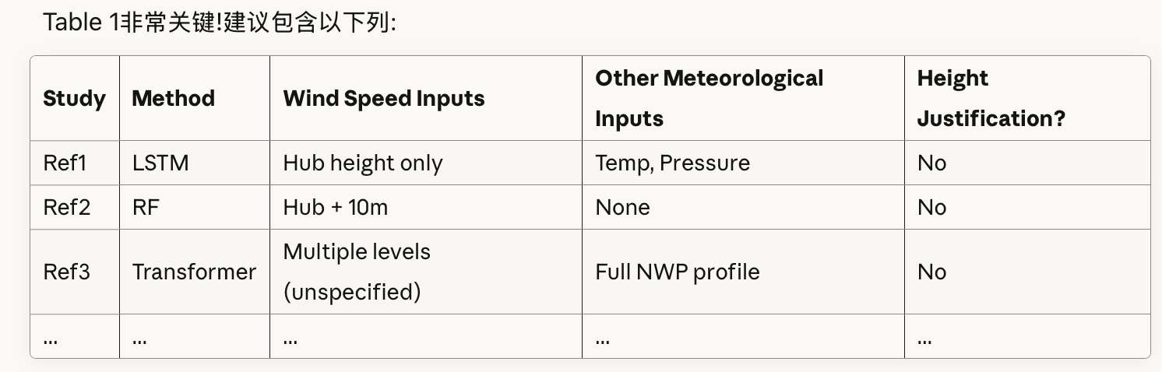
The hypothesis that hub height is power-representative has been supported by numerous studies demonstrating a high correlation with power matching. However, research has revealed contradictory patterns. One piece of evidence for this can be found in the work of Chen and Xu (2022), which reported correlations between multi-height observations and power generation at six wind farms in China. Among these, Wind Farm No. 4 demonstrated the strongest positive correlation (r=0.89) between wind speed at 10 meters—which is significantly below the rotor layer height of 50–90 meters—and wind farm power output, exceeding the correlation at hub height. Similar anomalies appeared across other sites, yet remained unexplained. This paradox reveals a fundamental flaw: that there is an absence of a physical framework capable of explaining why certain heights are only effective under specific conditions. This is also why this study selected a wind farm exhibiting a similar extreme pattern for analysis, aiming to establish a mechanistic understanding of the effectiveness of predictive factors rather than merely reporting statistical correlations.
To understand the conflict in this phenomenon, it is necessary to approach it from the perspective of the influence governing wind turbine and farm power generation, rather than concentrating on identifying the most important mathematical features. The research question should shift from "Which variables yield the best predictive performance?" to "What atmospheric conditions drive the varying power generation performance of wind farms, and through which observations can this driving relationship be captured and expressed?". This mechanistic perspective requires a re-examination of extant work and understanding.
Relevant studies have explored the impact of atmospheric conditions on the power generation performance of wind farms, progressing from idealized conditions to complex real-world scenarios. It is an established fact that the fundamental insights concerning the subject were first established in early studies conducted under controlled free-flow conditions. As demonstrated by Wagner et al. (2009), the rotor equivalent wind speed – defined as the vertical profile integrated over the swept area – exhibits superior performance in single-turbine power prediction when compared with single-point wind speed at hub height. This finding indicates that the performance of power generation is contingent not on a fixed single height, but rather on the vertical wind profile structure that is swept by the rotor. Wharton and Lundquist (2012) specifically selected wind turbines devoid of wake effects and revealed that atmospheric stability can engender a 15-20% power variation under the same wind speed conditions, with turbulent kinetic energy (TKE) emerging as a pivotal flow modulation factor that transcends wind speed itself.
Subsequent studies built upon these findings by extending them to actual wind farms, utilizing all available data without distinguishing wake conditions. Cutler et al. (2011) found that nacelle-level average wind speeds outperformed hub-height measurements from meteorological towers in characterizing overall-field power output, attributing this to their superior spatial representativeness at wind farm scales. Sasser et al. (2022) confirmed that rotor equivalent wind speed is a superior metric for measurement when compared with hub height observations, particularly when combined with atmospheric lapse rate information. Recent machine learning methodologies have been employed to quantify the importance of influential factors. Optis and Per-Sauer (2019) demonstrated that, in terms of predicting the outcome of a match, TKE is the strongest predictive factor after wind speed. This finding is consistent with the results reported by Kim and Kim (2023), who utilized an explainable AI (SHAP analysis) approach. Amongst the 13 meteorological factors considered, including wind speed, TKE, TI, and ε, wind speed emerged as the most significant factor. Turbulent variables (TKE > TI > ε) constituted the second tier of significant factors. However, it is worth noting that the field observation data used in the aforementioned studies may have been contaminated by wind turbine wake effects. The results presented may thus reflect a hybrid scenario involving both free-stream flow and wake influences, without systematically addressing this phenomenon.
Wake effects are a common phenomenon in wind farm environmental observations. Recent systematic studies have investigated flow field alterations induced by wakes, which fundamentally transform wind farm environments. As demonstrated in the seminal work of Barthelmie et al. (2007), the initial empirical evidence from field measurements revealed that wake interactions are responsible for significant power losses, ranging from 10% to 20%, and a substantial augmentation in turbulence intensity, reaching up to 20%. Asim et al. (2020) and Moss et al. (2024) further demonstrated that wakes introduce seasonal and spatial heterogeneity, including local acceleration, loss, and turbulence damping. This indicates that single-point measurements cannot represent inflow conditions under actual operating conditions of wind turbines.
These studies elucidate the key atmospheric influencing factors from diverse perspectives. Upon synthesis, it is evident that for free-flow conditions, atmospheric dynamic conditions in close proximity to the surface, such as equivalent wind speed (or wind profile over the swept area), stability, and turbulent kinetic energy, demonstrate a close correlation with power generation performance. In the context of comprehensive observational data, the average flow field, wind speed, and equivalent wind speed are of the utmost importance, with atmospheric stability and turbulence-related variables ranking a close second. However, empirical studies also indicate that the two flow types exhibit distinct responses to power generation, as the atmospheric conditions within the wake region are altered by turbine disturbance. However, when it comes to the practical implementation of forecasting and applications, it is essential to consider all flow states. It is therefore proposed that flow states be distinguished in order to identify and interpret key factors, with explanations being provided that are consistent with the underlying physical processes. The subsequent objective is to guide application-specific designs.
In summary, extant research suffers from a fundamental positioning bias: it focuses on mathematical feature ranking rather than understanding atmospheric physical processes. The following specific issues are identified: Firstly, there is a paucity of in-depth understanding of the physical response mechanisms governing total-field power. The scale of atmospheric processes to which total-field power responds remains unexplained, leading to a lack of physical basis for selecting predictive factors and preventing the mechanistic explanation of anomalous observations (such as the 10-metre height correlation reported by Chen & Xu). Secondly, research on free-flow and wake flows remains fragmented. It is imperative to note that the failure to undertake a comparative analysis of the differentiated characteristics of predictive factors under varying flow states hinders the selection of adaptive factors in mixed observational conditions. Thirdly, physical insights have not been translated into operational strategies. The significance of profiles, stability, and turbulence has not effectively guided practical day-ahead forecasts driven by NWP, with real-world applications still relying on empirical single-point strategies centered on hub height.
In order to address the aforementioned issues, the present study selected representative wind farms equipped with Met mast full-profile observations (10m, 30m, 50m, 70m) and conducted a three-tiered analysis: Firstly, all available observational data were analyzed using the EEMD decomposition and EOF analysis methods to elucidate the dominant meteorological response timescales and their physical mechanisms governing the overall power output of operational wind farms. Secondly, machine learning methods (SHAP) were employed to distinguish between free-stream and wake conditions based on wind direction, thereby revealing the differentiated characteristics and physical significance of predictive factors under different flow states. Thirdly, the integration of EC-WRF and GFS-WRF reanalysis NWP data with measured power output, combined with physical understanding and SHAP-identified features, day-ahead power forecasting strategies and LightGBM models tailored to different inflow characteristics were constructed.
The primary contributions of this study are as follows: (1) It is evident from a thorough examination of the available data that the selection of predictors should be based on atmospheric physical processes as opposed to mathematical weights. The employment of EEMD has been demonstrated to confirm that the full-field power response is reflective of atmospheric forcing at the weather scale, with the resultant manifestation of changes in vertical wind profile structure being direct. Consequently, the accuracy of the prediction is contingent upon the capture of the complete profile structure as opposed to a solitary fixed height, particularly the hub height. (2) The distinction between free-stream and wake flow, as revealed by SHAP, demonstrates unique influence characteristics. Core factors comprise profile variables (multi-height wind speeds) and density variables (temperature). Optimal height combinations vary across flow states; however, all serve to capture atmospheric forcing signals. (3) The provision of application strategies that are both practical and implementable is essential. Machine learning models driven by SHAP-identified factors are deployed for day-ahead power forecasting guided by NWP, achieving significantly enhanced prediction capabilities compared to baseline methods across varying inflow directions.

