物流信息供求网设计文档

目录

***一：设计背景***

***二：关键技术***

***三：模块设计***

***四: 模块设计***

一：设计背景

Mvc网上商城更快捷、更舒适、更安全。

二：关键技术

html、vs2019、

三、模块设计

四:模块设计

网站首页

提供信息浏览

<head id="Head1" runat="server">

<title>物流信息发布平台</title>

<link href="css/css.css" rel="stylesheet" type="text/css" />

<link href="css/css.css" rel="stylesheet" type="text/css" />

<link href="css/css.css" rel="stylesheet" type="text/css" />

<link href="css/css.css" rel="stylesheet" type="text/css" />

<link href="css/css.css" rel="stylesheet" type="text/css" />

<link href="css/css.css" rel="stylesheet" type="text/css" />

<link href="css/css.css" rel="stylesheet" type="text/css" />

<link href="css/css.css" rel="stylesheet" type="text/css" />

</head>

<body style="margin-top:0px; margin-bottom: 0px;">

<TABLE WIDTH=770 BORDER=0 align="center" CELLPADDING=0 CELLSPACING=0>

<form id="form1" runat="server">

<TR align="center" >

<TD WIDTH=770 height="38" COLSPAN=3 class="css" valign="top">

<uc1:head ID="Head2" runat="server" />

</TD>

</TR>

<TR>

<TD ROWSPAN=4 valign=top style="background-image: url(images/default_3.gif)">

<uc4:left1 id="Left1_1" runat="server"></uc4:left1></TD>

<TD COLSPAN=2 style="height: 105px">

<IMG SRC="images/default_4.gif" WIDTH=571 HEIGHT=91 ALT=""></TD>

</TR>

<TR>

<TD COLSPAN=2 style="width:571px;height: 203px" valign="top">

<table align=right cellspacing=1 bgcolor="#ADBDCE" style="height: 199px;width:557px">

<tr>

<td style="width: 40px; background-color: #adbdce; font-weight: bold; font-size: 13px;">

&nbsp; &nbsp;<asp:Image ID="Image1" runat="server" Height="15px" ImageUrl="images/biao.gif" />

&nbsp;

</td>

<td style="font-weight: bold; font-size: 13px; width: 197px;height:20px; background-color: #adbdce">货源信息</td>

<td style="background-color: #adbdce; font-size: 13px; color: #ffffff; text-align: right;"> &nbsp;<asp:HyperLink ID="HyperLink1" runat="server" ForeColor="White" NavigateUrl="Cargo_list.aspx" Font-Underline="False">更多信息</asp:HyperLink>&nbsp;&nbsp;&nbsp;</td>

</tr>

<tr bgcolor="#ADBDCE">

<td colspan="3" style="width: 100px; height: 118px; background-color: #FFFFFF; vertical-align: top;">

<asp:GridView ID="GridView1" runat="server" AutoGenerateColumns="False" HorizontalAlign="Right"

PageSize="8" Width="553px" BorderWidth="0px">

<Columns>

<asp:BoundField DataField="CargoName" HeaderText="货物名称" ReadOnly="True" SortExpression="CargoName" >

<ItemStyle HorizontalAlign="Center" />

</asp:BoundField>

<asp:BoundField DataField="Start" HeaderText="出发地点" ReadOnly="True" SortExpression="Start" >

<ItemStyle HorizontalAlign="Center" />

</asp:BoundField>

<asp:BoundField DataField="Whither" HeaderText="到达地点" ReadOnly="True" SortExpression="Whither" >

<ItemStyle HorizontalAlign="Center" />

</asp:BoundField>

<asp:BoundField DataField="EffectDate" HeaderText="有效日期" ReadOnly="True" SortExpression="EffectDate" >

<ItemStyle HorizontalAlign="Center" />

</asp:BoundField>

<asp:BoundField DataField="CargoDate" HeaderText="发货日期" ReadOnly="True" SortExpression="CargoDate" >

<ItemStyle HorizontalAlign="Center" />

</asp:BoundField>

<asp:HyperLinkField DataNavigateUrlFields="id" DataNavigateUrlFormatString="Cargo_open.aspx?id={0}"

HeaderText="详细信息" Target="_blank" Text="详细信息">

<ItemStyle HorizontalAlign="Center" />

</asp:HyperLinkField>

</Columns>

<RowStyle BackColor="#FBFBFF" Font-Size="12px" Height="17px" />

<HeaderStyle Font-Size="12px" BackColor="White" />

<AlternatingRowStyle BackColor="#FFFFF9" />

<FooterStyle BackColor="#FFFFF7" />

</asp:GridView>

</td>

</tr>

</table>

</TD>

</TR>

<TR>

<TD COLSPAN=2 style="WIDTH:571px;HEIGHT:205px"><table align=right cellspacing=1 bgcolor="#ADBDCE" style="height: 199px; width: 557px;">

<tr>

<td style="width: 50px; height: 10px; background-color: #adbdce; font-weight: bold; font-size: 13px;">

&nbsp; &nbsp;<asp:Image ID="Image2" runat="server" Height="15px" ImageUrl="images/biao.gif" /></td>

<td style="font-weight: bold; font-size: 13px;height:10px; background-color: #adbdce; width: 296px;">

车源信息</td>

<td style="background-color: #adbdce; font-size: 13px; color: #ffffff; height: 10px; text-align: right;">

<asp:HyperLink ID="HyperLink2" runat="server" Font-Underline="False" ForeColor="White"

NavigateUrl="Truck_list.aspx">更多信息</asp:HyperLink>

&nbsp;&nbsp; &nbsp;</td>

</tr>

<tr bgcolor="#ADBDCE">

<td colspan="3" style="width: 100px; height: 107px; background-color: #FFFFFF; vertical-align: top;">

<asp:GridView ID="GridView2" runat="server" AutoGenerateColumns="False" PageSize="8" Width="553px" BorderWidth="0px">

<Columns>

<asp:BoundField DataField="TruckType" HeaderText="车辆型号" ReadOnly="True" SortExpression="TruckType" />

<asp:BoundField DataField="TruckWeight" HeaderText="最大载重" ReadOnly="True" SortExpression="TruckWeight" />

<asp:BoundField DataField="Start" HeaderText="出发地点" ReadOnly="True" SortExpression="Start" />

<asp:BoundField DataField="Whither" HeaderText="到达地点" ReadOnly="True" SortExpression="Whither" />

<asp:BoundField DataField="TruckDate" HeaderText="发车时间" ReadOnly="True" SortExpression="TruckDate" />

<asp:HyperLinkField DataNavigateUrlFields="id" DataNavigateUrlFormatString="Truck_open.aspx?id={0}"

HeaderText="详细信息" Text="详细信息" Target="_blank" />

</Columns>

<RowStyle BackColor="#FBFBFF" Font-Size="12px" HorizontalAlign="Center" Height="18px" />

<AlternatingRowStyle BackColor="#FFFFF9" HorizontalAlign="Center" />

<HeaderStyle Font-Size="12px" />

</asp:GridView>

</td>

</tr>

</table>

</TD>

</TR>

<TR>

<TD COLSPAN=2 style="height:213px"><table align=right cellspacing=1 bgcolor="#ADBDCE" style="height: 199px; width: 557px;">

<tr>

<td style="width: 40px; height: 7px; background-color: #adbdce; font-weight: bold; font-size: 13px;">

&nbsp; &nbsp;<asp:Image ID="Image3" runat="server" Height="15px" ImageUrl="images/biao.gif" />

&nbsp;

</td>

<td style="font-weight: bold; font-size: 13px; width: 197px; background-color: #adbdce; height: 7px;">

司机信息</td>

<td style="background-color: #adbdce; font-size: 13px; color: #ffffff; height: 7px; text-align: right;">

<asp:HyperLink ID="HyperLink3" runat="server" Font-Underline="False" ForeColor="White"

NavigateUrl="Chauffeur_list.aspx">更多信息</asp:HyperLink>

&nbsp;&nbsp; &nbsp;</td>

</tr>

<tr bgcolor="#ADBDCE">

<td colspan="3" style="width: 100px; height: 137px; background-color: #FFFFFF; vertical-align: top;">

<asp:GridView ID="GridView3" runat="server" PageSize="8" AutoGenerateColumns="False" BorderWidth="0px" Font-Size="12px" Width="553px">

<Columns>

<asp:BoundField DataField="Type" HeaderText="发布类型" ReadOnly="True" SortExpression="Type" />

<asp:BoundField DataField="ChauffeurName" HeaderText="单位/姓名" />

<asp:BoundField DataField="DriveAge" HeaderText="驾驶年龄" />

<asp:BoundField DataField="TruckType" HeaderText="所开车型" />

<asp:BoundField DataField="Area" HeaderText="所在地区" />

<asp:HyperLinkField DataNavigateUrlFields="id" DataNavigateUrlFormatString="Chauffeur_open.aspx?id={0}"

HeaderText="详细信息" Text="详细信息" Target="_blank" />

</Columns>

<RowStyle BackColor="#FBFBFF" HorizontalAlign="Center" Height="17px" />

<AlternatingRowStyle BackColor="#FFFFF9" />

</asp:GridView>

</td>

</tr>

</table>

</TD>

</TR>

<TR>

<TD COLSPAN=2>

<IMG SRC="images/default_8.gif" WIDTH=770 HEIGHT=94 ALT=""></TD>

</TR>

<TR>

<TD ROWSPAN=3>

<uc3:left2 ID="Left2_1" runat="server" />

</TD>

<TD ROWSPAN=2 style="width: 572px; height: 210px;"><table align=right cellspacing=1 bgcolor="#ADBDCE" style="height: 199px; width: 557px;">

<tr>

<td style="width: 40px; height: 7px; background-color: #adbdce; font-weight: bold; font-size: 13px;">

&nbsp; &nbsp;<asp:Image ID="Image4" runat="server" Height="15px" ImageUrl="images/biao.gif" />

&nbsp;

</td>

<td style="font-weight: bold; font-size: 13px; width: 197px; background-color: #adbdce; height: 7px;">

二手车讯</td>

<td style="background-color: #adbdce; font-size: 13px; color: #ffffff; height: 7px; text-align: right;">

<asp:HyperLink ID="HyperLink4" runat="server" Font-Underline="False" ForeColor="White"

NavigateUrl="OldTruck_list.aspx">更多信息</asp:HyperLink>

&nbsp;&nbsp; &nbsp;</td>

</tr>

<tr bgcolor="#ADBDCE">

<td colspan="3" style="width: 100px; height: 142px; background-color: #FFFFFF; vertical-align: top;">

<asp:GridView ID="GridView4" runat="server" AutoGenerateColumns="False" PageSize="8" BorderWidth="0px" Font-Size="12px" Width="553px">

<Columns>

<asp:BoundField DataField="Type" HeaderText="发布类型" />

<asp:BoundField DataField="TruckName" HeaderText="车辆型号" />

<asp:BoundField DataField="MaxWeight" HeaderText="最大载重" />

<asp:BoundField DataField="Price" HeaderText="价格" />

<asp:BoundField DataField="Old" HeaderText="新旧程度" />

<asp:HyperLinkField DataNavigateUrlFields="id" DataNavigateUrlFormatString="OldTruck_open.aspx?id={0}"

HeaderText="详细信息" Text="详细信息" Target="_blank" />

</Columns>

<RowStyle BackColor="#FBFBFF" Height="18px" HorizontalAlign="Center" />

<AlternatingRowStyle BackColor="#FFFFF9" />

</asp:GridView>

</td>

</tr>

</table>

</TD>

</TR>

<TR>

</TR>

<TR>

<TD COLSPAN=1 style="width: 572px;height:208px"><table align=right cellspacing=1 bgcolor="#ADBDCE" style="height: 199px; width: 557px;">

<tr>

<td style="width: 40px; height: 7px; background-color: #adbdce; font-weight: bold; font-size: 13px;">

&nbsp; &nbsp;<asp:Image ID="Image5" runat="server" Height="15px" ImageUrl="images/biao.gif" />

&nbsp;

</td>

<td style="font-weight: bold; font-size: 13px; width: 197px; background-color: #adbdce; height: 7px;">

专线信息</td>

<td style="background-color: #adbdce; font-size: 13px; color: #ffffff; height: 7px; text-align: right;">

<asp:HyperLink ID="HyperLink5" runat="server" Font-Underline="False" ForeColor="White"

NavigateUrl="Way_list.aspx">更多信息</asp:HyperLink>

&nbsp;&nbsp; &nbsp;</td>

</tr>

<tr bgcolor="#ADBDCE">

<td colspan="3" style="width: 100px; height: 142px; background-color: #FFFFFF; vertical-align: top;">

<asp:GridView ID="GridView5" runat="server" AutoGenerateColumns="False" BorderWidth="0px" PageSize="8" Width="553px">

<Columns>

<asp:BoundField DataField="Type" HeaderText="发布类型" />

<asp:BoundField DataField="Start" HeaderText="出发地点" />

<asp:BoundField DataField="Whither" HeaderText="到达地点" />

<asp:BoundField DataField="Pirce" HeaderText="专线报价" />

<asp:BoundField DataField="Way" HeaderText="线路" />

<asp:HyperLinkField DataNavigateUrlFields="id" DataNavigateUrlFormatString="Way_open.aspx?id={0}"

HeaderText="详细信息" Text="详细信息" Target="_blank" />

</Columns>

<RowStyle BackColor="#FBFBFF" Font-Size="12px" Height="18px" HorizontalAlign="Center" />

<HeaderStyle Font-Size="12px" />

<AlternatingRowStyle BackColor="#FFFFF9" />

</asp:GridView>

</td>

</tr>

</table>

</TD>

</TR>

<TR>

<TD COLSPAN=2 style="height: 45px">

<uc2:foot ID="Foot1" runat="server" />

</TD>

</TR>

</form>

运行效果图

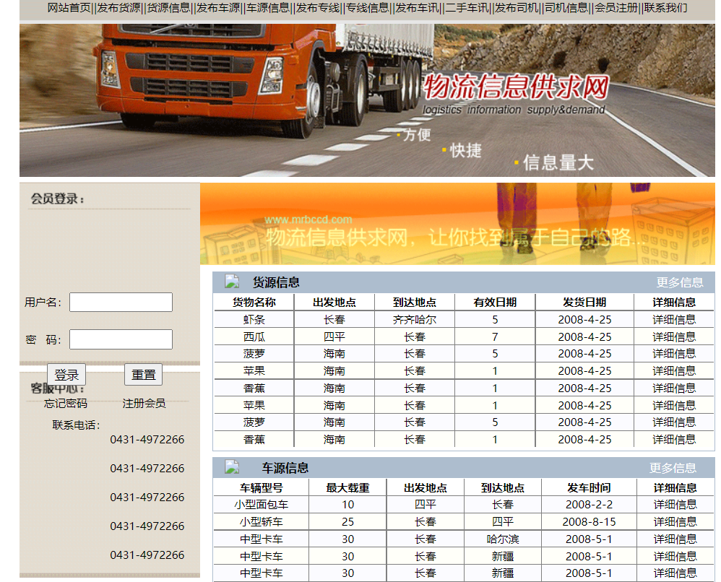

1. 注册模块

对输入的资料与数据库进行对比，如果存在相同数据则提示“已注册”，未存在的数据，择添加进数据库之中。

<head id="Head1" runat="server">

<title>发布车源信息</title>

<link href="css/css.css" rel="stylesheet" type="text/css" />

<link href="css/css.css" rel="stylesheet" type="text/css" />

<link href="css/css.css" rel="stylesheet" type="text/css" />

<link href="css/css.css" rel="stylesheet" type="text/css" />

<link href="css/css.css" rel="stylesheet" type="text/css" />

<link href="css/css.css" rel="stylesheet" type="text/css" />

<link href="css/css.css" rel="stylesheet" type="text/css" />

<link href="css/css.css" rel="stylesheet" type="text/css" />

</head>

<body style="margin-top:0px; margin-bottom: 0px;">

<TABLE WIDTH=770 BORDER=0 align="center" CELLPADDING=0 CELLSPACING=0 class=css>

<form id="form1" runat="server">

<TR align="center" >

<TD WIDTH=770 height="38" COLSPAN=3 class="css" valign="top">

<uc1:head ID="Head2" runat="server" />

</TD>

</TR>

<TR>

<TD ROWSPAN=2 valign=top style="background-image: url(images/default_3.gif)">

<uc4:left1 ID="Left1_1" runat="server" />

</TD>

<TD COLSPAN=2 style="height: 3px">

<asp:Image ID="Image1" runat="server" ImageUrl="images/default_4.gif" /></TD>

</TR>

<TR>

<TD COLSPAN=2 valign="top" style="width:571px;height: 635px">

<br />

<br />

<br />

<br />

<table width="463" border="1" align="center" cellspacing="0" bordercolor="#ADBDCE" style="height: 484px">

<tr align="center">

<td colspan="2" style="height: 35px">发布车源信息</td>

</tr>

<tr>

<td width="131" align="right">

<asp:RequiredFieldValidator ID="RequiredFieldValidator1" runat="server" ControlToValidate="TruckType"

ErrorMessage="车辆型号不能为空">*</asp:RequiredFieldValidator>车辆型号：</td>

<td style="width: 326px">&nbsp;<asp:TextBox ID="TruckType" runat="server"></asp:TextBox></td>

</tr>

<tr>

<td align="right">

&nbsp;<asp:RequiredFieldValidator ID="RequiredFieldValidator2" runat="server" ControlToValidate="TruckNumber"

ErrorMessage="车辆牌照不能为空">*</asp:RequiredFieldValidator>车辆牌照：</td>

<td style="width: 326px">&nbsp;<asp:TextBox ID="TruckNumber" runat="server"></asp:TextBox></td>

</tr>

<tr>

<td align="right">

<asp:CompareValidator ID="CompareValidator1" runat="server" ControlToValidate="TruckWeight"

Display="Dynamic" ErrorMessage="最大载重必须是数字" Operator="DataTypeCheck" Type="Integer">*</asp:CompareValidator>

<asp:RequiredFieldValidator ID="RequiredFieldValidator3" runat="server" ControlToValidate="TruckWeight"

ErrorMessage="最大载重不能为空" Display="Dynamic">*</asp:RequiredFieldValidator>最大载重：</td>

<td style="width: 326px">&nbsp;<asp:TextBox ID="TruckWeight" runat="server"></asp:TextBox>吨</td>

</tr>

<tr>

<td align="right">

<asp:CompareValidator ID="CompareValidator2" runat="server" ControlToValidate="TruckPrice"

ErrorMessage="运输价格必须是数字" Operator="DataTypeCheck" Type="Integer">*</asp:CompareValidator>

<asp:RequiredFieldValidator ID="RequiredFieldValidator4" runat="server" ControlToValidate="TruckPrice"

ErrorMessage="运输价格不能为空">*</asp:RequiredFieldValidator>运输价格：</td>

<td style="width: 326px">&nbsp;<asp:TextBox ID="TruckPrice" runat="server"></asp:TextBox>元</td>

</tr>

<tr>

<td align="right" style="height: 30px">

<asp:CompareValidator ID="CompareValidator3" runat="server" ControlToValidate="TruckDate"

Display="Dynamic" ErrorMessage="发车时间格式不正确" Operator="DataTypeCheck" Type="Date">*</asp:CompareValidator>

<asp:RequiredFieldValidator ID="RequiredFieldValidator5" runat="server" ControlToValidate="TruckDate"

ErrorMessage="发车时间不能为空">*</asp:RequiredFieldValidator>发车时间：</td>

<td style="width: 326px; height: 30px">&nbsp;<asp:TextBox ID="TruckDate" runat="server"></asp:TextBox>例如：2006-1-1</td>

</tr>

<tr>

<td align="right" style="height: 37px">

<asp:RequiredFieldValidator ID="RequiredFieldValidator6" runat="server" ControlToValidate="Start"

ErrorMessage="出发地点不能为空">*</asp:RequiredFieldValidator>出发地点：</td>

<td style="height: 37px; width: 326px;">&nbsp;<asp:TextBox ID="Start" runat="server" Width="240px"></asp:TextBox></td>

</tr>

<tr>

<td align="right">

<asp:RequiredFieldValidator ID="RequiredFieldValidator7" runat="server" ControlToValidate="Whither"

ErrorMessage="到达地点不能为空">*</asp:RequiredFieldValidator>到达地点：</td>

<td style="width: 326px">&nbsp;<asp:TextBox ID="Whither" runat="server" Width="240px"></asp:TextBox></td>

</tr>

<tr>

<td align="right">

&nbsp;<asp:RequiredFieldValidator ID="RequiredFieldValidator8" runat="server" ControlToValidate="Linkman"

ErrorMessage="联系人不能为空">*</asp:RequiredFieldValidator>联系人：</td>

<td style="width: 326px">&nbsp;<asp:TextBox ID="Linkman" runat="server" Width="114px"></asp:TextBox></td>

</tr>

<tr>

<td align="right">

<asp:RangeValidator ID="RangeValidator1" runat="server" ControlToValidate="Tel" ErrorMessage="联系电话必须是数字"

MaximumValue="99999999999" MinimumValue="00000000000">*</asp:RangeValidator>&nbsp;

<asp:RequiredFieldValidator ID="RequiredFieldValidator9" runat="server" ControlToValidate="Tel"

ErrorMessage="联系电话不能为空" Display="Dynamic">*</asp:RequiredFieldValidator>联系电话：</td>

<td style="width: 326px">&nbsp;<asp:TextBox ID="Tel" runat="server"></asp:TextBox></td>

</tr>

<tr>

<td align="right" style="height: 91px">车源描述：</td>

<td style="height: 91px; width: 326px;">&nbsp;<asp:TextBox ID="Bewrite" runat="server" Height="86px" TextMode="MultiLine"

Width="308px">无</asp:TextBox></td>

</tr>

<tr>

<td colspan="2" style="height: 40px; text-align: center">

<asp:ValidationSummary ID="ValidationSummary1" runat="server" ShowMessageBox="True"

ShowSummary="False" />

&nbsp;<asp:Button ID="Button1" runat="server" Text="　发布　" OnClick="Button1_Click" />

<input id="Reset1" type="reset" value="　重置　" /></td>

</tr>

</table>

<uc3:validate ID="Validate1" runat="server" />

</TD>

</TR>

<TR>

<TD COLSPAN=3 style="height: 45px">

<uc2:foot ID="Foot1" runat="server" />

</TD>

</TR>

</form>

</TABLE>

</body>

</html>

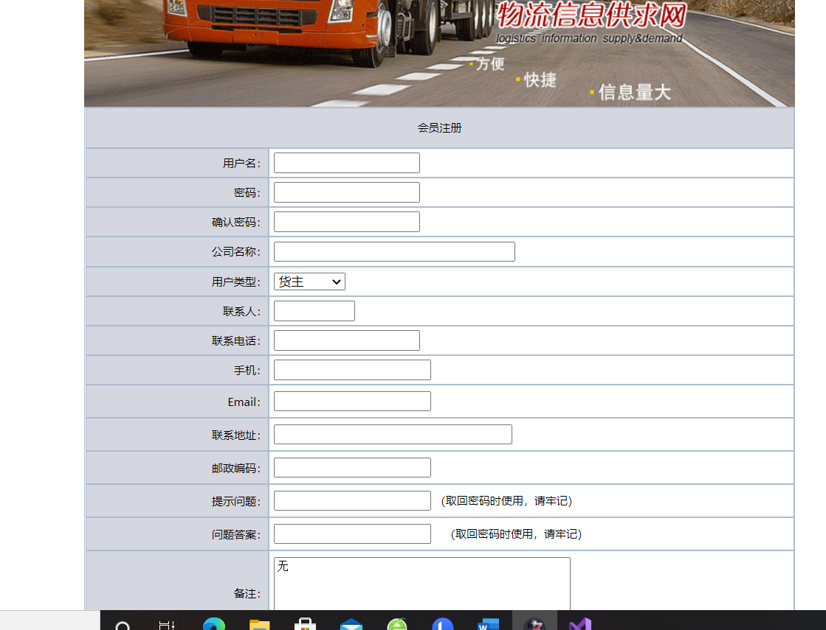

1. 登录模块。

账号与密码经由数据库对比没有出错，则跳转到首页。

<td height=200px>

<asp:Panel ID="Panel1" runat="server" Height="50px" Width="125px">

<table style="font-size: 12px; width: 188px; height: 184px" cellspacing="0">

<tr>

<td style="height: 45px" colspan="2">

</td>

</tr>

<tr>

<td style="width: 144px; height: 30px; text-align: right">

用户名：</td>

<td style="width: 194px; height: 30px">

<asp:TextBox ID="Username" runat="server" Width="106px"></asp:TextBox></td>

</tr>

<tr>

<td style="width: 144px; height: 49px; text-align: right">

密 &nbsp; 码：</td>

<td style="width: 194px; height: 49px">

<asp:TextBox ID="Userpwd" runat="server" Width="106px" TextMode="Password"></asp:TextBox></td>

</tr>

<tr>

<td align="center" colspan="2" style="height: 23px">

<asp:Button ID="Button1" runat="server" OnClick="Button1_Click" Text="登录" />

&nbsp; &nbsp; &nbsp; &nbsp; &nbsp;&nbsp;

<input id="Reset1" type="reset" value="重置" /></td>

</tr>

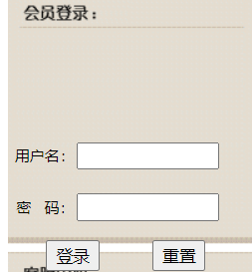

1. 货源信息模块

购物车模块，购物车中包含了用户准备购买的所有商品信息，包括名称、价格、编号。

<head runat="server">

<title>货源信息</title>

<link href="css/css.css" rel="stylesheet" type="text/css" />

</head>

<body topmargin="0">

<table width="770" border="0" align="center" cellspacing="0" style="clip: rect(auto auto auto auto)">

<tr>

<td style="width: 715px; height: 208px"><uc1:head ID="Head1" runat="server" />

</td>

</tr>

<tr>

<td style="width: 715px;height:350px;BACKGROUND-COLOR: #efefef" valign=top >

<form id="form1" runat="server">

<div>

<asp:GridView ID="GridView1" runat="server" AllowPaging="True" AutoGenerateColumns="False"

BackColor="White" BorderColor="White" BorderStyle="None" BorderWidth="2px" CellPadding="3"

CellSpacing="1" GridLines="None" PageSize="20" Font-Size="12px" OnPageIndexChanging="GridView1_PageIndexChanging" Width="770px" HorizontalAlign="Center" >

<PagerSettings FirstPageText="第一页" LastPageText="最后一页" Mode="NextPreviousFirstLast"

NextPageText="下一页" PreviousPageText="上一页" />

<FooterStyle BackColor="#C6C3C6" ForeColor="Black" />

<Columns>

<asp:BoundField DataField="CargoName" HeaderText="货物名称" SortExpression="CargoName" >

<ItemStyle HorizontalAlign="Center" />

</asp:BoundField>

<asp:BoundField DataField="CargoWeight" HeaderText="货物重量" ReadOnly="True" SortExpression="CargoWeight" >

<ItemStyle HorizontalAlign="Center" />

</asp:BoundField>

<asp:BoundField DataField="CargoPrice" HeaderText="运输价格" ReadOnly="True" SortExpression="CargoPrice" >

<ItemStyle HorizontalAlign="Center" />

</asp:BoundField>

<asp:BoundField DataField="Start" HeaderText="出发地点" ReadOnly="True" SortExpression="Start" >

<ItemStyle HorizontalAlign="Center" />

</asp:BoundField>

<asp:BoundField DataField="Whither" HeaderText="到达地点" ReadOnly="True" SortExpression="Whither" >

<ItemStyle HorizontalAlign="Center" />

</asp:BoundField>

<asp:BoundField DataField="EffectDate" HeaderText="有效期限" ReadOnly="True" SortExpression="EffectDate" >

<ItemStyle HorizontalAlign="Center" />

</asp:BoundField>

<asp:BoundField DataField="CargoDate" HeaderText="发货日期" ReadOnly="True" SortExpression="CargoDate" >

<ItemStyle HorizontalAlign="Center" />

</asp:BoundField>

<asp:HyperLinkField DataNavigateUrlFields="id" DataNavigateUrlFormatString="Cargo_open.aspx?id={0}"

HeaderText="详细信息" Target="_blank" Text="详细信息">

<ItemStyle HorizontalAlign="Center" />

</asp:HyperLinkField>

</Columns>

<RowStyle BackColor="#EFEFEF" ForeColor="Black" />

<SelectedRowStyle BackColor="#9471DE" Font-Bold="True" ForeColor="White" />

<PagerStyle BackColor="#C6C3C6" ForeColor="Black" HorizontalAlign="Right" />

<HeaderStyle BackColor="#ADBDCE" Font-Bold="False" ForeColor="Black" Wrap="False" Font-Italic="False" Font-Overline="False" Font-Strikeout="False" Font-Underline="False" />

</asp:GridView>

</div>

</form>

</td>

</tr>

<tr>

<td>

<uc2:foot ID="Foot1" runat="server" />

</td>

</tr>

</table>

</body>

</html>

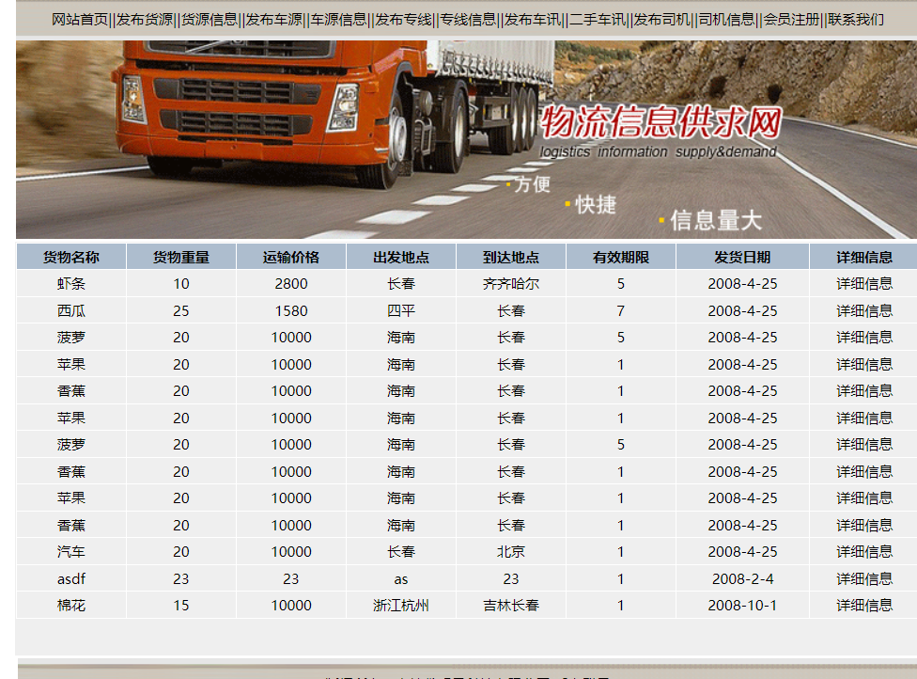

5：发布货源信息模块

给与客户与我们的联系

<head id="Head1" runat="server">

<title>发布货源信息</title>

<link href="css/css.css" rel="stylesheet" type="text/css" />

<link href="css/css.css" rel="stylesheet" type="text/css" />

<link href="css/css.css" rel="stylesheet" type="text/css" />

</head>

<body style="margin-top:0px; margin-bottom: 0px;">

<TABLE WIDTH=770 BORDER=0 align="center" CELLPADDING=0 CELLSPACING=0>

<form id="form1" runat="server">

<TR align="center" >

<TD WIDTH=770 height="38" COLSPAN=3 class="css" valign="top">

<uc1:head ID="Head2" runat="server" />

</TD>

</TR>

<TR>

<TD ROWSPAN=2 valign=top style="background-image: url(images/default_3.gif); width: 339px;">

<uc4:left1 ID="Left1_1" runat="server" />

</TD>

<TD COLSPAN=2 style="height: 3px">

<asp:Image ID="Image1" runat="server" ImageUrl="images/default_4.gif" /></TD>

</TR>

<TR>

<TD COLSPAN=2 valign="top" style="width:571px;height: 635px">

<br />

<br />

<br />

<br />

&nbsp;<table border="1" align="center" cellspacing="0" class="css" style="width: 457px; height: 491px" bordercolor="#adbdce">

<tr align="center">

<td height="40" colspan="2">发布货源信息</td>

</tr>

<tr>

<td align="right" style="width: 115px; height: 29px"><asp:RequiredFieldValidator

ID="RequiredFieldValidator1" runat="server" ControlToValidate="CargoName"

ErrorMessage="货物名称必须填写" Width="13px">*</asp:RequiredFieldValidator>货物名称：</td>

<td width="239" >&nbsp;<asp:TextBox ID="CargoName" runat="server"></asp:TextBox><span style="height: 29px; color: #ff0066;"></span></td>

</tr>

<tr>

<td align="right" style="width: 115px; height: 28px">

<asp:CompareValidator ID="CompareValidator1" runat="server" ControlToValidate="CargoWeight"

Display="Dynamic" ErrorMessage="输入数字" Type="Integer" Operator="DataTypeCheck">*</asp:CompareValidator>

<asp:RequiredFieldValidator ID="RequiredFieldValidator2" runat="server" ControlToValidate="CargoWeight"

Display="Dynamic" ErrorMessage="货物重量必须填写">*</asp:RequiredFieldValidator>货物重量：</td>

<td style="height: 28px">&nbsp;<asp:TextBox ID="CargoWeight" runat="server" Width="80px"></asp:TextBox>吨&nbsp;

</td>

</tr>

<tr>

<td align="right" style="width: 115px">

<asp:RequiredFieldValidator ID="RequiredFieldValidator3" runat="server" ControlToValidate="CargoPrice"

Display="Dynamic" ErrorMessage="运输价格必须填写">*</asp:RequiredFieldValidator>

<asp:CompareValidator

ID="CompareValidator2" runat="server" ControlToValidate="CargoPrice" Display="Dynamic"

ErrorMessage="请输入数字" Type="Integer" Operator="DataTypeCheck">*</asp:CompareValidator>运输价格：</td>

<td>&nbsp;<asp:TextBox ID="CargoPrice" runat="server"></asp:TextBox>元

</td>

</tr>

<tr>

<td align="right" style="width: 115px; height: 29px;">

<asp:CompareValidator ID="CompareValidator3" runat="server" ControlToValidate="CargoDate"

ErrorMessage="日期格式错误" Operator="DataTypeCheck" Type="Date">*</asp:CompareValidator>

<asp:RequiredFieldValidator

ID="RequiredFieldValidator4" runat="server" ControlToValidate="CargoDate" Display="Dynamic"

ErrorMessage="发货日期必须填写" Width="1px">*</asp:RequiredFieldValidator>

发货日期：</td>

<td rowspan="" style="height: 29px">&nbsp;<asp:TextBox ID="CargoDate" runat="server"></asp:TextBox>例如：2008-5-8</td>

</tr>

<tr>

<td align="right" style="width: 115px; height: 28px;">

&nbsp;<asp:RequiredFieldValidator ID="RequiredFieldValidator5" runat="server" ControlToValidate="Start"

Display="Dynamic" ErrorMessage="出发地点不能为空">*</asp:RequiredFieldValidator>出发地点：</td>

<td style="height: 28px">&nbsp;<asp:TextBox ID="Start" runat="server" MaxLength="50" Width="255px"></asp:TextBox><span style="height: 29px; color: #ff0066;"></span></td>

</tr>

<tr>

<td align="right" style="width: 115px">

<asp:RequiredFieldValidator ID="RequiredFieldValidator6" runat="server" ControlToValidate="Whither"

ErrorMessage="到达地点不能为空">*</asp:RequiredFieldValidator>到达地点：</td>

<td>&nbsp;<asp:TextBox ID="Whither" runat="server" Width="253px"></asp:TextBox><span style="height: 29px; color: #ff0066;"></span></td>

</tr>

<tr>

<td align="right" style="width: 115px">

<asp:RequiredFieldValidator ID="RequiredFieldValidator7" runat="server" ControlToValidate="Linkman"

ErrorMessage="联系人不能为空">*</asp:RequiredFieldValidator>联系人：</td>

<td colspan="">&nbsp;<asp:TextBox ID="Linkman" runat="server" Width="80px"></asp:TextBox><span style="height: 29px; color: #ff0066;"></span></td>

</tr>

<tr>

<td align="right" style="width: 115px; height: 26px;">

<asp:RangeValidator ID="RangeValidator1" runat="server" ControlToValidate="Tel" ErrorMessage="联系电话必须是数字"

MaximumValue="99999999999" MinimumValue="00000000000">*</asp:RangeValidator>

<asp:RequiredFieldValidator ID="RequiredFieldValidator8" runat="server" ControlToValidate="Tel"

Display="Dynamic" ErrorMessage="联系电话不能为空">*</asp:RequiredFieldValidator>联系电话：</td>

<td style="height: 26px">&nbsp;<asp:TextBox ID="Tel" runat="server"></asp:TextBox><span style="height: 29px; color: #ff0066;"></span></td>

</tr>

<tr>

<td align="right" style="width: 115px; height: 32px">有效期限：</td>

<td style="height: 32px">&nbsp;<asp:DropDownList ID="EffectDate" runat="server">

<asp:ListItem>1</asp:ListItem>

<asp:ListItem>2</asp:ListItem>

<asp:ListItem>3</asp:ListItem>

<asp:ListItem>4</asp:ListItem>

<asp:ListItem>5</asp:ListItem>

<asp:ListItem>6</asp:ListItem>

<asp:ListItem>7</asp:ListItem>

</asp:DropDownList>天</td>

</tr>

<tr>

<td align="right" style="width: 115px; height: 89px">备注：</td>

<td style="height: 89px">&nbsp;<asp:TextBox ID="Bewrite" runat="server" Height="69px" TextMode="MultiLine"

Width="315px" >无</asp:TextBox></td>

</tr>

<tr>

<td colspan="2" align="center">&nbsp;<asp:Button ID="Button1" runat="server" OnClick="Button1_Click" Text="　发布　" />

<input id="Button2" type="reset" value="　重置　" />&nbsp;

<asp:ValidationSummary ID="ValidationSummary1" runat="server" ShowMessageBox="True"

ShowSummary="False" />

<br />

</td>

</tr>

</table>

</TD>

</TR>

<TR>

<TD COLSPAN=3 style="height: 45px">

<uc2:foot ID="Foot1" runat="server" />

</TD>

</TR>

</form>

</TABLE>

<uc3:validate ID="Validate1" runat="server" />

</body>

</html>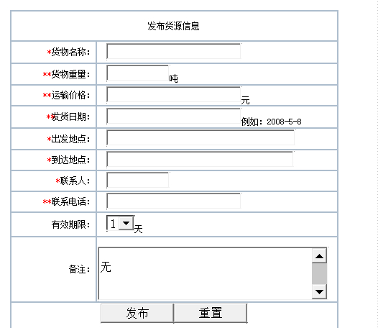

6：管理员登录模块

管理员模块是根据系统数据维护要求而设计的后台管理模块

<head runat="server">

<title>物流信息发布平台后台管理系统</title>

<script language=javascript>

function empty()

{

form1.username.value="";

form1.userpwd.value="";

form1.number.value="";

}

</script>

</head>

<body style="text-align: center">

<form id="form1" runat="server">

<div align=center>

&nbsp;<br />

<br />

<br />

<br />

<TABLE WIDTH=450 BORDER=0 CELLPADDING=0 CELLSPACING=0 align="center">

<TR>

<TD COLSPAN=5>

<IMG SRC="images/login_1.gif" WIDTH=450 HEIGHT=150 ALT=""></TD>

</TR>

<TR>

<TD ROWSPAN=3>

<IMG SRC="images/login_2.gif" WIDTH=198 HEIGHT=146 ALT=""></TD>

<TD COLSPAN=2 style="background-image: url(images/login_3.gif)">

<table style="font-size: 12px">

<tr>

<td style="width: 72px; height: 17px; text-align: right">

<asp:CustomValidator ID="CustomValidator1" runat="server" ControlToValidate="username"

Display="Dynamic" OnServerValidate="CustomValidator1_ServerValidate" ErrorMessage="用户名中含非法字符">*</asp:CustomValidator>

<asp:RequiredFieldValidator ID="RequiredFieldValidator1" runat="server" ControlToValidate="username"

ErrorMessage="用户名不能为空" Display="Dynamic">*</asp:RequiredFieldValidator>用户名：</td>

<td style="width: 100px; height: 17px">

<asp:TextBox ID="username" runat="server" Height="12px" Width="89px"></asp:TextBox></td>

</tr>

<tr>

<td style="width: 72px; height: 22px; text-align: right">

<asp:CustomValidator ID="CustomValidator2" runat="server" ControlToValidate="userpwd"

Display="Dynamic" ErrorMessage="密码中含有非法字符" OnServerValidate="CustomValidator2_ServerValidate">*</asp:CustomValidator>

<asp:RequiredFieldValidator ID="RequiredFieldValidator2" runat="server" ControlToValidate="userpwd"

ErrorMessage="密码不能为空" Display="Dynamic">*</asp:RequiredFieldValidator>密&nbsp; &nbsp; 码：</td>

<td style="width: 100px; height: 22px">

<asp:TextBox ID="userpwd" runat="server" Height="12px" Width="89px" TextMode="Password"></asp:TextBox></td>

</tr>

<tr>

<td style="width: 72px; text-align: right">

&nbsp;<asp:RequiredFieldValidator ID="RequiredFieldValidator3" runat="server" ControlToValidate="number"

ErrorMessage="验证码不能为空">*</asp:RequiredFieldValidator>验证码：</td>

<td style="width: 100px; text-align: left;"><asp:TextBox ID="number" runat="server" Height="12px" MaxLength="4" Width="32px" OnTextChanged="number_TextChanged"></asp:TextBox>

<asp:Label ID="Label1" runat="server" ForeColor="Red"></asp:Label></td>

</tr>

</table>

</TD>

<TD COLSPAN=2>

<IMG SRC="images/login_4.gif" WIDTH=56 HEIGHT=76 ALT=""></TD>

</TR>

<TR>

<TD style="height: 31px">

<asp:ImageButton ID="ImageButton1" runat="server" ImageUrl="images/login_5.gif" OnClick="ImageButton1_Click" /></TD>

<TD COLSPAN=2 style="height: 31px">

<img src="images/login_6.gif" onclick="empty()" style="cursor:hand"/></TD>

<TD ROWSPAN=2>

<IMG SRC="images/login_7.gif" WIDTH=55 HEIGHT=70 ALT=""></TD>

</TR>

<TR>

<TD COLSPAN=3>

<IMG SRC="images/login_8.gif" WIDTH=197 HEIGHT=39 ALT=""></TD>

</TR>

<TR>

<TD>

<IMG SRC="images/spacer.gif" WIDTH=198 HEIGHT=1 ALT=""></TD>

<TD>

<IMG SRC="images/spacer.gif" WIDTH=103 HEIGHT=1 ALT=""></TD>

<TD>

<IMG SRC="images/spacer.gif" WIDTH=93 HEIGHT=1 ALT=""></TD>

<TD>

<IMG SRC="images/spacer.gif" WIDTH=1 HEIGHT=1 ALT=""></TD>

<TD>

<IMG SRC="images/spacer.gif" WIDTH=55 HEIGHT=1 ALT=""></TD>

</TR>

</TABLE>

</div>

<asp:ValidationSummary ID="ValidationSummary1" runat="server" Font-Size="12px" />

&nbsp;

</form>

</body>

</html>

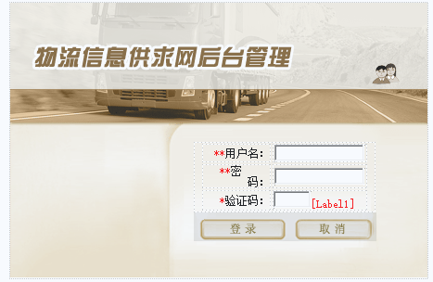

7。货源信息管理

通过这一步操作进行货源的审核

head runat="server">

<title>无标题页</title>

</head>

<body leftmargin="0" bgcolor=#efefef>

<form id="form1" runat="server">

<div>

<asp:GridView ID="GridView1" runat="server" AllowPaging="True" AutoGenerateColumns="False"

BackColor="White" BorderColor="White" BorderStyle="None" BorderWidth="2px" CellPadding="3"

CellSpacing="1" GridLines="None" PageSize="20" Font-Size="12px" OnPageIndexChanging="GridView1_PageIndexChanging" Width="570px" HorizontalAlign="Center" OnRowDataBound="GridView1_RowDataBound" OnSelectedIndexChanging="GridView1_SelectedIndexChanging" OnRowDeleting="GridView1_RowDeleting">

<PagerSettings FirstPageText="第一页" LastPageText="最后一页"

NextPageText="下一页" PreviousPageText="上一页" />

<FooterStyle BackColor="#C6C3C6" ForeColor="Black" />

<Columns>

<asp:BoundField DataField="CargoName" HeaderText="货物名称" SortExpression="CargoName" >

<ItemStyle HorizontalAlign="Center" />

</asp:BoundField>

<asp:BoundField DataField="CargoDate" HeaderText="发货日期" ReadOnly="True" SortExpression="Start" >

<ItemStyle HorizontalAlign="Center" />

</asp:BoundField>

<asp:BoundField DataField="username" HeaderText="发布用户" ReadOnly="True" SortExpression="Whither" >

<ItemStyle HorizontalAlign="Center" />

</asp:BoundField>

<asp:BoundField DataField="CargoNow" HeaderText="发布日期">

<ItemStyle HorizontalAlign="Center" />

</asp:BoundField>

<asp:BoundField DataField="Auditing" HeaderText="审核">

<ItemStyle HorizontalAlign="Center" />

</asp:BoundField>

<asp:HyperLinkField DataNavigateUrlFields="id" DataNavigateUrlFormatString="../Cargo_open.aspx?id={0}"

HeaderText="详细信息" Target="_blank" Text="详细信息">

<ItemStyle HorizontalAlign="Center" />

</asp:HyperLinkField>

<asp:CommandField HeaderText="删除" ShowDeleteButton="True">

<ItemStyle HorizontalAlign="Center" />

</asp:CommandField>

<asp:CommandField SelectText="通过/取消" ShowSelectButton="True">

<ItemStyle HorizontalAlign="Center" />

</asp:CommandField>

</Columns>

<RowStyle BackColor="#EFEFEF" ForeColor="Black" />

<SelectedRowStyle BackColor="#E8E8FF" Font-Bold="True" ForeColor="Black" />

<PagerStyle BackColor="#C6C3C6" ForeColor="Black" HorizontalAlign="Right" />

<HeaderStyle BackColor="#ADBDCE" Font-Bold="False" ForeColor="Black" Wrap="False" Font-Italic="False" Font-Overline="False" Font-Strikeout="False" Font-Underline="False" />

</asp:GridView>

<uc1:enter ID="Enter1" runat="server" />

&nbsp;

&nbsp;&nbsp;</div>

</form>

</body>

</html>

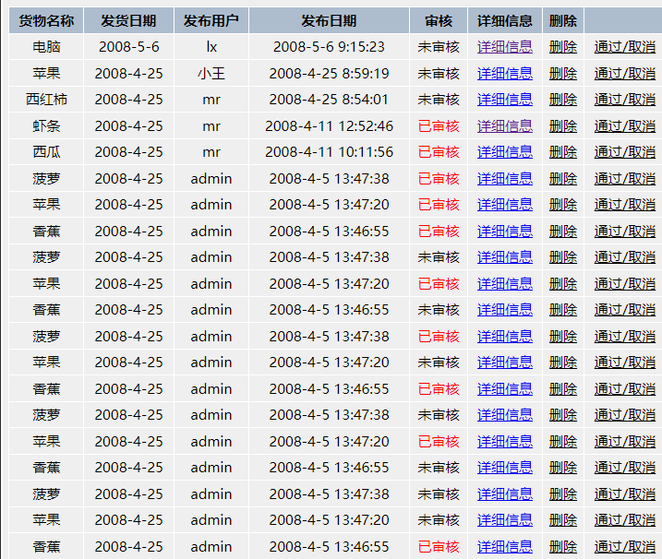

八：总结

物流信息供求网拥有较为完善的系统体系，对物流信息具有供、需需求的人群有着显著受益。