

OOForm 1.3.1

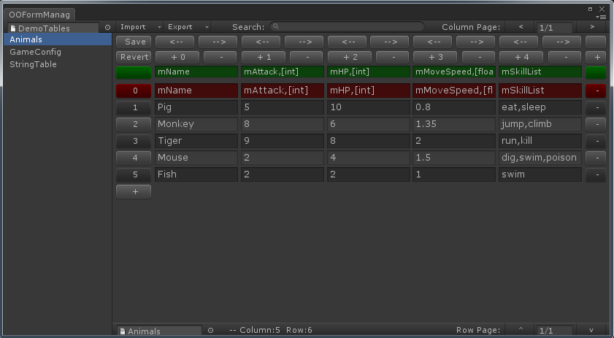

OOForm 1.3.1 document

1.About OOForm 3

1.1 Getting Started 3

2.Using OOForm 5

2.1 Creating a table. 5

2.2 Opening table 5

2.3 Using OOFormEditor 5

2.4 Using OOForm Manager 5

2.5 Using OOForm Menu Manager 6

2.6 Working with MS Excel. 7

3.Class OOFormArray reference 8

4.The end 11

# 1.About OOForm

OOForm is an easy to use table (maybe you call it sheet or form) system for Unity3d.

OOForm can help you to create tables for your games easily. For example game configuration table, role attribute table, localized string table etc.

OOForm provides an easy solution for creating and editing tables inside of Unity's interface as well as solutions to read/write and modify tables easily with scripting. Although not as powerful as database system, but for small and medium sized games is already enough.

OOForm uses paging to support large tables. So do not worry about your tables are too large.

OOForm's table data support format ('\t' for columns and '\n' for rows). And this version of OOForm will support “Json”, ”XML” and ”CSV” format file.

Simple but wonderful, this is OOForm. Hope you can love it.

## 1.1 Getting Started

Here I will show you a few simple steps to use OOForm.

**Step 1.Creating a table:** Select the “Resources” Folder in Project Window and click “Create->OOForm->Simple Table”. A table file will be created (named “Table_0”).

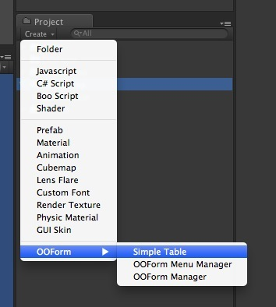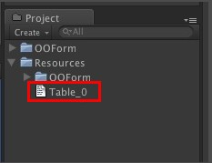

**Step 2.Opening table:** Click to select the new table file in Project Window. Then select menu “Window->OOForm->OOFormEditor” to open the OOFormEditor. The editor will open the selection table.

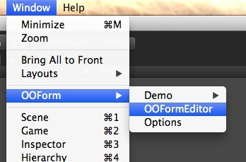

**Step 3.Editing table:** Following the simple tips.

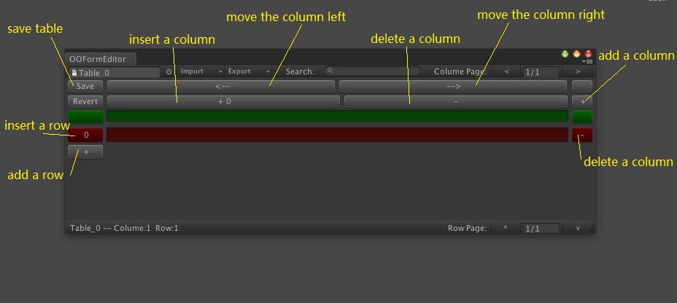

After inputting data, remember to “Save” it:

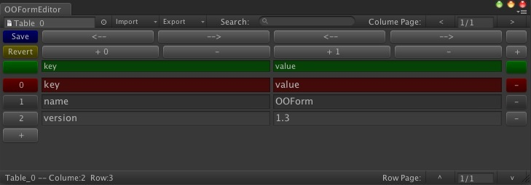

**Step 4.Reading table data by script:** New a C# script and add codes:

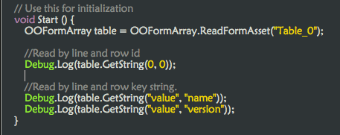

Now you can check the Console log.

Is that very easy? I think you will love it! Ha-ha…

About more of OOForm, read continue!

# 2.Using OOForm

## 2.1 Creating a table.

**Step 1**. Select the folder you want to store your table in the Project Window.

**Step 2**. Click on "Create->OOForm->Simple Table" in the Project Window.

OOForm will new a table file inside the folder you selected. It is named as "Table_[0...N]".

## 2.2 Opening table

Select the table file in Project Window. Then Select "**Window->OOForm->OOFormEditor**" to open OOFormEditor. OOFormEditor will open the selection table.

## 2.3 Using OOFormEditor

After opening the OOFormEditor, you can edit the table and input data. Following below tips:

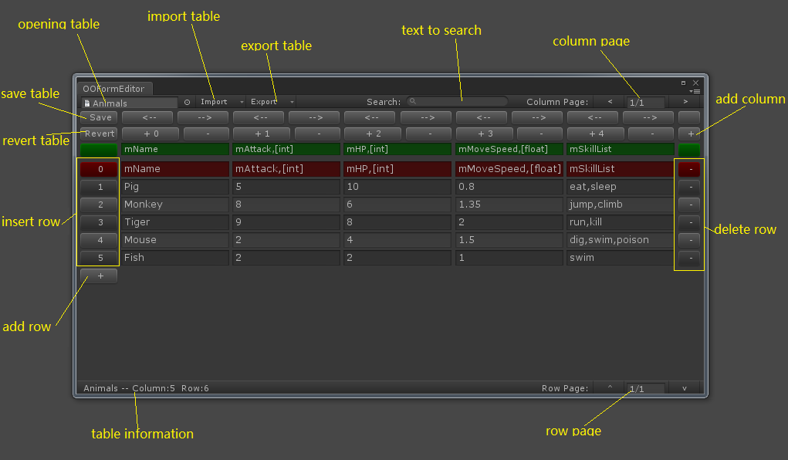

I think it’s easy to use. Right?

## 2.4 Using OOForm Manager

Have you found that a file “DemoTables” place in “Assets/OOForm/Demos/”?

Yes , I name it OOFormManager because I use it to manage a group of tables.

“OOFormManager” help you to manager a group of table files. You can create your other “OOFormManager” by menu “Create->OOForm->OOForm Manager”.

Click to select “OOFormManager”, you can see some buttons for managing tables in Inspector Window.

This can help you to manage your tables.

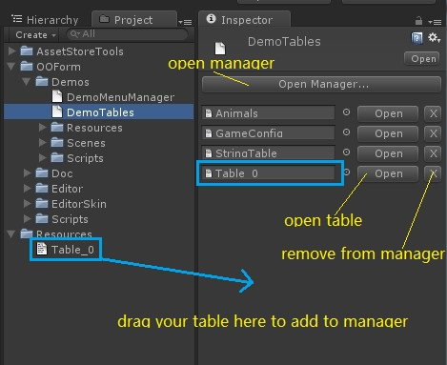

Tips: The “X” button just removes table from manager but do not delete table file.

## 2.5 Using OOForm Menu Manager

In old version, OOForm provide you a Creator to create a table with a menu item.

In version 1.3, it uses Menu Manager to open your table easier by menu item.

A file “-MenuManager” place in “Assets/OOForm/”.

If you select it. You can find like this.

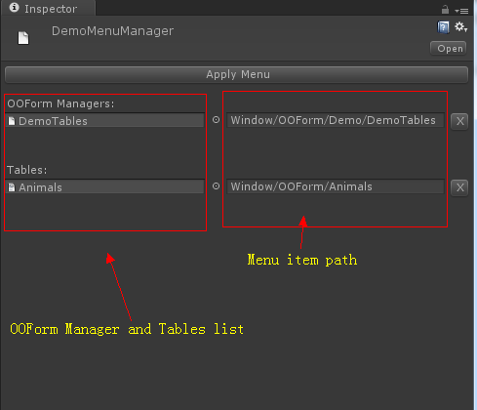

Like OOFormManager. Drag OOFormManagers or tables and drop to the inspector to add to it.

After setting it. Click “Apply Menu” to apply the setting. You can open the OOFormManager or table by clicking the menu path that you set to it.

You can click menu “Create->OOForm->OOForm Menu Manager” to add a new one.

## 2.6 Working with MS Excel.

Sometimes, you want to use MS Excel to speed up your data input.

1. In Mac OS, You can drag the table to Excel Icon to open the table.

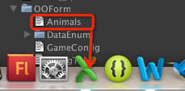

1. In Windows, You can use the same method as Mac OS to open table.

In version 1.3. Provide you a new method to use MS Excel or other Table tools to open table.

Select menu “Window->OOForm->Options” to open option window.

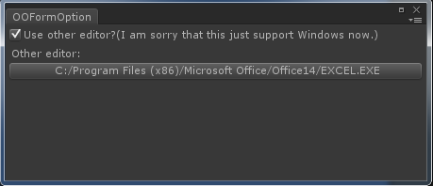

Check the “Use other editor?” and click the button to select the Excel.exe path.

Close the option window and select the OOFormManager. You can find a new button “Other” next to “Open”.

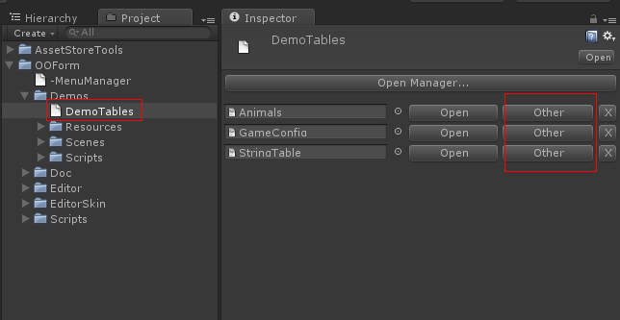

Click the “Other”, MS Excel will open the table.

But I’m sorry that it just works fine in Windows. If you have another method, please tell me. Thanks!!

# 3.Class OOFormArray reference

OOFormArray is the main class of OOForm.

All tables will read as an OOFormArray object. You can Read and write data with this class.

**Class static functions to read table to new an OOFormArray object:**

***OOFormArray ReadFromResources(string formPath)***

*Read a text asset as a table from "Resources".*

***OOFormArray ReadFromFile(string formPath)***

*Read a table file from path "[formPath]"*

***OOFormArray GetForm(string formString)***

Convert a table string to OOFormArray. *"formString" is the text of the table with format('\t' for columns and '\n' for rows).*

***OOFormArray ReadFromTextAsset(TextAsset asset)***

*Read table data from TextAsset object.*

***OOFormArray GetFormByCSVString(string formString)***

Convert a CSV format string to OOFormArray object.

***OOFormArray GetFormByJsonString(string jsonString)***

Convert a JSON array string to OOFormArray object. “jsonString” must to be an array.

***OOFormArray GetFormByXMLString(string xmlString)***

Convert XML string to OOFormarray object.

**Class Variables:**

***int mRowCount***

*Row count of table.*

***int mColumnCount***

*Column count of table.*

***int mCurrentRow***

*The reading row. This will make convenient access a same row data.*

***List<List<string>> mData***

*All the datas in the table. Yes ,It's a 2-D array. You can also read/write data by use "mData[column][row]" directly.*

***Dictionary<string, int> mColumnDic***

*This dictionary is built by the data of 0-column of table.*

***Dictionary<string, int> mRowDic***

*This dictionary is built by the data of 0-row of table.*

***Class Functions***

***string ToString()***

*This will return the text of the table with format('\t' for columns and '\n' for rows).*

***string ToCSVString()***

*This will return the text of the table with format CSV.*

***string ToXMLString()***

*This will return the text of the table with format XML.*

***string ToJsonString()***

*This will return the text of the table with format Json.*

***void SetCurrentRow(int currentRow)***

*Set the variable mCurrentRow.*

***void InsertColumn(int _index)***

*Insert a column before "_index" column.*

***void DeleteColumn(int _index)***

*Delete the "_index" column.*

***void InsertRow(int _index)***

*Insert a row before "_index" row.*

***void DeleteRow(int _index)***

*Delete the "_index" row.*

***int GetColumn(string columnKey)***

*Get column id by column key name from mColumnDic.*

***int GetRow(string rowKey)***

*Get row id by row key name from mRowDic.*

***public T GetObject<T>(int rowIndex)***

*Get one row data as type T. That’s very useful.*

***string GetString(params object[] args)***

*Get string data from table. Params here are free types. You can use column/row int id, column/row string name and enum. Format like "GetString(column, row)".*

*For example GetString(1, 2), GetString("Attack", "Tiger") , GetString("English", EStringTable.StringTips);*

*Also, you can use GetString("Attack") to access "Attack" column and mCurrentRow row.*

*Also you can check the demo how i use it.*

***bool SetString(String stringValue, params object[] args)***

*Set the stringValue to "args" position.*

*About the "args" see function "****string GetString(params object[] args)****".*

*Return if set success or not.*

Other data type Get/Set function:

***Int GetInt(params object[] args)***

***bool SetInt(int intValue, params object[] args)***

***float GetFloat(params object[] args)***

***bool SetFloat(float floatValue, params object[] args)***

***bool GetBool(params object[] args)***

***bool SetBool(bool boolValue, params object[] args)***

***Vector2 GetVector2(params object[] args)***

***bool SetVector2(Vector2 vec2, params object[] args)***

***Vector3 GetVector3(params object[] args)***

***bool SetVector3(Vector3 vec3, params object[] args)***

***Vector4 GetVector4(params object[] args)***

***bool SetVector4(Vector4 vec4, params object[] args)***

***Rect GetRect(params object[] args)***

***bool SetRect(Rect rect, params object[] args)***

# 4.The end

Thanks for using OOForm and your support.

If you have any advice, feel free to tell me. I will make it more wonderful.

**E-Mail:** [**hhj87121@163.com**](mailto:hhj87121@163.com)