首先，根据题目要求一共要做五个页面：

**第一个主页面**：在这个上面插入一些信息，有一个搜索栏

同时这个页面上得有一些栏目，具体如下：

|  |  |  |  |  |  |
| --- | --- | --- | --- | --- | --- |
| Colleges | Teaching Assistant Application | About Computer science | GPA | News | Talk to us |
|  |  |  |  |  |  |
|  |  |  |  |  |  |

类似于：网页背景，文件夹图片：background

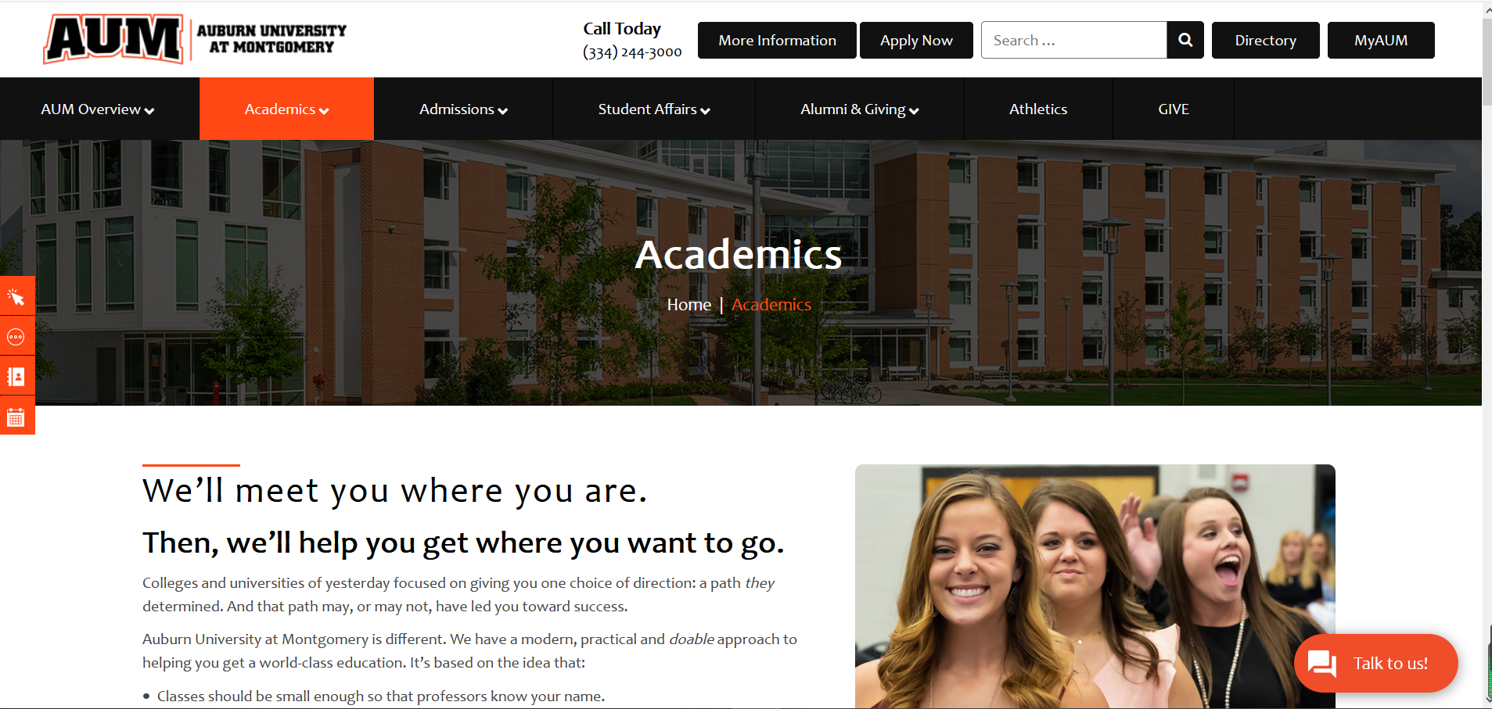

网页中要有一些文字，文字内容：(可以直接插入)，跟上图一样的排版

We’ll meet you where you are.

Then, we’ll help you get where you want to go.

Colleges and universities of yesterday focused on giving you one choice of direction: a path they determined. And that path may, or may not, have led you toward success.

Auburn University at Montgomery is different. We have a modern, practical and doable approach to helping you get a world-class education. It’s based on the idea that:

a, Classes should be small enough so that professors know your name.

b, Learning should be personalized, challenging and connected to the real world.

c, A college should know what success looks like to a student, and be able to help him/her achieve it.

d, Change is constant, and there are many ways to learn other than class work.

Contact to me:

Kai Xie

123456@qq.com

文本左侧插入图片：

文件夹中图片：academic：

第二个页面：课程页面，也就是表格中的colleges

类比网页;：https://www.aum.edu/academics/

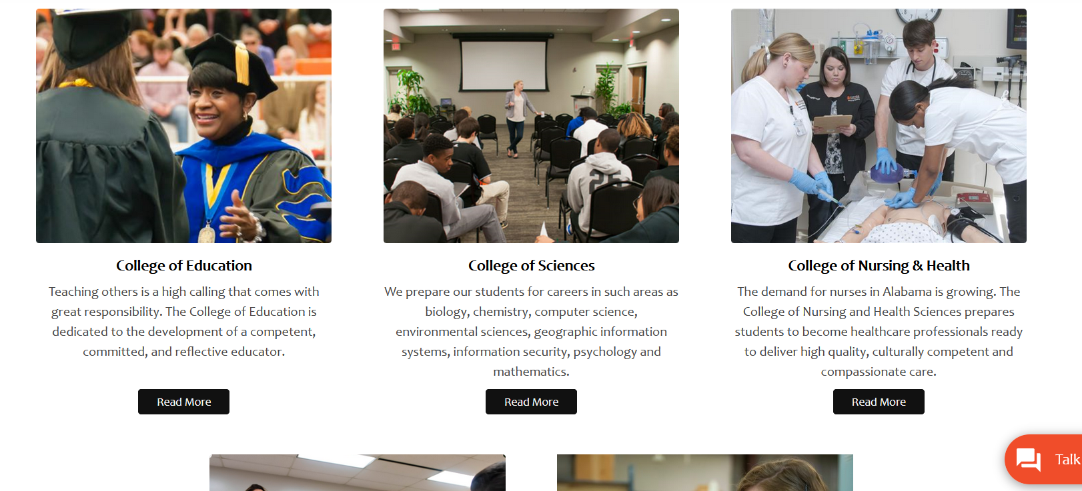

第三个网页：申请网页（也就是表格中的Application）

内容：可以重用已经做好的网页，文件夹中：

c12x_employee_table.html

网页的背景，原来的这几个页面中的背景是空白，需要添加背景，类似于：

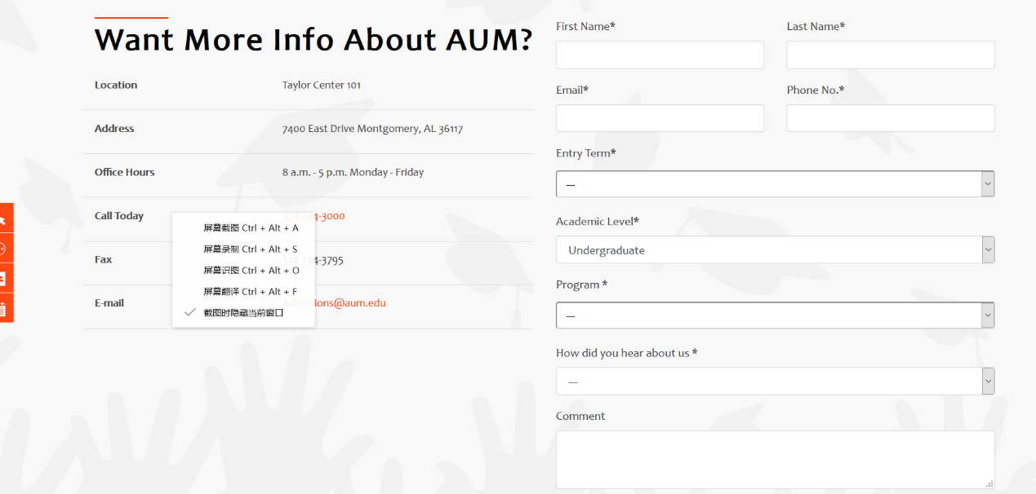

第四个页面：News

填充文字的内容：

**Computer Science Program Description**

Program Description

Do you want to know how to design and program the computers powering some of today’s greatest innovations? Ever wondered how your phone knows where the nearest Starbucks is, how Google’s self-driving car is even possible, or how your music and photos live in the cloud? Maybe you want to know how computers protect businesses — and people — and other cybersecurity issues. AUM’s Computer Science Program, with a curriculum based on the latest ACM/IEEE recommendations and an emphasis on high-performance computing, will prepare you for a career in computer programming, networking, database management, multimedia design or technology architecture.

Points of Pride

• You’ll have access to the most powerful computational resources and expertise in the

country through our partnership with the NSF-supported Extreme Science and Engineering

Discovery Environment.

• Computer Science faculty are engaged in the private sector, supporting research and partnerships with national and international user groups and initiatives.

Put Your Degree to Work

Note: While salaries vary depending on several factors including your level of experience, education and training, and geography and industry, here is a sampling of the future job growth and salaries in this area. Employment of computer and information technology occupations is projected to grow 12 percent from 2014 to 2024, faster than the average for all other occupations. The most recent median annual wage for computer and information technology occupations $79,390 — higher than the median annual wage for all other occupations.

For More Information

Contact Lei (Lee) Wu.

Department of Computer Science & Computer Information Systems (CSCI)

College of Science (CoS), Auburn University at Montgomery (AUM)

Office: Goodwyn Hall 310-Q

E-Mail: lwu@aum.edu