Assignment 3: Movie Database (Part 2)

Name: Qixiang Zhou

NUID: 001822974

# The snapshot of unit test:

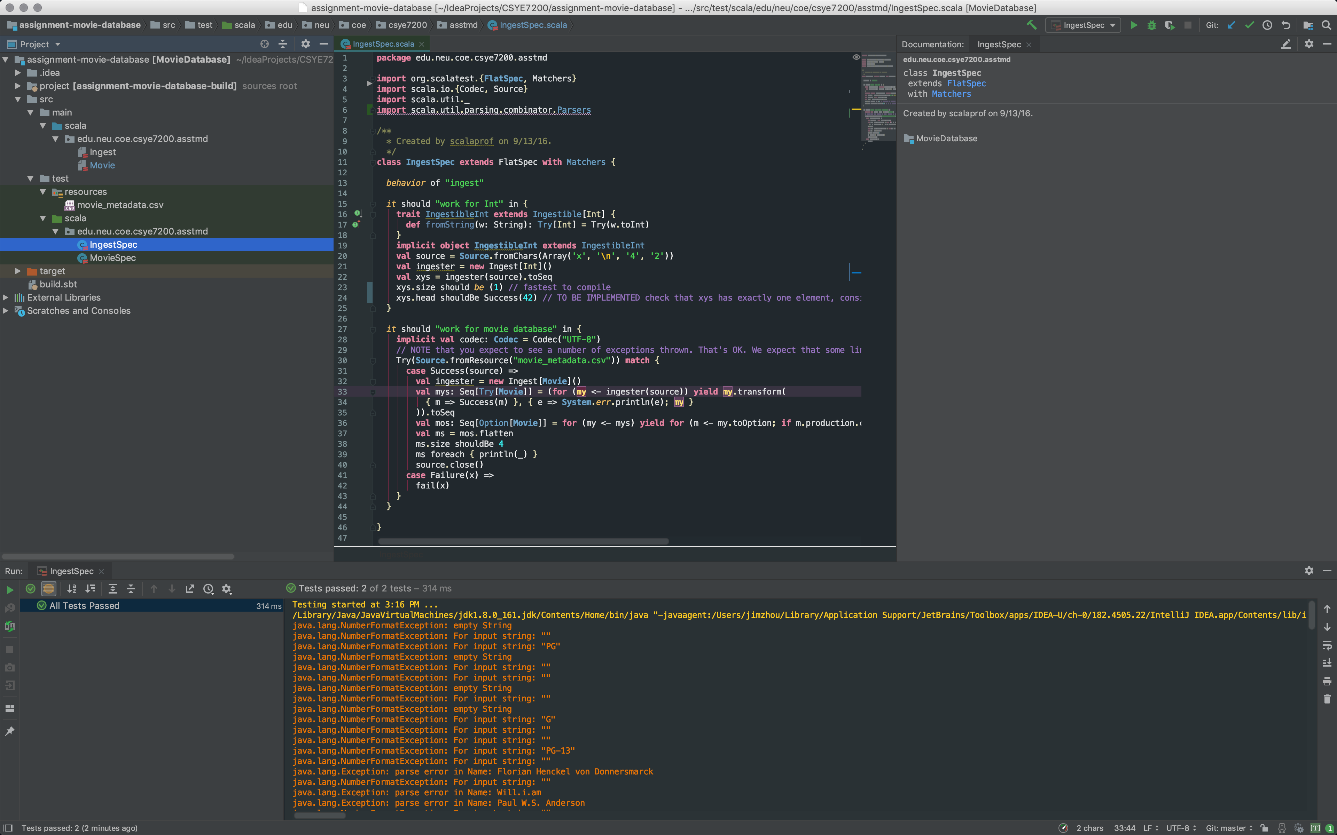

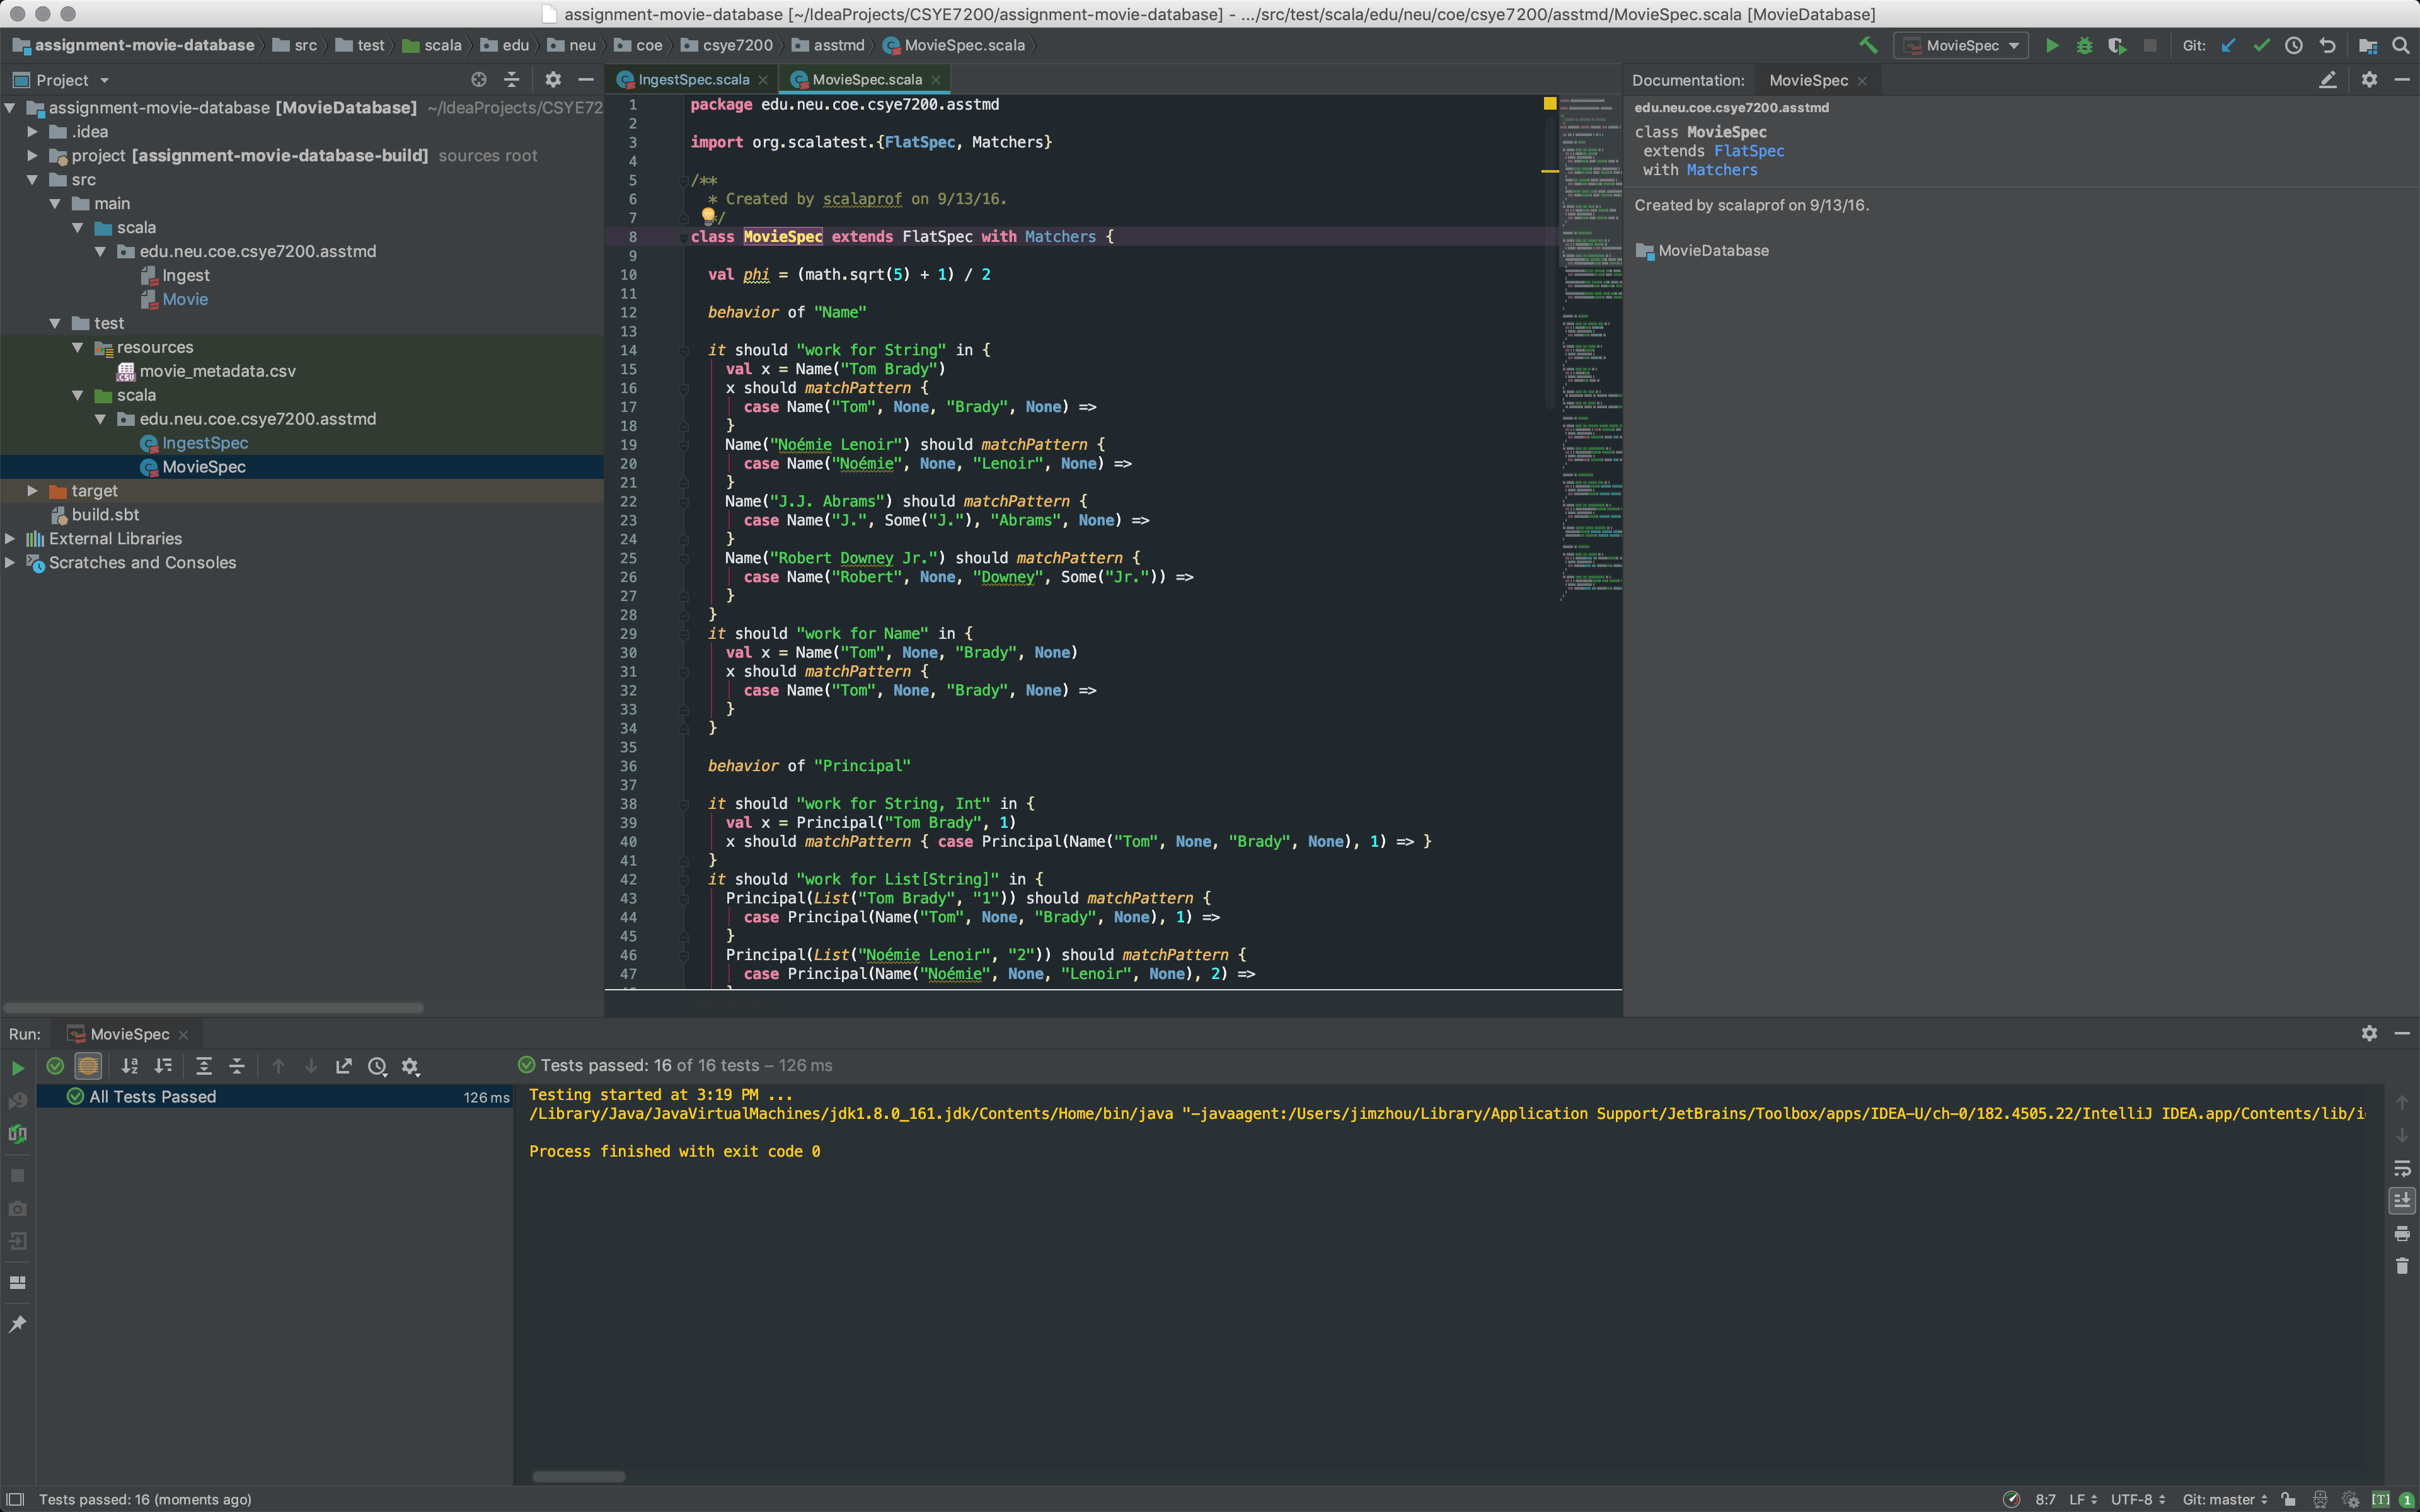

# The code I implemented:

