Assignment 5: Function Composition

Name: Qixiang Zhou

NUID: 001822974

# Snapshot of the test case

MovieSpec:

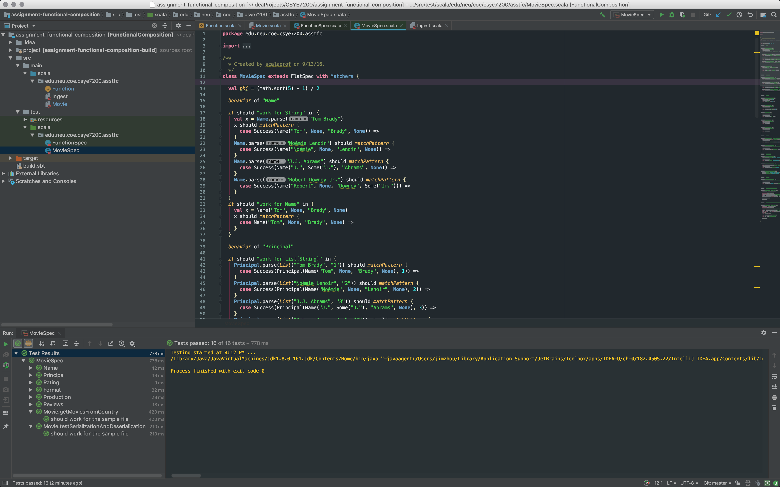

FunctionSpec:

