An exact algorithm for identical parallel machine scheduling under scenarios

Xie Han-Xin
School of Mechatronic Engineering and Automation
Shanghai University
Shanghai, China
E-mail: xhxbxs@126.com
Wang Bing
School of Mechatronic Engineering and Automation
Shanghai University
Shanghai, China
E-mail: susanbwang@shu.edu.cn

Abstract—This paper discusses an uncertain identical parallel machine scheduling problem. Discrete scenario set is used to describe the uncertain processing times in actual production conditions. Objective of this problem is to minimize the mean makespan among all scenarios, which reflects solution optimality in uncertain environment. The concept of mean scenario is defined in this paper and is used to transform the model of mean makespan under scenarios into traditional deterministic identical parallel machine problem. The cutting plane algorithm is used on the basis of the mean scenario to solve the problem. The developed algorithm was applied in extensive test cases, involving different sizes and parameters. The computational results show that this proposed algorithm can solve this parallel machine model in reasonable time and can be applied in practical problems.
Keywords-component; discrete scenarios; identical parallel machine scheduling ; cutting plane algorithm; exact algorithm

Introduction
Identical parallel machine scheduling is one of typical scheduling problems, span a wide variety of manufacturing environments [1].
The goal of this problem is usually to determine the sequence of jobs on the machines to optimize a certain production performance. The related research on parallel machine scheduling problems was initially carried out in a deterministic environment, in which the production parameters such as the processing time are known and fixed. However, the exactly processing times are always unknown in actual working conditions. Learning uncertain identical parallel machine scheduling problems plays more important role in engineering application[2][3]. Scenario method[4] is one efficient way to handle the uncertain parameters. Processing times are structured through scenario set. which is describe as a continuous interval[5] or a finite set of discrete values[6], each scenario is independent, no need of knowledge about exact distributions or historical data basic. This paper is mainly based on discrete scenarios.. There are many different optimization goals for uncertain scheduling models[7]-[9], mean makespan is one for problems under scenarios, which can reflects solution optimality in uncertain environment[10].
Uncertain identical parallel machine schedule are mainly solved by intelligent optimization algorithms, exact algorithms are always used for simple and deterministic problems. To improve the accuracy of the solutions, in this article, we design a method to transform the mean makespan model of identical parallel machine to traditional deterministic identical parallel machine problem, and then using a cutting plane algorithm[11] to solve it.

Problrm Description And Formulation

Deterministic Identical Parallel Machine Scheduling
Identical parallel machine scheduling problem is generally described as follows:
jobs and machines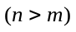,each job is available at time 0 and can be processed only once by arbitrary machine without interruption. No machine can process more jobs at same time. 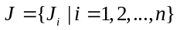 is the set of all jobs, 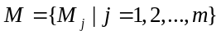 is the set of all machines, 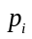is the processing time of . 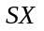is the set of available solutions, 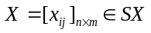 represents a specific feasible scheduling solution, and 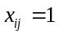if is assigned to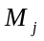, otherwise 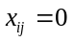. 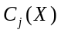is the completion time ofin schedule , computed as follows:
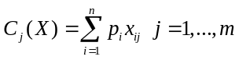
The maximum completion time of all machines in is
called makespan , defined as 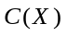：
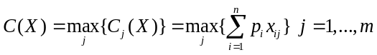
If is deterministic, such problem is called deterministic identical parallel machine scheduling (DIP).The optimization object of DIP is always to minimize the makespan:
(DIP):
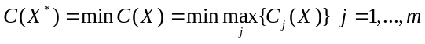
DIP model can also be expressed in mixed integer programming:
(DIP):
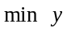
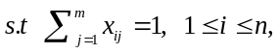
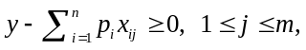
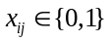

Mean Makespan Module Under Discrete Scenarios
In the uncertain environment, processing times are described by a set of finite scenarios, which is denoted by . And the number of scenarios in is denoted by 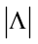. 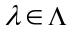represents a possible scenario in ,and 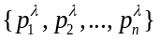 are the processing time of each job under .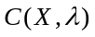represents the makespan of schedule under scenario :
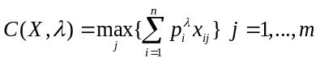
the mean makespan under all scenarios is called 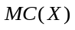：
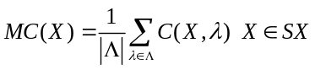
The scheduling model which minimizesis called MCM(mean-case model)：
(MCM):
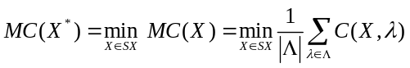
DEFINETION 1. is the mean scenario for, the processing time of each job under is defined as follows:
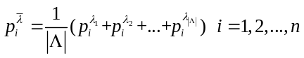
Property 1. The MCM model for uncertain identical parallel machine scheduling problem can be converted into the form of the DIP model in the mean scenario.
proof. We denoteas the makespan under scenario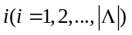, Then the MCM model of the identical parallel machine is expressed as follows:：
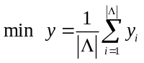
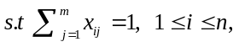
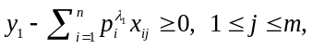
…
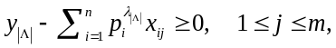
Adding (13) and (14) :
Simplify (16):
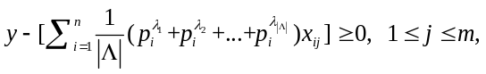
Substitute mean scenario into (17), the MCM model can be expressed like following:
(MCM):
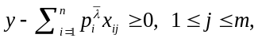
□
By solving (18)-(21), the optimal solution 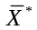in the mean scenario can be obtained, and then substituting it into (9) to obtain 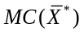, which is the optimal expected performance of the MCM of the identical parallel machine in the required multiple scenarios. The expressions of (21)-(24) are the same as the DIP (4)-(7), so existing DIP-solving algorithm can be used to solve the MCM model.

Solution Algorithm
In the previous section, we proposed the definition of the mean scenario, which can be used to transform the MCM into DIP module in single mean scenario. Then cutting plane method in [11] can be used. Based on this algorithm and mean scenario, we design an algorithm called MSMMA (Multi-Scenario Mean Makespan Algorithm).
The key steps of the MSMMA are briefly described below:

Cutting Plane Scheme
This method is proposed by Mokotoff[11]. Solving the mathematical programming model of DIP in a relaxtion feasible region. If it is not an integer solution, generating valid inequality according to the result and add it to the last linear programming polyhedron as a new constraint.
Repeat the process until a feasible solution is obtained.

Proposed Algorithm
Based on the original cutting method, this paper designs an algorithm MSMMA for solving the MCM model of identical parallel machine.
At beginning, input all scenarios of and calculate the mean scenario . Then reorder the jobs according to their processing times in , let 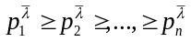to calculate the initial upper and lower bounds. Initial lower bound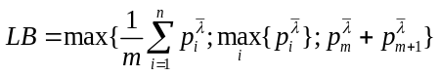[11], initial upper bound are the value obtained by using the LPT rule[12], that is, 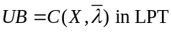.
The steps of MSMMA are as follows:
Step1: Calculate mean scene according to .
Step2: Reorder the jobs according to the processing time in to make .
Step3: Calculate the initial upper and lower bounds.
The initial solution 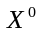is the scheduling solution obtained by using LPT.
Step4: If the initial upper and lower bounds are equal, then optimal solution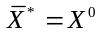 ,jump to Step6. else add constraint 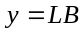.
Step5: Solve the relaxation solution according to the constraints. If the result happens to be an integer solution,, jump to Step 6, otherwise add the valid inequality, and 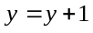.Repeat step 5.
Step6: Substitute final into (9) to get, output and.
The flow chart of the entire algorithm is as follows:
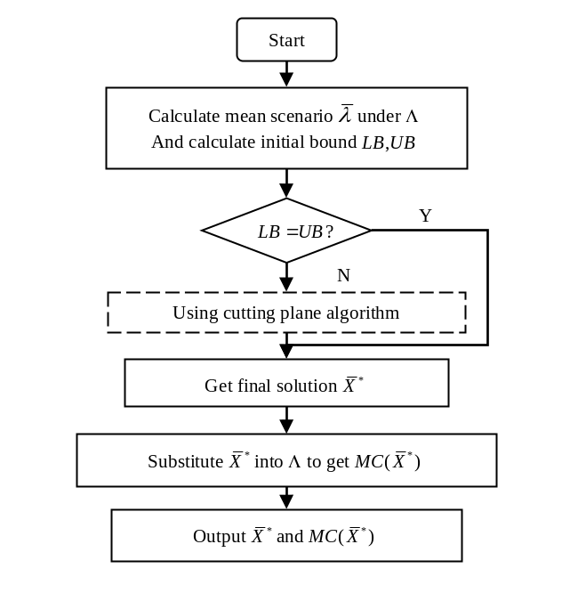
- Flow chart of MSMMA

Computer Results and Analysis
In order to test the entire algorithm, extensive computational experiments are carried out. All procedures are coded and implemented in C++ language and run in Visual Studio 2017 software under the windows10 operating system environment. The CPU of the simulation computer is Intel(R) Xeon(R) Gold 5188, 2.3GHz/256GB.
We select experiments from Mokotoff[11], and follow the approach in Daniels and Kouvelis[13] to generate the scenario. Every processing time are generated from the interval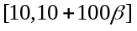, is the parameter that controls the range of processing time, selected in.(0.4,0.6,0.8,1.0). The scale and parameters are shown in Table 1. 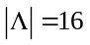scenarios are generated as a scenario set under each parameter combination 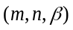 as a test case. And for each combination, 5 test problems are generated, resulting 340 test problems .In the actual test, it is found that the simulation results of the same parameter combination are similar. Therefore, the following simulations in this article will only show one test case result of a certain parameter combination.
- Test Instance
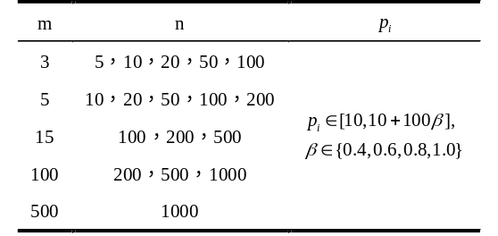

Table 2 shows the simulation results of three scales under different time parameter. i.e. the CPU time (in seconds) and the number of iterations to obtain the result. the results shows that in the same size. whether it is small-size(3*20) or larger-size(100*500), different time parameters mainly affect the value of processing time, thereby affecting the final. At the same time, it also has some influence on the CPU time and the iteration times. The larger the calculation example, the greater the absolute change in the CPU time and the number of iterations. But for the same scale, this amount of change is far less obvious than the change caused by the scale to the calculation time. Therefore, so when comparing the simulation results of different scales, we will only show the results in 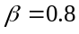.
- Computation Performance in Different
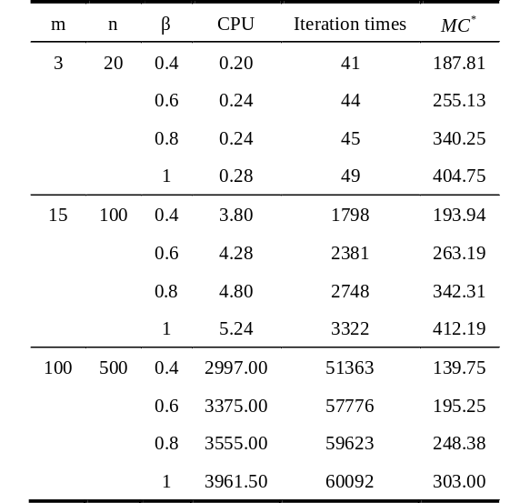

Table 3 shows the simulation results of different sizes under time parameter. It can be seen that the final is mainly affected by the ratio of job numbers and machine numbers n/m. A larger n/m means that more jobs will be assigned average machine, the overall running time will definitely increase. The CPU time and number of iterations increase as the scale increases. This change is more obvious in large-scale test cases. When the calculation example reaches a certain scale, such as (500*1000), the solution time of the accurate algorithm is already very large. At this time, the solution requires a lot of time and computer resources, but experiments have shown that quite large size problems can be solved by using this exact algorithm. It can be applied in practical problems.

- Result of MSMMA in Different Sizes
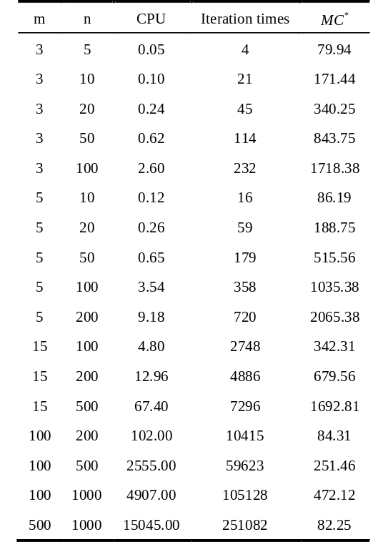.

Conclusions and Future Research
In this paper, the identical parallel machine expect makespan model under scenarios is studied, and the concept of mean scene is used to simplify the mathematical programming form of this model. And on this basis, combined with the existing algorithm, an accurate algorithm MSMMA is designed to solve such problem.
Experimental simulation results show that the algorithm can solve calculation examples of different scales. Without consuming too much time, the overall accuracy and quality of the solution can be improved, which makes up for the lack of relevant accurate algorithms in the current model.
At present, there are other optimization models based on expect makespan in the field of uncertain identical parallel machine scheduling. This method can also combined with other algorithms to improve the accuracy and efficiency. which also provides a new application direction for the research results of this paper. We will try further expansion and application in follow-up research.

References
- Mcnaughton R . Scheduling with Deadlines and Loss Functions[J]. Management Science, 1959, 6(1):1-12.
- [Daniels R L, Kouvelis P. Robust scheduling to hedge against processing time uncertainty in single-stage production[J]. Management Science, 1995, 41(2): 363-376.
- Allahverdi A , Aydilek H . Heuristics for the two-machine flowshop scheduling problem to minimise makespan with bounded processing times[J]. International Journal of Production Research, 2010, 48(21):6367-6385.
- Yu, Gang, Kouvelis, et al. Robust Discrete Optimization and Its Applications[M]. Robust discrete optimization and its applications .
- Xu X, Cui W, Lin J, et al. Robust makespan minimisation in identical parallel machine scheduling problem with interval data[J]. International Journal of Production Research, 2013, 51(12): 3532-3548.
- Allahverdi A , Aydilek H . Heuristics for the two-machine flowshop scheduling problem to minimise makespan with bounded processing times[J]. International Journal of Production Research, 2010, 48(21-22):p.6367-6385.
- A.K. Agrawala, E.G. Coffman, M.R. Garey, S.K. Tripathi, A static optimizationalgorithm minimizing expected flow time on uniform processors, IEEE Trans.Comput. 33 (1984) 351–357.
- M. van den Akker, H. Hoogeveen, Minimizing the number of late jobs in a stochastic setting using a chance constraint, J. Sched. 11 (2008)56–69.
- Hamzaoui M A , Sari Z . Optimal dimensions minimizing expected travel time of a single machine flow rack AS/RS[J]. Mechatronics, 2014, 31:158-168.
- Wang B , Xie H , Xia X , et al. A NSGA-II algorithm hybridizing local Simulated-annealing operators for a bicriteria robust job-shop scheduling problem under scenarios[J]. IEEE Transactions on Fuzzy Systems, 2018, PP(5):1-1.
- [Mokotoff E . An exact algorithm for the identical parallel machine scheduling problem[J]. European Journal of Operational Research, 2004, 152(3):758-769
- Graham R L. Bounds on multiprocessing timing anomalies[J]. SIAM journal on Applied Mathematics, 1969, 17(2): 416-429
- Daniels R L, Kouvelis P. Robust scheduling to hedge against processing time uncertainty in single-stage production[J]. Management Science, 1995, 41(2): 363-376.

