表2.1 IPMS松弛问题示例求解结果
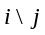 | 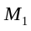 | 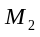
 | 1 | 0
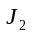 | 0 | 1
 | 0.33 | 0.67
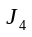 | 1 | 0
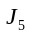 | 0 | 1
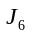 | 0 | 1
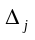 | 2 | 1

