cosh: github.com/pytorch/aten/src/ATen/cuda/llvm_complex.cpp:1016

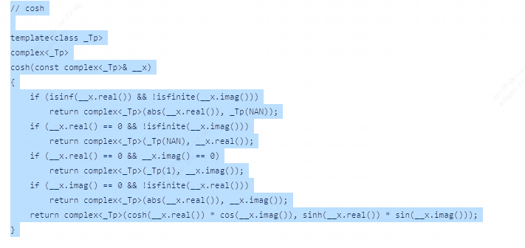

cos: github.com/pytorch/aten/src/ATen/cuda/llvm_complex.cpp:1124

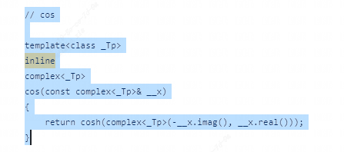

tanh: github.com/pytorch/aten/src/ATen/cuda/llvm_complex.cpp:1033

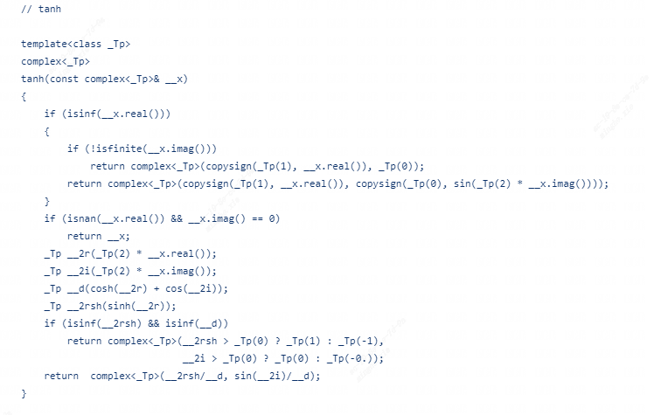

tan: github.com/pytorch/aten/src/ATen/cuda/llvm_complex.cpp:1134

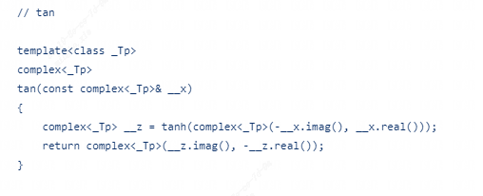

atanh: github.com/pytorch/aten/src/ATen/cuda/llvm_complex.cpp:968

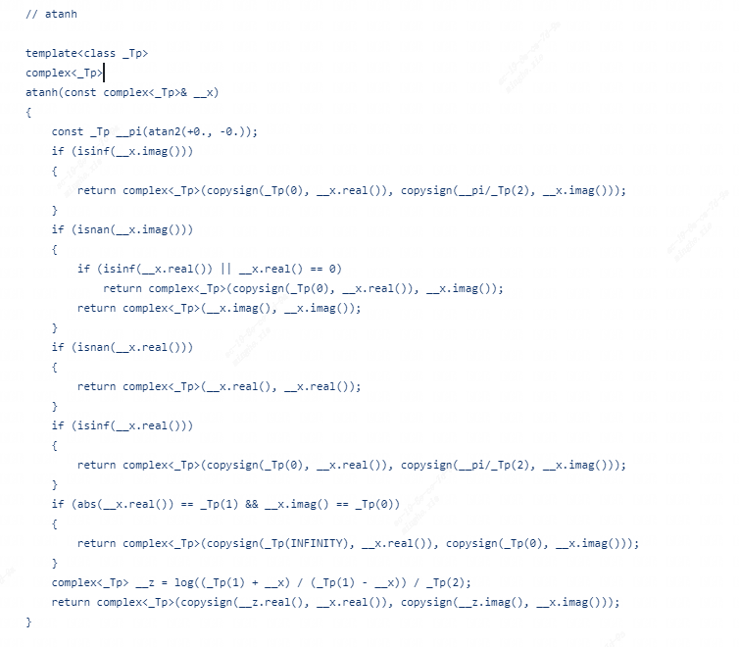

exp:github.com/pytorch/aten/src/ATen/cuda/llvm_complex.cpp:968

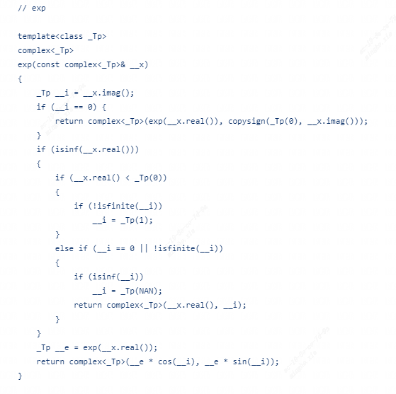

sinh: github.com/pytorch/aten/src/ATen/cuda/llvm_complex.cpp:1001

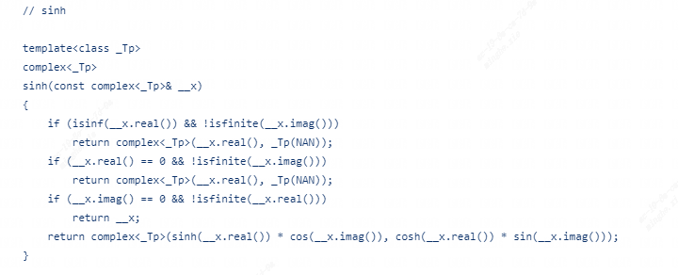

sin:github.com/pytorch/aten/src/ATen/cuda/llvm_complex.cpp:1114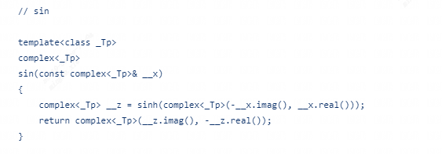

sqrt:github.com/pytorch/aten/src/ATen/cuda/llvm_complex.cpp:804

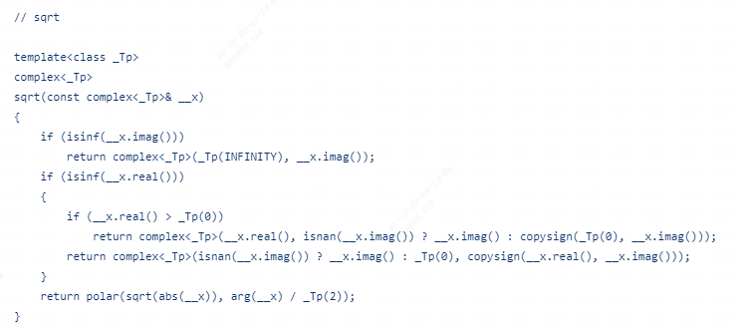

real 和 image ：github.com/pytorch/aten/src/ATen/cuda/llvm_complex.cpp:539

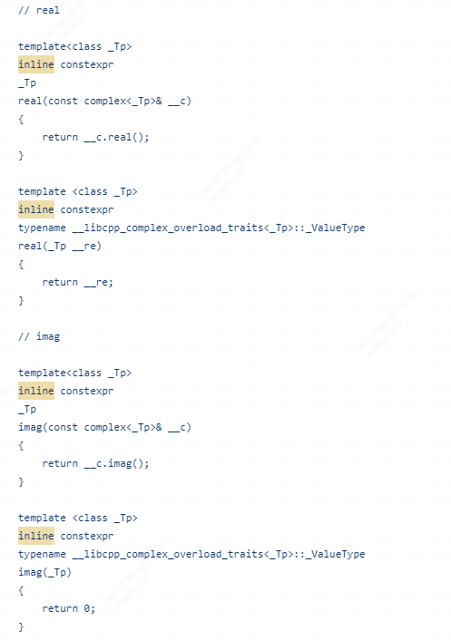

abs 和 arg：github.com/pytorch/aten/src/ATen/cuda/llvm_complex.cpp:575

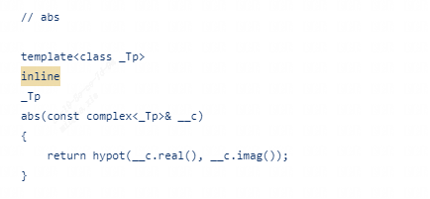

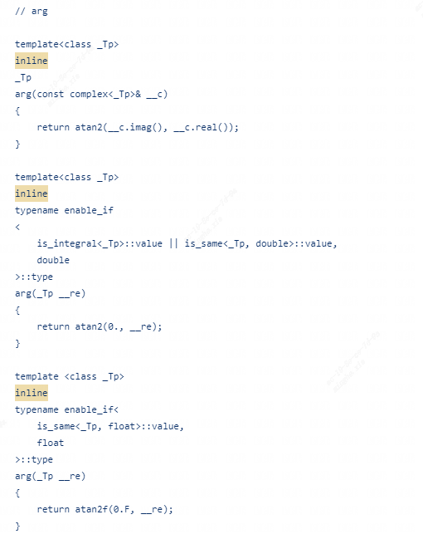

log：github.com/pytorch/aten/src/ATen/cuda/llvm_complex.cpp:774

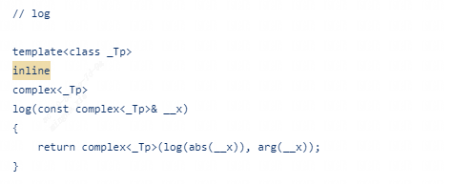

log10：github.com/pytorch/aten/src/ATen/cuda/llvm_complex.cpp:784

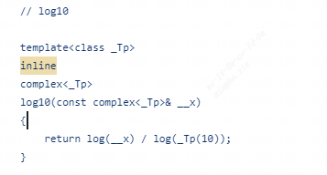

log2：github.com/pytorch/aten/src/ATen/cuda/llvm_complex.cpp:794

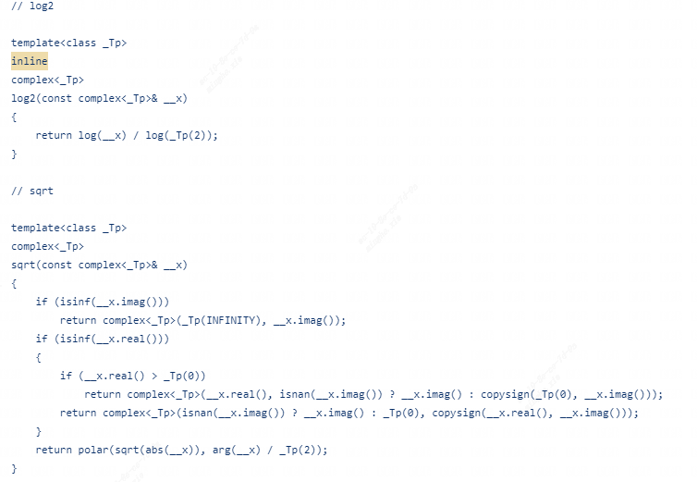

scalar_tensor：github.com/pytorch/aten/src/ATen/native/TensorFactories.cpp：755

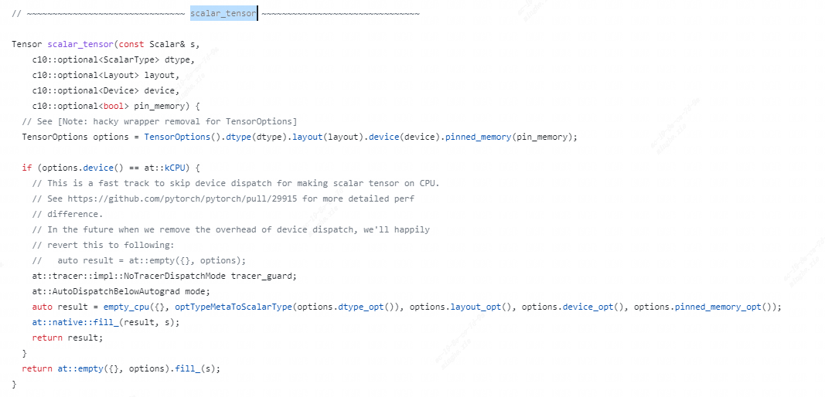

randn：github.com/pytorch/aten/src/ATen/native/TensorFactories.cpp：928

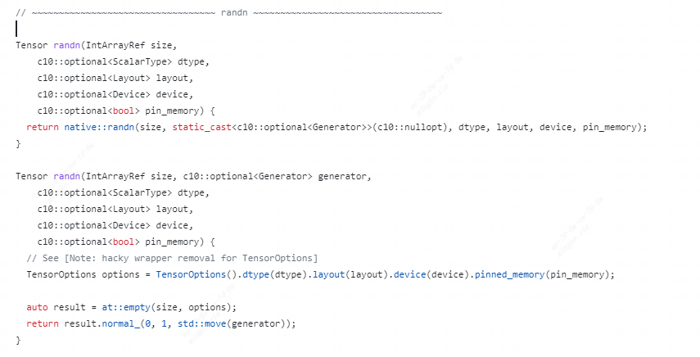

repeat：pytorch/aten/src/ATen/native/TensorShape.cpp:1478

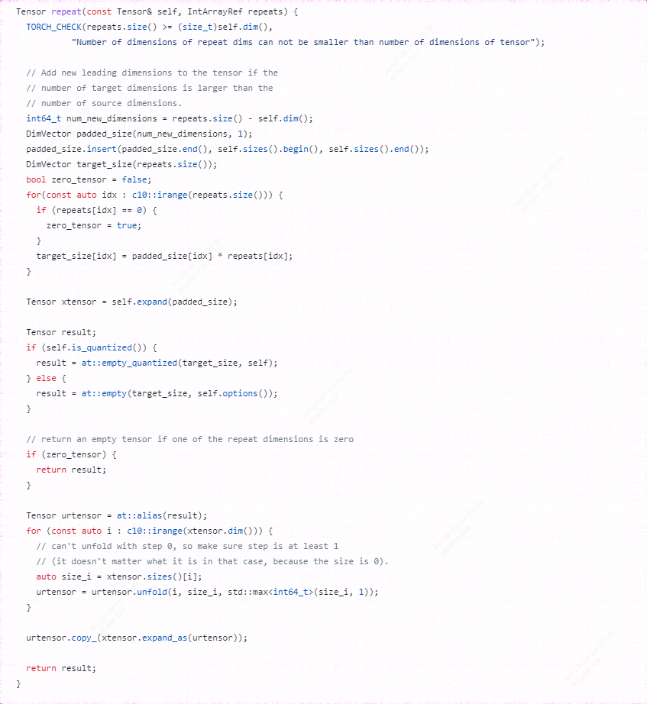

relu：pytorch/aten/src/ATen/native/Activation.cpp:507

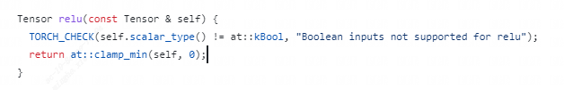

sigmoid：pytorch/aten/src/ATen/native/vulkan/ops/Clamp.cpp:444

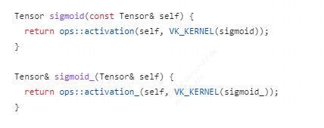

slice_scatter:pytorch/blob/main/aten/src/ATen/native/TensorShape.cpp:3898

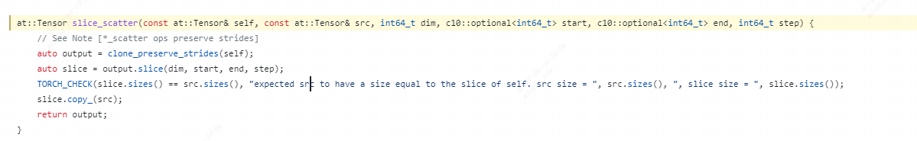

unsqueeze:pytorch/aten/src/ATen/native/TensorShape.cpp:3276

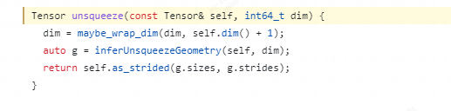

view:pytorch/aten/src/ATen/native/TensorShape.cpp:3648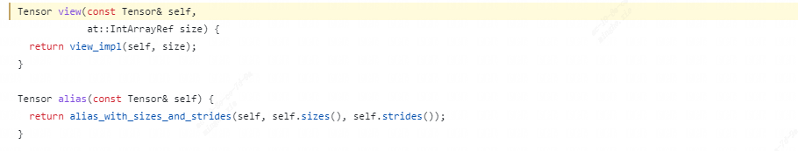

scatter_add:pytorch/aten/src/ATen/native/NamedTensor.cpp:384



remainder:pytorch/aten/src/ATen/native/BinaryOps.cpp:1184

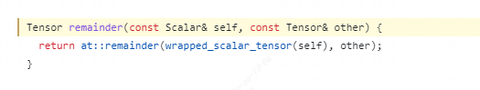

Reflection_pad2d和replication_pad2d:pytorch/aten/src/ATen/native/vulkan/ops/Padding.cpp:97 和101

