**PYNQ BOOTCAMP CDC ACCEPTANCE TEST**

**What is needed:**

|  |  |  |
| --- | --- | --- |
| S.No. | Item | Quantity |
| 1 | Ardumoto | 1 |
| 2 | Ethernet Cable | 1 |
| 3 | Power adapter | 1 |
| 4 | SD card | 1 |
| 5 | Modified Barrel connector | 1 |
| 6 | 9v Battery | 1 |
| 7 | Motors | 2 |
| 8 | PYNQ Board | 1 |
| 9 | Laptop with ethernet port | 1 |

**Connecting PYNQ Board to Host laptop:**

1. Configure the Static I.P address on Host laptop as 192.168.2.1
2. Connect ethernet cable between PYNQ Board and Laptop
3. Connect power adaptor to the board

**CDC acceptance Test Procedure:**

1. Connect Ardumoto shield on top of PYNQ board:

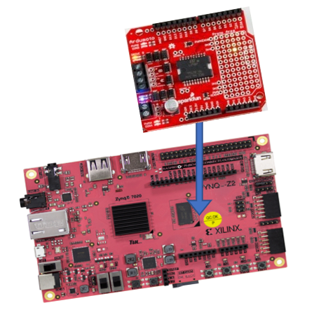

1. Connect Motor A and Motor B:

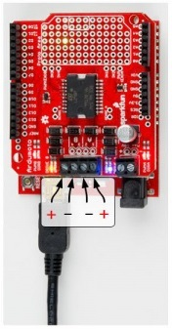

1. Connect battery to modified barrel connector and it to the Ardumoto shield:

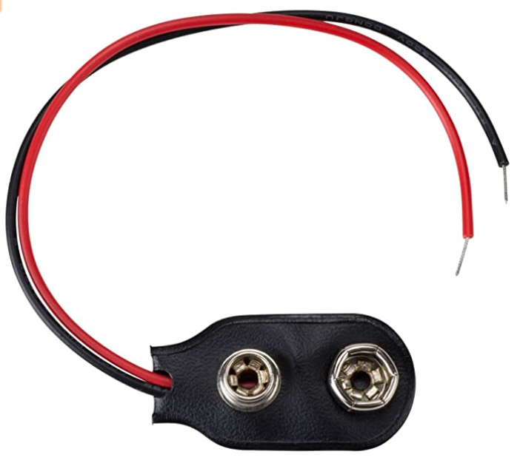 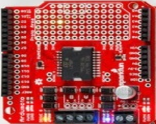



1. Power ON the board and wait for all LED on board to flash
2. Use browser to connect to the board: [http://192.168.2.99:9090](http://192.168.2.99:9090/)
3. Open “CDC Acceptance Test – Ardumoto” notebook
4. Use “Run” or kernel-> “restart and run all” to run through each of the cells in the test.

Observer motor rotation as expected by the test