Table of Contents
Designing with IP Integrator 2
Introduction 2
Tutorial Design Description 2
Step 1: Creating a Project 2
Step 2: Creating an IP Integrator Design 6
Step 3: Customizing IP 8
Step 4: Creating Connections 9
Step 5: Running Connection Automation 11
Step 6: Adding Masters and Block Automation 13
Step 7: Using the Address Editor 21
Step 8: Validating the Design 22
Step 9: Debugging the Design 23
Step 10: Creating and Implementing the Top-level Design 25

Designing with IP Integrator

Introduction
The Xilinx® Vivado® Design Suite IP Integrator lets you create complex system designs by
instantiating and interconnecting IP cores from the Vivado IP catalog onto a design canvas. You can create designs interactively through the IP Integrator design canvas GUI, or programmatically using a Tcl programming interface.

This tutorial walks you through the steps for building a basic IP subsystem design using the IP
Integrator. You will instantiate a few IPs in the IP Integrator and then stitch them up to create an
IP sub-system design. While working through this tutorial, you will be introduced to the IP Integrator GUI, run design rule checks (DRC) on your design, and then integrate the design into a top-level design in the Vivado Design Suite. Finally, you will run synthesis and implementation and generate a bitstream on the design.

Tutorial Design Description
This tutorial is based on a simple processor-based IP Integrator design. It contains peripheral IP cores and an AXI Interconnect core, which connects to a number of processors.
For the purpose of learning the different IP Integrator capabilities, we will manually do some of the steps described in this tutorial, instead of using an automated option all the time.
The design targets a Virtex UltraScale+ VCU118 Evaluation Platform with a xcvu9p-flga2104-2L-e part.

Step 1: Creating a Project

- Open the Vivado® Integrated Design Environment (IDE).
- On Linux, change to the directory where the Vivado tutorial design file is stored: cd
<Extract_Dir>/Vivado_Tutorial. Then launch the Vivado Design Suite: Vivado.
- On Windows, launch the Vivado Design Suite: Start → All Programs → Xilinx Design Tools→ Vivado 2023.2.
As an alternative, click the Vivado 2023.2 Desktop icon to start the Vivado IDE.

The Vivado IDE Getting Started page contains links to open or create projects and to view
documentation, as shown in the following figure:
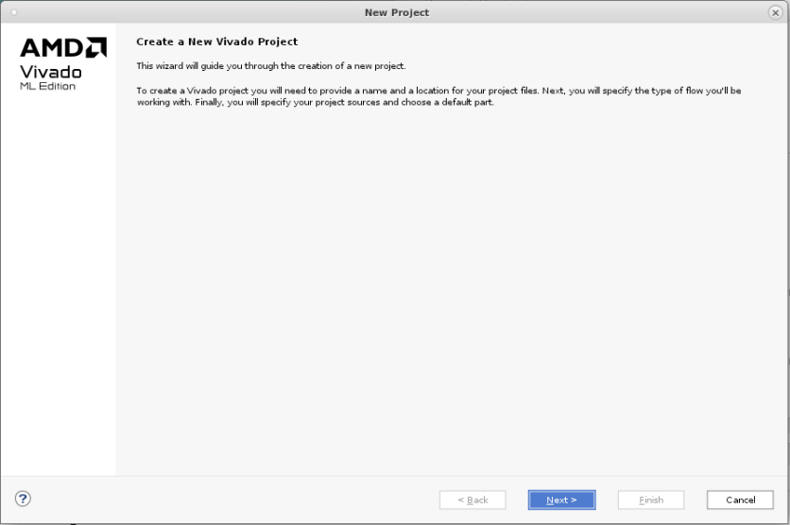
Note: Your Vivado Design Suite installation may be called something different from Xilinx Design Tools
on the Start menu.

- Under the Quick Start section, select Create Project.
- The New Project wizard opens. Click Next to confirm the project creation.
- In the Project Name page, shown in the following figure, set the following options:
a. In the Project name field, enter Lab-1.
b. In the Project location field, enter <IPI-Basics>, or your current folder work location.
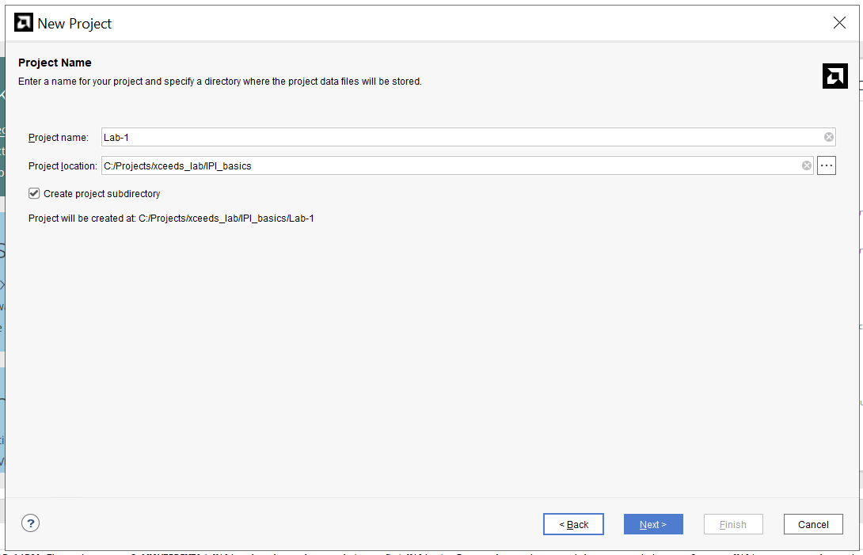
- Ensure that Create project subdirectory is checked and click Next.
- In the Project Type page, select RTL Project, and select Do not specify sources at this time, then click Next, as shown in the following figure:
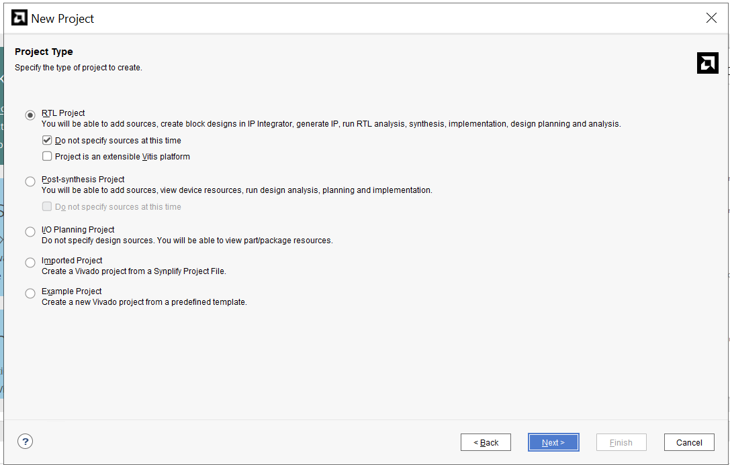

- Click next, and then you will land on the Default Part page. Click on the Boards tab to select the Virtex Ultrascale+ VCU118 Evaluation Platform.

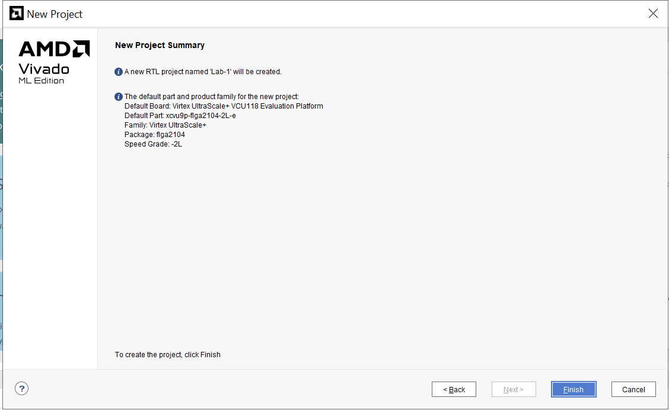
- Review the project summary in the New Project Summary page.
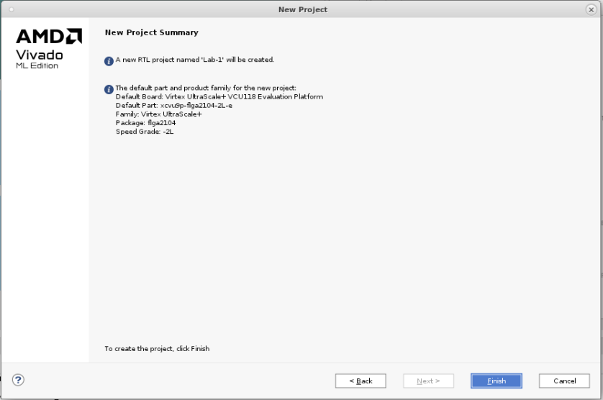

- Click Finish to create the project.
- The new project opens in the Vivado IDE.

Step 2: Creating an IP Integrator Design
- Using the Flow Navigator, select Create Block Design.
Notice how you can set Design Name, Directory, and source set in the Create Block Design dialog box. You can change or keep the default values and proceed.
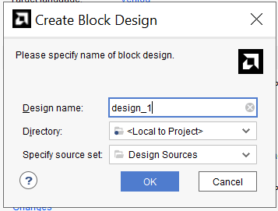

The Vivado IP Integrator displays a design canvas to let you quickly create complex
subsystem designs by integrating IP cores.

- There are a few different ways to add IPs in the block design-
- By clicking the Add IP button in the block design canvas.
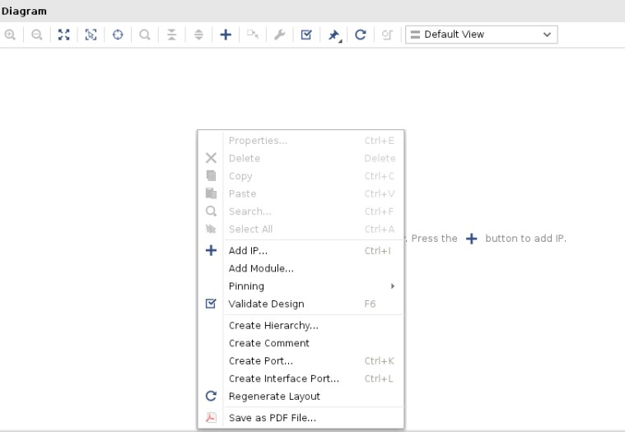
- You can also right-click on the design canvas to open the context menu and select Add IP.
- You can also add an IP by dragging and dropping the IP from the IP catalog to the block design canvas. In this case, you can search for the IP, select it and drag-and-drop it on the block design canvas.

TIP: To open the IP Details window beside the IP catalog, as shown in the following figure, type Ctrl-Q as described at the bottom of the IP catalog window. This window lets you see details of the currently selected IP in the catalog.
Let’s add IPs into our block design now.
- In the search field of the IP catalog, type gpio to find the AXI GPIO IP.
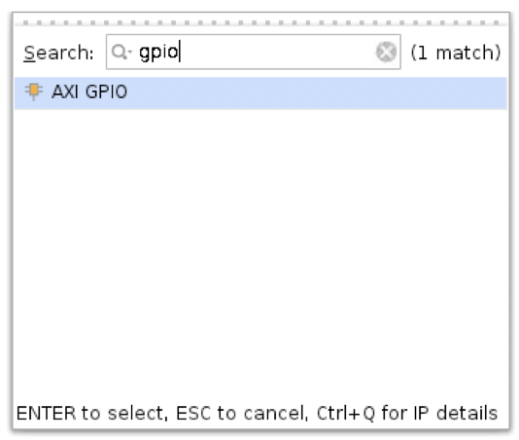

Select AXI GPIO core and press Enter on the keyboard or double-click the core in the IP catalog. The AXI GPIO core is instantiated onto the IP Integrator design canvas.

- Repeat step 2 to add the AXI BRAM Controller, AXI Uartlite, and the AXI SmartConnect.
- After adding all the IPs, the IP Integrator should look like this. The relative positions of the blocks placed on the canvas might be slightly different.
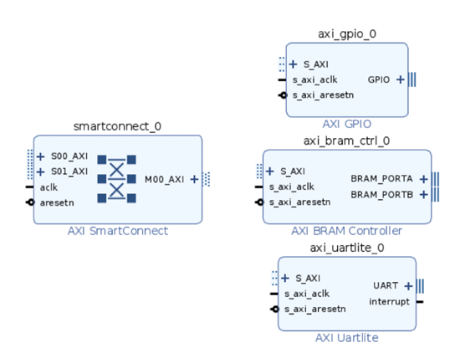
- Click the Regenerate Layout button if you need to better placement of the blocks on the canvas.

Step 3: Customizing IP
- Double-click the AXI SmartConnect core to open the Re-Customize IP dialog box, as shown in the following figure:
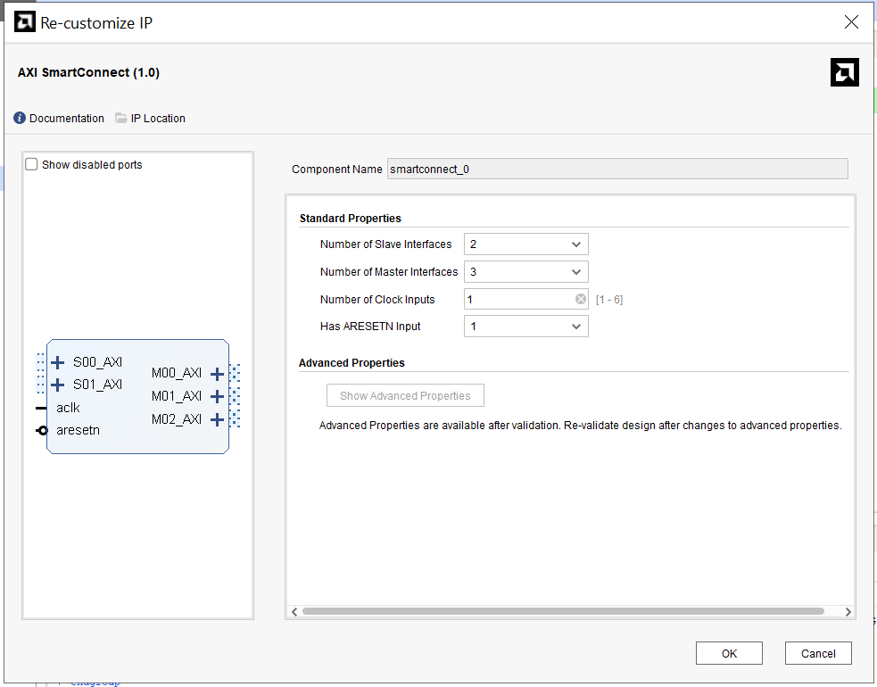
- In the Settings, change Number of Master Interfaces field to 3 from the drop-down menu.
- Leave all the remaining options as is and click OK.
The IP integrator re-customizes the AXI SmartConnect, changing the number of master interfaces to three, as shown in the following figure:
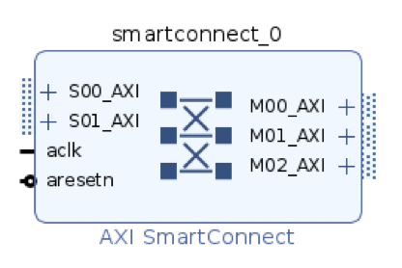
Now you can connect the three slave IP cores to the AXI SmartConnect.

Step 4: Creating Connections
At this point, you have instantiated several AXI slaves that you can access through a master such as a processor. To connect to a master controlling these slaves, first let’s create connectivity between the AXI SmartConnect and the instantiated IPs.
An interface is a grouping of signals that share a common function, containing both individual signals and multiple buses. By grouping these signals and buses into an interface, the Vivado IP Integrator can identify common interfaces and automatically make multiple connections in a single step. See the Vivado Design Suite User Guide: Designing IP Subsystems Using IP Integrator (UG994) for more information on interface pins and ports.

IMPORTANT! IP Integrator treats an external reset coming into the block design as asynchronous to the clocks. You should always synchronize the external resets with a clock domain in the IP subsystem to help the design meet timing.
You can use a Processor System Reset block (proc_sys_reset) to synchronize the reset. The Processing System Reset is a soft IP that handles numerous reset conditions at its input and generates appropriate system reset signals at its output; however, if a clock and a reset are external inputs to the block design, and the reset signal synchronizes externally to the clock, then you need to associate the related clock with the reset. This does not require the Processor System Reset block.

- Place the cursor on top of the M00_AXI interface pin of the AXI SmartConnect. Click and drag the cursor from the M00_AXI interface pin to the S_AXI interface port of AXI GPIO block.
Note: The cursor changes into a pencil indicating that a connection can be made from that interface pin. Clicking the mouse button here starts a connection on the M00_AXI interface pin.
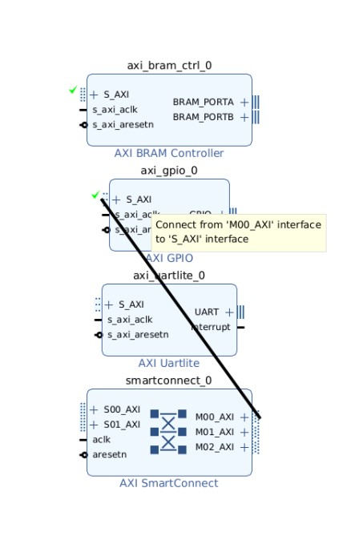
TIP: You must press and hold down the mouse button while dragging the connection from the M00_AXI pin to the S_AXI interface port.
As you drag the connection wire, a green checkmark appears on the S_AXI interface pin indicating that you can make a valid connection between these points. The Vivado IP Integrator highlights all possible connection points in the subsystem design as you interactively wire the pins and ports.
- Release the mouse button and Vivado IP Integrator makes a connection between the M00_AXI interface pin and the S_AXI port, as shown in the following figure:
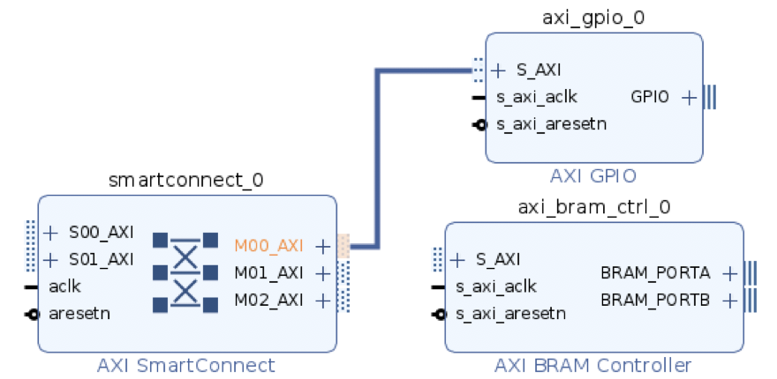
- Repeating the steps outlined above, connect the M01_AXI and the M02_AXI to the S_AXI interface ports of AXI Bram Controller and AXI Uartlite.
Note that the order of connection between M_AXI interfaces of the SmartConnect and S_AXI interfaces of the slave IPs does not matter.

The connections to the AXI SmartConnect should now appear as shown in the following figure:
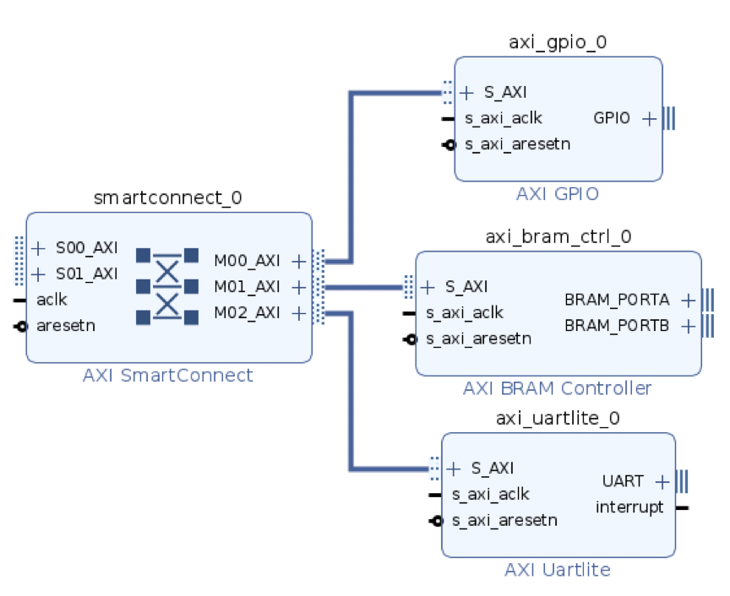
- Click the File → Save Block Design command from the main menu.

Step 5: Running Connection Automation
At this point, there are still some output interface pins that you must connect external to the subsystem design, such as the following:
- UART interface of the AXI Uartlite
- GPIO interface of the AXI GPIO
Also, note that the AXI BRAM Controller is not connected to a Block Memory Generator.
IP Integrator offers the Designer Assistance feature to automate certain kinds of connections. For the current subsystem design, you can connect the UART and GPIO interfaces to external ports using connection automation. You can also use the Designer Assistance feature to connect a Block Memory Generator to the BRAM Controller.
- Click Run Connection Automation in the banner at the top of the design canvas.
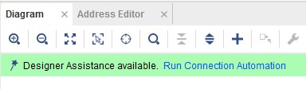
The Run Connection Automation dialog box opens.
- Only select the interface pins shown in the following figure. This selects all external interfaces and the BRAM Controller for auto connection.
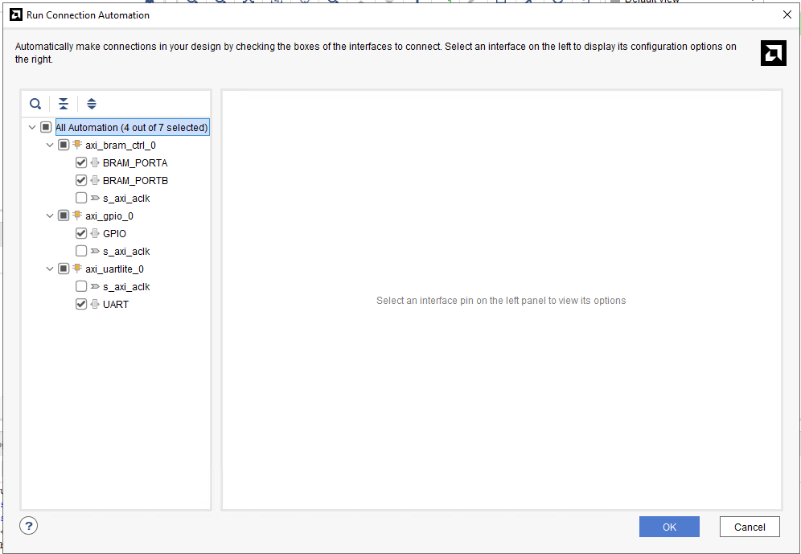

- Select and highlight the interfaces, as shown in the following figure, to see a description of the automation that the tool offers as well as any options needed to connect these interfaces.

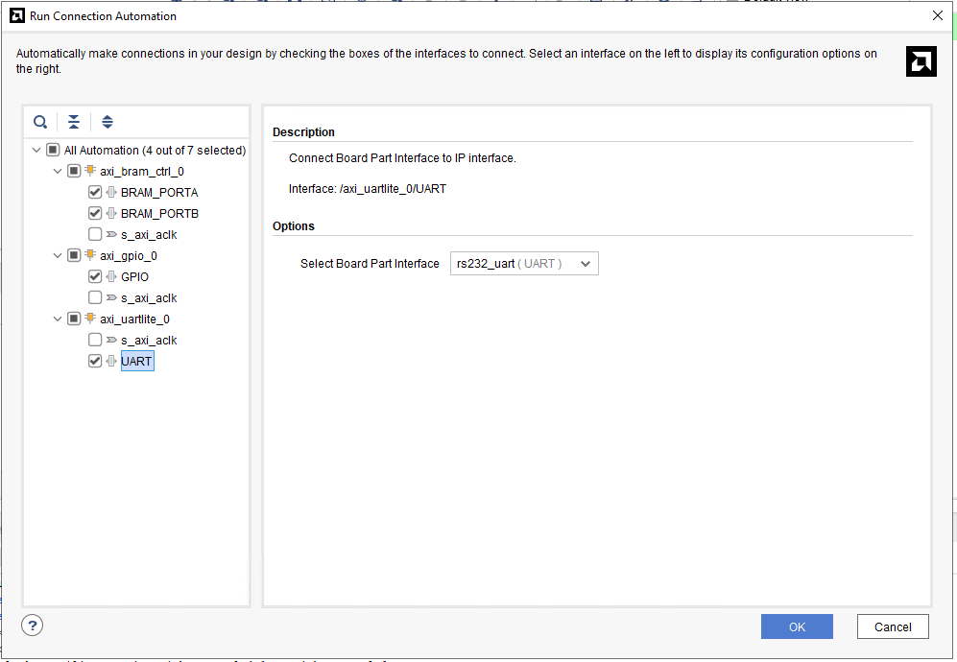
- Click OK.
- All the external interfaces connect to I/O ports, and the BRAM Controller connects to the Block Memory Generator, as shown in the following figure:

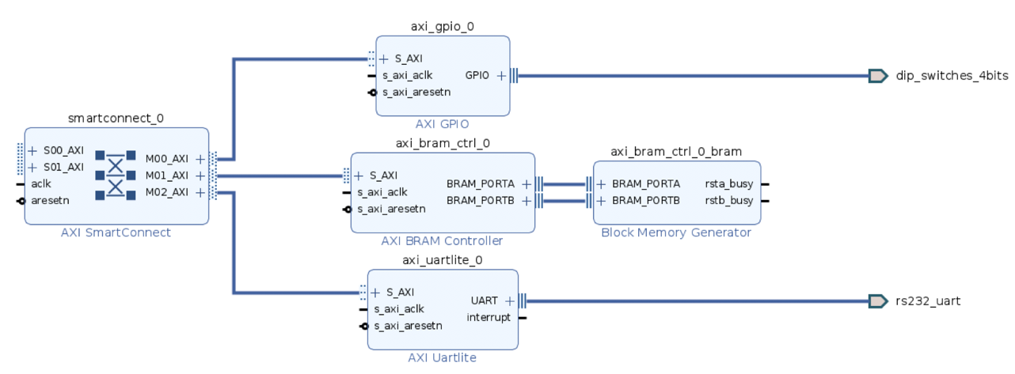
You can right-click on the external ports (dip_switches_4bits and rs232_uart in this design) and select the External Interface Properties command.

In the External Interface Properties window, you can change the name of the port if needed. The IP Integrator automatically assigns the name of the port when connection automation is run. For now, leave the port names as is.

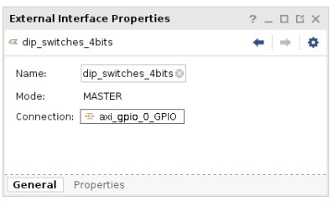

Step 6: Adding Masters and Block Automation

The next step is to add and connect the masters to the subsystem created so far.
- Right-click the design canvas to open the popup menu and select Add IP.
- In the search field, type Microblaze and double-click the core to instantiate it onto the canvas.
- Click Run Block Automation in the banner at the top of the design canvas.
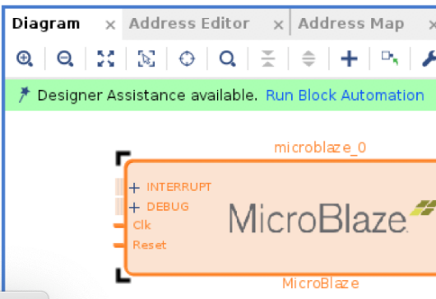
- Select all the default options in the Run Block Automation dialog box and click OK.
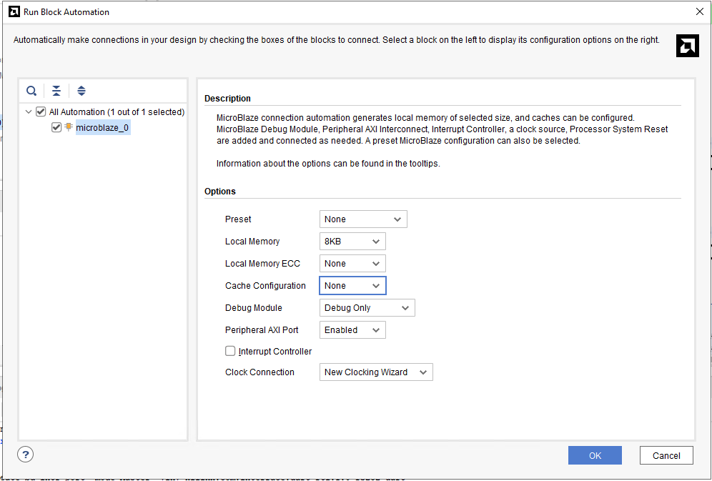
- The IP Integrator adds local memory and debug to the processor block and connects a Clocking Wizard and Processor System Reset to the subsystem.
- Click the Regenerate Layout button to redraw the subsystem design.
The optimized layout of the design should now look like the following figure:
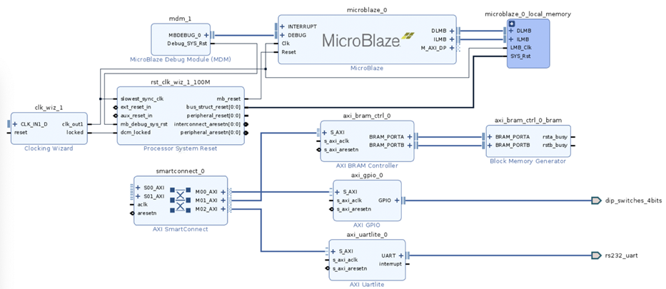

- Click Run Connection Automation in the banner at the top of the design canvas. The Run Connection Automation dialog box opens.


- Select All Automation (7 out of 7 selected) as shown in the following figure. This selects the external interfaces for clock and reset on the board, the s_axi_aclk of slave peripheral, and the master M_AXI_DP port of the processor for auto connection.
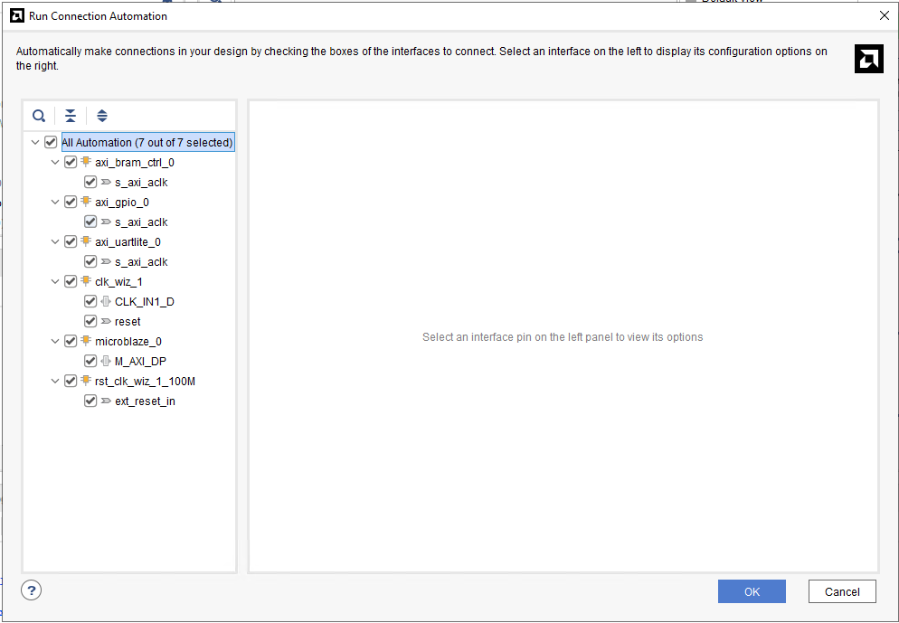
- Once connection automation is done, the design canvas should look something like the snapshot shown below:
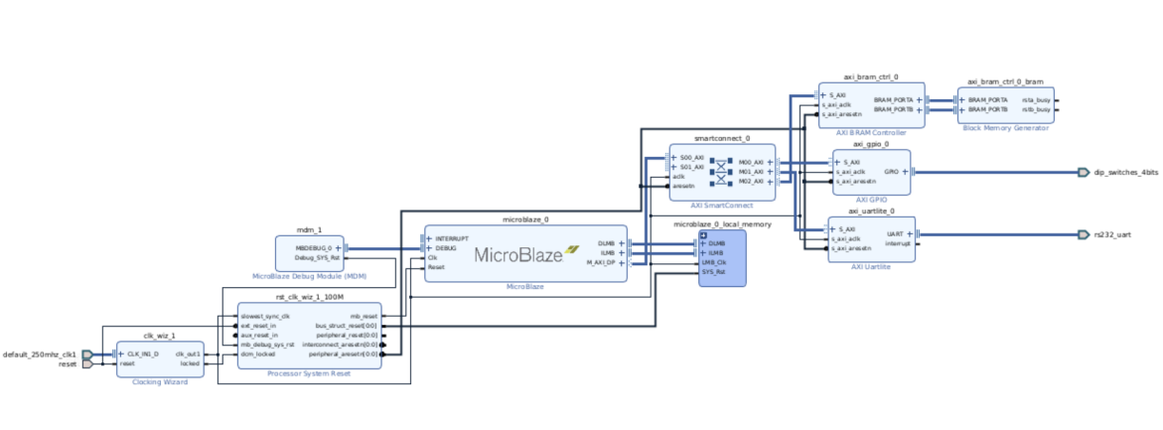

- You can also change the diagram view from Default to Interfaces view as shown below.
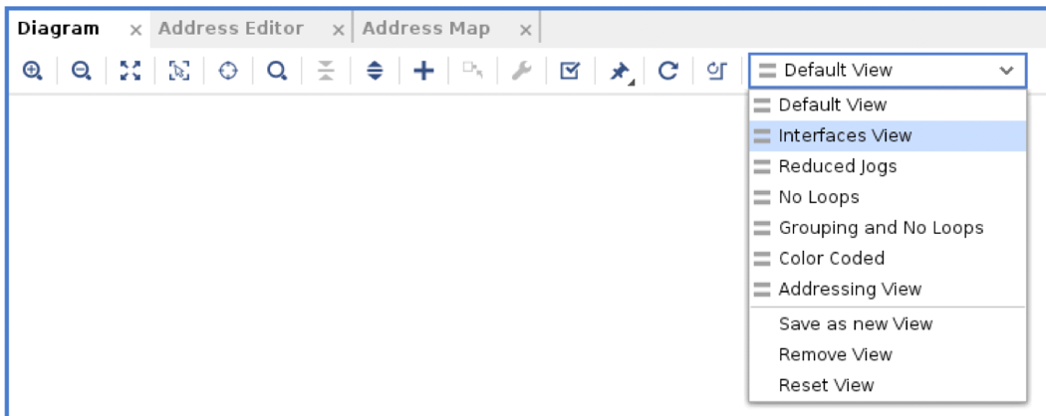

- The layout of the design should now look like the figure below with only interfaces showing on the canvas for better viewing. You can click the Regenerate Layout button to redraw the subsystem design. You can also change colors, layers and other general settings by clicking in the top right corner of the design canvas.

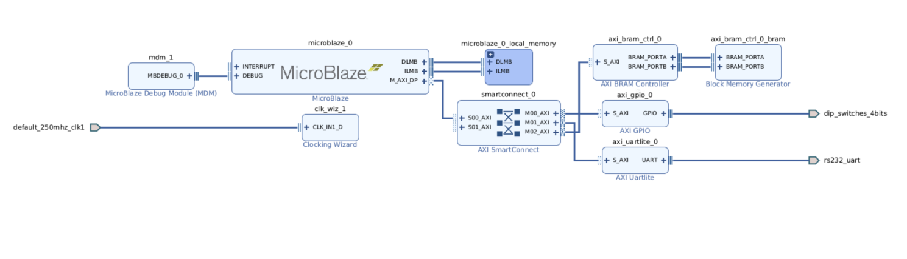

- There are different ways of changing the view on the canvas and better organizing the blocks. One of these capabilities is creating hierarchy levels to include one or more blocks. To do so, select the following blocks- microblaze_0, microblaze_0_local_memory, and mdm_1 by holding down the ctrl- button clicking on them one after the other. They should be highlighted in orange like the following figure-
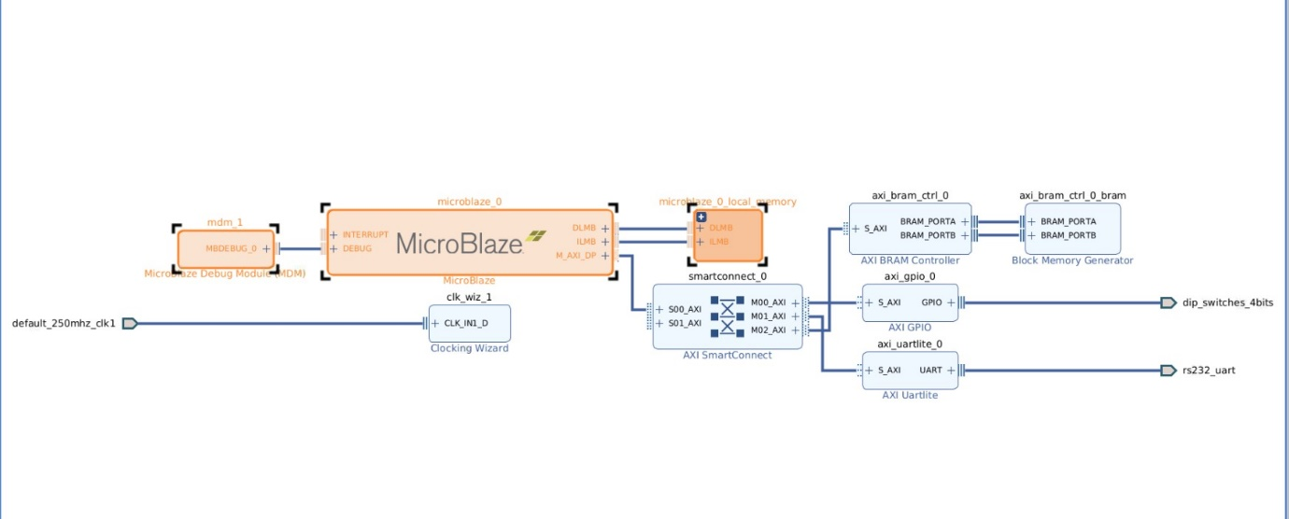
- Now, right-click and select Create Hierarchy.
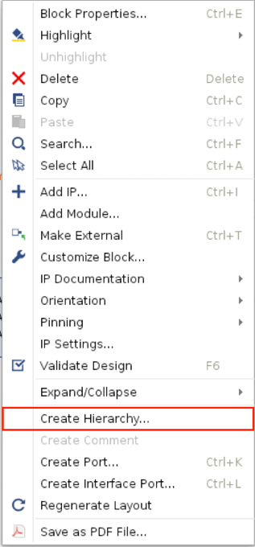
- You can assign a new name to the hierarchy or keep the default name in the dialog box, then click OK.
Note that you can expand the hierarchy to see the content inside by clicking on the + button on the top left of the block-
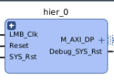
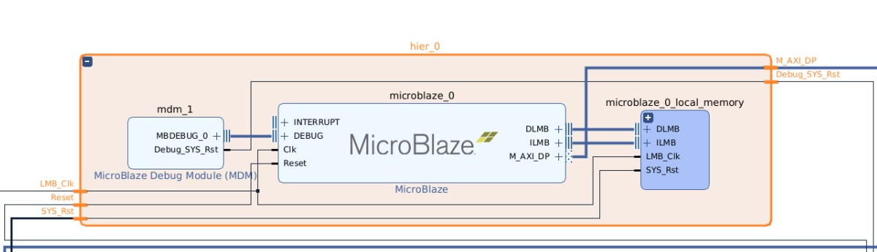
- Hierarchy levels can help with organizing the blocks on the canvas as well as replicating different sections of a block design. At this point, you have connected only one master to the SmartConnect block. To add the second master, we replicate the hierarchy block created in the previous step.
- Switch the diagram view from Interfaces to Default from the top canvas toolbar.
- Select the MicroBlaze subsystem hierarchy block previously created (hier_0), right-click and select copy.
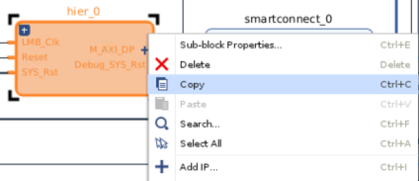

- Right-click on the white space area of the canvas and select paste. A second hierarchical level with the exact same content gets created.
- After creating both the hierarchies, you will now have 2 Microblaze Debug Modules. Change the BSCAN location of the Microblaze Debug Module (MDM) to EXTERNAL for both the debug modules. This is to avoid any implementation issues with both the BSCAN locations, as the might get assigned the same location.
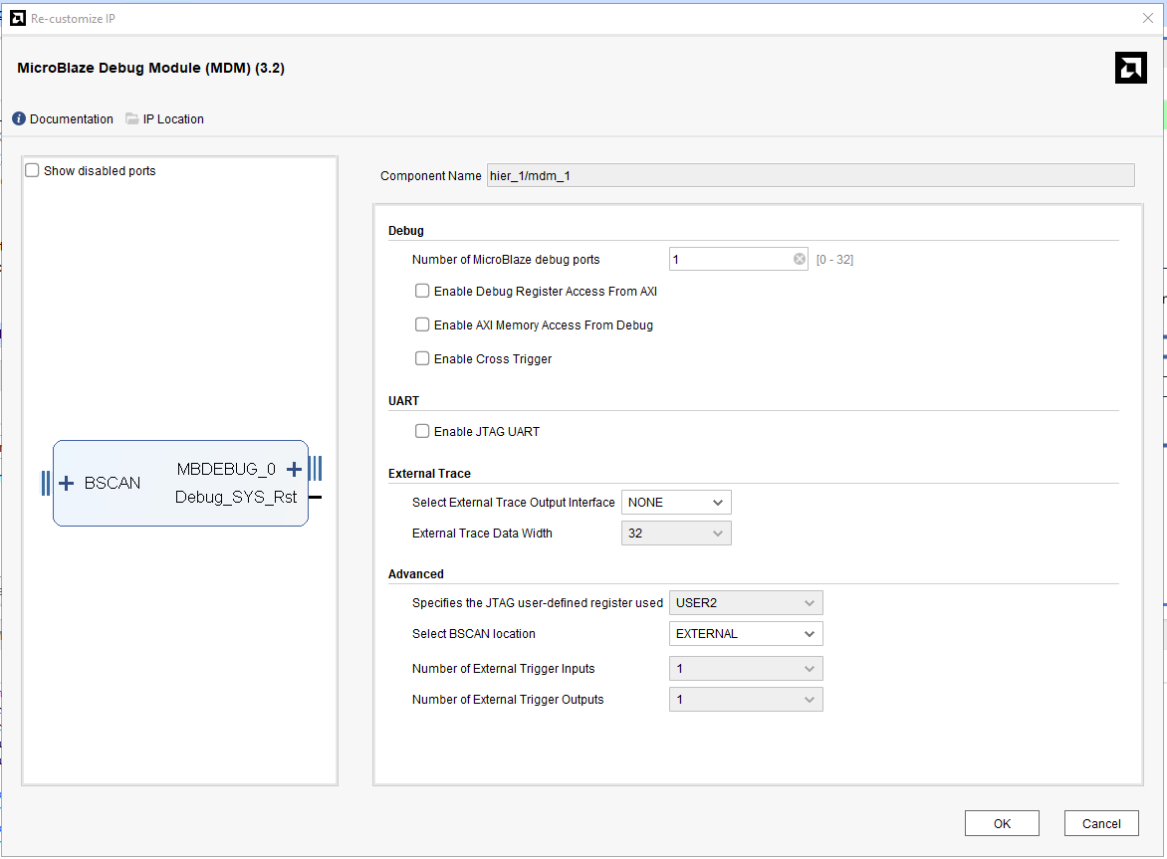
- Click Run Connection Automation in the banner at the top of the design canvas.

- Select All Automation (2 out of 2 selected) to connect M_AXI_DP of the MicroBlaze to the second master AXI port of the SmartConnect.
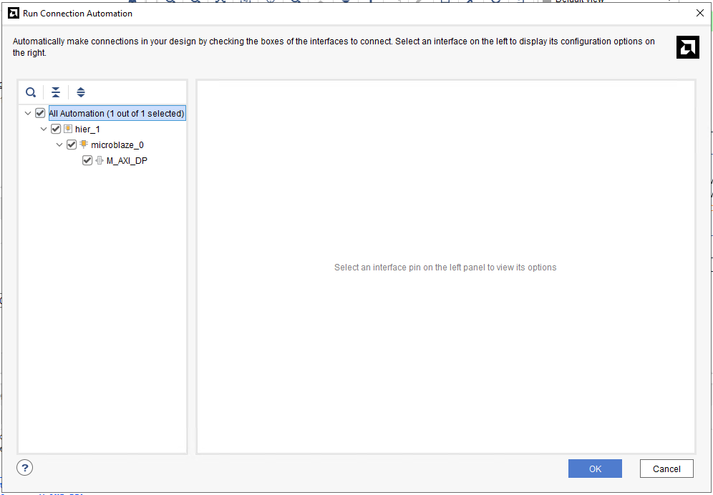

- Click the Regenerate Layout button to redraw the subsystem design.
The optimized layout of the design should now look like the following figure:
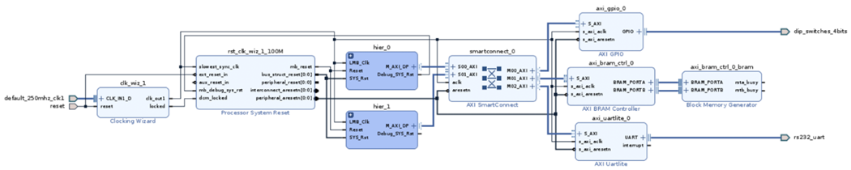
- The only remaining connection is the sys_rst port of the new hierarchical block.

Place the cursor on top of the pin and drag the connection to bus_struct_reset[0:0] port of the Processor System Reset block.

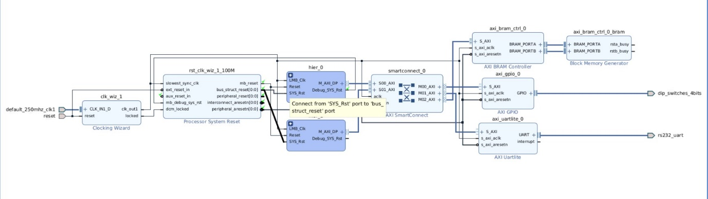

- Click on File → Save Block Design command from the main menu.

Step 7: Using the Address Editor
For various memory mapped master and slave interfaces, IP Integrator follows the industry
standard IP-XACT data format for capturing memory requirements and capabilities of endpoint
masters and slaves. This section provides an overview of how IP Integrator models address
information on a memory-mapped slave.

Master interfaces have address spaces, or address_space objects. Slave interfaces have an
address_space container called a memory map to map the slave to the address space of the
associated master. Typically, these memory maps are named after the slave interface pins, for example S_AXI, though that is not required.

The memory map for each slave interface pin contains address segments, or address_segment objects. These address segments correspond to the address decode window for that slave. A typical AXI4-Lite slave will have only one address segment, representing a range of addresses. However, some slaves, like a bridge, will have multiple address segments or a range of addresses for each address decode window.
When you map a slave to the master address space, a master address_segment object is created, mapping the address segments of the slave to the master. The Vivado IP Integrator can automatically assign addresses for all slaves in the design. However, you can also manually assign the addresses using the Address Editor. In the Address Editor, you see the address segments of the slaves, and can map them to address spaces in the masters.

TIP: The Address Editor tab only appears if the subsystem design contains an IP block that functions as a bus master. In the tutorial design, the processors connecting through the AXI SmartConnect are the bus masters.

- Click the Address Editor tab to show the memory map of all the slaves in the design.
Note: If the Address Editor tab is not visible then select Window → Address Editor from the main menu.

The IP Integrator has automatically assigned the addresses.
Note that there are three address networks. One is the shared network between processors accessing the peripherals (AXI BRAM, GPIO, and UART), and two networks for local memory belonging to each processor subsystem.
You can change the automatic address assignments by clicking in the corresponding column and changing the values.
- Change the size of the address segments for the AXI BRAM Controller core for the MicroBlaze in hier_1. Click the Range column, and select 64K from the drop-down menu as shown in the following figure:
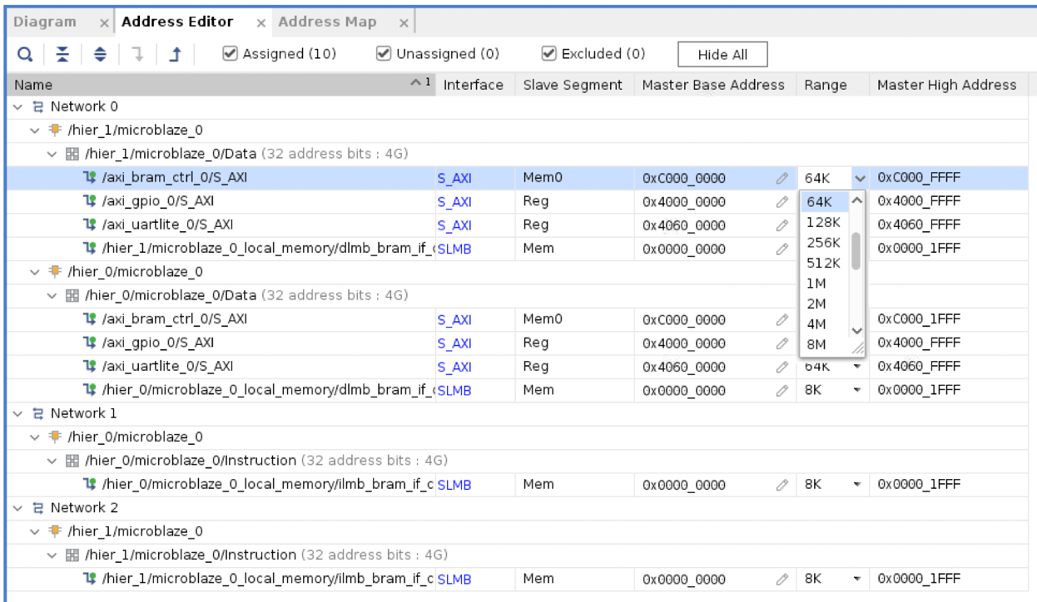
- Select the Diagram tab, to return to the IP Integrator design canvas.

Step 8: Validating the Design

- From the menu at the top of the IPI design canvas, run the IP subsystem design rule checks
(DRCs) by clicking the Validate Design button
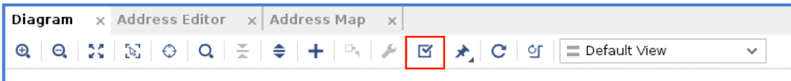
The Validate Design dialog box opens, and validation should be successful. Click OK.
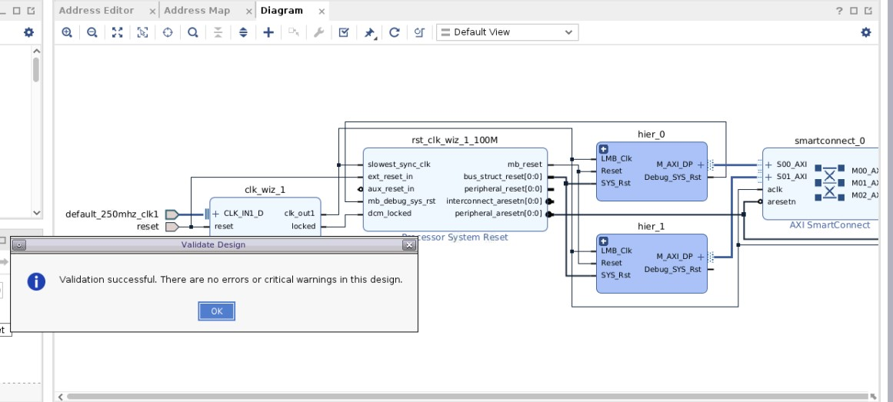
At this point, you should save the IP Integrator subsystem design again.
- Select File → Save Block Design command from the main menu to save the design.

Step 9: Debugging the Design

The System ILA debug core in IP integrator allows you to perform in-system debugging of block designs. This feature should be used when there is a need to monitor interfaces and signals in the design. We will demonstrate how to debug a signal in this section.
- Mark the interface between the AXI SmartConnect and AXI GPIO IPs by right-clicking on the net and selecting Debug from the context menu as shown in the following figure:
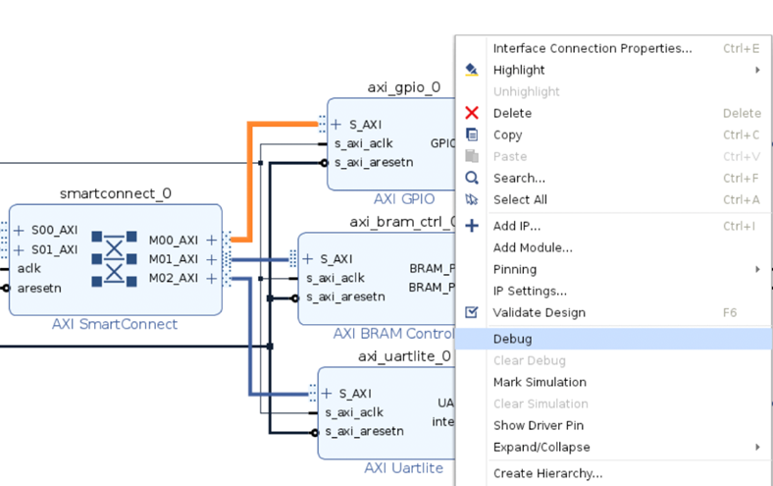

Note that nets and interface marked for debug show a small bug icon placed on top of the net or interface in the block design.

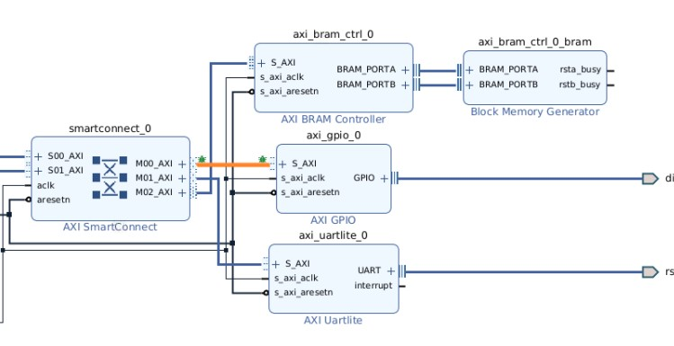
- Now, use Designer Assistance to connect the interface to the System ILA core.
- You can select the desired options for the System ILA core for debugging or accept the default values.
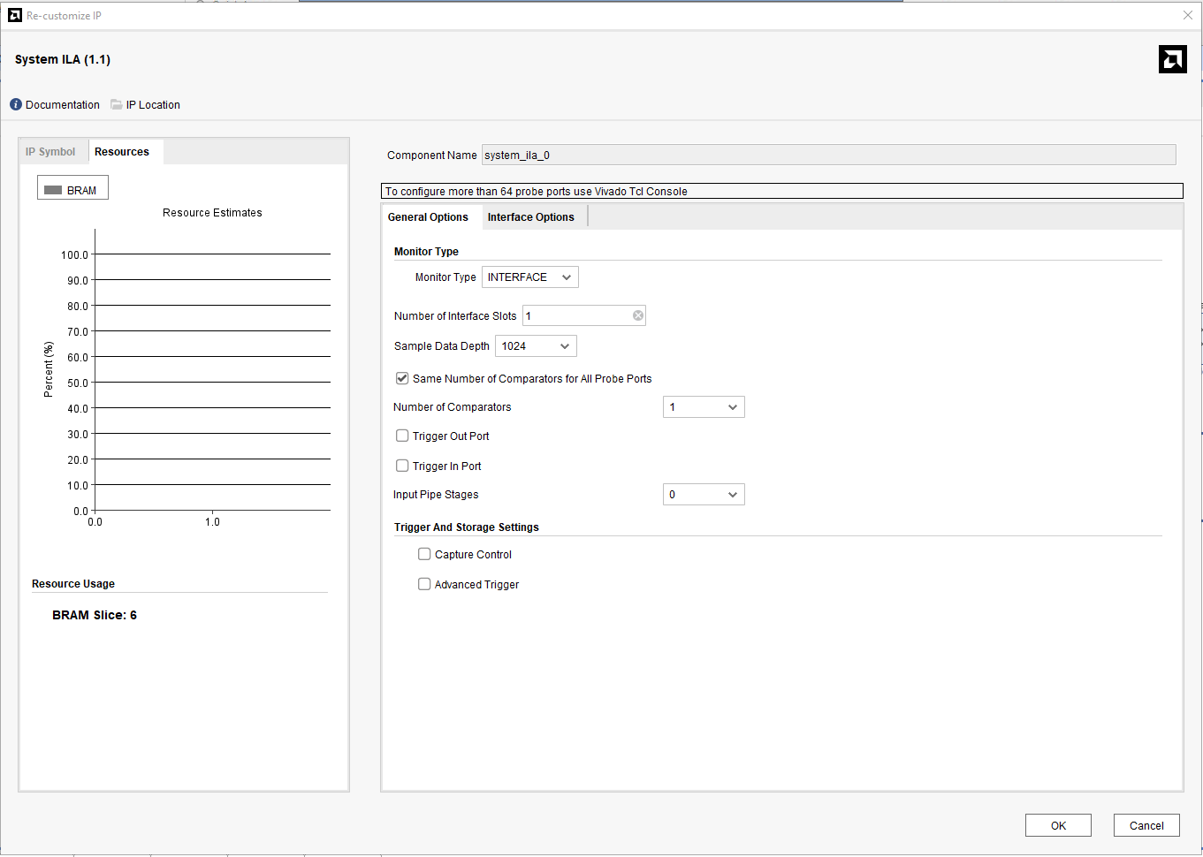

- Validate Design to ensure that design connectivity is correct.

Step 10: Creating and Implementing the Top-level Design
With the IP subsystem design completed and validated, it can be included as a module or block in the top-level design or it may be the top-level in the design. In either case, you need to generate the HDL files for the subsystem design.
- In the Sources window, right-click the top-level subsystem design, design_1, and select Generate Output Products.
The Generate Output Products dialog box lets you choose how to handle the synthesis of the block design. The three Synthesis Options include:
- Global: Synthesizes the block design as part of the top-level project rather than as an out-of-context block.
- Out-of-Context per IP: Synthesizes each IP in the block design separately, out-of-context of the block design or the top-level design. This prevents each IP from being synthesized unnecessarily but requires updating and re-synthesizing each IP when it is updated.
- Out-of-context per Block Design: Synthesizes the entire block design at one time, but out-of-context from the global or top-level design. This prevents the block design from being synthesized unnecessarily when the top-level design is synthesized but requires updating and re-synthesizing the block design when any of the IP in it are updated.
Leave the default selection of Out of Context per IP.
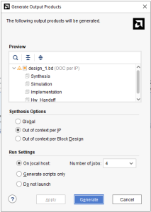
- Click Generate to generate all output products.
Alternatively, you can click Generate Block Design in the Flow Navigator, under the IP Integrator drop-down menu.
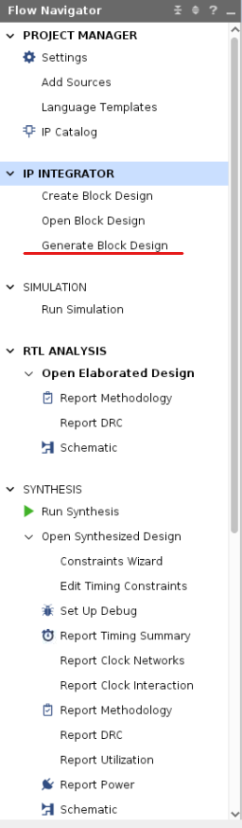
- The Out-of-Context (OOC) runs for each IP in the design launch, shown in the Design Runs tab below. OOC runs can take a few minutes to finish.
- After the Out-of-context runs are finished, in the Sources window, right-click the top-level subsystem design, design_1, and select Create HDL Wrapper.

The Create HDL Wrapper dialog box opens, and offers two choices:
- Copy generated wrapper to allow user edits: with this option you will modify the wrapper file. Often a block design is a subset of an overall project. In cases like these, you might need to edit the wrapper file and instantiate other design components in the wrapper. If the I/O interface of the block design changes in any manner, you must manually update the wrapper file to reflect those changes.
- Let Vivado manage wrapper and auto-update: with this option Vivado generates and updates the wrapper file as needed. The wrapper file created using this method is automatically updated every time output products for the block design are generated, to reflect the latest changes.

- Select the default option, Let Vivado manage wrapper and auto-update and click OK.
The Vivado IDE creates a top-level HDL wrapper for the design_1 block design and adds it to the design sources to the project and proceed to implementation.
- Once the top-level HDL source is added to the project, add the design constraints by clicking File → Add Sources. Then click on Add or Create Constraints and click Next. Then click on Add files to add the “/constraints/vcu118_rev2.0_12082017.xdc” file.
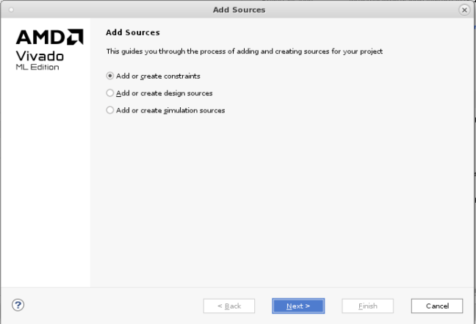
- Now, you have 3 options to move forward:
- Use the Run Synthesis command to run only synthesis.
- Use the Run Implementation command, which will first run synthesis if it has not been run and then run implementation.
- Use the Generate Bitstream command, which will first run synthesis, then run implementation if they have not been run, and then write the bitstream for programming the Xilinx device.
These options can be selected from the Flow Navigator.
- For this lab, we are going to generate the bitstream for the design. From the Flow Navigator, click on Generate Bitstream, which will automatically synthesize, implement, and generate the bitstream for the design.
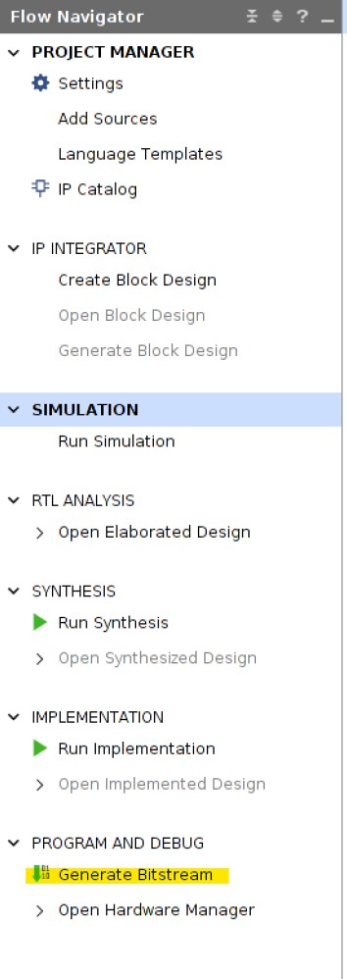
The No Implementation Results Available dialog box opens as seen in the following figure:
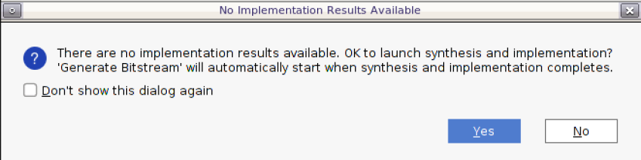
- When the bitstream generation completes, you will get the following message.
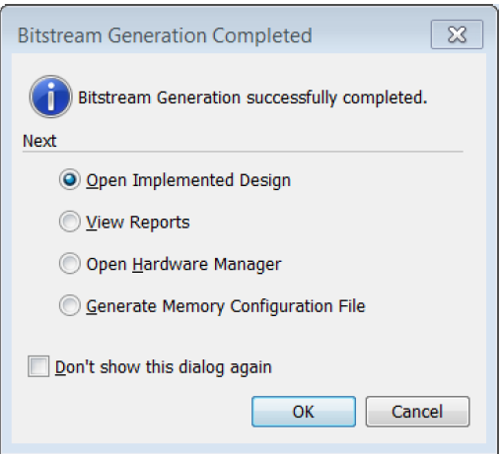
This marks the end of the tutorial. You can now exit Vivado.

