Contents
Designing with IP Integrator Design with RTL top 2
Introduction 2
Tutorial Design Description 2
Step 1: Creating an IPI design with RTL as top 2
Step 2: Running implementation and generating xsa 8
Step 3: Exporting Hardware Platform(xsa) to PetaLinux Project 11
Step 4: Analysing the device tree 14
Step 5: Booting PetaLinux Image on Hardware 15

Designing with IP Integrator Design with RTL top

Introduction
The AMD® Vivado® Design Suite IP Integrator lets you create complex system designs by instantiating and interconnecting IP cores from the Vivado IP catalog onto a design canvas. You can create designs interactively through the IP Integrator design canvas GUI, or programmatically using a Tcl programming interface.

Tutorial Design Description
This tutorial walks you through the steps of building an IPI design with RTL as top. You will generate the post implementation xsa and run it on the PetaLinux. While working through the tutorial you will learn how the BD addressing of an RTL top design gets mapped to device tree generated in the PetaLinux through Xilinx shell archive (xsa).

Step 1: Creating an IPI design with RTL as top
- Open the Vivado® Integrated Design Environment (IDE).
- On Linux, change to the directory where the Vivado tutorial design file is stored: cd
<Extract_Dir>/Vivado_Tutorial. Then launch the Vivado Design Suite: Vivado.
- On Windows, launch the Vivado Design Suite: Start → All Programs → AMD Design Tools→ Vivado 2023.2.
As an alternative, click the Vivado 2023.2 Desktop icon to start the Vivado IDE.
The Vivado IDE Getting Started page contains links to open or create projects and to view
documentation, as shown in the following figure:
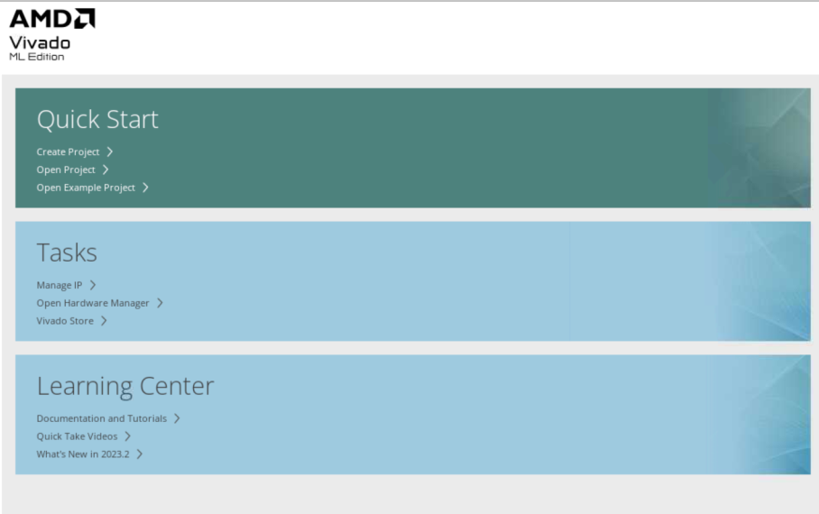

Note: Your Vivado Design Suite installation may be called something different from AMD Design Tools
on the Start menu.
- Under the Quick Start section, select Create Project.
- The New Project wizard opens. Click Next to confirm the project creation.
- In the Project Name page, shown in the following figure, set the following options:
- In the Project name field, enter Lab1 and specify a location where the project must be created.

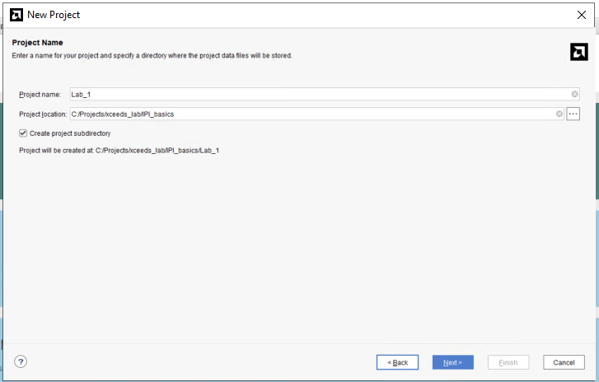

- Ensure that Create project subdirectory is checked and click Next.
- Click on Add Files and select the files from src_files/RTL_files folder.
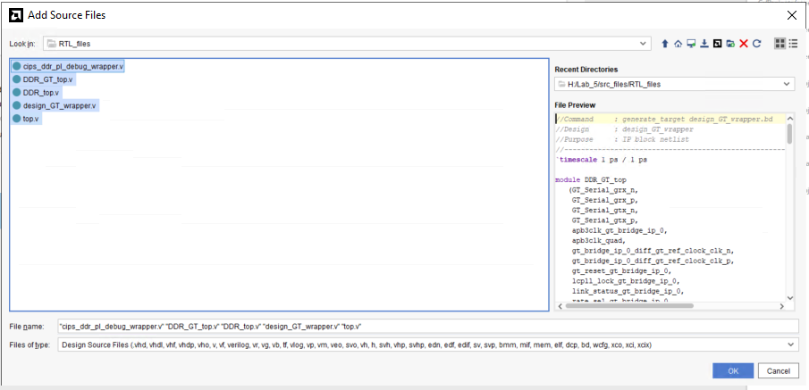
- Click OK and click Next.
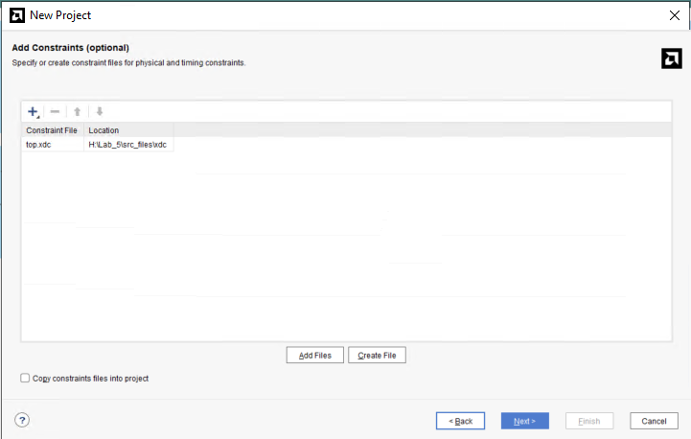
- In the Add constraints box, click Add Files and add the top.xdc from the src_files/xdc folder.
- Click next, and then you will land on the Default Part page. Click on the Boards tab to select the Versal VCK190 Evaluation Platform.

- Review the project summary in the New Project Summary page.
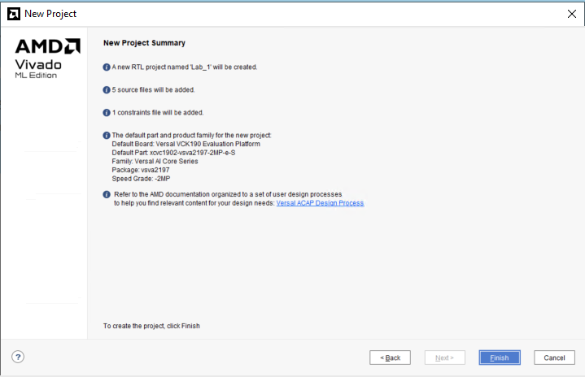
- Click Finish to create the Lab1 project.
- The new project opens in the Vivado IDE.
- Now the design looks as below, the gaps shown must be filled with the Block designs.
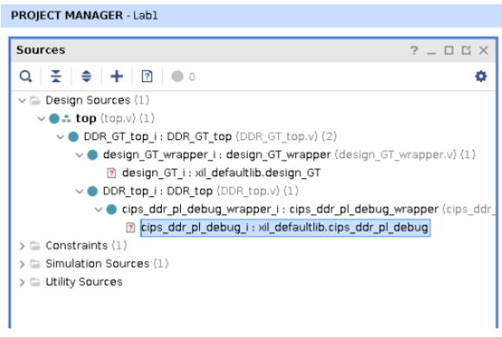
- Source the GT_bd.tcl and cips_ddr_pl_bd.tcl from src_files/tcl_files in the TCL Console.
- Once the BD (Block Designs) tcl files are sourced, you will see the hierarchy as below.
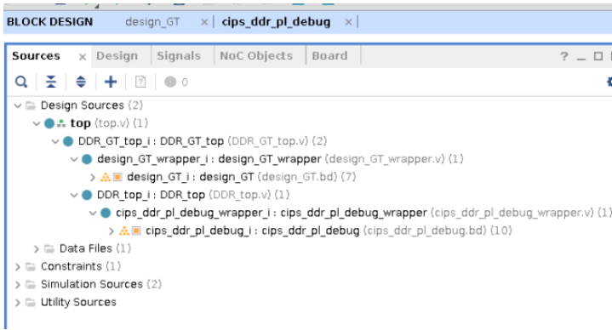
- Note that the design has block diagram under the 3 levels of RTL.

Step 2: Running implementation and generating xsa
- Open the BD cips_ddr_pl_debug, the block design connects the processing system to the DDR memory and BRAM through NOC (Network On Chip). AXI Bus is probed with ILA and counter is controlled with a VIO core.
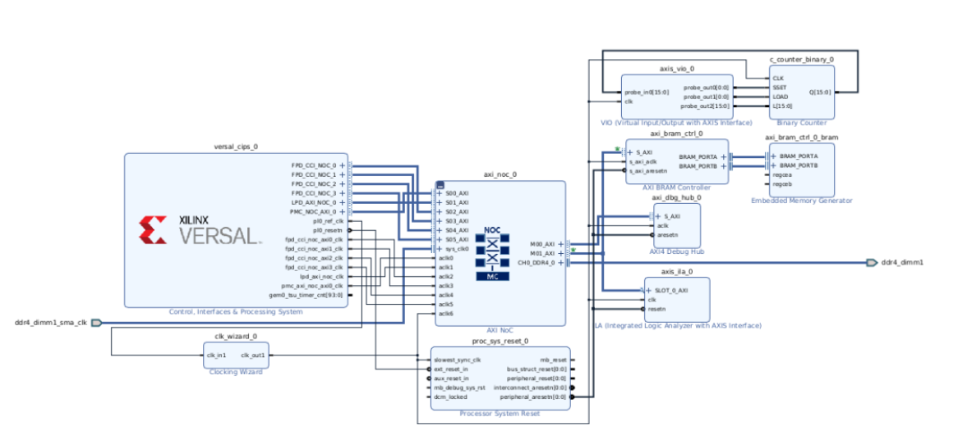
- Open the Address Editor and see the slave segment BRAM is at 0x20140000000 master CIPS base address.
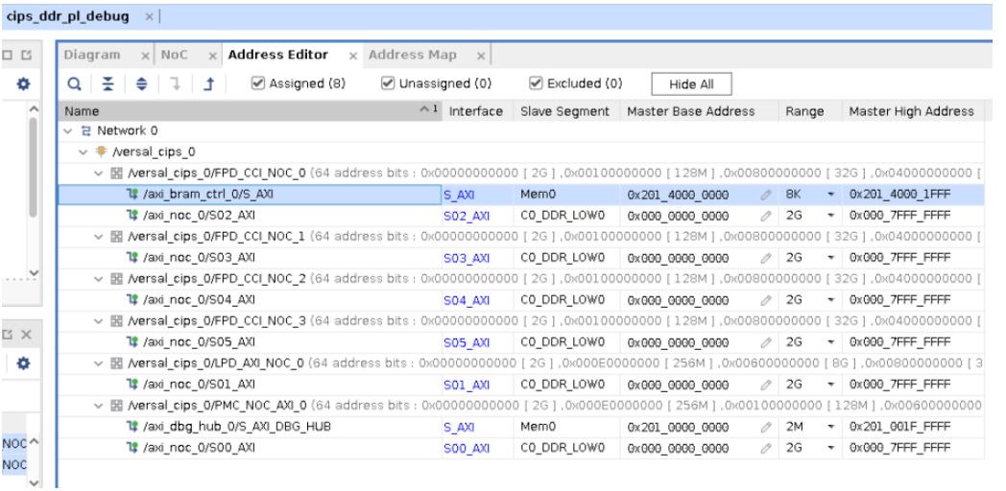
- Click on ‘Generate Device Image’ in the Flow navigator. Click Yes when prompted to launch Implementation and click OK to launch runs.
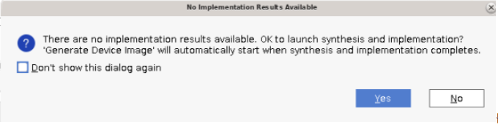
- The Design Runs tab looks as shown below. Full design synthesis and implementation will be launched after the block design are synthesized in Out of context.
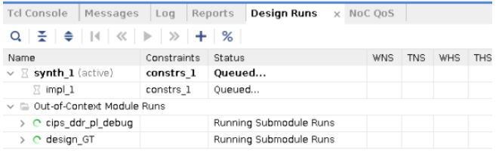
- Once the device Image is generated, Export the Hardware i:e generates the xsa from File > Export > Export Hardware. The XSA extension stands for Xilinx Shell Archive and these files are generated by Vivado to contain the required hardware information.
- In the Output, choose ‘Include device Image’ and click Ok.
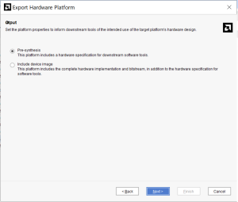

Step 3: Exporting Hardware Platform(xsa) to PetaLinux Project
PetaLinux tools enable developers to synchronize the software platform with the hardware design. PetaLinux is an embedded Linux Software Development Kit (SDK) targeting FPGA-based system-on-a-chip (SoC) design.
This section assumes that the following prerequisites have been satisfied:
- Peta Linux BSP is downloaded. You can download PetaLinux VCK190 BSP (BSP - 2.06 GB) from PetaLinux Downloads. For more information visit Project-Creation-Using-PetaLinux-BSP
- The Peta Linux tools installation is complete. For more information, see Installation Steps.
- Peta Linux Working Environment Setup is completed. For more details, see PetaLinux Working Environment Setup.
- Create a PetaLinux project
  - Change to the directory under which you want PetaLinux projects to be created. For example, if you want to create projects under /home/user
$cd /home/user
- Run petalinux-create command on the command console
$petalinux-create -t project -n vck190 -s <path-to-bsp>

When the above command runs, it tells you the projects that are extracted and installed from the BSP. If the specified location is on the Network File System (NFS), it changes the TMPDIR to /tmp/<projname-timestamp-id>; otherwise, it is set to $PROOT/build/tmp
Note: PetaLinux requires a minimum of 50 GB and a maximum of 100 GB /tmp space to build the project successfully when you create the project on NFS. Please refer to UG1144 for more details.
- Importing Hardware Configuration
This section explains the process of updating an existing PetaLinux project with a hardware configuration. This enables you to make the PetaLinux tools software platform ready for building a Linux system, customized to your new hardware platform
- Change into the directory of your PetaLinux project.
$cd vck190
- Copy the xsa generated in Step2 to the vck190 folder created in your location
- Import the hardware description with petalinux-config command using the following step
$petalinux-config --get-hw-description=. –silentconfig
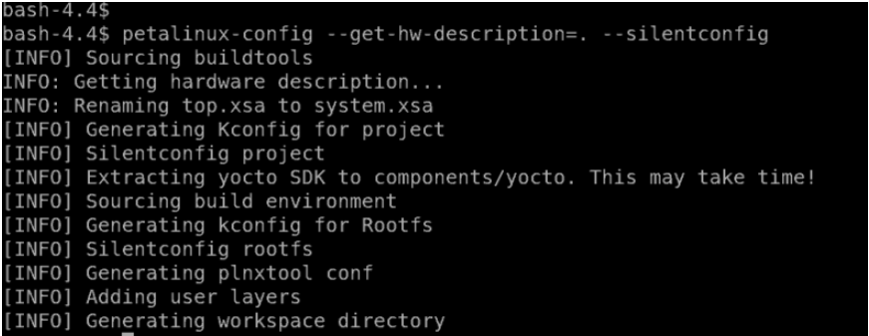
Note:When the petalinux-config --get-hw-description command runs for the PetaLinux project, the tool detects changes in the system primary hardware candidates. Please refer to UG1144 for more details.
- Build System Image
This step generates a device tree DTB file, PLM (for Versal® ACAP), PSM (for Versal ACAP) and TF-A (for Zynq UltraScale+ MPSoC and Versal ACAP), U-Boot, the Linux kernel, a root file system image, and the U-Boot boot script (boot.scr). Finally, it generates the necessary boot images.
- Run petalinux-build to build the system image:
$petalinux-build

Note:The compilation progress shows on the console. Wait until the compilation finishes.A detailed compilation log is in <plnx-proj-root>/build/build.log.When the build finishes, the generated images are stored in the < plnx-proj-root >/images/linux or /tftpboot directories. For more info refer to UG1144
- Generate Boot Image for Versal ACAP
This section is for Versal® ACAP only and describes how to generate boot image BOOT.BIN for vck190.A boot image usually contains a PDI file (imported from hardware design), PLM, PSM firmware, Arm® trusted firmware, U-Boot, and DTB.
- Execute the following command to generate the boot image in .bin format:
$petalinux-package --boot --u-boot –force

Note: Specifying --u-boot adds all the required images to boot up to U-Boot into BOOT.BIN. Please refer to UG1144 for details

Step 4: Analysing the device tree
- The device tree generated(system.dtb) can be found inside vck190/images/linux folder.
The system.dtb is a compiled binary device tree. This will be copied to your image. So, now we are going to check the if the BRAM address 0x20140000000 (mentioned in Setp2, point2) is correctly mapped in the device tree. For this the dtb file must be converted to dts.
- We will be using dtc – device tree compiler which takes an input a device-tree in a given format and output in another format. In the below command dtc takes the system.dtb(binary format) and outputs dts (human readable source format)
- In the device tree you can see axi_bram_ctrl is assigned at 0x20140000000. So, ideally this address should be same as the BRAM base address in the design IPI address editor (refer to Setp2, point2)
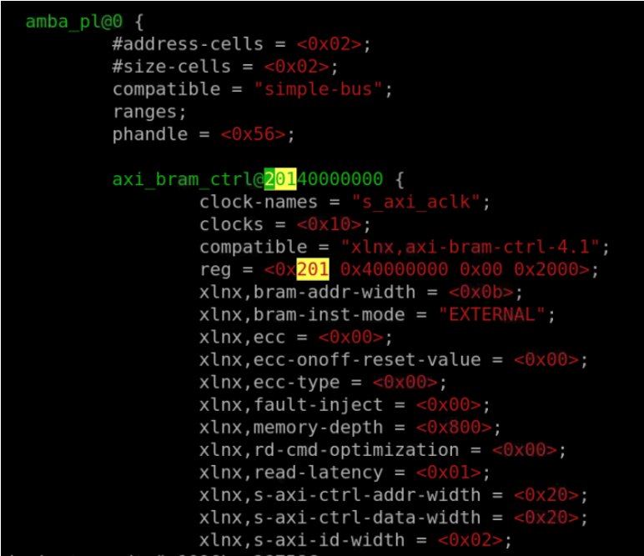
Open the design and observe the axi_bram_ctl Master base address.

Step 5: Booting PetaLinux Image on Hardware
This section describes how to boot a PetaLinux image on hardware with an SD Card.
- This section assumes that a serial communication program such as minicom/kermit/gtkterm has been installed; the baud rate of the serial communication program has been set to 115200 bps.
- Copy the following files from /linux/images/ into the root directory of the first partition, which is in FAT32 format in the SD card:
  - BOOT.BIN
  - image.ub
  - boot.scr
- Extract the rootfs.tar.gz folder into the ext4 partition of the SD card.
- Connect the serial port on the board to your workstation.
- Open a console on the workstation and start the preferred serial communication program (For example: kermit, minicom, gtkterm) with the baud rate set to 115200 on that console.
- Power off the board.
- Set the boot mode of the board to SD boot. Refer to the board documentation for details.
- Plug the SD card into the board.
- Power on the board.
- A boot message displays on the serial console.
- Once the image is booted, use devmem to verify the memory contents.
- Use devmem again to verify the write was successful.
Refer to below link for more detail's other methods of booting:
Boot-a-PetaLinux-Image-on-Hardware-with-SD-Card
Boot-a-PetaLinux-Image-on-Hardware-with-TFTP
Boot-a-PetaLinux-Image-on-Hardware-with-JTAG

