Steps to alter Mathworks STAP Simulink model for use with AMD Demo:

1. Open Mathworks STAP Simulink model by executing the following command:
   1. openExample('radar/slexSTAPExampleExample')
2. Save a copy as “xRadar.slx” in the design/xRadar_MatlabModel/Radar directory
   1. This copy will be the working copy to preserve the original and will be referred to as “the model.”
3. Copy Simulink blocks from extra_stap_blocks.slx and insert them into the model as shown in the below diagram. Also comment out the STAP and Visualization blocks.
   1. 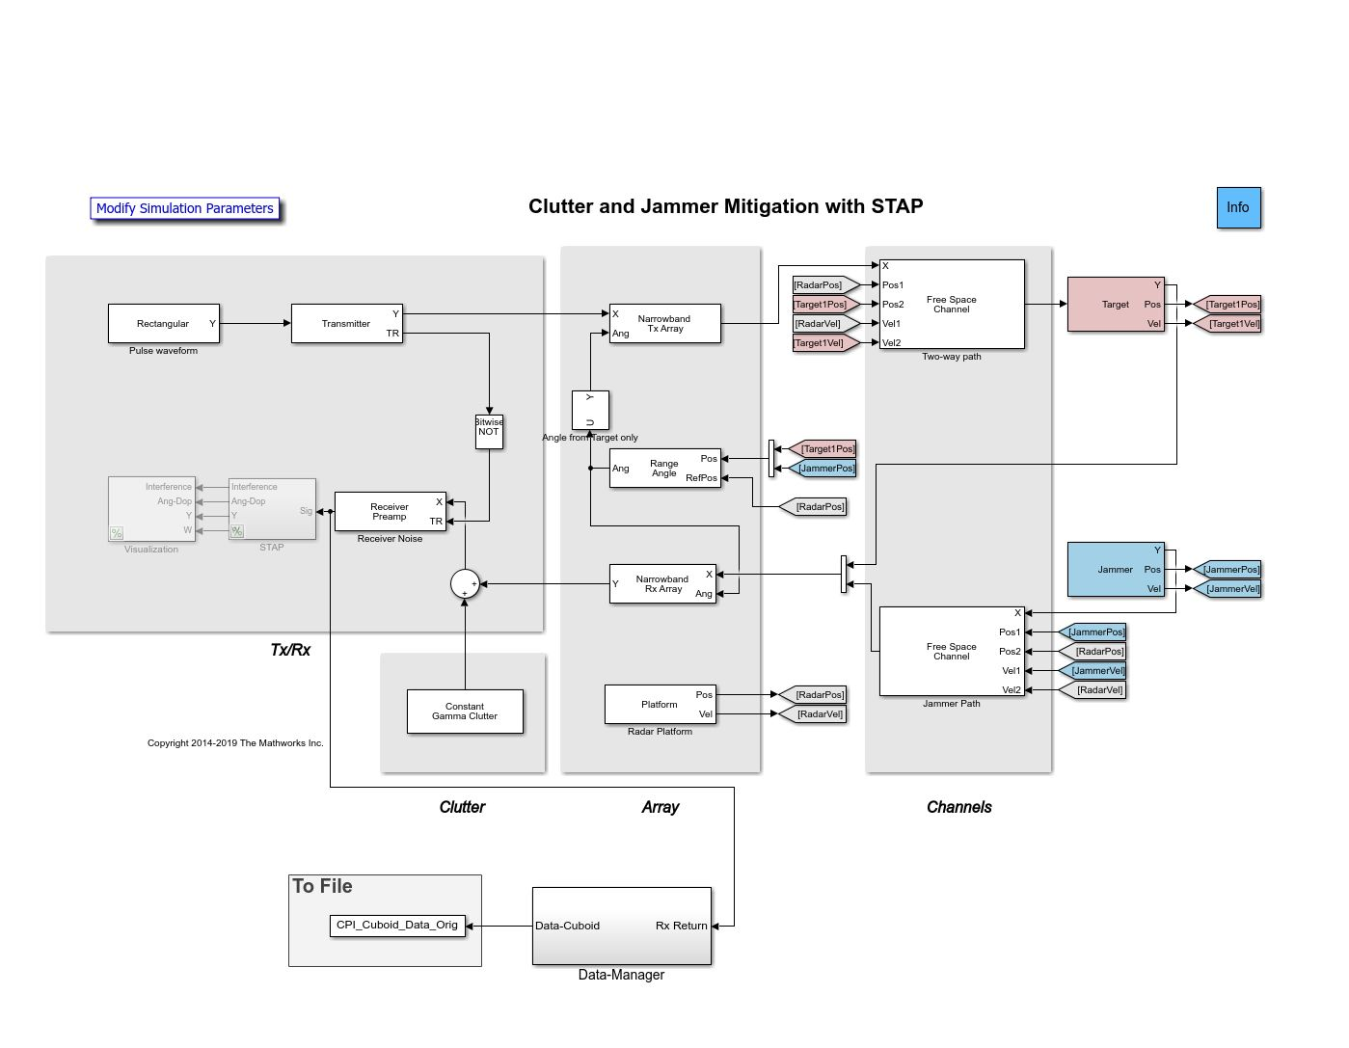
4. For each of the next steps, make sure to hit “Apply” and then “OK” in the dialog boxes.
5. Access the model properties by right clicking on the canvas as shown below:
   1. A screenshot of a computer

      Description automatically generated
   2. Edit the model Pre-Load callback function to xRadarParam(); match the picture below:
      1. A screenshot of a computer

         Description automatically generated
6. Edit the Jammer/Barrage “effective power” parameter to paramSTAP.effPower
   1. A screenshot of a computer

      Description automatically generated
7. Edit the Receiver “Preamp Gain” and “Reference Temperature” to paramSTAP.rxGain and paramSTAP.refTemp respectively
   1. A screenshot of a computer

      Description automatically generated
8. Change Constant Gamma Clutter “Terrain gamma value” parameter to paramSTAP.clutterGamma
   1. A screenshot of a computer

      Description automatically generated
9. Save the model changes