Jonathan Tweedle

2019/07/24

CSHP 230 B Su 19: Web Applications In C#

Assignment 05

Styling with jQuery and Bootstrap

# Introduction

# Topic 1

## Sub Topic A



Figure 1: I am all alone

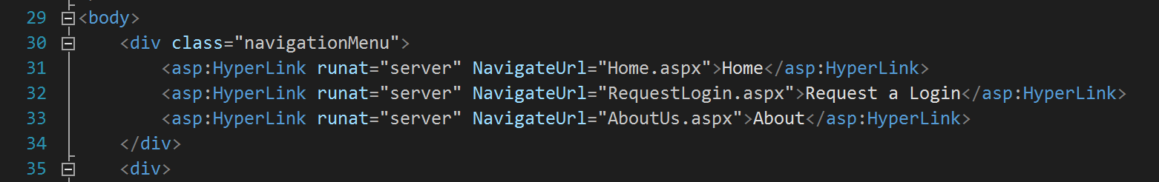

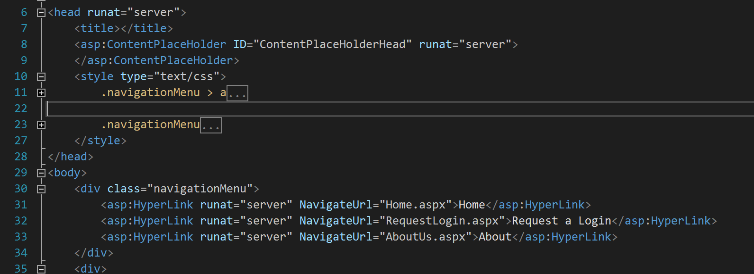

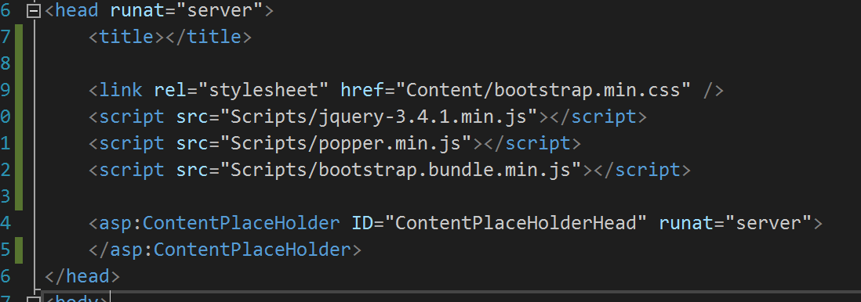

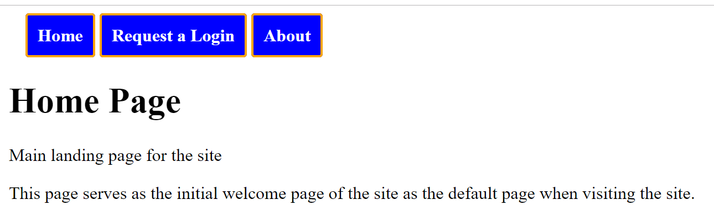



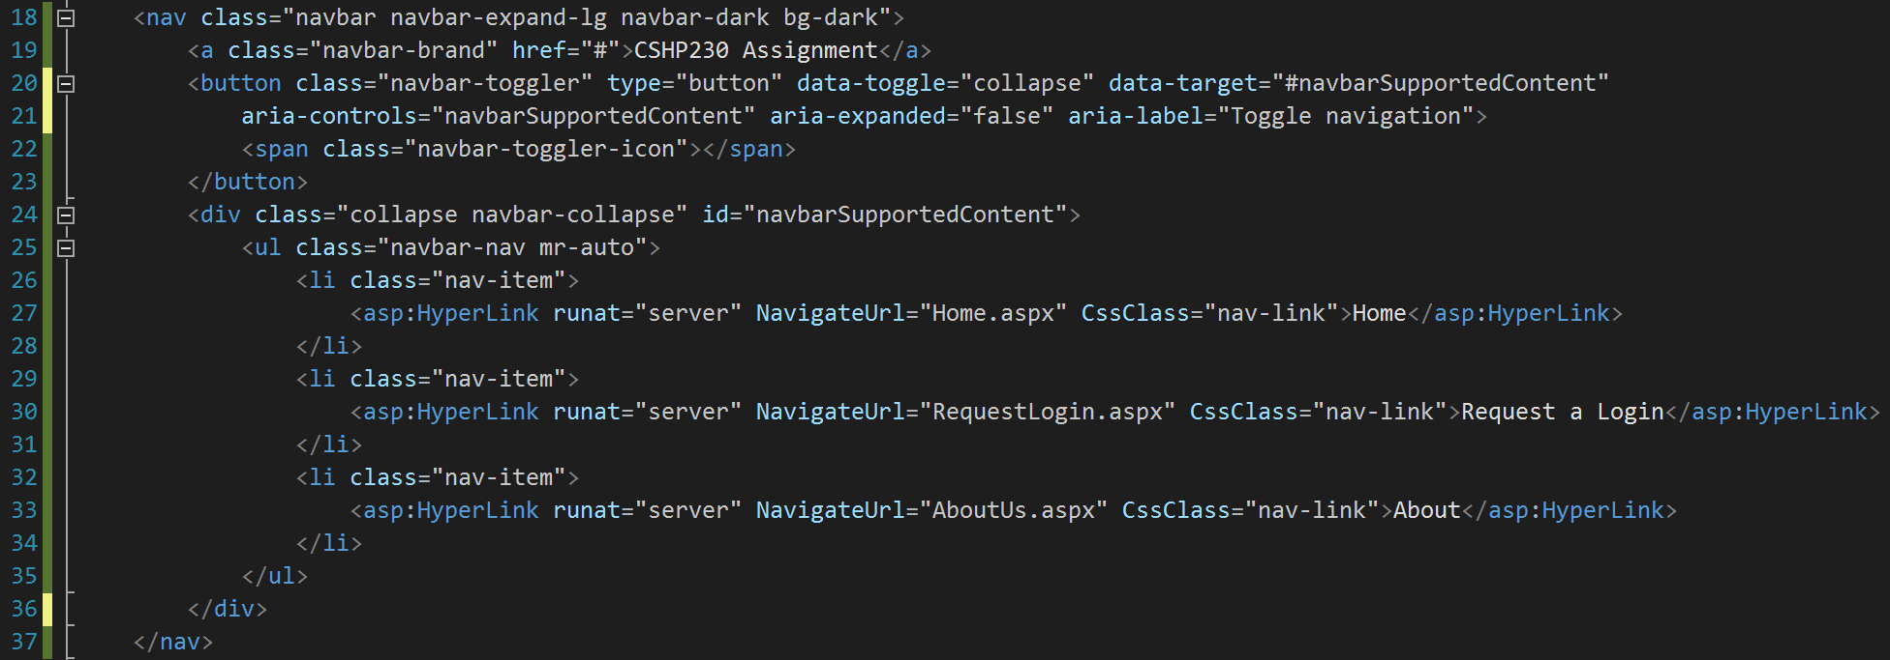

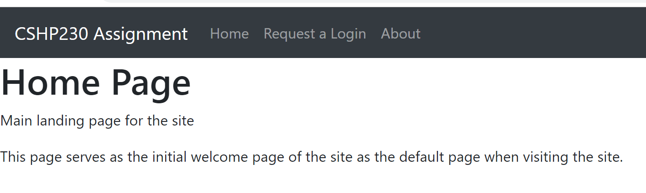

## Sub Topic B

# Topic 2

## Sub Topic A

## Sub Topic B

# Summary