電通二乙微處理器實驗 實驗結報

實驗名稱 | Lab-12 溫濕度感應器
組別 |  | 組員 | 蘇峻緯

- 實驗目的
了解使用linkit 7697，並用溫溼度感測器來量測
結合timer，做溫溼度感測
最後上傳到MCS Cloud
- 實驗步驟
CHECK POINT #1
安裝DHT-11 Library，使用範例檔，並修改腳位，和DHTTYPE，來測量溫溼度，讓DH-T11一直量測溫溼度。

CHECK POINT #2
修改timer1之_callback1，來量測溫溼度，並修改timer1.start使其1秒量一次，達到整合timer與DHT-11量測溫濕度。

CHECK POINT #3
在MCS Cloud創建新的測試產品，在裡面添加兩個浮點數顯示器單位分別為攝氏(溫度)和百分比(濕度)，使用linkit 7697 取得溫溼度感測器的溫溼度並使用timer每隔10秒將溫溼度上傳到MCS Cloud。
- 程式碼
CHECK POINT #1
#include "DHT.h"

#define DHTPIN 7

#define DHTTYPE DHT11 // DHT 11

// Connect pin 1 (on the left) of the sensor to +5V
// NOTE: If using a board with 3.3V logic like an Arduino Due connect pin 1
// to 3.3V instead of 5V!
// Connect pin 2 of the sensor to whatever your DHTPIN is
// Connect pin 4 (on the right) of the sensor to GROUND
// Connect a 10K resistor from pin 2 (data) to pin 1 (power) of the sensor

// Initialize DHT sensor.
// Note that older versions of this library took an optional third parameter to
// tweak the timings for faster processors. This parameter is no longer needed
// as the current DHT reading algorithm adjusts itself to work on faster procs.
DHT dht(DHTPIN, DHTTYPE);

void setup() {
Serial.begin(9600);
Serial.println(F("DHTxx test!"));

dht.begin();
}

void loop() {
// Wait a few seconds between measurements.
delay(2000);

// Reading temperature or humidity takes about 250 milliseconds!
// Sensor readings may also be up to 2 seconds 'old' (its a very slow sensor)
float h = dht.readHumidity();
// Read temperature as Celsius (the default)
float t = dht.readTemperature();

// Check if any reads failed and exit early (to try again).
if (isnan(h) || isnan(t)) {
Serial.println(F("Failed to read from DHT sensor!"));
return;
}
Serial.print(F("Humidity: "));
Serial.print(h);
Serial.print(F("% Temperature: "));
Serial.print(t);
Serial.println(" *C");

}

CHECK POINT #2
#include "Arduino.h"
#include "LTimer.h"
#include "DHT.h"
#define DHTPIN 7
#define DHTTYPE DHT11 // DHT 11
DHT dht(DHTPIN, DHTTYPE);
float h,t;
// instantiation
LTimer timer1(LTIMER_1);

void setup()
{
Serial.begin(9600);
// initialization
timer1.begin();

dht.begin();

timer1.start(1000, LTIMER_REPEAT_MODE, _callback1, NULL);
}
void loop() {
h = dht.readHumidity();
t = dht.readTemperature();
}

void _callback1(void *usr_data)
{

if (isnan(h) || isnan(t)) {
Serial.println(F("Failed to read from DHT sensor!"));
return;
}

Serial.print(F("Humidity: "));
Serial.print(h);
Serial.print(F("% Temperature: "));
Serial.print(t);
Serial.println(" *C");
}

CHECK POINT #3
#include "Arduino.h"
#include "LTimer.h"
#include "DHT.h"
#include <LWiFi.h>
#include <WiFiClient.h>
#include "MCS.h"
#define DHTPIN 7
#define DHTTYPE DHT11 // DHT 11

#define _SSID "test1"
#define _KEY "pigpigpig"
MCSDevice mcs("DdzhSxQU", "zaMTvKPwx6gjT7a1");
MCSDisplayFloat Temperature("Temperature");
MCSDisplayFloat Humidity("Humidity");

DHT dht(DHTPIN, DHTTYPE);
float h, t;
// instantiation
LTimer timer1(LTIMER_1);

void setup()
{
Serial.begin(9600);
// initialization
timer1.begin();

dht.begin();

timer1.start(10000, LTIMER_REPEAT_MODE, _callback1, NULL);

while (WL_CONNECTED != WiFi.status())
{
Serial.print("WiFi.begin(");
Serial.print(_SSID);
Serial.print(",");
Serial.print(_KEY);
Serial.println(")...");
WiFi.begin(_SSID, _KEY);
}
Serial.println("WiFi connected !!");
mcs.addChannel(Temperature);
mcs.addChannel(Humidity);
while (!mcs.connected())
{
Serial.println("MCS.connect()...");
mcs.connect();
}
Serial.println("MCS connected !!");
}
void loop() {
h = dht.readHumidity();
t = dht.readTemperature();
mcs.process(100);
Temperature.set(t);
Humidity.set(h);
while (!mcs.connected())
{
Serial.println("re-connect to MCS...");
mcs.connect();
if (mcs.connected())
Serial.println("MCS connected !!");
}
}

void _callback1(void *usr_data)
{
if (isnan(h) || isnan(t)) {
Serial.println(F("Failed to read from DHT sensor!"));
return;
}
Serial.print(F("Humidity: "));
Serial.print(h);
Serial.print(F("% Temperature: "));
Serial.print(t);
Serial.println(" *C");
}

- 實驗結果及分析
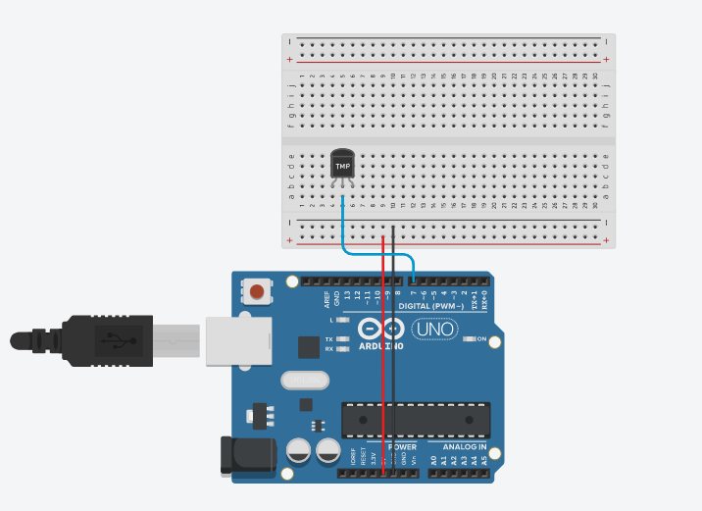
- 心得討論
還是有點不太會使用timer，上傳到MCS Colud 時間有時候會比10秒快或著是慢，雖然DHT-11元件小小顆的，但精準度卻不是很高。
電路圖
