Software Design Document (SDD)
Module: SPI Driver
Version | 1.0
Authors | David Mijares, Ximena Cedillo, Xavier Clemente
Files | SPI.h / SPI.c
Target MCU | STM32F411RE (Cortex-M4) — SPI2 peripheral
Course | Microcontrollers and Embedded Systems — CETYS Universidad

1. Introduction

1.1. Purpose
This document describes the software design and architecture of the SPI driver module developed for the STM32F411RE microcontroller, as part of the Microcontrollers and Embedded Systems lab at CETYS Universidad. The design is based on the code in SPI.h and SPI.c and provides details on register-level algorithms, control flow, and data transfer sequences to guide implementation and testing.
This SDD serves as a reference for maintenance and future improvements of the SPI2 communication firmware used in the Lab 5 sensor integration.

1.2. Scope
The SPI driver is a low-level software component that abstracts the STM32F411RE SPI2 peripheral registers and exposes a clean C API. The system performs the following operations:
- Initializes SPI2: enables APB1 clock, resets CR1/CR2, configures Master mode, baud rate divider (PCLK/16), 8-bit data frame, Mode 0 (CPOL=0/CPHA=0), software slave management, and enables the peripheral.
- Transmits multiple bytes by polling TXE before each byte write and waiting for BSY=0 after the last byte.
- Receives multiple bytes by sending a dummy 0x00 byte to generate SCK, polling RXNE, and reading DR per byte.
- Controls an external Chip Select pin via GPIO BSRR: spi_csEnable() drives the pin LOW (assert), spi_csDisable() drives it HIGH (deselect).
- All operations are blocking (polling); no interrupts or DMA are used.
- Does not depend on HAL libraries — all hardware interaction uses direct MCU register access.

1.3. Definitions and Acronyms
Term | Definition
SPI | Serial Peripheral Interface — four-wire full-duplex synchronous protocol
SPI2 | SPI peripheral instance 2 on STM32F411RE; located on APB1 bus (max 42 MHz)
SCK | Serial Clock — generated by the master to synchronize data transfer
MOSI | Master Out Slave In — data line from master to slave (PB15 on STM32F411RE)
MISO | Master In Slave Out — data line from slave to master (PB14 on STM32F411RE)
CS / NSS | Chip Select / Slave Select — active-low signal to select a peripheral device
CR1 | Control Register 1 — SPE(6), MSTR(2), BR[5:3], DFF(11), CPOL(1), CPHA(0), SSM(9), SSI(8)
CR2 | Control Register 2 — interrupt and DMA enable bits; set to 0 by this driver
SR | Status Register — TXE(1), RXNE(0), BSY(7), OVR(6) flags
DR | Data Register — write to transmit, read to receive
TXE | Transmit Buffer Empty flag — SR bit 1; set when DR can accept a new byte
RXNE | Receive Buffer Not Empty flag — SR bit 0; set when DR contains received data
BSY | Busy flag — SR bit 7; set while SPI is transmitting/receiving
OVR | Overrun Error flag — SR bit 6; set when data was received but not read in time
SPE | SPI Enable bit — CR1 bit 6; enables the peripheral
MSTR | Master Selection bit — CR1 bit 2; configures Master mode
BR | Baud Rate control bits — CR1 bits 5:3; divider = 2^(BR+1); 011=PCLK/16
DFF | Data Frame Format — CR1 bit 11; 0=8-bit, 1=16-bit
CPOL | Clock Polarity — CR1 bit 1; 0=idle low (Mode 0/1)
CPHA | Clock Phase — CR1 bit 0; 0=first edge (Mode 0/2)
SSM | Software Slave Management — CR1 bit 9; allows software control of NSS
SSI | Internal Slave Select — CR1 bit 8; sets internal NSS high when SSM=1
BSRR | Bit Set/Reset Register — upper 16 bits reset pin, lower 16 bits set pin
APB1 | Advanced Peripheral Bus 1 — SPI2 clock source; max 42 MHz on STM32F411RE
FR-x | Functional Requirement x as defined in this document

1.4. Requirements
All functional requirements implemented in SPI.h / SPI.c are listed below.
Req. ID | Type | Description
FR-1 | Functional | spi_init() shall enable the SPI2 peripheral clock via RCC->APB1ENR, reset CR1 and CR2, configure Master mode, baud rate PCLK/16, 8-bit frame, Mode 0, software slave management, and enable the peripheral via SPE.
FR-2 | Functional | spi_transmit() shall poll SR.TXE before writing each byte to DR, and wait for SR.BSY=0 after the last byte. It shall also clear the OVR flag if present.
FR-3 | Functional | spi_receive() shall write a dummy byte (0x00) to DR to generate SCK, poll SR.RXNE, read DR into the receive buffer for each byte, and wait for SR.BSY=0 after the last byte.
FR-4 | Functional | spi_csEnable() shall drive the specified GPIO pin LOW by writing to BSRR (BRx bit = pin+16), asserting the Chip Select line.
FR-5 | Functional | spi_csDisable() shall drive the specified GPIO pin HIGH by writing to BSRR (BSx bit = pin), deasserting the Chip Select line.

2. System Architecture

2.1. High-Level Design
The SPI driver follows a layered firmware architecture separating application logic from hardware access:
- Application / Sensor Layer: Calls spi_csEnable(), spi_transmit(), spi_receive(), spi_csDisable() to communicate with external peripherals. Never accesses SPI2 registers directly.
- SPI Driver Layer (SPI.c / SPI.h): The only layer that accesses SPI2 hardware registers (CR1, CR2, SR, DR) and RCC APB1ENR. Provides a complete blocking polling API for master-mode communication.
- GPIO Driver Layer (GPIO.c / GPIO.h): Configures PB13 (SCK), PB14 (MISO), PB15 (MOSI) to AF5, and the CS pin to push-pull output. Also provides the gpio[] array used by spi_csEnable/Disable for BSRR access.
- Hardware Layer: STM32F411RE SPI2 peripheral registers accessed through CMSIS SPI_TypeDef. Not directly accessible from layers above the SPI driver.

2.2. Class Diagram
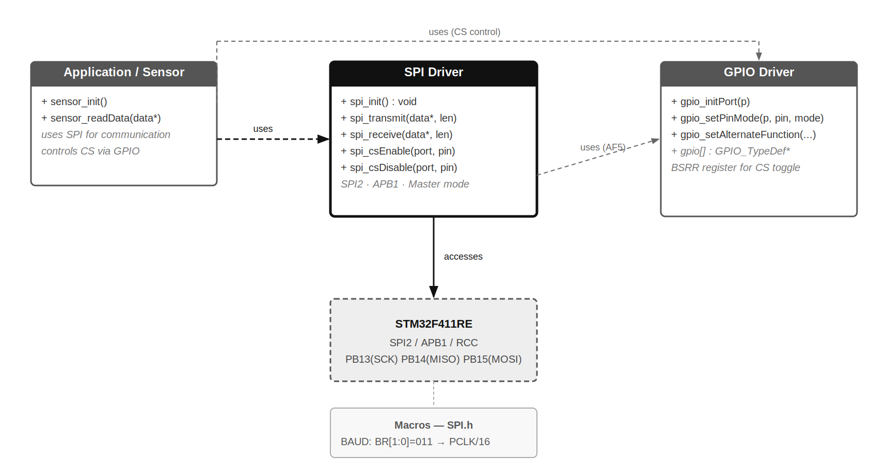
Fig. 1 — Class Diagram: SPI Driver Module
Fig. 1 shows the three software modules and their relationships. The Application/Sensor layer depends on the SPI driver for bus transactions and on the GPIO driver for CS pin control. The SPI driver depends on GPIO only for Alternate Function pin configuration during initialization. The SPI driver directly accesses SPI2 hardware registers.

2.3. Module Interfaces
- Public API (SPI.h): spi_init(), spi_transmit(), spi_receive(), spi_csEnable(), spi_csDisable(). All return void.
- Configuration: Fixed baud rate divider BR[2:0]=011 (PCLK/16), 8-bit frame, Mode 0 (CPOL=0, CPHA=0), software slave management. All hardcoded in spi_init().
- Dependencies: stm32f4xx.h (CMSIS SPI_TypeDef, RCC_TypeDef), GPIO.h (gpio[] array and port_t enum), stdint.h. No HAL or LL library.

3. Detailed Design

3.1. Module Description
The SPI driver (SPI.c / SPI.h) provides full SPI2 master-mode communication for the STM32F411RE using direct register access and polling. It supports two transfer patterns: transmit-only and receive-only (full-duplex via dummy byte). Chip Select control is delegated to two dedicated GPIO BSRR functions, allowing the caller to manage CS independently from data transfer.

3.2. Initialization — FR-1
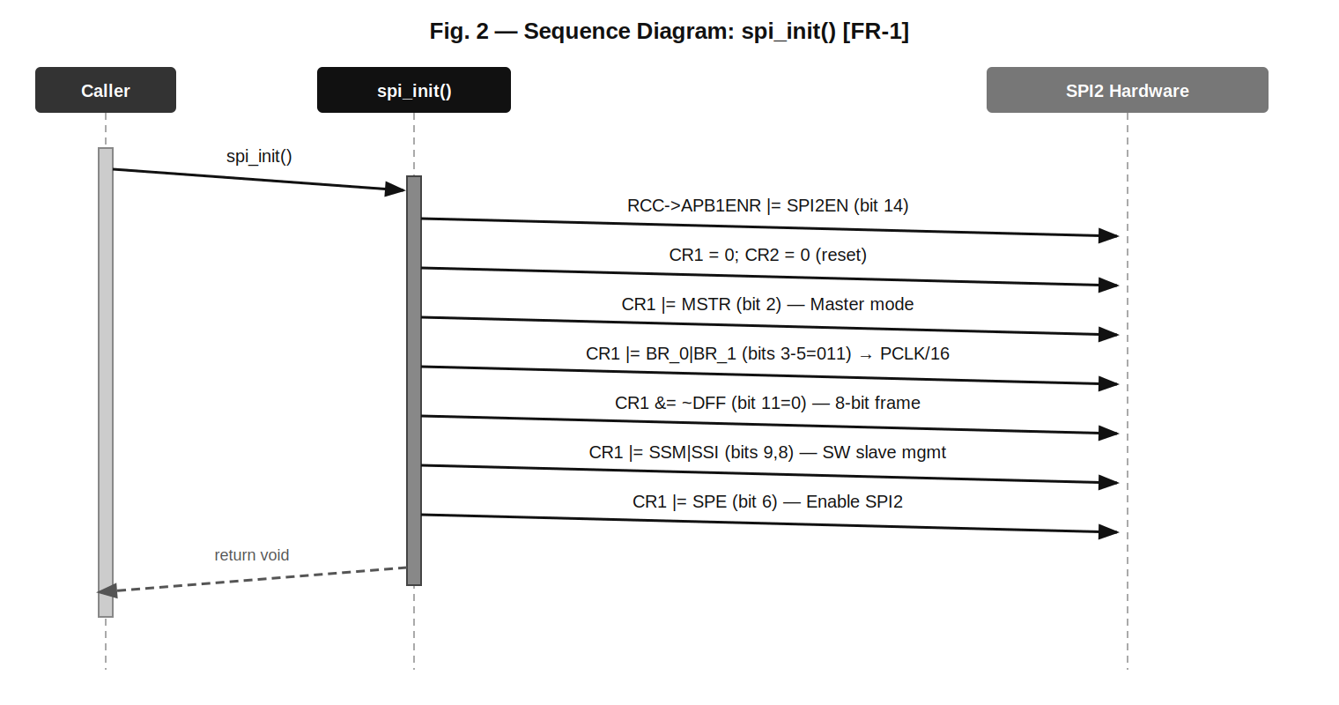
Fig. 2 — Sequence Diagram: spi_init() [FR-1]
Fig. 2 shows the seven sequential hardware write operations performed by spi_init(): APB1 clock enable, CR1/CR2 reset, MSTR set, baud rate BR[1:0]=011, DFF clear (8-bit), SSM+SSI set, and finally SPE enable. The SPI2 peripheral is fully ready for transfers after this call.

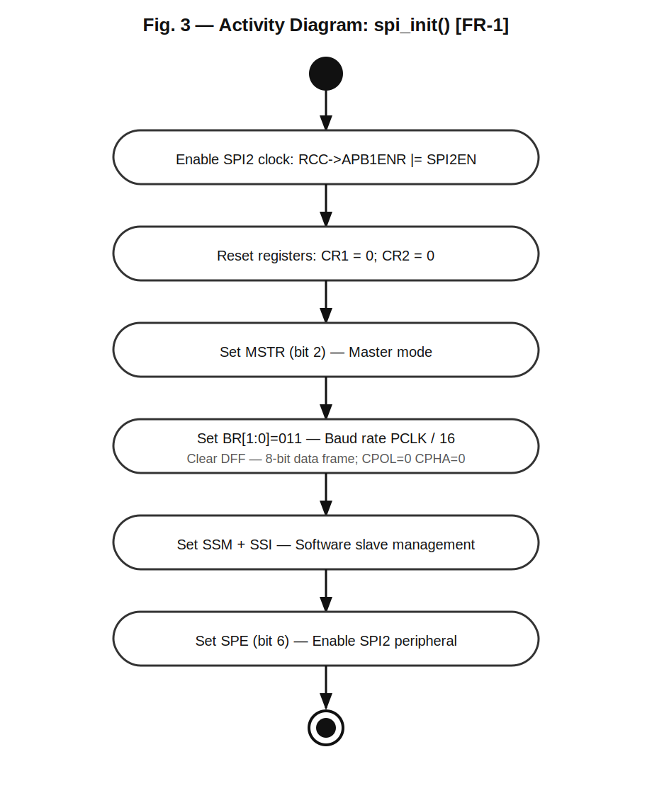
Fig. 3 — Activity Diagram: spi_init() [FR-1]
Fig. 3 confirms the strictly linear flow of spi_init() with no decision branches. All six configuration steps execute in fixed order. The function always succeeds when called with a valid system clock after GPIO pins have been configured to AF5.

3.3. Transmit — FR-2
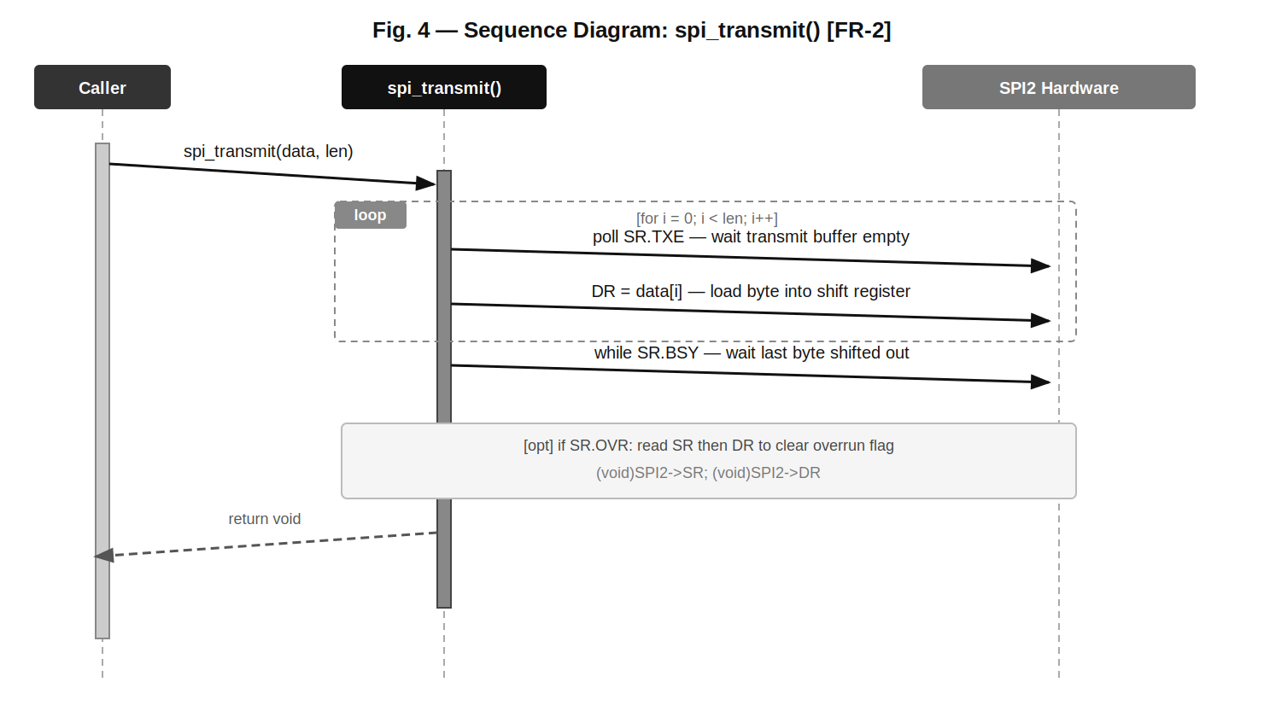
Fig. 4 — Sequence Diagram: spi_transmit() [FR-2]
Fig. 4 shows the transmit loop: for each byte the function polls SR.TXE until the transmit buffer is empty, then writes the byte to DR. After the last byte the function waits for SR.BSY=0, which indicates the shift register has finished clocking out the final frame. The optional OVR flag clear prevents stale received data from triggering errors in subsequent receive operations.

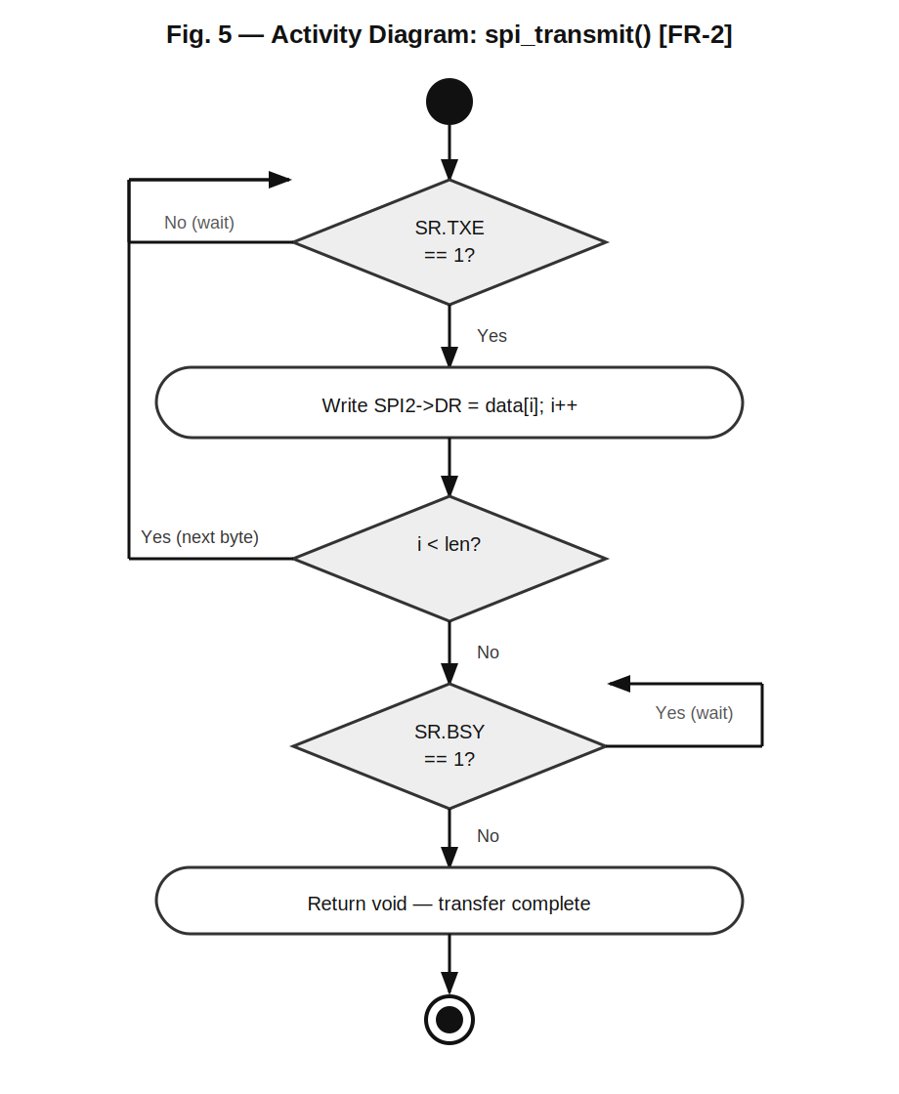
Fig. 5 — Activity Diagram: spi_transmit() [FR-2]
Fig. 5 shows three decision diamonds: the TXE poll loop (wait for buffer empty before writing), the loop-back condition (more bytes remaining), and the BSY poll loop (wait for final frame completion). The OVR clear is not shown as a diamond because it is an optional cleanup step, not a blocking condition.

3.4. Receive — FR-3
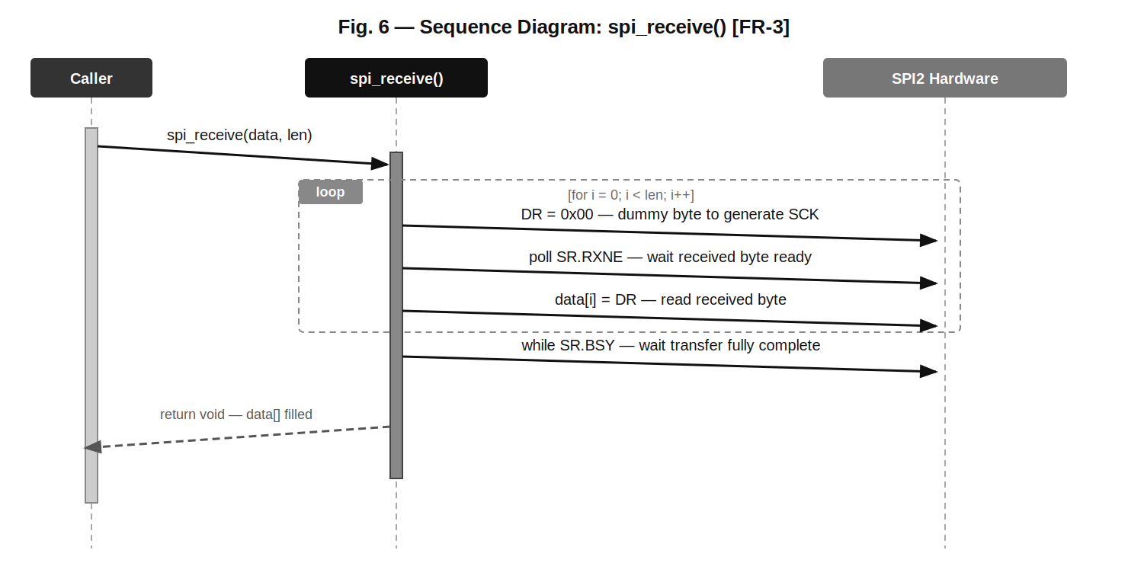
Fig. 6 — Sequence Diagram: spi_receive() [FR-3]
Fig. 6 shows the receive loop: for each byte, a dummy 0x00 is written to DR to generate the SCK clock pulses, then RXNE is polled until the incoming byte is ready in DR, which is then read into the buffer. SPI full-duplex hardware always shifts data in both directions simultaneously; the dummy byte drives the clock so the slave can respond.

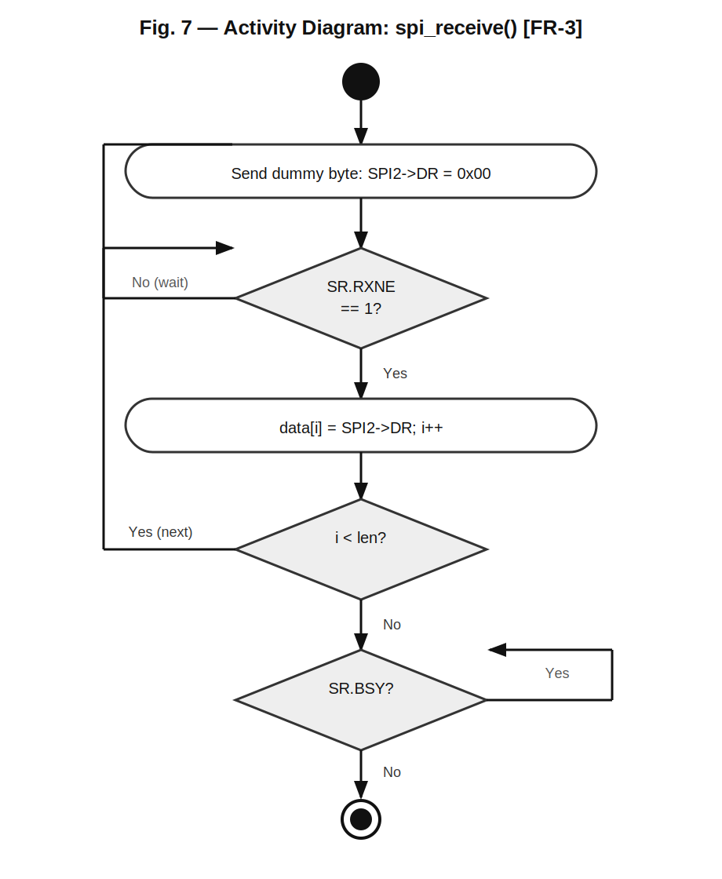
Fig. 7 — Activity Diagram: spi_receive() [FR-3]
Fig. 7 mirrors the structure of the transmit activity with three decision diamonds: RXNE poll (wait for received byte), loop-back (more bytes), and BSY poll (final frame complete). Note that TXE is not polled here — writing 0x00 directly to DR is valid because spi_receive() is only called after the SPI bus is known to be idle.

3.5. Chip Select Control — FR-4, FR-5
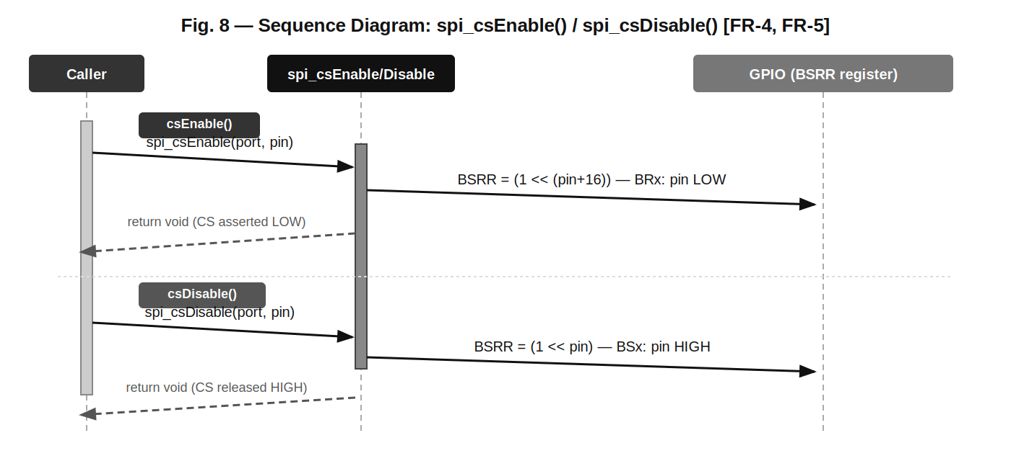
Fig. 8 — Sequence Diagram: spi_csEnable() / spi_csDisable() [FR-4, FR-5]
Fig. 8 shows both CS control functions. spi_csEnable() writes the BRx bit (pin+16) in BSRR to atomically drive the CS pin LOW, asserting the selected peripheral. spi_csDisable() writes the BSx bit (pin) in BSRR to drive the CS pin HIGH, deasserting the peripheral. BSRR is a write-only register with atomic bit-level control — no read-modify-write is required, making it interrupt-safe.

3.6. State Diagram — SPI Driver System
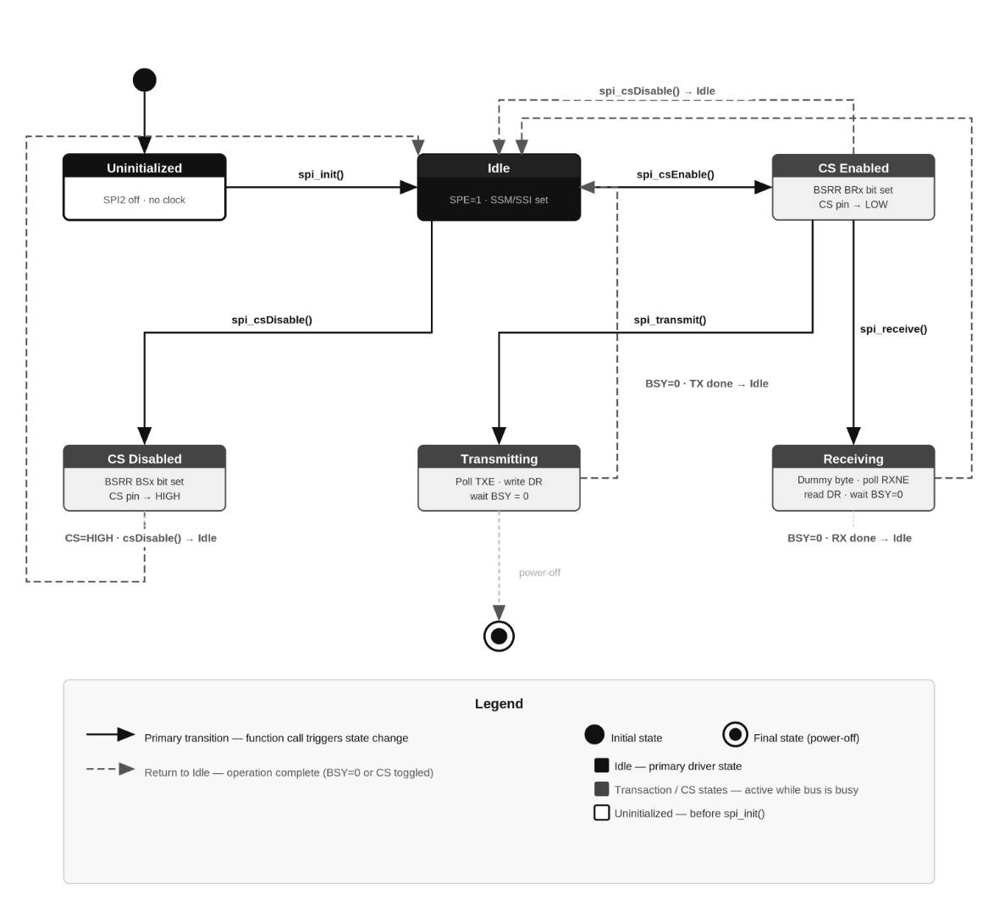
Fig. 9 — State Diagram: SPI Driver System
Fig. 9 shows the five runtime states of the SPI driver. From Uninitialized the driver moves to Idle after spi_init(). From Idle, spi_csEnable() moves to CS Enabled, from which spi_transmit() or spi_receive() start the respective transaction states. spi_csDisable() from Idle moves directly to CS Disabled. All transaction and CS states return to Idle after their operation completes.

3.7. Driver Internals
Baud Rate: BR[2:0]=011 selects a clock divider of 2^(3+1) = 16. With SPI2 on APB1 at 16 MHz (HSI, no PLL): SCK = 16 MHz / 16 = 1 MHz. With PLL at 42 MHz: SCK = 42 MHz / 16 = 2.625 MHz. The divider is hardcoded; no runtime configuration API is provided.

Mode 0 (CPOL=0, CPHA=0): SCK idles LOW. Data is sampled on the first (rising) edge and shifted on the second (falling) edge. This is the default mode for most sensors and memory devices. CPOL and CPHA bits are left at 0 after CR1 reset.

Software Slave Management (SSM+SSI): Setting SSM=1 disables the hardware NSS pin management and allows CR1.SSI to substitute as the internal NSS level. Setting SSI=1 keeps the internal NSS HIGH in master mode, preventing a MODF (Mode Fault) error. The physical CS pin is controlled by the application via spi_csEnable/Disable instead.

OVR Flag Handling: After spi_transmit(), the SR.OVR flag may be set if the MISO line shifted in data that was never read from DR. The driver clears it by sequentially reading (void)SPI2->SR and (void)SPI2->DR. This prevents the flag from corrupting a subsequent spi_receive() call.

BSRR Atomicity: The GPIO Bit Set/Reset Register (BSRR) is a write-only 32-bit register. Bits 31:16 reset the pin (output LOW) and bits 15:0 set the pin (output HIGH). A single 32-bit write is atomic at the hardware level, so spi_csEnable/Disable are interrupt-safe without requiring a critical section.

4. Application Programming Interfaces

4.1. Data Types and Macros
No custom enumeration types or macros are defined in SPI.h. The driver uses only stdint.h types (uint8_t, uint32_t), CMSIS SPI_TypeDef and RCC_TypeDef register structures, and the port_t enum and gpio[] array from GPIO.h.

Configuration is fully static (compile-time): baud rate divider = 16, data frame = 8 bits, Mode 0, software slave management. To change these parameters the function body in spi_init() must be edited.

4.2. Register Map
Register | Offset/Address | Access | Used By / Purpose
RCC->APB1ENR | 0x40023840 | R/W | spi_init() — bit 14 enables SPI2 clock
SPI2->CR1 | +0x00 | R/W | spi_init() — MSTR, BR[5:3], DFF, SSM, SSI, SPE configuration
SPI2->CR2 | +0x04 | R/W | spi_init() — reset to 0 (all interrupts/DMA disabled)
SPI2->SR | +0x08 | R | spi_transmit() / spi_receive() — TXE, RXNE, BSY, OVR flag polling
SPI2->DR | +0x0C | R/W | spi_transmit() (write) / spi_receive() (write dummy + read)
GPIOx->BSRR | +0x18 | W | spi_csEnable() (BRx bit) / spi_csDisable() (BSx bit)

4.3. Function Definitions

spi_init
Function Name | spi_init
Syntax | void spi_init(void)
Parameters (in) | N/A
Parameters (out) | N/A
Return value | void | Always succeeds. No error reporting.
Description | Initializes SPI2 peripheral (FR-1). Steps: (1) enable SPI2 clock via RCC->APB1ENR bit 14; (2) reset CR1=0 and CR2=0; (3) set MSTR (master mode); (4) set BR[1:0]=011 (PCLK/16); (5) clear DFF (8-bit frame); (6) set SSM+SSI (software slave management); (7) set SPE (enable peripheral).
Constraints | Must be called after GPIO pins PB13 (SCK), PB14 (MISO), PB15 (MOSI) have been configured to Alternate Function 5. CPOL=0 and CPHA=0 (Mode 0) are implicit — not configurable at runtime. SystemCoreClock must reflect the actual CPU frequency.
Available via | SPI.h

spi_transmit
Function Name | spi_transmit
Syntax | void spi_transmit(uint8_t *data, uint32_t len)
Parameters (in) | data | uint8_t* — Pointer to byte array to transmit. Must be valid for len bytes.
Parameters (in) | len | uint32_t — Number of bytes to transmit.
Parameters (out) | N/A
Return value | void
Description | Transmits len bytes over SPI2 (FR-2). For each byte: polls SR.TXE until clear, writes data[i] to DR. After all bytes: polls SR.BSY until clear. If SR.OVR is set, reads SR then DR to clear the overrun flag.
Constraints | Blocking — may hang if SPI2 is not initialized or clock is stopped. No timeout. CS must be asserted by the caller (spi_csEnable()) before calling and released (spi_csDisable()) after. data pointer must not be NULL.
Available via | SPI.h

spi_receive
Function Name | spi_receive
Syntax | void spi_receive(uint8_t *data, uint32_t len)
Parameters (in) | len | uint32_t — Number of bytes to receive.
Parameters (out) | data | uint8_t* — Buffer to store received bytes. Caller must allocate at least len bytes.
Return value | void
Description | Receives len bytes over SPI2 (FR-3). For each byte: writes 0x00 to DR to generate SCK, polls SR.RXNE, reads DR into data[i]. After all bytes: polls SR.BSY until clear.
Constraints | Blocking. The SPI bus clock is generated only by master writes to DR — the dummy byte 0x00 triggers the clock for each received byte. CS must be asserted by the caller before calling. Received data is not valid until RXNE is set.
Available via | SPI.h

spi_csEnable
Function Name | spi_csEnable
Syntax | void spi_csEnable(port_t p, uint8_t pin)
Parameters (in) | p | port_t — GPIO port index (A–H from port_t enum). Indexes into the global gpio[] array.
Parameters (in) | pin | uint8_t — Pin number 0–15 on the specified port.
Parameters (out) | N/A
Return value | void
Description | Drives the specified GPIO pin LOW to assert the SPI Chip Select line (FR-4). Writes (1 << (pin+16)) to gpio[p]->BSRR, which sets the BRx bit to atomically clear the output register bit.
Constraints | The pin must be previously configured as output push-pull (MODE=01) by the caller. The function validates p < GPIOs_SIZE before accessing the gpio[] array. BSRR write is atomic — no critical section needed.
Available via | SPI.h

spi_csDisable
Function Name | spi_csDisable
Syntax | void spi_csDisable(port_t p, uint8_t pin)
Parameters (in) | p | port_t — GPIO port index (A–H from port_t enum).
Parameters (in) | pin | uint8_t — Pin number 0–15 on the specified port.
Parameters (out) | N/A
Return value | void
Description | Drives the specified GPIO pin HIGH to deassert the SPI Chip Select line (FR-5). Writes (1 << pin) to gpio[p]->BSRR, which sets the BSx bit to atomically set the output register bit.
Constraints | Same constraints as spi_csEnable(). Should be called after the last spi_transmit() or spi_receive() to properly terminate the SPI transaction and release the bus for other devices.
Available via | SPI.h

5. Future Enhancements
- Configurable baud rate, data frame (8/16-bit), CPOL, CPHA, and SSM mode via a spi_config_t structure passed to spi_init().
- Support for SPI1 and SPI3 via a spi_t enum (SPI_1, SPI_2, SPI_3) and an array of SPI_TypeDef* pointers.
- Full-duplex spi_transferByte() / spi_transfer() function that transmits and receives simultaneously, eliminating the need for separate transmit and receive calls.
- Timeout mechanism: add a counter-based timeout to all polling loops (TXE, RXNE, BSY) to avoid infinite blocking on hardware faults.
- Interrupt-driven and DMA-based transfers using CR2 TXEIE, RXNEIE, ERRIE, TXDMAEN, RXDMAEN bits for non-blocking operation.
- 16-bit data frame support: configuring DFF=1 in CR1 and adjusting DR write/read to uint16_t for wider peripherals.
- Error detection: explicit checking and reporting of MODF (Mode Fault), OVR (Overrun), and CRCERR flags from SR.

