Software Design Document (SDD)
Module: Sensor Driver

STM32F4xx — Microcontrollers and Embedded Systems, CETYS Universidad
Module | Sensor Driver
Authors | David Mijares, Ximena Cedillo, Xavier Clemente
Platform | STM32F4xx
Clock | 16 MHz (HSI)
Course | Microcontrollers and Embedded Systems — CETYS Universidad

1. Introduction

1.1. Purpose
This document describes the design and architecture of the Sensor driver module for Lab Assignment 3 (ADC Driver Development and Sensor-Controlled PWM Application). It provides details on data structures, algorithms, and control flow to guide implementation and testing of the Sensor module.

1.2. Scope
The Sensor driver is a mid-level software component for the STM32F411RE microcontroller. It abstracts the ADC and GPIO hardware by providing a clean API for higher-level application modules to read analog sensor values (e.g., potentiometer voltage). Internally, it relies on the ADC driver and GPIO driver to configure hardware and acquire data.

1.3. Definitions and Acronyms
Term | Definition
ADC | Analog-to-Digital Converter
GPIO | General Purpose Input/Output
PWM | Pulse Width Modulation
SRS | Software Requirements Specification
SDD | Software Design Document
CMSIS | Cortex Microcontroller Software Interface Standard
EOC | End Of Conversion (ADC status register bit)
MCU | Microcontroller Unit
port_t | Enumerated type representing a GPIO port (PORTA, PORTB, ...)
Sensor_Status_t | Enumerated return type for Sensor module functions

1.4. Requirements
All requirements specific to this module are derived from the ADC SRS located at: SRS/ADC/SRS-ADC_Driver.md (MSE_LabCourse repository). The Sensor module also satisfies functional requirements FR-1 through FR-9 of the ADC SRS as part of Task 2 of Lab Assignment 3.

2. System Architecture

2.1. High-Level Design
- Layered Architecture:
  - Application Layer: Calls Sensor module functions (sensor_init, sensor_startConversion, sensor_readValue) from main.c to map ADC values to PWM duty cycle.
  - Sensor Module Layer: Provides a clean API (Sensor.h / Sensor.c) to configure and read an analog sensor. Internally delegates hardware access to ADC and GPIO drivers.
  - ADC Driver Layer: Provides functions to initialize, configure channels, start conversions, and read ADC data registers (ADC.h / ADC.c).
  - GPIO Driver Layer: Provides gpio_setPinMode() to configure the analog input pin (GPIO.h / GPIO.c).
  - Hardware Layer: Actual STM32F411RE ADC1 and GPIOA registers accessed through CMSIS definitions (stm32f411xe.h).

2.2. Module Interfaces
- Public API: Functions declared in Sensor.h.
- Dependencies:
  - ADC.h / ADC.c: adc_init, adc_setChannel, adc_enableADC, adc_startSingleConversion, adc_startContinuosConversion, adc_readData.
  - GPIO.h / GPIO.c: gpio_setPinMode.
  - CMSIS: stm32f411xe.h, stm32f4xx.h - MCU-specific register definitions (ADC_TypeDef, GPIO_TypeDef, RCC).

3. Detailed Design

3.1. Class Diagram
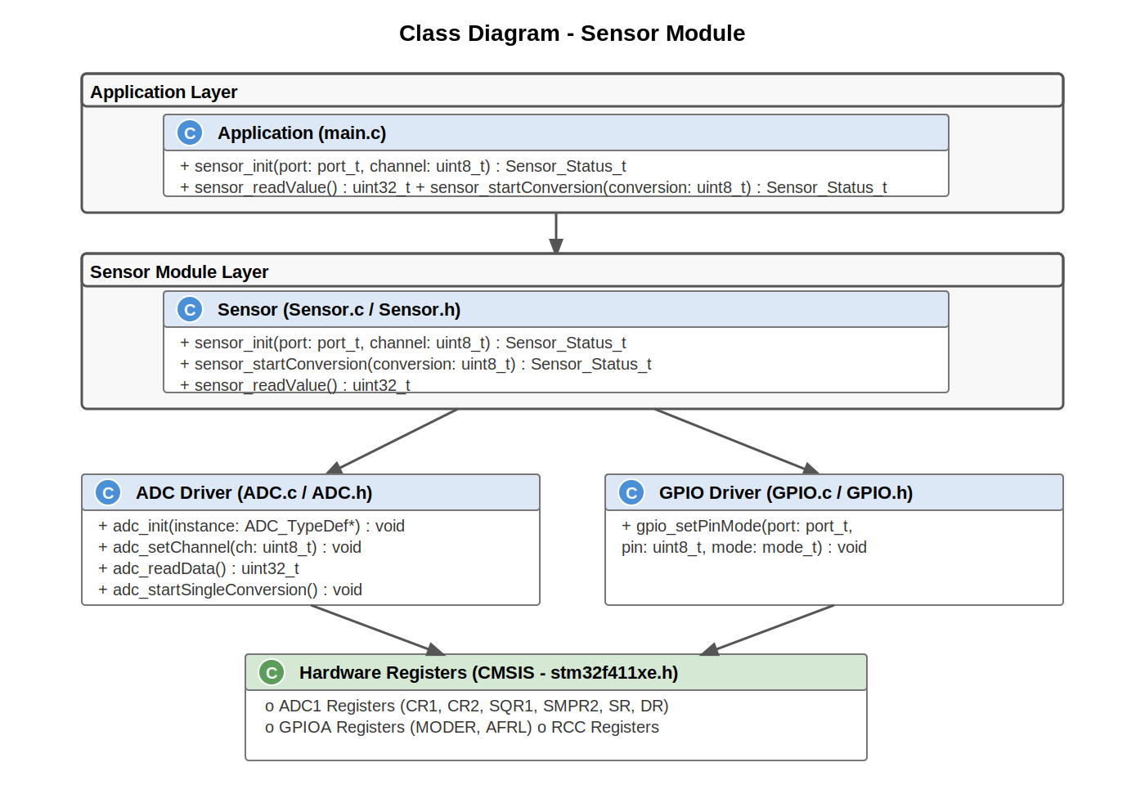
Figure 1. Class Diagram - Sensor Module

3.2. Module Behavior (Sequence Diagrams, State Machines, etc.)

3.2.1. sensor_init
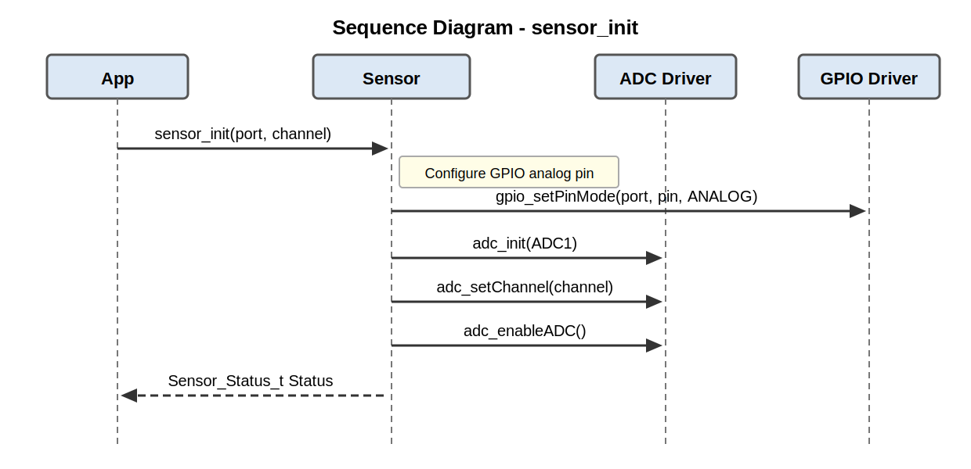
Figure 2. Sequence Diagram - sensor_init

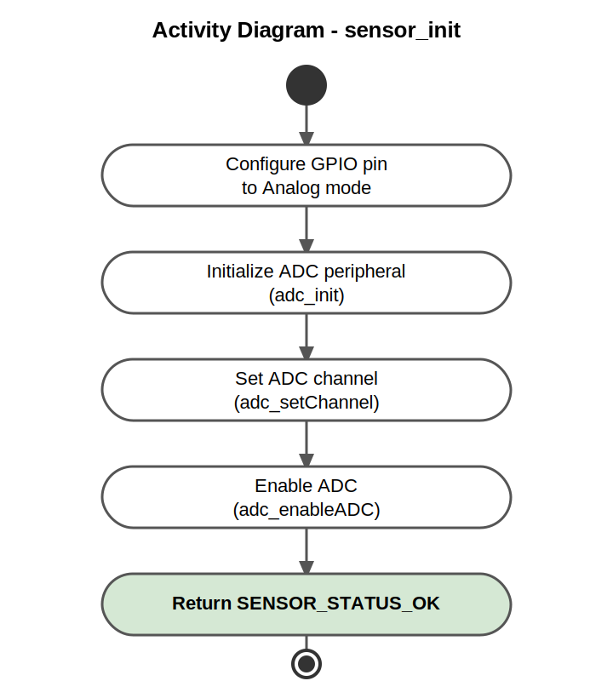
Figure 3. Activity Diagram - sensor_init

3.2.2. sensor_startConversion
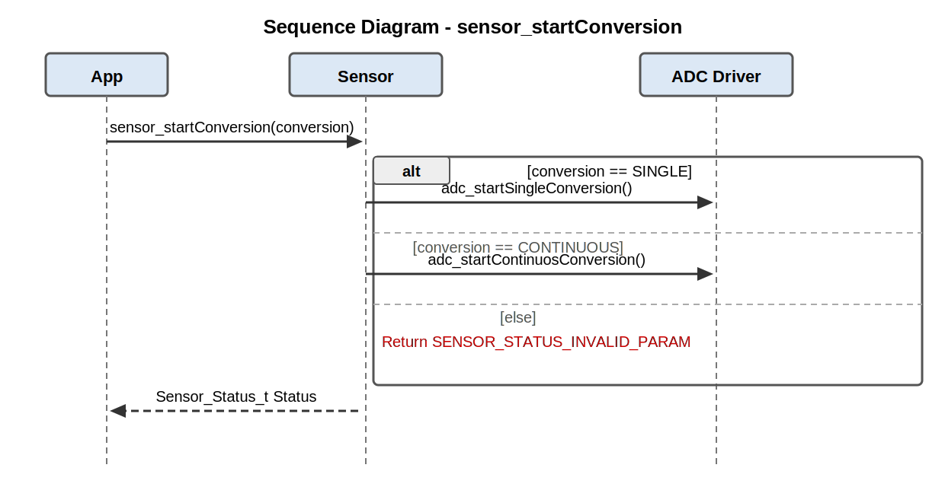
Figure 4. Sequence Diagram - sensor_startConversion

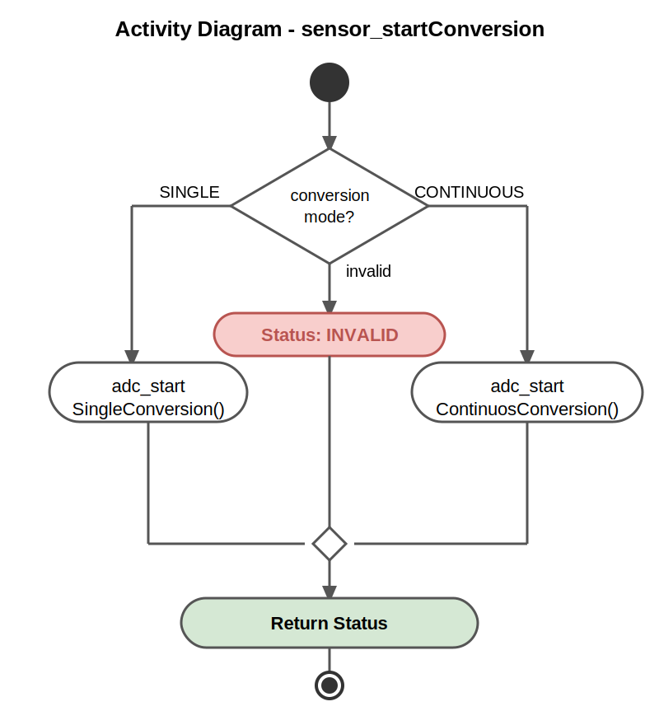
Figure 5. Activity Diagram - sensor_startConversion

3.2.3. sensor_readValue
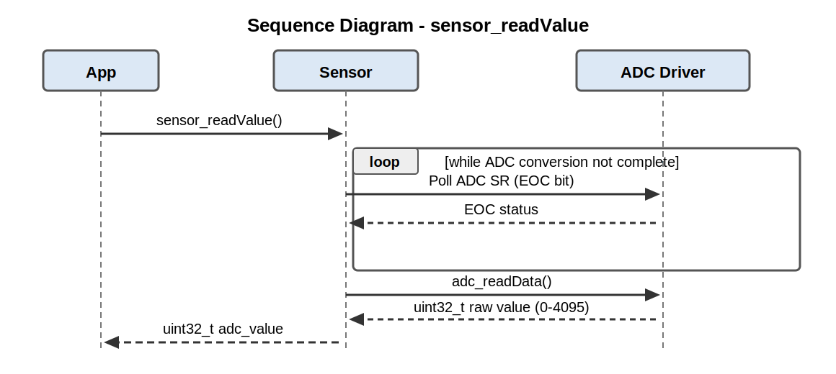
Figure 6. Sequence Diagram - sensor_readValue

3.2.4. State Diagram
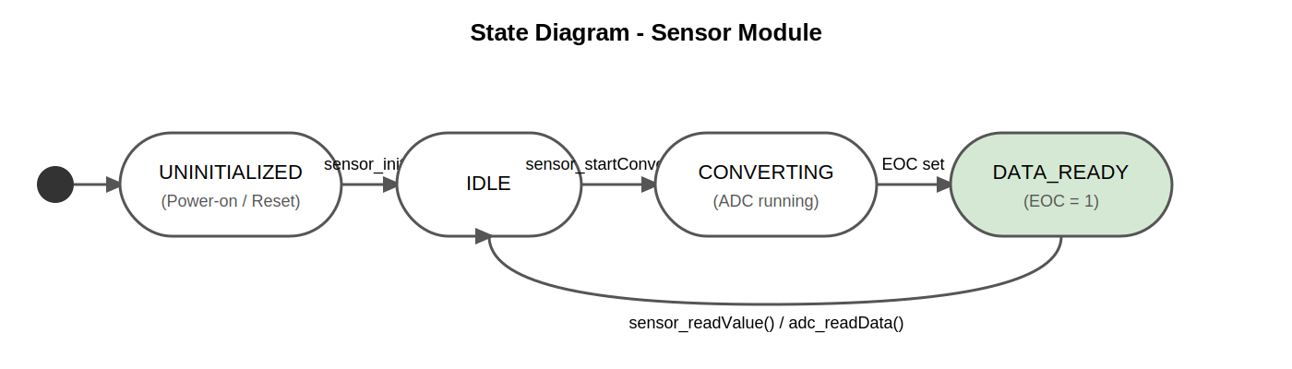
Figure 7. State Diagram - Sensor Module

3.3. Sensor Driver
The Sensor module abstracts the analog signal acquisition pipeline for the STM32F411RE. It acts as a bridge between the application layer and the low-level ADC and GPIO drivers. The module operates as follows:

Initialization (sensor_init): As shown in Figure 2 and Figure 3, upon initialization the module configures the specified GPIO pin to analog mode by calling gpio_setPinMode() with the ANALOG mode parameter. This ensures the microcontroller's pin is electrically configured to accept an analog voltage level. It then initializes the ADC peripheral via adc_init(ADC1), sets the target channel using adc_setChannel(), and enables the ADC with adc_enableADC(). A successful initialization returns SENSOR_STATUS_OK.

Conversion Start (sensor_startConversion): As illustrated in Figure 4 and Figure 5, this function selects between single and continuous ADC conversion modes based on the conversion parameter. If conversion == SINGLE, it calls adc_startSingleConversion(), which triggers a one-shot conversion by setting the SWSTART bit in ADC CR2. If conversion == CONTINUOUS, it calls adc_startContinuosConversion() which enables the CONT bit before triggering SWSTART. An invalid conversion parameter returns SENSOR_STATUS_INVALID_PARAM.

Read Value (sensor_readValue): As depicted in Figure 6, this function polls the ADC Status Register (SR) until the End Of Conversion (EOC) bit is set, indicating that a conversion result is available in the Data Register (DR). It then calls adc_readData() which reads the 12-bit result from the ADC DR register and returns a uint32_t value in the range 0 to 4095. The application layer maps this range to a PWM duty cycle (0-100%) to control LED brightness, completing the sensor-actuator feedback loop.

State transitions (Figure 7): The module begins in UNINITIALIZED state. After a successful sensor_init() call it transitions to IDLE. Once sensor_startConversion() is called it enters CONVERTING state while the ADC hardware performs the conversion. When the EOC flag is set it transitions to DATA_READY. Calling sensor_readValue() reads the result and returns the module to IDLE, ready for the next conversion cycle.

4. Application Programming Interfaces

4.1. Data Types and Macros
Sensor_Status_t: This enumeration represents the set of status return values used throughout the Sensor module to indicate the result of each operation.

Member Name | Value | Notes / Definition
SENSOR_STATUS_OK | 0x00 | Operation completed successfully.
SENSOR_STATUS_INVALID_PARAM | 0x01 | Invalid parameter passed to function (e.g., unsupported conversion mode).
SENSOR_STATUS_NOT_INITIALIZED | 0x02 | Function called before sensor_init() was invoked.

port_t: This enumeration type represents the GPIO port used to connect the analog sensor. It is defined in GPIO.h.

Value | Notes / Definition
PORTA | GPIO Port A (used for ADC1 channels 0-7 on STM32F411RE, e.g., PA0 = ADC1_IN0).
PORTB | GPIO Port B.
PORTC | GPIO Port C.

SENSOR_ADC_INSTANCE: This macro defines the ADC peripheral instance used by the Sensor module. Its value is ADC1 (as defined in CMSIS stm32f411xe.h).

SENSOR_ADC_CHANNEL: This macro defines the default ADC channel connected to the analog sensor. Its value is 0 (ADC1_IN0, mapped to pin PA0 on the STM32 Nucleo-64 board).

4.2. Error Codes
The Sensor module APIs have a return type of Sensor_Status_t. Error codes relevant to this module are listed below.

Code | Notes / Definition
SENSOR_STATUS_OK (0x00) | Operation was successful.
SENSOR_STATUS_INVALID_PARAM (0x01) | Invalid parameter. Returned by sensor_startConversion() when an unsupported conversion mode is specified.
SENSOR_STATUS_NOT_INITIALIZED (0x02) | The sensor module has not been initialized. Returned when sensor_startConversion() or sensor_readValue() is called before sensor_init().

4.3. Function Definitions

sensor_init
Function Name | sensor_init
Syntax | Sensor_Status_t sensor_init(port_t port, uint8_t channel)
Parameters (in) | port - port_t: GPIO port where the analog sensor pin is located (e.g., PORTA). channel - uint8_t: ADC channel number corresponding to the sensor pin (e.g., 0 for ADC1_IN0 / PA0).
Parameters (inout) | None
Parameters (out) | None
Return value | Sensor_Status_t: SENSOR_STATUS_OK if initialization was successful. SENSOR_STATUS_INVALID_PARAM if an invalid port or channel is provided.
Description | Initializes the Sensor module. Configures the specified GPIO pin to Analog input mode, initializes the ADC1 peripheral, sets the ADC channel, and enables the ADC. Must be called before any other Sensor module function.
Constraints | This function must be called once before calling sensor_startConversion() or sensor_readValue(). Calling sensor_init() more than once re-initializes the peripheral without error.
Available via | Sensor.h

sensor_startConversion
Function Name | sensor_startConversion
Syntax | Sensor_Status_t sensor_startConversion(uint8_t conversion)
Parameters (in) | conversion - uint8_t: Conversion mode selector. SINGLE (0): Starts a single one-shot ADC conversion. CONTINUOUS (1): Starts continuous ADC conversion mode.
Parameters (inout) | None
Parameters (out) | None
Return value | Sensor_Status_t: SENSOR_STATUS_OK if the conversion was started successfully. SENSOR_STATUS_INVALID_PARAM if an unsupported conversion mode is provided. SENSOR_STATUS_NOT_INITIALIZED if sensor_init() has not been called.
Description | Starts an ADC conversion on the configured channel. Depending on the conversion parameter, it either triggers a single conversion or enables continuous conversion mode by delegating to the ADC driver (adc_startSingleConversion or adc_startContinuosConversion).
Constraints | sensor_init() must be called before this function. In single mode, sensor_readValue() should be called after conversion completes (EOC flag). In continuous mode, sensor_readValue() may be called repeatedly.
Available via | Sensor.h

sensor_readValue
Function Name | sensor_readValue
Syntax | uint32_t sensor_readValue(void)
Parameters (in) | None
Parameters (inout) | None
Parameters (out) | None
Return value | uint32_t: 12-bit ADC conversion result in the range 0 to 4095. Returns 0 if the module is not initialized or if a conversion has not been started.
Description | Reads the latest ADC conversion result from the analog sensor. Internally polls the ADC Status Register (SR) until the End Of Conversion (EOC) bit is set, then calls adc_readData() to retrieve the 12-bit value from the ADC Data Register (DR). The application can then map this value to a PWM duty cycle (e.g., 0-4095 maps to 0-100%).
Constraints | This function blocks until the EOC bit is set in the ADC SR register. If a conversion is never started, this function will block indefinitely. No timeout mechanism is implemented in the current design.
Available via | Sensor.h

4.4. Internal Function Definitions
The Sensor module does not expose internal (static) helper functions at this version. All logic is contained directly within the three public API functions described in Section 4.3. Future refactoring may introduce private helper functions such as sensor_waitEOC() or sensor_validateChannel().

5. Future Enhancements
- Add a timeout mechanism in sensor_readValue() to prevent infinite blocking if the ADC hardware fails or is not started correctly.
- Implement sensor_stopConversion() to allow graceful termination of continuous conversion mode.
- Support for multiple sensor instances (e.g., multiple potentiometers or temperature sensors on different ADC channels) by adding an instance index parameter.
- Add DMA-based conversion support to avoid CPU polling and improve efficiency in real-time applications.
- Implement interrupt-driven conversion completion notification using ADC end-of-conversion interrupt (ADC_IRQHandler).
- Add input voltage scaling utility to convert raw ADC counts to voltage in millivolts based on the reference voltage (VREF+).

