

Promote to King
v2.3.1 Complete Website User Manual
Including the built-in Team Points client/server database workflow
Prepared 3 August 2026
Release: PromoteToKing Standalone v2.3.1
Scope
This manual covers public navigation, all administrator tools, the administration modal, local simulation, production database installation, interruption-safe updates, UTC monthly queries, CSV export, security and troubleshooting.

Contents and conventions
Section | Topic
1 | Administrator navigation and access
2 | Match Assistant
3 | Upcoming Matches Analyzer
4 | Match Creation Analyzer
5 | Open Match Analyzer
6 | Match Recruitment Assistant
7 | Challenge Assistant
8 | Administration - logs
9 | Administration - diagnostics
10 | Administration - match data management
11 | Team Points - control and data collection
12 | Team Points - UTC period query and CSV
13 | Mobile layout
14 | Local Python/SQLite simulation
15 | Production installation overview
16 | IONOS database and schema installation
17 | CRON and interruption-safe processing
18 | Scoring, coverage and CSV semantics
19 | Backup, security and troubleshooting

Screenshot notation
- Red numbered circles identify controls or information areas. The matching numbered explanation appears to the right of each screenshot.
- Screenshots are representative documentation captures of the integrated v2.3.1 interface. Live result lists appear after the relevant analysis or database operation completes.
- UTC means Coordinated Universal Time. Team Points month selection is inclusive at both ends.

1. Administrator navigation and access
The main page keeps Match Assistant public and reveals the remaining tools only in administrator mode.
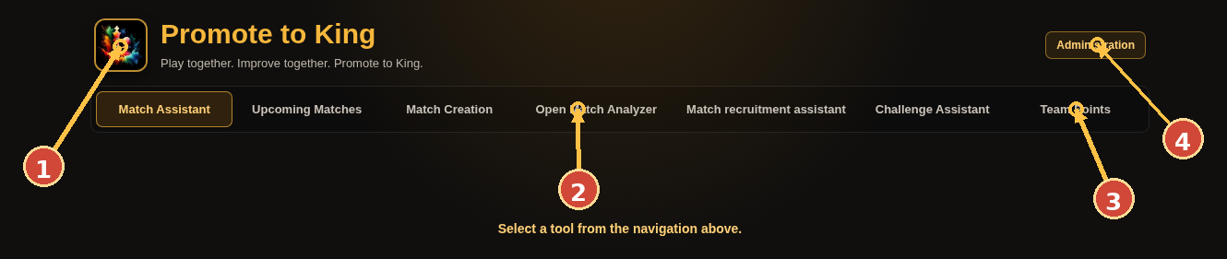 | 1. Club logo: opens the configured Promote to King Chess.com club page.  2. Main tool tabs: select one tool; each is loaded in a persistent same-origin frame.  3. Team Points: built-in administrator-only collection, process-monitoring, query and CSV module.  4. Administration: opens logs, diagnostics and tracked-match data management.
Typical workflow: 1) For local testing, open the page with ?admin=1. 2) For simulated OAuth, open with ?oauth=1 and log in with a verified club administrator username. 3) Use Ctrl-click or middle-click on a tab to open that tool as a standalone page.

2. Match Assistant
Find daily team matches that suit a member and rank them by recommendation.
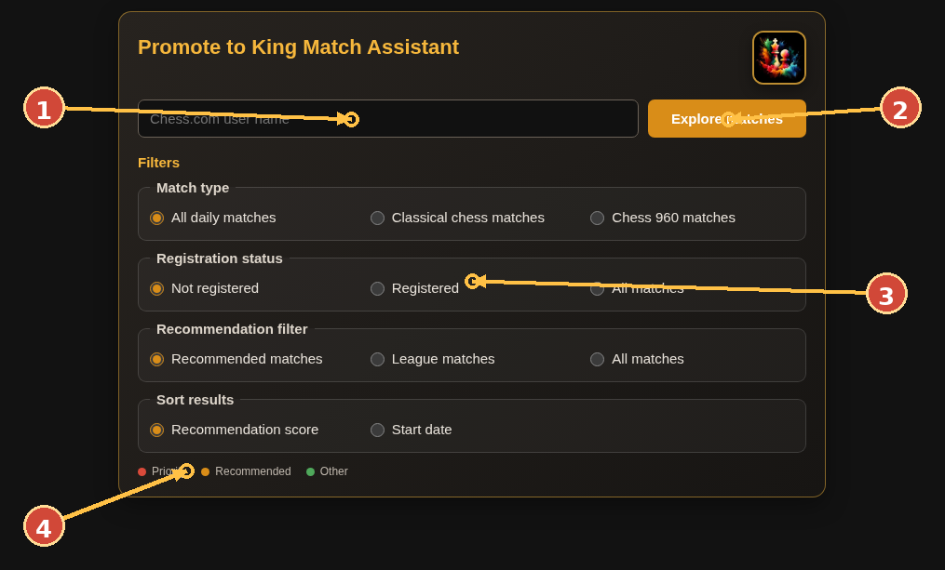 | 1. Enter the Chess.com username. With simulated OAuth enabled, the authenticated username can be filled automatically.  2. Start the analysis. Progress and a safe cancel control appear while requests are running.  3. Use match type, registration, recommendation and sorting filters to narrow the result list.  4. Result color legend: priority league, recommended, and other eligible matches.
Typical workflow: 1) Enter a current Promote to King member username. 2) Choose the desired filters before or after analysis; cached data supports fast re-filtering. 3) Open a result to inspect match details and the integrated detailed match analysis.

3. Upcoming Matches Analyzer
Analyze registration, lineup strength, lock readiness, player participation and recruitment needs for upcoming matches.
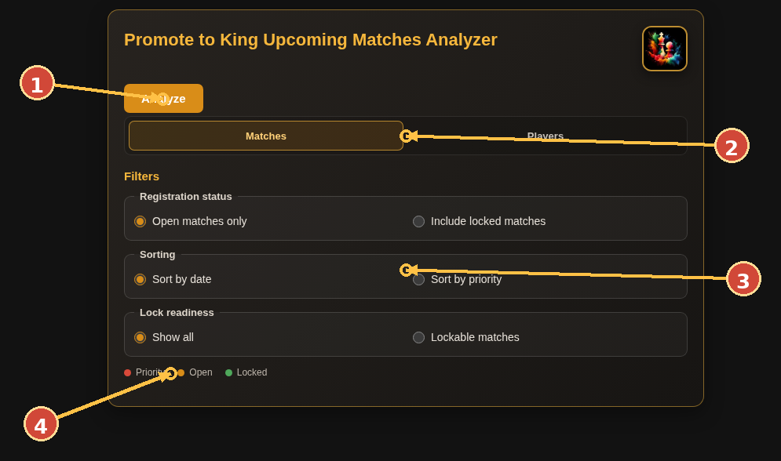 | 1. Analyze: loads the current club match index and computes the upcoming-match dataset.  2. Switch between match-centric results and the registered-player summary.  3. Filter registration status, sorting order and lock readiness.  4. Color legend distinguishes priority, open and locked matches.
Typical workflow: 1) Select Analyze and wait for the bounded progress sequence. 2) Use Matches for per-match projections and recruitment recommendations. 3) Use Players to search and sort aggregated registration, rating and timeout statistics.

4. Match Creation Analyzer
Summarize registration load, ongoing activity, opponents, players and scoring projections across the club match portfolio.
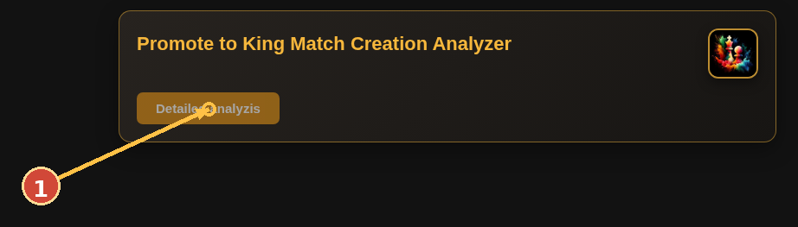 | 1. Detailed analysis: starts the staged data acquisition. Basic statistics appear before the deeper processing completes.
Typical workflow: 1) Open the tool and select Detailed analysis. 2) Review Match creation, Teams and players, and Scoring tabs after processing. 3) Use chart bars and opponent/player search controls for drill-down.

5. Open Match Analyzer
Analyze any Chess.com team match from either team perspective, including lineup and in-progress score projections.
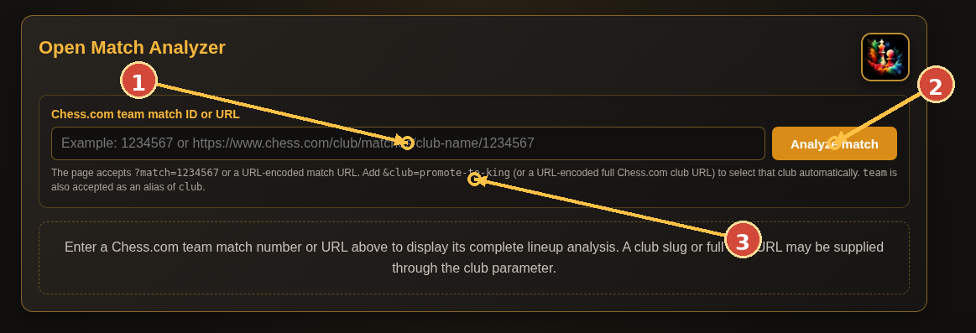 | 1. Enter a numeric team-match ID or complete Chess.com match URL.  2. Analyze match: loads the match and displays the team selector and detailed results.  3. Optional URL parameters can preselect the match and club for direct links or embedded use.
Typical workflow: 1) Paste the ID or URL. 2) Select Analyze match. 3) Choose the team perspective when prompted, then inspect strength, eligibility and score projection sections.

6. Match Recruitment Assistant
Build a list of eligible club members who can be invited to a specific match.
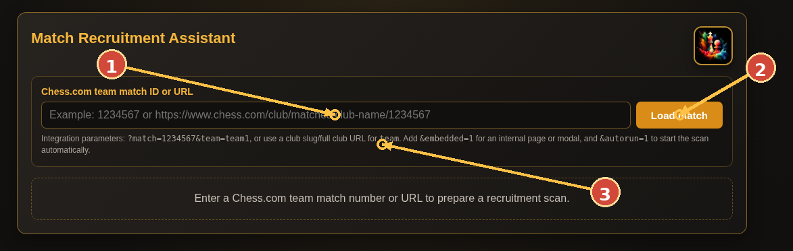 | 1. Enter a match ID or URL.  2. Load match: downloads match rules and the configured team roster.  3. Integration parameters support preselected team, embedded display and automatic scanning.
Typical workflow: 1) Load the target match. 2) Confirm the selected team when the standalone page allows it. 3) Adjust timeout/current-game criteria, run the scan and use the eligible-player list for recruitment.

7. Challenge Assistant
Maintain the club list, validate existing challenges and identify suitable new-challenge or rematch opportunities.
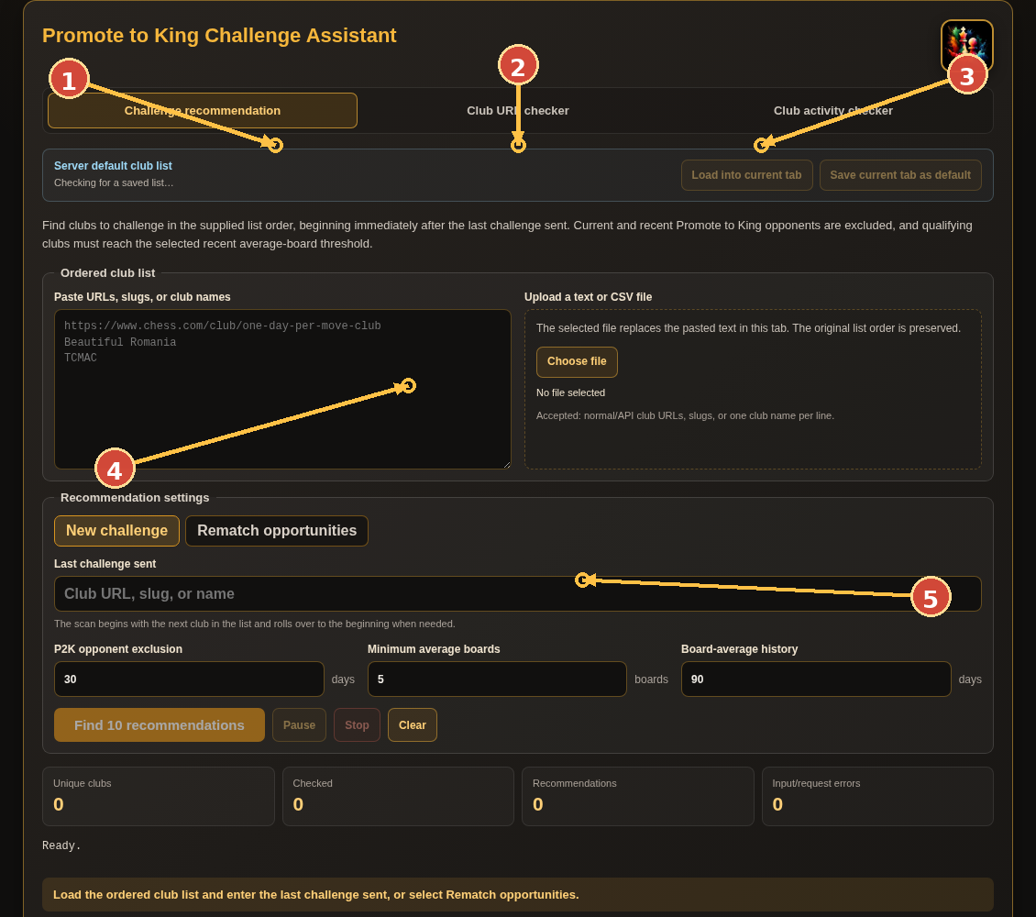 | 1. Challenge recommendation: default workspace for finding candidate clubs.  2. Club URL checker: validate or inspect one club directly.  3. Club activity checker: check freshness and activity-related data.  4. Club-list data: load or edit the managed list used for recommendations.  5. Recommendation controls: choose mode and constraints, then find and filter opportunities.
Typical workflow: 1) Load or refresh the club list. 2) Choose New challenge or Rematch opportunities. 3) Set match rules, rating, size and timing constraints, then run recommendations.

8. Administration - logs
Review Match Assistant usage and scheduled/manual task executions in UTC.
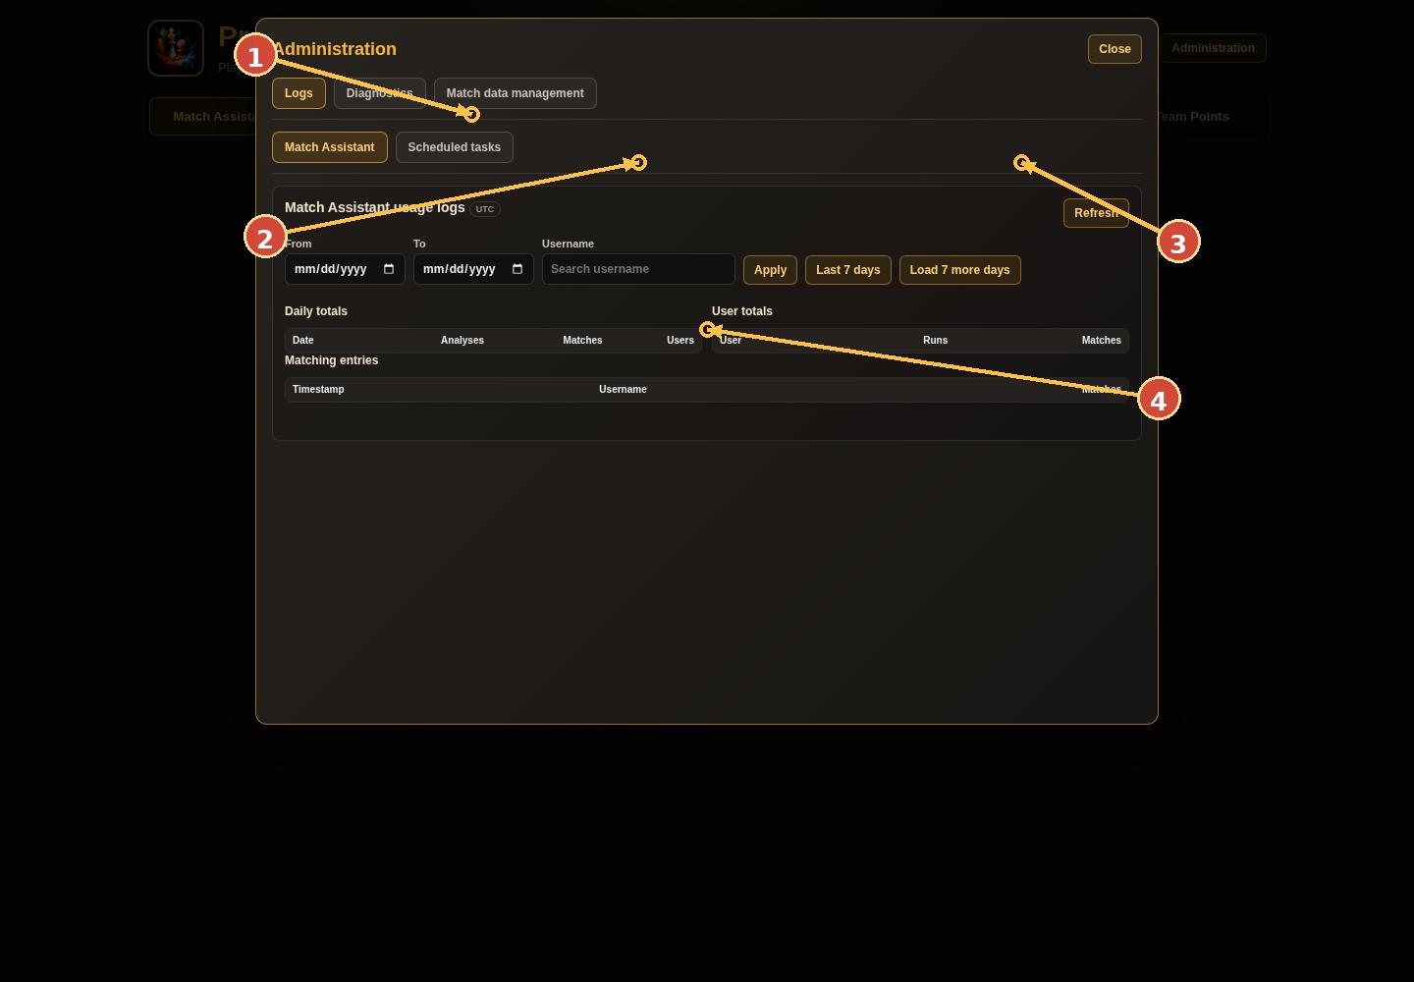 | 1. Administration sections: Logs, Diagnostics and Match data management.  2. Date, username, result, trigger and task-type filters depend on the selected log category.  3. Refresh and manual recording actions update the selected log view.  4. Summary cards and tables show daily, user and individual execution details.
Typical workflow: 1) Open Administration and keep Logs selected. 2) Switch between Match Assistant and Scheduled tasks subtabs. 3) Apply filters, load earlier seven-day windows or launch Record data now.

9. Administration - diagnostics
Inspect runtime versions, cache state, API status and client diagnostics without changing analytical data.
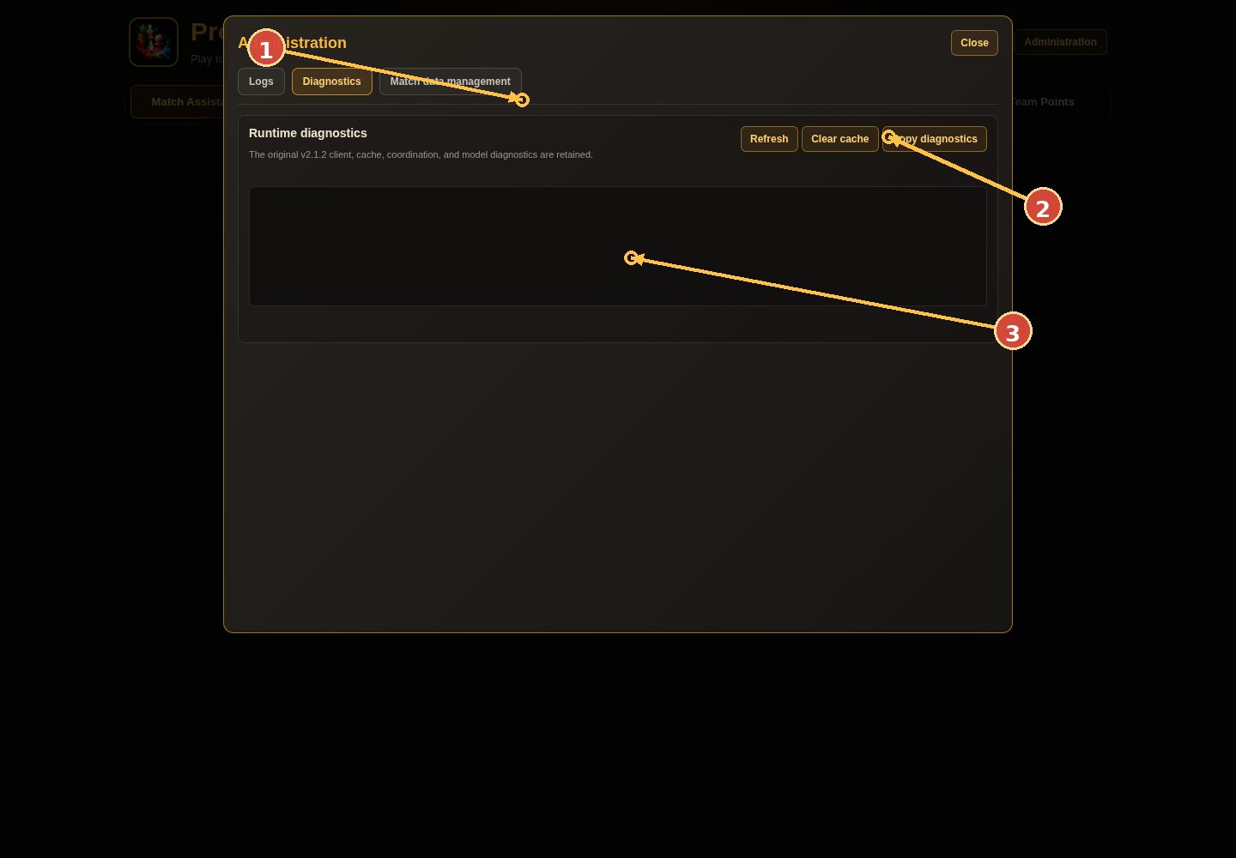 | 1. Select Diagnostics in the Administration modal.  2. Refresh, clear the client cache, or copy the diagnostic report.  3. The grid and log area display runtime checks and detected issues.
Typical workflow: 1) Select Refresh after reproducing a problem. 2) Copy diagnostics before clearing cache so the original state is retained. 3) Use Clear cache only when stale client data is suspected.

10. Administration - match data management
Follow matches, capture snapshots, inspect history and remove finished or unfollowed tracking data.
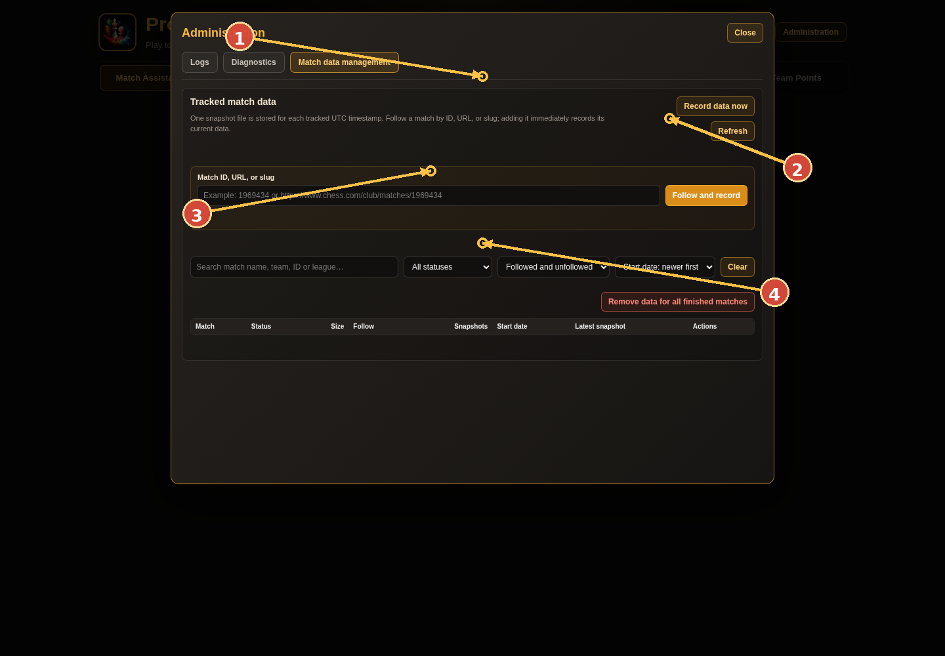 | 1. Select Match data management.  2. Record data now and Refresh control snapshot acquisition and display.  3. Add a match by ID, URL or slug; search, filter and sort the tracked set.  4. The table provides follow status, snapshots, last update and history actions.
Typical workflow: 1) Add a match to follow; its current snapshot is recorded immediately. 2) Use Record data now for a manual capture of followed active matches. 3) Open history to navigate lineup changes; confirm destructive cleanup operations.

11. Team Points - control and data collection
Connect to the protected server API and control the durable collection queue.
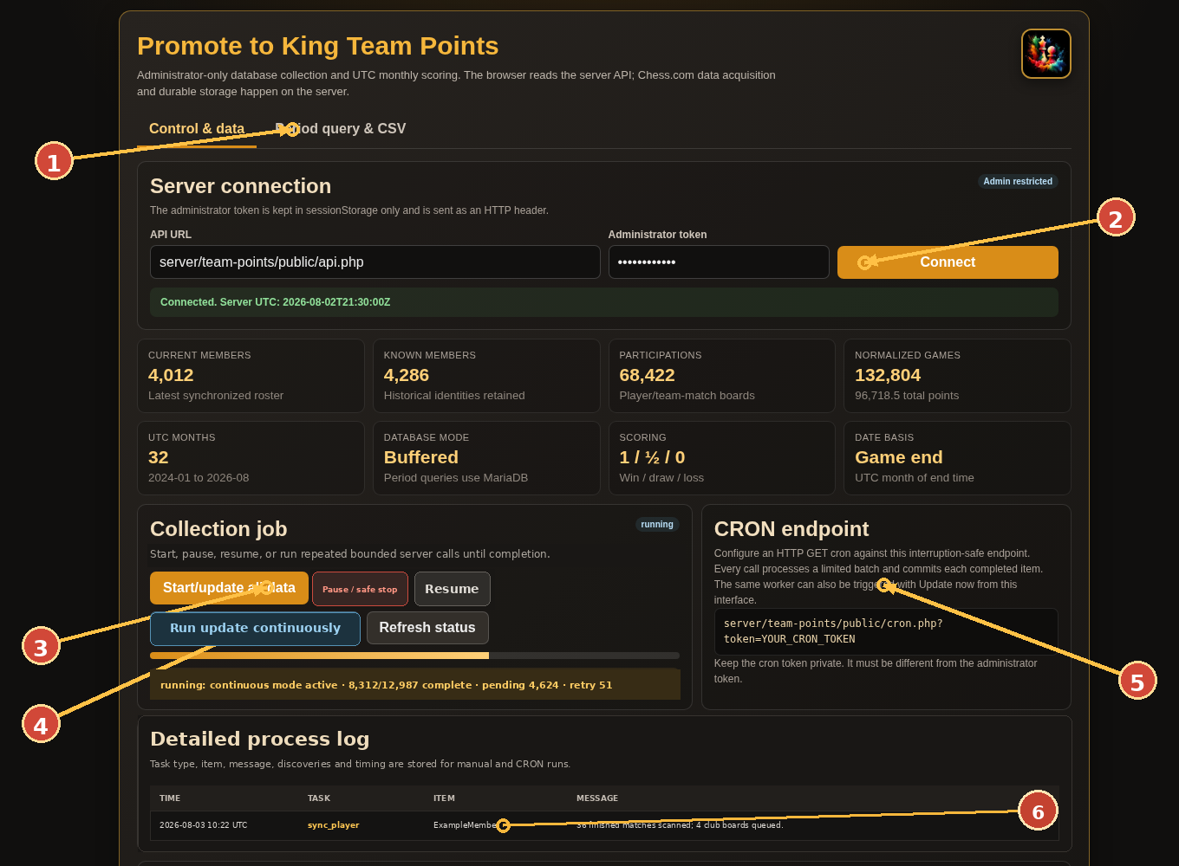 | 1. Internal tabs switch between collection controls and period/CSV queries.  2. Enter the administrator token and connect; the token remains in browser sessionStorage.  3. Start, pause and resume the persistent full-sync job; all progress is stored server-side.  4. Run update continuously chains bounded server calls until completion, safe pause or failure.  5. The private CRON URL processes the same queue on a schedule without conflicting with a manual worker.  6. Detailed process logs identify task type, item, discoveries, retries, failures, timing and completion.
Typical workflow: 1) Connect, then select Start/update all data. 2) Select Run update continuously; the page repeats short server-safe invocations automatically. 3) Use Pause / safe stop and Resume when needed, and supervise the process overview, task breakdown, detailed log, retries and worker invocations.

12. Team Points - UTC period query and CSV
Calculate scores from stored normalized events without contacting Chess.com.
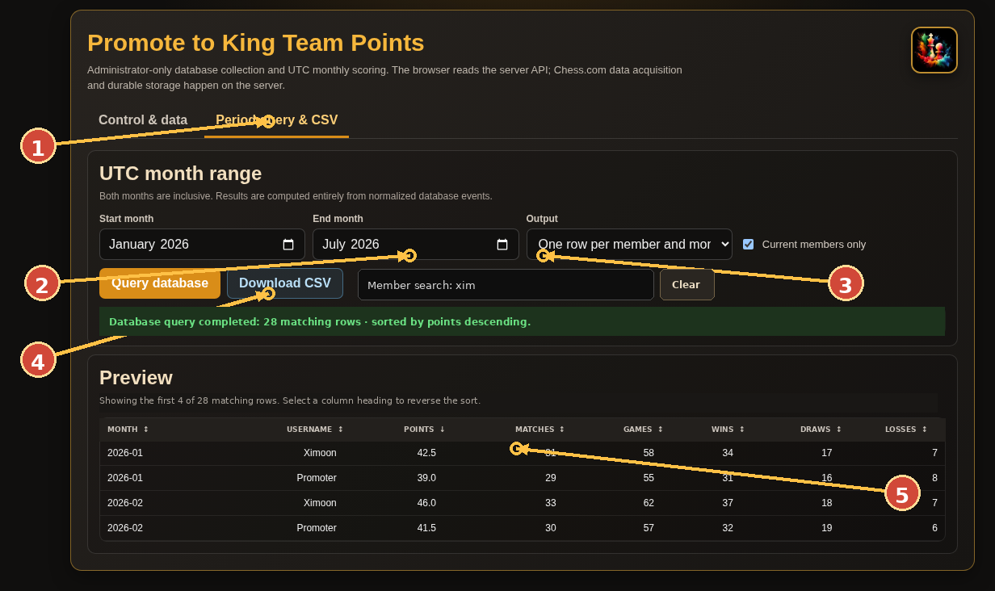 | 1. Open Period query & CSV.  2. Choose inclusive start and end UTC months.  3. Select totals, monthly rows or game events; optionally restrict to current members and search part of a username.  4. Query database for a preview; select a column heading to sort ascending or descending.  5. Download CSV exports the complete result using the same range, member filter and sort order.
Typical workflow: 1) Choose the UTC months and output shape. 2) Optionally search a member and restrict to current members. 3) Query, select sortable headings as needed, then download the complete UTF-8 CSV.

13. Mobile layout
The interface reflows into a single-column layout on narrow screens.
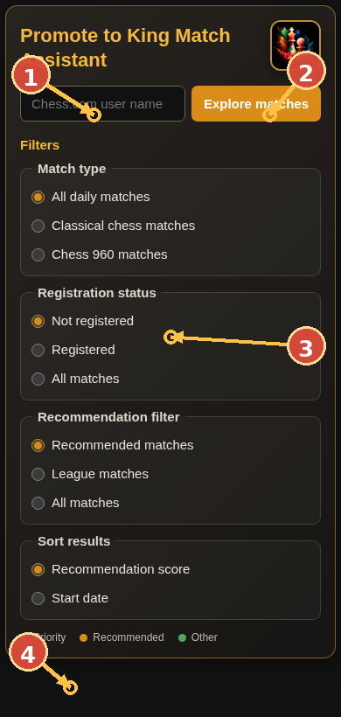 | 1. Username input remains at the top.  2. Primary action stays visible beside or beneath the input depending on width.  3. Filter choices stack vertically for touch operation.  4. The result legend remains visible at the bottom of the filter area.
Typical workflow: 1) Use portrait orientation for forms and filters. 2) For dense tables or charts, rotate to landscape or open the larger modal view. 3) Tooltips and modals are constrained to the visible viewport.

14. Local Python/SQLite simulation
Purpose: test the complete website and the Team Points workflow without PHP, MariaDB or a network connection to Chess.com.
- Extract the integrated ZIP and open a terminal in the extracted top-level folder.
- Run `python serve_team_points_local.py --reset` or `py serve_team_points_local.py --reset` on Windows.
- Open `http://127.0.0.1:8000/?admin=1`.
- Open Team Points and connect with token `local-admin`.
- Start the job and select Run update continuously. Test pause/resume, logs, member search and sorting. The durable simulation database is `data/team-points-local.sqlite3`.
- Test scheduled processing with `http://127.0.0.1:8000/server/team-points/public/cron.php?token=local-cron`.

What the combined launcher preserves
- Every original website page and browser workflow included in v2.3.1.
- The original `serve_local.py` APIs for logs, diagnostics, challenge lists, tracking and history.
- A Team Points SQLite queue, deterministic sample events, process logs, search, sorting and CSV.
- Manual update and CRON calls that continue the same checkpointed queue.

Restart behavior
- Stop with Ctrl+C. Restart without `--reset` to continue the saved job.
- Use `--reset` only when a clean demonstration database is required.

15. Production installation - overview
- Back up the existing website and database-related configuration.
- Choose a current PHP version for the domain; the module requires PHP 8.1+ and recommends a maintained version such as PHP 8.4.
- Create an IONOS MariaDB/MySQL database and record host, port, database name, username and password.
- Copy `server/team-points/config/config.example.php` to `config.local.php` and enter credentials plus two different random tokens.
- Upload the complete integrated archive by FTP, including all `.htaccess` files.
- Open the one-time installer, enter the administrator token and create the `p2k_tp_` tables.
- Delete or rename `install.php` after success.
- Connect from Team Points, run the continuous manual update to validate the system, then configure CRON.

Files that contain private values
File / value | Protection rule
server/team-points/config/config.local.php | Never publish; included .htaccess denies web access.
admin_token | Enter only in the protected interface; stored in sessionStorage and sent as a header.
cron_token | Keep the full CRON URL private because the token is in its query string.
database password | Use only in config.local.php and provider backup tools.

16. IONOS database and schema installation

Create the database
- Open Menu > Hosting.
- In Databases, choose Create Database (or Manage, then Create Database).
- Choose MariaDB or MySQL, set a strong password and save.
- Copy the displayed hostname, port, database name and username into config.local.php.

Install the tables
- Upload the configured package to the web root.
- Open `https://YOUR-DOMAIN/server/team-points/public/install.php`.
- Enter the administrator token and select Install database tables.
- After the success message, delete or rename install.php.
Alternative: Open IONOS phpMyAdmin from Hosting > Databases > Manage > Open and import `server/team-points/sql/schema.sql`. The installer and manual import create the same prefixed schema; one method is sufficient.

Database access limitation
IONOS generally restricts the hosting database to applications running in the associated IONOS webspace. This is why the desktop simulator uses SQLite rather than direct MariaDB access.

17. CRON and interruption-safe processing
Production CRON URL: https://YOUR-DOMAIN/server/team-points/public/cron.php?token=YOUR_PRIVATE_CRON_TOKEN
- Open Menu > Hosting > Cronjobs > Manage.
- Create a cronjob and paste the full HTTPS URL into HTTP GET.
- Choose the available schedule and activate the task.
- Check Team Points > Detailed process log and Recent worker invocations after the first call.

Why a 60-second host limit is safe
- The default application budget is 45 seconds and 25 queue items per invocation.
- Each item is committed independently before the worker claims the next item.
- A `partial` result means the invocation stopped at a safe checkpoint; the next call continues.
- Stale running items return to retry after the configured recovery interval.
- A MariaDB named lock prevents two manual/CRON workers from processing concurrently.

Six-hour schedule
- Use four daily HTTP jobs at different times when the account interface permits separate daily times.
- With SSH/server-side CRON, use: `0 */6 * * * /usr/bin/curl -fsS "CRON_URL" >/dev/null`.

18. Scoring, coverage and CSV semantics

Scoring
Result group | Result codes | Points
Win | win | 1.0
Draw | agreed, repetition, stalemate, insufficient, 50move, timevsinsufficient | 0.5
Loss | other completed loss codes | 0.0

Date attribution
- Each game is placed in the UTC calendar month of its individual `end_time`. Two games from one board can therefore fall in different months.
- Start and end month inputs are inclusive. A January-to-March query includes every event from 1 January 00:00 UTC through the instant before 1 April 00:00 UTC.

Output shapes
- Totals: one row per member for the complete selected period.
- Monthly: one row per member and UTC month.
- Events: one row per normalized game with match, board/game URL, end time, result and points.

Historical coverage limitation
- The initial discovery starts from the current Chess.com club roster and retains former members after they have been observed.
- Chess.com does not expose a guaranteed all-time historical membership roster. Unknown former members who left before the first collection cannot be guaranteed in an exhaustive all-time total.

19. Backup, security and troubleshooting

Backup
- Back up MariaDB through phpMyAdmin or hosting backup tools before schema or configuration changes.
- Preserve `p2k_tp_members`, `p2k_tp_participations`, `p2k_tp_point_events`, queue, cache and worker-run tables.
- Do not delete active queue records while a job is running.

Common errors
Symptom | Action
Missing configuration | Create `server/team-points/config/config.local.php` from the example file.
Database connection error | Recheck the exact IONOS host, database name, user and password; do not assume localhost.
SCHEMA_NOT_INSTALLED | Run the one-time installer or import schema.sql in phpMyAdmin.
ADMIN_AUTH_FAILED | The interface token must match admin_token.
CRON_AUTH_FAILED | The URL token must match cron_token.
Repeated partial CRON results | Normal while work remains; inspect progress, retries and recent invocations.
HTTP 429 | Leave the item for retry and keep serial requests plus the configured delay.
Original local APIs unavailable | Start `serve_team_points_local.py`, which proxies the unchanged v2.3.0 simulator.

Official IONOS references checked
- https://www.ionos.com/help/hosting/setting-up-mysql-databases/setting-up-mysql-or-mariadb-databases-in-your-ionos-account/
- https://www.ionos.com/help/hosting/cron-jobs/cron-job-manager/
- https://www.ionos.com/help/hosting/managing-php-versions-in-the-control-panel/displaying-or-changing-php-versions/
- https://www.ionos.com/help/hosting/using-mysql-databases-for-web-projects/opening-phpmyadmin/
- https://www.ionos.com/help/hosting/troubleshooting-mysql-databases/connection-and-access-problems-with-mysqlmariadb-databases/

