44MPLY PROJECT REPORT: Ice Cream Vs Pizza
Abstract
This project builds an image classification system to distinguish between ice cream pizza using K-Nearest Neighbors (KNN) and Support Vector Machine (SVM) classifiers. A dataset of 100 images across two classes was organized into folder-based labels. Images were resized to 64x64, converted to grayscale, normalized, and representing using Histogram of Oriented Gradients (HOG) features. KNN was tuned with cross-validation, selecting k=1, and both models were evaluated using accuracy, precision, recall, F1-score, and confusion matrices. On the test set, SVM achieved 0.90 accuracy, outperforming KNN at 0.70. A real-world test on unseen images showed SVM generalizing better (0.90 accuracy) while KNN dropped to 0.50. The project demonstrates that feature engineering plus margin-based classification can improve performance on image data.
Introduction
Image classification is a foundational task in machine learning where a model learns to recognize visual categories from pixel data. In this project, the goal is to classify images into two class ice and pizza using two traditional machine learning algorithms: KNN and SVM. KNN is a simple distance-based method that predicts a label based on the closest training examples, while SVM constructs a separating boundary with maximum margin in feature space. To make images usable for these algorithms, we extract visual features using HOG which emphasizes edges and textures that help distinguish objects.
Dataset Description
The dataset consists of 100 images across two classes: Icecream and pizza, organized into separate folders under as single dataset directory. Each class contains 50 images. The dataset was collect from Kaggle, and the images were named with a consistent convention (e.g., icecream_001.jpg, pizza_001.jpg). An additional unseen dataset was prepared for real-world testing, containing images that were not used in training or validation.
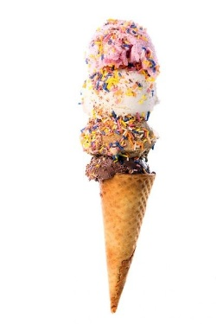 | 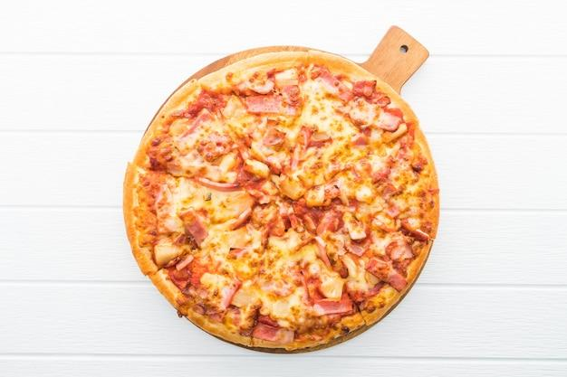
Figure 1: Sample images from each class
Image processing
All images were resized to 64x64 pixels for uniformity and converted to grayscale to reduce dimensionality. Pixel values were normalized to the range [0,1]. This preprocessing ensures that both KNN and SVM receive features of equal length and comparable scale.
Feature Extraction
Images were represented using Histogram of Oriented Gradients (HOG) features. HOG captures local edge orientations by computing gradient histograms over small spatial cells, making it suitable for recognizing object shapes and textures. Parameters used were 9 orientations, 8x8 pixels per cell and 2x2 cells per block with L2-Hys normalization. For a 64x64 image, this produced a 1,764-legnth feature vector.
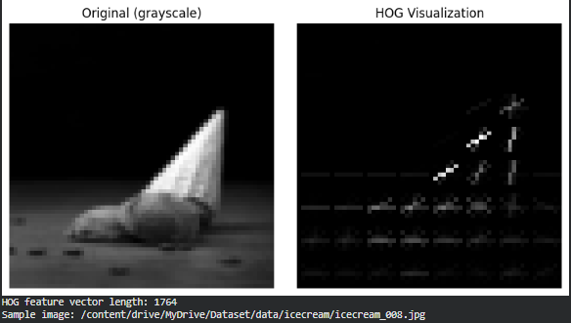
Figure 2: HOG visualization of a sample image (left: grayscale, right: HOG map)
Model Development
For KNN, features were standardized and the number of neighbors was selected using cross-validation. Odd k values from 1 to 15 were tested using 5-fold cross-validation, and the best value was k=1 with accuracy = 0.76.
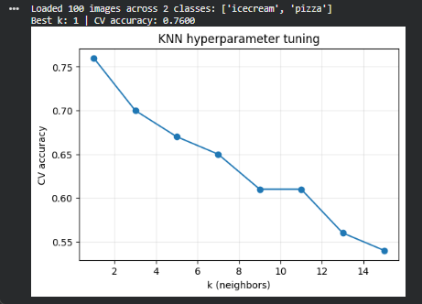
Figure 3: KNN hyperparameter tuning: CV accuracy vs. k (best k = 1).
For SVM, an RBF kernel with C=1.0 was used. Features were standardized to ensure equal scaling, which is important for both KNN distances and SVM margins.

Evaluation
The dataset was split into 80% training and 20% testing, stratified by class. Performance was evaluated using accuracy, precision, recall, F1-score, and confusion matrices. For KNN, overall accuracy was 0.70, the macro-average/precision/recall/F1 were 0.8125/0.70/0.6703, and the weighted-average F1 was 0.6703. Class-wise, KNN had precision 1.0 and recall 0.40 for ice-cream and precision 0.625, recall 1.00 for pizza, indicating it tended to over-predict pizza and missed many ice-cream images. For SVM, accuracy improved to 0.90 with macro-average precision/recall/F1 = 0.9167/0.90/0.8990 and weighted-average F1 = 0.8900. Class-wise, SVM achieved precision 1.00, recall 0.80 for ice-cream and precision 0.8333, recall 1.00 for pizza, showing better balance and fewer ice-cream errors. The confusion matrices confirms this: KNN misclassified 6 out of 10 ice-cream images, while SVM reduced that to 2.
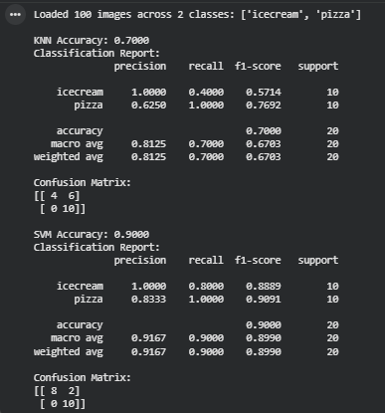
Figure 4: Classification reports and confusion matrices for KNN and SVM on the test set.
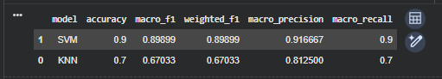
Figure 5: Summary table comparing KNN and SVM performance (accuracy, macro/weighted F1, macro precision, macro recall).
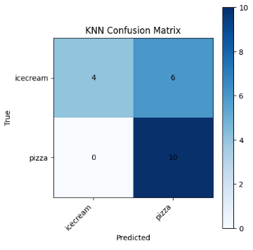 | 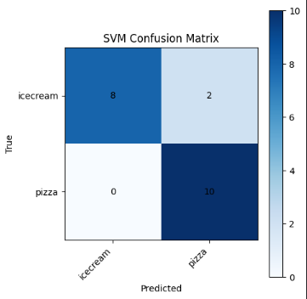
Figure 6:KNN Confusion Matrix and SVM Confusion Matrix
Results and Discussion
SVM clearly outperformed KNN on the test set, achieving higher accuracy and a more balanced precision–recall profile. The KNN model tended to over-predict the pizza class, which is reflected in its lower recall for ice-cream (many ice-cream images were mislabelled as pizza). This likely happened because the HOG features of some ice-cream images especially cones and circular scoops share edge patterns and textures that resemble pizza slices, plates, or toppings. In other words, the local gradient patterns captured by HOG can look similar across the two classes when shapes and backgrounds overlap.
SVM handled this overlap better by learning a separating boundary that maximizes the margin between classes. The confusion matrices show that SVM reduced the number of ice-cream errors substantially while still classifying all pizza images correctly. The misclassified examples from KNN also suggest that background clutter, lighting differences, and presentation (e.g., ice-cream on plates or wooden boards) contribute to confusion. These factors make the edge patterns less distinctive and cause KNN, which relies on local neighbourhood similarity, to pull those samples toward the pizza class.
Overall, the results indicate that SVM is more robust for this task, especially in high-dimensional HOG feature space. The misclassification analysis supports the idea that a margin-based classifier can better separate classes that share similar textures and shapes, while KNN remains sensitive to local variations and noise.
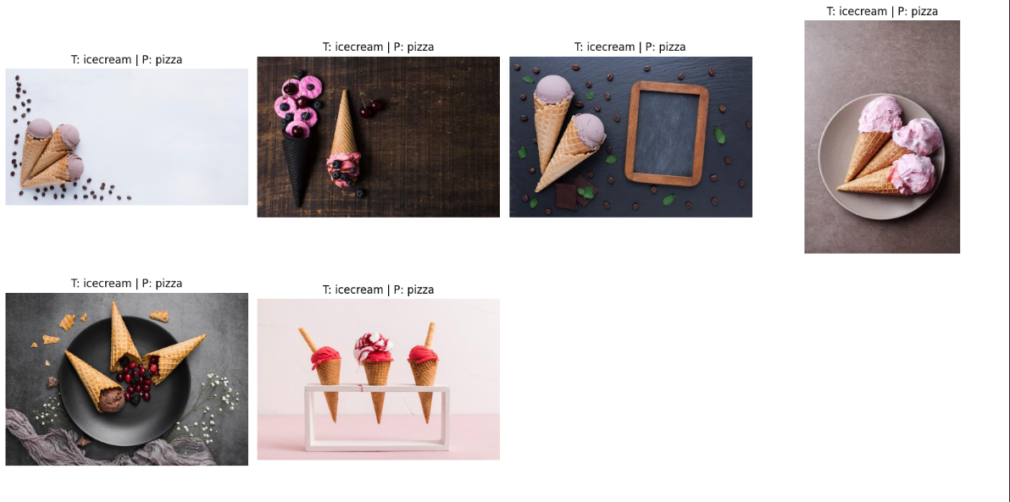
Figure 7: Examples of misclassified images (T = true, P = predicted).
Real-World Testing
To evaluate generalization, 10 unseen images (5 per class) were tested. KNN achieved accuracy = 0.50 predicting all images as pizza. SVM achieved accuracy = 0.90, correctly classifying 4/5 ice-cream images and all pizza images. This indicates that SVM is more robust when the test images differ from the training set.
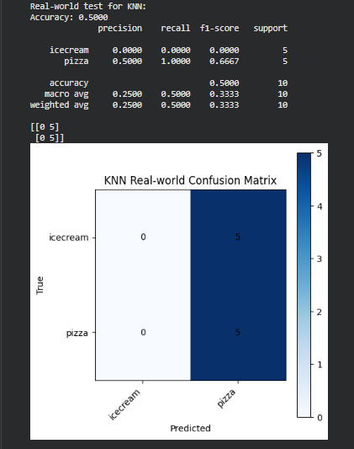 | 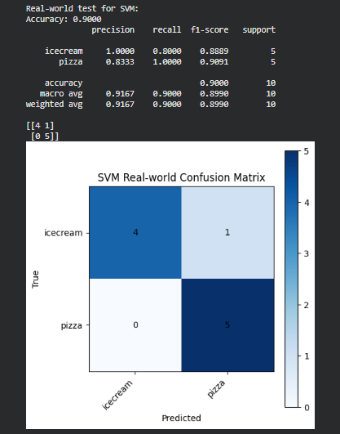
Figure 8: Real-world test results (confusion matrix and summary table)
Reflection
This project showed how traditional machine learning models can classify images when paired with strong feature extraction. A key challenge was choosing a good k value for KNN, which was resolved with cross-validation. Another challenge was that KNN struggle to generalize to unseen images, while SVM handle the same data much better. I learned that feature engineering and proper model selection can make a large difference in performance, even with the same dataset.
Conclusion
Both KNN and SVM can perform image classification using HOG features, but SVM produced the best accuracy and generalization in this project. The results suggest that margin-based classifiers are more effective for these image features than simple nearest-neighbour methods. Future improvements could include using more data, trying additional classes, or exploring feature extractors such as colour histograms or CNN-based embeddings.

