
Drone Mission Planner
Multi-UAV Mission Planning & Dynamic Simulation Platform

USER MANUAL • VERSION 1.0.0 • JULY 2026
Local desktop software for editing, planning, simulating, recovering, validating, and reporting cooperative 2D drone missions.

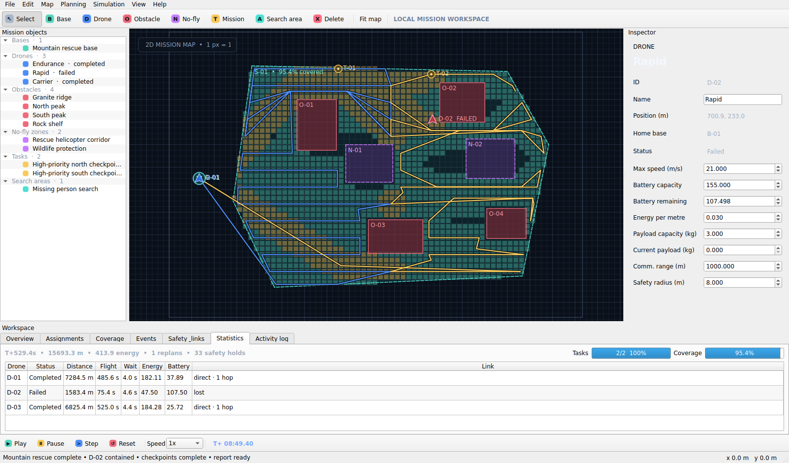
Final mountain search-and-rescue acceptance dashboard

Contents
1. Product scope and safety notice
2. Install and launch
3. Interface tour
4. Compose and save a mission
5. Point missions and cooperative search
6. Run and control simulation
7. Faults and live replanning
8. Collision and communication constraints
9. Statistics and report export
10. Release examples
11. Shortcuts and troubleshooting
This manual documents the standalone Windows release and the equivalent source build. Interface labels use the English text shown by version 1.0.

1. Product scope and safety notice
Drone Mission Planner is a fully local software simulation. It creates and evaluates 2D mission plans but does not connect to real aircraft, issue flight commands, replace a certified ground-control station, or provide regulatory authorization.
- Mission editing: bases, aircraft, missions, obstacles, no-fly zones, and search polygons.
- Deterministic routing and assignment with payload, energy, reserve, and return constraints.
- Fixed-step simulation with coverage, failures, live replanning, collision holds, and radio links.
- HTML, JSON, and CSV reporting plus reproducible example projects.

2. Install and launch

Standalone Windows application
- Download and extract DroneMissionPlanner-Windows-x64.zip.
- Open the extracted folder and run DroneMissionPlanner.exe.
- If SmartScreen appears, review the publisher/source information and choose the action permitted by your organization.
- No Python installation is required.

Run from source
python -m venv .venv
python -m pip install -e ".[dev]"
python run.py
- Recommended source runtime: Python 3.12.
- Projects use the .dmproj extension and are human-readable JSON.
- Press F1 after launch for the in-app five-step guide.

3. Interface tour

Main window: object tree, map, inspector, workspaces, and simulation controls
Region | Purpose
Top tools | Select/place/draw objects; fit the complete map.
Object tree | Browse groups, IDs, task states, and aircraft states.
Map | Pan, zoom, select, inspect routes, coverage cells, and radio edges.
Inspector | Edit validated aircraft, mission, base, and area parameters.
Workspace tabs | Assignments, Coverage, Events, Safety & links, Statistics, and Activity log.
Bottom controls | Play, Pause, Step, Reset, speed, and deterministic simulation time.

4. Compose and save a mission
- Choose Base and click the map. Add at least one Drone; it automatically references the first base.
- Place Mission points. Use the inspector to set priority, payload, duration, speed, battery, safety radius, and communication range.
- Choose Obstacle or No-fly and drag a rectangle. Protected cells are inflated by each active aircraft's safety radius during planning.
- Use the wheel to zoom; middle-drag or Space-drag to pan; press F to fit the map.
- Save with Ctrl+S. Version 1.0 projects migrate in memory to schema 1.1 and save as 1.1.
Project validation rejects duplicate IDs, out-of-map positions, grids larger than 500×500 cells, invalid payload/battery values, missing references, and malformed search settings.

5. Point missions and cooperative search

Point missions
Planning → Auto assign all missions evaluates every unfinished mission against every aircraft. The cost includes route length, workload, battery risk, deadline risk, payload, safe return, and a 15% reserve. Open Assignments for per-task outcomes and detailed rejection reasons.

Cooperative search
- Choose Search area and drag a rectangle. Polygon areas can be loaded from a project file.
- Edit scan spacing, boundary margin, and target coverage.
- Choose Planning → Plan area coverage (Ctrl+Shift+C).
- One vertical strip is assigned to each available drone; alternating scan passes route around protected cells and return home.
- During simulation, teal cells have one visitor and amber cells have multiple distinct visitors.
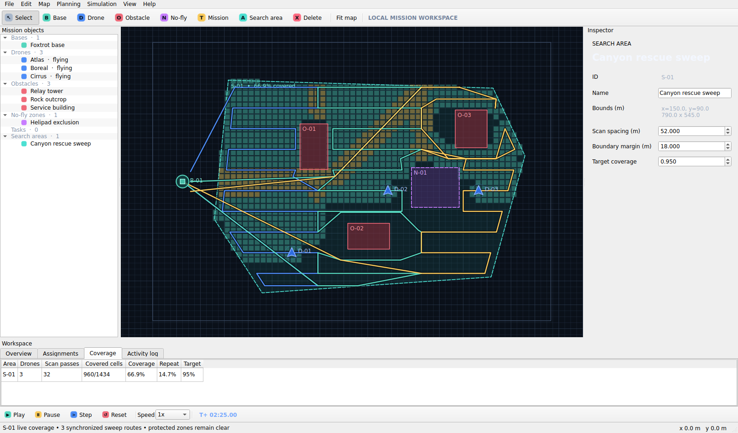
Three-drone area sweep with live unique/repeat coverage

6. Run and control simulation
- Play uses a fixed 0.05 s logical step; UI frame rate never changes the final result.
- Pause freezes logical time. Step advances exactly one logical tick.
- Speed changes wall-clock playback only: 0.5x, 1x, 2x, 5x, or 10x.
- Reset restores the current engine's initial positions, battery, tasks, coverage, events, conflicts, and replan counter.
- Aircraft transition through idle, takeoff, flight, execution, return, completion, failure, or emergency states.

7. Faults and live replanning
- Select an operational drone and press Ctrl+Shift+F, or schedule a deterministic future failure from the Simulation menu.
- The failed aircraft stops immediately at its exact live position and battery.
- Only unfinished work is released; completed checkpoints are not repeated.
- Operational aircraft replan from their live positions without resetting time, distance, energy, coverage, or event history.
- Add a Mission or draw a No-fly zone while an engine exists to trigger live insertion/replanning. Cancel an unfinished mission from the Simulation menu.
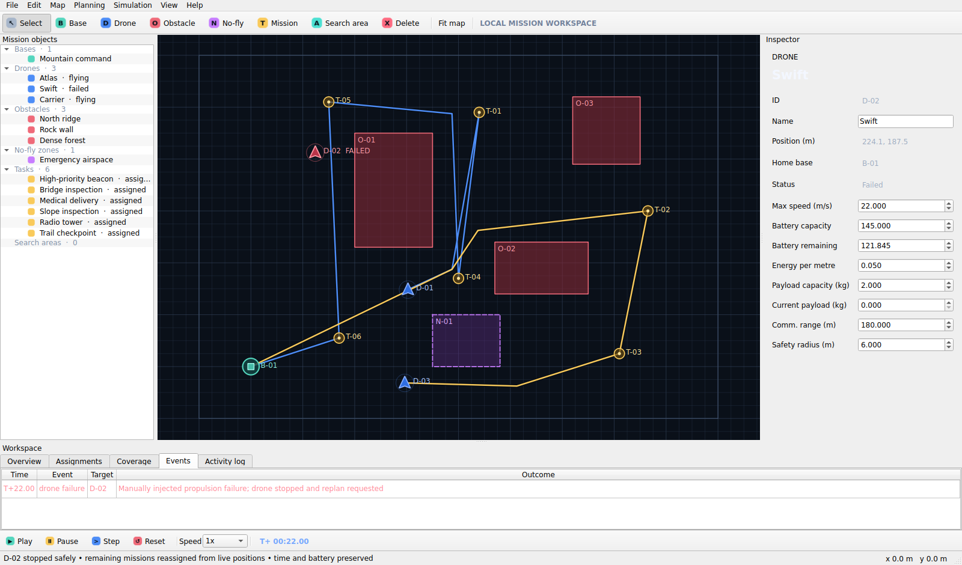
D-02 failure, visible event, and rebuilt future routes

8. Collision and communication constraints
The engine samples future trajectories over a two-second horizon. If predicted separation falls below the combined safety radii, the lower task-priority drone waits until the conflict clears. Equal priorities use a stable ID rule.
Radio edges require distance to be within both endpoints' ranges. Safety & links identifies Direct, Relay, or Lost, shortest hop count, nearest base, disconnect duration, and active policy. Under auto_return, a grace interval expires before an obstacle-safe route home is activated.
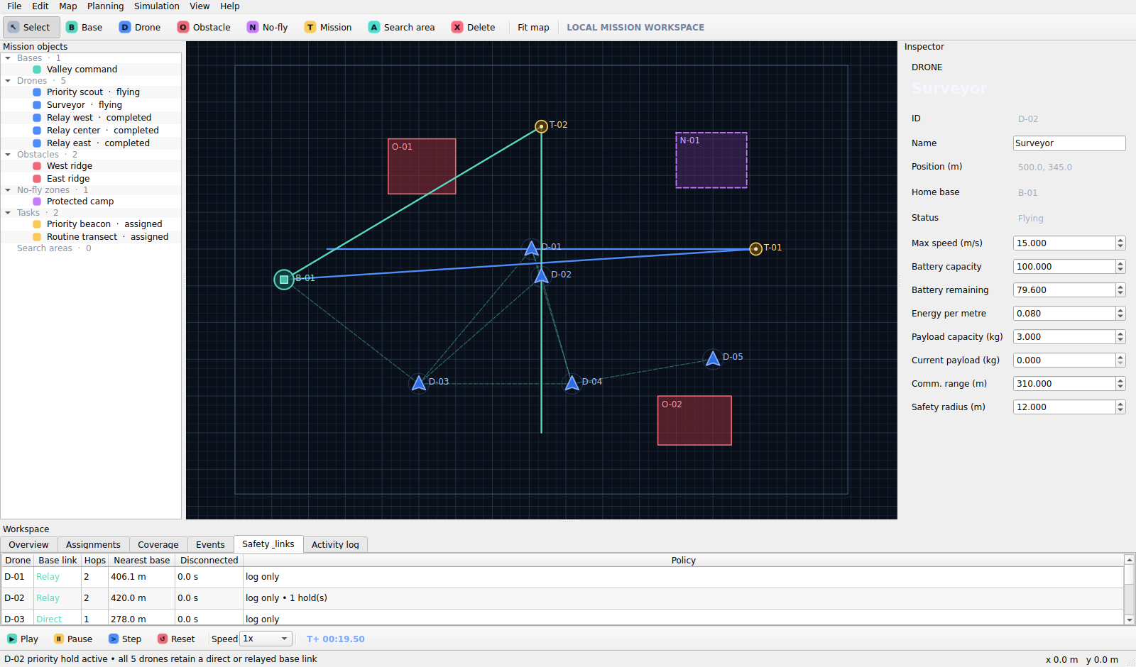
Crossing-flight hold and multi-hop relay graph

9. Statistics and report export
- Statistics: status, distance, flight/wait time, energy, battery, completed tasks, and radio link per aircraft.
- System summary: mission time, completion rate, coverage, replans, collision holds, and communication losses.
- Press Ctrl+E and choose HTML for a shareable dashboard, JSON for structured automation, or CSV for a per-aircraft table.

Final 100% checkpoints and 95.4% accessible-area coverage

10. Release examples
File | Scenario
inspection_demo.dmproj | Three-drone priority inspection around buildings and a crane exclusion zone.
delivery_demo.dmproj | Payload-aware light/cargo/heavy medical deliveries.
rescue_demo.dmproj | Final three-drone mountain search, D-02 failure, two-drone recovery, 95%+ coverage.
safety_constraints_demo.dmproj | Priority crossing hold plus a three-relay communication chain.

11. Shortcuts and troubleshooting
Shortcut | Action
Ctrl+S | Save project
F | Fit map
Ctrl+Shift+P | Auto assign point missions
Ctrl+Shift+C | Plan area coverage
Ctrl+Space | Play
. | Single logical step
Ctrl+Shift+F | Fail selected drone
Ctrl+E | Export report
F1 | Quick start
- Planning failure: read Assignments/Activity log for exact reachability, payload, battery, home-base, or reserve reasons.
- Lost link: inspect dashed edges and per-node ranges; failed/emergency drones cannot relay.
- Blocked deletion: structural objects are protected while an engine exists; cancel missions or reopen the project.
- Corrupt/incompatible project: the open dialog reports parse, schema, validation, and reference errors without terminating the app.
- More detail: docs/troubleshooting.md and docs/developer-guide.md in the release package.

END OF USER MANUAL • DRONE MISSION PLANNER 1.0

