K Means Cluster Algorithm

I have implemented 3 initialization method, namely random initialization, using gonzales’ algorithm, and k means++. Using maximal iteration and predefined convergence threshold to control for stopping criterion. Also a similarity function and convergence performance were implemented for evaluation.

Firstly I will introduce three initialization methods.

Then I will design some experiments to see the properties of each method, i.e. stabilization, convergence speed and so on.

1. Initialize the cluster center:
input:
k: the number of clusters
indices: pixel value. For example: I(x,y)
indices_length: length*width. For example: for a image 200*200, indices_length = 400
output:
centers: centers[index]
center_length = k

random_shuffle(indices_length)
for(index:k)
get the elements of random_shuffle sequently rnd
centers[index] = indices[rnd]

Attention: avoiding choosing two indices with same pixels

2. Intialize centers in the k-means using gonzales’ algorithm
input:
k: the number of clusters
indices: pixel value. For example: I(x,y)
indices_length: length*width. For example: for a image 200*200, indices_length = 400
output:
centers: centers[index]
center_length = k

1. Choose the first cluster center randomly.
2. for ( index : k )
for ( j : indices_length )
calculate the minimum length(difference of RGB/Gray Value) among all the centers and pixels in the image, so that the centers we choose are spaced apart from each other

3. Initialize centers in the k_means using kmeans++
input:
k: the number of clusters
indices: pixel value. For example: I(x,y)
indices_length: length*width. For example: for a image 200*200, indices_length = 400
output:
centers: centers[index]
center_length = k

1. Choose the first cluster center randomly. Centers[0] = indices[index] which index = rand_int(n)
2. calculate the for each point i closestDistSq[i] = d(center[0],indices[i]), and the sum of distance
3. for (i:k)
choose a number randomly from 0 to sum
find a suitable candidate for next cluster center w.r.t the random number we choosed above
computer the new potential, ensure that the minimal distance with all cluster centers will be maximized!!
(example candidate(c), d(c,1) = 100, d(c,2) = 100, d(c,3) = 1, even though the first 2d is big, but it is near to the third center! So that it is not a good candidate! )
update the new closetDistSq[i] for each point.

Now I will do some test of this algorithm.
1. For three initialization method, let iteration=1,cluster=2 (most simple case) to see the cluster
result. The result of method 1 would have big differences.
2. For three initialization method, observe the difference convergence speed.
3. See the cluster result of different images. Choose different k.

1. Iteration = 1;
cluster = 2;
Run 5 times.

Method 1:






Method 2:





Method 3:



It seems that method 2 is more stable than the other two methods. Then here comes the question, which is stable between method 1 and 3. Let’s run more cases and have a look.

Method 1:









Method 3:








As we can see, Method 3 has more better clustering results. So method 3 is more stable than 1 in this case. It is the same as the analysis. In addition, it use the probability to choose the initialized point, so it is also not ‘hard’ like method 2. It means, it has also some instable cases.

2. k =10;
iteration = 10;

Method 1:

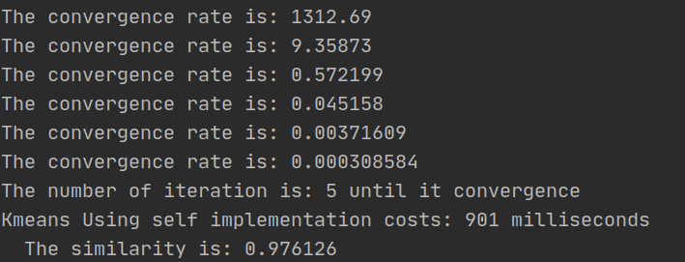


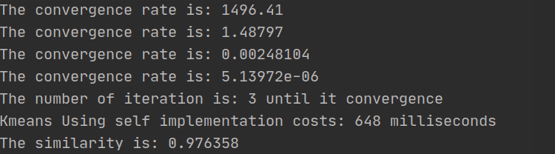


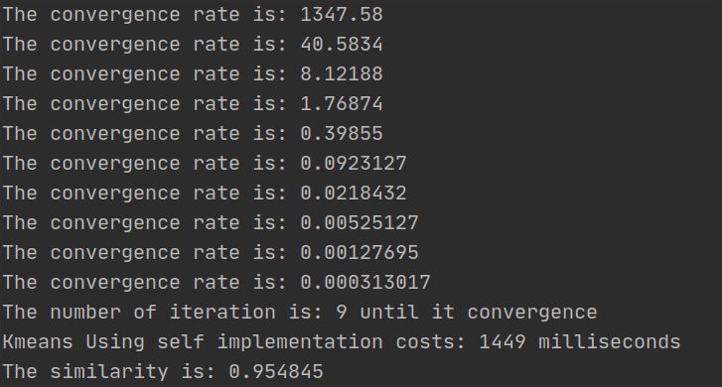

Method 2:

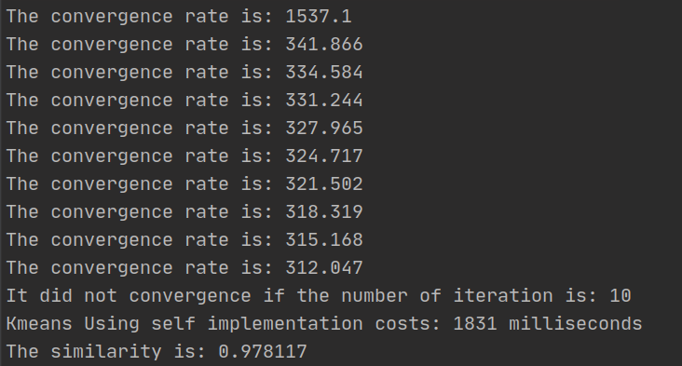

It did not convergence in 10 iterations.
Now change iteration to 10000 and see.
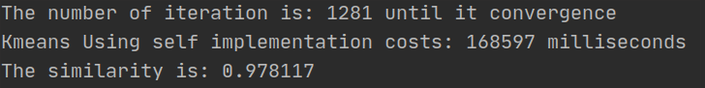

Even though method 2 is well performed but convergence is very slow compared with method1 and method 3. Let’s see the next.


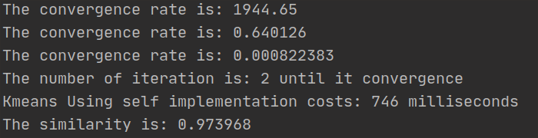
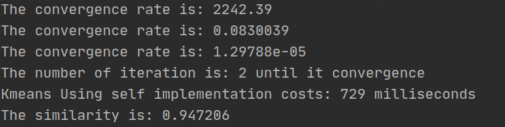


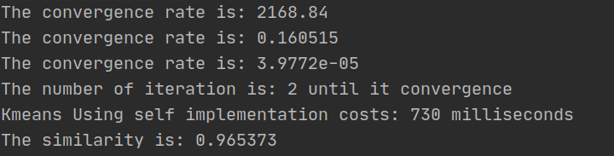
Method 3:

3. Use method 3 to see cluster results from different k.

Original image


k = 2


k=3


k=4


k=5


k=10


k =100


Original image


k = 10;


Conclusion:
1. Initialization plays an important roll in the k means algorithm.
2. Three methods can segment image with good performance.
- Method 1 and 3 convergent faster than method 2.
- Method 2 and method 3 performs better than method 1. It means more stable.
3. Method 3 balance the clustering result and the convergence rate best.

