Adding Sales Record

In the table ‘Melody_performance’

1. Click New item

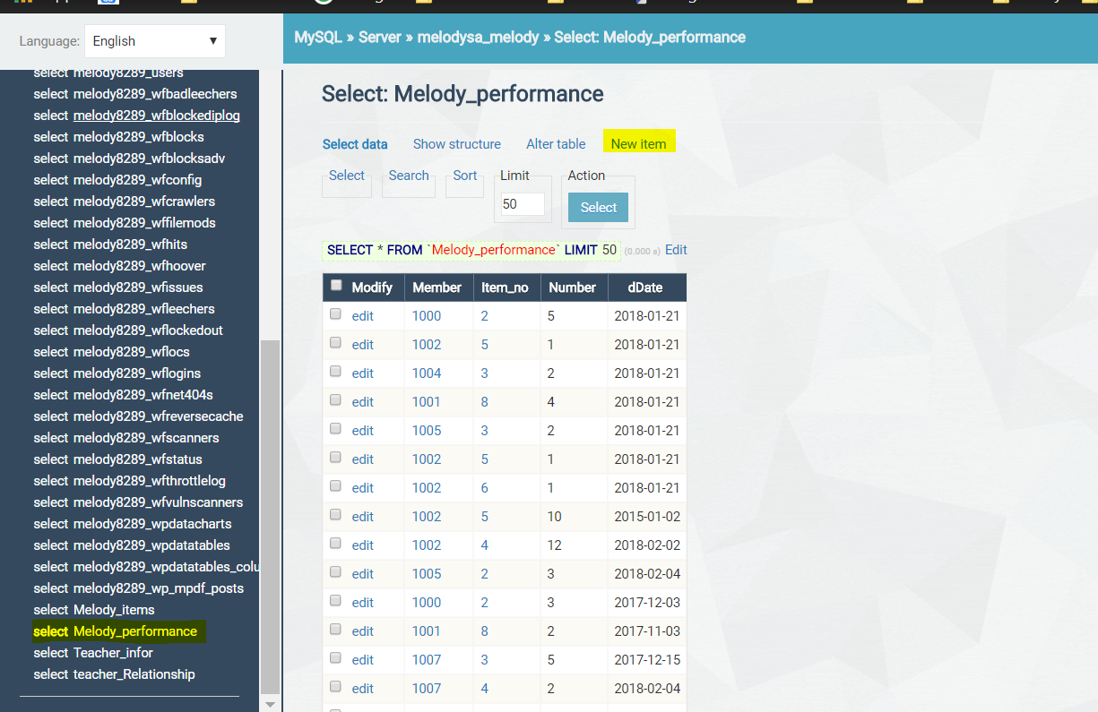

1. In the new Item view, add relevant Member ID, item_no, Number of item, dDate(in format of YYYY-MM-DD)

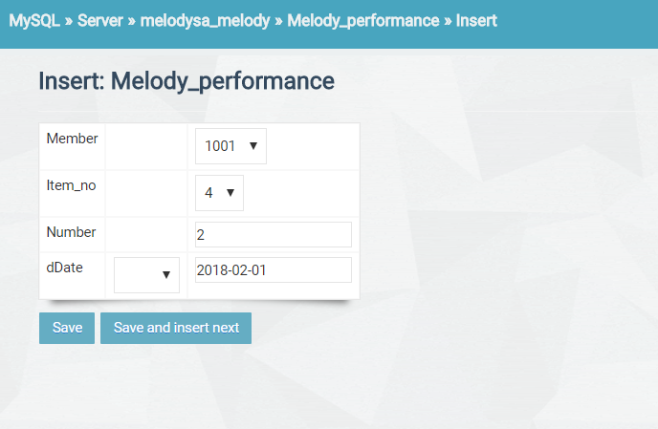

1. Click Save to save this record.
2. Admin may also edit and delete sales record by clicking edit and edit -> delete.

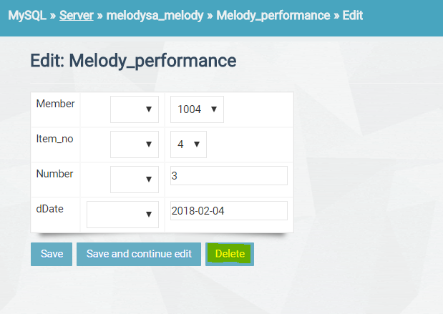

Adding Members

1. Select Teacher_infor table.

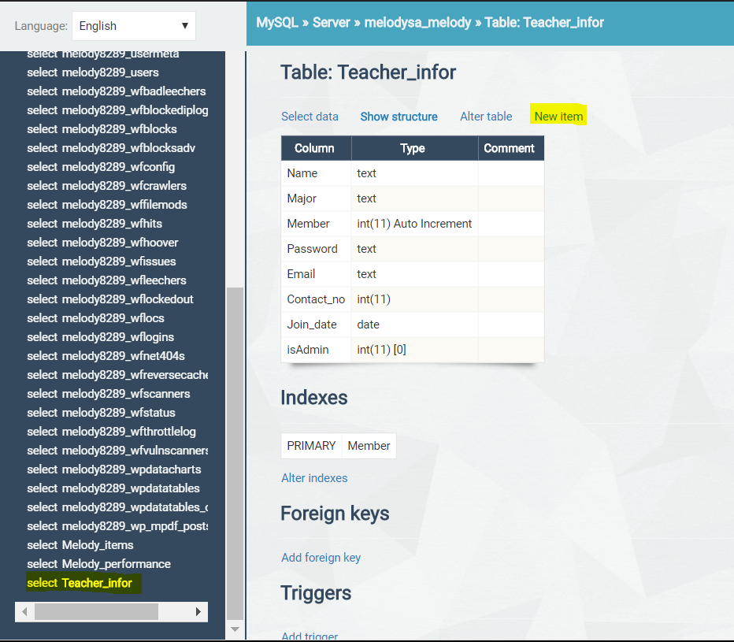

1. Click New item button to create a new member
2. Fill the table with Member name, the Major member(upper level) of this member, Member ID, Password, Email address, Contact number, Join date, isAdmin (0 means normal member, 1 means administrator)

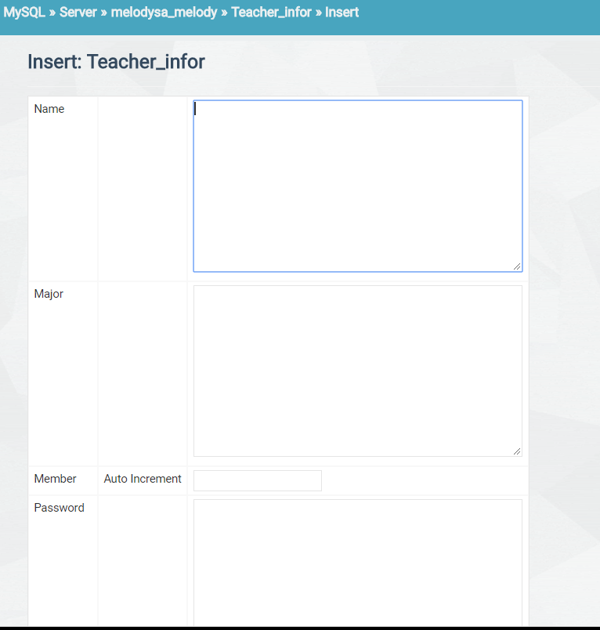

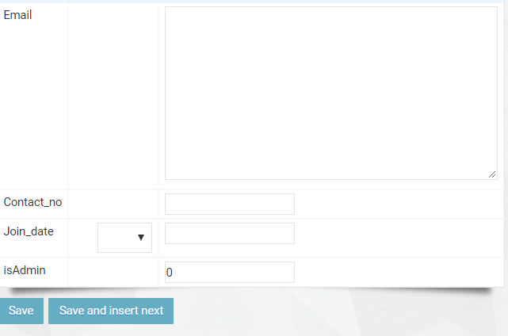

1. Click Save to finish the process.
2. Admin may also edit and delete members by click edit or edit->delete.

