**Melody Webpage Administrator Document**

Contents

1. Database 1

2. Sales Items 5

3. Adding Member 7

4. Adding Sales Record 15

# 1. Access to the database

## 1.1 Login and find the “ARI Adminer”

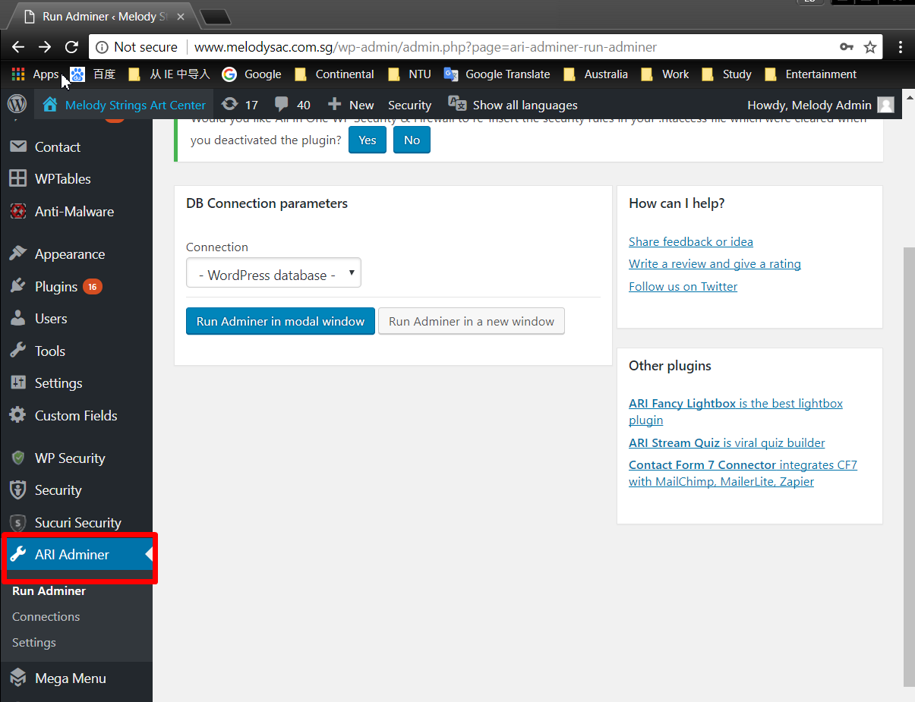

## 1.2 Click “Run Adminor in modal Window”

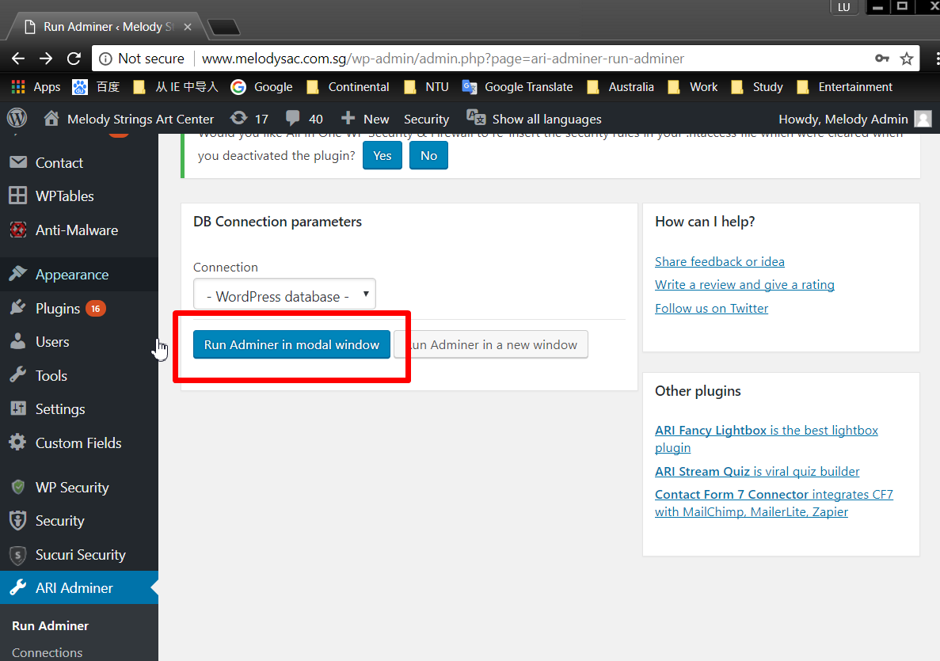

## 1.3 Three related tables inside the database

There are 3 related tables inside this database, and you can find it at the last of the table list.

The first one is “Melody_items”, which contains the item’s price, number(unique) and the percentage for each member level. You need to modify it at the first time to add all the items and the classes price.

The second one is “Melody_performance”, which contains the detail of the sales record. You need to add item if there’s a member has some new sales records.

The third one is “Teacher_infor”, which contains the details of members like name, contact number, email, member number, join date and password. You need to add item if there’s new member join.

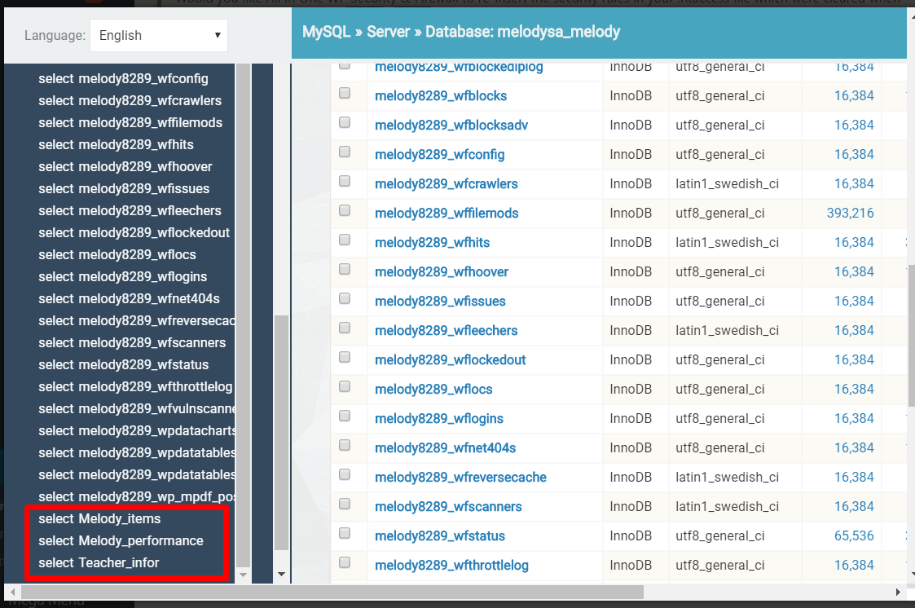

# 2. Melody Items

Click the “select Melody_items”, the manage table will be shown.

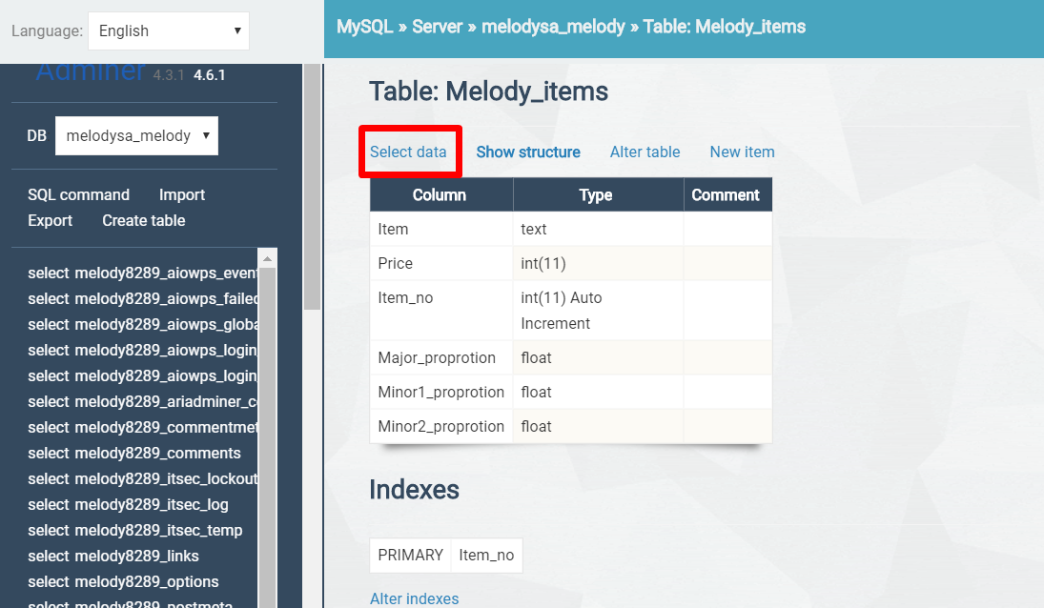

Then click “Select data”, all the information inside the table will be shown as following.

To modify the item, click “edit”.

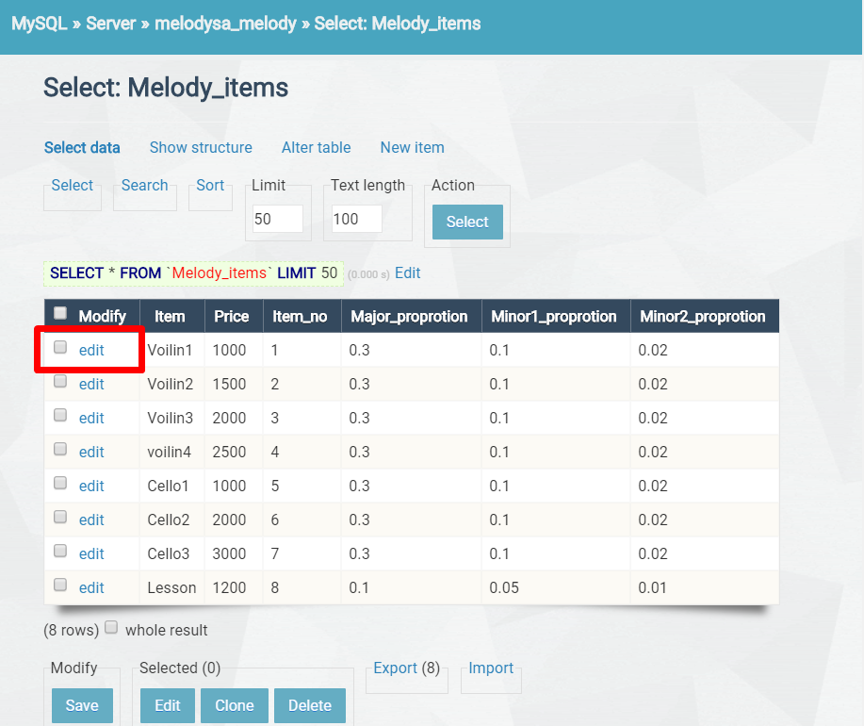

Then modify the details about this item.

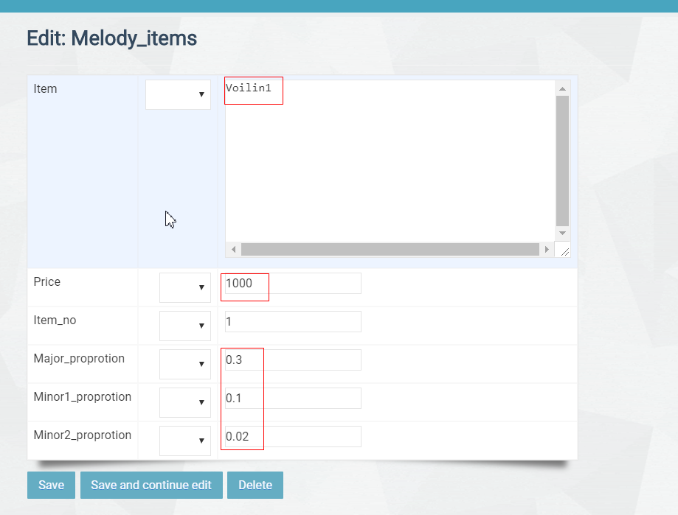

Click “Save” to save the modification.

# 3.Adding Member

To add a new member, there are three things you need to do.

One is update the database to add the new member’s profile, like name, contact number, member id and password.

Then you need to upload the member’s contract which is in pdf format.

The last thing is upload the member’s profile image if it is available.

## 3.1 The database

### 3.1.1 Select Teacher_infor table.

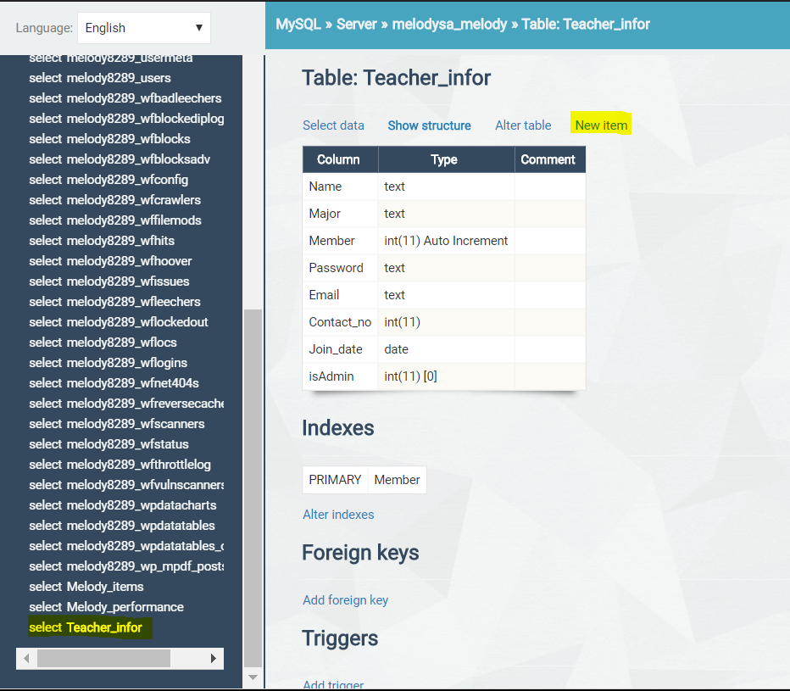

### 3.1.2 Click New item button to create a new member

### 3.1.3 Fill the table

Fill the table with Member name, the Major member(upper level) of this member, Member ID, Password, Email address, Contact number, Join date, isAdmin (0 means normal member, 1 means administrator)

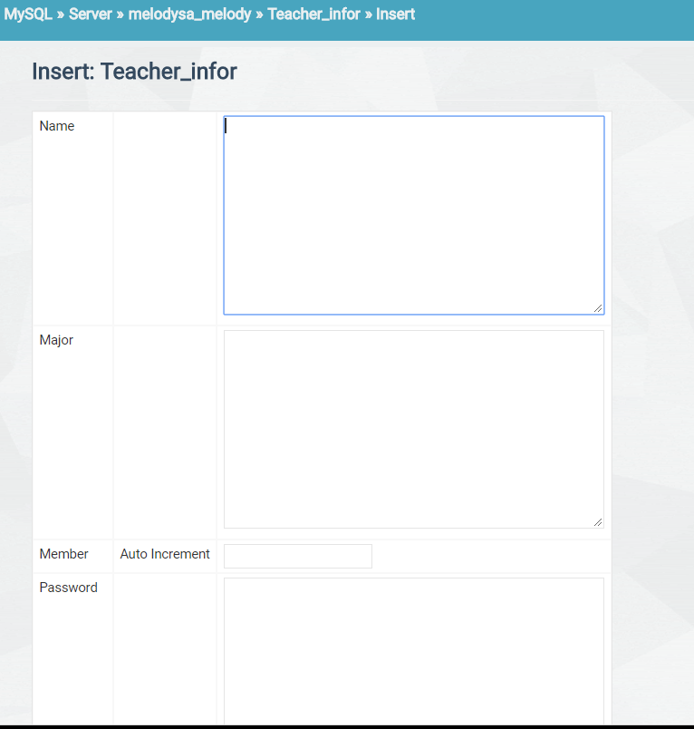

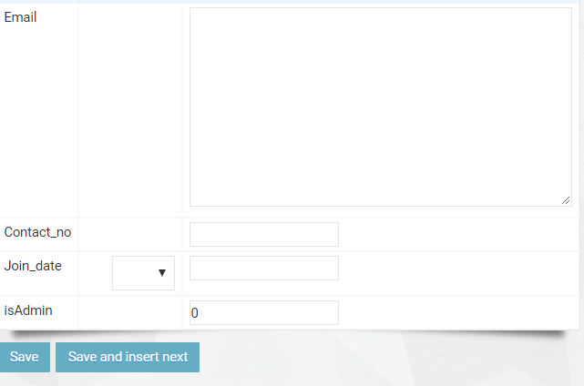

### 3.1.4 Click Save to finish the process.

### 3.1.5 Admin may also edit and delete members by click edit or edit->delete.

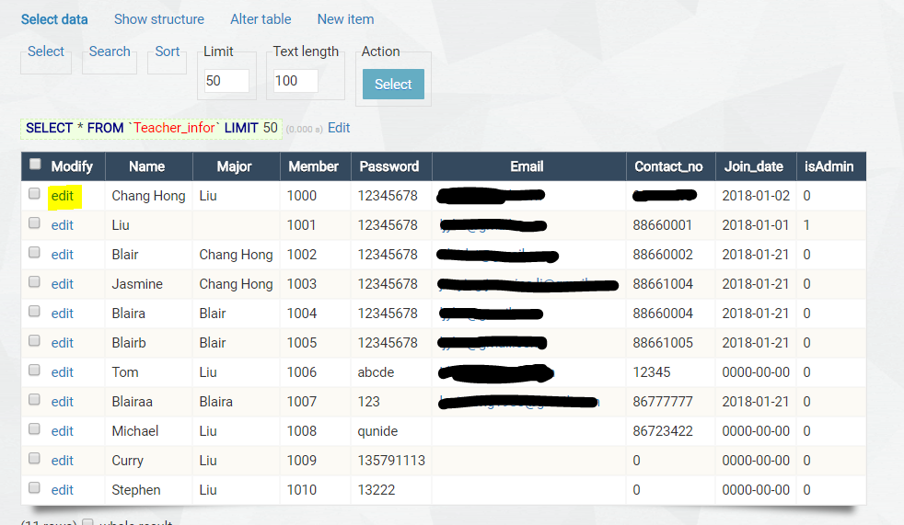

## 3.2 Upload Contract PDF

Choose the “File Manager” in the admin page

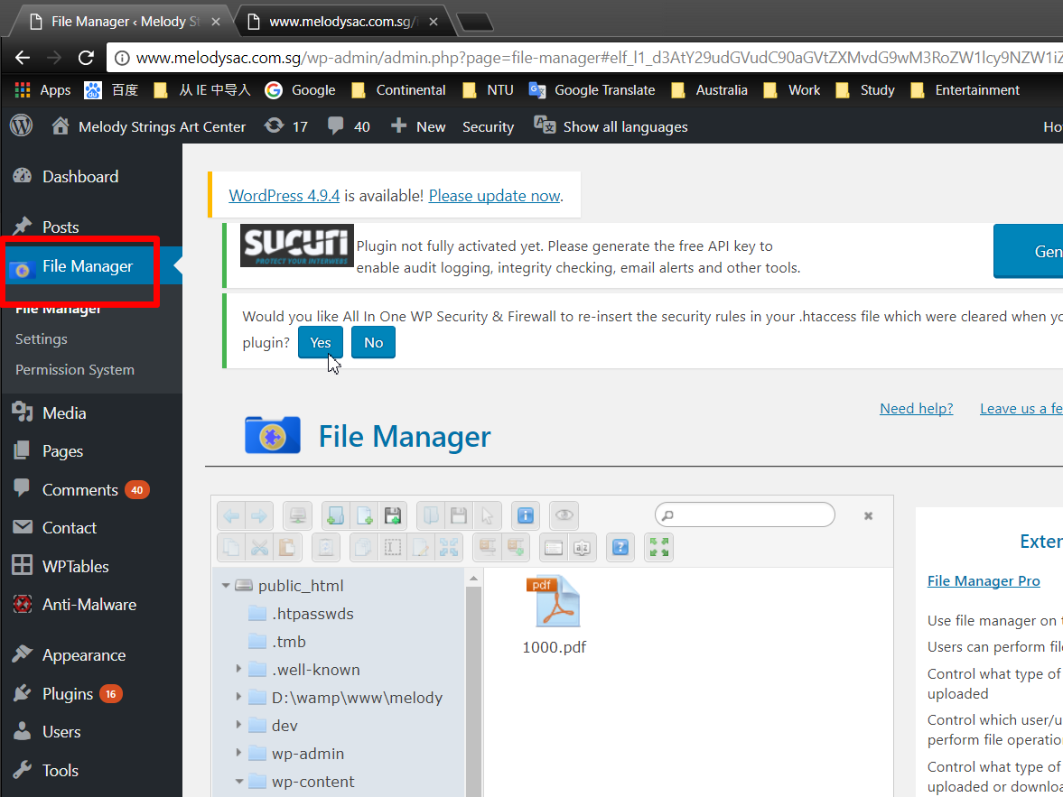

Go to the location wp-content/themes/top3themes/MemberInfo/ContractPDF

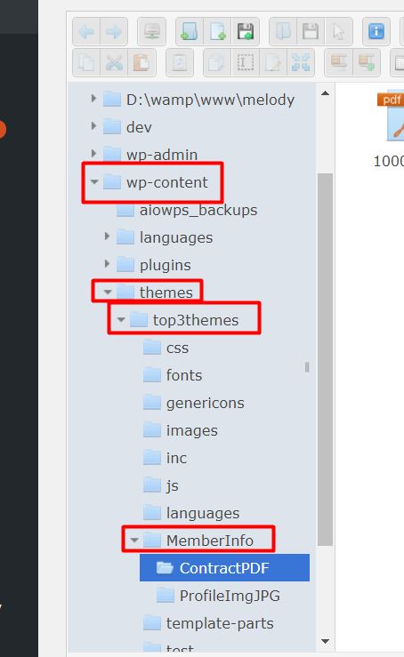

Drop the contract to this folder. Please notice that the file name should be member ID like following.

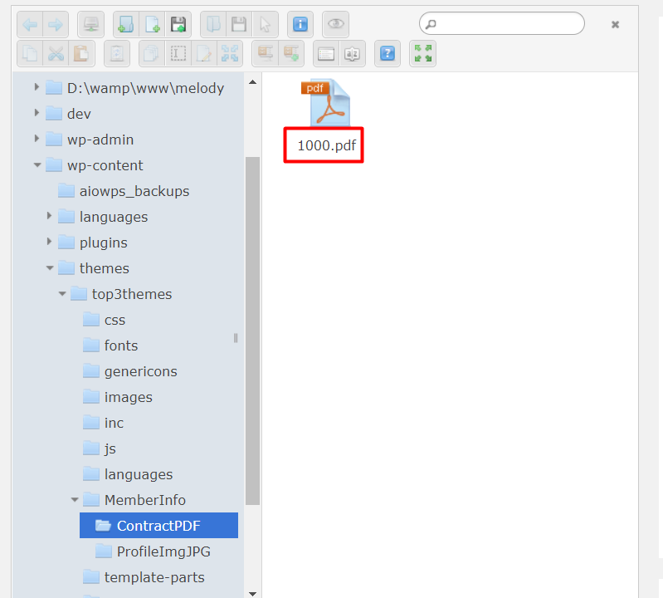

## 3.3 Upload Profile Image

Choose the “File Manager” in the admin page



Go to the location wp-content/themes/top3themes/MemberInfo/ProfileImgJPG, and drag the image to this folder. Please notice that the file name should be member ID and the format must be jpg like following.

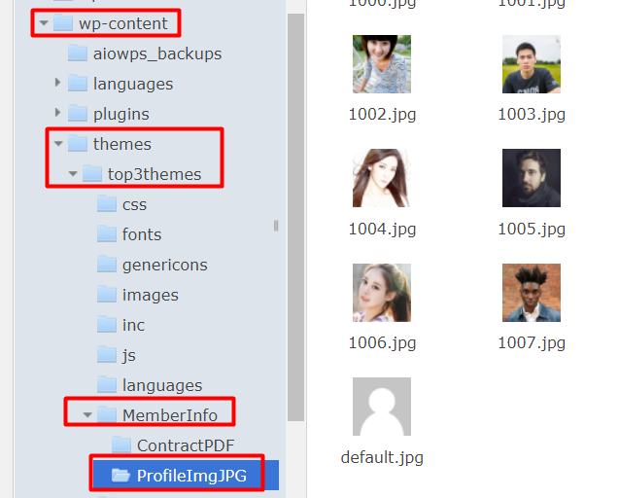

# 4. Adding Sales Record

In the table ‘Melody_performance’

## 4.1 Click New item

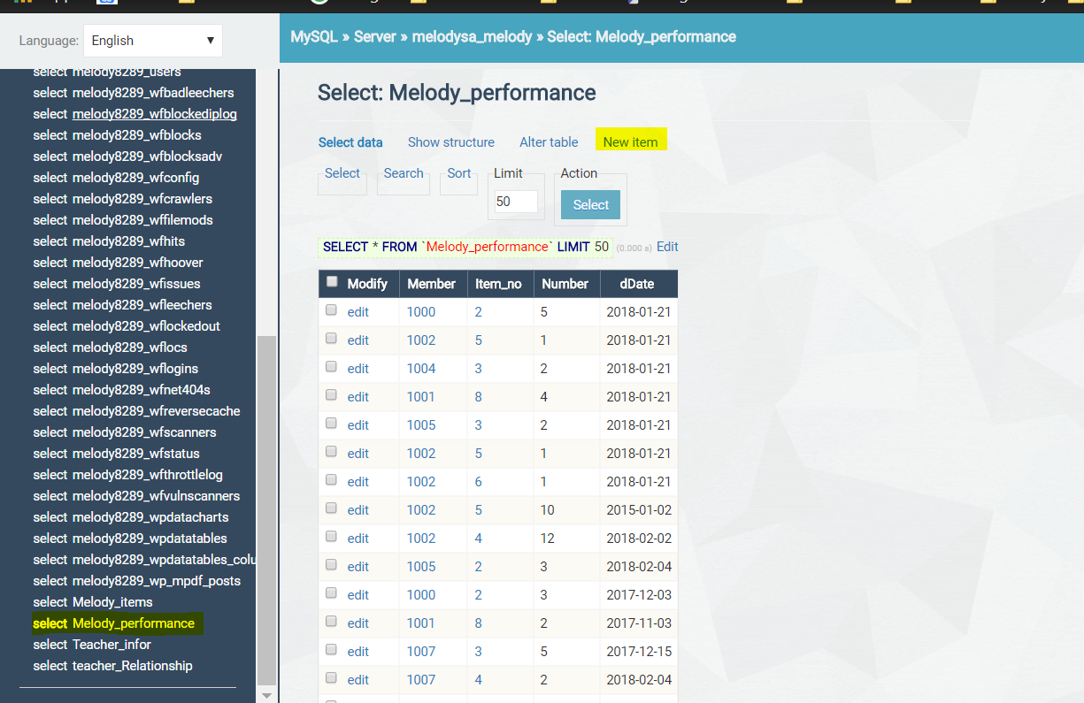

## 4.2 In the new Item view, add relevant Member ID, item_no, Number of item, dDate(in format of YYYY-MM-DD)

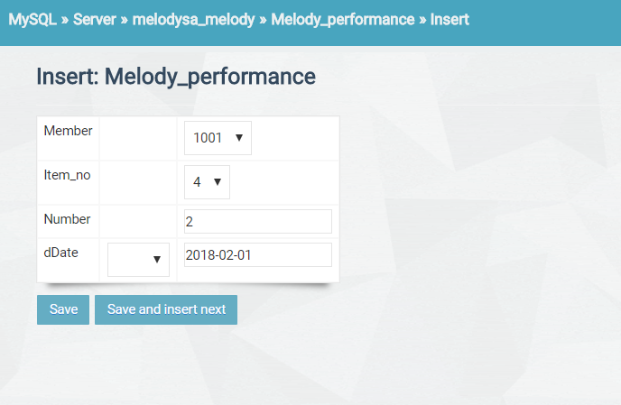

## 4.3 Click Save to save this record.

## 4.4 Admin may also edit and delete sales record by clicking edit and edit -> delete.

