**Proj1 finished by Xin TONG**

**1.What movies has ‘Edward Norton' appeared in?**

[SELECT](http://localhost/phpmyadmin/url.php?url=https://dev.mysql.com/doc/refman/5.5/en/select.html) `Movie` FROM `appeared_in` WHERE `STAR` = "Edward Norton"

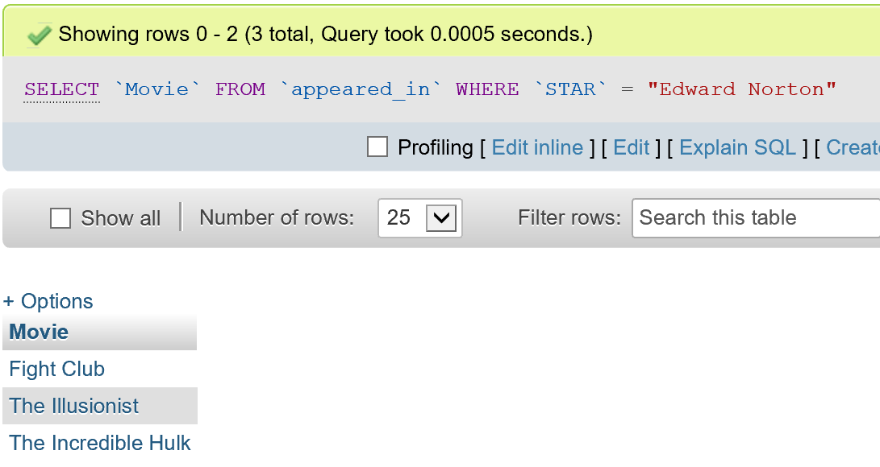

**2.Who has starred along with 'Brad Pitt' in the some movie?**

[SELECT](http://localhost/phpmyadmin/url.php?url=https://dev.mysql.com/doc/refman/5.5/en/select.html) DISTINCT STAR FROM appeared_in WHERE Movie [IN](http://localhost/phpmyadmin/url.php?url=https://dev.mysql.com/doc/refman/5.5/en/comparison-operators.html#function_in)([SELECT](http://localhost/phpmyadmin/url.php?url=https://dev.mysql.com/doc/refman/5.5/en/select.html) Movie FROM appeared_in WHERE STAR = "Brad Pitt") HAVING STAR<>"Brad Pitt"

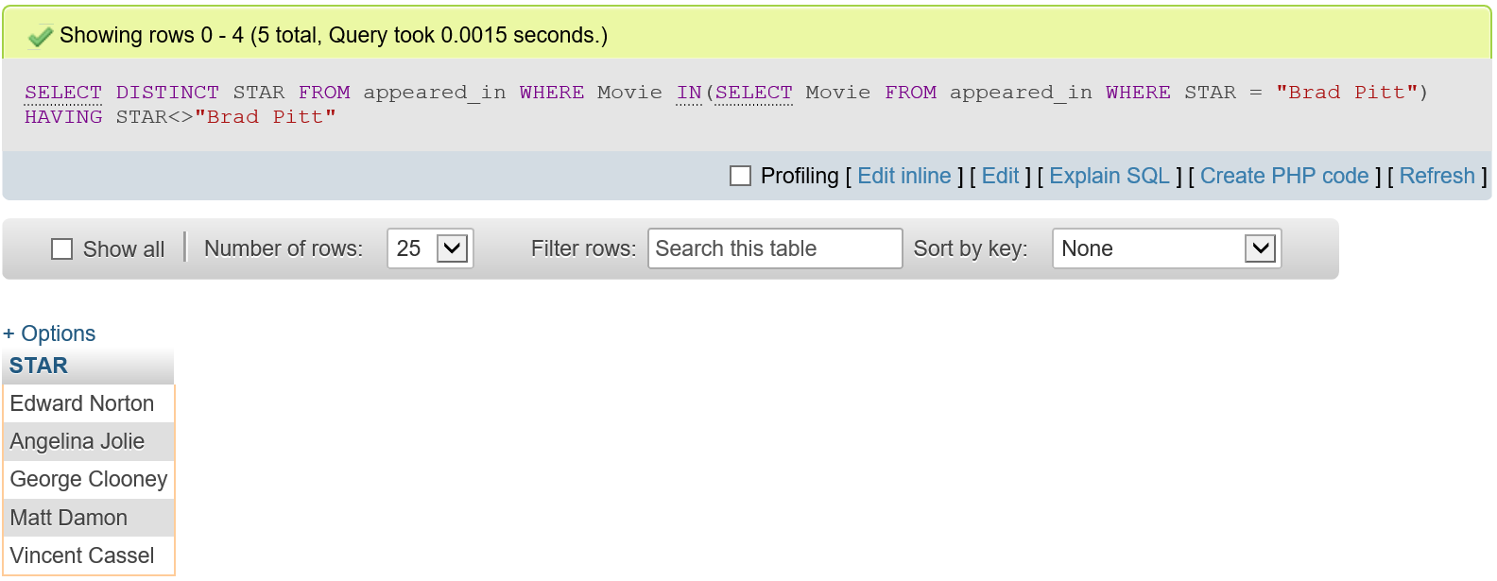

1. **How much money, in total, have movies earned in which 'Tom Hanks' and 'Rita  
   Wilson' starred together?**

SELECT SUM(a.HOW_MUCH)FROM made_money AS a

WHERE a.movie IN (SELECT DISTINCT b.movie From appeared_in AS b

WHERE b.STAR='Tom Hanks' AND b.movie IN (SELECT c.movie FROM appeared_in AS c

WHERE c.STAR='Rita Wilson'))

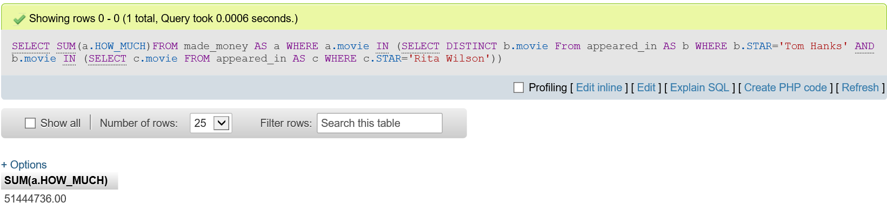

**4.Who has (have) divorced 'Ben Affleck'?**

SELECT STAR FROM in_couple WHERE COUPLE_NUM IN

(SELECT A.COUPLE_NUM FROM in_couple A, divorced B WHERE A.STAR = "Ben Affleck" AND B.COUPLE_NUM = A.COUPLE_NUM)

AND STAR <> "Ben Affleck"

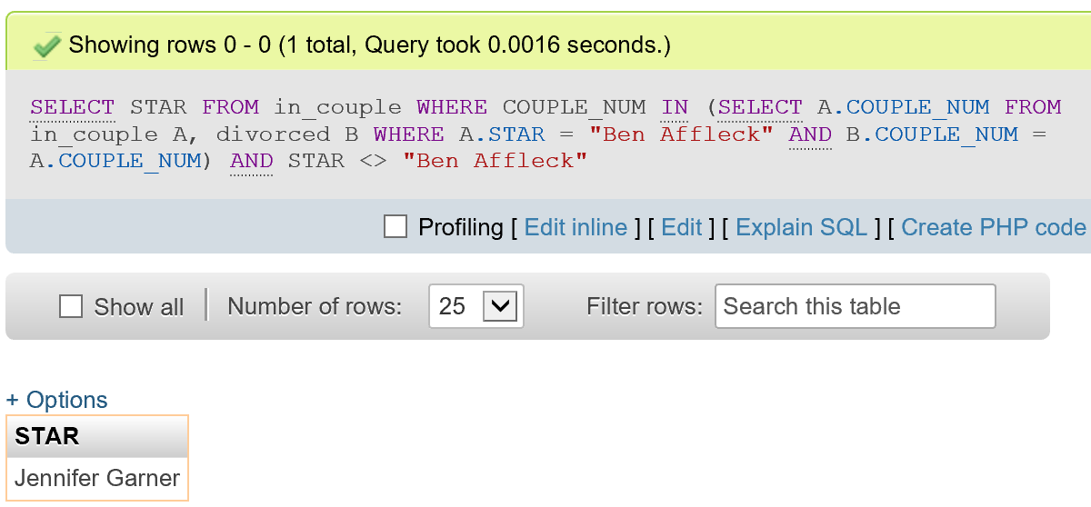

**5.Which stars were married and then divorced on the same day?**

SELECT STAR FROM in_couple WHERE COUPLE_NUM IN

(SELECT A.COUPLE_NUM FROM divorced A, married B WHERE A.DAY = B.DAY AND A.COUPLE_NUM = B.COUPLE_NUM)

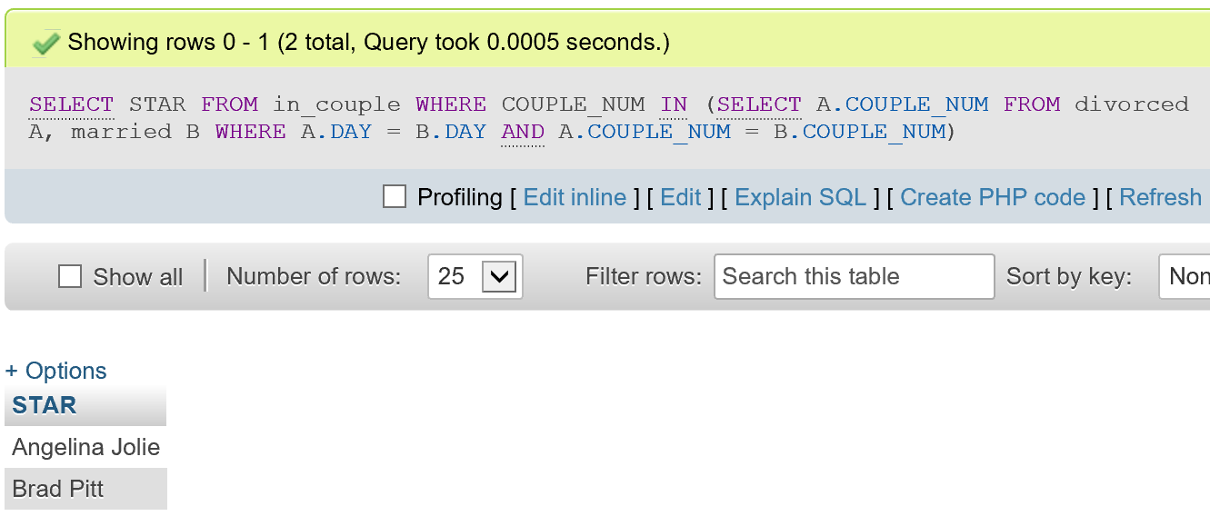

**6.What stars who married one another could possibly have met while working on  
the same movie?**

SET sql_mode=(SELECT REPLACE(@@sql_mode,'ONLY_FULL_GROUP_BY',''));

SELECT DISTINCT A.STAR, B.STAR

FROM appeared_in A, appeared_in B, in_couple C, in_couple D, married

WHERE A.Movie=B.Movie

AND A.STAR<>B.STAR AND C.COUPLE_NUM = D.COUPLE_NUM

AND A.STAR = C.STAR AND B.STAR = D.STAR GROUP BY C.COUPLE_NUM

HAVING(SELECT C.COUPLE_NUM IN (SELECT COUPLE_NUM FROM married));

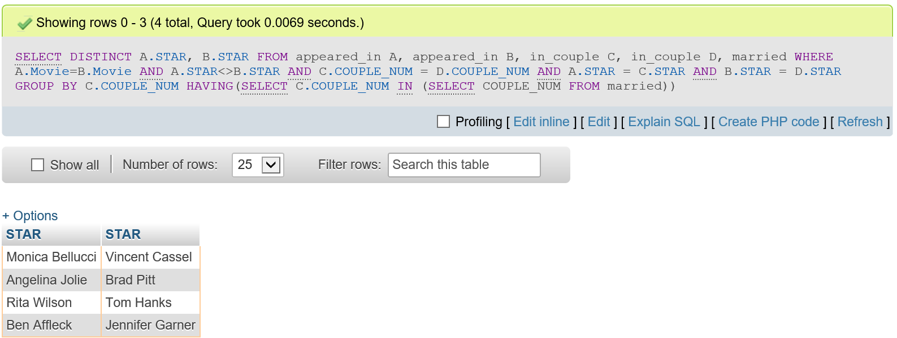

**7.What star has appeared in the most movies?**

[SELECT](http://localhost/phpmyadmin/url.php?url=https://dev.mysql.com/doc/refman/5.5/en/select.html) STAR FROM

([SELECT](http://localhost/phpmyadmin/url.php?url=https://dev.mysql.com/doc/refman/5.5/en/select.html) STAR, [COUNT](http://localhost/phpmyadmin/url.php?url=https://dev.mysql.com/doc/refman/5.5/en/group-by-functions.html#function_count)(Movie) AS [COUNT](http://localhost/phpmyadmin/url.php?url=https://dev.mysql.com/doc/refman/5.5/en/group-by-functions.html#function_count) FROM appeared_in GROUP BY STAR ORDER BY [COUNT](http://localhost/phpmyadmin/url.php?url=https://dev.mysql.com/doc/refman/5.5/en/group-by-functions.html#function_count) DESC) A WHERE A.COUNT >= ALL

([SELECT](http://localhost/phpmyadmin/url.php?url=https://dev.mysql.com/doc/refman/5.5/en/select.html) [COUNT](http://localhost/phpmyadmin/url.php?url=https://dev.mysql.com/doc/refman/5.5/en/group-by-functions.html#function_count)(Movie) AS NEWCOUNT FROM appeared_in GROUP BY STAR ORDER BY NEWCOUNT DESC)

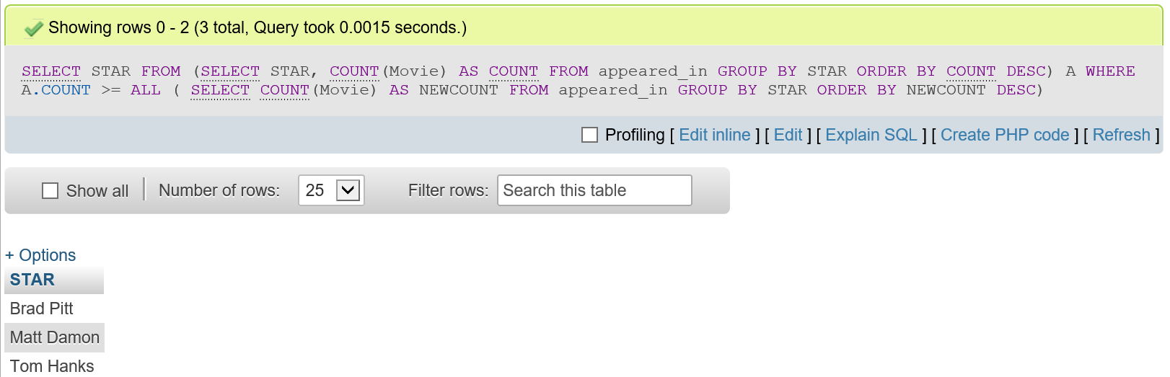

**8.Which pairs of stars were married to each other more than once?**

SET sql_mode=(SELECT REPLACE(@@sql_mode,'ONLY_FULL_GROUP_BY',''));

SELECT x.STAR, y.STAR FROM (SELECT COUPLE_NUM,STAR FROM in_couple NATURAL JOIN married GROUP BY COUPLE_NUM)x , in_couple y

WHERE x.COUPLE_NUM =y.COUPLE_NUM and x.STAR<>y.STAR

Group BY x.STAR HAVING COUNT(x.STAR)>1 AND COUNT(y.STAR)>1

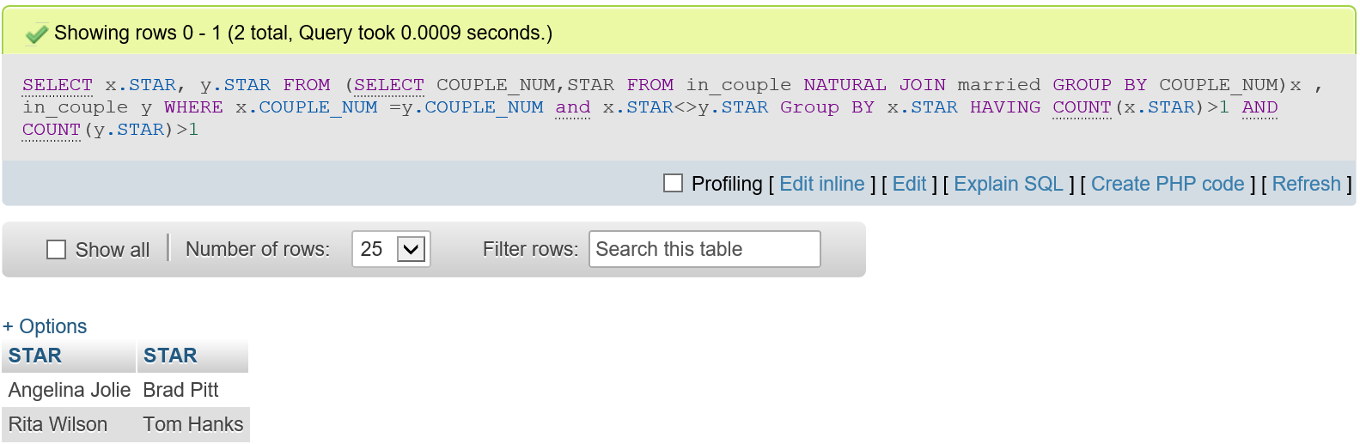

**9.Which star or stars have been divorced at least two times?**

SELECT STAR FROM (in_couple NATURAL JOIN divorced)

GROUP BY STAR HAVING COUNT(STAR)>1

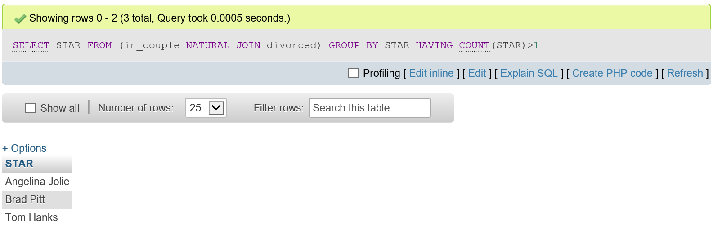

**10.Which star has averaged the highest box office for all films appeared in?**

[SELECT](http://localhost/phpmyadmin/url.php?url=https://dev.mysql.com/doc/refman/5.5/en/select.html) Tab.STAR FROM ([SELECT](http://localhost/phpmyadmin/url.php?url=https://dev.mysql.com/doc/refman/5.5/en/select.html) STAR , [AVG](http://localhost/phpmyadmin/url.php?url=https://dev.mysql.com/doc/refman/5.5/en/group-by-functions.html#function_avg)(HOW_MUCH) AS avgm FROM made_money NATURAL JOIN appeared_in GROUP BY STAR)Tab ORDER BY Tab.avgm DESC LIMIT 1

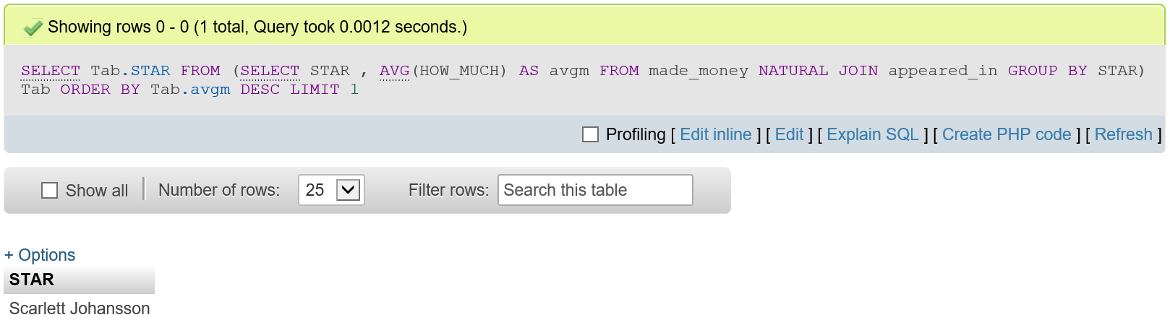

**11.What couple averaged the most money per film while they were married?**

SET sql_mode=(SELECT REPLACE(@@sql_mode,'ONLY_FULL_GROUP_BY',''));

SELECT aSTAR, bSTAR

FROM(SELECT aSTAR, bSTAR, cnum, MAX(ave)

FROM(SELECT aSTAR, bSTAR, cnum, avg(HOW_MUCH) as ave

FROM(SELECT * FROM(SELECT cnum, STAR as aSTAR, bSTAR, DAY as finalday, firstday, Movie

FROM(SELECT couple_num as cnum, aSTAR as STAR, bSTAR, firstday, DAY

FROM(SELECT A.couple_num as couple_num, A.star as aSTAR, B.star as bSTAR, A.day as firstday

FROM(SELECT * From in_couple NATURAL JOIN married

GROUP BY couple_num)A, in_couple B

WHERE A.couple_num = B.couple_num AND A.star<>B.star)q

NATURAL JOIN divorced)w NATURAL JOIN appeared_in)e NATURAL JOIN made_money

WHERE day_opened<finalday AND day_opened>firstday

UNION

SELECT Movie, cnum, aSTAR, bSTAR, finalday, firstday, HOW_MUCH, day_opened

FROM(SELECT cnum, aSTAR, STAR as bSTAR, DAY as finalday, firstday, Movie

FROM(SELECT firstday, DAY, couple_num as cnum, aSTAR, bSTAR as STAR

FROM(SELECT A.couple_num as couple_num, A.star as aSTAR, B.star as bSTAR, A.day as firstday

FROM(SELECT * FROM in_couple NATURAL JOIN married

GROUP BY couple_num)A, in_couple B

WHERE A.couple_num = B.couple_num

AND A.star<>B.star)q NATURAL JOIN divorced)w

NATURAL JOIN appeared_in)e NATURAL JOIN made_money

WHERE day_opened>firstday AND day_opened<finalday )r

GROUP BY cnum

ORDER BY AVG(HOW_MUCH)DESC)t)y;

