***495 Project2 finished by XinTONG***

***Q1:***

***Enforce the constraint that categories of a movie must be either “Romantic”, “Comedy”, “Drama”, or “Action”. Suppose, the default value for the Category field is “Action”. If a non-allowed value is inserted/updated, the category for that tuple must be changed to the default value.***

DROP TRIGGER if exists m_category1;

delimiter //

CREATE TRIGGER m_category1

BEFORE UPDATE ON made_money

FOR EACH ROW

BEGIN

IF new.category=NULL OR

(new.category<> 'Romantic' AND new.category<> 'Comedy' AND new.category<>'Drama' AND new.category<>'Action')

THEN

SET new.category='Action';

END IF;

END;

//

delimiter ;

DROP TRIGGER if exists m_category2;

delimiter //

CREATE TRIGGER m_category2

BEFORE INSERT ON made_money

FOR EACH ROW

BEGIN

IF new.category=NULL OR

(new.category<> 'Romantic' AND new.category<> 'Comedy' AND new.category<>'Drama' AND new.category<>'Action')

THEN

SET new.category='Action';

END IF;

END;

//

delimiter ;

***Q2:***

***Enforce the following condition: A star can only be a part of a “Comedy” movie, only if he/she has performed in at least one “Romantic”, “Comedy”, or “Drama” movie previously. Upon insertion of a tuple violating this (e.g., a Comedy movie associated with a star who has previously done only “Action” movies), the category of the movie must be updated to “Drama”.***

DROP TRIGGER if exists star_movie;

delimiter //

CREATE TRIGGER star_movie AFTER INSERT ON appeared_in

FOR EACH ROW BEGIN

IF (NOT EXISTS (SELECT *

FROM made_money, appeared_in WHERE made_money.movie=appeared_in.movie AND new.star=appeared_in.star

AND new.movie<>appeared_in.movie

AND (made_money.category ='Romantic'

OR made_money.category ='Comedy'

OR made_money.category ='Drama')

AND made_money.day_opened<

(SELECT made_money.day_opened from made_money WHERE made_money.movie=new.movie)))

THEN UPDATE made_money SET made_money.category='DRAMA' WHERE made_money.category='comedy' AND made_money.movie=new.movie ;

END IF;

END;

// delimiter ;

***Q3:***

***Enforce the constraint: A star cannot be married to multiple stars simultaneously.***

DROP TRIGGER if exists star_marriage;

delimiter //

CREATE TRIGGER star_marriage AFTER INSERT ON married

FOR EACH ROW BEGIN

IF EXISTS(

select distinct * from in_couple C left join

married M on C.COUPLE_NUM = M.COUPLE_NUM left join divorced D on C.COUPLE_NUM = D.COUPLE_NUM,

(select W.STAR from married Ma, in_couple W, in_couple H

where new.COUPLE_NUM = W.COUPLE_NUM

and new.COUPLE_NUM = H.COUPLE_NUM and W.STAR != H.STAR) as FS

where FS.star = C.STAR and C.COUPLE_NUM != new.COUPLE_NUM and

new.day >= ifnull(M.DAY, "2020-12-12") and new.day <= ifnull(D.DAY, "2020-12-12"))

THEN

SIGNAL SQLSTATE '45000'

SET MESSAGE_TEXT = "ERROR: Check constraint on married.";

END IF;

END;

// delimiter ;

***Q4:***

***Enforce that, a movie must make at least $1,000 in the box office, and cannot make more than 3 billion ($3,000,000,000) in the box office. Also, if a movie  category is “Action”, then it should make at least $10,000, and if category is  “Comedy”, it cannot make more than $1,000,000,000.***

DROP TRIGGER if exists movie_money;

delimiter //

CREATE TRIGGER movie_money BEFORE INSERT ON made_money

FOR EACH ROW

BEGIN

IF EXISTS(

select * from made_money A

where new.HOW_MUCH<1000

or new.how_much>3000000000

or (new.how_much<10000 and new.Category='Action')

or (new.how_much>1000000000 and new.Category='Comedy'))

THEN

SIGNAL SQLSTATE '45000'

SET MESSAGE_TEXT = " ERROR: Check constraint on made money.";

END IF;

END;

// delimiter ;

***Q5：***

***Using a trigger, ensure that the divorce date of a couple is at least the same or  after their marriage date. If this is violated, set the divorce date to be the same as the marriage date.***

DROP TRIGGER if exists Divorce_condition;

delimiter //

CREATE TRIGGER Divorce_condition BEFORE INSERT ON divorced

FOR EACH ROW BEGIN

IF EXISTS(

select * from married

where married.couple_num=new.couple_num

and new.day<married.day)

THEN

set new.day=(select married.day from married where married.COUPLE_NUM = new.COUPLE_NUM);

END IF;

END;

// delimiter ;

***Q6:***

***We want to keep a log file containing data (movie & category) from rows that have been inserted into “MADE_MONEY” table into the given “LOG_DATA” table. Use a trigger to accomplish this goal.***

DROP TRIGGER if exists log_data;

delimiter //

CREATE TRIGGER log_data AFTER INSERT ON made_money

FOR EACH ROW

BEGIN

insert into log_data

values (new.MOVIE, new.Category);

END;

// delimiter ;

1. ***Insert a new movie, with values (“IRON MAN”, 1000000, 2008-05-02,  
   “ACTON”) in MADE_MONEY table.***

INSERT into made_money

VALUES ('IRON MAN',10000000,'2008-05-02','ACTION')



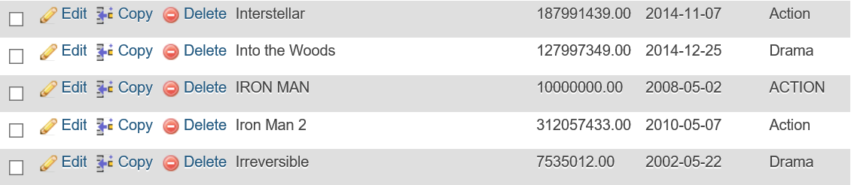

***b) Update the CATEGORY of the movie “Fight Club” to “Horror in  
MADE_MONEY table.***

UPDATE made_money

SET category='Horror' WHERE movie='Fight Club'



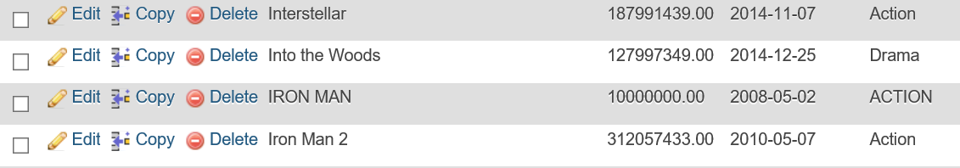

***c) Insert a new tuple in APPEARED_IN table, with values (“Matt Damon”, “Bruce  
Almighty”).***

INSERT INTO APPEARED_IN  
VALUES('Matt Damon','Bruce Almighty')





***d) Insert a new tuple in MARRIED, with values (1, 2015-06-26).***

INSERT INTO MARRIED

VALUES(1, '2015-06-26')



***e) Insert two new tuples in MADE_MONEY, having values (“Most Welcome”,  
8000, 2012-07-07, “Action”) and (“Speed”, 9000, 2010-03-28, “Comedy”).***

INSERT INTO made_money

VALUES ('Most Welcome', 8000, '2012-07-07', 'Action')



INSERT INTO made_money

VALUES ('speed', 9000, '2010-03-28', 'Comedy')



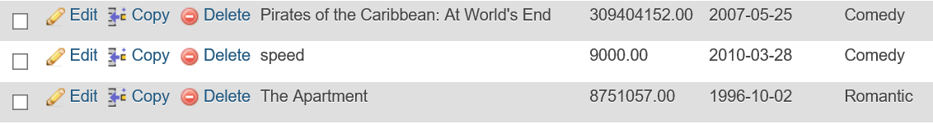

***f) Insert a new tuple in MADE_MONEY, having values (“Hangover”, 1500000000,  
2011-03-05, “Comedy”).***

INSERT INTO made_money

VALUES('Hangover', 1500000000, '2011-03-05', 'Comedy')



***g) Insert a new tuple in DIVORCED, with values (6, 2004-01-01)***

INSERT INTO divorced

VALUES (6,'2004-01-01')



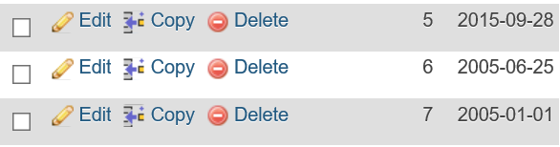

***Test Q6:***

insert into MADE_MONEY

values('newmovie', 56667870, '2013-11-01', 'action')



