Xin Zhao (ID:2002778508)

EE 511 (Brandon Franzke)

Project 1 (Due 1/19/2017)

Question 1: Simulate a Bernoulli trial 50 times. Count the number of head and the longest run of head as well as general a histogram for this outcomes.

I use MATLAB to finish this assignment. In this coding, I use several functions. That is zeros (general a 1 by n matrix), rand (generate the random number for counting head), and categorical and histogram (both of these for generating a histogram). The most important part is the for loop. The thought is if the random number is bigger than 0.5, we think the result is the head and record the number of head. Meanwhile, we defined another of variable “count” to record the number of continuous of head at the same time give this number to the variable “longest”. When we meet tail, the count is becoming 0, but before that we need to compare the number of count and the number of longest to make sure the longest is the largest number of run of head. Then we can calculate the number of head and the largest number of run of head.

Logically, the probability of Bernoulli trial is 0.5. In reality, it is hard to reach this outcome exactly. Sometime the probability of head is bigger than 0.5, sometimes it is smaller than 0.5. It is because the times of trial are not enough to make the outcome extremely close to the 0.5. So we need to do more trials to compare the outcomes.

Here is the coding and histogram:

count = 0;

longest=0;

head = 0;

a=zeros(1,50);

b=zeros(1,50);

limit = 0.5;

for i=1:50

a(i)=rand();

if a(i)>1-limit

b(i)=1;

head = head +1;

count = count + 1;

if longest < count

longest = count;

end

else

count = 0;

end

end

head

longest

c=categorical(b,[1,0],{'head','tail'});

h=histogram(c,'BarWidth',0.5);

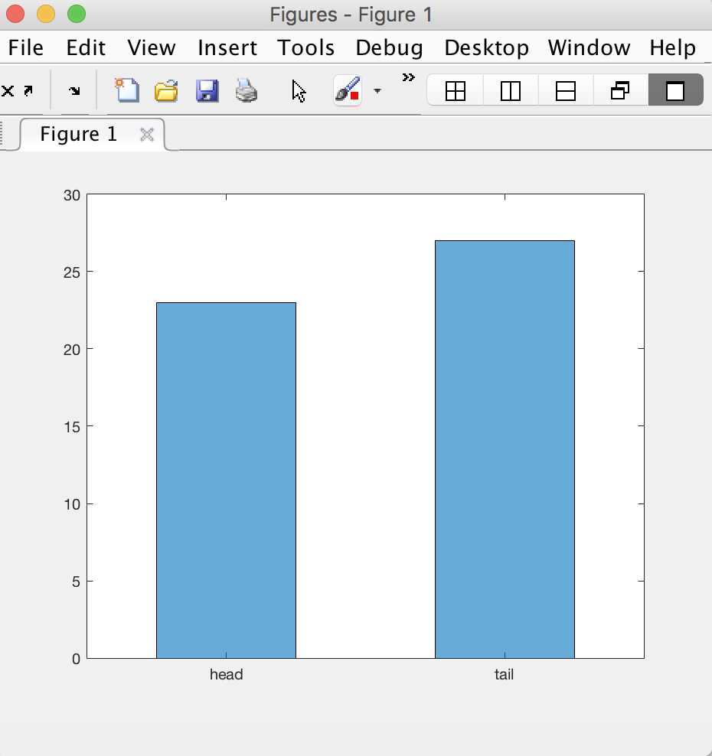

Question 1a: Repeat the above experiment 20,100, 200 and 1000 times. Generate a histogram for each showing the number of heads in 50 flips.

This trial is based on the Question 1, so I just add and change some functions and code. I add a for loop to achieve the 20,100, 200 and 1000 times of repeating above experiment. Moreover, I create an array b to record the head number of each 50 flip. And according to array b, we can generate a histogram.

Discussion: with the increasing number of trial, the outcome looks like still a little bit disperse. Maybe no matter how many trials that we do, the outcome just can very close to the 0.5 instead of equal to the 0.5.

Here is the coding and histogram:

head = 0;

n=input('times\n');

a=zeros(1,50);

b=zeros(1,n);

%limit = input('probability:\n')

limit = 0.5;

for i=1:n

for j=1:50

a(j)=rand();

if a(j)>1-limit

head = head +1;

end

end

b(i)=head;

head=0

end

b

h=bar(b);

20 times:

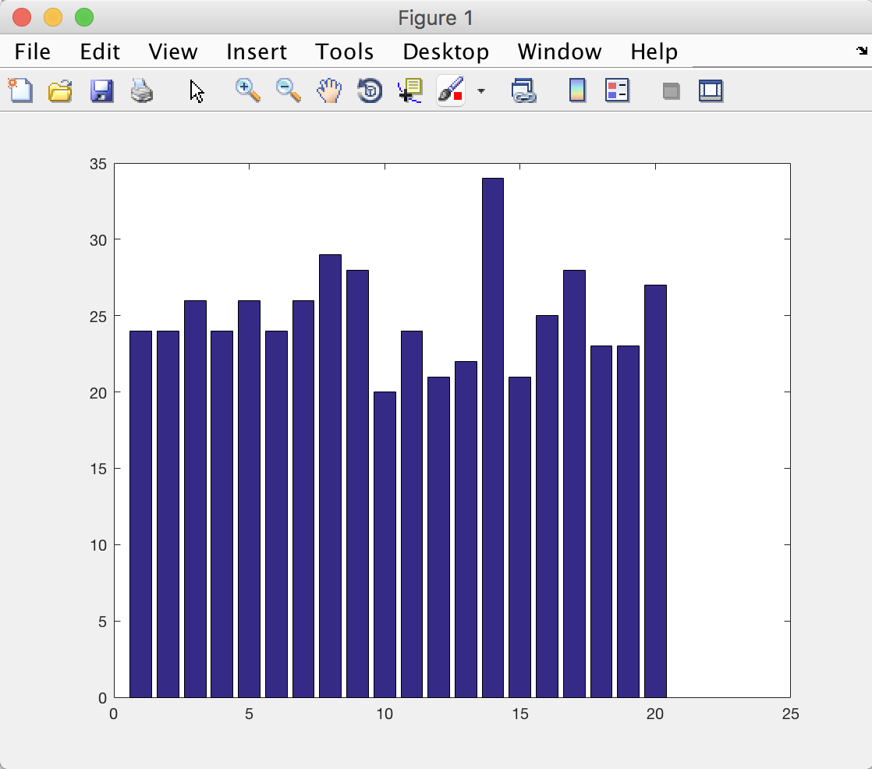

100 times:

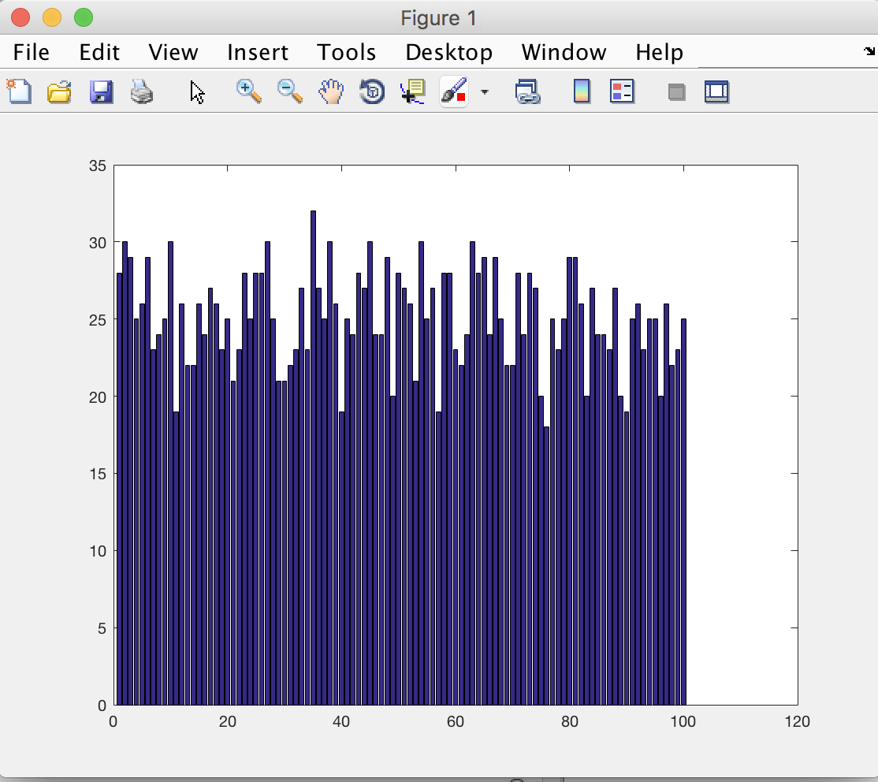

200 times:

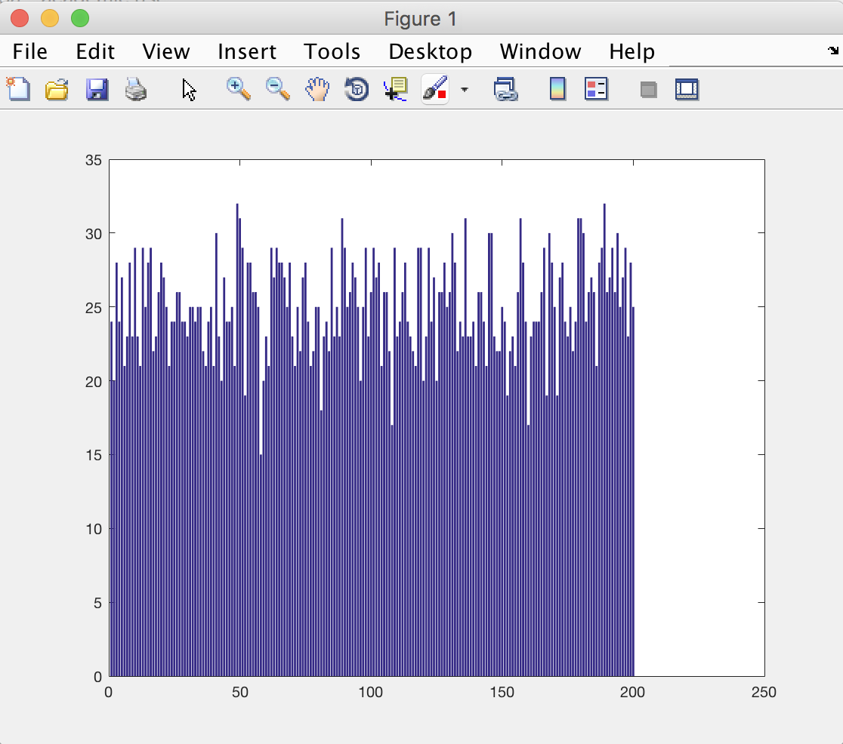

1000 times:

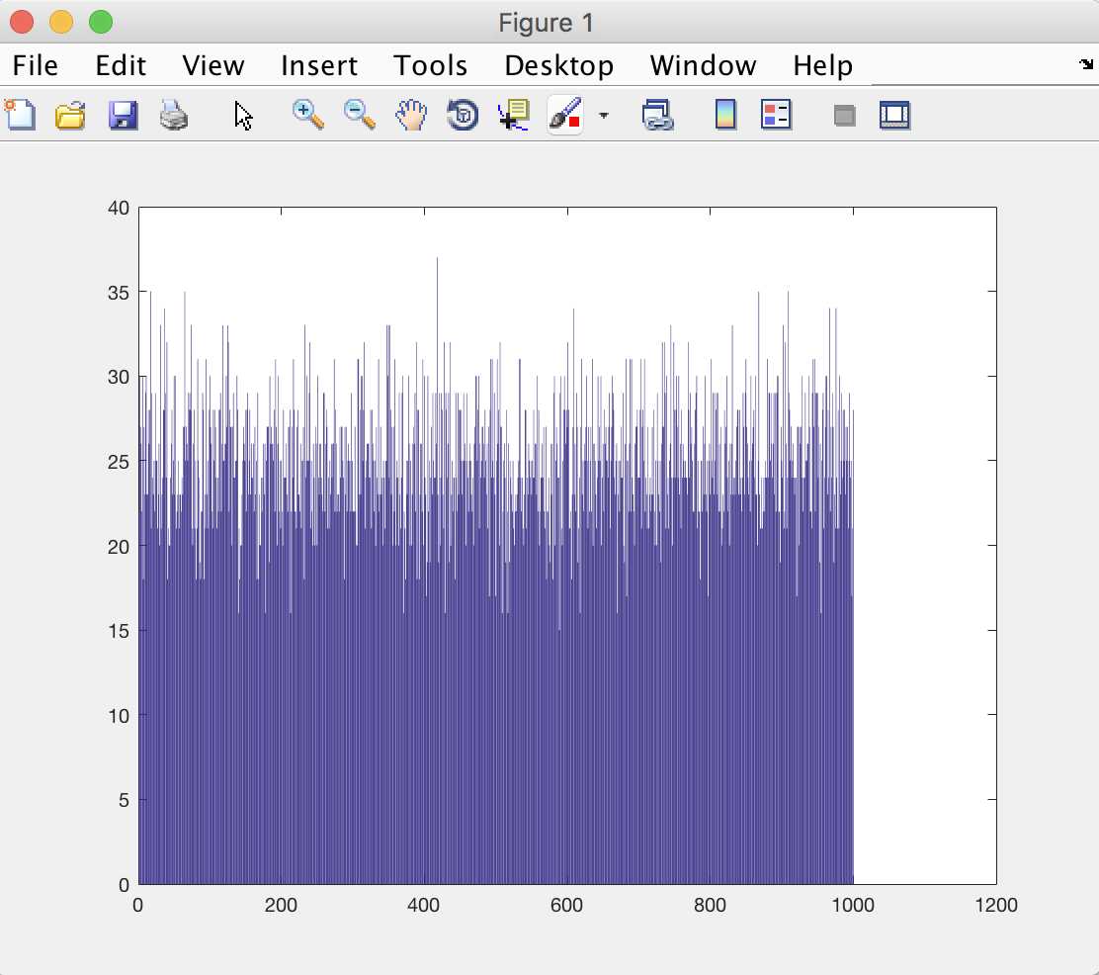

Question 2: Simulate a Bernoulli trial 200 times and P(head)=0.8. Count the number of head and the longest run of head as well as general a histogram for this outcomes.

This question is similar with the question 1. The difference between question 1 and question 2 is that in question 1, P(head)=0.5. However, in question 2, P(head)=0.8. So I just need to change the code a(i)>1-0.5 to a(i)>1-0.8. In this trial, the number of head is much bigger than previous trial.

Here is the coding and histogram:

count = 0;

longest=0;

head = 0;

a=zeros(1,200);

b=zeros(1,200);

limit = 0.8;

for i=1:200

a(i)=rand();

if a(i)>1-limit

b(i)=1;

head = head +1;

count = count + 1;

if longest < count

longest = count;

end

else

count = 0;

end

end

head

longest

c=categorical(b,[1,0],{'head','tail'});

h=histogram(c,'BarWidth',0.5);

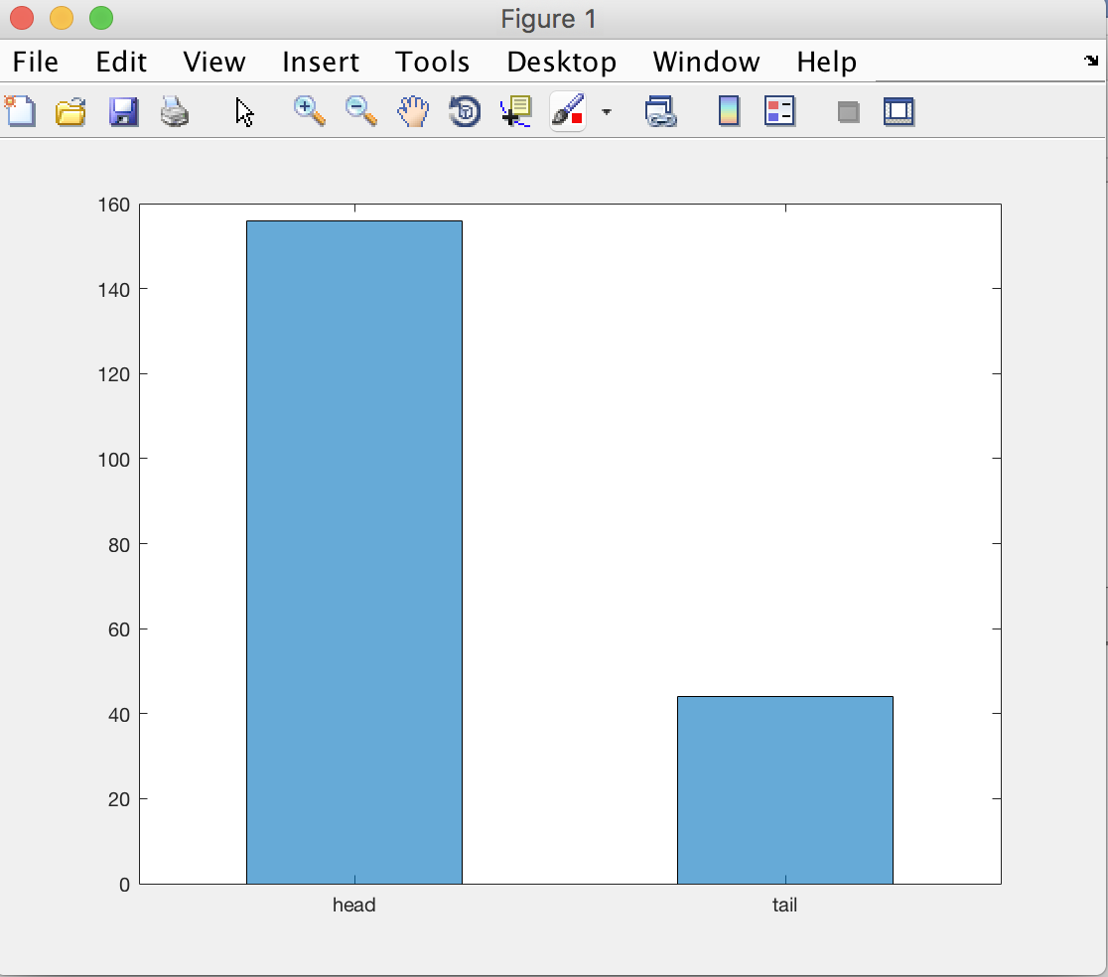

Question 3: Simulate tossing a fair coin 100 times. Generate a histogram showing the heads run lengths.

I would like to use a for loop to figure out this question. Create an array b that is used for record the heads run length. Using a for loop to achieve calculating the number of run head, after record b(j) once, we clear the number and restart to calculate. Then we can get the array b and generate a histogram.

Here is the coding and histogram:

count = 0;

head = 0;

a=zeros(1,100);

b=zeros(1,100);

limit = 0.5;

for j=1:100

a(j)=rand();

if a(j)>1-limit

head =head+1;

count=count+1;

else

b(j)=count;

count=0;

end

end

b

h=bar(b);

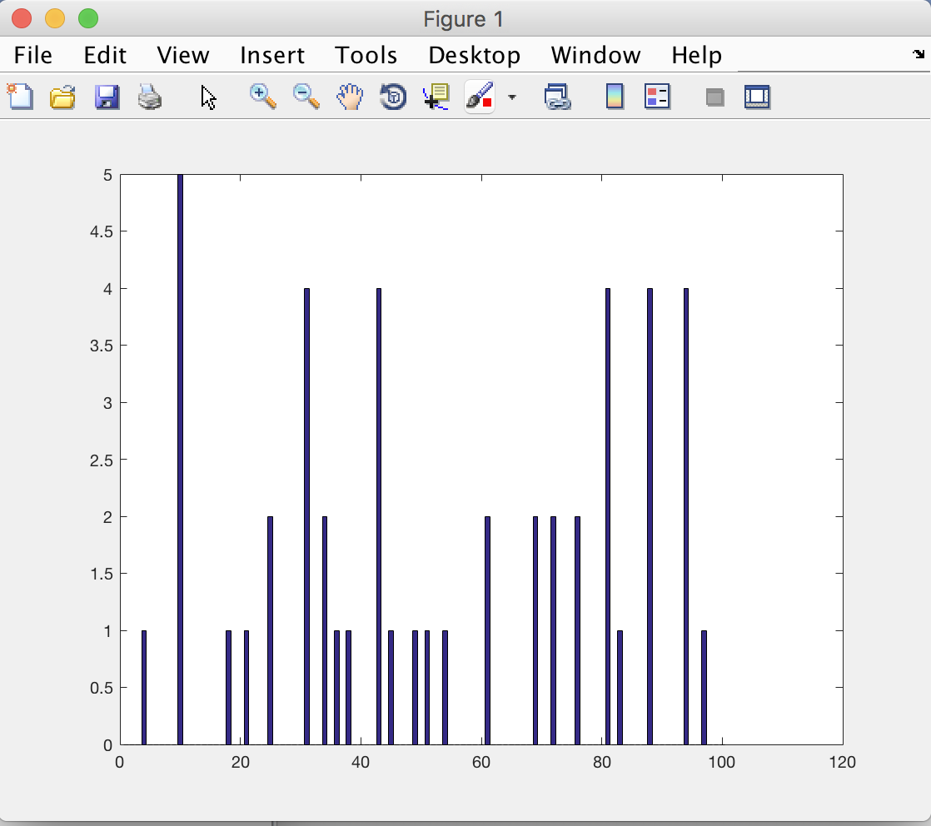

Question 4: Simulate tossing a fair coin and count the number of tosses until reaching a user-specified positive number of heads.

In this coding, I use while loop, input an expectation number of head. If the number of head is smaller than the expectation number, this loop is always keep repeating, at the same time counting the number of trial. Until the number of head equals to expectation number, the program ends.

Here is the coding and histogram:

n=input('head number\n');

i=0;

count=0;

while count<n

i=i+1;

if rand()>0.5

count=count+1;

end

end

i

In conclusion, from this project, I practiced how to use the for loop, how to generate different kinds of histograms, how to define a variable, and give a value to variable. If I cannot find the problem, I can run the code one line by one line on the MATLAB to find the problem out.