**Report**

**Overview**

|  |  |
| --- | --- |
| **Content** | **Specifics** |
| Roles | sales_representative  construction_mgr  buyers |
| Scheduled Job | task_schedule |
| Alternate Indexes | subdivision_idx  room_idx |
| De-normalization | Materialized view: construction_progress |
| Test Cases | 2 scenarios |

**3 Roles**

* **Sales_representative:** The role of sales representative will be able to see all the tables except for the table “employee”. This role will be able to select, insert, update and delete the tables “decoratorchoice”, “contract”, “house”, and “buyer”. A sales representative needs to create, modify or delete contracts and houses. The sales representative also needs to create, modify, or delete a buyer and create, modify or delete decorator choice sheets. This role will be able to select from “subdivision”, “"Subdivision-Style", “style”, “Option”, “Style-Elevation”, “schooldistrict”, “school”, “house”, “lot”, “elevation”, “room”, “constructionsheet”, “task”, “agent”, “bank”, and “employee”.

As the role **sales_representative** has been created, during the actual test, it is possible that an error will be raised since the role has been created. Please change the name of the role if you would like to correctly create the role and grant it to a new user. In our run, the role is successfully created and the result is attached below along with the granting process to the new user and how to test it from the new user’s account.

REM create a role of sales representative

CREATE ROLE sales_representative;

GRANT select, insert, update, delete ON decoratorchoice TO sales_representative;

GRANT select, insert, update, delete ON contract TO sales_representative;

GRANT select, insert, update, delete ON buyer TO sales_representative;

GRANT SELECT, insert, update, delete ON house TO sales_representative;

GRANT SELECT ON subdivision TO sales_representative;

GRANT SELECT ON "Subdivision-Style" TO sales_representative;

GRANT SELECT ON style TO sales_representative;

GRANT SELECT ON "Option" TO sales_representative;

GRANT SELECT ON "Style-Elevation" TO sales_representative;

GRANT SELECT ON schooldistrict TO sales_representative;

GRANT SELECT ON school TO sales_representative;

GRANT SELECT ON lot TO sales_representative;

GRANT SELECT ON elevation TO sales_representative;

GRANT SELECT ON room TO sales_representative;

GRANT SELECT ON constructionsheet TO sales_representative;

GRANT SELECT ON task TO sales_representative;

GRANT SELECT ON agent TO sales_representative;

GRANT SELECT ON bank TO sales_representative;

GRANT SELECT ON employee TO sales_representative;

To test the role, we grant the role “sales_representative” to the user advdb. To ensure the role has been successfully granted, open a new window and switch to the user advdb. Try to update the table “sudivision” on the other user’s schema. An error will be raised indicating that the user advdb does not have privilege to do so. Then, test to insert a new record into the table “house” on the other user’s scheme. The row will be successfully inserted.

GRANT sales_representative TO advdb;

update SCHEMA_USERNAME.subdivision

set map = 'no map'

where subdivision_id = 'S0001';

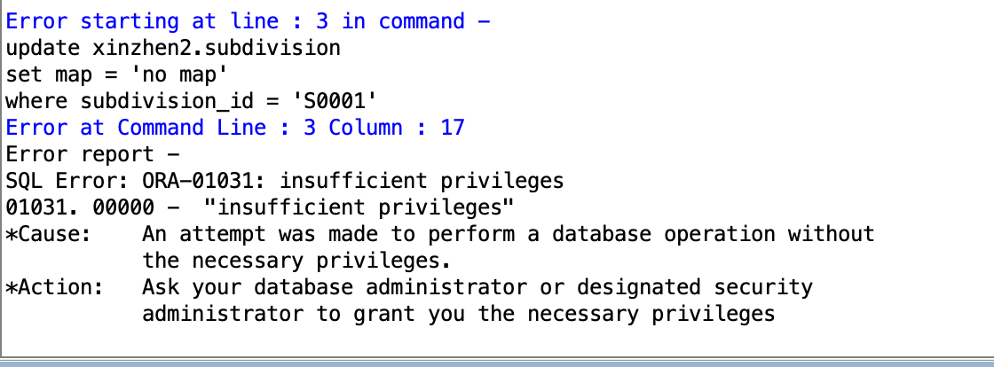

INSERT INTO SCHEMA_USERNAME.house

VALUES

('H0011', 789000, NULL, 800, NULL, 1);

1 row inserted.

DELETE FROM SCHEMA_USERNAME.house

WHERE house_id = 'H0011';

1 row deleted.

* **Construction_Mgr:** The role of construction will be able to see all the tables except for the table “employee”. This role will be able to select, insert, update and delete the tables “constructionsheet”, “task”, “room”, and “house”, “elevation”, “subdivision”, “Subdivision-Style”, “style”, “Option”, and “Style-Elevation”. A construction manager needs to create, modify or delete houses. The construction manager also needs to create, modify, or delete any construction related table with the house. This role will be able to select from “lot”, “schooldistrict”, “school”, “agent”, “bank”, “decoratorchoice”, and “contract”.

As the role **Construction_Mgr** has been created, during the actual test, it is possible that an error will be raised since the role has been created. Please change the name of the role if you would like to correctly create the role and grant it to a new user. In our run, the role is successfully created and the result is attached below along with the granting process to the new user and how to test it from the new user’s account.

REM create role of construction manager

CREATE ROLE construction_mgr;

GRANT select, insert, update, delete ON constructionsheet TO construction_mgr;

GRANT select, insert, update, delete ON task TO construction_mgr;

GRANT select, insert, update, delete ON room TO construction_mgr;

GRANT select, insert, update, delete ON house TO construction_mgr;

GRANT select, insert, update, delete ON elevation TO construction_mgr;

GRANT select, insert, update, delete ON subdivision TO construction_mgr;

GRANT select, insert, update, delete ON "Subdivision-Style" TO construction_mgr;

GRANT select, insert, update, delete ON style TO construction_mgr;

GRANT select, insert, update, delete ON "Option" TO construction_mgr;

GRANT select, insert, update, delete ON "Style-Elevation" TO construction_mgr;

GRANT select ON lot TO construction_mgr;

GRANT select ON schooldistrict TO construction_mgr;

GRANT select ON school TO construction_mgr;

GRANT select ON agent TO construction_mgr;

GRANT select ON bank TO construction_mgr;

GRANT select ON decoratorchoice TO construction_mgr;

GRANT select ON contract TO construction_mgr;

GRANT select ON buyer TO construction_mgr;

To test the role, we grant the role “construction_mgr” to the user advdb. To ensure the role has been successfully granted, open a new window and switch to the user advdb. Try to update the table “contract” on the other user’s schema. An error will be raised indicating that the user advdb does not have privilege to do so. Then, test to insert a new record into the table “style” on the other user’s scheme. The row will be successfully inserted.

GRANT construction_mgr TO advdb;

REM Insertion with no priviledge

INSERT INTO SCHEMA_USERNAME.contract

VALUES

('C0011', 'H0011', 'B0001', 'E0001', 'Portfolio Loan', 850000.00, 'EA001', 'BA003', '9-Sep-2022', '10-Sep-2021', 1, 1, 1);

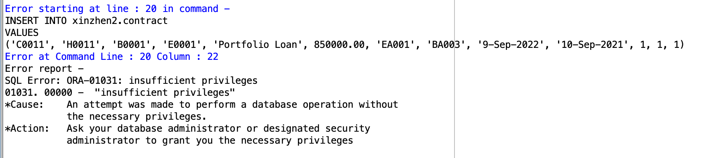

REM Insertion with priviledge

INSERT INTO SCHEMA_USERNAME.style

VALUES

('new style', 4);

1 row inserted.

* **Buyers:** The role of buyers will be able to see the tables related to house. They will only be able to see construction stage 1, 4, and 7. Two views are created for users to see the construction progress. The buyers will be able to see tables “subdivision”, “Subdivision-Style”, “ style”, “Style-Elevation”, “schooldistrict”, “school”, “house”, “lot”, “elevation”, and “room”. The buyers will be able to see two views “construction_stage” and “option_view”.

As the role **Buyers** has been created, during the actual test, it is possible that an error will be raised since the role has been created. Please change the name of the role if you would like to correctly create the role and grant it to a new user. In our run, the role is successfully created and the result is attached below along with the granting process to the new user and how to test it from the new user’s account.

REM create role of buyer

CREATE ROLE buyers;

GRANT SELECT ON subdivision TO buyers;

GRANT SELECT ON "Subdivision-Style" TO buyers;

GRANT SELECT ON style TO buyers;

GRANT SELECT ON "Style-Elevation" TO buyers;

GRANT SELECT ON schooldistrict TO buyers;

GRANT SELECT ON school TO buyers;

GRANT SELECT ON house TO buyers;

GRANT SELECT ON lot TO buyers;

GRANT SELECT ON elevation TO buyers;

GRANT SELECT ON room TO buyers;

GRANT select ON construction_stage to buyers;

GRANT SELECT ON option_view to buyers;

To test the role, we grant the role “buyers” to the user advdb. To ensure the role has been successfully granted, open a new window and switch to the user advdb. Try to update the table “contract” on the other user’s schema. An error will be raised indicating that the user advdb does not have privilege to do so. Then, test to select a new record to see the view “construction_stage” on the other user’s scheme.

GRANT buyers TO advdb;

REM Insertion with no previledge

INSERT INTO SCHEMA_USERNAME.contract

VALUES

('C0011', 'H0011', 'B0001', 'E0001', 'Portfolio Loan', 850000.00, 'EA001', 'BA003', '9-Sep-2022', '10-Sep-2021', 1, 1, 1);

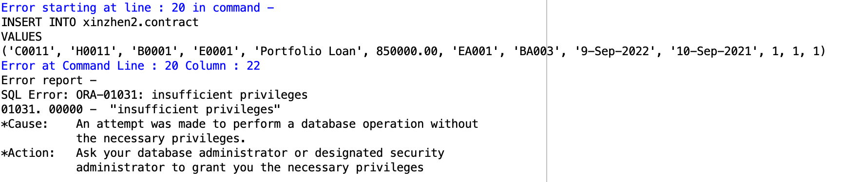

REM Selection with previledge

SELECT * FROM xinzhen2.construction_stage;

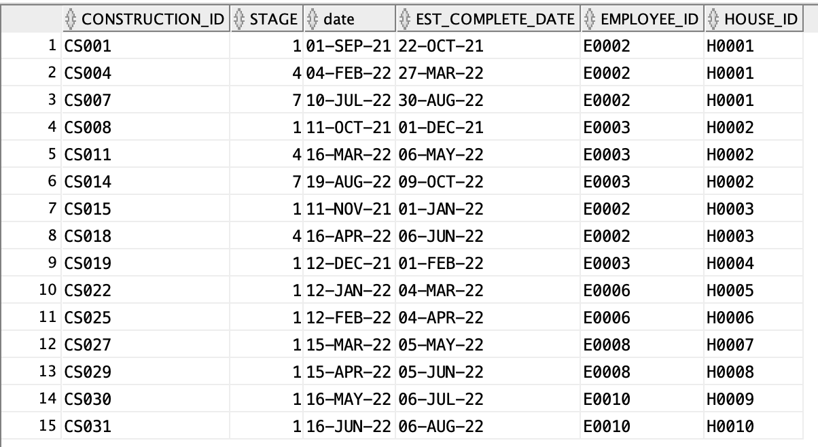

**1 Scheduled Job**

* **task_schedule:** A schedule job to update the column percent_complete in tabletaskprogress. It is used to update the task progress on a daily basis. The scheduled job adds 1 to all percentage completed that are less than 100 every day starts from the job created date.

BEGIN

DBMS_SCHEDULER.CREATE_JOB (

job_name => 'task_schedule',

job_type => 'PLSQL_BLOCK',

job_action => 'UPDATE taskprogress

SET percent_complete = percent_complete+1

WHERE percent_complete <100;',

start_date => sysdate,

repeat_interval => 'FREQ=DAILY',

enabled => true);

END;

**2 Alternate Indexes**

* **subdivision_idx**: unique alternate index for attribute subdivision_name in table subdivision because subdivision_name is a candidate key

CREATE INDEX subdivision_idx ON subdivision (subdivision_name);

This alternate index can help users retrieve information about subdivisions much more quickly without scanning through the whole table if they only know the subdivision names but not subdivision id, which is the primary key, thus making the whole process more time-saving and efficient.

Sample Query:

SELECT subdivision_id,subdivision_name, map

FROM subdivision

WHERE subdivision_name = ‘Palm Springs’;

* **room_idx**: unique alternate index for attribute room_name in table room because room_name is a candidate key

CREATE INDEX room_idx ON room (room_name);

This alternate index can help users retrieve information about room much more quickly without scanning through the whole table if they only know the room names but not the specific room id, which is the primary key, thus making the whole process more time-saving and efficient..

Sample Query:

SELECT hr.house_id, r.room_name, hr.floor,

hr."size", hr.num_window

FROM room r JOIN "House-Room" hr USING(room_id)

WHERE r.room_name = 'Study';

**1 De-normalization**

* We denormalized the originally normalized entities ConstructionSheet, TaskProgress and Task by creating a materialized view **construction_progress**. This view joined three tables to aggregate all tasks and task progress for constructions, which can lead to repeated/redundant information for construction_id and task_id but can also improve the read performance of our database, although at the expense of losing some write performance.
* In this case, when database users want to know the the tasks progress of one specific house, either in one specific stage or all stages, they don’t have to join all three tables mentioned above but directly retrieve the information from the materialized view construction_progress, increasing query efficiency. This view will be updated whenever there’s an update in any of the three tables.

CREATE MATERIALIZED VIEW construction_progress

REFRESH ON COMMIT

AS

SELECT c.house_id, c.stage, t.task_desc,tp.percent_complete

FROM constructionsheet c, taskprogress tp, task t

WHERE c.construction_id = tp.construction_id

AND t.task_id = tp.task_id;

Before denormalization

SELECT c.house_id, c.stage, t.task_desc, tp.percent_complete

FROM constructionsheet c JOIN taskprogress tp

USING(construction_id)

JOIN task t USING(task_id)

WHERE c.house_id = 'H0003';

After denormalization

SELECT *

FROM construction_progress

WHERE house_id = 'H0003';

**2 Test Cases for Business Use**

* **Scenario 1**

/*

The first report demonstrates the basic information for all houses of Eggshell co.By running this query, for each house you can check the house id, city, construction manager, Sales manager, buyer, and its current status (complete or not. If not complete, which stage).

*/

SELECT UNIQUE h.house_id, l.city,

ecs.fname||' '||ecs.lname AS Construction_Manager,

ec.fname||' '||ec.lname AS Sales_Manager,

b.lname||' '||b.fname AS Buyer,

CASE -- status of houses, complete or in which stage

WHEN cs.stage = 7 AND tp.percent_complete = 100

THEN 'Complete'

ELSE 'Stage '||cs.stage

END AS current_progress

FROM house h, lot l, constructionsheet cs, contract c, employee ecs, employee ec, taskprogress tp, buyer b

WHERE h.house_id = l.house_id

AND h.house_id = cs.house_id

AND h.house_id = c.house_id

AND c.buyer_id = b.buyer_id

AND cs.employee_id = ecs.employee_id

AND c.employee_id = ec.employee_id

AND cs.construction_id = tp.construction_id

AND (h.house_id, cs.stage) IN -- find the lastest stage number for each house

(SELECT h.house_id, max(cs.stage)

FROM constructionsheet cs, house h

WHERE cs.house_id = h.house_id

GROUP BY h.house_id)

ORDER BY house_id;

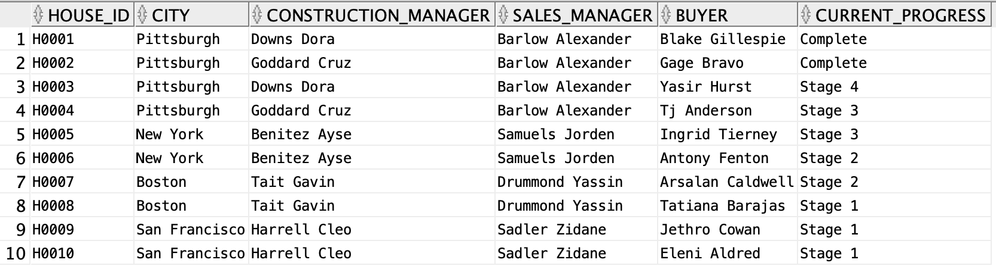

* **Scenario 2**

/*

The second report is about the details of houses,

Including the city, house base price, style, elevation type,Additional elevation price,

how many decoration jobs, total decoration cost, and the overall whole cost

*/

SELECT h.house_id, l.city, h.base_price, s.style_name, e.elevation_name,

e.additional_cost_sketch AS elevation_price, -- elevation price

count(dc.choice_id) AS decoration#, -- how many decoration

NVL(sum(dc.item_price),0) AS decoration_price, -- decoration price

h.base_price+e.additional_cost_sketch+NVL(sum(dc.item_price),0) AS total_price -- total price

FROM house h, lot l, "STYLE" s, elevation e, decoratorchoice dc

WHERE h.house_id = l.house_id

AND l.elevation_name = e.elevation_name

AND l.style_name = s.style_name

AND h.house_id = dc.house_id(+)

GROUP BY h.house_id, l.city, h.base_price, s.style_name, e.elevation_name, e.additional_cost_sketch

ORDER BY h.house_id;

