CSE 201 Project High Level Design Document

## Team Member Names

Shuyao Zhang

Nathan Falk

Xinchao Lu

Chengkai Huang

## Team Project Title

GameHub

### Project Description

Our project is similar to the example project. We are making a question board where a user can ask a question and have another user reply. The replies will be voted on by other users through a point system so the best reply can be determined. The user with the best reply will also be rewarded points that will be visible on their profile. The general theme/topic of the site is video games.

## Overall Design Description

This project will have an object oriented design. The front end will be a website with multiple pages designed with html and CSS. The backend will be created using Java and will store data such as usernames and passwords, questions asked, replies to a question, how many points a certain reply received, etc.

## UML Diagram 1

The first UML Diagram is a use case diagram. It shows what kind of things a user will be able to do on the website.

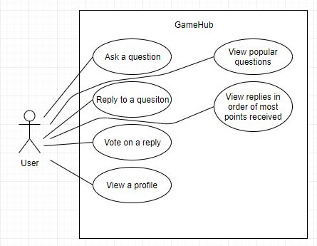

## UML Diagram 2

The second UML Diagram is another use case diagram. This diagram shows what kind of things an administrator will be able to do. The administrator will be able to act as a normal user, but will have a few extra permissions.

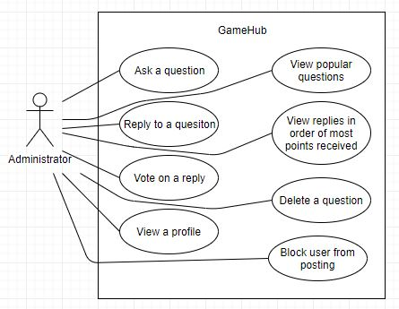

## UML Diagram 3

The third UML Diagram is a class diagram. This diagram shows the question class with some of the methods and attributes. A question will have an identification number attached to it as well as the content of the question. We will be using methods such as getAuthor which will take in the question identification number and return the author’s username.

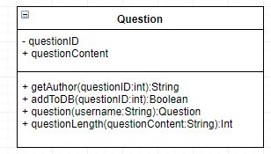

## UML Diagram 4

The fourth UML diagram is a sequence diagram. This is how a question would be added. Anything less than 10 characters is likely a poor post, so the length of the question is confirmed to be greater than 10 characters before being added.

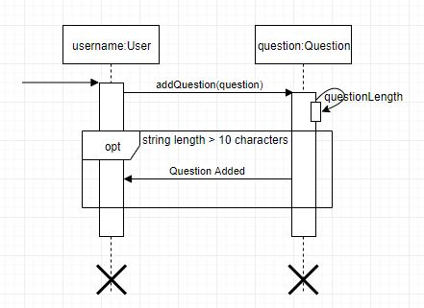

## UML Diagram 5

The final UML diagram is another sequence diagram. This shows part of how creating an account would go. Some of the material on the website could be inappropriate for children, so we would like to check the age of the user before they are able to create an account. This is a way of trying to keep children from viewing the inappropriate content.

